OGM Web Sayfasında Yer Alan Haberler

United Nations Forestry Forum Started
​UNFF 9 meetings were started in New York. The meeting are headed by Deputy Undersecretary Dr. Mahir Kucuk with the participation of delegation.

Environment and Forestry Minister, Prof. Dr. Veysel Eroğlu, GDF General Director, Osman KAHVECI, and GDA General Director, Hanefi Avci with the delegation will participate in to the "Ministerial Meeting" will be held on 2 to 3 February.

The United Nation Forestry Forum is the top level of structure in Forestry Field. The 9th session of the Forum began at United Nations Headquarters in New York. Turkey will participate for the first time at Ministerial level to UNFF.

Rising Value of the International Agenda: Forests and Forestry
Nowadays, environmental concerns are increasing at the global level. Forests and forestry are becoming so significant in this issue.

Especially the last 15-20 years, a matter of forestry has been pulled entirely to the international platform, international cooperation has become inevitable for the conservation and sustainable management of forests.
Conference on Environment and Development held in Rio in 1992 by United Nations (UN). Deforestation is a environmental threat to climate change, and also in biodiversity that has been said clearly in this conference.
Without the forests impossible!

According to data from the United Nations;
·The forests are about 31% of the world's land area.
·1.6 billion people, in other words, the world's population, 23% of them are dependent on the forest in their daily lives. They are also part of the world's poorest population.
·The forests are directly their home for more than 300 million people.
·Terrestrial biological diversity in forests is home to 80%.
·For trading forest products in the market value was U.S. $ 327 billion in 2004.
·The forest ecosystems store approximately 67 % carbon in the world terrestrial system.
·About 1/5 of global carbon dioxide emissions is caused by the destruction of forests. This amount is almost the same as the emissions from the all transport sector.
According to the data if the subject evaluates without the forests;
·Neither, in Rio in 1992 agreed that at the global level, "Sustainable Development " with the concept of "Biological Diversity, Fighting Desertification and Climate Change with" Conventions targeted goals,
·Nor, Millennium Summit is agreed in 2000 that "The Millennium Development Goals" is impossible to reach.

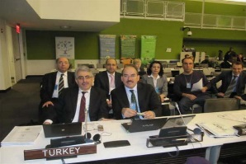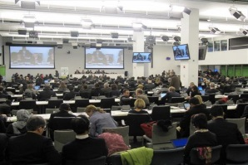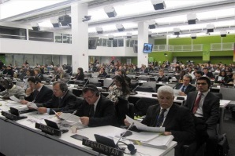
Opening of the International Year of Forests
​Opening of the International Year of Forests and The Exhibition was held under the auspices of Assembly President, Mr. Mehmet Ali Şahin in The Grand National Assembly Assembly on Tuesday January, 18 2011.
The Grand National Assembly of Turkey in the program's opening speech was made by General Manager KAHVECİ Osman, Speeches made by Environment and Forestry Minister Prof. Dr.Veysel EROGLU and the Assembly President, Mr. Mehmet Ali Sahin and then the opening ceremony started. President of the Assembly, Deputies, Foreign Heads of Missions and the guests viewed the exhibition with interest and appreciation.

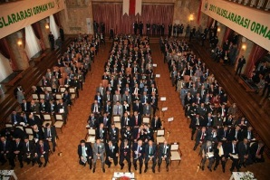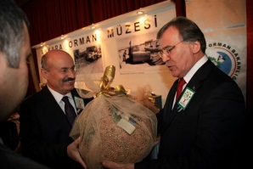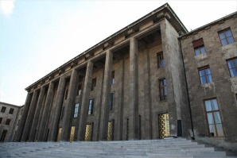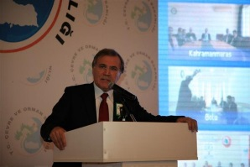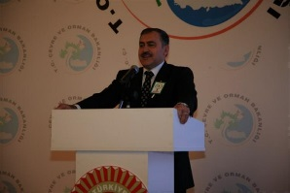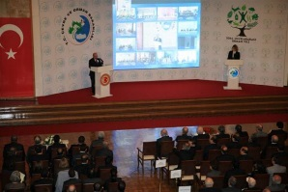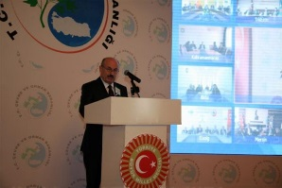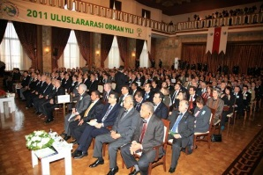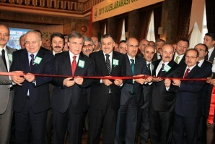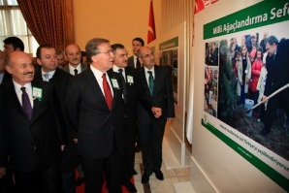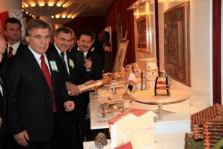

Exhibition Photos and Posters of 2011 Forest Year
​The exhibition was opened in Parliament on January 18, 2011.To be opened in New York in this month.

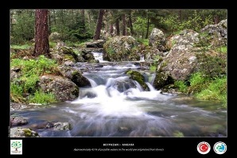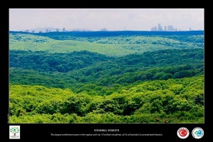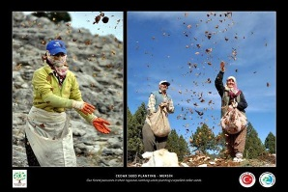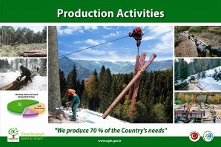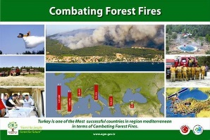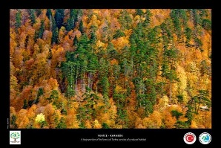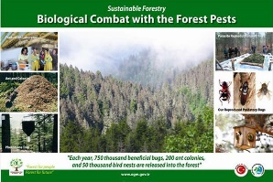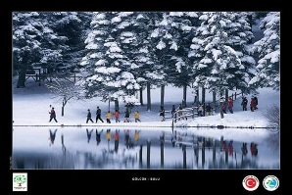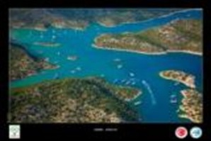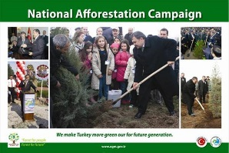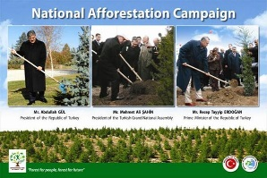

UNFF delegation and United Nations Permanent Representative met with Ambassador Ertuğrul APAKAN
Deputy Undersecretary Dr. Mahir Kucuk and the technical committee met during lunch with Ambassador Mr. Ertuğrul Apakan in the Permanent Representation of Turkish in New York.
During the meeting, the Ambassador Mr. Ertugrul Apakan expressed satisfaction with the latest developments in Turkish forestry, and the Least Developed Countries meeting will be held in Istanbul in May, which was highlighted the importance of our country.
Mr. Apakan added that they would continue their support for preparations which will be held at the House of Turkish photo exhibition and reception on the Turkish forest and forestry on Feb. 3, 2011 for the International Year of Forest.
Ambassador Ertugrul Apakan and led by Deputy Undersecretary Dr.Mahir Kucuk with delegation discussed the topics that are summarized below.

Deputy Director General of Forestry Ismail BELEN provided Country Opinion in UNFF 9th Session
The country opinion on forestry was presented by Deputy Director General of Forestry Ismail BELEN in General Assembly meeting of the United Nations Forests Forum 9th Session.
In his speech, Turkey recognizes the value of the forests for the humanity and our world, so as a reflection of the importance given to the UNFF and its activities, Turkey is participating in the UNFF9 with a large delegation headed by Prof. Dr. Veysel EROĞLU, the Minister of the Environment and Forestry, our delegation includes ministerial bureaucrats, academicians, NGO representatives and experts at ministerial level of participation is provided for the first time, he said.
At the end of his speech, in UNFF 9 Session, Deputy Director General Ismail BELEN invited to the opening of photo exhibition on the "The Turkish Forest and forestry" the representatives of participating countries of the United Nations Permanent Missions to be held in New York on February 3, 2011.

A side event on "Forestry Activities in Turkey" will organize at the local time today 01:00 p.m. to 03:00 p.m. by Turkey.

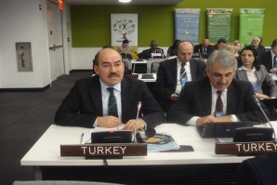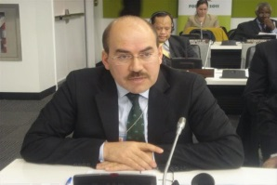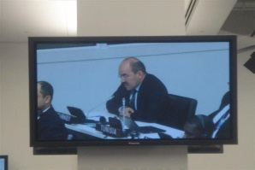

International Video Conferencing
Activities within the framework of the International Year of Forests, Forestry Form Session of the United Nations (UNFF9) are organized in New York, United States of America.

In this context, the Permanent Missions of Turkey to the United Nations, February, 3 2011 event will be held on Thursday by Ministry of Environment and Forest.

The event will be headed by Environment and Forestry Minister Mr. Prof. Dr. Veysel Eroğlu, Deputy Undersecretary of Mahir Kucuk, General Manager Osman Kahveci with a delegation participation in a meeting. As well as the meeting will be observed live Video Conference System with the Forest Region Directorates.

The program of Mr. Minister starts at 08:15 pm and will end at 11:00 pm. by the time of Turkey on February 3, 2011 Thursday.

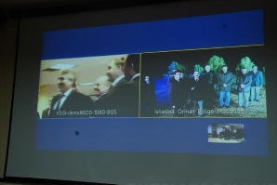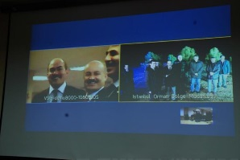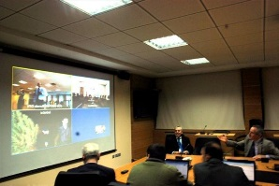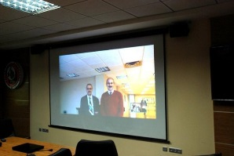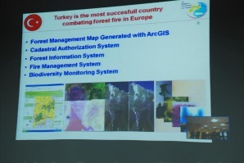

New York – Istanbul 1 million 2011 pieces seedlings
During the meeting in New York City, activities within the framework of the International Year of Forestry; his speech on the theme of "Forestry for People" by Environment and Forestry Minister Prof. Dr. Veysel Eroğlu with the participation of Regional directorates and video conference have been completed. Within the framework of the International Year of Forests 300 million seedlings will be planted in our country this year. During the meeting, 1 million 2011 of seedlings will be planted in Istanbul was mentioned. So, the first seedlings were already planted in Istanbul.
General Directorate Of Forestry - Data Processing Center - Ankara [ Address: Orman Genel Müdürlüğü Gazi Tesisleri 06560 Beştepe/ANKARA ]

