[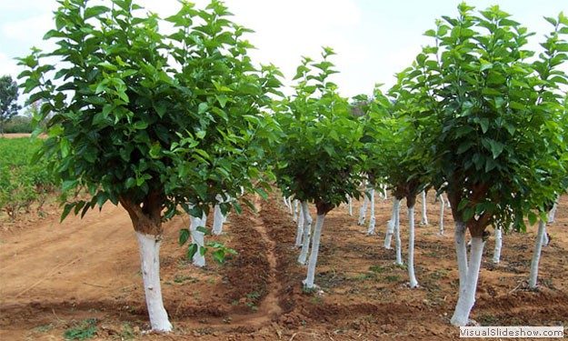](http://www.google.com.tr/url?sa=i&rct=j&q=&esrc=s&frm=1&source=images&cd=&cad=rja&uact=8&ved=0CAcQjRw&url=http://202.138.105.5/sericulture/Index.aspx&ei=lYQtVZLiHMvfaPOegtAC&bvm=bv.90790515,d.bGQ&psig=AFQjCNEVqo-FmjietQXroyPiyRtxE3zrTg&ust=1429132796130305)

[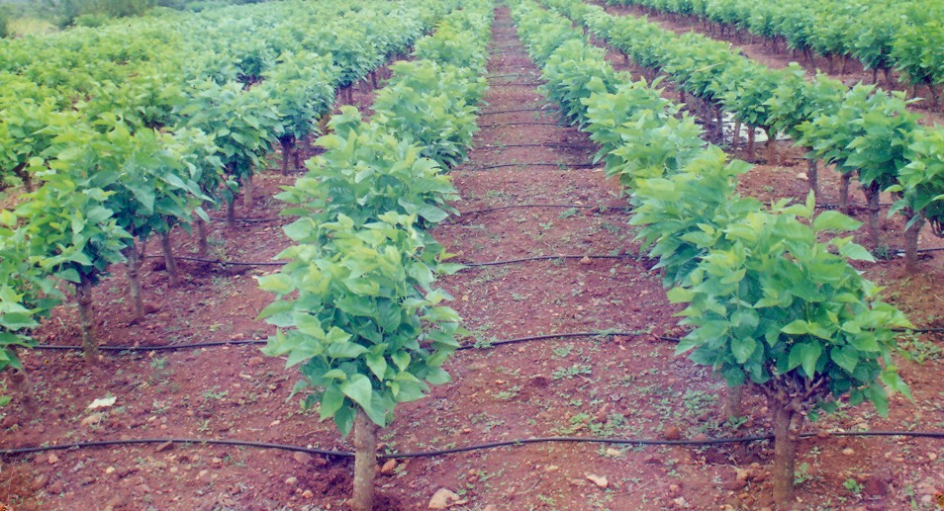](http://www.google.com.tr/url?sa=i&rct=j&q=&esrc=s&frm=1&source=images&cd=&cad=rja&uact=8&ved=0CAcQjRw&url=http://kssrdi.org/technology/technology_view.asp?id=46&ei=zIQtVa6XOMfuaOb9gJAD&bvm=bv.90790515,d.bGQ&psig=AFQjCNEJMsuFkBEojhREQ0_69k8iY3i2fg&ust=1429132871227280)

[](http://www.google.com.tr/url?sa=i&rct=j&q=&esrc=s&frm=1&source=images&cd=&cad=rja&uact=8&ved=0CAcQjRw&url=http://kssrdi.org/technology/technology_view.asp?id=268&ei=DIUtVefvGIziaq39gfAM&psig=AFQjCNEb57jMblvnJEqeNUk1nkndOS8nsA&ust=1429132925129097)

[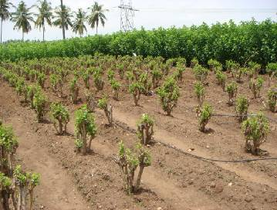](http://www.google.com.tr/url?sa=i&rct=j&q=&esrc=s&frm=1&source=images&cd=&cad=rja&uact=8&ved=0CAcQjRw&url=http://agritech.tnau.ac.in/sericulture/seri_mulberry%20cultivation.html&ei=OoUtVcnlNcPUapOXgKAD&psig=AFQjCNEb57jMblvnJEqeNUk1nkndOS8nsA&ust=1429132925129097)

[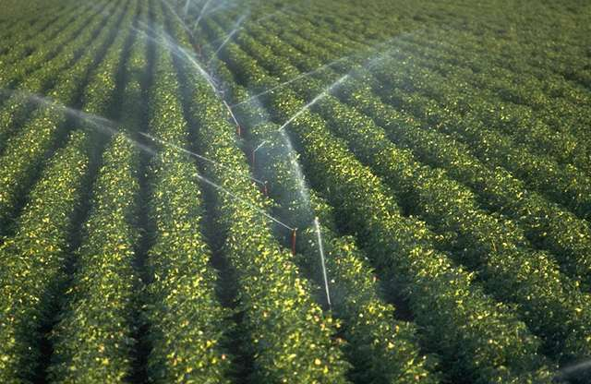](http://www.google.com.tr/url?sa=i&rct=j&q=&esrc=s&frm=1&source=images&cd=&cad=rja&uact=8&ved=0CAcQjRw&url=http://www.sustainablebizintl.com/category/sustainable-viticulture/&ei=goUtVbmKIc_PaP2WgcgK&psig=AFQjCNEb57jMblvnJEqeNUk1nkndOS8nsA&ust=1429132925129097)