 | DECLARATION  OF  INTENTION | 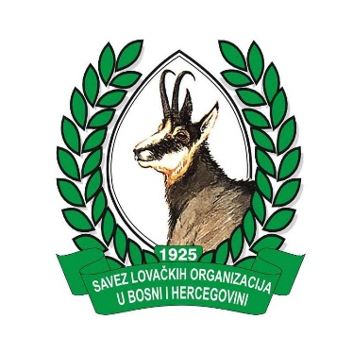
The Chamber of Forest Engineers of |  | The Association of Hunting Organizations in Bosnia and Herzegovina
Turkey |  | Bosnia and Herzegovina

Preamble
Forests, which are the common assets of the whole world, are vital for many issues such as the well-being and happiness of humanity, conservation of biodiversity, adaptation to climate change, energy, and water and food security.
Forests are one of the key sectors in achieving the “2030 Sustainable Development Goals” adopted by the United Nations General Assembly in 2015.
“The United Nations Strategic Plan for Forests 2017-2030 (UNSPF)” and “The Six Global Forest Goals and 26 Associated Targets ” adopted in 2017 have set a global road map for forests and forestry in achieving sustainable development goals.
Achieving these goals requires a common understanding and cooperation at national and international level between all sectors, including the public, private sector, academic circles and non-governmental organizations.
In this context, Chamber of Forest Engineers of Turkey and The Association of Hunting Organizations in Bosnia and Herzegovina (hereinafter referred to as Parties) have signed this Declaration of Intention to cooperate with the principles and procedures set out below.
Article 1: Purpose
The purpose of this Declaration of Intention is to determine the principles and procedures of co-operation.
Article 2: Scope
This “Declaration of Intention” encompasses the matters contained in this text. Additional agreements may be made if the Parties agreed upon them.

Article 3: Issues to be cooperated
The Parties have agreed to cooperate on the following issues.
- Transforming our world: the 2030 Agenda for Sustainable Development
- “The United Nations Strategic Plan for Forests 2017-2030 (UNSPF)” and “The Six Global Forest Goals”
- EU Forest Strategy, Ministerial Commitments of Forest Europe
- Sustainable land management
- Sustainable forest management
- Coordinating activities to increase cooperation between members of the Parties such as student exchange, internship support and job search support,
- Other issues agreed by the Parties

Article 4: Ways of Cooperation
The Parties may cooperate with one or more of the forms listed below.
- To organize events such as joint meetings, workshops, conferences, symposia etc.
- To participate in activities organized by one of the Parties and to represent each other upon request,
- To prepare projects jointly or separately, to be a partner in projects prepared by one of the Parties,
- To submit project proposal jointly to international and regional institutions and organisations such European Commission, the World Bank, the Global Environment Agency (GEF), the European Environment Agency etc..
- To submit project proposal to national agencies of any countries.
- To prepare publication , report and working document in digital media and other platforms together,
- To establish international platforms, to join the existing ones.
- To cooperate with any method not to be written here, to be agreed by the Parties.

Article 5: Responsibilities of the Parties
This Declaration of Intention was prepared and signed within the framework of mutual goodwill. It does not bring any legal or economic responsibility to any of the Parties. Each party is liable to comply with its national legislation and responsibilities.
The Parties undertake the necessary efforts in the framework of the principles of mutual goodwill in order to announce this cooperation and to ensure its continuity.
Article 6: Dispute of the Resolutions
In the event of a dispute within the framework of this Declaration of Intention, a solution will be sought in the framework of mutual goodwill. In case of cooperation within a project or activity, each activity will be dealt with and solved independently.
Article 7: Termination
The Parties may cancel this agreement – without assigning any reason – at any time upon informing the other party in writing.
Article 8: Language
This Declaration of Intention was prepared in English. The Parties may translate and publish in their national languages. In case of dispute, the English text shall prevail.
Article 9: Entry into force
This Declaration of Intention shall enter into force on the date of signature.
This Declaration of Intention is composed of 9 Articles signed in Antalya/Turkey.

03.12.2018

 | 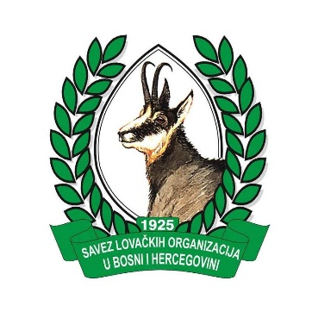
The Chamber of Forest Engineers of | The Association of Hunting Organizations in Bosnia and Herzegovina
TURKEY | BOSNIA AND HERZEGOVINA
Hasan TÜRKYILMAZ  President | Muhamed HODZIC  President

