Pine Honey as a Non-Wood Forest Product

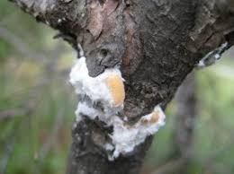
6 December 2020, Edited

TABLE OF CONTENTS
Foreword 4
Acronyms and Abbreviations 5
1. Introduction 6
1.1. Beekeping and honey production in Turkey 6
1.2. Pine honey 6
1.3. The giant pine scale, Marchalina hellenica 6
1.4. Pine honey production in Turkey 7
1.5. Honey and pine honey statistics 8
2. Economical Value and Usages 8
2.1. Economical value 8
2.2. Areas of usage 9
2.3. Contribution to rural development focusing on youth and women 9
3. Specific Sectoral Policies Administrative Structure 10
3.1. Honey production forest action plans 11
3.2. Standards 11
3.3. Production procedures 11
3.4. Administrative Structure 12
4. Challenge, Recommendations and Conclusions 12
References 14

TABLES
Table 1. Number of agriculture holdings in apiculture, Honey and wax production (TurkStat2020a) 8

FIGURES
Figure 1 Top ten honey producers between 2015-2018 in the world (FAOSTAT) 6
Figure 2. Turkey honey production in last five year 8

PICTURES
Picture 1. Effect of Marchalina hellenica beetle on red pine (Pinus brutia) branch and trunk 7
Picture 2.Forests where Marchalina hellenica is found naturally in Turkey 7
Picture 3. Beekeeper women 10

TEXT BOXES
Text Box 1. Beekeeping in Ordu province/estimetion for Turkey 9

Foreword
Forests are home to economically important products which are important for food security in addition to environmental and ecosystem contributions such as conservation of biological diversity, combating climate change, sustainable water and land management. Products from forests and other wooded land can be classified as wood products, non-wood products and forest services. Food and Agriculture Organization of the United Nations (FAO) defines non-wood forest products (NWFPs) as “goods derived from forests that are tangible and physical objects of biological origin other than wood”.
Due to its geographical position and climate conditions Turkey is very rich in terms of NWFPs. In recent years, Turkey started to give great importance to NWFPs by making the necessary legislative and administrative arrangements. Reflecting the importance of NWFPs, the Department of Non-Wood Products and Services (DNWFPS) was established as the central unit of the General Directorate of Forestry (GDF) in 2011. The DNWFPS is responsible to determine the scope of NWFPs, carry out inventory and value assessment, promote and plan the production and marketing of NWFPs and forest ecosystem services and implement any other related projects (GDF2020a).
A Letter of Agreement (LoA) was signed between FAO and the Chamber of Forest Engineers of Turkey (CFE) for "Provision of technical guidelines on sustainable management of NWFPs and the status reports on specific selected products” on 20 December 2019.
In line with this LoA, CFE prepared “Pine Honey as a Non-Wood Forest Product” which gives general information about pine honey and beekeeping activities in Turkey. During the preparation of the report CFE worked in close collaboration with respective institutions and local stakeholders. The findings were also discussed with stakeholders during consultations meetings with representatives of three different regions of Turkey, responsible national institutions and consultation workshop with respective stakeholders.
The main findings on beekeeping and pine honey are:
- Beekeeping is one of the important agricultural business in Turkey. The average honey production for the past five years is 109 115 tons annually. There are approximately 80 000 agriculture holdings in apiculture/beekeeping. (TurkStat2020a).
- The overall contribution of the sector to the national economy is estimated around 1 billion USD as per data of the Turkish Association of Beekeepers (TAB). Based on the active member of TAB, approximately 200 000 people are dealing with beekeeping in Turkey in total. (TAB, 2020)
- Pine honey is a unique honey produced by an insect called Marchalina hellenica lives in Pinus brutia forests. More than %90 pine honey production of the world comes from Turkey. (FAO, 2020). The estimated annual contribution of pine honey can be calculated as 200 million USD at retail prices (BELEN).
- There is no law in Turkey exlusively for beekeeping. However, the basic law on beekeeping is "Veterinary Services, Plant Health, Food and Feed Law". The regulatory function of the forestry sector for beekeeping is relatively new.
- Pine honey is included in Communiqué of Turkish Food Codex (TFC) very recently in 2020.

Acronyms and Abbreviations
CFE/OMO Chamber of Forest Engineers of Turkey
Communiqué of NWFPs Communiqué on Inventory and Planning of NWFPs and Production and Sales Principles
DNWFPS Department of Non-Wood Forest Products and Services of GDF
ENDP Eleventh National Development Plan (2019-2023) of Turkey
EuroStat European Statistical Office
FAO Food and Agriculture Organization of the United Nations
FRA 2020 Global Forest Resources Assessment 2020
GDF General Directorate of Forestry of Turkey
ha hectare(s)
INCREDIBLE Project Innovation Networks of Cork, Resins and Edibles in the Mediterranean Basin Project
LoA Letter of Agreement
MoAF Ministry of Agriculture and Forestry of Turkey
MT Ministry of Trade of Turkey
NWFP Non-Wood Forest Product
OG Offical Gazzette of Turkey
StarTree A pan-European project to support the sustainable exploitation of forest resources for rural development.
TAB Turkish Association of Beekeepers
TFC Turkish Food Codex
TL Turkish Lira
TSE Turkish Standards Institution
TUIK Turkish Statistical Institute (TurkStat)
USD United States Dollar
USD/TRY Rate According to the average dollar rate in 2019 by the Central Bank of the Republic of Turkey which was 5,68 TL.)

Introduction

Beekeping and honey production in Turkey
Having the climatic benefit of enjoying all four seasons, Turkey possesses many bee races and ecotypes, which easily accommodate themselves to the diverse ecologic conditions and utilizing rich floral resources providing nectar and pollen throughout the year.
Particularly the Mediterranean and the Aegean region with mild climate and specific topogrophies that lead micro-climate varieties and blossoming periods, are preferred by beekeepers for such reasons as wintering their colonies, obtaining a rich nectar and pollen source, and benefiting from the relatively early start of spring. In addition, there is a considerable source of honeydew on the pine trees in the southwest of the country.
According to FAO statistics, Turkey is the second largest producer of honey in the world produces the most honey in general.
Figure 1 Top ten honey producers between 2015-2018 in the world (FAOSTAT)
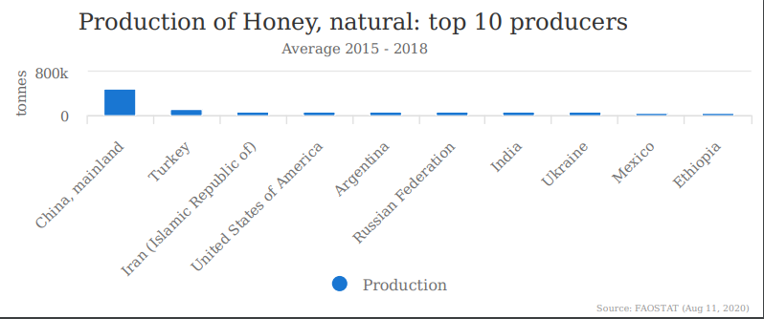

Pine honey
Pine honey is a unique honey produced by bees, not from flower pollen, but honeydew produced by an insect (Marchalina hellenica ) which lives in the body of some pine tree species. Most of the world's pine honey (about 90%) is produced in the South-West region, particularly in Muğla province of Turkey because of the suitable climatic conditions and relative humidity for Marchalina hellenica and its natural host, Pinus brutia. (FAO, 2020)
The most important feature of pine honey is that it can be stored for years without spoiling or crystallization, which is favourable also for marketing. Its color is darker than most of the flower honeys. Pine honey, with its resistance to crystallization and its preventive feature against the spoilage, is a product with a wide range of uses and significant export.

The giant pine scale, Marchalina hellenica
Marchalina hellenica is a common scale insect species in Turkish pine forests mainly in Aegean region. Its honeydew has great economic importance because it is collected by honeybees and made into “pine honey" in Turkey. (ÜLGENTÜRK). This insect is also found mainly in the Aegean and Eastern Mediterranean and Italy’s Ischia islands. It is hosted by different types of pine in Greece, especially Pinus brutia, P. halepensis and P. pinea, rarely in P. sylvestris and P. nigra. It can be found in the cracks and under the scales of the bark of these trees, hidden under the white cotton-like wax it secretes.
It can be found in bark crevices, covered by white waxy secretions. The insect has 1 generation per year (although in some cases 2 generations have been observed). It is considered that Marchalina hellenica mainly reproduces through parthenogenesis, as males are rarely found. Females are apterous and lay approximately 200-300 yellow, oval-shaped eggs covered by waxy secretions. Scientific research has been ongoing to determine important factors underlying the better quality pine honey production. Researchers found put that the honeydew insect, the host plant on which the insect feeds, the annual production of honey per hive, and finally the weather conditions (temperature, relative humidity, wind speed-direction) are important factor during the honeydew collection that affects the chemical composition (water content, acidity etc.)
Picture 1. Effect of Marchalina hellenica beetle on red pine (Pinus brutia) branch and trunk
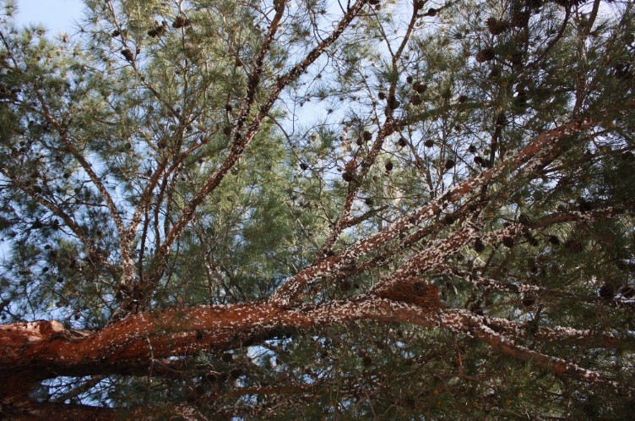 | 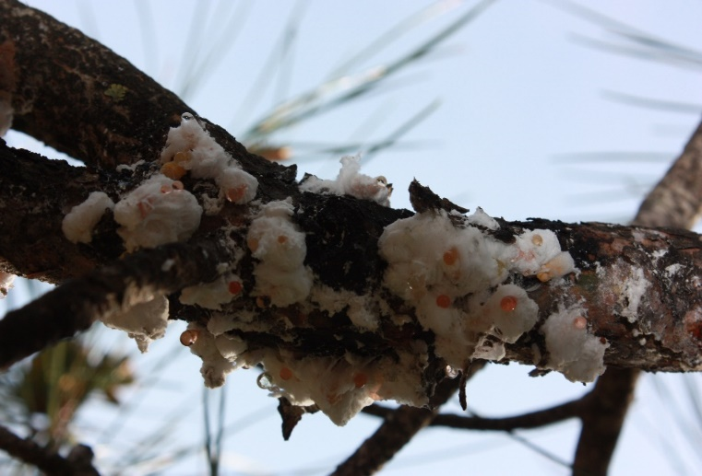

Pine honey production in Turkey
Marchalina hellenica is the main component of pine honey production. This insect exists mostly in the centre of Muğla and surrounding areas. It is found in the areas from the Fethiye coastline to the coastline of Kuşadası; while its density is high in some regions.

Picture 2.Forests where Marchalina hellenica is found naturally in Turkey
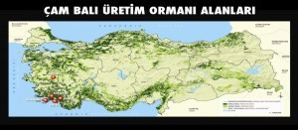 | 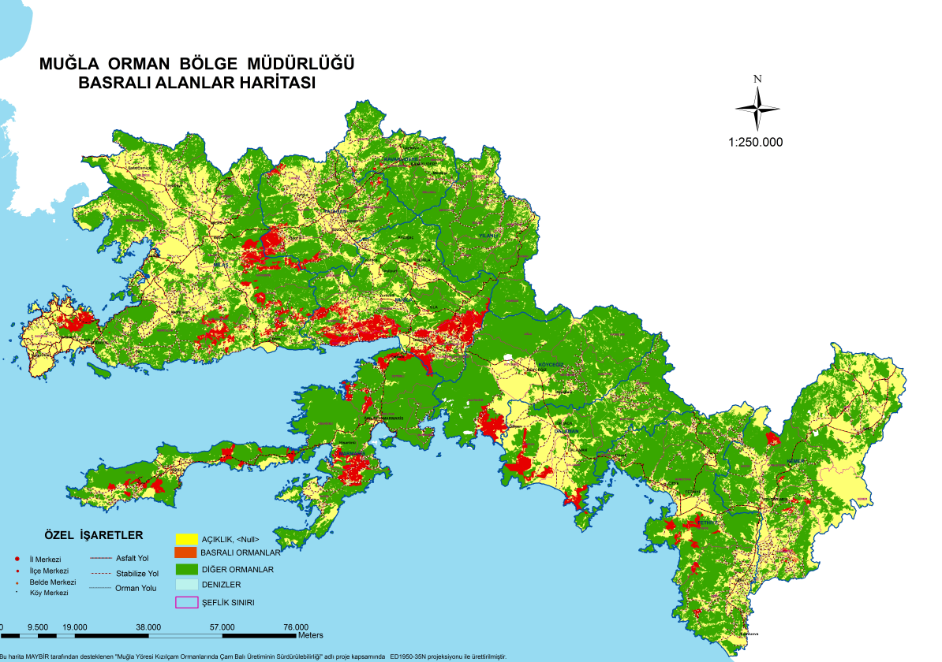

Muğla province ranks first in Turkey in the production of pine honey and considered the center of world pine honey production. The total area of Muğla province is 1 227 859 ha and 829 309 ha is forest. Marchalina hellenica is found in 8% of the total forest area in Muğla province which account for 66 305 ha. (AVCI, 2020).

Honey and pine honey statistics
According to TUIK, the highest amonth of honey produced in last five years was occured in 2017 with around 114 tons while it was minimum in 2015 as seen Figure 2

Figure 2. Turkey honey production in last five year

Table 1. Number of agriculture holdings in apiculture, Honey and wax production (TurkStat2020a)
Year | Number of agriculture holdings in apiculture | Number of hives | Honey  Ton | Wax ton
2015 | 83 475 | 7 748 287 | 108 128 | 4 756
2016 | 84 047 | 7 900 364 | 105 727 | 4 440
2017 | 83 210 | 7 991 072 | 114 471 | 4 488
2018 | 81 830 | 8 108 424 | 107 920 | 3 987
2019 | 80 675 | 8 128 360 | 109 330 | 3 971

Economical Value and Usages

Economical value
It is really difficult to calculate the total contribution of the beekeeping industry to the country's economy. There is a serious individual and family-based activity in the sector that is not recorded. A significant part of the honey and other beekeeping products produced are consumed by family, friends, and relatives without entering the registered markets.
Honey is an important export material for Turkey. In 2019 a total of 3 845 988 kg honey was exported to approx. 50 countries. Turkey has achieved 14 787 486 USD in export earnings. Accordingly, the export price of 1 kg honey in 2019 was 3.84 USD. (TurkStat2020b).
These are the official statistics related to Turkey's honey and beekeeping sector. But Mr. Ziya Şahin, President of the “Turkey Beekeepers Association (TAB)”, implies that the real figures are a bit different. He said that, in a phone conversation made on 27th of August, 2020, there have been many difficulties obtaining the real data and standardizing the sector.
Regarding pine honey, almost a quarter of the honey produced in Turkey is pine honey. Pine honey is produced entirely in forest areas dominated by red pine (Pinus brutia). The annual production amount as the average of several years is 15 000-30 000 tons. It comes mainly from Muğla province, then the others as Aydın, İzmir, Antalya, Balıkesir. One kg pine honey is about 3 USD at the field, and approximately 10 USD at the market at retail for the consumers. If we take the annual production as 20 000 tons and the price is as listed above, the estimated annual contribution can be calculated as 60 million USD at the field and 200 million USD at retail prices (BELEN).

Areas of usage
Pine honey is distinguished from flower honey by its dark color and high values ​​of pH, ash content, and electrical conductivity. (Reig, 1998). It is known that pine honey has many antioxidant compounds. Antioxidant substances in honey reduce the damage of colonic inflammation to the colon. It can be effective in increasing probiotic bacteria in the system, thereby helping to strengthen the immune system, reduce indigestion, lower cholesterol, and prevent colon cancer.
It is beneficial to consume pine honey for the healthy development of children in cases of iron deficiency. It is also useful in the fixation of bones, in the treatment of anemia and anorexia. (Krell, 1996)Since pine honey has a high value in terms of mineral substances, it has been stated that it has a very nutritious feature. (Bladenopoulou, 1984)
It nourishes the hair and contributes to the strengthening of the hair follicles. It is used for lowering high blood pressure. It supports a healthy digestive system and flora even sensitive stomachs can digest easily. It is effective against helicobacteria. It is a full stomach friend with its protective and preventive effect.

Contribution to rural development focusing on youth and women
Beekeeping is a traditional agricultural activity performed in nearly every region in Turkey. Because of its way of performing, it is not easy to have exact and verified numbers but some examples as follows can be given.
Most of the people dealing with beekeeping are the members of TAB. Taking into consideration TAB has 72 048 members as 2020, it can be said that 216 144 people are dealing with beekeeping in Turkey in total.
Text Box 1. Beekeeping in Ordu province/estimetion for Turkey
As of 2019, according to the information received from Akın Çifçi (President of Ordu Beekeepers Association, http://www.oray-bir.com/) there were 2800 active beekeepers who members of the union in the province of Ordu.

Taking into consideration that Ordu beekeepers produced 15% of the honey production of Turkey and value is around 176 million USD can be said that the overall contribution of the sector could be calculated as 1 173 million USD. However, this is not a scientific or official calculation and can be used for a general idea.

Members of the Ordu Beekeepers Association | 2 800 people
With their workers /Member+2 people | 8 400 people
Annual Honey Production | 16 000 ton
Total contribution to city economy | 176 million USD
Etimated total contribution of beekeeping sector to national economy | 1 173 million USD

Picture 3. Beekeeper women
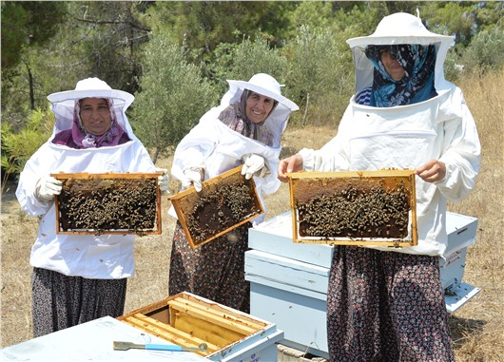
For pine honey, beekeeping sector provides employment for 35-40 thousand people in Muğla province, including beekeepers, honeycomb producers, hive producers, honey collectors, packaging material producers, marketers and shippers thanks to pine honey and its fields.
In order to contribute to the sustainability of the beekeeping profession and to increase the production of bee products with higher economic value than honey, such as royal jelly, pollen and propolis as well as improve the livelihood of women and youth, Bal Parmak, one of the leading private company of Turkey dealing with specifically pine honey established Beekeeping Academy in 2018. Bal Parmak clearly stated that women and youth are at the centre of the Beekeeping Academiy and they are essential to contribute to the development of agricultural production and beekeeping in the country. (BALPARMAK, 2018)
On the 6th International Mugla Beekeeping and Pine Honey Congress in Turkey organized in Muğla Province, attended by youth and women and create a platform for discussion the technical and economic problems of the world of beekeeping. (MAYBIR, 2020)
A lot of projects related to beekeeping has also been included in the Grant Program supported by the European Union and and Turkey, particularly women are key targets with the program called “Promoting Women's Employment Grant Program”. Beekeeping, Queen Bee and Organic Honey Production and Employment Project for Young Women” The projects that he has partnered in Bingöl Provincial Directorate of Agriculture have been completed.

Specific Sectoral Policies Administrative Structure
Currently the basic law related to beekeeping is the "Veterinary Services, Plant Health, Food and Feed Law". Based on this Law, "Beekeeping Regulation" published in 2011. (OG, Beekeeping Regulation, 2011)
Although most of the beekeeping activities are carried out in and around the state-owned forests and other wooded lands specifically related to pine honey, the regulatory function of the forestry sector for beekeeping is relatively new. "Honey Forests Communiqué" numbered 307 was published in 2017. (GDF, Honey Production Forest Communique, 2017)
Pine honey included in Communiqué of TFC in 2020. TFC defines pine honey as follows: ''The secretion produced by honey bees, which is collected and processed by the honey bees using the carbohydrate-rich sweet sap of Marchalina hellenica that lives on some pine trees (Pinus brutia, P. nigra, P. pinea)''

Honey production forest action plans
Due to its importance and as the continuation of ongoing activities, the GDF implemented the “First Honey Forest Action Plan 2013-2018” (GDF, First Honey Production Action Plan 2013-2018, 2013).”
Following the completion of the First Honey Forest Action Plan, the "Second Honey Forest Action Plan" covering the years 2018-2023 has been prepared and put into effect. Under the umbrella of this second action plan, 720 ha of honey forest will be established by 2023. (GDF, Second Honey Forest Action Plan 2018-2023, 2018) By the end of 2019, there are 484 Honey Forests equals 60 646 hectares in total were established in Turkey. (GDF, Forestry Statistics of 2019, 2020)

Standards
The following standardization institutes can be listed which are relevant for beekeeping and honey production:
- Turkish Standards Institution
- International Organization for Standardization-ISO
- Turkish Patent and Trademark Office-TurkPatent
- Turkish Food Codex
- EU Standards
There has not been any specific standard approved either by the Turkish Standard Institution or the International Organization for Standardization for pine honey. For general bee products the standards developed and currently in effect by the Turkish Standards Institute are as follows. (BALMER)
- TSE 6666 - Royal Jelly,
- ICS 65.140 - Honey Bee Venom,
- TSE 10255 - Pollen,
- TS 12910 - Bee Glue (Propolis),
- TS 2936 - Beeswax,
- TSE 3036 - Honey
With regard to patent, there are two geographical signs for pine honey issued by Turkish Patent and Trademark Office in line with “Paris Convention for the Protection of Industrial Property” and national legislations.
- Muğla Pine Honey- Registered at 15.08.2018 on behalf of Muğla Province Bee Farmers Association (TurkPatent, Muğla Pine Honey, 2018)
- Marmaris Pine Honey- Registered at 06.11.2019 (TurkPatent, Marmaris Pine Honey, 2019)

Production procedures
The production period of pine honey is carried out in September-November. During this period, 2-3 collection can be done from the bees transferred to the pine honey production areas depending on the year and ecological conditions. The produced pine honey is taken to cans and sold to the wholesaler or the companies that supply to the market.

Administrative Structure
The main ministry for pine honey is MoAF. There are several DGs under MoAF dealing with pine honey issues as shown below:
- General Directorate of Forests
- General Directorate of Nature Conservation and National Parks
- General Directorate of Animal Production
- Genera Directorate of Plant Production
- General Directorate of Food and Control
- General Directorate of Agricultural Research and Policies (TAGEM)- Apiculture Research Institute
- Universities
- NGOs (such as Turkish Association of Beekeepers)
Apart from the MoAF, as there is pine honey production in “Specially Protected Environmental Areas”, the Ministry of Environment and Urbanisation is concerned with pine honey production.

Challenge, Recommendations and Conclusions
Although pine honey is an agricultural product in terms of legislation related to food and agriculture, it is produced in forest areas as a NWFP.
The main problems for pine honey areas could be listed as follows:
- Inventory and mapping of the areas where the giant pine scale “Marchalina hellenica" is spread naturally,
- Understanding the life cycle of Marchalina hellenica, ensuring its health and sustainability
- Determination of forests to be reserved for pine honey production within the scope of "Honey Forests Communiqué" and Communiqué of NWFPs,
- Determining international standards for pine honey production and marketing, increasing export opportunities
As of 2020, the natural range of Marchalina hellenica has not been fully determined. There are different approaches and figures released by universities, agriculturalists, GDF, non-governmental organizations, beekeeping farmers and forest villagers in terms of distribution areas and production. On the other hand, it is seen that Marchalina hellenica has been moved to forests and trees outside of its natural range due to its high economic return.
Another shortcoming is that the biology and life cycle of Marchalina hellenica is not fully known. Beekeepers generally carry out their activities with traditional methods, and not much attention is paid to Marchalina hellenica itself, which is the basic element in the production of pine honey. Many factors affect the health, production capacity and sustainability of the insect. For example, it has been observed that the health of the insect was affected due to the drought in 2020 and honey production decreased significantly.
Although Turkish beekeepers know the time of honey secretion in the life cycle of the Marchalina hellenica, they are not successful in turning it into production. Despite all their experience in production timing issues, planning and implementation errors are the main cause of failure. Capacity-building activities are needed to enhance better productivity in pine honey production.
Another challenge is about the status of Marchalina hellenica related to forestry activities. Recently there has been some debate about this insect, whether it is harmful or not for red pine body and its capacity for producing woody materials. In Turkey Marchalina hellenica is in the list of the insects which are harmful to the forest because of its possible capacity to reduce wood increment.
In 2006, Marchalina hellenica was included in the European and Mediterranean Plant Protection alert list but in 2008 it was excluded (EPPO). In Turkey, the insect is still considered to be harmful for trees but expected to be deleted from the list especially for natural distribution areas. (CARFU, A Unique Non-Wood Forest Product: Pine Honey, 2015) In short, Marchalina hellenica could be described as both harmful and beneficial for two contrasting reasons. First, it is the most significant of several honeydew-producing insects in Greece and Turkey, and pine honey production relies mainly on Marchalina hellenica honeydew in both countries. For this reason, it has been intentionally introduced in many sites in these countries and its population size has been increased locally. Second, it is a pine pest as it feeds on the sap of the pine trees and can cause increment loss, desiccation, branch dieback, increasing crown transparency and tree decline. Heavy infestation by Marchalina hellenica may leave the host trees vulnerable to attack by secondary pests such as bark beetles. It is also considered a pest by foresters. Therefore, population management of Marchalina hellenica can be an important issue particularly out of its native range. Therefore, strong coordination has to be enhanced among different organizations responsible for NWFP, livestock, food and pest control. (AVCI P. D., 2020)
There is an excessive and uncontrolled bee entrance in the forestry area, especially during the production of pine honey. In some regions, hives are put on top of each other and this situation causes failure in productivity meaning that unable to get the maximum product (honey) from the unit beehive. Additionally, high density of colonies in the areas, trigger the transmission of all kinds of bee diseases.
With regard to forest management, determination of forests to be reserved for pine honey production within the scope of "Honey Forests Communiqué" and “Communiqué of NWFPs” is an important issue. In Turkey there has been an icreasing demand for wood-based forest products and this demand triggers wood production activities. In addition to wood demand and production, tourism, agriculture, mining activities, thermal power plants, forest fires emerge as major threats.
There are conflicts between tourism and beekeeping in many areas, especially in Muğla province. The busiest period of these two sectors corresponds to the same time. Therefore, in some regions, there are also situations where bees harm tourists.
Agricultural activities, especially in areas close to forested areas, can cause damages to insects including bees. Pollution of soil and water affects the beekeeping sector adversely.
Power plants create a very dense cloud of dust in the area where they operate, decreasing the moisture needed for the Marchalina hellenica thermal power plants and mines and quarries cause excessive air pollution in the region where they are located.
Within the framework of the relevant regulation, circular and action plan, a legal status namely “natural honey forests” should be given to pine honey production areas as indicated Communiqué of NWFPs and Honey Forests Communiqué. If such a legal status is given, problems with competitive sectors such as tourism and mining can be solved more easily, transparently and effectively.

References

AVCI. (2020, Novmber 30). Current Status of Honey Forests and Pine Honey Production Areas. (P. D. AVCI, Ed.) Retrieved December 5, 2020, from http://www.gonder.org.tr/wp-content/uploads/2020/12/Prof-Dr-Mustafa-Avci-Calistay-Sunu-30-Kasim-2020.pdf
AVCI, P. D. (2020, August 27). (I. Belen, Interviewer)
BALCI, Ö. (2020, August 27).
BALMER. (n.d.). Balmer - Black Sea Bee Products Centre. Retrieved December 5, 2020, from http://www.bal-mer.com/TSE-Standardi--TSE-3036-Bal
BALPARMAK. (2018). Retrieved August 2020, from http://www.balparmakaricilikakademisi.com.tr/
BELEN, İ. (n.d.). A Unique Non-Wood Forest Product: Pine Honey. Retrieved August 2020, from http://www.carfu.org/?p=524
Bladenopoulou, T. a. (1984). A comparative analysis of Greek pine and blossom honey. Nea Melissa 2, 7-10 (in Greek).
CARFU. (n.d.). Retrieved 2020, from http://www.gonder.org.tr/?p=9885
CARFU. (n.d.). (İ. Belen, Ed.) Retrieved December 5, 2020, from http://www.gonder.org.tr/wp-content/uploads/2014/10/Ar%C4%B1c%C4%B1l%C4%B1%C4%9F%C4%B1n-Desteklenmesine-%C4%B0li%C5%9Fkin-Bakanl%C4%B1k-Talimat%C4%B1-2-Mart-2010.pdf
CARFU. (2015). A Unique Non-Wood Forest Product: Pine Honey. (İ. Belen, Editor, & T. F. Future, Producer) Retrieved August 2020, from http://www.carfu.org/?p=524
CARFU. (n.d.). Beekeeping in Ordu Province. (İ. Belen, Ed.) Retrieved August 2020, from http://www.gonder.org.tr/?p=9885
CARFU2019. (n.d.). Azerbaijan’s Natural Wealth and Ecology Workers Trade Union Joins PLANFOR. Retrieved from http://www.carfu.org/?p=1478
developmen, T. s. (n.d.). Trade statistics for international business developmen. Retrieved from https://www.trademap.org/Index.aspx
EPPO. (n.d.). EPPO Reporting Service. Retrieved 2020, from https://gd.eppo.int/reporting/article-1097
FAO. (2020). FAO STAT. Retrieved from http://www.fao.org/faostat/en/#home
FAO. (2020, August). The buzz around Turkish pine honey. Ankara. Retrieved from http://www.fao.org/support-to-investment/news/detail/en/c/1276394/
FAO. (2020a). Global Forest Resources Assessment 2020: Main report. Rome. Rome: Food and Agriculture Organisation. Retrieved August 2020, from https://doi.org/10.4060/ca9825en
Földhazi. (1994). Analysis and quantitation of sugars in honey of different botanical origin using high performance liquid chromatography, Univ. horticulture food industry, dep. food chemistry nutrition sci., 1118 Budapest, Hungary.
GDF. (2013). First Honey Production Action Plan 2013-2018. Retrieved from https://www.ogm.gov.tr/ekutuphane/Yayinlar/Bal%20Orman%C4%B1%20Eylem%20Plan%C4%B1%20%282013-17%29.pdf
GDF. (2017). Honey Production Forest Communique. (GDF, Ed.) Retrieved from https://www.ogm.gov.tr/ekutuphane/Tebligler/Bal%20Ormanlar%C4%B1%20%C4%B0%C5%9Fletilmesi%20ve%20Y%C3%B6netilmesi.pdf
GDF. (2018). Second Honey Forest Action Plan 2018-2023. Retrieved August 2020, from https://www.ogm.gov.tr/ekutuphane/Dokumanlar/Bal%20Orman%C4%B1%20Eylem%20Plan%C4%B1%20(2018-2023).pdf
GDF. (2020). Forestry Statistics of 2019. Retrieved 2020, from https://www.ogm.gov.tr/ekutuphane/Sayfalar/Istatistikler.aspx?RootFolder=%2Fekutuphane%2FIstatistikler%2FOrmanc%C4%B1l%C4%B1k%20%C4%B0statistikleri&FolderCTID=0x012000301D182F8CB9FC49963274E712A2DC00&View={4B3B693B-B532-4C7F-A2D0-732F715C89CC}
GDF2020a. (n.d.). Organisation of the GDF. Retrieved August 2020, from https://www.ogm.gov.tr/lang/en/Pages/Organization/Units.aspx
K, O. A. (2017). CHEMOMETRIC EVALUATION OF THE GEOGRAPHICAL ORIGIN OF. Food and Health.
Krell. (1996). Value-added products from beekeeping. FAO AGRICULTURAL SERVICES BULLETIN No. 124. Retrieved from http://www.fao.org/3/w0076e/w0076e00.htm
Lachmanatall. (2007). Analysis of minority honey components: Possible use for the evaluation of honey quality, Food Chemistry, Volume 101, Issue 3, 2007, Pages 973-979. In J. K. Lachman.
MAYBIR. (2020). Mugla Beekeeping & Pine Honey Congress. Retrieved from https://www.muglacongress.org/eng/?p=home
Office, F. A. (2020). FAO. Retrieved from http://www.fao.org/europe/news/detail-news/es/c/1276387/
OG. (2010). Veterinery Services, Plant Health, Food and Feed Law. Retrieved August 2020, from https://www.resmigazete.gov.tr/eskiler/2010/06/20100613-12.htm
OG. (2011). Beekeeping Regulation. Retrieved August 2020, from https://www.resmigazete.gov.tr/eskiler/2011/11/20111130-9.htm
OG. (2020). Turkish Food Code-Honey Communication. Retrieved from https://www.resmigazete.gov.tr/eskiler/2020/04/20200422-13.htm
Reig, M. a. (1998). Mateo and Bosch- Reig, 1998. Classification of Spanish Unifloral Honeys by Discriminant Analysis of Electrical Conductivity, Color, Water Content, Sugars, and pH, J. Agric. Food Chem. 1998, 46, 393−400.
Şahin, Z. (2020, August 27). (İ. Belen, Interviewer)
TAB. (2020). Turkish Association of Beekepers. Retrieved December 4, 2020, from http://www.tab.org.tr/en/
The Turkish Constitutional Court of the Republic of Turkey. (2020). Constitution of the Republic of Turkey. Ankara. Retrieved August 2020, from https://www.anayasa.gov.tr/en/legislation/turkish-constiution/
TurkPatent. (2018). Muğla Pine Honey. Retrieved from https://www.ci.gov.tr/Files/GeographicalSigns/379.pdf
TurkPatent. (2019). Marmaris Pine Honey. Retrieved 2020, from https://www.ci.gov.tr/Files/GeographicalSigns/a09b775c-a8da-4c06-a18b-031b52ec84fb.pdf
TurkStat2020a. (n.d.). Main Statistics. Retrieved August 2020, from http://www.tuik.gov.tr/PreTablo.do?alt_id=1002
TurkStat2020b. (n.d.). Retrieved August 2020, from https://biruni.tuik.gov.tr/disticaretapp/disticaret.zul?param1=25&param2=4&sitcrev=0&isicrev=0&sayac=5802
ÜLGENTÜRK. (n.d.). Ant species (Hymenoptera: Formicidae) associated with Marchalina hellenica. Retrieved 2020, from https://dergipark.org.tr/tr/download/article-file/64125

