Chestnut as a Non-Wood Forest Product

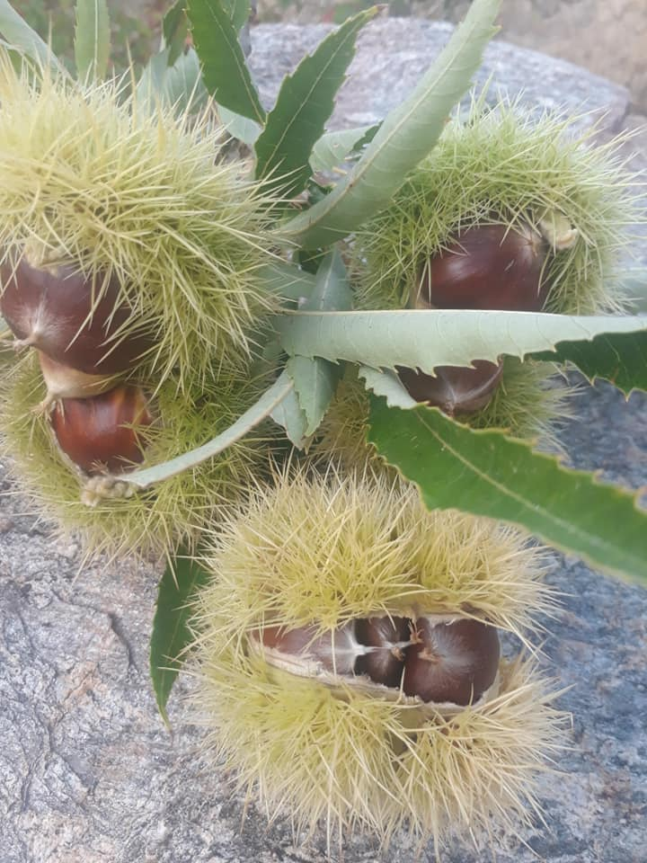

6 December 2020, Final, Edited Version

TABLE OF CONTENTS

Foreword 4
Acronyms and Abbreviations 5
1. Introduction 6
1.1. Distribution of chestnut forests 6
1.2. Chestnut as non-wood forest products 7
2. Economical Value, Usages and Trade 8
2.1 Economical Value 8
2.2. Export and Import 11
2.2 Areas of Usage 13
3. Challenges and recommendations 14
3.1. Diseases 14
3.2. Recommendations 14
References 15

Tables
Table 1. Chestnut forests by region in Turkey (ha) 6
Table 2. Chestnut utilization and areas that chestnuts harvested 7
Table 3. Chestnut collection in Turkey for last five years (2015-2019) 9
Table 4. Total annual income of chestnut fruit annually for the year 2000 10
Table 5. Export and import of chestnut fruit in 2015-2019 11
Table 6. Top five exported countries 12
Table 7. Chestnut import to Turkey (kg/year) 12
Table 8. Chestnut diseases 14

Figures
Figure 1. Distribution of chestnut in Europe 6
Figure 2. Distribution of forests in Turkey 6
Figure 3. Ratio of chestnut fruit harvested in 2019 8
Figure 4. The ratio of collection in the provinces to country total in 2019 8
Figure 5. Last five years chestnut harvest in Turkey (tons / year) 9
Figure 6. Forest areas where chestnut fruits are harvested 10
Figure 7. Chestnut export and export income for 2015-2019 11
Figure 8. Top five exported countries (kg/year) 12
Figure 9. Chestnut import from China (kg/year) 13
Figure 10. Unit Export and Import Prices (kg/USD) 13

Pictures
Picture 1. Natural forests, intensive production areas and chestnut trees in hazelnut groves 7
Picture 2. Chestnut flowers for beekeeping 10

Foreword

Forest ecosystems provide substantial economically important products that are essential to the livelihood of its dependents. The forest and tree products are classified as wood products, non-wood products and forest services. Food and Agriculture Organization of the United Nations (FAO) defines non-wood forest products (NWFP) as “goods derived from forests that are tangible and physical objects of biological origin other than wood”. Globally, the reported value of NWFPs was about 7.71 billion USD in 2015. (FAO, 2020a).
Due to its geographical position and climate conditions, Turkey has very rich non-wood forest products. In recent years, Turkey started to give great importance to NWFPs by making the necessary legislative and administrative arrangements. As one the reflections of the importance, the Department of Non-Wood Products and Services (DNWFPS) was established as the central unit of the General Directorate of Forestry (GDF) in 2011.
As the specialized agency, FAO is conducting several studies on different issues with Turkey by cooperating with both public institutions, non-governmental organizations and other stakeholders. In this context a Letter of Agreement (LoA) was signed between FAO and the Chamber of Forest Engineers of Turkey (CFE) for "Provision of technical guidelines on sustainable management of NWFPs and the status reports on specific selected products” on 20 December 2019.
In line with this LoA, CFE as the Service Provider, prepared the report of “Bay Leaf as a Non-Wood Forest Product” which gives general information about bay leaf production, harvesting and usages in Turkey.
The report of “Anatolian Chestnut (Castanea Sativa Mill) as a Non-Wood Forest Product” was prepared by the team of CFE consultants working in close collaboration with respective institutions and local stakeholders. The team is grateful for the contributions and support provided by FAO and GDF, particularly DNWFPS staff. The findings also discussed with stakeholders during “consultations meetings with three different regions, update meeting with responsible national institutions and consultation workshop with respective stakeholders”
The main findings of chestnut are:
- In Turkey, the state-owned forests have 262 045 hectares of chestnut. The chestnut forests subject to nut production is 74 897 hectares
- Most of the chestnut trees are found in state-owned forests but the nuts are generally produced in the orchards established in agricultural lands.
- According to a study conducted in 2001, the total contribution of chestnut fruit to the country's economy was calculated as 116 million USD annually.
- In 2019, a total of 72 655 tons of chestnut fruits were harvested. Also, in 2019, 14 225 tons of chestnut fruits were exported, and in return, approximately 36 million USD export revenue was obtained. On the other hand, approximately 2 tons of chestnut fruits were imported in the same year.
- 71 percent of total exports in 2017 and 80 percent of 2019 total exports were made to Italy. This situation, being so dependent on only one market, actually poses the danger of fragility for the export market.
- Chestnut forests have great potential to Turkey's economy in the medium and long term so that they should be paid well attention to in policy documents, regional or provincial rural development plans.

Acronyms and Abbreviations
CFE/OMO Chamber of Forest Engineers of Turkey
Communiqué of NWFPs Communiqué on Inventory and Planning of NWFPs and Production and Sales Principles
DNWFPS Department of Non-Wood Forest Products and Services of GDF
ENDP Eleventh National Development Plan (2019-2023) of Turkey
EuroStat European Statistical Office
FAO Food and Agriculture Organization of the United Nations
FRA 2020 Global Forest Resources Assessment 2020
GDF General Directorate of Forestry of Turkey
ha hectare(s)
INCREDIBLE Project Innovation Networks of Cork, Resins and Edibles in the Mediterranean Basin Project
LoA Letter of Agreement
MAF Ministry of Agriculture and Forestry of Turkey
MT Ministry of Trade of Turkey
NWFP Non-Wood Forest Product
OWL Other Wooded Land
StarTree A pan-European project to support the sustainable exploitation of forest resources for rural development.
TL Turkish Lira
TSE Turkish Standards Institution
TUIK Turkish Statistical Institute (TurkStat)
USD/TRY Rate According to the average dollar rate in 2019 by the Central Bank of the Republic of Turkey which was 5.68 TL)

Introduction

Distribution of chestnut forests
Fagaceae (Cupuliferae) includes eight genera (Castanea, Castanopsis, Fagus, Lithocarpus, Nothofagus, Quercus, Trigonobalanis, Chrysolepis) and about a 600–800 species. The genus Castanea is widespread in the Northern Hemisphere and includes 12 or 13 species according to classification.
The sweet chestnut (Castanea sativa Mill.) is native to central-southern Europe (the northern Iberian Peninsula, the South of France, central-northern Italy, the southern Balkan Peninsula) and Asia Minor (western and northern Turkey, the Caucasus). It can be found at sea level in its northern range, and at up to 1 400 m above sea level in Greece and 1 700 m in Asia Minor. This tree has been widely planted and cultivated outside its natural range throughout the warm-temperate climate regions, such as South and North America and Australia. (EU, 2020)
Figure 1. Distribution of chestnut in Europe  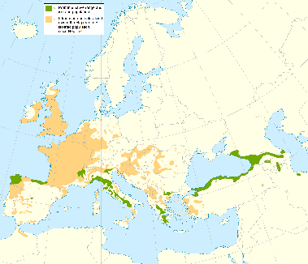 | Figure 2. Distribution of forests in Turkey  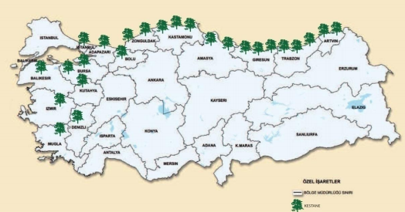
In Turkey, the state-owned forests have 262 045 hectares of chestnut as shown in Table 1 (GDF, 2013).
Table 1. Chestnut forests by region in Turkey (ha)
Regions Name | Pure chestnut forests |  | Mixed chestnut forests where chestnut is predominant |  | Mixed chestnut forests where other species are predominant |  | Total
 | Productive | Degraded | Productive | Degraded | Productive | Degraded
Adapazarı | 894 | 955 | 11 635 |  | 4 001 | 18 | 17 503
Amasya | 452 | 124 | 1 166 | 0 | 2 640 | 0 | 4 382
Artvin | 2 659 | 560 | 14 736 | 0 | 9 481 | 84 | 27 520
Balıkesir | 998 | 118 | 2 206 | 15 | 12 911 | 31 | 16 278
Bolu | 34 | 0 | 1 005 | 0 | 9 174 | 0 | 10 212
Bursa | 629 | 169 | 5 025 | 420 | 6 507 | 414 | 13 164
Denizli | 76 | 15 | 85 | 0 | 4 | 0 | 180
Giresun | 6 021 | 1 572 | 7 238 | 1 178 | 9 618 | 5 075 | 30 702
İstanbul | 2 628 | 0 | 1 246 | 0 | 12 234 | 0 | 16 108
İzmir | 2 179 | 82 | 31 | 1 257 | 27 | 532 | 4 108
Kastamonu | 2 588 | 1 174 | 7 970 | 194 | 11 817 | 92 | 23 833
Kütahya | 4 | 77 | 39 | 0 | 246 | 689 | 1 054
Muğla | 864 | 24 | 0 | 0 | 22 | 13 | 923
Trabzon | 1 322 | 1 795 | 31 469 | 261 | 28 957 | 5 119 | 68 926
Zonguldak | 665 | 126 | 5 284 | 0 | 19 838 | 1 240 | 27 151
Total | 22 013 | 6 791 | 89 136 | 3 324 | 127 475 | 13 306 | 262 045

Chestnut as non-wood forest products
The main provinces having chestnut are in the Black Sea region, where most of chestnut forests are natural. The chestnut forests in Turkey subject to nut production is 74 897 hectares. Table 2 provides the utilization amount and respective harvested area region by region according to data provided by GDF (GDF, NWFPs inventories at the end of 2019, 2019)
Table 2. Chestnut utilization and areas that chestnuts harvested
Regional Directorate of Forests | Utilization (tons) | Area harvested (ha)
Artvin | 143 | 1 832
Balıkesir | 752 | 2 844
Bolu | 33 | 848
Bursa | 14 | 912
Çanakkale | 1 448 | 1 340
Denizli | 13 | 69
Eskisehir | 64 | 650
Giresun | 13 766 | 14 600
Istanbul | 58 | 3 654
Izmir | 1 756 | 5 574
Kastamonu | 965 | 2 825
Kutahya | 53 | 382
Sakarya | 98 | 10 127
Trabzon | 2 012 | 20 405
Zonguldak | 3 005 | 8 835
Total | 24 180 | 74 897

Picture 1. Natural forests, intensive production areas and chestnut trees in hazelnut groves
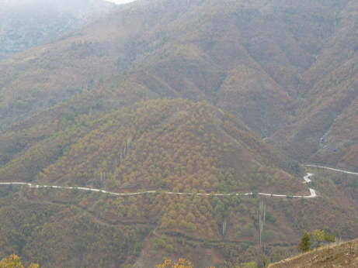 | 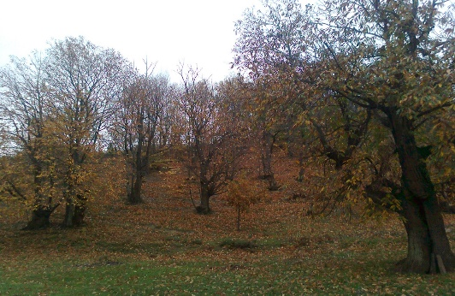 | 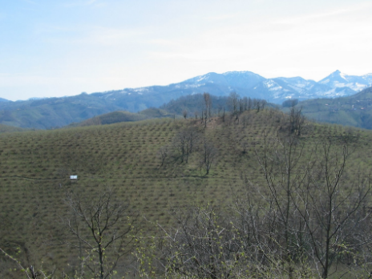

Most of the chestnut trees are found in state-owned forests but the nuts are generally produced in the orchards established in agricultural lands. In 2019, the total chestnut harvested was 72 655 tons. 24 thousand tons collected from state-owned forests, in other words 33 percent, and the remaining 48 thousand tons, that is, 67 percent, was collected from private chestnut gardens in agricultural areas.
Figure 3. Ratio of chestnut fruit harvested in 2019

While natural chestnut forests are predominantly located in provinces in the Black Sea Region such as Trabzon, Giresun, Ordu, Sinop and Kastamonu, chestnut fruit is harvested mostly in Aegean Region provinces such as Aydın and İzmir. In fact, this situation, the partially intact chestnut forests in the Black Sea Region, contains a very important potential.
Figure 4. The ratio of collection in the provinces to country total in 2019

Economical Value, Usages and Trade

2.1 Economical Value
According to the TUIK data of 2019, chestnut harvesting in Turkey was 72 655 tons annually. Regarding the total economic value of chestnut trees and its products, a comprehensive study is needed to measure the total annual contribution. For this, it is necessary to know at least the value of wood-based products obtained from chestnuts, animal nutrition made from chestnut leaves, chestnut honey and tea produced by using chestnut flowers, and ultimately the economic values ​​of chestnut fruit.
There is a total of 262 045 hectares of chestnut forests in Turkey as noted in the relevant section. Only 74 897 hectares of these forests, in other words about 29 percent, are reserved for chestnut fruit harvesting. In the remaining forests, normal silvicultural activities are carried out and wood-based forest products are produced.

Figure 5. Last five years chestnut harvest in Turkey (tons / year)

Table 3. Chestnut collection in Turkey for last five years (2015-2019)
Provinces | Annual nut collection (Tones)
 | 2015 | 2016 | 2017 | 2018 | 2019
Afyonkarahisar | 2 | 2 | 12 | 27 | 27
Antalya | 73 | 73 | 73 | 73 | 73
Artvin | 251 | 228 | 207 | 209 | 209
Aydin | 21 215 | 25 423 | 24 304 | 26 248 | 32 232
Balıkesir | 1 033 | 1 217 | 1 118 | 1 117 | 1 159
Bartın | 2 843 | 3 277 | 4 090 | 3 601 | 5 933
Bitlis | 14 | 13 | 12 | 12 | 12
Bursa | 1 943 | 2 134 | 1 990 | 1 822 | 1 820
Denizli | 1 891 | 2 120 | 1 898 | 1 761 | 1 777
Düzce | 547 | 609 | 578 | 598 | 606
Giresun | 148 | 200 | 229 | 228 | 235
Isparta | 12 | 6 | 6 | 5 | 5
Kastamonu | 9 715 | 3 114 | 3 124 | 3 126 | 3 125
Kocaeli | 395 | 459 | 454 | 453 | 396
Kutahya | 2 795 | 2 448 | 2 075 | 1 988 | 1 999
Manisa | 2 482 | 2 502 | 2 354 | 2 309 | 2 333
Muğla | 90 | 105 | 93 | 82 | 85
Ordu | 592 | 652 | 553 | 485 | 469
Rize | 501 | 576 | 549 | 504 | 574
Sakarya | 72 | 56 | 55 | 55 | 55
Samsun | 613 | 624 | 600 | 315 | 307
Sinop | 3 993 | 4 001 | 3 755 | 3 655 | 3 676
Tokat | 1 | 2 | 2 | 2 | 2
Trabzon | 58 | 108 | 107 | 105 | 98
Yalova | 579 | 638 | 725 | 732 | 726
Zonguldak | 1 180 | 1 364 | 1 246 | 1 295 | 1 307
Canakkale | 930 | 1 151 | 1 113 | 1 118 | 1 217
Istanbul | 40 | 45 | 40 | 45 | 30
Izmir | 9 742 | 11 603 | 11 542 | 11 610 | 12 168
Total | 63 750 | 64 750 | 62 904 | 63 580 | 72 655
Figure 6. Forest areas where chestnut fruits are harvested

Picture 2. Chestnut flowers for beekeeping
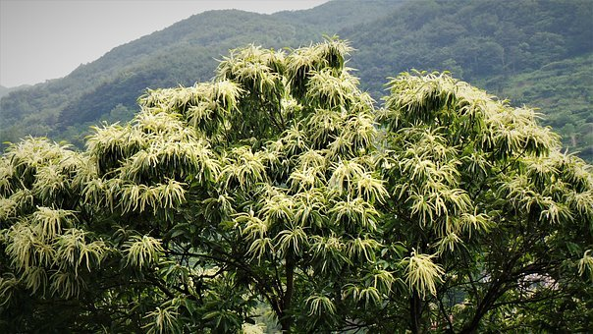 | 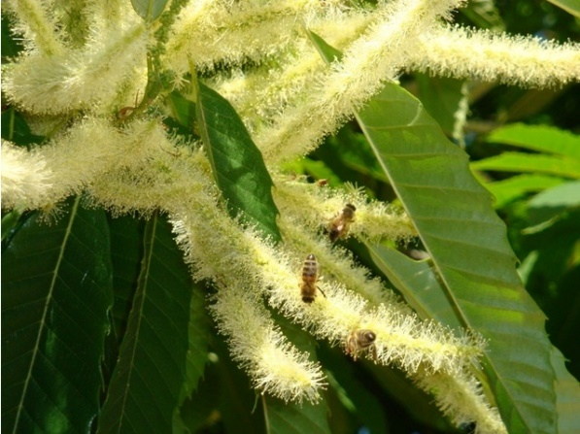

On the other hand, the value of the chestnut's ecosystem services should also be included in the calculation of national account. Chestnut trees and fruits are important elements of cultural life. In many places, they are considered as one of the useful and enjoyable activities for children, as mushroom picking.
In the light of these explanations, it can be stated that the most important part of chestnut that can be measured economically is chestnut fruit. However, a significant part of the chestnut fruit is consumed informally/unrecorded. A study conducted as a "master thesis" in the Faculty of Forestry of Karadeniz Technical University in 2000 will give an idea about this issue. . (BELEN, 2001)
Table 4. Total annual income of chestnut fruit annually for the year 2000
The total annual income from chestnuts, including export, internal consumption and unrecorded consumption, can be calculated as follows:
- Export: 6 679 623 USD equivalent to 6 264 tons (average figures of the last ten years).
- Internal consumption: 94 774 000 USD equivalent to 47 387 tons product (the average price of the nut has been accepted at a retail price of 2 USD/kg based on market observations.
- Unrecorded internal consumption: The export and official internal consumption amount to 53 651 tons, but nut production is 68 652 tons annually. Therefore, the difference between the two figures is unrecorded consumption. If we assume that these products were consumed at a minimum 1 USD/kg, then it is possible to calculate 14 973 000 USD equivalent to 14 973 tons have been earned.

As a consequence, the total income of chestnut nuts can be calculated:
- Export 6 679 623 USD
- Internal consumption recorded 94 774 000 USD
- Unrecorded internal consumption 14 973 000 USD
- Total income 116 426 623 USD

2.2. Export and Import
Chestnut is one of Turkey's major agricultural export products. The export trend is increasing gradually. For the years of 1990 to 1999, Turkey's annual export was 6 000 tons in average. In 2019 export reached to 14 225 tons annually and Turkey earned 35 837 609 USD of income from export. Accordingly, one fifth of the total harvested chestnut is exported. These data are the data of fresh or dried chestnut fruits, and in some cases, the chestnut fruit can be exported by removing the shell. However, since the export of "peeled off chestnut fruit" is very low and negligible, it was not added here.
Table 5. Export and import of chestnut fruit in 2015-2019
Year | Export- kg | Export- USD | Import-kg | Import-USD
2015 | 5 528 807 | 14 794 175 | 524 | 518
2016 | 8 297 416 | 24 993 281 | 75 | 75
2017 | 9 797 491 | 36 786 802 | 815 | 928
2018 | 12 957 165 | 43 111 046 | 1 511 050 | 1 437 754
2019 | 14 225 237 | 35 837 609 | 2 362 020 | 1 687 782

Figure 7. Chestnut export and export income for 2015-2019

The main buyer of Turkish chestnuts is Italy. The chestnuts sold to Italy continue regularly over the years and are increasing gradually.
45 percent of total exports in 2015, 71 percent of total exports in 2017 and 80 percent of 2019 total exports were made to Italy. This situation, being so dependent on a market, actually poses the danger of fragility for the export market.
Table 6. Top five exported countries
Countries | Years (year/kg)
 | 2015 | 2017 | 2019
 | Export (KG) | Export (KG) | Export (KG)
Italy | 2 476 430 | 6 907 885 | 11 327 813
Lebanon | 1 912 269 | 17 42 131 | 1 281 545
Jordan | 388 675 | 172 250 | 67 560
Germany | 186 711 | 295 235 | 293 700
Saudi Arabia | 118 835 | 26 265 | 186 375

Figure 8. Top five exported countries (kg/year)

Although Turkey’s chestnut imports are low, imports from China have increased significantly over the past few years, exceeding two thousand tons in 2019.
Table 7. Chestnut import to Turkey (kg/year)
Country | 2015 | 2016 | 2017 | 2018 | 2019
China | 509 | 74 577 | 749 | 1 489 000 | 2 362 020
Greece | 10 | 0 | 0 | 0 | 0
Uzbekistan | 3 | 0 | 0 | 0 | 0
Bosnia and Herzegovina | 3 | 0 | 0 | 0 | 0
Spain | 0 | 0 | 42 | 0 | 0
Italy | 0 | 0 | 24 | 22 | 0

When TUIK records are examined, it is seen that imports have been made from countries such as Greece, Uzbekistan, Bosnia and Herzegovina, Spain and Italy so far. But these numbers are negligible.
Figure 9. Chestnut import from China (kg/year)

On the other hand, when unit export and import prices are analyzed, it is seen that export prices are approximately 2-3 times higher than import prices.
Figure 10. Unit Export and Import Prices (kg/USD)

2.2 Areas of Usage
Chestnut trees are important for several usage areas. Communities that lived in forested areas in ancient times and did not have enough wheat flour, called the chestnut “bread tree” as it was their major food source.
Chestnut is an economically important forest species due its precious wood and fruit production. Depending on the development age, closeness, and site of the stand of pure forest, its annual wood increment is approximately 2-6 m³ per hectare. Its timber is very useful in terms of durability and decorative properties. It is a highly valued resource in the furniture sector as it has long fiber and ability to easy bending and processing. Since chestnut timber is water-resistant, it is preferred primarily for the construction of wharves and boats, yachts, and ships.
It is used in window joinery, facade cladding, garden tables and chairs (young shoots of chestnut are used instead of bamboo), fence pile, parquet, playgrounds, home, and office decoration. The residues and billet of chestnut wood are used in the production of coal and gunpowder, and their shells are used in the production of plywood. Since the chestnut contains tannins in its branches, leaves and fruits, it is used to get brown color in the paint industry.
In addition, edible fruits, chestnut sugar, chestnut honey, chestnut marmalade, hand tools made from shoots, etc. products also contribute to local and national economy.

Challenges and recommendations

Diseases
The forest stands of Turkey, have been seriously destroyed by serious fungus diseases, particularly blight and phytophthora root rot (ink disease). Recently Chestnut gall wasps are also found in the Chestnut Forests of Turkey.
Table 8. Chestnut diseases
Diseases | Latin names of the agents | Places where damage occurs
Chestnut blight (canker) | Cryphonectria parasitica (Murr.) | Trunk and Branches
Root rot | Phytophthora cambivora (Petri) | Roots
Chestnut gall wasp | Dryocosmus kuriphilus | Bud
Chestnut worm | Laspeyresia spiendana | Fruits
Chestnut moth | Pammene fasciana (L) | Fruits
Tuber bees | Dryocosmus kuriphilus | Buds

Recommendations
Chestnut forests have great potential to Turkey's economy in the medium and long term so they should be paid well attention to in policy documents, regional or provincial rural development plans. Prepare and implement national/international projects on chestnut to share traditional knowledge and experiences and to benefit from cutting edge innovation in chestnut sector should be initiated. Consultation meetings should be organized at province or regional level with participation of all relevant stakeholders including NGOs. GDF, together with other partners, should increase effectiveness in the combat strategies in the light of the available inventory data for each region or for each NWFP to combat diseases.
It should be encouraged that the forest villagers living in or next to the chestnut forests should educate in support the disease-fighting activities. Particular studies and projects should be developed to find out the roots of diseases, impacts on the chestnut forests and dependent communities. In order to protect chestnut forests more effectively, a close cooperation should be made between Village Legal Entities and Forestry Directorates. In this way, joint protection and utilization protocols will be prepared and chestnut utilization plans will become operational.
Depending on locality, 'Chestnut Seed Gardens' and 'Chestnut Graft Gardens, completely free from diseases, should establish to maintain healthy and disease resilient chestnut forests by GDF. The new chestnut seedlings and grafts needed by the citizens in the regions should be obtained from the gardens of chestnut seeds and cuttings should be provided. A strong partnership between GDF and private sector such as candied chestnuts, furniture, shipbuilding should be promoted with aim of increasing domestic and international market.

References
BELEN. (2001). Utilisation from chestnut as non wood forest product in the World and Turkey. http://www.fao.org/3/y3660e/y3660e05.htm#P1398_260616 adresinden alındı
CARFU. (2020). CARFU. (I. Belen, Editör) November 20, 2020 tarihinde The Foundation of the People Caring for Future: http://www.gonder.org.tr/?p=10014 adresinden alındı
EU. (2020, November 20). EU SCIENCE HUB. (T. E. Commission, Prodüktör) November 20, 2020 tarihinde https://ec.europa.eu/jrc/en/research-topic/forestry/qr-tree-project/sweet-chestnut adresinden alındı
FAO. (2020a). Global Forest Resources Assessment 2020: Main report. Rome. Rome: Food and Agriculture Organisation. August 2020 tarihinde https://doi.org/10.4060/ca9825en adresinden alındı
GDF. (2013). Chesnut Action Plan. November 20, 2020 tarihinde General Directorate of Forests adresinden alındı
GDF. (2019). NWFPs inventories at the end of 2019.
OGM. (2013). Kestane Eylem Planı. https://www.ogm.gov.tr/ekutuphane/Yayinlar/Forms/AllItems.aspx adresinden alındı
OGM. (2014). STANDARD STUDY METHODS (SSM) AGAINST CHESTNUT DISEASES .
OGM. (2016). Communiqué on Inventory and Planning of NWFPs and Production and Sales Principles. https://www.ogm.gov.tr/ekutuphane/Tebligler/302%20say%C4%B1l%C4%B1%20odun%20d%C4%B1%C5%9F%C4%B1%20orman%20%C3%BCr%C3%BCnlerinin%20envanter%20ve%20planlanmas%C4%B1%20ile%20%C3%BCretim%20ve%20sat%C4%B1%C5%9F%20esaslar%C4%B1%20Tebli%C4%9Fi.pdf adresinden alındı
OGM. (2018). Strategic Plan (2019-2023). https://www.ogm.gov.tr/ekutuphane/StratejikPlan/Orman%20Genel%20M%C3%BCd%C3%BCrl%C3%BC%C4%9F%C3%BC%20Stratejik%20Plan%20(2019-2023).pdf.

