Resin as a Non-Wood Forest Product

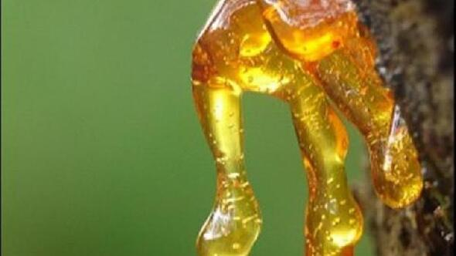

6 December 2020, Edited

CONTENTS
Foreword 4
Acronyms and Abbreviations 5
1. Introduction 6
1.1. Production 6
1.2. Eligible trees 7
1.3. Economic Yield 8
1.4. Trade in Turkey 9
2. Specific Sectoral Policies 10
2.1. Communique on NWFPs 10
2.2. Action Plans-Resin Action Plan (2017-2021) 10
2.3. Technical Guidelines 10
2.3.1. Works and processes to be applied before resin production 10
2.3.2. Principles to be applied in resin production 11
2.3.3. Principles to be followed in the completion of resin production 12
2.3.4. Rules to be followed during resin sales 12
2.4. Standards 12
2.5. Production Procedures 12
3. Administrative structure 13
4. Challenges and Recommadations 13
4.1. Diseases 13
4.2. Problems in Production and Harvesting Phase 13
4.3. Recommadations 14
REFERENCES 15

Tables
Table 1. Prices of 1-ton resin at different stage 9

Figures
Figure 1. Turkey's annual resin production-ton/year 7
Figure 2. Potential resin production area of Turkey (ha) 7
Figure 3. Prices of 1 ton resin at different stages 9
Figure 4. Natural resin import to Turkey/year/ton 9
Figure 6. Natural resin production/ goal 10
Figure 6. The Regional Directorates of Forestry eligibile to produce natural resin 13

PICTURES
Picture 1. A resine on Pinus brutia tree 6
Picture 2. Resin production from trees 8

Foreword

Forest ecosystems provide substantial economically important products that are essential to the livelihood of its dependents. The forest and tree products are classified as wood products, non-wood products and forest services. Food and Agriculture Organization of the United Nations (FAO) defines non-wood forest products (NWFP)s as “goods derived from forests that are tangible and physical objects of biological origin other than wood”. Globally, the reported value of NWFPs was about 7.71 billion USD in 2015. (FAO, 2020a).
Due to its geographical position and climate conditions Turkey has very rich non-wood forest products. In recent years, Turkey started to give great importance to NWFPs by making the necessary legislative and administrative arrangements. As one the reflections of the importance, the Department of Non-Wood Products and Services (DNWFPS) was established as the central unit of the General Directorate of Forestry (GDF) in 2011.
As the specialised agency, FAO is conducting several studies on different issues with Turkey by cooperating with both public institutions, non-governmental organizations and other stakeholders. In this context a Letter of Agreement (LoA) was signed between FAO and the Chamber of Forest Engineers of Turkey (CFE/OMO) for "Provision of technical guidelines on sustainable management of NWFPs and the status reports on specific selected products” on 20 December 2019.
In line with this LoA, CFE as the Service Provider, prepared the report of “Resin as a Non-Wood Forest Product” which gives general information about resin production, harvesting and usages in Turkey.
The report of “Resin as a NWFP” was prepared by the team of CFE consultants working in close collaboration with respective institutions and local stakeholders. The team is grateful for the contributions and support provided by FAO and GDF, particularly DNWFPS staffs. The findings also discussed with stakeholders during “consultations meetings with three different regions, update meetings with responsible national intitutions and consultation workshop with respective stakeholders”
The main findings of “Resin as a NWFP” are as follows:
- Resin production showed an uneven process. The annual production, which approached 7 000 tons in the 1970s, has decreased since 1983, and hardly any production was made in the 2000s. In 2017, the "Resin Action Plan" was prepared and it was aimed to increase the production.
- Resin is produced mainly from Turkish pine/red pine- Pinus brutia and the maritime pine - Pinus pinaster. In addition to these two trees, a little amount of resin production is made from black pine- Pinus nigra roots. However, the area suitable for natural resin production has been calculated around 100 000 hectares.
- Due to the limited production in Turkey, natural resin demand is met through imports. As of 2020, Turkey has been importing natural resin around 11 thousand tons annually. The commercial value of import is around 20 million USD. Regulations on natural resin imports are made by the Ministry of Trade.
- In current practice, the average resin production is around 2 kg product per tree in Turkey. It is aimed to increase the annual resin production, which was around 420 tons by 2020, to 5 000 tons by 2023.

Acronyms and Abbreviations
CFE/OMO Chamber of Forest Engineers of Turkey
Communiqué of NWFPs Communiqué on Inventory and Planning of NWFPs and Production and Sales Principles
DNWFPS Department of Non-Wood Forest Products and Services of GDF
ENDP Eleventh National Development Plan (2019-2023) of Turkey
EuroStat European Statistical Office
FAO Food and Agriculture Organization of the United Nations
FRA 2020 Global Forest Resources Assessment 2020
GDF General Directorate of Forestry of Turkey
ha hectare(s)
INCREDIBLE Project Innovation Networks of Cork, Resins and Edibles in the Mediterranean Basin Project
LoA Letter of Agreement
MoAF Ministry of Agriculture and Forestry of Turkey
MT Ministry of Trade of Turkey
NWFP Non-Wood Forest Product
OG Official Gazetta of Turkey
OWL Other Wooeded Land
StarTree A pan-European project to support the sustainable exploitation of forest resources for rural development.
TL Turkish Lira
TSE Turkish Standards Institution
TUIK Turkish Statistical Institute (TurkStat)
USD United States Dollar
USD/TRY Rate According to the average dollar rate in 2019 by the Central Bank of the Republic of Turkey which was 5,68 TL.)

Introduction
Apart from essential oils, which offer a variety of flavours and fragrances, resins are perhaps the most widely used and traded category of non-wood forest products other than items directly consumed as food, fodder and medicine (FAO, 1995). Perceiving it as a chemical product makes the definition and comprehension of the resin difficult. Simply put, the viscous liquid flowing from the outside of the trees is called resin. This liquid is a substance that varies in darkness according to the age of the tree, and is quite sticky.
In technical term, it is a solid or semi-solid material, usually a complex mixture of organic compounds called terpenes, which is insoluble in water but soluble in certain organic solvents. Oil-soluble resins are soluble in oils and hydrocarbon-type solvents; spirit-soluble resins are soluble in alcohols and some other solvents.
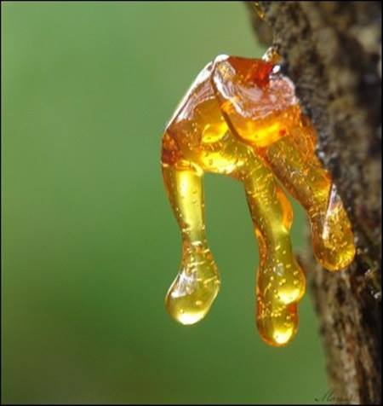
Picture 1. A resine on Pinus brutia tree

In Turkey, according to the “Communiqué Numbered 302 on “Inventory and Planning of Non-Wood Forest Products and Production and Sales Principles (Communiqué of NWFPs)” natural resins classified under the umbrella of “balsamic oils” (GDF, 2016).

Production
Chapter 6 of Communiqué of NWFPs describes details from the production stage to the sales. Looking at the historical process of resin production, following four stages can be listed:
- Until 1874, there were no legislative regulations regarding resin production.
- The first resin regulation was published in 1874 and was implemented until 1959.
- Different methods were followed between the years 1959 and2013.
- Since 2013, “Inventory and Planning of Non-Wood Forest Products, and Production and Sales Processes” Comminique has been implemented.
Resin production showed an uneven process. The annual production, which approached 7 000 tons in the 1970s, has decreased since 1983, and hardly any production was made in the 2000s. In 2017, the "Resin Action Plan" was prepared and it was aimed to boost the production (GDF, 2017).
Figure 1. Turkey's annual resin production-ton/year

Eligible trees
Resin is produced mainly from Pinus brutia and Pinus pinaster. In addition to these two trees, a little amount of resin is produced from Pinus nigra roots. Although it is technically possible to produce resin from Pinus pinea, it’s not used for productionfor the time being as more income is obtained from pistachio production.
As of 2019, there are 5 736 371 ha of Pinus brutia in Turkey. 3 577 425 of that area is productive and 2 158 946 is degraded. It means one-fifth of Turkey's forests are composed of Turkish pine/red pine forests (GDF, 2020). However, the area suitable for natural resin production has been calculated around 100 000 hectares (GDF, 2017).
Pinus pinaster is not among Turkey's natural trees. It has been grown mainly for industrial purposes. The issue of natural resin production from Pinus pinaster has come to the fore in recent years. Especially since 2013, resin production from Pinus pinaster has started in provinces such as Sakarya and Bursa. It has been calculated that around 2 000 hectares of Pinus pinaster forest can produce natural resin (GDF, 2017).
Figure 2. Potential resin production area of Turkey (ha)

Due to the limited production in Turkey, natural resin demand is met through imports. As of 2020, Turkey has been importing natural resin around 11 thousand tons annually. The commercial value of this is around 20 million USD.
Regulations on natural resin imports are made by the Ministry of Trade / Economy. "Communiqué on Imports of Only Natural Resin and Resin Acids Obtained from Natural Resins" was published in the Official Gazette (OG) No. 30118 dated July 8, 2017 (OG, 2017).
In current practice, the average resin production is about 2 kg/per tree in Turkey. 2.5 million trees should be processed for the targeted production of 5 thousand tons. One person can process approximately 2 500 trees in a year. With a production of this volume, 1 000 people will be employed for a period of 7 months. Coupled with other relevant employment areas, this number will reach 5 000 people.

Picture 2. Resin production from trees
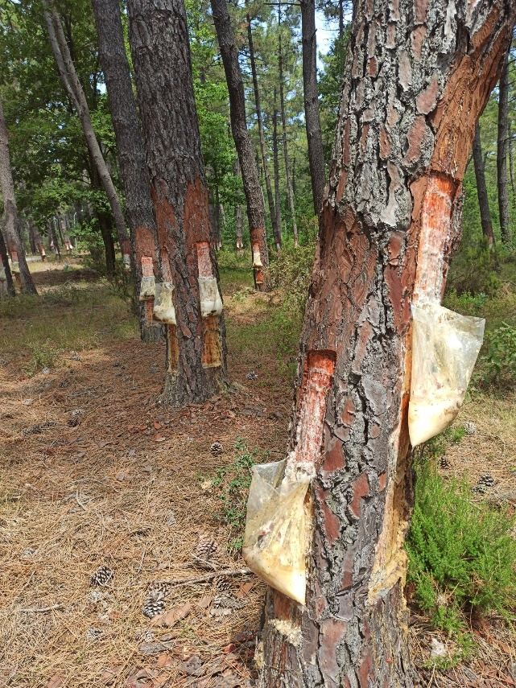 | 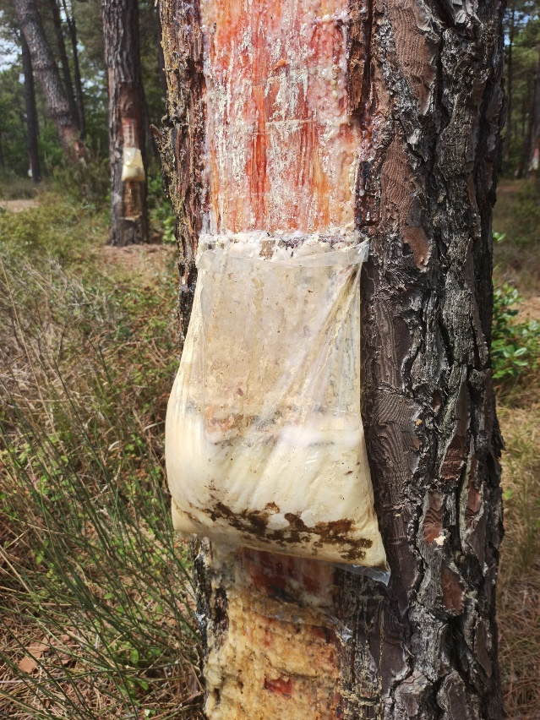

Economic Yield
Resin production went into a decline after 1983 and in some years, it was not produced at all. The main reason is that imported artificial resin is cheaper, in other words, it was the economic reasons forcing the situation.
In recent years, restrictions have been imposed on the use and trade of petroleum-derived products due to environmental concerns. The use of natural products has grown in every field. On the other hand, especially in Turkey, there is an increased demand for natural resin, which is produced from state-owned forests where no chemicals are used.
Red pine forests from where resin can be produced are predominantly located in the Mediterranean Region. There is serious competition among different sectors such as tourism, beekeeping, grazing and mining.
For resin production, forest villagers are permitted by GDF over the "tariff price". For the year 2020, the tariff price of 1 kg of resin has been determined as 0.13 TL. In other words, the tariff to be paid to GDF for 1 ton of resin is 130 TL, which is approximately 23 USD. (GDF, 2020) Forest villagers can sell raw resin for 2.5-3 TL per kilogram to resin processing facilities. Resin processing facilities can sell a kilogram of resin to the next user for approx. 7 TL.
Prices calculated in USD are shown below.

Table 1. Prices of 1-ton resin at different stage
Products | USD | TL
Tariff set by GDF for forest villagers for harvesting | 23 | 130
Price of auction-open bid for producers other than forest villagers | 176 | 130
Raw resin prices sold to resin processing facilities | 528 | 3 000
End consumer price | 1 232 | 7 000

When the price of resin in different stages is evaluated, it is seen that there are big differences between the price in the forest and the price for the end consumer, like many other non-wood forest products. In the resin sample, this difference is seven-fold.
Figure 3. Prices of 1 ton resin at different stages

Trade in Turkey
Since the production was almost completely halted after the 1980s, the natural resin trade came to an end. The sector has continued to operate based entirely on imports.
Figure 4. Natural resin import to Turkey/year/ton

In 2018, 11 800 tons of raw resin were imported and 19 700 000 USD was paid in return. Accordingly, the import price of 1 ton of raw resin was around 1 670 USD. The domestic resin price has been calculated roughly as 1 232 USD, with a price difference of approximately 500 USD per ton. When this is coupled with the tendency to use natural products, the demand for resin grew up. Forests have the capacity to meet a significant part of this demand

Specific Sectoral Policies

Communique on NWFPs
The most recent, comprehensive, political and technical guideline used by GDF so as to enhance sustainable utilization of NWFPs is Communiqué on NWFPs, which was put into practice in 2016. (GDF, 2016)
In addition to the Communiqué of NWFPs, the list of the NWFPs and collection prices from state-owned forests are determined with “Tariff Prices of Non-Wood Forest Products” at the beginning of each year (GDF, 2020). Natural resins are classified under the category of “balsamic oils”

Action Plans-Resin Action Plan (2017-2021)
An action plan has been prepared and put in force by GDF to lower the dependency of Turkey on the need for resin and its derivatives and to enhance the potential production in an efficient and sustainable fashion.
Within the scope of the Resin Action Plan which was put into effect in 2017, Regional Directorates of Forestry have determined resin production areas. Within this framework, trainings were delivered to GDF staff, forest villagers and the relevant private sector.
Under current circumstances, ​​red pine and coastal pine areas that can be reserved for resin production are around 100 000 hectares in total. It is aimed to raise the annual resin production, which was around 420 tons by 2020, to 5 000 tons by 2023.
Figure 6. Natural resin production/ goal

Technical Guidelines
Resin production is regulated by the Communiqué on NWFPs (GDF, 2016). The resin production is included in the communiqué "Chapter 6" and includes details from the production stage to the sales stage.
Accordingly, the works to be done before starting the resin production, the rules to be followed during the resin production, the rules to be followed during the completion of the production works and the sales were determined separately.

Works and processes to be applied before resin production
Issues to be considered in the determination of resin production areas;
- In forests operated in line with Ecosystem Based Functional Forest Management Plans, production will be made in areas having "NWFP Production” function.
- In forests that are not operated in line with Ecosystem Based Functional Forest Management, the areas where resin will be produced will be determined by the Regional Directorate commission, where technical staff of the forest management and planning, silviculture, non-wood products and services branch offices will also participate.
- Wood production forests that provide high quality wood, areas with protection status and areas with very low bonitet class will not be subject to resin production.
Production-related issues and issues to be followed in preparatory work;
- The method to be applied in resin production will be the acid paste method.
- Since trees will be produced with a diameter of 26 cm and above, these trees will be determined and marked by the officers engaged in production under the control and supervision of the Chief Engineer of Forest Sub-District Directorate (Forest Chief).
- It will be ensured that other forestry activities are completed before the production starts.
- In production, standard bleaching grates having 10 cm wide wound, which is fixed according to the mouth, and 12 cm wide discharge chute and 13 cm wide mouth will be made to allow the excrement to flow into the collection vessel from these 10 cm wounds.
- Before the production season, 60% sulfuric acid (𝐻₂𝑆𝑂₄), silica gel and kaolin to be used in the production of various percentages after mixing the prepared acid paste will be supplied in sufficient quantity. The supplied or commissioned acid-paste will be controlled at Forestry Research Institutes.

Principles to be applied in resin production

- Principles to be applied in the bleaching process;
- Before watering the trees, bleaching will be started at the end of February and early March, one month before production.
- At first, blending process is started by leaving a distance of a collecting vessel from the soil level. In order to continue the production on the same tree following the first wound, it will be bleached parallel to the axis of the tree.
- The bark of a 10-13 cm wide and 40-50 cm high section will be thinned up to 3-5 cm parallel to the axis of the tree by the grinding grater. This part will be used for production for one season.
- Production will start when the seasonal temperature reaches 18 ° C on average.

- Principles to be applied in resin collection after bleaching process;

- 3-4 weeks after the polishing process, a section of 8-10 cm in width and 2.5-3 cm in height will be peeled from the bottom of the area where it is polished with a suitable grater. During this process, the cambium layer of the tree will not be damaged.
- Instead of joining the upper crust of the wound surface, a 3 mm thick acid-paste will be applied by a plastic injector.
- In the acid-paste composition used, the amount of acid will not exceed 60%, and the amount of applied paste will also prevent the injectors from squeezing too thick acid-paste because of the excess acid that penetrates the tree.
- The duration of the wounding varies according to the temperature of the regions. While it will be 10 days in the Mediterranean and Aegean regions it will be 13 days in others. The height worked on the tree at the end of the season with these periods will reach 50 cm at most.
- Considering the production method and yield, collection will be made after 2 or 3 wounds. Collection will be done at least 5 times during the production season.

Principles to be followed in the completion of resin production

- The wound length in the tree trunk will be 40-50 cm in one production season.
- Production will be terminated when the air temperature drops below 18 ºC.
- After collecting the last resins flowing from the wound surface under the influence of the heat, collecting vessels, nails and drainage grooves will be collected, cleansing graters, wound knives and injectors will be cleaned and stored for the next production season.
- Resins that accumulate on the wound surface that are rich in collophane are also collected by scraping with a suitable stripping tool and stored separately.

Rules to be followed during resin sales
Issues to be taken into consideration in order to achieve efficient resin sales;
- Auction sales method will be preferred,
- As production depends on the air temperature, sales tenders will start from January and it will be planned by calculating that the air temperature will reach production when the temperature reaches 18 ºC and field delivery will be planned to these dates.
- Sales parties can also include one or more compartments, and compartments that include basins.
- For resin production, each of the trees over 26 cm diameter will have 1 kg / tree / year yield to be estimated.
- If the resin production will be subject to sale by the administration, the Auction Sale Specification of NWFP, having an example, will be used.

Standards
TSE, as a standardization body, provides standards aimed at enabling industrialists to produce goods and services in compliance with rules, laws, codes and standards applicable in global markets.
Although the resin is not specifically addressed in the TSE standards, it is standardized in various grades with resin-containing materials such as paints and varnishes. TS 8750 code in the chemistry specialization group represents varnishes-anacardium resin-based materials and products (TSE, 1991).

Production Procedures
There have been some techniques and methods to produce resin from state-owned forests by GDF. In 1982, the "Second National Resin Congress" was organized by GDF in Izmir. Among the decisions taken in this Congress, it was requested to try modern resin production methods and to research on the production method to be recommended. Following this Congress decision, a comprehensive research project was carried out and resin production methods were evaluated (ÖNAL, 1983). However, due to the decrease in resin production since 1983 for economic reasons, the research results could not be put into practice.
In the past years, the production of resin in Turkey was carried out by the Greek Sofiko method, one of the great wound methods, regardless of the physiological and technological features of the planted trees. However, this method has been abandoned as it both reduces the yield of the resin and makes kindling on the tree. Since 1956, “Mazek-Fialla Line Method” has been researched, applied and good results have been obtained. This success has been achieved as a result of good application of the resin production works as well as less damage to the tree compared to the previous method.

Administrative structure
The main ministry for resin is MoAF. Resin is produced in 10 different regional directorates in Turkey; namely Antalya, Balıkesir, Bursa, Çanakkale, Denizli, İzmir, İstanbul, Mersin, Muğla and Sakarya.
Figure 6. The Regional Directorates of Forestry eligibile to produce natural resin
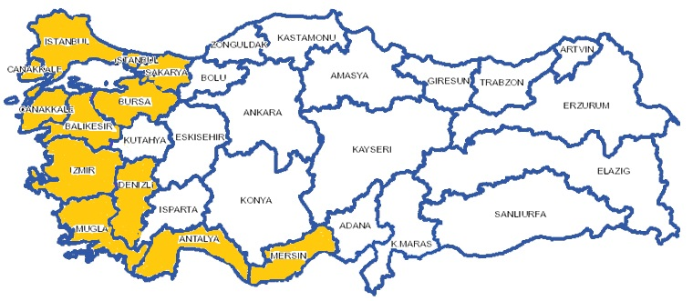

However, the fact that forest areas suitable for resin production are mostly in the Mediterranean (Antalya), Aegean (Muğla, Aydın, İzmir) and Marmara (İstanbul, Adapazarı etc.) regions increases competitive sectors, especially tourism, and as a result, other institutions are emerging.
A significant portion of the forests in these regions are "protected areas" in different status. These "protected areas" generally fall under the responsibility of the General Directorate of Nature Conservation and National Parks. Due to some protected areas as “Specially Protected Environmental Areas”, the Ministry of Environment and Urbanisation becomes also a part of resin production. GDF plays an important role in the production and sale processes of resin in Turkey. In GDF database, buyers of resin, which are also accepted as stakeholders, according to years and regions are recorded.

Challenges and Recommadations

Diseases
Resin is a disease-free substance due to its structure. On the other hand, tree species that are subject to resin production can host various diseases. While various diseases can occur in parts of trees such as trunk, crown and root, some insects can also cause diseases in trees. Important forest pests such as the pine processionary (Thaumetopoea pityocampa) can disrupt the function of trees in resin-producing areas and reduce the yield of resin-producing tree individuals.

Problems in Production and Harvesting Phase
As resin production takes place in forest areas, it may not be possible to control environmental factors in these areas. Being affected from extreme weather conditions, the production may fluctuate with various weather conditions.
The knowledge and education of the people working in the production sector regarding the resin production is another area that may present problems. In order to contribute to the efficient and sustainable production, the producers must be trained on the subject.

Recommadations
Attention should be paid to resin production areas in policy documents, regional or provincial rural development plans.
Prepare and implement national/ international projects on resin to share knowledge and experiences and to benefit from innovation in resin production sector is important.
Consultation meetings should be organized at provincial or regional level with the participation of all relevant stakeholders including NGOs to share experiences, discuss problems and provide solutions.
GDF should increase effectiveness of combating strategies in the light of the available inventory data for each region or NWFPs to combat against diseases.
It should be encouraged that the forest villagers living inside or in close proximity to resin production forests should be educated to support the struggle against diseases. In order to protect resin forests more effectively, a close cooperation should be made between Village Legal Entities and Forestry Directorates.
A strong partnership between GDF and private sector should be promoted with aim of increasing domestic and international market.

References

EUFORGEN. 2020. the European Forest Genetic Resources Programme. [Çevrimiçi] 2020. http://www.euforgen.org/species/.
FAO. 2020. Global Forest Resources Assessment 2020: Main report. Rome. Rome : Food and Agriculture Organisation, 2020.
—. 2020a. Global Forest Resources Assessment 2020: Main report. Rome. Rome : Food and Agriculture Organisation, 2020a.
—. 1995. Gums, resins and latexes of plant origin. [dü.] J.J.W. Coppen. 1995. ISBN 92-5-103757-4.
GDF. 2016. Communiqué on NWFPs. [Çevrimiçi] 2016. Communiqué No. 302 on Inventory and Planning of NWFPs and Production and Sales Principles (Communiqué of NWFPs). https://www.ogm.gov.tr/ekutuphane/Tebligler/302%20say%C4%B1l%C4%B1%20odun%20d%C4%B1%C5%9F%C4%B1%20orman%20%C3%BCr%C3%BCnlerinin%20envanter%20ve%20planlanmas%C4%B1%20ile%20%C3%BCretim%20ve%20sat%C4%B1%C5%9F%20esaslar%C4%B1%20Tebli%C4%9Fi.pdf.
—. 2020. Official Forestry Statistics. [Çevrimiçi] 2020. https://www.ogm.gov.tr/ekutuphane/Sayfalar/Istatistikler.aspx?RootFolder=%2Fekutuphane%2FIstatistikler%2FOrmanc%C4%B1l%C4%B1k%20%C4%B0statistikleri&FolderCTID=0x012000301D182F8CB9FC49963274E712A2DC00&View={4B3B693B-B532-4C7F-A2D0-732F715C89CC}.
—. 2020. Organisation of the GDF. 2020.
—. 2017. Resine Action Plan 2017-2021. [Online] 2017. https://www.ogm.gov.tr/ekutuphane/Yayinlar/Re%C3%A7ine_Eylem_Plan%C4%B1.pdf.
—. 2020. Tariff Prices of NWFPs Set for 2020, Communiqué No: 294/8. 2020.
GDF2020a. Organisation of the GDF.
OG. 2017. Communiqué on Imports of Only Natural Resin and Resin Acids Obtained from Natural Resins. Turkish Official Gazette. [Çevrimiçi] 8 July 2017. https://www.resmigazete.gov.tr/eskiler/2017/07/20170708-4.htm.
—. 2016. The Law on Forest Engineers, Forest Industrial Engineers and Woodworking Industrial Engineers. 2016.
ÖNAL, s. 1983. Stimulation of Resin Flow in Calabrian and Scoth Pine with Chemicals. [prod.] TURKISH FORESTRY RESEARCH INSTITUTE. 1983.
The Turkish Constitutional Court of the Republic of Turkey. 2020. Constitution of the Republic of Turkey. Ankara : yazarı bilinmiyor, 2020.
TSE. 1991. TS 8750-Varnishes-Cashew Resin Based. 1991.

