Truffle as a Non-Wood Forest Product

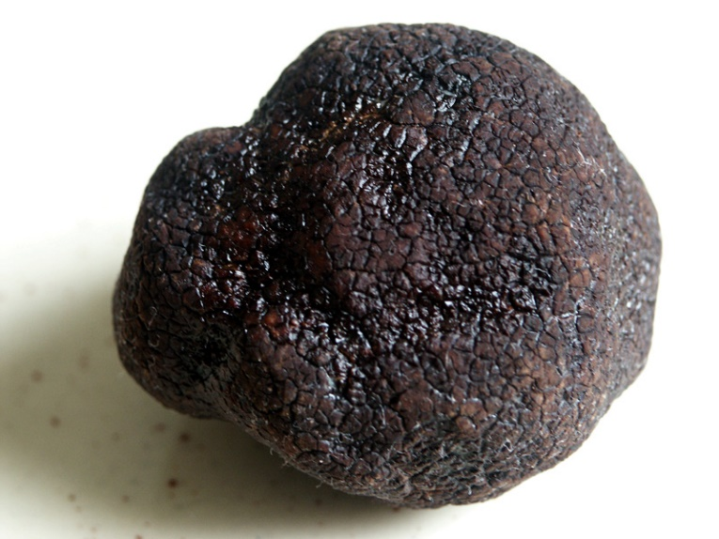

10 December 2002, Final Draft

Table of Contents

Foreword 4
Acronyms and Abbreviations 6
1. Introduction 8
1.1. Distribution 8
1.2. Botanical and Ecological Features 10
2. Economical Value, Usages and Trade 10
2.1. Prices in Europe 11
2.2. Areas of Usage 11
2.3. Trade 11
3. Specific Sectoral Policies 12
3.1. Truffle Forest Action Plan-2014 12
3.2. Communique on NWFPs-2016 13
3.3. Truffle Orchard Feasibility Study and Investor Guidelines-2020 14
3.4. The Communiqué of Truffle Harvest and Sales Procedures and Principles-2020 15
3.5. Standards 15
3.6. Inventory Procedures 15
3.7. Production and Harvesting Procedures 16
4. Administration and Structure 16
4.1. The Structure of the Ministry of Agriculture and Forestry 16
4.2. Other Stakeholder 17
5. Challenges and Recommendations 17
5.1 Diseases 17
5.2 Recommendations 17
REFERENCES 19

Tables
Table 1. List of truffles observed in Turkey 8
Table 2. Classification of NWFPs in Turkey based on their forms 13
Table 3. Mushrooms 13

Figures
Figure 1 Distribution of hypogenous fungi in Turkey 9
Figure 2. Symbiotic life cycle of truffles 10

Pictures
Picture 1. Tuber melanosporum -Black truffle, Tuber magnatum, White Truffle 8

Foreword

In addition to environmental and ecosystem contributions such as conservation of biological diversity, combating climate change, sustainable water and land management, ecosystem services, forests are also home to economically important products which are important for food security. The forest and tree products are classified as wood products, non-wood products and forest services. Food and Agriculture Organization of the United Nations (FAO) defines non-wood forest products (NWFP)s as “goods derived from forests that are tangible and physical objects of biological origin other than wood”. Globally, the reported value of NWFPs was about 7.71 billion USD in 2015. (FAO, 2020a).
Due to its geographical position and climate conditions Turkey has very rich non-wood forest products. In recent years, Turkey started to give great importance to NWFPs by making the necessary legislative and administrative arrangements. As one the reflections of the importance, the Department of Non-Wood Products and Services (DNWFPS) was established as the central unit of the General Directorate of Forestry (GDF) in 2011. The DNWFPS is responsible to determine, carry out or make works related to the inventory, value assessment, diagnosis, promotion, planning, mapping, project design, production and marketing of NWFPs and forest ecosystem services. (GDF, 2020a).
As the specialized agency, FAO is conducting several studies on different issues with Turkey by cooperating with both public institutions, non-governmental organizations and other stakeholders. In this context a Letter of Agreement (LoA) was signed between FAO and the Chamber of Forest Engineers of Turkey (CFE) for "Provision of technical guidelines on sustainable management of NWFPs and the status reports on specific selected products” on 20 December 2019.
In line with this LoA, CFE as the Service Provider prepared “Truffle as a Non-Wood Forest Product” which gives general information about truffle harvesting, production and usage activities in Turkey. While preparing this report, Turkey's current legislation and practices, FAO's web page on non-wood forest products, related publications on the subject, especially "Non ‐ Wood Forest Products in International Statistical Systems", web pages of completed or ongoing projects, and publications and reports produced such as INCREDIBLE and StarTree have been taken into consideration.
Truffle as a Non-Wood Forest Product was prepared by the team of CFE consultants working in close collaboration with respective institutions and local stakeholders. The team is grateful for the contributions and support provided by FAO and GDF, particularly DNWFPS staff. The findings also discussed with stakeholders during “consultations meetings with three different regions, update meeting with responsible national institutions and consultation workshop with respective stakeholders”
The main findings of the report on truffle are:
- Turkey has a very rich biological diversity which is also reflected in the presence of mushrooms. Studies of hypogenous fungi have so far revealed 79 species from 30 genera belonging to 21 families including 5 ascomycetes and 16 basidiomycetes in Turkey.
- Truffles have a world trading volume of 3.5 billion USD in 2019, expected to increase to 6 billion USD during next decade. Turkey has a target to reach 350 million USD yearly trade volume, grabbing a 10% share in the short term, and an action plan made operational since 2014.
- According to 2019 statistics compiled by GDF, truffles were a source of livelihood for nearly 200 families in Turkey, the price of truffles varied between 100-500 USD/kg depending on the type and quality,
- It is very difficult to give an exact figure about the annual truffle production amount worldwide. The producers are generally small-scale producers, sell their products to local markets without officially registering the sale.
- As of the end of 2019, a total of 384 hectare potential area has been determined for truffle production by GDF.
- Truffle, which was not even on the agenda of Turkey 5-6 years ago, has attracted the attention of the society, from hunters to investors, from consumers to tourism . According to data provided by GDF total volume of truffle production was around 40 tons. In 2019 It is expected that truffle production will increase in the coming years.

Acronyms and Abbreviations

CFE Chamber of Forest Engineers of Turkey
Communiqué of NWFPs Communiqué on Inventory and Planning of NWFPs and Production and Sales Principles
Communiqué of Truffle Communiqué of Truffle Harvest and Sales Procedures and Principles
DNWFPS Department of Non-Wood Forest Products and Services of GDF
ENDP Eleventh National Development Plan (2019-2023) of Turkey
FAO Food and Agriculture Organization of the United Nations
FRA 2020 Global Forest Resources Assessment 2020
GDF General Directorate of Forestry of Turkey
ha hectare(s)
INCREDIBLE Project Innovation Networks of Cork, Resins and Edibles in the Mediterranean Basin Project
LoA Letter of Agreement
MAF Ministry of Agriculture and Forestry of Turkey
MT Ministry of Trade of Turkey
NWFP Non-Wood Forest Product
OWL Other Wooded Land
StarTree A pan-European project to support the sustainable exploitation of forest resources for rural development.
TAB Turkish Association of Beekeepers
TL Turkish Lira
TSE Turkish Standards Institution
TUIK Turkish Statistical Institute (TurkStat)
USD United States Dollar
USD/TRY Rate According to the average dollar rate in 2019 by the Central Bank of the Republic of Turkey which was 5,68 TL.)

1. Introduction

Forest ecosystems provide important revenues for the countries in terms of NWFPs which are becoming important sector in economic manner.
As one of the important products, truffles, known as “the black diamond”, grow in forests, under the soil with roots of trees and carries spores. Truffle production has been seen in certain areas and is performed with specially-trained dogs. In recent years, a special attention has been given to the truffle species in the forestry activities in Turkey. Among others, GDF has implemented a Truffle Forest Action Plan (2014-2018).

1.1 Distribution
Of the nearly 200 species of truffles, about 32 are mainly found in the Mediterranean region, and the black truffle (Tuber melanosporum) is the most sought-after species. T. melanosporum can be found in calcareous soil in forests of southern Europe, mainly in France, Spain and east to north-central Italy.

Picture 1. Tuber melanosporum -Black truffle, Tuber magnatum, White Truffle
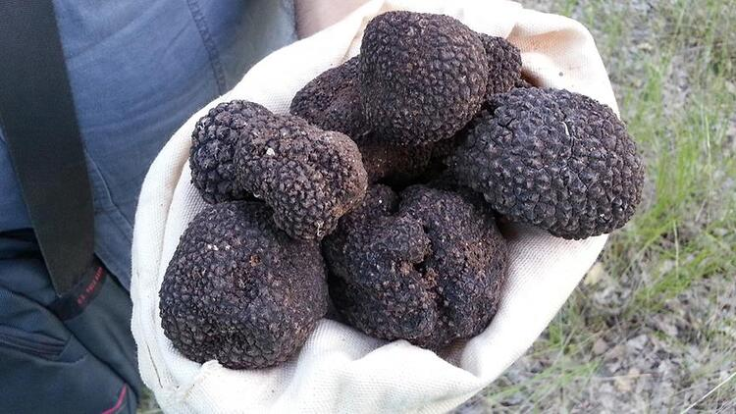 | 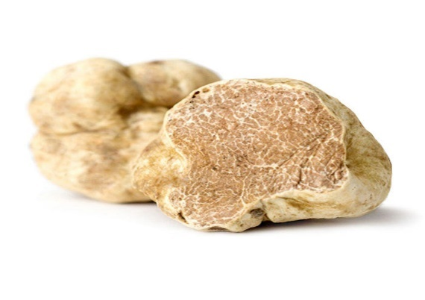

The Italian white truffle or T. magnatum is found nearly exclusively in small areas of Italy, Croatia and Romania, which together with its unique aroma and quality, make it the most expensive of the truffles. Other important culinary and commercial truffles include T. aestivum, T. brumale and T. borchii which are found in woodlands of Croatia, Slovenia, Serbia, Portugal, Switzerland, Germany, Hungary, Bulgaria, Greece and Turkey.

With regard to Turkey, truffle could naturally grow in many regions of Turkey, especially in the Mediterranean, Aegean, Marmara and Black Sea regions.
Studies of hypogenous fungi in Turkey have so far revealed 79 species from 30 genera belonging to 21 families including 5 ascomycetes and 16 basidiomycetes. (TÜRKOĞLU, 2015)
Table 1. List of truffles observed in Turkey
- Tuber mesentericum Vittad.  - Tuber aestivum Vittad.  - Tuber nitidum Vittad.  - Tuber rufum Pico  - Tuber excavatum Vittad.  - Tuber brumale Vittad.  - Tuber borchii Vittad.  - Tuber ferrugineum Vittad.  - Tuber puberulum Berk. & Broome  - Choiromyces meandriformis Vittad.  - Terfezia leptoderma Tul. & C.Tul  - Terfezia olbiensis Tulasne & C.Tulasne  - Terfezia mbiguou (Moris) Trappe  - Terfezia claveryi Chatin  - Terfezia boudieri Chatin  - Tirmania pinoyi (Maire) Malençon  - Sarcosphaera coronaria (Jacq.) J. Schröt  - Picoa juniperi Vittad  - Picoa lefebvrei (Pat.) Maire  - Genea mbiguous Vittad.  - Genea klotzschii Berk. & Broome  - Genea sphaerica Tul. & C. Tul.  - Geopora cooperi Harkn.  - Geopora mbiguous (Lév.)  - Geopora sumneriana (Cooke) M.Torre  - Geopora arenosa (Fuckel) S.Ahmad  - Stephensia mbiguous (Vittad.) Tul. & C.Tul.  - Elaphomyces leucocarpus Vittad.  - Elaphomyces muricatus Fr.  - Gymnomyces xanthosporus (Hawker) A.H.Sm.  - Hymenogaster griseus Vittad.  - Hymenogaster vulgaris Tul. & C.Tul.  - Hymenogaster thwaitesii Berk. & Broome  - Hymenogaster olivaceous Vittad. | - Hymenogaster citrinus Vittad.  - Hymenogaster hessei Soehner  - Hymenogaster luteus Vittad.  - Hymenogaster lycoperdineus Vittad.  - Hymenogaster rehsteineri Bucholtz  - Reddellomyces parvulosporus (G.W. Beaton & Malajczuk) Trappe, Castellano & Malajczuk  - Reddellomyces westraliensis (G.W. Beaton & Malajczuk) Trappe, Castellano & Malajczuk  - Melanogaster broomeanus Berk.  - Melanogaster mbiguous (Vittad.) Tul. & C. Tul.  - Melanogaster macrosporus Velen  - Melanogaster variegatus (Vittad.) Tul. & C. Tul.  - Alpova corsicus P.-A. Moreau & F. Rich.  - Leucogaster nudus (Hazsl.) Hollós  - Leucogaster tozzianus (Cavara & Sacc.) Mattir. Ex Zeller & C.W. Dodge  - Leucogaster liosporus R.Hesse  - Leucogaster luteomaculatus Zeller & C.W.Dodge  - Leucophleps aculeatispora Fogel  - Octaviania asterosperma Vittad.  - Protoglossum aromaticum (Velen.) J.M. Vidal | 54.Hysterangium clathroides Vittad. 55.Hysterangium epiroticum Pacioni 56. Hysterangium fragile Vittad. 57.Hysterangium nephriticum Berk. 58.Hysterangium calcareum R. Hesse 59 .Hysterangium inflatum Rodway  60.Gautieria otthii Trog  61.Gautieria retirugosa Th. Fr.  62.Gautieria trabutii (Chatin) Pat.  63.Gautieria graveolens Vittad,  64.Gautieria monticola Harkn.  65.Descomyces albus (Berk.) Bougher & Castellano  66. Setchelliogaster tenuipes (Setch.) Pouzar  67.Chondrogaster pachysporus Maire  68.Hydnangium virescens Quél.,  69.Rhizopogon luteolus Fr.  70.Rhizopogon roseolus (Corda) Th.Fr  71.Rhizopogon marchii (Bres.) Zeller & C.W.Dodge,  72.Rhizopogon ochraceorubens A.H.Sm  73.Rhizopogon fuscorubens A.H. Sm., 74.Rhizopogon vulgaris (Vittad.) M. Lange  75.Torrendia pulchella Bres. 76.Chlorophyllum agaricoides (Czern.) Vellinga  77.Phallogaster saccatus Morgan  78. Sclerogaster compactus (Tul. & C. Tul.) Sacc.  79. Sclerogaster hysterangioides (Tul. & C. Tul.) Zeller & C.W. Dodge

Figure 1 Distribution of hypogenous fungi in Turkey
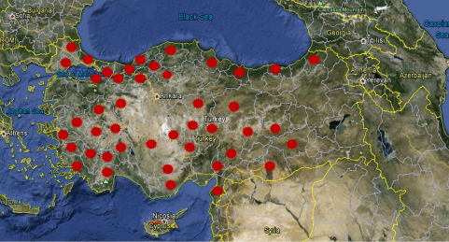

1.2. Botanical and Ecological Features
Truffles generate mycorrhizal relation with trees. All the oak species, pine species, hazel linden, hornbeam, poplar, alder are the trees that host the generation of truffle. Mycorrhizal mushrooms work as an extension of root system of the plant, transporting more water and nutrients that a plant can take up. The mycorrhizal symbiosis between the truffle and the host tree is presented in the below in Figure 2. (Leeetall, 2020).
Figure 2. Symbiotic life cycle of truffles
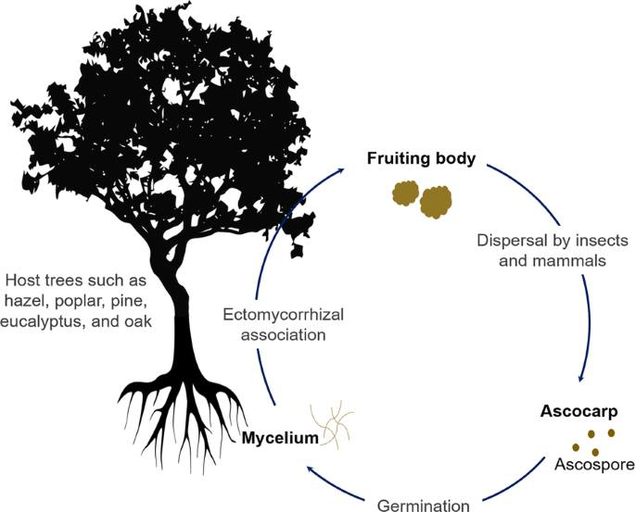
Truffles grow well in the calcareous soils with pH ranging from 7.5 to 9. Soil texture characteristics are sandy, clay or graveled. They have an important role in food and water transport between plant and soil. Truffles which completed growing phases under the soil are also a very significant part of the forest ecosystem when they are considered as a food resource. When it matures, it spreads a strong odor, this odor is recognized by the animals and truffle is found by digging the soil. Unlike other mushrooms, truffle needs animals to spread its spores as it grows underground. Spores of truffles pass through the digestive tract of the animals and spread to large areas. The spores that spread around the environment regenerate truffle colonies by germinating. The wide presence of truffles in the forest ecosystem may provide evidence that the forests and forest life are well-maintained.

2. Economical Value, Usages and Trade

Despite the difficulties to get the information about the trade volume and value of truffles, following figures has been determined and officially shared by GDF in 2020.. (GDF, Truffle Economy Growing, 2020) and (MinisterofMoAF, 2019)
- Truffles have a world trading volume of 3.5 billion USD, expected to increase to 6 billion USD during next decade.
- Turkey has a target to reach 350 million USD, grabbing a 10% market share in the short term, and an action plan made operational since 2014.
- In 2019, truffles were a source of livelihood so far for nearly 200 families in Turkey, stressing that due to its natural distribution in a limited region and short cultivation, the price of truffles varied between 100-500 USD/kg depending on the type and quality.

2.1. Prices in Europe
Truffle trade is more developed in European countries. Compared with Turkey, it is observed that the price is quite high. its price varies between 100-3 500 USD/ kg, depending on its species and quality.
- Tuber magnatum is around 3500 USD/kg
- Tuber melanasporum is around 1000 USD/kg
- Tuber aestivum is around 200 USD/kg
The amount of truffle species with high economic value has decreased twenty times in the last hundred years. While the demand for truffle species worldwide is increasing day by day, the dramatic reduction in the number of truffles has accelerated the cultivation of truffles. (Truffle Application and Research Center, 2019)

2.2. Areas of Usage
The truffle is a perishable and seasonal product. The harvesting season for black truffles is from mid-November to mid-March in the northern hemisphere, but it varies with regions, and the truffle maturation is staggered over the winter season. Truffle production is variable over the 3-month season and quantities and qualities depend on weather conditions of the entire previous year. Truffles are sold fresh, canned or frozen.
Whole fresh truffles are the products with the greatest economic value. Categories are based on size, aromas and appearance. For example, truffles from 5 to 15 grams with knobby shapes may be sold at a lower price, while the larger, intact and more uniformly shaped high-quality fresh truffles will be sold to restaurants at higher prices.
Truffle products are marketed worldwide for the production extra virgin olive oil with truffle, rice with black truffles, cheeses and truffle liqueurs, etc.
Not only intact truffles are sold. Truffle pieces that have been broken during the washing process, transport or at the time of harvest can be also marketed. France allows the sale of fresh T. melanosporum and T. brumale, not only as a whole but also in pieces. Truffle peelings or trims are from truffles that have had unacceptable or rotten pieces removed due to insect damage, freezing, immaturity and/or small pieces that have broken-off in the process of cleaning. This is the least expensive of truffle products and is used as a preserved product rather than served fresh.

2.3. Trade
It is very difficult to give an exact figure about the annual truffle production amount worldwide including Turkey, since most of the producers are small-scale producers selling their products to local markets without reporting the sale. For these reasons, governments have very little data on truffle production.
The most updated information revealed by GDF at the date of 3 December 2020, expressed that as end of 2019, the annual truffle production in Turkey is about 40 tons and contribution to national economy is around 32 million USD. (GDF, Truffle Economy Growing, 2020)

3. Specific Sectoral Policies

Detection and harvesting of truffles have been on the agenda in recent years, and the "Truffle Forest Action Plan" covering the years 2014-2018 was prepared in 2014. The most recent, comprehensive, political and technical guideline used by GDF with aim of enhancing sustainable utilization of NWFPs including truffles is Communiqué Numbered 302 on “Inventory and Planning of Non-Wood Forest Products and Production and Sales Principles”, was put into practice in 2016. Work continued within the framework of this truffle action plan and Communiqué, and additional political documents and guidelines were prepared in 2020. In this context, "Truffle Orchard Feasibility Study and Investor Guidelines" was published in August 2020.
“The Communiqué of Truffle Harvest and Sales Procedures and Principles" was published on in September 2020. (CARFU, 2020)

3.1. Truffle Forest Action Plan-2014
Based on technical studies realized in line with the protocol between the GDF and Muğla Sıtkı Koçman University (one of the state universities dealing with mushrooms and truffles) the Truffle Forest Action Plan (2014-2018) was prepared and put into action. The aim of the action plan is to improve the income level of the forest villagers, support scientific studies on the determination of the truffle species required for establishment of natural truffle forests and to provide practical trainings in the field. (GDF, Truffle Action Plan(2014-2018), 2014)

“Truffle Forest Action Plan” targets have been determined as follows in more detail:
- Determining and conducting scientific studies on truffle species in the country,
- Creating "Natural Truffle Forests" by taking natural truffle distribution areas under protection,
- Protecting the regions with very dense truffle potential from natural truffle forests as gene resources,
- Establishing "Artificial Truffle Forests and Gardens" by planting truffle grafted saplings in vacant areas suitable for truffle cultivation,
- Giving truffle hunting course to volunteers,
- Organizing seminars promoting truffle mushrooms
The expected outputs of the “Truffle Forest Action Plan” are determined as follows.
- Illegal collection and species smuggling will be prevented by giving seminars on truffles to forest law enforcement officers.
- By providing truffle hunting course to volunteers, random collection of truffles will be prevented and sustainable management of truffles will be ensured.
- The truffle species that grow naturally in the country will be identified and their geographical distribution and mapping will be made.
- With the collection of natural truffle species as non-wood products, the creation of a truffle market, the promotion of truffle cultivation, and the increase in private afforestation, an alternative employment area will be provided for rural areas.
- Introducing the naturally growing truffles, and introducing truffles to the culinary culture.
- As studies on truffles will increase awareness about truffles, there will be a new income gate for forest villagers.
- With the natural and artificial truffle gardens to be established, alternative employment areas will be offered to the local people by showing the feasibility of cultivation of truffles.
- By drawing attention to the development of forest trees and the benefit provided by the mycorrhizal relationship, adequate utilization of ectomycorrhizal seedlings in the forestry sector will be ensured.
- Errors that may occur during truffle collection will be reduced and natural balance and biological diversity will be preserved.
- Truffle are quite common in Europe, tourists coming to Turkey in demand as a food and therefore is imported. With truffle production, this demand will be met from domestic sources.
- Truffle production and truffle fishing will also contribute to ecotourism.
Truffle Forest Action Plan has triggered many studies and new legislation as detailed below.

3.2. Communique on NWFPs-2016
The most recent, comprehensive, political and technical guideline used by GDF with aim of enhancing sustainable utilization of NWFPs is Communiqué Numbered 302 on “Inventory and Planning of Non-Wood Forest Products and Production and Sales Principles”, was put into practice in 2016.
Accordingly, the mushrooms are classified among the 7 categories of NWFPs based on their forms displayed in Table 2. (GDF, 2016)
Table 2. Classification of NWFPs in Turkey based on their forms
No | Groups | Species examples that can be included in these groups
1 | Trees | Stone pine, linden, carob, wild pear etc.
2 | Shrubs and Bushes | Bay-Laurel, boxwood, rosehip, bilberry etc.
3 | Herbs | Sage, thyme, rosemary, chamomile, mint etc.
4 | Geophytes | Salep, cyclamen, snowdrop etc.
5 | Algae-Lichens | Bryophytes, Usnea barbata, lichens etc.
6 | Mushrooms | Porcini (bear mushroom), common morel, truffles
7 | Other NWFPs | Forest humus, harvesting residues, pine roots etc.

Beside the Communiqué of NWFPs, at the beginning of each year, the list of the NWFPs and their prices for collection from state-owned forests are determined with “Tariff Prices of Non-Wood Forest Products” (GDF, 2020).
The detailed list of mushrooms is shown in Table 3.
Table 3. Mushrooms
Turkish name of the product | English name of the product | Latin Name (if available)
Trüf Mantarı | Truffle Mushroom | Tuber spp.
Domalan Mantarları | Truffles Mushrooms | Terfezia spp.
Sedir Mantarı | Cedar Mushroom | Tricholoma anatolicum
Kuzu Göbeği Mantarı | Lamb Belly Mushroom | Morchella conica,
Tavuk ayağı mantarı | Yellow mushroom | Cantharellus cibarius
Ayı Mantarı | Penny bun mushroom | Boletus edulis
Cüce Kız Mantarı | Chanterelle | Cantharellus spp.
Yenilebilen diğer Tabii Mantarlar | Other Edible Mushrooms | +

3.3. Truffle Orchard Feasibility Study and Investor Guidelines-2020
In 2020, “Truffle Orchard Feasibility Study and Investor Guidelines" was published by GDF. The aim of the guide is to assist the private sector to invest in truffles. In summary, this guide contains the following sections.
- Introduction of truffles
- Need and market potential for truffles
- Establishing a truffle orchard and its ecological needs
- Truffle cultivation
- Truffle harvest
- Government grants
In the guide, it is stated that truffle gardens can also be established widely, considering that truffles can spread naturally in areas from sea level to 1850 meters altitude. It is stated that natural truffle forests are generally located on the south facing, and it is recommended that the gardens be established on the south side. It is not recommended to establish a garden in areas with high groundwater and slow surface flow.
During the establishment of truffle nurseries, it is important to choose healthy seeds and to plant them properly. Tree seed to be used in the production of truffles are inoculated using truffle spores. They are sterilized and germinated in vermiculite or perlite. Germinated plants are removed from the vermiculite and pruned to promote the side roots.
After each sapling is inoculated with enough suspension to contain a 2-3 gr. truffle spore, the saplings are first transplanted into a container and then taken to a fully controlled greenhouse environment. At the end of 6 months, the root of the seedlings is examined under a stereo microscope. If it is determined that the entire root is formed with the desired truffle fungus mycorrhiza, it is approved to plant the seedlings in the soil. Following truffle inoculation, mushroom production can be made at the earliest 7-10 years later. However, for a good production, seedlings should be well cared for, irrigation should be followed and weeds should be cleaned.
Currently, truffle inoculation is made to mostly oak seedlings. All oak species found in Turkey is suitable for the production of truffles. However, in practice, saplings of Quercus robur, Quercus ithaburensis, Quercus ithaburensis, Quercus infectoria are vaccinated. In addition to oaks, species such as linden, chestnut and hazelnuts are also vaccinated. In addition, coniferous species such as Pinus pinea are also vaccinated, although they are not commercially available yet. (Uluçoban, 2020)

It is stated that truffles can be grown more easily in Mediterranean climates with mild spring, non-hot summer, autumn without early frost and winters without extreme cold. In the garden establishment, a planting method is recommended so that 550 saplings are placed on one-hectare area.
An average of 50-100 kg of product can be obtained in a year from a one-hectare truffle garden created from mycorrhizal oak trees. In the guide, it is stated that 25% of the expenditures to be made for nurseries and 65% of the expenditures in case of establishing a garden can be given as grants, provided that the projects are approved by OGM. (GDF, Truffle Orchard Feasibility Study and Investor Guidelines, 2020)

3.4. The Communiqué of Truffle Harvest and Sales Procedures and Principles-2020
The Communiqué of Truffle Harvest and Sales Procedures and Principles (Communiqué of Truffle) was published on 13.09.2020. The Communiqué on truffle consists of main text and two supplements as follows:
- Macroscopic and Microscopic Features of Commercially Used Truffle Species
- Feasibility Study format of Afforestation to be established for Truffle Production
With this circular, the determination and mapping of truffles to be collected for commercial purposes, natural and artificial truffle areas, rules for collecting truffles from these areas, issues regarding truffle dog breeding and use were determined. (GDF, Communiqué of Truffle, 2020)
Harvest times of truffles allowed to be collected are determined as follows.
- Tuber magnatum between September 1st and December 31st (122 days),
- Tuber melanosporum between 15 November - 15 March (122 days),
- Tuber brumale between January 1 and March 15 (74 days),
- Tuber aestivum between 1 May and 30 November (214 days),
- Tuber uncinatum between October 1st to December 31st (92 days)
- Tuber borchii, T. maculatum between December 1 and April 30 (137 days),
- Tuber macrosporum between September 1 and December 31 (122 days),
- Tuber mesentericum from 1 September to 31 January (153 days).

3.5. Standards
Turkish Standards Institution (TSE), as a standardization body prepared a standard (TS 2410) for cultivated fresh mushrooms including truffles. (TSE, 2005) . There is no special standard for truffles.

3.6. Inventory Procedures
The detection and inventory of the naturally existing truffles is made by GDF and "Utilization Plans" are prepared. Areas with natural truffles are recorded as "natural truffle forest". In addition to natural areas, there are also "truffle orchards/gardens", in other words, "artificial truffle forests" created by planting with truffle seedlings. As of the end of 2019, GDF registered "truffle forest" in a total of 384 hectares, 322 of which are natural and 62 artificial.

3.7. Production and Harvesting Procedures
The harvesting procedures are determined according to truffles found in forest naturally and in orchards established intentionally.
As of the end of 2019, no harvest has been made from artificial truffle gardens yet. Nevertheless, it is known that, 50-100 kg of truffle can be harvested in a productive year from one-hectare truffle garden created from mycorrhizal oak trees,
Detection and harvesting of truffles naturally found in forests are subject to the following rules determined by the "Communiqué of Truffle" and further explanation can be include based on field investigations.
- The truffle search is done with the help of one or at most two certified dogs. Truffle species secrete a strong and characteristic odor when ripe. Specially-trained dogs that are sensitive to the smell the truffle secretes are used to collect all maturing truffles in forests. Training of dogs can be started from the age of three months. At the meeting held with the President of the "Truffle Mushroom Promotion and Research Association" on December 9, 2020, the following issues were addressed.
  - Although there is no official record, as of the end of 2019, Turkey there are around 150 trained truffle dogs.
  - These dogs can be bought and sold in the market for 2000 USD.
  - The first dog was brought from Spain in 2011. Puppies can be trained.
  - Recently, dogs come from Bulgaria especially. (Uluçoban, 2020)
- Earth excavation is done using a cane with a metal tip, the soil can be dug up to a depth of 50 cm.
- The holes drilled for truffle removal are immediately filled with soil removed from this hole and the ground is leveled.
- Individual pickers are allowed to harvest a maximum total of 5 kilograms per day.
- Once harvested truffles are removed from the soil, they are stored in a cotton cloth bag.
- Since truffle deteriorates quickly in the outdoor environment, it cannot be kept under normal weather conditions. For this reason, it is recommended to be consumed fresh without waiting. If stored in the refrigerator at +2 - +4 degrees without moistening, it has a shelf life of 3 weeks. For this reason, a sales certificate is issued by the forest administration without delay.
Truffle inoculated saplings planted in the soil begin to yield the first harvest after 7-10 years. It is very important that the truffle species are ripe enough for its harvest. Because the harvest before ripening makes truffle species very low in value. Also, during harvesting, it is important to harvest only mature truffles without disrupting the ectomycorrhizal structure.

4. Administration and Structure

4.1. The Structure of the Ministry of Agriculture and Forestry
The Ministry of Agriculture and Forestry is the main ministry and government body for mushrooms including truffles. General Directorate of Plant Production is the main institute responsible for mushroom in general. But for truffle mainly found and cultivated in state-owned forests, the GDF is the responsible institute.

4.2. Other Stakeholder
In addition to government institutions, there are few organizations both from private and civil society sectors that have been investing it resources of truffle production and raising public awareness mainly in the southwest of the Turkey. Some of them could be listed below:
- Truffle Mushroom Promotion and Research Association- http://trufder.org/
- Muğla Sıtkı Koçman University Truffle Application and Research Center- http://trufmer.mu.edu.tr/en

5. Challenges and Recommendations

5.1 Diseases
There is no special study conducted on the diseases and pests of truffles in Turkey. However, attention should be paid to the following issues in general.
Maintaining a healthy black truffle orchard is a long-term project that requires thoughtful planning and vigilance over several decades. There are many factors that can affect health of the host tree or the developing truffle below the ground. An important initial factor is the selection of tree species. When planting tree seedlings that are either non-native or come from off-site populations of a particular species, there is a risk that these trees may suffer damage from mildew, frosts, insects and drought due to poor adaptation to climate conditions, while subjected to unfamiliar watering regimes and frequent tree pruning. Another factor is the extensive planting of monocultures over large areas of land. The ecology of hypogenous fungi involves spore dispersal by insects and mammals.

5.2 Recommendations
The following recommendations have been made to ensure the sustainable use of truffles.
- Although very good studies have been carried out in recent years, it is not known exactly which species exist in the country's forests and where they have spread. Inventory studies initiated by GDF should be completed with a GIS-based database logic in accordance with international standards.
- With the " Communiqué of Truffle " put into effect in 2020, the legislation required in terms of GDF has been developed and completed to a great extent. At this stage, since the truffle is completely detected in state forests, GDF legislation may be considered sufficient. On the other hand, since it is not exported yet, other institutions have not been involved. However, if the harvest and production increases as planned, it will be traded more and become an export product. For this reason, cooperation with the relevant parties should be developed at the beginning stage, import and export legislation should be prepared in cooperation with the Ministry of Trade, standards should be developed in cooperation with national and international partners such as TSE and ISO, and intellectual ownership studies such as geographical product signs should be initiated in accordance with the "Paris Convention for the Protection of Industrial Property".
- The presence, distribution and benefits of truffles are not fully known. President of Truffle Research and Promotion Association states that 1 000-2 000 tons of natural truffles can be harvested annually and that this capacity is available in forests. However, the 2019 harvest was only 40 tons.
- In this context, a more comprehensive and longer training program should be organized for the identification and harvesting of natural truffle species. In this context, training centers can be established near the forests where truffles are spreading throughout the year. One-week trainings can be organized for different groups in these training centers specifically for forest villagers.
- Detection and extraction of natural truffles in forests is largely done by trained hunting dogs. A common program has not yet been made for breeding, training, protecting and promoting these dogs. It would be useful to prepare a comprehensive action plan for hunting dogs. With the widespread use of truffle gardens and the opening up of existing areas, it is obvious that these hunting dogs will be needed more.
- It takes a long time for truffle gardens to be established and harvested. "Truffle Orchard Feasibility Study and Investor Guidelines" was prepared by GDF to guide investors who are interested in this subject. The establishment of a truffle nursery and a truffle garden has started to be financially supported by grants and favorable loans. However, since both the legislation and the truffle issue are quite new, they are not known by the public. Action plans should be prepared and implemented for the establishment and sustainable management of nurseries and gardens.
- Depending on locality, 'Truffle Gardens' and 'Truffle Inoculate Gardens" completely free from diseases, should establish to maintain healthy and disease resilient truffle forests by the General Directorate of Forestry. The new inoculated saplings needed by the citizens in the regions should be obtained from the gardens of truffles. A strong partnership between GDF and private sector should be promoted with aim of increasing domestic and international market.
- Although it has not been on the agenda as of today, competition will begin between truffle and wood production in the near future. Nowadays, truffles are mostly found in degraded oak forests, and these areas also meet the firewood needs of the surrounding villagers and wood production is made from these areas. Degraded oak forests are the areas where in-forest grazing is the most intense. Subjecting these degraded oak areas to afforestation, especially coniferous species, both damages truffle production and causes deterioration of the existing ecosystem. This issue should be handled in detail by GDF, and the "best management method” that will provide "the greatest good" for the ecosystem, human and environment should be determined.
- There is a need for academic studies and academicians on truffles. In this regard, GDF should play a leading role and establish a platform to bring relevant academics together. In addition, the "Forestry Research Institutes" affiliated to GDF and the Institutes affiliated to the General Directorate of Agricultural Research and Policies should deal with the truffle issue more closely.
- There is only one NGO active in the truffle field. This number should be increased and existing and future NGOs should be supported technically and financially. Consultation meetings should be organized at province or regional level with participation of all relevant stakeholders including NGOs to share experiences, discuss problems and provide solutions.
- Today, truffles can find buyers at very good prices. This situation arises from the value of the mushroom on the one hand, and the low production and availability on the other hand. When the product supply increases, prices will also be affected and will likely tend to decrease. For this reason, studies should be started to increase the consumption of truffles, to increase the usage areas, to facilitate the transportation to the market and the consumer, especially to export, and to increase the long-term storage opportunities.
- Truffle mushroom is an internationally recognized product. European countries, especially countries such as France, Italy and Bulgaria, have been producing truffles for many years. In Turkey, it come to the fore over the past decade. Following this, cooperation demands started to come from countries such as Iran, Azerbaijan, Uzbekistan and Kyrgyzstan.
- FAO is considered to be a very suitable platform for developing international cooperation on truffles. Turkey, is a member of both and the European Forestry Commission and the Near East Forestry Commission. FAO's Central Asia Sub-Regional Office based in Ankara serves Turkey, Azerbaijan, Kyrgyzstan, Kazakhstan, Uzbekistan, Turkmenistan and Tajikistan.

REFERENCES

(2020). Trüf mantarı tanıtım ve araştırma derneği: http://trufder.org/ adresinden alındı
COŞKUN M, C. S. (2017). A New Activity in Turkey's Agricultural Forestry: Truffle Mushroom Cultivation.
FAO. (2020). Global Forest Resources Assessment 2020: Main report. Rome. Rome: Food and Agriculture Organisation. August 2020 tarihinde https://doi.org/10.4060/ca9825en adresinden alındı
FAO. (2020a). Global Forest Resources Assessment 2020: Main report. Rome. Rome: Food and Agriculture Organisation. August 2020 tarihinde https://doi.org/10.4060/ca9825en adresinden alındı
Fischer C, O. D. (2017). “BEST PRACTICES FOR CULTIVATION OF TRUFFLES”. TRUMAP Project.
GDF. (2011). Forestry Map f Turkey. https://www.ogm.gov.tr/lang/en/Documents/Forest%20Atlas.pdf adresinden alındı
GDF. (2014). Truffle Action Plan(2014-2018). https://www.ogm.gov.tr/Lists/Haberler/Attachments/606/Tr%C3%BCf%20Eylem%20Plan%C4%B1.pdf adresinden alındı
GDF. (2016). Communiqué on NWFPs. 2020 tarihinde https://www.ogm.gov.tr/ekutuphane/Tebligler/302%20say%C4%B1l%C4%B1%20odun%20d%C4%B1%C5%9F%C4%B1%20orman%20%C3%BCr%C3%BCnlerinin%20envanter%20ve%20planlanmas%C4%B1%20ile%20%C3%BCretim%20ve%20sat%C4%B1%C5%9F%20esaslar%C4%B1%20Tebli%C4%9Fi.pdf adresinden alındı
GDF. (2020). Organisation of the GDF. August 2020 tarihinde https://www.ogm.gov.tr/lang/en/Pages/Organization/Units.aspx adresinden alındı
GDF. (2020). Tariff Prices of NWFPs Set for 2020, Communiqué No: 294/8.
GDF2020a. (tarih yok). Organisation of the GDF. August 2020 tarihinde https://www.ogm.gov.tr/lang/en/Pages/Organization/Units.aspx adresinden alındı
LastMinuteTours. (2020). LastminuteTurkey. Source:http://www.lastminuteturkey.com/cities/turkeyinfo.asp adresinden alındı
Leeetall. (2020). Potentials of trufes in nutritional. August 2020 tarihinde https://fungalbiolbiotech.biomedcentral.com/articles/10.1186/s40694-020-00097-x adresinden alındı
MinisterofMoAF. (2019, June). (D. SABAH, Röportaj Yapan) DAILY SABAH. 2020 tarihinde https://www.dailysabah.com/business/2019/06/07/turkey-aims-to-reach-350-million-in-truffle-exports adresinden alındı
MoAF. (2014). Fifth National Report of UN Convention on Biological Diversity. https://www.cbd.int/doc/world/tr/tr-nr-05-en.pdf adresinden alındı
OG. (2016). The Law on Forest Engineers, Forest Industrial Engineers and Woodworking Industrial Engineers. https://www.resmigazete.gov.tr/eskiler/2006/07/20060708-2.htm adresinden alındı
OGM. (2013). Forest Atlas . OGM.
OGM. (2013). TRÜF EYLEM PLANI.
otherq, L. H. (2020). Potentials of truffles in nutritional and medicinal applications: a review.
The Turkish Constitutional Court of the Republic of Turkey. (2020). Constitution of the Republic of Turkey. Ankara. August 2020 tarihinde https://www.anayasa.gov.tr/en/legislation/turkish-constiution/ adresinden alındı
TSE. (2005). Cultivated mushrooms - Fresh. https://intweb.tse.org.tr/Standard/Standard/Standard.aspx?081118051115108051104119110104055047105102120088111043113104073101088073089086083050082051052073 adresinden alındı
TURKOGLU A, C. M. (2014). New records of some Ascomycete truffle fungi from Turkey.
TÜRKOĞLU, A. (2014). Hidden Treasure Underground: Truffles. http://trufmer.mu.edu.tr/Newfiles/330/Content/YER%20ALTINDAK%C4%B0%20G%C4%B0ZL%C4%B0%20HAZ%C4%B0NE%20%20%C3%B6zet.pdf adresinden alındı
TÜRKOĞLU, A. e. (2015). Turkey’s Diverse Geography And Climates Foster A Rıch Hypogeous Mycota. (A. TÜRKOĞLU, Dü.) http://www.aturkoglu.com/files/TPostr%20Arizona_2015_Turkey%E2%80%99s%20Diverse%20Geography%20and%20Climates%20Foster%20a%20Rich%20Hypogeous%20Mycota.30.07.2015%20(2).pdf adresinden alındı

http://www.fao.org/forestry/nwfp/en/
http://www.fao.org/3/a-i6731e.pdf,
-https://www.incredibleforest.net/
https://star-tree.eu/

