Bay Leaf as a Non-Wood Forest Product

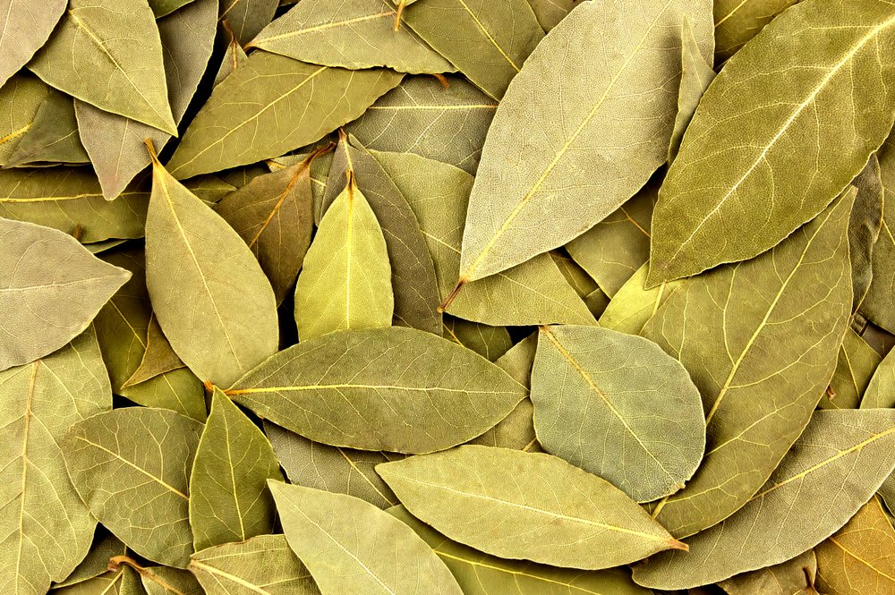

13 May 2021

CONTENTS

Foreword 4
Acronyms and Abbreviations 5
1. Introduction 6
2. Economical value, usages and trade 7
2.1. Economical value 7
2.2. Areas of usage 9
2.3. Contribution to Rural Development 9
2.4. Trade/Export 9
3. Specific sectoral policies 10
3.1. Communique on NWFPs 10
3.2. Action Plans 10
3.3. Technical guidelines 11
3.4. Standards 13
3.5. Inventory procedures 13
3.6. Stakeholders 13
4. Recommendations 13
References 15

TABLES
Table 1. Area of bay trees and production of bay leaf in 2019 6
Table 2.General statistics of bay leaf for the last 10 years (2009-2019) 7
Table 3. Top five countries with highest exports in 2015 10
Table 4. Top five countries with the highest exports in 2016 10
Table 5. Top five countries with the highest exports in 2017 10
Table 6. Top five countries with the highest exports in 2018 10
Table 7. Top five countries with the highest exports in 2019 10
Table 8. A typical value chain of bay leaf 13

FIGURES
Figure 1. Bay Leaf Production of Turkey for the Last 10 Years (2009-2019) 7
Figure 2. Bay leaf export for the last 10 years 8
Figure 3. Export/Production Ratio (%) for last 10 years (2009-2019) 8
Figure 4. Turkey's bay leaf production/harvesting projection 11

PICTURES
Picture 1.Women working in separating leaves from bay tree branches 9
Picture 2. Branches are transported to where the scales are installed for measurement. 12
Picture 3. Seperation of bay leaves from branches 12

Foreword

This report titled "Bay Leaf as a Non-Wood Forest Product" has been prepared by the Chamber of Forest Engineers of Turkey (OMO) within the scope of the Letter of Agreement (LoA) namely “Provision of Technical Guidelines on Sustainable Management of Non-Wood Forest Products (NWFPs) and the Status Reports on Specific Selected Products” signed with the Food and Agriculture Organization (FAO) on December 20, 2019.
The report has been prepared in close collaboration with the relevant stakeholders, particularly the Department of Non-Wood Products and Services (DNWFPS) of the General Directorate of Forestry (GDF). The results were also discussed with stakeholders during “consultations meetings with three different regions of Turkey, update meetings with responsible national institutions and consultation workshop with respective stakeholders”.
The main findings on bay leaf are:
- There are 180 400 hectares of bay trees in 2019. Bay leaf production, which was around 15 thousand tons in 2012, increased to 32 600 tons by the end of 2019.
- In 2019, the direct income earned by forest villagers from the harvest of bay leaves was 26.4 million USD. The total contribution of bay leaf to the country's economy was 264 million USD.
- According to the 2023-2030 projection of GDF, it is planned to increase the bay leaves production to 150 000 tonnes and its contribution to the country's economy to 1 billion USD.

Acronyms and Abbreviations
OMO Chamber of Forest Engineers of Turkey
Communiqué of NWFPs Communiqué on Inventory and Planning of NWFPs and Production and Sales Principles
DNWPS Department of Non-Wood Products and Services of GDF
ENDP Eleventh National Development Plan (2019-2023) of Turkey
EuroStat European Statistical Office
FAO Food and Agriculture Organization of the United Nations
FRA 2020 Global Forest Resources Assessment 2020
GDF General Directorate of Forestry of Turkey
GTIP Customs Tariff Statistics Position
ha hectare(s)
INCREDIBLE Project Innovation Networks of Cork, Resins and Edibles in the Mediterranean Basin Project
KOSGEB Small and Medium Enterprises Development Organization of Turkey
LoA Letter of Agreement
MAF Ministry of Agriculture and Forestry of Turkey
MT Ministry of Trade of Turkey
NWFP Non-Wood Forest Product
StarTree A pan-European project to support the sustainable exploitation of forest resources for rural development.
TL Turkish Lira
TSE Turkish Standards Institution
TUIK Turkish Statistical Institute (TurkStat)
USD United States Dollar
USD/TL Rate According to the average dollar rate in 2019 by the Central Bank of the Republic of Turkey which was 5.68 TL)

Introduction

The bay tree (Laurus nobilis) spread throughout the entire coastline of Turkey, from Hatay to the Northeastern Black Sea and can be found at an altitude of 0 - 1200 m. Bay trees are large shrub-form plants belonging to the genus Laurus of the Lauraceae family

Bay trees are “maquis shrubland plants, remaining evergreen, 2-10 m. tall, frequently branched, small trees or shrubs. They have the ability to sprout plenty of roots and stems. March-May is the blooming season that varies according to regions. The male flowers are darker yellow in appearance, more abundant and cluster, while the female flowers are light yellow in color and more sparse on the branch.

Bay trees like places where the winter is temperate and the summers are hot, and although the soil demand is not too much, it prefers water beds with enough moisture. It is also observed on the arid southern slopes, where there is no seepage water or moist stream environment but is open to marine effect. Bay trees love calcareous, humus and cool soils. The average temperature of the areas where it grows rarely drops below zero and the annual precipitation amount ranges between 600 mm and 2000 mm.

According to GDF, Turkey had a total area of 180 400 hectares of bay trees in the whole country in 2019. The total amount of bay leaf production was 32 600 tons in 2019.

Table 1. Area of bay trees and production of bay leaf in 2019
No | Regional Directorate of Forestry | Area (ha) | 2019 annual production (tons)
1 | Adana | 7 941 | 1 850
2 | Amasya | 2 254 | 500
3 | Antalya | 21 367 | 1 220
4 | Balıkesir | 3 530 | 364
5 | Bolu | 153 | 64
6 | Bursa | 16 678 | 4 050
7 | Çanakkale | 1 452 | 0
8 | Isparta | 471 | 42
9 | İstanbul | 6 603 | 910
10 | İzmir | 15 406 | 40
11 | Kahramanmaraş | 20 744 | 1 590
12 | Kastamonu | 5 660 | 800
13 | Mersin | 23 092 | 1 160
14 | Muğla | 15 771 | 490
15 | Sakarya | 12 102 | 5 420
16 | Zonguldak | 27 176 | 14 100
 | Total | 180 400 | 32 600

Economical value, usages and trade

Economical value
The contribution of bay leaf to Turkey’s national economy was calculated as 264 084 507 USD in 2019. Turkey has exported approximately 13 600 tons and has the export value at around 38 million USD. (GDF, A cure-all Defne, 2020).

As shown in Table 2 production of bay leaf significantly increased in recent years especially after 2012. Bay leaf production, which was around 15 thousand tons in 2012, increased to approximately 33 thousand tons by the end of 2019. The regulations made by GDF, the establishment of DNWPS, preparation and implementation of the Communiqué of NWFPs and Bay Leaf Action Plan (2016-2020), training of the relevant people played an important role in the increase of bay leaf production. On the other hand, the increase in both domestic and foreign demand for bay leaves is the most important factor. Today, there is no marketing problem for the bay leaf. All products produced in accordance with the standards and put on the market can find buyers.
Table 2.General statistics of bay leaf for the last 10 years (2009-2019)
Year | Total Production (kg) | Export quantity (kg) | Production / Export Ratio (%) | Export value-USD | Unit Price-kg/USD
2009 | 18 256 000 | 9 063 000 | 49,6 | 24 301 033 | 2,68
2010 | 15 416 000 | 8 891 000 | 57,7 | 25 618 067 | 2,88
2011 | 13 928 000 | 9 345 000 | 67,1 | 26 143 140 | 2,80
2012 | 15 232 000 | 10 482 000 | 68,8 | 29 951 348 | 2,86
2013 | 15 177 000 | 10 676 000 | 70,3 | 32 231 082 | 3,02
2014 | 15 578 000 | 12 255 000 | 78,7 | 35 762 159 | 2,92
2015 | 21 634 000 | 12 741 000 | 58,9 | 35 889 541 | 2,82
2016 | 21 800 000 | 14 063 000 | 64,5 | 40 100 766 | 2,85
2017 | 28 000 000 | 12 708 000 | 45,4 | 36 058 749 | 2,84
2018 | 28 500 000 | 14 589 000 | 51,2 | 40 195 850 | 2,76
2019 | 32 600 000 | 13 512 000 | 41,4 | 38 234 826 | 2,83

Figure 1. Bay Leaf Production of Turkey for the Last 10 Years (2009-2019)

When the price of bay leaf is examined, it is evaluated that export figures rather than domestic consumption can give a more meaningful idea. Despite the depreciation of the Turkish lira against the USD and the increase in the amount of bay leaves exported, the unit bay leaf export price remained unchanged, remained almost constant and even increased slightly. For example, 1 kg of bay leaf, which was 2.86 USD in 2012, was exported with an average price of 2.83 USD in 2019.

Figure 2. Bay leaf export for the last 10 years

On the other hand, comparison of total production and exported quantity will also be an important indicator in terms of production / price / market. In 2012, 10.5 thousand tons, in other words 69% of the total bay leaves, which were around 15.2 thousand tons, were exported. In 2019, a total of 32.6 thousand tons were produced, of which 13.5 tons, in other words, 41% were exported.
Figure 3. Export/Production Ratio (%) for last 10 years (2009-2019)

As a result;
- Bay leaf is one of the most precious products of Turkey's forests.
- Harvesting increases regularly.
- Bay leaf is an important export product. Although the export amount is increasing, the export/harvesting ratio is in a downward trend. This ratio, which was 69% in 2012, decreased to 41% in 2019. Both export and domestic prices have not decreased, but this decrease in the rate is an issue that needs to be addressed. The increase in harvesting should also be caught in exports, and foreign market opportunities should be increased for this aim.

Areas of usage
Bay leaf market is a growing market. Among the main factors driving the growth are the growing demand for culinary use and the spread of awareness on health benefits in the Asia-Pacific and Mediterranean regions. The essential oil bay leaf is used in the production of soap and also as an aroma in the food and cosmetics industries; dry fruits and dry leaves are used for adding fragrance to food and consumed as tea, respectively. For instance, it is used in the cuisine, especially in meat (fish, white, red etc.), roasts, meatballs, sauces, spice mixtures, etc. as well as preservation in the food industry.

Contribution to Rural Development
Bay leaves have a great potential in Turkey, most likely it will become one of the products that generate higher income than classical forest raw products in some certain areas and to substaintially contribute to the local and national economy. In a press release made by GDF, it was stated that the direct income earned by forest villagers from the harvest of bay leaves is 26.4 million USD. The total contribution of bay leaf to the country's economy is calculated as 264 million USD. (GDF, A cure-all Defne, 2020)

Picture 1.Women working in separating leaves from bay tree branches
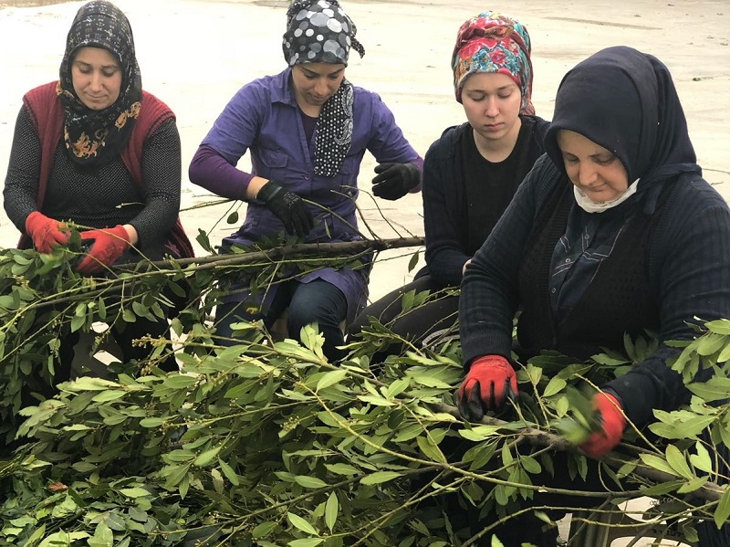

Trade/Export
The trade of bay leaves and oils is organized under different groups in international trade databases.
In Turkey, bay leaf is being traded under the Customs Tariff Statistics Position (GTIP) numbered “091099”. This GTIP code covers “ginger, saffron, turmeric (curcuma), thyme, bay leaves, curry and other spices" group, which includes some other spices in the trade classification, and is specifically coded as "091099500000". The top five countries where Turkey exported to are provided in following tables between 3-7.

Table 3. Top five countries with highest exports in 2015  Year Country Export Value-USD  2015 Vietnam 15 480 612  Eagen Free Zone 3 499 017  Poland 2 537 580  USA 1 752 139  Brazil 1 400 376 | Table 4. Top five countries with the highest exports in 2016  Year Country Export Value-USD  2016 Vietnam 18 642 407  Eagen Free Zone 4 521 442  USA 2 900 384  Poland 1 654 476  Germany 1 277 347
Table 5. Top five countries with the highest exports in 2017  Year Country Export Value-USD  2017 Vietnam 14 200 934  Eagen Free Zone 3 603 051  USA 2 490 603  Poland 1 962 406  Japan 1 449 183 | Table 6. Top five countries with the highest exports in 2018  Year Country Export Value-USD  2018 Vietnam 18 041 239  Eagen Free Zone 4 244 146  USA 2 521 502  Poland 1 661 312  Japan 1 478 614
Table 7. Top five countries with the highest exports in 2019
Year | Country | Export Value-USD
2019 | Vietnam | 8 659 474
 | Eagen Free Zone | 5 117 363
 | China | 3 304 696
 | USA | 2 785 309
 | Poland | 2 006 591

As it can be seen at the tables, different years were included to see if the export increased to one country and decreased to another over the years. It is seen that Vietnam came first by far in 5 years. After Vietnam, USA, Poland, Japan, Germany, Brazil and China were among the top five exported countries in 2015-2019. In 2019, China entered the list for the first time.

Specific sectoral policies

Communique on NWFPs
Communiqué on “Inventory and Planning of Non-Wood Forest Products and Production and Sales Principles”, which was put into practice in 2016 is the most recent, comprehensive, political and technical guideline used by GDF with the aim of enhancing sustainable utilization of NWFPs.

Action Plans
GDF prepared the Bay Leaf Action Plan covering the years 2016-2020 (GDF, Bay Leaf Action Plan, 2016). The purpose of the plan is to contribute to sustianable management of bay trees found in state-owned forest, to increase areas by establishing bay tree orchards in agricultural areas especially in forest villages, to make neseccary regulations for harvesting.
In this context, the rehabilitation, protection and maintenance of the areas that can produce high quality bay leaves on a national scale, the development of bay seed areas where the increasing need for fixed oil can be met, the development of transportation and machine working opportunities in the bay areas, training of resource managers, collectors and stakeholders, and promotion of internal consumption opportunities are planned.
It is also planned to expand collection areas in suitable state-owned forests, to improve quality and therefore price by introducing national/international standards and certifications, to support the harvesters and industrialists, technically and financially, to produce and innovate more value-added products, to improve the financial status and resources of collectors, improvement of SMEs and to search more export possibilities.
Within the “Bay Leaf Action Plan” 1 250 ha area rehabilitation, 160 km road network, inventory and protection of 100 ha seed collection areas and training of 5 000 people are targeted.
According to the 2023-2030 projection of GDF, it is planned to increase the bay leaves production to 150 000 tons and its contribution to the country's economy to 1 billion USD.
In addition to the Action Plan, the following explanations can be made for the economic potential of the bay leaf. As stated before, Turkey has a total of 180 400 hectares of bay forest. Considering that bay leaves can be harvested every three years in these areas, it is calculated that 60 thousand hectares of bay tree forest can be subject to harvesting annually. However, when considering 10-12 tons of dried bay leaf production is possible in a hectare in one year, Turkey's annual production of bay leaf can be reached up to 600 000 tons. (60 thousand hectare* 10 ton= 600 000 tons)

However, the annual production in 2019 was 32 600 tons. The difference here is not due to the low production per hectare, but to the scarcity of forests allocated for bay leaf production. When all bay forests are put into production at full capacity, annual production figures will increase considerably.

Figure 4. Turkey's bay leaf production/harvesting projection

Technical guidelines
Bay leaf harvesting is carried out in accordance with the provisions of Communiqué of NWFPs. The majority of bay leaf is collected from state-owned forest land by forest villagers, and some quantity by private landowners. During the bay leaf cutting process, the cut shoots are collected and tied. After the fastening process, the transfer to the scale begins. The bay leaves collected by the forest villager reaches the drying/processing facility in three different ways through the agent/trader, through the cooperative or individually by person. (CARFU, 2020)

Since the bay trees are cut from their roots, bay leaves can be produced in an area generally every three years. This three-year period may be longer if there is a drought or if the soil quality/habitat condition is not good. The cutting of laurel trees generally starts in August in places close to the sea, depending on the ripening of the leaves. As the altitude increases, the time to start work changes.

Picture 2. Branches are transported to where the scales are installed for measurement.
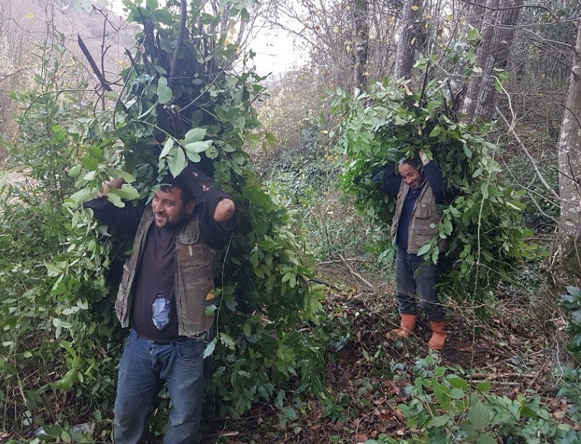 | 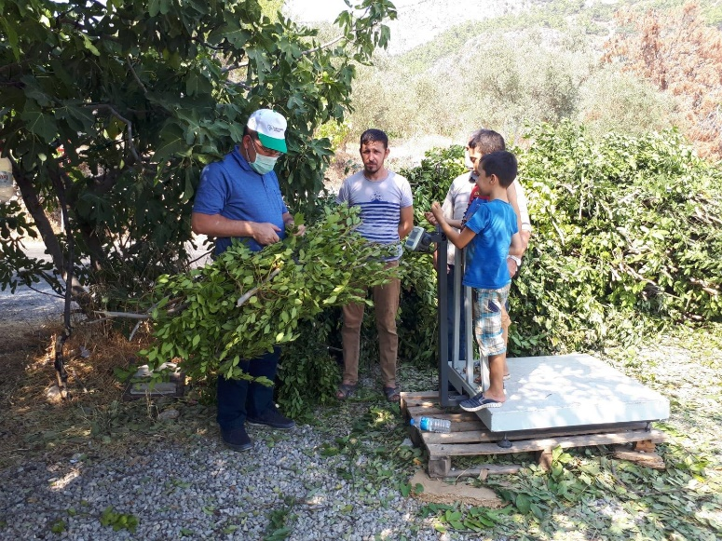

The bay leaf harvested from the unit area may vary depending on the condition of the forest. It is possible to harvest around 60 tons of branched bay leaves per hectare in a suitable stand. After the leafy bay tree branches are brought to the processing facilities, the leaves are first separated from the branches and then dried in special drying equipment (ovens).

Picture 3. Seperation of bay leaves from branches
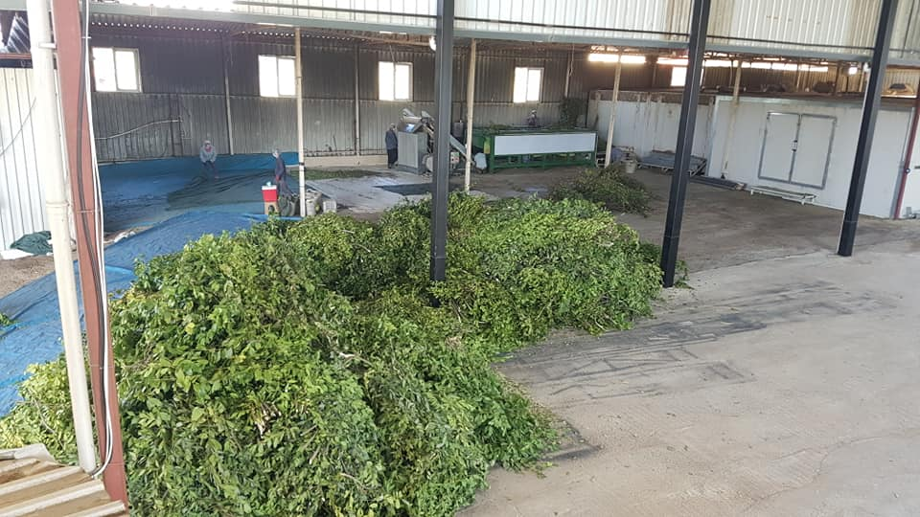 | 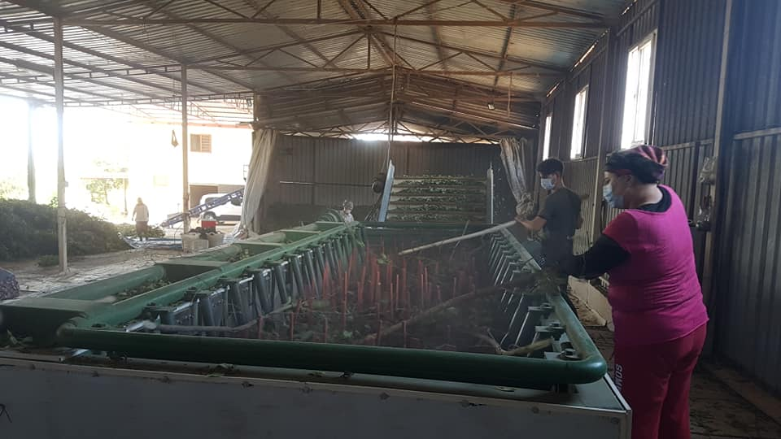

In a productive bay tree forest, a person can deliver 300 kg of leafy bay tree branches in one day. As of 2020, 0.35 USD is paid for 1 kg of leafy bay tree branch. Considering that a person can deliver an average of 300 kg of leafy bay tree branches a day, his daily earnings can be calculated as 105 USD. However, when calculating the total annual income, it should be taken into account that a forest area can be harvested every three years and it can be worked for approximately 15 days in a year. In general, one-fifth of dried bay leaves are obtained from leafy branches. In this case, it can be said that 10-12 tons of dried bay leaves are produced from a hectare area every 3 years (AKAT, 2020).

Standards
TS 1017 of The Turkish Standard Institution (TSE) comprises bay leaf and TS 5205 specifies the laurel oil which are extracted from bay tree leaves and seeds.

Inventory procedures
Bay tree inventory is made in linne with Communiqué of NWFPs. Prior to field studies, in order to determine the extent of traditional knowledge and potential locations, literature and resource researches are reviewed, surveys and interviews are conducted with respective stakeholders. Based on the data obtained from the literature and interviews, the areas where targeted NWFPs could be found are identified. The identified locations overlap with the forest stand map to find out the division, partition and stand spread. Areal data collected through field studies and great amount of information including, density, vitality, companion types, locality are noted for next yield inventory and planning studies. According to the sampling method envisaged in accordance with the data obtained, the size and number of the sample areas are determined and the locations to be sampled are marked on the map.

Stakeholders
Bay leaves collection is mostly conducted by forest villagers, while private companies are the main processors and traders of the bay leaves.
Table 8. A typical value chain of bay leaf
Production | Collection/Harvesting | Processing | Sale
- GDF-DNWFPS  - Regional Directorates of Forest- Division of NWFPs and Services  - Forest Management Directorates  - Forest Management Chiefs  - Consulting / planning firms on behalf of the GDF | - Forest villagers who have rights and permits  - Workers working in the field, Chief of the Villages  - Intermediaries who mediate with forest management | - Forest Villagers  - Cooperatives  - Private Sector | - Direct Buyers from Source  - Intermediaries between buyers and peasants  - Cooperatives  - Direct Sellers at the Markets and Bazaars  - Final Sellers  - Exporters  - Packaged Products Sellers  - Processed Products Sellers- Cosmetics

Recommendations
In order to benefit of bay leaves in the long term, it is necessary to provide training programmes especially for harvesters. Considering its value at international market, creating an effective value chain from filed to the end consumers has great importance .
Activities carried out at the academic level in relation to the cultivation of bay plants are promising.
Products obtained from bay trees should have a certain standardization. In this sense, geographical indication (GI) can play an important role. Production of bay leaves, bay leaf soap and other bay leaf products in accordance with the standards demanded nationally and globally should be encouraged.
Preparing and implementing national and international projects to share traditional knowledge and experiences will have positive effect on marketing. Consultation meetings should be organized at province or regional level with participation of all relevant stakeholders including NGOs..
In order to protect bay tree area effectively, a close cooperation should be made between forest villagers and GDF. A strong partnership between GDF and private sector should be promoted with aim of increasing domestic and international market.

References
Agency, W. M. (2014). Rural Development Plan (2014-2019).
Ajansı, B. K. (2018). Defne Fiziblite Raporu. Batı Karadeniz Kalkınma Ajansı.
AKAT, A. (2020, November 14). (İ. Belen, Interviewer)
Anonymous. (2020). Presidential Decree on Institutions Affiliated to Ministries.
CARFU. (2020). Field visit for bay leaf-9 September 2020. The Foundation of the People Caring for Future. Retrieved November 14, 2020, from http://www.gonder.org.tr/?p=9948
Center, I. T. (n.d.). International Trade Center. Retrieved from https://www.intracen.org/
DÜZENLI A, K. D. (2012). Türkiyede Defne ve Defnecilik . Orman Genel Müdürlüğü.
FAO. (1999). Towards a harmonized definition of non-wood forest products. http://www.fao.org/3/x2450e/x2450e0d.htm#fao%20forestry.
FAO. (2018). The State of the World’s Forests 2018. http://www.fao.org/3/I9535EN/i9535en.pdf.
FAO. (2020a). Global Forest Resources Assessment 2020: Main report. Rome. Rome: Food and Agriculture Organisation. Retrieved August 2020, from https://doi.org/10.4060/ca9825en
GDF. (2016). Bay Leaf Action Plan. Retrieved November 14, 2020, from https://www.ogm.gov.tr/ekutuphane/Yayinlar/Defne_Eylem_Plani.pdf
GDF. (2020, October 21). Retrieved November 13, 2020, from https://www.ogm.gov.tr/SitePages/OGM/OGMHaberler.aspx?List=aad1782a%2D50b0%2D49db%2Db602%2Dddf5724a0b9e&ID=2099&Source=https%3A%2F%2Fwww%2Eogm%2Egov%2Etr%2FLists%2FHaberler%2FAllItems%2Easpx&ContentTypeId=0x010008A5F3956C8A3F41A909DA4B1EFDF0CE
GDF2020a. (n.d.). Organisation of the GDF. Retrieved August 2020, from https://www.ogm.gov.tr/lang/en/Pages/Organization/Units.aspx
KAVAKLI, Ş. (2012). Ege Bölgesi Doğal Defne Populasyonunda Genetik Farklılıkların Belirlenmesi. Ege Üniversitesi Fen Bilimleri Ensitütüsü, İzmir.
MÜDÜRLÜĞÜ, E. O. ( 2005). Defne El Kitabı. EGE ORMANCILIK ARAŞTIRMA ENSTİTÜSÜ MÜDÜRLÜĞÜ .
OGM. (2016). Communiqué on Inventory and Planning of NWFPs and Production and Sales Principles. Retrieved from https://www.ogm.gov.tr/ekutuphane/Tebligler/302%20say%C4%B1l%C4%B1%20odun%20d%C4%B1%C5%9F%C4%B1%20orman%20%C3%BCr%C3%BCnlerinin%20envanter%20ve%20planlanmas%C4%B1%20ile%20%C3%BCretim%20ve%20sat%C4%B1%C5%9F%20esaslar%C4%B1%20Tebli%C4%9Fi.pdf
OGM. (2018). Strategic Plan (2019-2023). https://www.ogm.gov.tr/ekutuphane/StratejikPlan/Orman%20Genel%20M%C3%BCd%C3%BCrl%C3%BC%C4%9F%C3%BC%20Stratejik%20Plan%20(2019-2023).pdf.
ÖZEL, N. (2006). Defnenin Biyolojik Özellikleri ve Yetişme Ortamı İstekleri, . izmir: İzmir Orman Bölge Müdürlüğü.
Sangun, M. A. (2007). Comparison of Chemical Composition of the Essential oil of Laurus nobilis L., leaves and Fruits from Different Regions of Hatay, Turkey. Journal of Environmental Biology , 731-733.
SEMERCİ, A. a. (2017). Defne Bitkisinin Hatay İli Ekonomisindeki Yeri ve Önemi. Süleyman Demirel Üniversitesi, Ziraat Fakültesi Dergisi, 125-134.
UN. (2020). UN Operational Rates of Exchange. Retrieved November 14, 2020, from https://treasury.un.org/operationalrates/OperationalRates.php
Vakıf, Y. D. (2018). Defne Değer Zincir Analizi.

The term “Maquis shrubland” refers to plant formations made of shrubs and small trees (maximum 4-5 metres), generally evergreen, sometimes scented, which create a thick and intricate vegetation, with a very variable floristic composition. The Maquis shrubland is typical of the regions surrounding the Mediterranean basin.https://www.parconazionaledelvesuvio.it/en/biodiversity/maquis-shrubland-and-the-woods/
According to the "UN Operational Rates of Exchange" figures, it was 1 USD/1.787 TL on 31 Dec 2012, and 1 USD/5.956 TL on 31 Dec 2019. (UN, 2020)
GTIP stands for Customs Tariff Statistics Position. All over the world, the basis of the tariff scale of each country is the Harmonized System Nomenclature (AS). Nomenclature means systematic numbering or naming of all products subject to international trade according to international rules and interpretations. https://normastandart.com.tr/en/
TS 1017- https://intweb.tse.org.tr/Standard/Standard/Standard.aspx?081118051115108051104119110104055047105102120088111043113104073086097077104080043119114090074100
TS 5205- https://intweb.tse.org.tr/Standard/Standard/Standard.aspx?081118051115108051104119110104055047105102120088111043113104073099075114121104057043052083100069

