Pine Honey as a Non-Wood Forest Product

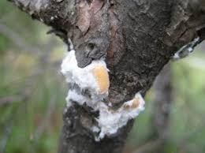

13 May 2021

TABLE OF CONTENTS
Foreword 4
Acronyms and Abbreviations 5
1. Introduction 6
1.1. Beekeeping and honey production in Turkey 6
1.2. Pine honey 7
1.3. The giant pine scale, Marchalina hellenica 7
1.4. Pine honey production in Turkey 8
2. Economical Value and Usages 8
2.1. Economical value 8
2.2. Areas of usage 8
2.3. Contribution to rural employment 9
3. Sectoral Policies and Administrative Structure 10
3.1. Honey forests action plans 10
3.2. Standards 10
3.3. Production procedures 11
3.4. Administrative structure 11
4. Challenges and Recommendations 11
References 14

TABLES
Table 1. Number of agricultural holdings in apiculture, honey and wax production (TUIK2020a) 7

FIGURES
Figure 1. Top ten honey producers in the world, 2015-2018 (FAOSTAT) 6
Figure 2. Turkey’s honey production in the last five years 6

PICTURES
Picture 1. Effect of Marchalina hellenica beetle on Turkish pine branches and trunks 7
Picture 2. Location of forests where Marchalina hellenica is found in Muğla province 8
Picture 3. Beekeeper women 9

TEXT BOXES
Text box 1. Beekeeping in Ordu province/Estimation for Turkey 9

Foreword

This report titled "Pine Honey as a Non-Wood Forest Product " has been prepared by the Chamber of Forest Engineers of Turkey (OMO) within the scope of the Letter of Agreement (LoA) namely “Provision of Technical Guidelines on Sustainable Management of Non-Wood Forest Products (NWFPs) and the Status Reports on Specific Selected Products” signed with the Food and Agriculture Organization (FAO) on December 20, 2019.
The report has been prepared in close collaboration with the relevant stakeholders, particularly the Department of Non-Wood Products and Services (DNWPS) of the General Directorate of Forestry (GDF). The results were also discussed with stakeholders during “consultations meetings with three different regions of Turkey, update meetings with responsible national institutions and consultation workshop with respective stakeholders”.
The main findings on beekeeping and pine honey are:
- The average honey production for the past five years is 109 115 tons annually. There are approximately 80 000 agricultural holdings in apiculture/beekeeping. (TUIK2020a).
- The overall contribution of the sector to the national economy is estimated around 1 billion USD as per data of the Turkish Association of Beekeepers (TAB). Based on the active members of TAB, approximately 200 000 people are dealing with beekeeping in Turkey in total. (TAB, 2020)
- Pine honey is a unique honey is produced by honeybees from the honeydew secreted by the aphids (Marchalina hellenica) that lives in Pinus brutia trees. More than 90 percent of the world’s pine honey production comes from Turkey. (FAO, 2020). The estimated annual contribution of pine honey was 200 million USD in 2019 at retail prices
- There is no law in Turkey exclusively for beekeeping. However, the basic law on beekeeping is the "Veterinary Services, Plant Health, Food and Feed Law". The regulatory function of the forestry sector for beekeeping is relatively new.
- Pine honey was included in the Communiqué of Turkish Food Codex (TFC) very recently in 2020.

Acronyms and Abbreviations
OMO Chamber of Forest Engineers of Turkey
Communiqué of NWFPs Communiqué on Inventory and Planning of NWFPs and Production and Sales Principles
DNWPS Department of Non-Wood Products and Services of GDF
ENDP Eleventh National Development Plan (2019-2023) of Turkey
EuroStat European Statistical Office
FAO Food and Agriculture Organization of the United Nations
FRA 2020 Global Forest Resources Assessment 2020
GDF General Directorate of Forestry of Turkey
ha hectare(s)
INCREDIBLE Project Innovation Networks of Cork, Resins and Edibles in the Mediterranean Basin Project
LoA Letter of Agreement
MoAF Ministry of Agriculture and Forestry of Turkey
MT Ministry of Trade of Turkey
NWFP Non-Wood Forest Product
OG Offical Gazette of Turkey
StarTree A pan-European project to support the sustainable exploitation of forest resources for rural development.
TAB Turkish Association of Beekeepers
TFC Turkish Food Codex
TL Turkish Lira
TSE Turkish Standards Institution
TUIK Turkish Statistical Institute (TurkStat)
USD United States Dollar
USD/TL Rate According to the average dollar rate in 2019 by the Central Bank of the Republic of Turkey which was 5.68 TL.)

Introduction

Beekeeping and honey production in Turkey
Having the climatic benefit of enjoying all four seasons, Turkey possesses many bee races and ecotypes, which easily accommodate themselves to the diverse ecologic conditions and utilizing rich floral resources providing nectar and pollen throughout the year.
Particularly the Mediterranean and the Aegean regions with a mild climate and specific topographies that lead micro-climate varieties and blossoming periods are preferred by beekeepers for wintering their colonies, obtaining a rich nectar and pollen source, and benefiting from the relatively early start of spring. In addition, there is a considerable source of honeydew on the pine trees in the southwest of the country.
According to FAO statistics, Turkey is the second largest producer of honey in the world.
Figure 1. Top ten honey producers in the world, 2015-2018 (FAOSTAT)
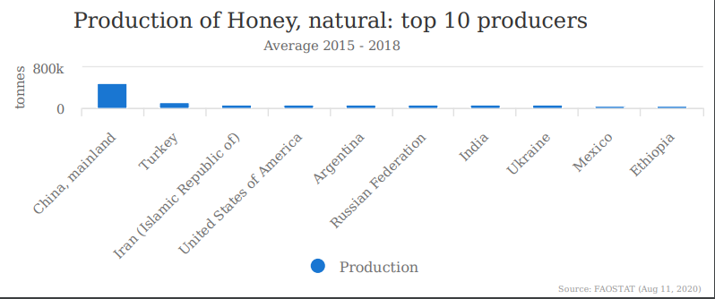
According to TUIK, the most honey in the past five years was produced in 2017, while the lowest amount was produced in 2016 (Figure 2).

Figure 2. Turkey’s honey production in the last five years

Table 1. Number of agricultural holdings in apiculture, honey and wax production (TUIK2020a)
Year | Number of holdings | Number of hives | Honey ton | Wax ton
2015 | 83 475 | 7 748 287 | 108 128 | 4 756
2016 | 84 047 | 7 900 364 | 105 727 | 4 440
2017 | 83 210 | 7 991 072 | 114 471 | 4 488
2018 | 81 830 | 8 108 424 | 107 920 | 3 987
2019 | 80 675 | 8 128 360 | 109 330 | 3 971

Pine honey
Pine honey is a unique honey produced by bees, not from flower pollen, but from honeydew produced by an insect (Marchalina hellenica) that lives in the body of some pine tree species. Most of the world's pine honey (about 90 percent) is produced in the South-West region, particularly in Muğla province of Turkey. (FAO, 2020)
The most important feature of pine honey is that it can be stored for years without spoiling or crystallization, which is favourable also for marketing. Pine honey is a product with a wide range of uses and significant export potential.

The giant pine scale, Marchalina hellenica
Marchalina hellenica is a common scale insect species in Pinus brutia (Turkish pine) forests mainly in the Aegean region. Its honeydew has great economic importance because it is collected by honeybees and made into “pine honey" in Turkey. (ÜLGENTÜRK). This insect is also found in the Aegean and Eastern Mediterranean and Italy’s Ischia islands. It is hosted by different types of pine in Greece, especially Pinus brutia, P. halepensis and P. pinea, rarely in P. sylvestris and P. nigra. Researchers found that the honeydew insect, the host plant on which the insect feeds, the annual production of honey per hive, and finally the weather conditions (temperature, relative humidity, wind speed and direction) are all important factors affecting the chemical composition (water content, acidity etc.) of the honey. (AVCI, 2020)
Picture 1. Effect of Marchalina hellenica beetle on Turkish pine branches and trunks
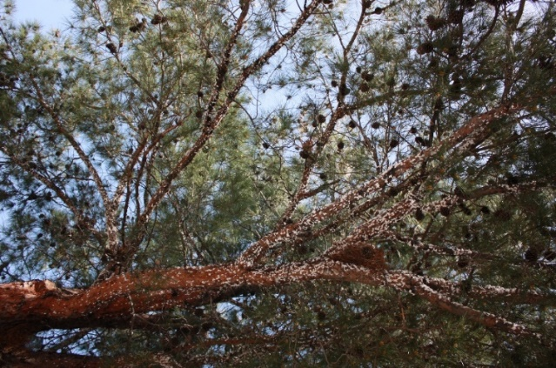 | 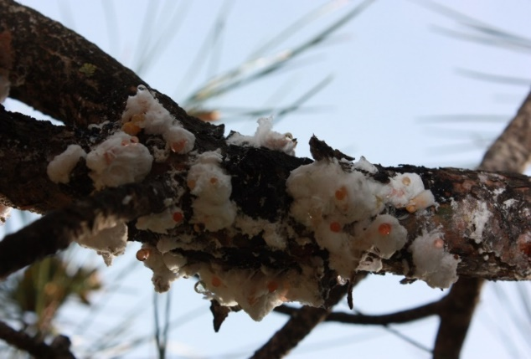

Pine honey production in Turkey
Marchalina hellenica exists mostly in the centre of Muğla and surrounding areas from the Fethiye coastline to the coastline of Kuşadası; while its density is high in some regions.

Picture 2. Location of forests where Marchalina hellenica is found in Muğla province
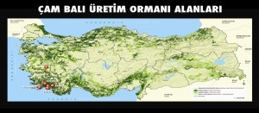 | 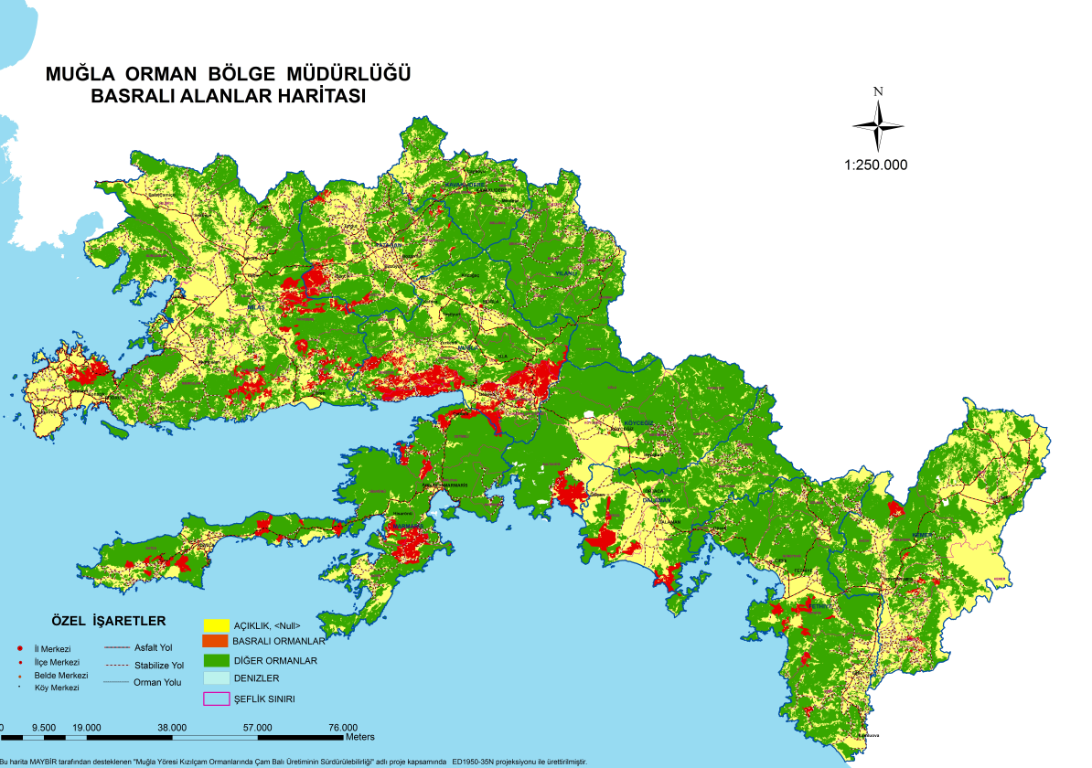

Muğla province is considered the center of the world’s pine honey production. The total area of Muğla province is 1 227 859 ha and 829 309 ha is forest. Marchalina hellenica is found in 8 percent of the total forest area of Muğla province which accounts for 66 305 ha. (AVCI, 2020).

Economical Value and Usages

Economical value
It is difficult to calculate the total contribution of the beekeeping industry to the country's economy. A significant part of the honey and other beekeeping products are consumed by family, friends, and relatives without entering the registered markets.
Honey is an important export material for Turkey. In 2019 a total of 3 845 988 kg honey was exported to approximately 50 countries. Turkey has achieved 14 787 486 USD in export earnings. The export price of honey in 2019 was 3.84 USD/kg. (TurkStat2020b).
Almost a quarter of the honey produced in Turkey is pine honey. Pine honey is produced entirely in forest areas dominated by Turkish pine (Pinus brutia). The annual production is 15 000-30 000 tons on average. The majority of the honey comes from Muğla province, the remaining amount is from Aydın, İzmir, Antalya and Balıkesir. One kg pine honey costs 3 USD at the field, and approximately 10 USD at the market at retail for the consumers. Calculating with the annual production as 20 000 tons and the prices listed above, the estimated annual contribution can be calculated as 60 million USD at the field and 200 million USD at retail prices (BELEN, 2015).

Areas of usage
Pine honey is distinguished from flower honey by its dark color and high values ​​of pH, ash content, and electrical conductivity. (Reig, 1998). Pine honey has many antioxidant compounds that reduce the damage of colonic inflammation, can increase the number of probiotic bacteria in the system, thereby helping to strengthen the immune system, reduce indigestion, lower cholesterol, and prevent colon cancer.
It is beneficial to consume pine honey for the healthy development of children in cases of iron deficiency. It is also useful in the fixation of bones, in the treatment of anemia and anorexia. (Krell, 1996)Since pine honey has a high mineral content, it has been stated that it has a very nutritious feature. (Bladenopoulou, 1984). It nourishes the hair and contributes to the strengthening of the hair follicles. It is used for lowering high blood pressure. It supports a healthy digestive system and flora even sensitive stomachs can digest easily. It is effective against helicobacteria.

Contribution to rural employment
Beekeeping is a traditional agricultural/forestry activity performed in nearly every rural region in Turkey. Because of its way of performing, it is not easy to have exact and verified numbers but some examples as follows can be given. Most of the people dealing with beekeeping are the members of the TAB. Taking into consideration that TAB has 72 048 members as 2020, it can be said that 216 144 people are dealing with beekeeping in Turkey in total.
Text box 1. Beekeeping in Ordu province/Estimation for Turkey
As of 2019, according to the information received from Akın Çifçi (President of Ordu Beekeepers Association, http://www.oray-bir.com/) there were 2 800 active beekeepers who were members of the union in the province of Ordu.

Considering that Ordu beekeepers produced 15 percent of the honey in Turkey and the value was around 176 million USD, the overall contribution of the sector could be calculated as 1 173 million USD. However, this is not a scientific or official calculation and should be used only for getting a general idea.

Members of the Ordu Beekeepers Association | 2 800 people
With their workers /Member+2 people | 8 400 people
Annual Honey Production | 16 000 ton
Total contribution to city economy | 176 million USD
Etimated total contribution of beekeeping sector to national economy | 1 173 million USD

Picture 3. Beekeeper women
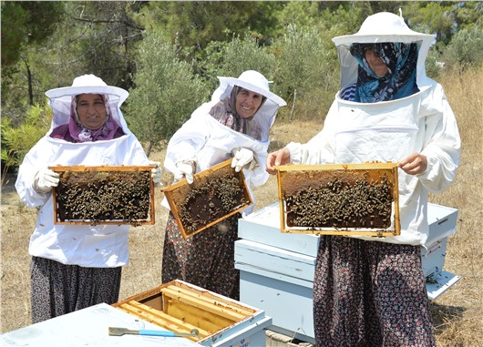
The beekeeping sector provides employment for 35-40 thousand people in Muğla province, including beekeepers, honeycomb producers, hive producers, honey collectors, packaging material producers, marketers and shippers thanks to pine honey.

Sectoral Policies and Administrative Structure
Currently the basic law related to beekeeping is the "Veterinary Services, Plant Health, Food and Feed Law". Based on this Law, the "Beekeeping Regulation" was published in 2011. (OG, Beekeeping Regulation, 2011)
Although most of the beekeeping activities are carried out in and around the state-owned forests and other wooded lands the regulatory function of the forestry sector for beekeeping is relatively new. The first regulatory action of forestry organization regarding beekeeping was the Ministerial Order dated 2010 with a title of “Supporting Beekeeping". "Honey Forests Communiqué" numbered 307 was published in 2017. (GDF, Honey Forest Communique, 2017)
Pine honey was included in the Communiqué of Turkish Food Codex (TFC) in 2020. TFC defines pine honey as: ''The secretion produced by honey bees, which is collected and processed by the honey bees using the carbohydrate-rich sweet sap of Marchalina hellenica that lives on some pine trees (Pinus brutia, P. nigra, P. pinea)''

Honey forests action plans
Beside the legislations, due to its importance and as the continuation of ongoing activities, the GDF has been implemented actions plans for beekeeping. The “First Honey Forest Action Plan” put into force in 2013. (GDF, First Honey Forest Action Plan, 2013).”
Following the completion of the first one, the "Second Honey Forest Action Plan" covering the years 2018-2023 has been prepared and put into effect.
By 2019, 484 honey forests (60 646 hectares in total) were established in Turkey. (GDF, Forestry Statistics, 2020). Under the umbrella of this second action plan, 720 honey forest (10 080 hectares) will be established by 2023. (GDF, Second Honey Forest Action Plan, 2018)

Standards
The following standardization institutes are relevant for beekeeping and honey production:
- Turkish Standards Institution (TSE)
- International Organization for Standardization (ISO)
- Turkish Patent and Trademark Office (TurkPatent)
- Turkish Food Codex (TFC)
- EU Standards
There has not been any specific standard approved either by TSE or the ISO for pine honey. For general bee products the standards developed and currently in effect by TSE are as follows. (BALMER)
- TSE 6666 - Royal Jelly,
- ICS 65.140 - Honey Bee Venom,
- TSE 10255 - Pollen,
- TS 12910 - Bee Glue (Propolis),
- TS 2936 - Beeswax,
- TSE 3036 - Honey
With regard to patent, there are two geographical indication (GI)for pine honey issued by TurkPatent in line with “Paris Convention for the Protection of Industrial Property” and national legislations.
- Muğla Pine Honey - Registered on 15.08.2018 on behalf of Muğla Province Bee Farmers Association (TurkPatent, Muğla Pine Honey, 2018)
- Marmaris Pine Honey - Registered on 06.11.2019 (TurkPatent, Marmaris Pine Honey, 2019)
Beside the national effort, there has been some activities with The European Bank for Reconstruction and Development (EBRD) to register this unique honey with a geographical indication (GI) at European Union level. (EBRD, 2019)

Production procedures
The production period of pine honey is September - November. During this period, 2-3 collections can be done from the bees transferred to the pine honey production areas depending on the year and ecological conditions. The produced pine honey is stored in cans and sold to wholesalers or to companies suppplying the market.

Administrative structure
The main ministry for pine honey is the MoAF. There are several General Directorates (DGs) under MoAF dealing with pine honey issues as shown below:
- General Directorate of Forests
- General Directorate of Nature Conservation and National Parks
- General Directorate of Animal Production
- Genera Directorate of Plant Production
- General Directorate of Food and Control
- General Directorate of Agricultural Research and Policies (TAGEM) - Apiculture Research Institute
Apart from the MoAF, as there is pine honey production in “Specially Protected Environmental Areas”, the Ministry of Environment and Urbanisation is also concerned with pine honey production.

Challenges and Recommendations
Although pine honey is an agricultural product in terms of legislation related to food and agriculture, it is produced in forest areas as a NWFP.
The main problems for pine honey areas are:
- Inventory and mapping of the areas where the giant pine scale “Marchalina hellenica" is spread naturally,
- Understanding the life cycle of Marchalina hellenica, ensuring its health and sustainability,
- Determination of forests to be reserved for pine honey production within the scope of "Honey Forests Communiqué" and Communiqué of NWFPs,
- Determining international standards for pine honey production and marketing, increasing export opportunities.
As of 2020, the natural range of Marchalina hellenica has not yet been fully determined. Different data is released by universities, agriculturalists, GDF, non-governmental organizations, beekeeping farmers and forest villagers about distribution areas and production. Marchalina hellenica has also been moved to forests and trees outside of its natural range due to its high economic return.
Another shortcoming is that the biology and life cycle of Marchalina hellenica is not fully known. Beekeepers generally carry out their activities with traditional methods, and not much attention is paid to Marchalina hellenica itself, which is the basic element in the production of pine honey. Many factors affect the health, production capacity and sustainability of the insect. For example, it has been observed that the health of the insect was affected due to the drought in 2020 and honey production decreased significantly.
Although Turkish beekeepers know the time of honey secretion in the life cycle of the Marchalina hellenica, they are not successful in turning it into production. Despite all their experience in production timing issues, planning and implementation errors are the main cause of failure. Capacity-building activities are needed to enhance better productivity in pine honey production.
Another challenge is the status of Marchalina hellenica related to forestry activities. Recently there has been some debate about this insect, whether it is harmful or not for Turkish pine body and its capacity for producing woody materials.
In 2006, Marchalina hellenica was included in the European and Mediterranean Plant Protection alert list but in 2008 it was excluded (EPPO). In Turkey, the insect is still considered to be harmful for trees but expected to be deleted from the list especially for natural distribution areas. (CARFU, A Unique Non-Wood Forest Product: Pine Honey, 2015)
In short, Marchalina hellenica could be described as both harmful and beneficial for two contrasting reasons. First, it is the most significant of several honeydew-producing insects in Greece and Turkey, and pine honey production relies mainly on Marchalina hellenica honeydew in both countries. For this reason, it has been intentionally introduced in many sites in these countries and its population size has been increased locally. Second, it is a pine pest as it feeds on the sap of the pine trees and can cause increment loss, desiccation, branch dieback, increasing crown transparency and tree decline. Heavy infestation by Marchalina hellenica may leave the host trees vulnerable to attack by secondary pests such as bark beetles. It is also considered a pest by foresters. Therefore, population management of Marchalina hellenica can be an important issue particularly out of its native range. Therefore, strong coordination has to be enhanced among different organizations responsible for NWFPs, livestock, food and pest control. (AVCI P. D., 2020)
There is an excessive and uncontrolled bee presence in the forestry area, especially during the production of pine honey. In some regions, hives are put on top of each other, which decreases productivity. Additionally, high density of colonies in one area can trigger the transmission of various bee diseases.
With regard to forest management, determination of forests to be reserved for pine honey production within the scope of "Honey Forests Communiqué" and “Communiqué of NWFPs” is an important issue.
In Turkey there has been an increasing demand for wood-based forest products and this demand triggers wood production activities. In addition to wood demand and production, tourism, agriculture, mining activities, thermal power plants, forest fires emerge as major threats. There are conflicts between tourism and beekeeping in many areas, especially in Muğla province. The busiest periods of both sectors occur at the same time, causing situations that bees harm tourists. Agricultural activities close to forested areas can cause damages to insects including bees. Pollution of soil and water affects the beekeeping sector adversely.
Within the framework of the relevant regulation, circular and action plans, the legal status of “natural honey forests” could be given to pine honey production areas as indicated in Communiqué of NWFPs and Honey Forests Communiqué. If such a legal status is given, problems with competitive sectors such as tourism and mining can be solved more easily, transparently and effectively.

References

AVCI. (2020). Current Status of Honey Forests and Pine Honey Production Areas. (P. D. AVCI, Ed.) Retrieved December 2020, from http://www.gonder.org.tr/wp-content/uploads/2020/12/Prof-Dr-Mustafa-Avci-Calistay-Sunu-30-Kasim-2020.pdf
AVCI, P. D. (2020, August 27). (I. Belen, Interviewer)
BALCI, Ö. (2020, August 27).
BALMER. (n.d.). Balmer - Black Sea Bee Products Centre. Retrieved December 5, 2020, from http://www.bal-mer.com/TSE-Standardi--TSE-3036-Bal
BALPARMAK. (2018). Retrieved August 2020, from http://www.balparmakaricilikakademisi.com.tr/
BELEN, İ. (2015). A Unique Non-Wood Forest Product: Pine Honey. Retrieved August 2020, from http://www.carfu.org/?p=524
Bladenopoulou, T. a. (1984). A comparative analysis of Greek pine and blossom honey. Nea Melissa 2, 7-10 (in Greek).
CARFU. (n.d.). Retrieved 2020, from http://www.gonder.org.tr/?p=9885
CARFU. (n.d.). (İ. Belen, Ed.) Retrieved December 5, 2020, from http://www.gonder.org.tr/wp-content/uploads/2014/10/Ar%C4%B1c%C4%B1l%C4%B1%C4%9F%C4%B1n-Desteklenmesine-%C4%B0li%C5%9Fkin-Bakanl%C4%B1k-Talimat%C4%B1-2-Mart-2010.pdf
CARFU. (2015). A Unique Non-Wood Forest Product: Pine Honey. (İ. Belen, Editor, & T. F. Future, Producer) Retrieved August 2020, from http://www.carfu.org/?p=524
CARFU. (n.d.). Beekeeping in Ordu Province. (İ. Belen, Ed.) Retrieved August 2020, from http://www.gonder.org.tr/?p=9885
CARFU2019. (n.d.). Azerbaijan’s Natural Wealth and Ecology Workers Trade Union Joins PLANFOR. Retrieved from http://www.carfu.org/?p=1478
developmen, T. s. (n.d.). Trade statistics for international business developmen. Retrieved from https://www.trademap.org/Index.aspx
EBRD. (2019). Turkish pine honey producers eye wider market, apply for geographical indication. Retrieved 2021, from https://www.ebrd.com/news/2019/turkish-pine-honey-producers-eye-wider-market-apply-for-geographical-indication.html
EPPO. (n.d.). EPPO Reporting Service. Retrieved 2020, from https://gd.eppo.int/reporting/article-1097
FAO. (2020). FAO STAT. Retrieved from http://www.fao.org/faostat/en/#home
FAO. (2020, August). The buzz around Turkish pine honey. Ankara. Retrieved from http://www.fao.org/support-to-investment/news/detail/en/c/1276394/
FAO. (2020a). Global Forest Resources Assessment 2020: Main report. Rome. Rome: Food and Agriculture Organisation. Retrieved August 2020, from https://doi.org/10.4060/ca9825en
Földhazi. (1994). Analysis and quantitation of sugars in honey of different botanical origin using high performance liquid chromatography, Univ. horticulture food industry, dep. food chemistry nutrition sci., 1118 Budapest, Hungary.
GDF. (2013). First Honey Forest Action Plan. Retrieved from https://www.ogm.gov.tr/ekutuphane/Yayinlar/Bal%20Orman%C4%B1%20Eylem%20Plan%C4%B1%20%282013-17%29.pdf
GDF. (2017). Honey Forest Communique. (GDF, Ed.) Retrieved from https://www.ogm.gov.tr/ekutuphane/Tebligler/Bal%20Ormanlar%C4%B1%20%C4%B0%C5%9Fletilmesi%20ve%20Y%C3%B6netilmesi.pdf
GDF. (2018). Second Honey Forest Action Plan. Retrieved August 2020, from https://www.ogm.gov.tr/ekutuphane/Dokumanlar/Bal%20Orman%C4%B1%20Eylem%20Plan%C4%B1%20(2018-2023).pdf
GDF. (2020). Forestry Statistics. Retrieved 2020, from https://www.ogm.gov.tr/ekutuphane/Sayfalar/Istatistikler.aspx?RootFolder=%2Fekutuphane%2FIstatistikler%2FOrmanc%C4%B1l%C4%B1k%20%C4%B0statistikleri&FolderCTID=0x012000301D182F8CB9FC49963274E712A2DC00&View={4B3B693B-B532-4C7F-A2D0-732F715C89CC}
GDF2020a. (n.d.). Organisation of the GDF. Retrieved August 2020, from https://www.ogm.gov.tr/lang/en/Pages/Organization/Units.aspx
K, O. A. (2017). CHEMOMETRIC EVALUATION OF THE GEOGRAPHICAL ORIGIN OF. Food and Health.
Krell. (1996). Value-added products from beekeeping. FAO AGRICULTURAL SERVICES BULLETIN No. 124. Retrieved from http://www.fao.org/3/w0076e/w0076e00.htm
Lachmanatall. (2007). Analysis of minority honey components: Possible use for the evaluation of honey quality, Food Chemistry, Volume 101, Issue 3, 2007, Pages 973-979. In J. K. Lachman.
MAYBIR. (2020). Mugla Beekeeping & Pine Honey Congress. Retrieved from https://www.muglacongress.org/eng/?p=home
Office, F. A. (2020). FAO. Retrieved from http://www.fao.org/europe/news/detail-news/es/c/1276387/
OG. (2010). Veterinery Services, Plant Health, Food and Feed Law. Retrieved August 2020, from https://www.resmigazete.gov.tr/eskiler/2010/06/20100613-12.htm
OG. (2011). Beekeeping Regulation. Retrieved August 2020, from https://www.resmigazete.gov.tr/eskiler/2011/11/20111130-9.htm
OG. (2020). Turkish Food Code-Honey Communication. Retrieved from https://www.resmigazete.gov.tr/eskiler/2020/04/20200422-13.htm
Reig, M. a. (1998). Mateo and Bosch- Reig, 1998. Classification of Spanish Unifloral Honeys by Discriminant Analysis of Electrical Conductivity, Color, Water Content, Sugars, and pH, J. Agric. Food Chem. 1998, 46, 393−400.
Şahin, Z. (2020, August 27). (İ. Belen, Interviewer)
TAB. (2020). Turkish Association of Beekepers. Retrieved December 4, 2020, from http://www.tab.org.tr/en/
The Turkish Constitutional Court of the Republic of Turkey. (2020). Constitution of the Republic of Turkey. Ankara. Retrieved August 2020, from https://www.anayasa.gov.tr/en/legislation/turkish-constiution/
TUIK2020a. (n.d.). Main Statistics. Retrieved August 2020, from http://www.tuik.gov.tr/PreTablo.do?alt_id=1002
TurkPatent. (2018). Muğla Pine Honey. Retrieved from https://www.ci.gov.tr/Files/GeographicalSigns/379.pdf
TurkPatent. (2019). Marmaris Pine Honey. Retrieved 2020, from https://www.ci.gov.tr/Files/GeographicalSigns/a09b775c-a8da-4c06-a18b-031b52ec84fb.pdf
TurkStat2020b. (n.d.). Retrieved August 2020, from https://biruni.tuik.gov.tr/disticaretapp/disticaret.zul?param1=25&param2=4&sitcrev=0&isicrev=0&sayac=5802
ÜLGENTÜRK. (n.d.). Ant species (Hymenoptera: Formicidae) associated with Marchalina hellenica. Retrieved 2020, from https://dergipark.org.tr/tr/download/article-file/64125

TAB states that each official member generally engages in beekeeping with at least two non-members. It has been stated that people who do beekeeping without being a member of TAB are generally family members (spouse, children, etc.) of TAP members. It has been understood that such a method is applied due to the formalities of the membership process.
http://www.gonder.org.tr/wp-content/uploads/2014/10/Ar%C4%B1c%C4%B1l%C4%B1%C4%9F%C4%B1n-Desteklenmesine-%C4%B0li%C5%9Fkin-Bakanl%C4%B1k-Talimat%C4%B1-2-Mart-2010.pdf
https://web.ogm.gov.tr/ekutuphane/Dokumanlar/Bal%20Orman%C4%B1%20Eylem%20Plan%C4%B1%20(2018-2023).pdf

