Resin as a Non-Wood Forest Product

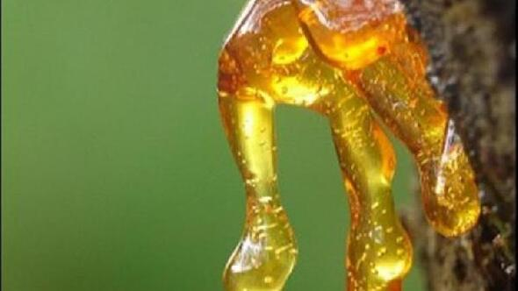

13 May 2021

CONTENTS
Foreword 4
Acronyms and Abbreviations 5
1. Introduction 6
1.1. Resin Extraction 6
1.2. Eligible trees 7
1.3. Economic Yield 8
1.4. Resin Import 9
2. Specific Sectoral Policies 10
2.1. Communique on NWFPs 10
2.2. Resin Action Plan (2017-2021) 10
2.3. Technical Guidelines 10
2.4. Standards 10
2.5. Resin Extraction Methods 10
3. Administrative structure 11
4. Challenges and Recommadations 12
References 13

Tables
Table 1. Prices of resin at different stage (ton/USD) (GDF, 2020) 7

Figures
Figure 1. Turkey's annual resin extraction (ton/year) 6
Figure 2. Potential resin extraction area of Turkey (ha) 7
Figure 3. Prices of resin at different stages (ton/USD) 8
Figure 4. Natural resin import to Turkey (ton/year) 8
Figure 5. Natural resin extraction/target 9
Figure 6. The Regional Directorates of Forestry eligibile to produce natural resin 10

PICTURES
Picture 1. A resin on Pinus brutia tree 5
Picture 2. Resin extraction from trees 10

Foreword

This report titled "Resin as a Non-Wood Forest Product" has been prepared by the Chamber of Forest Engineers of Turkey (OMO) within the scope of the Letter of Agreement (LoA) namely “Provision of Technical Guidelines on Sustainable Management of Non-Wood Forest Products (NWFPs) and the Status Reports on Specific Selected Products” signed with the Food and Agriculture Organization (FAO) on December 20, 2019.
The report has been prepared in close collaboration with the relevant stakeholders, particularly the Department of Non-Wood Products and Services (DNWPS) of the General Directorate of Forestry (GDF). The results were also discussed with stakeholders during “consultations meetings with three different regions of Turkey, update meetings with responsible national institutions and consultation workshop with respective stakeholders”.
The main findings of resin are:
- Resin extraction activities showed an uneven process. The annual production, which approached 7 000 tons in the 1970s, has decreased since 1983, almost stopped in the 2000s. Recently, the changes in the global market situation forced for a revival of resin harvesting. In 2017, the "Resin Action Plan" was prepared by GDF to increase the production.
- Resin has been extracted mainly from Turkish pine (Pinus brutia) and the maritime pine (Pinus pinaster) by the forest villagers. In addition to these two trees, a small amount of resin is extracted from black pine (Pinus nigra) roots. However, the area suitable for natural resin extraction has been calculated to be around 100 000 hectares.
- Due to the limited harvesting in Turkey, natural resin demand is met through imports. As of 2020, Turkey has been importing around 11 thousand tons natural resin annually.
- In current practice, the average resin extraction is around 2 kg product per tree in Turkey.

Acronyms and Abbreviations
OMO Chamber of Forest Engineers of Turkey
Communiqué of NWFPs Communiqué on Inventory and Planning of NWFPs and Production and Sales Principles
DNWPS Department of Non-Wood Forest Products and Services of GDF
ENDP Eleventh National Development Plan (2019-2023) of Turkey
EuroStat European Statistical Office
FAO Food and Agriculture Organization of the United Nations
FRA 2020 Global Forest Resources Assessment 2020
GDF General Directorate of Forestry of Turkey
ha hectare(s)
INCREDIBLE Project Innovation Networks of Cork, Resins and Edibles in the Mediterranean Basin Project
LoA Letter of Agreement
MoAF Ministry of Agriculture and Forestry of Turkey
MT Ministry of Trade of Turkey
NWFP NonWood Forest Product
OG Official Gazette of Turkey
OWL Other Wooded Land
StarTree A pan-European project to support the sustainable exploitation of forest resources for rural development.
TL Turkish Lira
TSE Turkish Standards Institution
TUIK Turkish Statistical Institute (TurkStat)
USD United States Dollar
USD/TL Rate According to the average dollar rate in 2019 by the Central Bank of the Republic of Turkey which was 5,68 TL.)

Introduction
Apart from essential oils, which offer a variety of flavours and fragrances, resins are perhaps the most widely used and traded category of NWFPs other than items directly consumed as food, fodder and medicine (FAO, 1995). Perceiving it as a chemical product makes the definition and comprehension of the resin difficult. Simply put, the viscous liquid flowing from the outside of the trees is called resin. This liquid is a substance that varies in darkness according to the age of the tree, and is quite sticky.
In technical term, it is a solid or semi-solid material, usually a complex mixture of organic compounds called terpenes, which is insoluble in water but soluble in certain organic solvents. Oil-soluble resins dissolve in oils and hydrocarbon-type solvents whereas spirit-soluble resins dissolve in alcohols and some other solvents.
Currently natural resin is obtained from three different sources:
  - Pine Resin (Gum Resin): Pine resin is harvested in a similar way to pine resin rubber, which is collected through a labor-intensive process by wounding the trunks of planted, living pine trees using various methods.
  - Sulphate Resin: It is obtained as a by-product during the production of pulp from resin pine chips using the sulphate (kraft) method.
  - Wood Extraction Resin: It is obtained by chipping and extracting with a capital-intensive technology from resinous pine bottom logs and roots that wait in the soil for a long time after cutting.
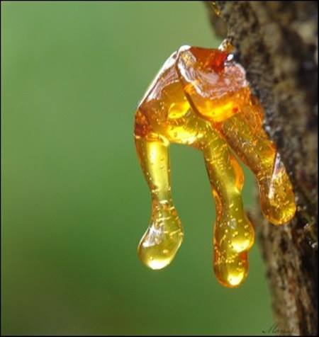
Picture 1. A resin on Pinus brutia tree

In Turkey, according to the “Communiqué on Inventory and Planning of NWFPs and Production and Sales Principles (Communiqué of NWFPs)” natural resins are classified under the umbrella of “balsamic oils” (GDF, 2016) together with oriental sweetgum oil (obtained from Liquidambar orientalis), gum (obtained mainly from Pinus spp. and Picea orientalis), astragalus gum (obtained from Astragalus gummifer), mastic gum (obtained from Pistacia lentiscus) and kenger gum (obtained from Gundelia tournefortii)

Resin Extraction
Looking at the historical process following stages can be listed:
- Until 1874, there was no legislative regulation,
- The first resin regulation was published in 1874 and was implemented until 1959,
- Since 2013, Communiqué of NWFPs has been implemented.
Resin extraction showed an uneven process. The annual extraction, which approached 7 000 tons in the 1970s, decreased since 1983, and hardly any production was made in the 2000s. Recently in line with market requirements the demand increased. In 2017, the "Resin Action Plan" was prepared to boost the extraction (GDF, 2017).
Figure 1. Turkey's annual resin extraction (ton/year)

Eligible trees
Resin is extracted mainly from Pinus brutia and Pinus pinaster. In addition to these two trees, a small amount of resin is harvested from Pinus nigra roots. While it is theoretically possible to produce resin from Pinus pinea, it is not currently used for production because pine nut harvesting generates more income.
Forests are mainly used for wood production in Turkey. However, Pinus brutia trees, in particular, may be subjected to resin extraction before final cutting for wood. The extraction of resin using the correct technique has no detrimental effect on the growth of the tree's height and diameter.
In terms of the habitat suitable for resin extraction, it is appropriate to separate at least 5 ha for each harvesting site. Resin can be collected more effectively once the trees reach a diameter of 25-30 cm. Under normal conditions, it is possible to harvest resin from a tree continuously for 12-15 years. (BELEN, 2020).The beginning time of resin extraction changes according to the location and altitude. Extraction should be done before vegetation season. (ACAR, 2000)
As of 2019, there are 5 736 371 ha of Pinus brutia in Turkey meaningone-fifth of Turkey's forests are composed of Pinus brutia which has the potential for resin production (GDF, 2020). However, the area suitable for natural resin extraction has been calculated to be around 100 000 hectares (GDF, 2017).
Pinus pinaster is not a native tree of Turkey. It has been mostly planted for industrial purposes. In recent years, the question of natural resin extraction from Pinus pinaster has come to the forefront. Resin extraction from Pinus pinaster has begun in provinces such as Sakarya and Bursa, especially since 2013. It has been calculated that around 2 000 hectares of Pinus pinaster forest can produce natural resin (GDF, 2017).
Figure 2. Potential resin extraction area of Turkey (ha)

In current practice, the average annual resin extraction is about 2 kg/per tree in Turkey. One person can harvest approximately 2 500 trees in a year.

Economic Yield
Resin extraction went into a decline after 1983 and in some years, it was not produced at all. The main reason was that imported artificial resin was cheaper.
In recent years, restrictions have been imposed on the use and trade of petroleum-derived products due to environmental concerns. The use of natural products has grown in every field. On the other hand, especially in Turkey, there is an increased demand for natural resin, which is produced from state-owned forests where no chemicals are used.
For resin extraction, forest villagers are allowed by GDF in line with the "tariff price". For the year 2020, the tariff price of 1 kg of resin was determined as 0.13 TL. In other words, the tariff to be paid to GDF for 1 ton of resin is 130 TL, which is approximately 23 USD. (GDF, 2020) Forest villagers can sell raw resin for 2.5-3 TL per kilogram to resin processing facilities. Resin processing facilities can sell a kilogram of resin to the end user for approx. 7 TL.
Prices calculated in USD are shown below.

Table 1. Prices of resin at different stage (ton/USD) (GDF, 2020)
Products | USD
Tariff set by GDF for forest villagers for harvesting | 23
Price of auction for producers other than forest villagers | 176
Prices of the raw resin sold to resin processing facilities | 528
End consumer price | 1 232

When the price of resin in different stages is evaluated, it is discovered that, as with many other NWFPs, there are major variations between the price in the forest and the price for the end user. This difference is seven times greater in the resin sample.
Figure 3. Prices of resin at different stages (ton/USD)

Resin Import
Resin is a natural raw material that plays an important role in the bio-economy due to its multiple applications (INCREDIBLE) in the paper, paint and the other industries. (ACAR, 2000). But due to the limited production in Turkey, natural resin demand is met mainly through imports.
Figure 4. Natural resin import to Turkey (ton/year)

In 2018, 11 800 tons of raw resin were imported and 19 700 000 USD was paid in return. Accordingly, the import price of 1 ton of raw resin was around 1 670 USD. The domestic resin price was calculated roughly as 1 232 USD, with a price difference of approximately 500 USD per ton. When this is coupled with the tendency to use natural products, the demand for resin grew up.
Regulations on natural resin imports are made by the Ministry of Trade."Communiqué on Imports of Only Natural Resin and Resin Acids Obtained from Natural Resins" was published in the Official Gazette (OG) No. 30118 dated July 8, 2017 (OG, 2017).

Specific Sectoral Policies

Communique on NWFPs
The most recent, comprehensive, political and technical guideline used by GDF to enhance the sustainable utilization of NWFPs is the Communiqué on NWFPs, which was put into practice in 2016. (GDF, 2016)
In addition to the Communiqué of NWFPs, the list of the NWFPs and collection prices from state-owned forests are determined at the beginning of each year together with the “Tariff Prices of Non-Wood Forest Products” (GDF, 2020). Natural resins are classified under the category of “balsamic oils”

Resin Action Plan (2017-2021)
An action plan has been prepared by GDF to minimize Turkey's reliance on resin and its derivatives, as well as to increase harvesting in a productive and sustainable way. Within the scope of the Resin Action Plan which was put into effect in 2017, Regional Directorates of Forestry have determined resin extraction areas. Within this framework, trainings were delivered to GDF staffs, forest villagers and the relevant private sector.
Figure 5. Natural resin extraction/target

Technical Guidelines
Resin extraction is regulated by the Communiqué on NWFPs and Resin Action Plan (GDF, 2016). Harvesting, transportation and stockpiling activities in the resin tapping are detailed in the Chapther 6 of Communiqué on NWFPs.

Standards
Although the resin is not specifically addressed in the Turkish Standards Institution (TSE) standards, it is standardized in various grades with resin-containing materials such as paints and varnishes. TS 8750 code in the chemistry specialization group represents varnishes-anacardium resin-based materials and products (TSE, 1991).

Resin Extraction Methods
There are some techniques and methods which have been applied by GDF to extract resin from state-owned forests. One of the decisions taken during the National Resin Congress organised in 1982 was to try modern resin extraction methods and to conduct research. Following this Congress, a comprehensive research project was carried out and resin extraction methods were evaluated (ÖNAL, 1983). However, due to a decline in resin extraction after 1983 for economic reasons, the research findings could not be put into practice.
Resin extraction from injured trees is realized either by treating wood chips with resin, evaporation or some solvent and distillation or using sulfide terebentine and tall oil (ACAR, 2000)
Picture 2. Resin extraction from trees
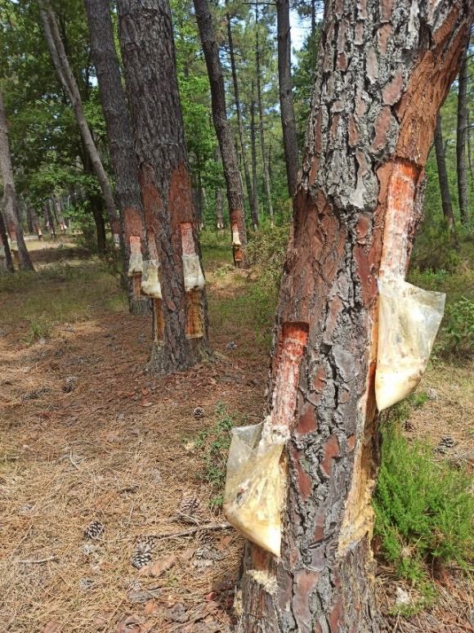 | 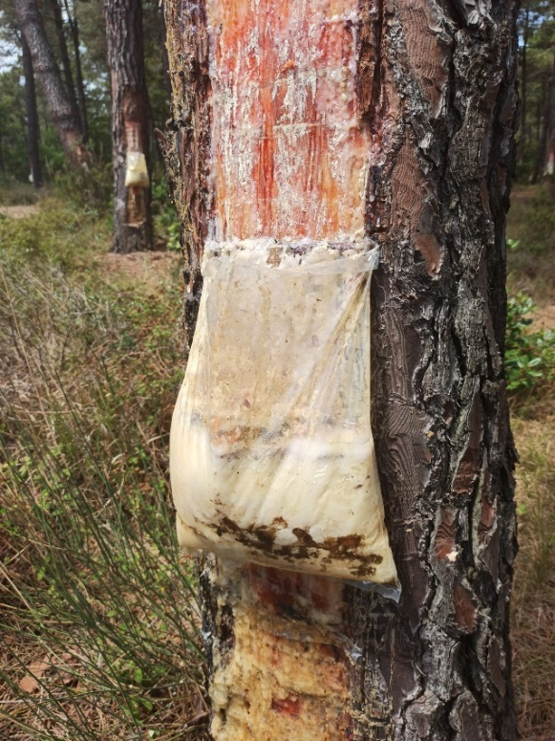

Administrative structure
The main ministry for resin is MoAF. Resin is produced in 10 different regional forestry directorates in Turkey; namely Antalya, Balıkesir, Bursa, Çanakkale, Denizli, İzmir, İstanbul, Mersin, Muğla and Sakarya.
Figure 6. The Regional Directorates of Forestry eligibile to produce natural resin
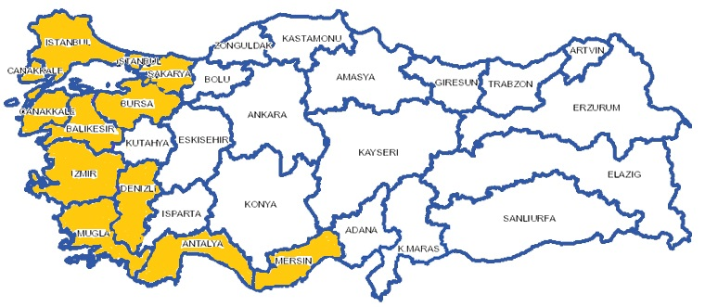
However, since forest areas suitable for resin extraction are mostly in the Mediterranean (Antalya), Aegean (Muğla, Aydın, İzmir) and Marmara (İstanbul, Adapazarı etc.) regions, some competitive sectors, especially tourism and mining, have emerged playing an important role.
A significant portion of the forests in these regions has "protected areas" status in various ways. These "protected areas" generally fall under the responsibility of the General Directorate of Nature Conservation and National Parks of MoAF. Since certain protected areas are declared as “Specially Protected Environmental Areas”, the Ministry of Environment and Urbanisation has become involved in resin extraction. GDF plays an important role in the extraction and sale processes of resin in Turkey. Tappers and buyers of resin, who are also considered stakeholders, are registered in the GDF database based on their history and regions.

Challenges and Recommadations
Resin is a disease-free substance due to its structure. On the other hand, tree species that are subject to resin extraction can host various diseases. While various diseases can occur in parts of trees such as trunk, crown and root, some insects can also cause diseases in trees. Important forest pests such as the pine processionary (Thaumetopoea pityocampa) can disrupt the function of trees in resin areas and reduce the yield.
Wounding the tree for resin extraction may also increase the tree's susceptibility to infection. But with the help of well trained tappers, wound size is determined in order for trees to self-repair.
Since resin extraction occurs in forest areas, environmental factors can be uncontrollable. As a result of being affected by severe weather conditions, resin productivity and quality can fluctuate with changing weather conditions.
Priority is given to training all staff, specifically resin tappers, for maximum resin yield, minimal destruction in the physical and mechanical features of tree and better-quality gum resin. It is stated that approximately 18.3 % of the resin harvested is lost during the resin manufacturing process from the tree to the end user. About 14% of this is due to the evaporation of the terebentin and 4.3% due to resin leakage from the pots. Besides, leaving the resin barrels uncovered and filled pots waiting can cause resin’s purity to deteriorate.
Stockpiling time affects the quality and quantity. The resin stockpiling time can result in a low terebentine rate but high acid number. Besides, unsuitable stockpiling factors with hot climate and some reactions can cause oxidation and low acid number. As a result of improper stockpiling, evaporation of the terebentine causes important losses. At the same time, weathering the resin results in oxidized resin acid which decreases resin quality. Thus, necessary actions should be taken to prevent the evaporation of the terebentine. (ACAR, 2000). It is important that the harvested resin be delivered to the buyer as early as possible and in the most cost-effective way. For this reason, the road and transportation network within the forest as well as the rural road network outside forest that will deliver the resin to industrial facilities or other buyers, should be sufficient.
The wellbeing of trees and sustainable management of forests is vital to the resin harvest. The trees should not be damaged in order to exract the rasin to at maximum level.
According to the findings of the field studies and interviews with relevant people, there are no barriers to the marketing of resins harvested in accordance with the technique. However, it is considered that there is a need to develop an effective "supply and value chain" that includes both physical and human stakeholders. Despite the fact that the state owns all forests where resin is harvested, which has advantages, , state forestry agencies and officers tend to harvest mainly wood based products, and competition with such sectors as tourism, beekeeping, grazing and mining poses difficulties for resin.

References
ACAR. 2000. The Effect of Harvesting, Transportation and Stockpiling Activities in The Resin Tapping on The Resin Productivity and Quality. October 2000. Seminar on Harvesting of Non-Wood Forest Products.
BELEN, İ. 2020. Examination in resin production forests. [Çevrimiçi] 11 Eylül 2020. Examination in resin production forests-Location: Karacaören Village / Karacasu District / Aydin / Turkey, Date: September 11, 2020. http://www.gonder.org.tr/?p=10004.
EUFORGEN. 2020. the European Forest Genetic Resources Programme. [Çevrimiçi] 2020. http://www.euforgen.org/species/.
FAO. 2020. Global Forest Resources Assessment 2020: Main report. Rome. Rome : Food and Agriculture Organisation, 2020.
—. 2020a. Global Forest Resources Assessment 2020: Main report. Rome. Rome : Food and Agriculture Organisation, 2020a.
—. 1995. Gums, resins and latexes of plant origin. [dü.] J.J.W. Coppen. 1995. ISBN 92-5-103757-4.
GDF. 2016. Communiqué on NWFPs. [Çevrimiçi] 2016. Communiqué No. 302 on Inventory and Planning of NWFPs and Production and Sales Principles (Communiqué of NWFPs). https://www.ogm.gov.tr/ekutuphane/Tebligler/302%20say%C4%B1l%C4%B1%20odun%20d%C4%B1%C5%9F%C4%B1%20orman%20%C3%BCr%C3%BCnlerinin%20envanter%20ve%20planlanmas%C4%B1%20ile%20%C3%BCretim%20ve%20sat%C4%B1%C5%9F%20esaslar%C4%B1%20Tebli%C4%9Fi.pdf.
—. 2020. Official Forestry Statistics. [Çevrimiçi] 2020. https://www.ogm.gov.tr/ekutuphane/Sayfalar/Istatistikler.aspx?RootFolder=%2Fekutuphane%2FIstatistikler%2FOrmanc%C4%B1l%C4%B1k%20%C4%B0statistikleri&FolderCTID=0x012000301D182F8CB9FC49963274E712A2DC00&View={4B3B693B-B532-4C7F-A2D0-732F715C89CC}.
—. 2020. Organisation of the GDF. 2020.
—. 2017. Resine Action Plan 2017-2021. [Online] 2017. https://www.ogm.gov.tr/ekutuphane/Yayinlar/Re%C3%A7ine_Eylem_Plan%C4%B1.pdf.
—. 2020. Tariff Prices of NWFPs Set for 2020, Communiqué No: 294/8. 2020.
GDF2020a. Organisation of the GDF.
INCREDIBLE. Innovation Networks of Cork, Resins and Edibles in the Mediterranean basin. [Çevrimiçi] [Alıntı Tarihi: 20 March 2021.] https://incredibleforest.net/inet/resins.
OG. 2017. Communiqué on Imports of Only Natural Resin and Resin Acids Obtained from Natural Resins. Turkish Official Gazette. [Çevrimiçi] 8 July 2017. https://www.resmigazete.gov.tr/eskiler/2017/07/20170708-4.htm.
—. 2016. The Law on Forest Engineers, Forest Industrial Engineers and Woodworking Industrial Engineers. 2016.
ÖNAL, s. 1983. Stimulation of Resin Flow in Calabrian and Scoth Pine with Chemicals. [prod.] TURKISH FORESTRY RESEARCH INSTITUTE. 1983.
The Turkish Constitutional Court of the Republic of Turkey. 2020. Constitution of the Republic of Turkey. Ankara : yazarı bilinmiyor, 2020.
TSE. 1991. TS 8750-Varnishes-Cashew Resin Based. 1991.

