Truffle as a Non-Wood Forest Product

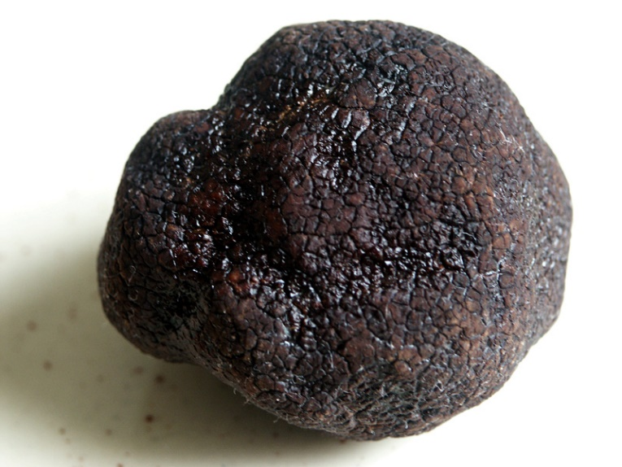

13 May 2021

Table of Contents

Foreword 3
Acronyms and Abbreviations 4
1. Introduction 5
1.1 Distribution 5
1.2. Botanical and Ecological Features 5
2. Economical Value, Usages and Trade 6
2.1. Prices in Europe 6
2.2. Areas of Usage 6
2.3. Trade 7
3. Specific Sectoral Policies 7
3.1. Truffle Forest Action Plan 7
3.2. Truffle Orchard Feasibility Study and Investor Guidelines 8
3.3. The Communiqué of Truffle Harvest and Sales Procedures and Principles-2020 9
3.4. Standards 9
3.5. Inventory Procedures 9
3.6. Wild Mushroom Picking and Harvesting Procedures 9
4. Administration 10
5. Challenges and Recommendations 10
References 12

Figures
Figure 1. Symbiotic life cycle of truffles 7

Pictures
Picture 1. Black truffle and white truffle 6

Foreword
This report titled "Truffle as a Non-Wood Forest Product" has been prepared by the Chamber of Forest Engineers of Turkey (OMO) within the scope of the Letter of Agreement (LoA) namely “Provision of Technical Guidelines on Sustainable Management of Non-Wood Forest Products (NWFPs) and the Status Reports on Specific Selected Products” signed with the Food and Agriculture Organization (FAO) on 20 December 2019.
The report has been prepared in close collaboration with the relevant stakeholders, particularly the Department of Non-Wood Products and Services (DNWPS) of the General Directorate of Forestry (GDF). The results were also discussed with stakeholders during “consultations meetings with three different regions of Turkey, update meetings with responsible national institutions and consultation workshop with respective stakeholders”.
The main findings on truffle are:
- Turkey has a very rich biological diversity which is also reflected in the presence of mushrooms.
- According to 2019 statistics compiled by GDF, truffles were a source of livelihood for nearly 200 families in Turkey, the price of truffles varied between 100-500 USD/kg depending on the type and quality,
- It is very difficult to give an exact statistic about the annual truffle harvesting amount worldwide. The producers are generally small-scale producers, sell their products to local markets without officially registering.
- As of the end of 2019, a total of 384-hectare potential area has been determined for truffle production and harvesting by GDF.
- Truffle, which was not even on the agenda of Turkey 5-6 years ago, has attracted the attention of the society, from hunters to investors, from consumers to tourism.
- The total volume of truffle production was around 40 tons in 2019 according to data provided by GDF. It is expected that truffle production will increase in the coming years.

Acronyms and Abbreviations

OMO Chamber of Forest Engineers of Turkey
Communiqué of NWFPs Communiqué on Inventory and Planning of NWFPs and Production and Sales Principles
Communiqué of Truffle Communiqué of Truffle Harvest and Sales Procedures and Principles of GDF
DNWPS Department of Non-Wood Products and Services of GDF
ENDP Eleventh National Development Plan (2019-2023) of Turkey
FAO Food and Agriculture Organization
GFRA 2020 Global Forest Resources Assessment 2020
GDF General Directorate of Forestry of Turkey
ha hectare(s)
INCREDIBLE Project Innovation Networks of Cork, Resins and Edibles in the Mediterranean Basin Project
LoA Letter of Agreement
MoAF Ministry of Agriculture and Forestry of Turkey
MT Ministry of Trade of Turkey
NWFP Non-Wood Forest Product
OWL Other Wooded Land
StarTree A pan-European project to support the sustainable exploitation of forest resources for rural development.
TAB Turkish Association of Beekeepers
TL Turkish Lira
TSE Turkish Standards Institution
TUIK Turkish Statistical Institute (TurkStat)
USD United States Dollar
USD/TL Rate According to the average dollar rate in 2019 by the Central Bank of the Republic of Turkey which was 5,68 TL.)

1. Introduction
Forest ecosystems provide important revenues for the countries in terms of NWFPs which are becoming important sector in economic manner.
As one of the important products, truffles, known as “the black diamond”, grow in forests, under the soil with roots of trees and carries spores. Truffle production has been seen in certain areas and is performed with specially-trained dogs. In recent years, a special attention has been given to the truffle species in the forestry activities in Turkey.

1.1 Distribution
Of the nearly 200 species of truffles, about 32 are mainly found in the Mediterranean region, and the black truffle (Tuber melanosporum) is the most sought-after species. T. melanosporum can be found in calcareous soil in forests of southern Europe, mainly in France, Spain and east to north-central Italy. The white truffle (Tuber magnatum) is found nearly exclusively in small areas of Italy, Croatia and Romania, which together with its unique aroma and quality, make it the most expensive of the truffles.

Other important culinary and commercial truffles include T. aestivum, T. brumale and T. borchii which are found in woodlands of Croatia, Slovenia, Serbia, Portugal, Switzerland, Germany, Hungary, Bulgaria, Greece and Turkey. Studies of hypogenous fungi in Turkey have so far revealed 79 species from 30 genera belonging to 21 families including 5 ascomycetes and 16 basidiomycetes. (TÜRKOĞLU, 2015)

Picture 1. Black truffle and white truffle
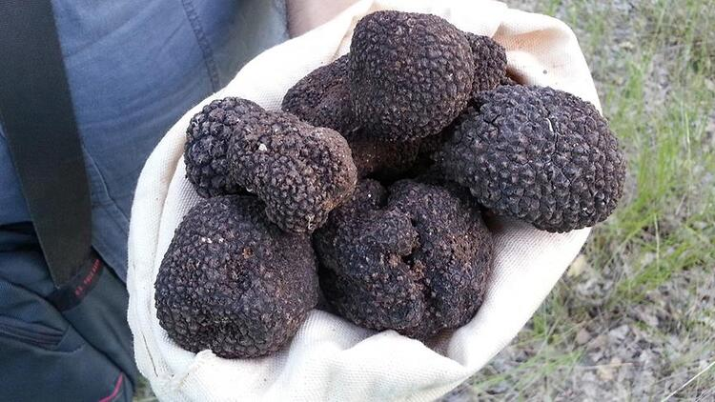 | 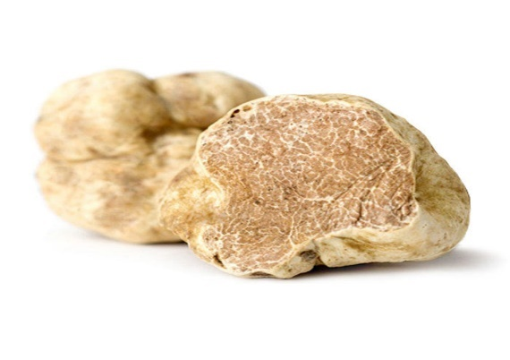

1.2. Botanical and Ecological Features
Truffles generate mycorrhizal relation with trees. All the oak species, pine species, linden, hornbeam, poplar, alder are the trees that host the generation of truffle. Mycorrhizal mushrooms work as an extension of root system of the plant, transporting more water and nutrients that a plant can take up. The mycorrhizal symbiosis between the truffle and the host tree is presented in the below in Figure 1. (Leeetall, 2020).
Truffles grow well in the calcareous soils with pH ranging from 7.5 to 9. Soil texture characteristics are sandy, clay or graveled. They have an important role in food and water transport between plant and soil. The wide presence of truffles in the forest ecosystem may provide evidence that the forests and forest life are well-maintained.

Figure 1. Symbiotic life cycle of truffles
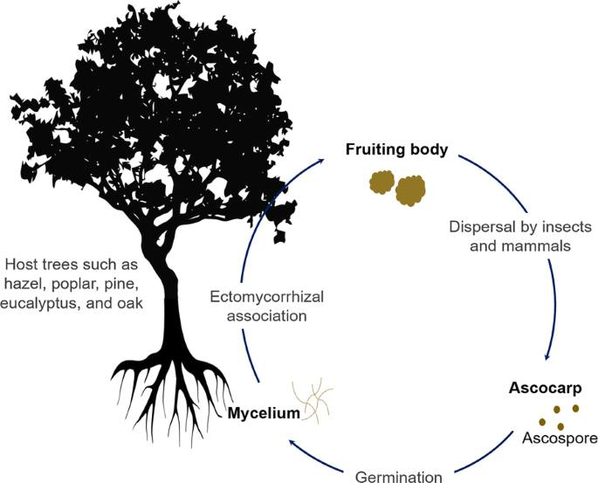

2. Economical Value, Usages and Trade
Despite the difficulties to get the information about the trade volume and value of truffles, following numbers officially shared by GDF in 2020. (GDF, Truffle Economy Growing, 2020)
- Truffles have a world trading volume of 3.5 billion USD, expected to increase to 6 billion USD during next decade.
- Turkey has a target to reach 350 million USD, grabbing a 10% market share in the short term, and an action plan made operational since 2014.
- In 2019, truffles were a source of livelihood so far for nearly 200 families in Turkey, stressing that due to its natural distribution in a limited region and short cultivation, the price of truffles varied between 100-500 USD/kg depending on the type and quality.

2.1. Prices in Europe
Truffle trade is more developed in European countries. Compared with Turkey, it is observed that the price is quite high varies between 100-3500 USD/ kg, depending on species and quality.
- Tuber magnatum is around 3500 USD/kg
- Tuber melanasporum is around 1000 USD/kg
- Tuber aestivum is around 200 USD/kg
The amount of truffle species with high economic value has decreased twenty times in the last hundred years. While the demand for truffle species worldwide is increasing day by day, the dramatic reduction in the number of truffles has accelerated the cultivation of truffles. (Truffle Application and Research Center, 2019)

2.2. Areas of Usage
The truffle is a perishable and seasonal product. The harvesting season for black truffles is from mid-November to mid-March in the northern hemisphere, but it varies with regions, and the truffle maturation is staggered over the winter season. Truffle production is variable over the 3-month season and quantities and qualities depend on weather conditions of the entire previous year.
Truffles are sold fresh, canned or frozen. Whole fresh truffles are the products with the greatest economic value. Categories are based on size, aromas and appearance. For example, truffles from 5 to 15 grams with knobby shapes may be sold at a lower price, while the larger, intact and more uniformly shaped high-quality fresh truffles will be sold to restaurants at higher prices.
Not only intact truffles are sold. Truffle pieces that have been broken during the washing process, transport or at the time of harvest can be also marketed. France allows the sale of fresh T. melanosporum and T. brumale, not only as a whole but also in pieces. Truffle peelings or trims are from truffles that have had unacceptable or rotten pieces removed due to insect damage, freezing, immaturity and/or small pieces that have broken-off in the process of cleaning. This is the least expensive of truffle products and is used as a preserved product rather than served fresh.

2.3. Trade
It is very difficult to give an exact figure about the annual truffle trade amount worldwide including Turkey, since most of the producers are small-scale producers selling their products to local markets without reporting.
The most updated information revealed by GDF at the date of 3 December 2020, expressed that as end of 2019, the annual truffle production in Turkey is about 40 tons and contribution to national economy is around 32 million USD. (GDF, Truffle Economy Growing, 2020)

3. Specific Sectoral Policies
Detection and harvesting of truffles have been on the agenda in recent years, and the "Truffle Forest Action Plan" covering the years 2014-2018 was prepared in 2014. The Communiqué on NWFPs was put into practice in 2016. Besides, additional political documents and guidelines were prepared in 2020. In this context, "Truffle Orchard Feasibility Study and Investor Guidelines" was published in August 2020. “The Communiqué of Truffle Harvest and Sales Procedures and Principles" was published on in September 2020. (CARFU, 2020)

3.1. Truffle Forest Action Plan
Based on technical studies realized in line with the protocol between the GDF and Muğla Sıtkı Koçman University (one of the state universities dealing with mushrooms and truffles) the Truffle Forest Action Plan (2014-2018) put into action. The aim of the action plan is to improve the income level of the forest villagers, support scientific studies on the determination of the truffle species required for establishment of natural truffle forests and to provide practical trainings in the field. (GDF, Truffle Action Plan, 2014)
“Truffle Forest Action Plan” targets are;
- Determining and conducting scientific studies on truffle species,
- Creating "Natural Truffle Forests" by taking natural truffle distribution areas under protection,
- Protecting the regions with very dense truffle potential as gene resources,
- Establishing "Artificial Truffle Forests and Gardens" by planting truffle grafted saplings,
- Giving truffle hunting training to volunteers,
- Organizing seminars promoting truffle mushrooms
The expected outputs of the “Truffle Forest Action Plan” are;
- Illegal collection and species smuggling will be prevented by giving seminars on truffles to forest law enforcement officers.
- By providing wild truffle picking course to volunteers, random collection of truffles will be prevented and sustainable management of truffles will be ensured.
- The truffle species that grow naturally in the country will be identified and their geographical distribution and mapping will be made.
- The creation of a truffle market, the promotion of truffle cultivation, and the increase in private afforestation, an alternative employment area will be provided for rural areas.
- Introducing the naturally growing truffles, and introducing truffles to the culinary culture.
- With the natural and artificial truffle gardens to be established, alternative employment areas will be offered to the local people by showing the feasibility of cultivation of truffles.
- By drawing attention to the development of forest trees and the benefit provided by the mycorrhizal relationship, adequate utilization of ectomycorrhizal seedlings in the forestry sector will be ensured.
- Truffle are quite common in Europe, tourists coming to Turkey in demand as a food and therefore is imported. With increased truffle production, this demand will be met from domestic sources.
- Truffle production and truffle fishing will also contribute to ecotourism.

3.2. Truffle Orchard Feasibility Study and Investor Guidelines
In 2020, “Truffle Orchard Feasibility Study and Investor Guidelines" was published by GDF. The aim of the guide is to assist the private sector to invest in truffles. In summary, this guide contains the following sections.
- Introduction of truffles
- Needs and marketing potential for truffles
- Establishing a truffle orchard and its ecological needs
- Truffle cultivation
- Truffle harvest
- Government grants
In this guide, it is stated that truffle gardens can also be established widely, considering that truffles can spread naturally in areas from sea level to 1850 meters altitude. It is stated that natural truffle forests are generally located on the south facing, and it is recommended that the gardens be established on the south side. It is not recommended to establish a garden in areas with high groundwater and slow surface flow.
During the establishment of truffle nurseries, it is important to choose healthy seeds and to plant them properly. Tree seed to be used in the production of truffles are inoculated using truffle spores. They are sterilized and germinated in vermiculite or perlite. Germinated plants are removed from the vermiculite and pruned to promote the side roots.
After each sapling is inoculated with enough suspension to contain a 2-3 gr. truffle spore, the saplings are first transplanted into a container and then taken to a fully controlled greenhouse environment. At the end of 6 months, the root of the seedlings is examined under a stereo microscope. If it is determined that the entire root is formed with the desired truffle fungus mycorrhiza, it is approved to plant the seedlings in the soil. Following truffle inoculation, mushroom production can be made at the earliest 7-10 years later. However, for a good production, seedlings should be well cared for, irrigation should be followed and weeds should be cleaned.
Currently, truffle inoculation is made to mostly oak seedlings. All oak species found in Turkey is suitable for the production of truffles. However, in practice, saplings of Quercus robur, Quercus ithaburensis, Quercus ithaburensis, Quercus infectoria are vaccinated. In addition to oaks, species such as linden, chestnut and hazelnuts are also vaccinated. In addition, coniferous species such as Pinus pinea are also vaccinated, although they are not commercially available yet. (Uluçoban, 2020)

It is stated that truffles can be grown more easily in Mediterranean climates with mild spring, non-hot summer, autumn without early frost and winters without extreme cold. In the garden establishment, a planting method is recommended so that 550 saplings are placed on one-hectare area.
An average of 50-100 kg of product can be obtained in a year from a one-hectare truffle garden created from mycorrhizal oak trees. In this guide, it is stated that 25% of the expenditures to be made for nurseries and 65% of the expenditures in case of establishing a garden can be given as grants, provided that the projects are approved by OGM. (GDF, Truffle Orchard Feasibility Study and Investor Guidelines, 2020)

3.3. The Communiqué of Truffle Harvest and Sales Procedures and Principles
The Communiqué of Truffle Harvest and Sales Procedures and Principles (Communiqué of Truffle) was published on 13 September 2020. The Communiqué on truffle consists of main text and two supplements as follows:
- Macroscopic and Microscopic Features of Commercially Used Truffle Species
- Feasibility Study format of Afforestation to be established for Truffle Production
With this circular, the determination and mapping of truffles to be collected for commercial purposes, natural and artificial truffle areas, rules for collecting truffles from these areas, issues regarding truffle dog breeding and use were determined. (GDF, Communiqué of Truffle, 2020)
Harvest times of truffles allowed to be collected are:
- Tuber magnatum between 1 September and 31 December (122 days),
- Tuber melanosporum between 15 November - 15 March (122 days),
- Tuber brumale between 1 January and 15 March (74 days),
- Tuber aestivum between 1 May and 30 November (214 days),
- Tuber uncinatum between 1 October to 31 December (92 days)
- Tuber borchii, T. maculatum between 1 December and 30 April (137 days),
- Tuber macrosporum between 1 September and 31 December (122 days),
- Tuber mesentericum from 1 September to 31 January (153 days).

3.4. Standards
Turkish Standards Institution (TSE), as a standardization body prepared a standard (TS 2410) for cultivated fresh mushrooms including truffles. (TSE, 2005) . There is no special standard for truffles.

3.5. Inventory Procedures
The detection and inventory of the naturally existing truffles is made by GDF and "Utilization Plans" are prepared. Areas with natural truffles are recorded as "natural truffle forest". In addition to natural areas, there are also "truffle orchards/gardens", in other words, "artificial truffle forests" created by planting with truffle seedlings. As of the end of 2019, GDF registered "truffle forest" in a total of 384 hectares, 322 of which are natural and 62 artificial.

3.6. Wild Mushroom Picking and Harvesting Procedures
The harvesting procedures are determined according to truffles found in forest naturally and in orchards established intentionally.
As of the end of 2019, no harvest has been made from artificial truffle gardens yet. Nevertheless, it is known that, 50-100 kg of truffle can be harvested in a productive year from one-hectare truffle garden created from mycorrhizal oak trees.
Detection and harvesting of truffles naturally found in forests are subject to the following rules determined by the "Communiqué of Truffle" and further explanation can be include based on field investigations.
- The truffle search is done with the help of one or at most two certified dogs. Truffle species secrete a strong and characteristic odor when ripe. Specially-trained dogs that are sensitive to the smell the truffle secretes are used to collect all maturing truffles in forests. Training of dogs can be started from the age of three months. At the meeting held with the President of the "Truffle Mushroom Promotion and Research Association" on 9 December 2020, the following issues were addressed.
  - Although there is no official record, as of the end of 2019, there are around 150 trained truffle dogs in Turkey
  - These dogs can be bought and sold in the market for 2 000 USD.
  - The first dog was brought from Spain in 2011. Puppies can be trained.
  - Recently, dogs come from Bulgaria especially. (Uluçoban, 2020)
- Earth excavation is done using a cane with a metal tip, the soil can be dug up to a depth of 50 cm. The holes drilled for truffle removal are immediately filled with soil removed from this hole and the ground is leveled.
- Individual pickers are allowed to harvest a maximum total of 5 kilograms per day.
- Once harvested truffles are removed from the soil, they are stored in a cotton cloth bag.
- Since truffle deteriorates quickly in the outdoor environment, it is recommended to be consumed fresh without waiting.
- Truffle inoculated saplings planted in the soil begin to yield the first harvest after 7-10 years. Because the harvest before ripening makes truffle species very low in value, it is very important that the truffle species are ripe enough for its harvest. Also, during harvesting, it is important to harvest only mature truffles without disrupting the ectomycorrhizal structure.

4. Administration
The Ministry of Agriculture and Forestry (MoAF) is the main government body for mushrooms including truffles. General Directorate of Plant Production is the main institute responsible for mushroom in general. But for truffle mainly found and cultivated in state-owned forests, the GDF is the responsible institute.
In addition to government institutions, there are few organizations both civil society sectors and universities dealing with truffles as shown below:
- Truffle Mushroom Promotion and Research Association- http://trufder.org/
- Muğla Sıtkı Koçman University Truffle Application and Research Center- http://trufmer.mu.edu.tr/en

5. Challenges and Recommendations
One of the main challenges Turkey faces is not having enough information and infrastructure. There is not enough information about the current situation, future and diseases of truffles and negative effects of any activity on truffles.
Currently the truffle harvesting is made entirely in public forests. If a private person wants to collect truffles, he/she should get permission from GDF in line with Communiqué on Truffle.
Seedlings with truffle mycorrhiza are available in the market but not common. OGM produces seedlings in state-owned nurseries.
There is no special study conducted on the diseases and pests of truffles in Turkey. However, maintaining a healthy truffle orchard is a long-term project that requires thoughtful planning and vigilance over several decades.
There are many factors that can affect health of the host tree or the developing truffle below the ground. An important initial factor is the selection of tree species. When planting tree seedlings that are either non-native or come from off-site populations of a particular species, there is a risk that these trees may suffer damage from mildew, frosts, insects and drought due to poor adaptation to climate conditions, while subjected to unfamiliar watering regimes and frequent tree pruning. Another factor is the extensive planting of monocultures over large areas of land. The ecology of hypogenous fungi involves spore dispersal by insects and mammals.
The following recommendations could be suggested to ensure the sustainable use of truffles.
- Although very good studies have been carried out in recent years, it is not known exactly which species exist in the country's forests and where they have spread. Inventory studies initiated by GDF should be completed with a GIS-based database logic in accordance with international standards.
- The presence, distribution and benefits of truffles are not fully known. The Truffle Research and Promotion Association states that 1000-2000 tons of natural truffles can be harvested annually in forests. However, the 2019 harvest was only 40 tons.
- Detection and digging of natural truffles in forests is largely done by trained hunting dogs. A common program has not yet been made for breeding, training, protecting and promoting these dogs. It would be useful to prepare a comprehensive action plan for mushroom hunting dogs.
- Depending on locality, 'Truffle Gardens' and 'Truffle Inoculate Gardens" completely free from diseases, should establish to maintain healthy and disease resilient truffle forests by GDF. The new inoculated saplings needed by the citizens in the regions should be obtained from the gardens of truffles. A strong partnership between GDF and private sector should be promoted with aim of increasing domestic and international market.
- There is a need for academic studies and academicians on truffles. In this regard, GDF should play a leading role and establish a platform to bring relevant academics together.
- There are a few NGOs active in the truffle field. This number should be increased and existing and future NGOs should be supported technically and financially. Consultation meetings should be organized at province or regional level with participation of all relevant stakeholders including NGOs to share experiences, discuss problems and provide solutions.
- Currently truffles are sold at very good prices. When the product supply increases, prices will also be affected and will likely tend to decrease. For this reason, studies should be started to increase the consumption of truffles, to increase the usage areas, to facilitate the transportation to the market and the consumer, especially to export, and to increase the long-term storage opportunities.

References

CARFU. (2020, December 10). CARFU. Retrieved 2020, from The Foundation of the People Caring for Future: http://www.gonder.org.tr/?p=10424
COŞKUN M, C. S. (2017). A New Activity in Turkey's Agricultural Forestry: Truffle Mushroom Cultivation.
FAO. (2020). Global Forest Resources Assessment 2020: Main report. Rome. Rome: Food and Agriculture Organisation. Retrieved August 2020, from https://doi.org/10.4060/ca9825en
FAO. (2020a). Global Forest Resources Assessment 2020: Main report. Rome. Rome: Food and Agriculture Organisation. Retrieved August 2020, from https://doi.org/10.4060/ca9825en
Fischer C, O. D. (2017). “BEST PRACTICES FOR CULTIVATION OF TRUFFLES”. TRUMAP Project.
GDF. (2011). Forestry Map f Turkey. Retrieved from https://www.ogm.gov.tr/lang/en/Documents/Forest%20Atlas.pdf
GDF. (2014). Truffle Action Plan. Retrieved from https://www.ogm.gov.tr/Lists/Haberler/Attachments/606/Tr%C3%BCf%20Eylem%20Plan%C4%B1.pdf
GDF. (2016). Communiqué on NWFPs. Retrieved 2020, from https://www.ogm.gov.tr/ekutuphane/Tebligler/302%20say%C4%B1l%C4%B1%20odun%20d%C4%B1%C5%9F%C4%B1%20orman%20%C3%BCr%C3%BCnlerinin%20envanter%20ve%20planlanmas%C4%B1%20ile%20%C3%BCretim%20ve%20sat%C4%B1%C5%9F%20esaslar%C4%B1%20Tebli%C4%9Fi.pdf
GDF. (2020, September 13). Communiqué of Truffle. Retrieved December 10, 2020, from http://www.gonder.org.tr/wp-content/uploads/2020/12/Truf-Mantari-Hasadi-Ile-Satis-Usul-ve-Esaslari-Tamimi-Eylul-2020.pdf
GDF. (2020, December 3). General Directorate of Forest. Retrieved December 9, 2020, from https://www.ogm.gov.tr/SitePages/OGM/OGMHaberler.aspx?l=aad1782a-50b0-49db-b602-ddf5724a0b9e&i=2119
GDF. (2020). Organisation of the GDF. Retrieved August 2020, from https://www.ogm.gov.tr/lang/en/Pages/Organization/Units.aspx
GDF. (2020). Tariff Prices of NWFPs Set for 2020, Communiqué No: 294/8.
GDF. (2020, August). Truffle Orchard Feasibility Study and Investor Guidelines. (GDF, Ed.) Retrieved December 10, 2020, from http://www.gonder.org.tr/wp-content/uploads/2020/12/TRUF-MANTARI-BAHCE-Truferi-TESISI-PROJESI-REHBERI-Agustos-2020.pdf
GDF2020a. (n.d.). Organisation of the GDF. Retrieved August 2020, from https://www.ogm.gov.tr/lang/en/Pages/Organization/Units.aspx
LastMinuteTours. (2020). LastminuteTurkey. Retrieved from Source:http://www.lastminuteturkey.com/cities/turkeyinfo.asp
Leeetall. (2020). Potentials of trufes in nutritional. Retrieved August 2020, from https://fungalbiolbiotech.biomedcentral.com/articles/10.1186/s40694-020-00097-x
MinisterofMoAF. (2019, June). (D. SABAH, Interviewer) DAILY SABAH. Retrieved 2020, from https://www.dailysabah.com/business/2019/06/07/turkey-aims-to-reach-350-million-in-truffle-exports
MoAF. (2014). Fifth National Report of UN Convention on Biological Diversity. Retrieved from https://www.cbd.int/doc/world/tr/tr-nr-05-en.pdf
OG. (2016). The Law on Forest Engineers, Forest Industrial Engineers and Woodworking Industrial Engineers. Retrieved from https://www.resmigazete.gov.tr/eskiler/2006/07/20060708-2.htm
OGM. (2013). Forest Atlas . OGM.
OGM. (2013). TRÜF EYLEM PLANI.
The Turkish Constitutional Court of the Republic of Turkey. (2020). Constitution of the Republic of Turkey. Ankara. Retrieved August 2020, from https://www.anayasa.gov.tr/en/legislation/turkish-constiution/
Truffle Application and Research Center. (2019). Retrieved December 9, 2020, from Muğla Sıtkı Koçman University: http://trufmer.mu.edu.tr/en/founding-information-3075
TSE. (2005). Cultivated mushrooms - Fresh. Retrieved from https://intweb.tse.org.tr/Standard/Standard/Standard.aspx?081118051115108051104119110104055047105102120088111043113104073101088073089086083050082051052073
TURKOGLU A, C. M. (2014). New records of some Ascomycete truffle fungi from Turkey.
TÜRKOĞLU, A. (2014). Hidden Treasure Underground: Truffles. Retrieved from http://trufmer.mu.edu.tr/Newfiles/330/Content/YER%20ALTINDAK%C4%B0%20G%C4%B0ZL%C4%B0%20HAZ%C4%B0NE%20%20%C3%B6zet.pdf
TÜRKOĞLU, A. e. (2015). Turkey’s Diverse Geography And Climates Foster A Rıch Hypogeous Mycota. (A. TÜRKOĞLU, Ed.) Retrieved from http://www.aturkoglu.com/files/TPostr%20Arizona_2015_Turkey%E2%80%99s%20Diverse%20Geography%20and%20Climates%20Foster%20a%20Rich%20Hypogeous%20Mycota.30.07.2015%20(2).pdf
Uluçoban, N. (2020, December 9). President of Truffle Research and Promotion Association. (İ. Belen, Interviewer) Retrieved December 10, 2020, from http://www.gonder.org.tr/?p=9911

