Report of the Events Including a Brief Summary and List of Participants

- Consultation Meetings in three different regions- 5-20 September 2020
- Update Meeting with responsible national institutions- 1 October 2020
- Consultation Workshop- Organized virtually- 21 October 2020
- Webinar organized by Mediterranean Model Forest Network- 19 November 2020

“Light in Weight, Heavy in Value”

13 May 2021

Background and Brief Summary 3
1. Consultation meetings in three different regions- 5-20 September 2020 4
1.1. Resin 4
1.2. Truffle 4
1.3. Pine Honey 5
1.4. Bay Leaf 5
1.5. Chestnut 6
1.6. Interviewed persons 6
2. Update Meeting with responsible national institutions- 1 October 2020 6
3. Consultation Workshop- Organized virtually- 21 October 2020 6
4. Consolidate the findings with other ongoing projects in Mediterranean Region-19 November 2020 7
5. Annexes 10
5.1. Annex-1: List of people interviewed during consultation meetings (5-20 September 2020) 10
5.2. Agenda and List of Participants for Update Meeting-1 October 2020 11
5.2.1. Agenda 11
5.2.2. List of Participants 12
5.3. Agenda and List of Participants for Consultation Workshop-21 October 2020 13
5.3.1. Agenda 13
5.3.2. List of Participants 15
5.4. Agenda of the Webinar Organized by Model Forest Secretariat-19 November 2020 19

Background and Brief Summary

A Letter of Agreement (LoA) was signed between Food and Agriculture Organization of the United Nations (FAO) and the Chamber of Forest Engineers of Turkey (OMO/CFE) for "Provision of Technical Guidelines on sustainable management of NWFPs and the Status Reports on specific selected products” on 20 December 2019.

In line with this LoA signed, OMO/CFE prepared the following deliverables:
1. D1-NWFP Assessment Report
2. D2-NWFP Policy Report
3. D3-Detailed Analyses of Selected NWFPs (Chestnut, Pine Honey, Resin, Truffle and Bay Leaf)

The LoA indicates to conduct consultation meetings, update meeting and consultation workshop on the findings with relevant stakeholders (local, national and private) to enhance their inputs and prepare “Deliverable 4: Photo report about the event including a brief summary and list of participants”

In accordance with this purpose, three events organized by CFE/OMO as follows:

a-Consultation Meetings in three different regions- 5-20 September 2020
b-Update Meeting with responsible national institutions- 1 October 2020
c-Consultation Workshop- Organized virtually 21 October 2020

The LoA also indicates to "consolidate the findings with other ongoing projects in the REU or Mediterranean Region". For this aim Mr. İsmail Belen participated as one of the panelists to "Webinar - The Model Forest of Mediterranean Network: community, product, management" organized by the Secretariat of Mediterranean Model Forest Network

Deliverable 4 prepared to summarizes these events and findings.

The importance of NWFPs was once again understood from these activities and face-to-face interviews with the relevant people. NWFPs have a very important role in many issues such as sustainable forest management, protection of biological diversity, development of rural employment and food security. However, the potential of the sector is not fully understood. There is a lack of standards in data compilation and reporting.

The forestry organization is traditionally prone to wood-based forest product production. NWFPs production has to compete with sectors such as tourism, agriculture and mining. Recently, GDF's support to the sector and institutional structuring has been met with great satisfaction.

There is a serious cooperation opportunity with Mediterranean countries on NWFPs. Committee on Mediterranean Forestry Questions-Silva Mediterranea of FAO and Mediterranean Model Forest Network could be good platforms to exchange experience.

The “7th Mediterranean Forest Week” which is expected to be organized in Turkey by FAO in 2021 could be a good platform for regional cooperation on NWFPs.

Consultation meetings in three different regions- 5-20 September 2020

Several provinces and districts of Turkey have been visited and consultation meetings have been organized as shown at the following table.

Province | District | NWFP | Regional Directorate of Forest | Sub-Regional Directorate of Forest
Kocaeli | İzmit | Resin | Adapazarı | İzmit
İstanbul | Beykoz | Resin | İstanbul | Kanlıca
Muğla | Seydikemer | Truffle | Muğla | Seydikemer
Muğla | Dalaman | Pine Honey | Muğla | Dalaman
Muğla | Köyceğiz | Bay Leaf | Muğla | Köyceğiz
Aydın | Karacasu | Resin | Muğla | Nazilli
Aydın | Nazilli | Chestnut | Muğla | Nazilli
Giresun | Dereli/Espiye/  Tirebolu/Ünye | Chestnut | Giresun | Dereli/Espiye/  Tirebolu/Ünye

Resin
Resin production and harvesting activities in Istanbul, Izmit and Aydin provinces were examined on-site and producers / harvesterss were interviewed. Findings in the field are in line with the previous reports. Long interruption of resin production by the GDF weakened the sector. There was no problem in production activities caused by COVID-19. There is a shortage of workers who are expert on harvesting.

Picture 1. Resin production sites in İzmit and İstanbul
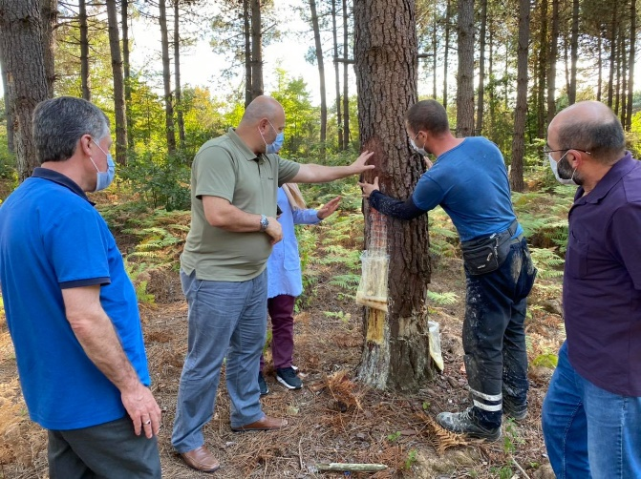 | 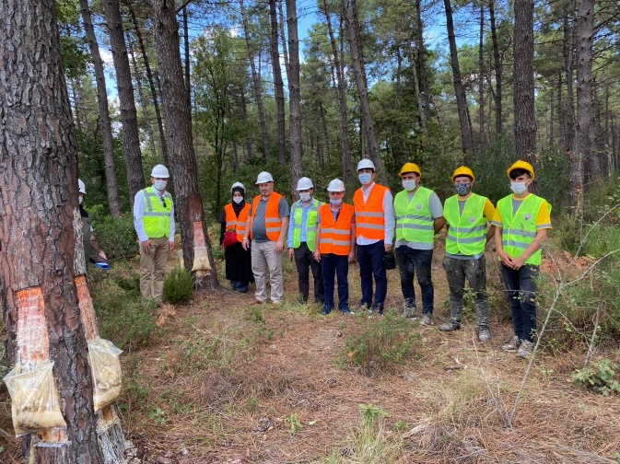

Truffle
Truffles are fairly new issue for Turkey. Currently, truffles that are found naturally in forests are offered to the markets. This situation threatens the continuity of supply. Truffle grafted saplings of various trees such as oak, hazelnut and chestnut started to be grown. However, these seedlings are very expensive. Truffle mushrooms are currently under the responsibility of the GDF. There is a need for legislation regulating the sector. http://www.gonder.org.tr/?p=9911

Picture 2 Truffle Saplings-Dog, Area
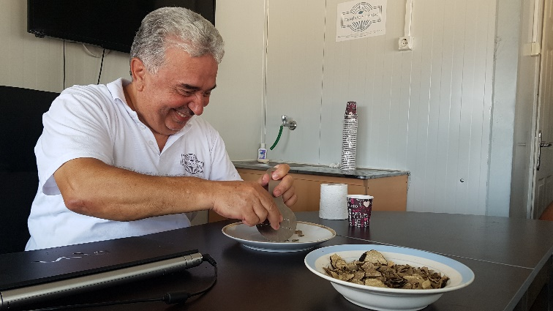 | 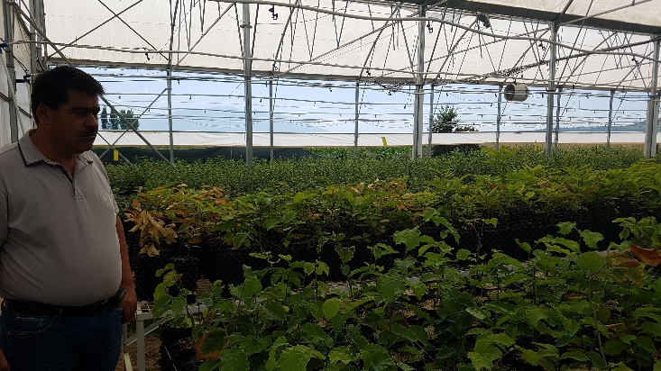

Pine Honey
Most of the world's pine honey production is made in the Turkish pine forests in Muğla. http://www.gonder.org.tr/?p=9984 Therefore, pine honey is completely a forest product. This year there has been a serious increase in the demand for pine honey. There were no difficulties in production due to COVID-19.

Picture 3. Pine honey sites
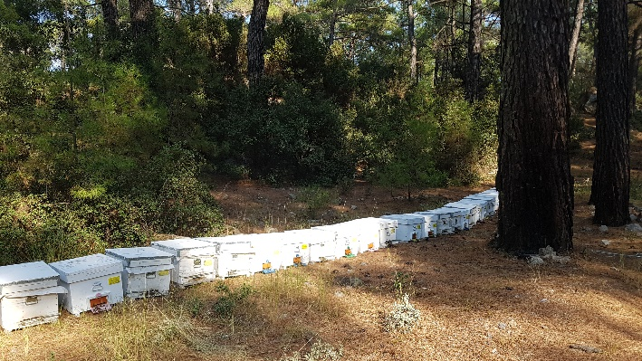 | 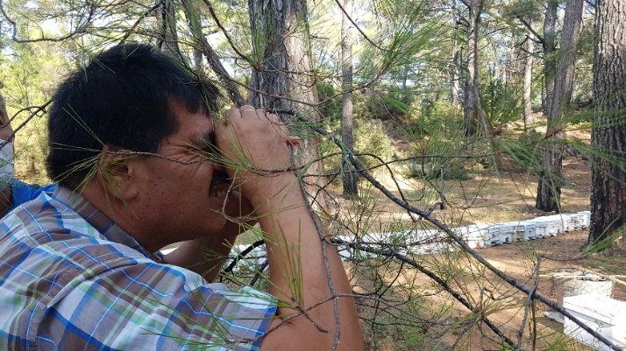

Bay Leaf
There is no problem in the sale and marketing of bay leaf. All products harvested can be exported. The biggest problem is the lack of "skilled workers". Quality of leaf directly affects prices. Thinning cuts are needed in natural bay areas. Oxidation begins when leaves / branches are broken during harvesting.

Picture 4. Bay leaf harvesting
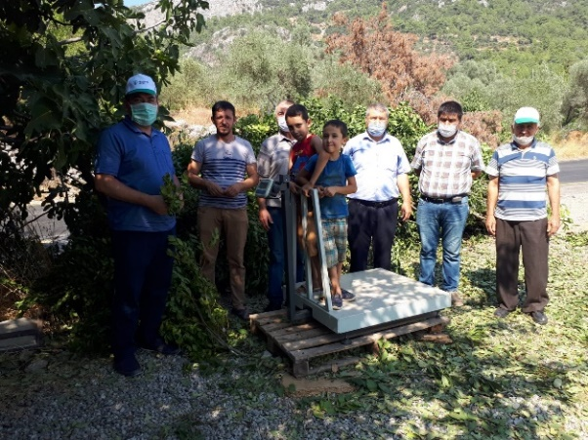 | 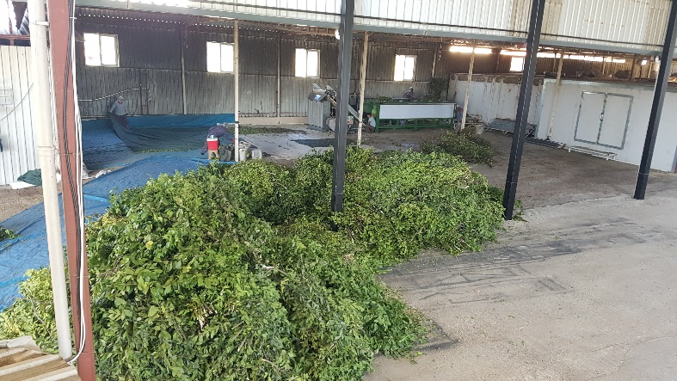

Chestnut
The biggest problem in chestnuts is disease. On the other hand, facilities are needed for the processing of chestnut fruits. Chestnut fruit is mainly produced in Aydın province. Chestnut forests in the Black Sea Region are mostly used for timber. However, beekeepers oppose cutting down chestnut trees.

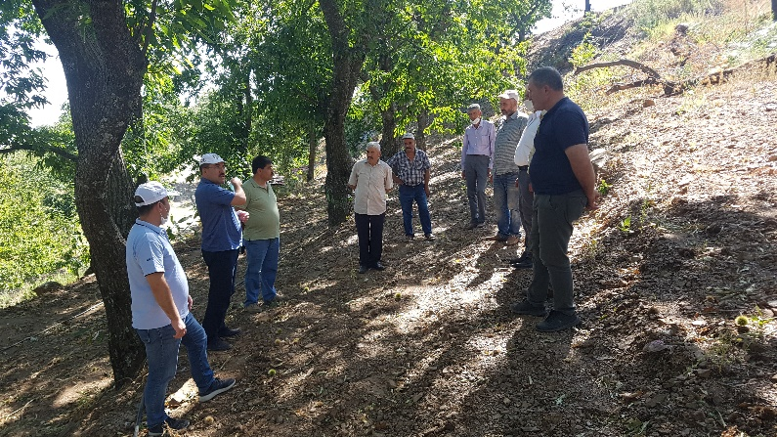 | 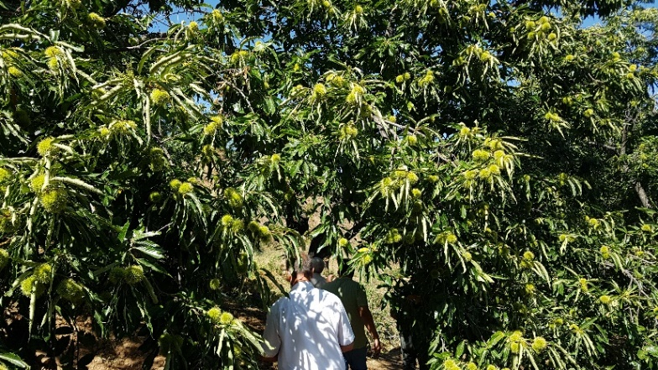

Interviewed persons
For this task, a total of 61 people were interviewed in 5 provinces in three different regions, including the Aegean, Marmara and Black Sea regions. The list of interviewees is given in the appendix.

Update Meeting with responsible national institutions- 1 October 2020

Following the interviews and examinations on the field, a one-day "update meeting" was held on October 1, 2020, with the participation of the representatives of the Ministry of Agriculture and Forestry, where the findings and field observations in the reports were shared.

A total of 19 people attended this meeting. The meeting agenda and contact information of the participants are given in the attachment.

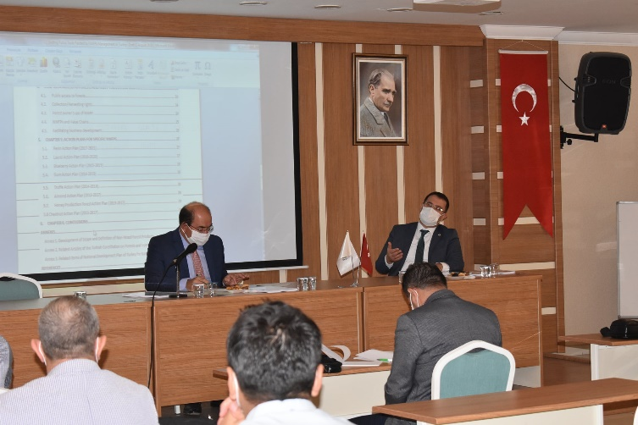 | 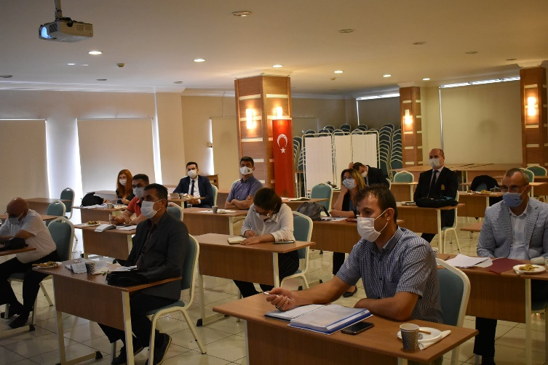

Consultation Workshop- Organized virtually- 21 October 2020

As part of the LoA the "Consultation Workshop on the Final Findings with Respective Stakeholders" organized virtually upon prior approval by FAO at the date of 21 October 2020. In total there were 106 participants from different public institutions, NGOs, private sectors, villagers, mukhtars, harvesters, academic institutions. We had 31 materials for the workshop. Some of them are presentations, some of them are videos and voice records. The Agenda and Participants listed in Annexes.
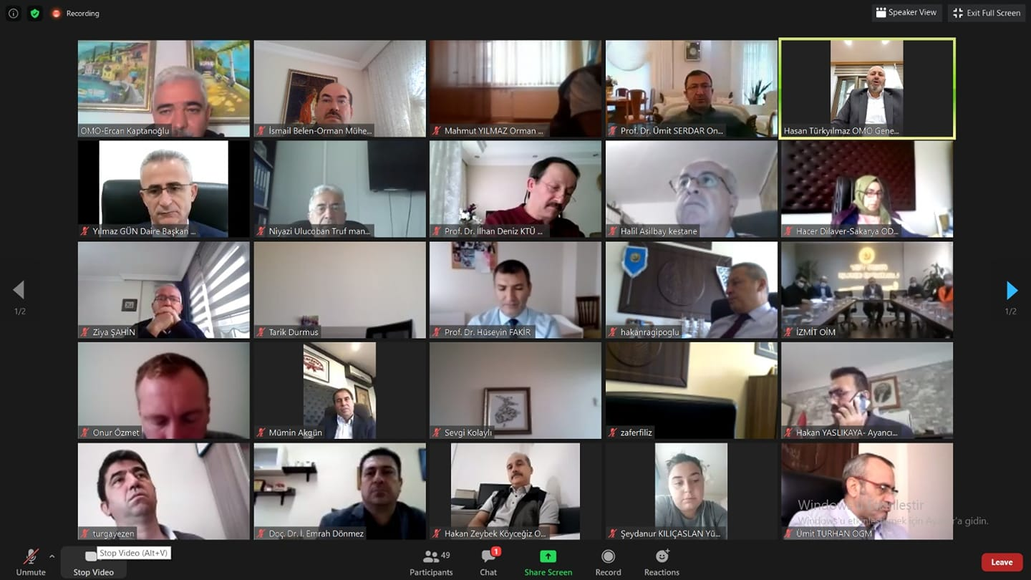

Consolidate the findings with other ongoing projects in Mediterranean Region-19 November 2020

As part of an activity envisaged by the LoA, Mr. İsmail Belen participated as one of the panelist to "Webinar - The Model Forest of Mediterranean Network: community, product, management" organised by the Secretariat of Mediterranean Model Forest Network https://www.medmodelforest.net/en/ on 19 November 2020 and shared the findings. The Agenda of webinar attached in Annexes

Annexes

Annex-1: List of people interviewed during consultation meetings (5-20 September 2020)

- Ahmet Akat, Akat Forest Product Company
- Ahmet Güneş, Director of Giresun Regional Directorate of Forest
- Ahmet Kara, Vice President of OMO
- Ali Burak Arabalı, Agricultural Engineer, Demirsoy Tarim (Agriculture) Ltd.
- Alpaslan Kadı, Director of Ünye Forest District Directorate
- Aşkın Akçin, Chief Engineer of Aybastı Forest Sub-District Directorate
- Aylin Özyurt, Truffle Mushroom Grower
- Beyza Yavuz, Beekeeper
- Cemal Esen, Huş Engineering-Resin
- Cemil Dikik, Driver, Fethiye Forest District Directorate
- Emrah Yaşa, Chief Engineer of Kefken Forest Sub-District Directorate
- Emre Genç , Still Trafic-Resin
- Ercan Dikici, Chestnut Producer
- Ercan Kıran, Director of Dereli Forest District Directorate
- Erdinç Kurt, Director of Kanlıca Forest District Directorate
- Erdoğan Atıcı, Huş Engineering-Resin
- Erhan Ayan, Chief Engineer of Bozyaka Forest Sub-District Directorate
- Ertuğrul Demiral , Forestry Officer
- Ezgi Çelik, Deputy Director of Dereli Forest District Directorate
- Gürhan Zorlu, Director of Fethiye Forest District Directorate
- Hacer Dilaver, Division Director of NWFP of Adapazarı
- Hakan Yıldırım, Chestnut Producer
- Hakan Zeybek, Director of Köyceğiz Forest District Directorate
- Hasan Türkyılmaz, President of OMO
- Hikmet Aksoy, Still Trafic- Resin
- Hulusi Kıyak, Beekeeper
- İlyas Erdönmez, Huş Engineering-Resin
- İsmail Karakozak, Resin Manufacturer
- Kemal Aksoy, Resin Manufacturer
- Mahmut Ferhatoğlu, Division Director of NWFP-İstanbul
- Mehmet Bıçakçı, Chestnut Producer
- Murat Uçum, Huş Engineering-Resin
- Mustafa İşçioğlu, Director of İzmit Forest District Directorate
- Mustafa Özyiğit, Resin Manufacturer
- Mustafa Rifat Biçer, Chief of Engineer of Nazilli Forest Sub-District Directorate
- Mutluhan Kurt, Director of Espiye Forest District Directorate
- Nazmi Arıcan, Mukhtar
- Necdet Balcı, Chair of Istanbul Brunch, OMO
- Niyazi Uluçoban, Director, Demirsoy Tarim (Agriculture) Ltd.
- Nuray Uluçoban, Director of Nursery, Demirsoy Tarim (Agriculture) Ltd.
- Olcay Boru, Chestnut Producer
- Ömer Kahraman, Director of Seydikemer Forest Directorate
- Özcan Fidan, Chestnut Producer
- Özkan Çark, Director of Bulancak Forest District Directorate
- Rıza Doğaç, Beekeeper
- Şahap Agas, Huş Engineering-Resin
- Şenol Dirik, Accountant, Fethiye Forest District Directorate
- Serkan Başoğlu, Chestnut Producer
- Sevil Şen, Chief Engineer of Fatsa Forest Sub-District Directorate
- Turgay Deligöz, Chief Engineer of Alemdağ Forest Sub-District Directorate
- Türkay Karaçay, Director of Nazilli Forest District Directorate
- Uğur Aktaş, Director of Ordu Forest District Directorate
- Utku Özyurt, Truffle Mushroom Grower
- Vedat Dilaver, Chair, OMO
- Veli Türk, Beekeeper
- Yasin Yaprak, Director of Muğla Regional Directorate of Forest
- Yüksel Şentürk, Resin Manufacturer
- Yüksel Yanmadık, Division Director Non-Wood Forest Products and Services
- Yusuf Şahin, Director of Istanbul Regional Directorate of Forest
- Ziya Polat, Director of Sakarya Regional Directorate of Forest
- Ziya Şahin, President of Turkish Beekeepers Association

Agenda and List of Participants for Update Meeting-1 October 2020

Agenda

Date: 1 October 2020 Thursday
Place: Beştepeler Mah. 31.Sk. No:3 Beştepe Yenimahalle – ANKARA/Turkey

Agenda
Session 1: General Discussion
- 10:00-10:15 Opening Speeches and Introduction
- 10:15-11:00 Discussion on D1: NWFPs Assessment Report of Turkey-2020
- 11:00-11:30 Coffee Break
- 11:30-12:30 Discussion on D2: NWFP Policy Report
- 12:30-14:00 Lunch Break
Session 2: Discussion on Detailed Analyses of Selected NWFPs
- 14:00-14:30 Chestnut
- 14:30-15:00 Bay Leaf
- 15:00-15:30 Coffee Break
- 15:30-16:00 Pine Honey
- 16:00-16:30 Truffle
- 16:30-17:00 Resin
Session 3: Conclusion
- 17:00-17:30 Conclusion and Closing the Update Meeting
Expected Participants
- General Directorate of Forestry
  - Department of Combating Forest Pest
  - Forest Management and Planning Department
  - Department of Silviculture
  - Department of Nursery and Seed
  - Department of Non-Wood Forest Products and Services
  - Department of Forest-Village Relations
  - Foreign Relations, Training and Research Department
  - Central Anatolia Forest Research Institute
  - Forest Tree Breeding and Seeds Research Institute
- General Directorate of Plant Production
  - Department of Arable Field and Horticulture
  - Department of Best Agricultural Practices and Organic Agriculture
- General Directorate of Food and Control
  - Phytosanitary and Quarantine Department
- General Directorate of Livestock
  - Department of Poultry and Small Pets

List of Participants

No | Name Surname | Department/Unit | Title
1 | Ergin ÇİLALİ | Department of Best Agricultural Practices and Organic Agriculture | Unit Coordinator
2 | Osman ASLAN | Department of Best Agricultural Practices and Organic Agriculture | Agricultural Engineer
3 | Gülten Bulut | Department of Poultry and Small Pets | Agricultural Engineer
4 | Ramazan Özşahin | Department of Poultry and Small Pets | Agricultural Engineer
5 | Uğur KARAKOÇ | Foreign Relations, Training and Research Department | Forest Engineer
6 | Ümit TURHAN | Foreign Relations, Training and Research Department | Deputy Head of the Department
7 | M. Mustafa TUNCER | Department of Nursery and Seed | Deputy Head of the Department
8 | Özgür BALCI | Department of Non-Wood Forest Products and Services | Head of Department
9 | Tarık DURMUŞ | Department of Non-Wood Forest Products and Services | Forest Engineer
10 | U. Ahmet ŞEKERCAN | Department of Non-Wood Forest Products and Services | Division Director
11 | Zafer Filiz | Department of Non-Wood Forest Products and Services | Division Director
12 | Dr. Yasemin TAYANÇ | Forest Tree Breeding and Seeds Research Institute | Biologist
13 | Turgay EZEN | Forest Tree Breeding and Seeds Research Institute | Forest Engineer
14 | Ali TUTKUN | Department of Forest-Village Relations | Division Director
15 | Adem Sinan HINIS | Department of Combating Forest Pests | Forest Engineer
16 | Ercan KAPTANCIOĞLU | Consultant | Consultant
17 | Hayriye AKÖZ | Consultant | Reporter
18 | İsmail BELEN | Consultant | Consultant
19 | Yasin GÜNEŞ | Consultant | Accountant

Agenda and List of Participants for Consultation Workshop-21 October 2020

Agenda

Date: 21 October 2020 Wednesday
Place: Virtual Workshop by Zoom Platform

Agenda
09:30-09:45 Opening Speech by Hasan Türkyılmaz-President- Chamber of Forest Engineers
Introduction and Adoption of the Agenda
09:45-10:30 Discussion on Deliverable 1: NWFPs Assessment Report of Turkey-2020 and Deliverable 2: NWFP Policy Report
    - Presentation of D1 (OMO) and D2
10:30-13:30 Discussions of Deliverable 3: Detailed Report of Selected Non-Wood Forest Products, Deliverable 4: Photo Report About the Event Including a Brief Summary and List of Participants, Update Meeting Held on 1 October 2020
- Chestnut
    - Mr. Hakan Yıldırım-Mukthar-Head of Village of Nazilli, Aydın Province
    - Mr. Nihat Günay- Mukthar-Head of Village-Erfelek- Sinop Province
    - Mr. Mahmut Yılmaz- Forest Engineer-Ünye-Ordu Province
    - Mr. Mümin Akgün- Industrialist- Candied Chestnut- Bursa Province
    - Mr. Halil Asilbay-NGO- Chestnut Future Protection Association- Germany
    - University:
      - Prof. Dr. Sevgi Kolaylı (Ms.)-Karadeniz Technical University Faculty of Science- Trabzon Province
      - Prof. Dr. Ümit Serdar- Ondokuzmayıs University- Faculty of Agriculture- Samsun Province
- Bay Leaf
    - Mr.Âdem Rondu-Industrialist-Bursa Province
    - Ahmet Akat- Harvester/Industrialist- Muğla Province
    - Mr.Sadettin Güler- Researcher- Western Mediterranean Forest Research Institute- Antalya Province
- Pine Honey
    - Mr. Veli Türk- Beekeeper-Muğla Province
    - Mr.Hulusi Kıyak- Beekeeper-Muğla Province
    - Ms. Beyza Yavuz- Beekeeper, Muğla Province
    - Mr. Mehmet Emin Benzer- Agricultural Development Cooperative, Muğla Province
    - Mr- Ziya Şahin- NGO-Turkish Association of Beekeepers, Ankara
    - Prof. Dr. Mustafa Avcı- Isparta Applied Science University, Isparta Province
    - Prof. Dr. Hüseyin Fakir- Isparta Applied Science University, Isparta Province
14:00-15:00 Discussions of Deliverable 3: Detailed Report of Selected Non-Wood Forest Products, Deliverable 4: Photo Report About the Event Including a Brief Summary and List of Participants, Update Meeting Held on 1 October 2020

- Truffle
    - Mr. Onur Özmet- Truffle Hunter, Sakarya Province
    - Ms. Aylin Özyurt- Owner of the Company
    - Mr. Niyazi Uluçoban- Truffle Promotion and Research Association
    - Prof. Dr. Hasan Hüseyin Doğan- Konya Selçuk University
- Resin
    - Mr. Erdoğan Atıcı – Harvester- Sakarya Province
    - Mr. Kemal Aksoy- Harvester-Aydın Province
    - Mr. Salih Güran- Industrialist- Balıkesir Province
    - Prof. Dr. İlhan Deniz- Karadeniz Technical University
- Discussion on D3 Reports
    - Collectors/Producers/Villagers/Private Companies
    - NGOs
    - Universities/Academicians
    - Public Institutes
16:00-16:45 Presentations and Discussions on Deliverable 5: Guidelines on sustainable management, production and marketing of NWFPs in line with international standards and market requirements:
Presentations;
- Mr. İsmail Belen- Chamber of Forest Engineers,
- Mr. Galip Çağtay Tufanoğlu-General Directorate of Forestry
- Ms. Fatma Ayhan- General Directorate of Plant Production
- Ms. Gülten Bulut-General Directorate of Livestock
16:45-17:00 Presentation on Deliverable 6: Status Update Reports on The Selected NWFPs Along with Recommendations in The Value Chain
- Mr. Yıldıray Lise- Nature Conservation Center
17:00-17:15 Presentations and Discussions on Deliverable 7: Consult the Findings with Other Ongoing Projects in REO or Mediterranean Region
    - Mr. Umit Turhan- Deputy Head of Deputy Head of Department, Foreign Relations, Training and Research Department, General Directorate of Forests
17:15-17:30 Conclusions and Closing the Consultation Workshop

List of Participants

No | Name of the NWFP | Sector | Name of the Participant | Position
1 | Bay Leaf | NGO | Yıldıray LİSE | Deputy Director General
2 | Bay Leaf | Private Sector | Adem RONDU | Owner of the Company
3 | Bay Leaf | Private Sector | Ahmet Akat | Owner of the Company
4 | Bay Leaf | Public | Hasan YILDIZ | Division Director for NWFPs
5 | Bay Leaf | Public | Saadettin GÜLER | Researcher
6 | Chestnut | Mukthar-Head of Village | Hakan Yıldırım | Mukthar-Head of Village
7 | Chestnut | Mukthar-Head of Village | Nihat Günay | Mukthar-Head of Village
8 | Chestnut | NGO | Halil Asilbay | President
9 | Chestnut | Private Sector | Mehmet Bıçakçı | Harvester/Producer
10 | Chestnut | Private Sector | Mümin Akgün | Owner of the Company
11 | Chestnut | Private Sector | Olcay Boru | Harvester/Producer
12 | Chestnut | Private Sector | Özcan Fidan | Harvester/Producer
13 | Chestnut | Private Sector | Serkan Başoğlu | Harvester/Producer
14 | Chestnut | Public | Ercan Kıran | Director of Forest District Directorate
15 | Chestnut | Public | Ersan Dikici | Harvester/Producer
16 | Chestnut | Public | Hakan Yaslıkaya | Director of Forest District Directorate
17 | Chestnut | Public | Mahmut Yılmaz | Engineer
18 | Chestnut | Public | Mustafa Rifat Biçer | Chief Engineer of Forest Sub District
19 | Chestnut | Public | Mutluhan Kurt | Director of Forest District Directorate
20 | Chestnut | Public | Özkan Çark | Director of Forest District Directorate
21 | Chestnut | Public | Uğur Aktaş | Director of Forest District Directorate
22 | Chestnut | University | Prof. Dr. Ümit Serdar | Academician
23 | Chestnut | University | Prof.Dr.Sevgi Kolaylı | Academician
24 | General | NGO | Ahmet Kara | Vice President
25 | General | NGO | Ercan KAPTANOĞLU | Adviser
26 | General | NGO | Hasan Türkyılmaz | President
27 | General | NGO | Hayriye AKÖZ | Reporter
28 | General | NGO | İsmail BELEN | Consultant
29 | General | NGO | Nihat Karakaya | Member
30 | General | NGO | Prof Dr Türker DÜNDAR | Member
31 | General | NGO | Yasin GÜNEŞ | Accountant
32 | General | Public | Adem Sinan HINIS | Engineer
33 | General | Public | Ahmet Güneş | Regional Director of Forestry
34 | General | Public | Cengiz BUDAN | Head of Department
35 | General | Public | Dr. Mehmet Zafer KALAYCI | Head of Department
36 | General | Public | Fatma Ayhan | Engineer
37 | General | Public | Galiğ Çağtay TUFANOĞLU | Deputy Head of Department
38 | General | Public | Gülten Bulut | Engineer
39 | General | Public | Hacer Dilaver | Division Director for NWFPs
40 | General | Public | M. Mustafa TUNCER | Deputy Head of Department
41 | General | Public | Mehmet Akbıyıkoğlu | Deputy Director of Forest District Directorate
42 | General | Public | Mehmet Mustafa Tuncer | Deputy Head of Department
43 | General | Public | Mehmet Rıdvan Çörtü | Deputy Head of Department
44 | General | Public | Mehmet Yaycıoğlu | Division Director for NWFPs
45 | General | Public | Mehmet Yıldız | Deputy Head of Department
46 | General | Public | Muhammet Aslanhan | Division Director for NWFPs
47 | General | Public | Ömer Kahraman | Director of Forest District Directorate
48 | General | Public | Özgür BALCI | Head of Department
49 | General | Public | Sabri Yalçın | Division Director for NWFPs
50 | General | Public | Tarık DURMUŞ | Engineer
51 | General | Public | Turgay EZEN | Researcher
52 | General | Public | Türkay Karaçay | Director of Forest District Directorate
53 | General | Public | Uğur KARAKOÇ | Engineer
54 | General | Public | Ümit TURHAN | Deputy Head of Department
55 | General | Public | Yasin Yaprak | Reional Director of Forestry
56 | General | Public | Yusuf Şahin | Regional Director of Forestry
57 | General | Public | Yüksel YANMADIK | Division Director for NWFPs
58 | General | Public | Zafer FİLİZ | Division Director for Plant Production
59 | General | Public | Ziya Polat | Regional Director of Forestry
60 | General | University | Doç. Dr. İ. Emrah DÖNMEZ | Academician
61 | General | University | Doç.Dr.Nevzat GÜRLEVİK(Dekan Yrd.) | Vice Dean
62 | General | University | Prof. Dr. Hüseyin FAKİR | Academician
63 | Pine honey-honey | Mukthar-Head of Village | Nazmi Arıcan | Mukthar-Head of Village
64 | Pine honey-honey | NGO | Akın Çiftçi | President of Provincial Brunch
65 | Pine honey-honey | NGO | Mehmet Emin Benzer | President
66 | Pine honey-honey | NGO | Ziya ŞAHİN | President
67 | Pine honey-honey | Private Sector | Beyza Yavuz | Producer
68 | Pine honey-honey | Private Sector | Hulusi Kıyak | Producer
69 | Pine honey-honey | Private Sector | Veli Türk | Harvester/Producer
70 | Pine honey-honey | Private Sector | Yusuf Keskin | Producer
71 | Pine honey-honey | Public | Esra Topal | Chief Engineer of Forest Sub District
72 | Pine honey-honey | Public | Ramazan Özşahin | Engineer
73 | Pine honey-honey | Public | U. Ahmet ŞEKERCAN | Division Director for NWFPs
74 | Pine honey-honey | University | Prof. Dr. Mustafa AVCI | Academician
75 | Resine/Rosin | NGO | Necdet Balcı | Head of Provincial Branch
76 | Resine/Rosin | NGO | Vedat Dilaver | Head of Provincial Branch
77 | Resine/Rosin | Private Sector | Cemal Esen | Harvester/Producer
78 | Resine/Rosin | Private Sector | Erdoğan Atıcı | Harvester/Producer
79 | Resine/Rosin | Private Sector | İlyas Erdönmez | Harvester/Producer
80 | Resine/Rosin | Private Sector | İsmail İşeri | Harvester/Producer
81 | Resine/Rosin | Private Sector | İsmail Karakozak | Harvester/Producer
82 | Resine/Rosin | Private Sector | Kemal Aksoy | Harvester/Producer
83 | Resine/Rosin | Private Sector | Murat Uçum | Harvester/Producer
84 | Resine/Rosin | Private Sector | Mustafa Özyiğit | Harvester/Producer
85 | Resine/Rosin | Private Sector | Salih GÜRAN | Owner of the Company
86 | Resine/Rosin | Private Sector | Yılmaz Kaya | Harvester/Producer
87 | Resine/Rosin | Private Sector | Yüksel Şentürk | Harvester/Producer
88 | Resine/Rosin | Public | Emrah Yaşa | Chief Engineer of Forest Sub District
89 | Resine/Rosin | Public | Erdinç Kurt | Director of Forest District Directorate
90 | Resine/Rosin | Public | Erhan Ayan | Chief Engineer of Forest Sub District
91 | Resine/Rosin | Public | Hakan Zeybek | Director of Forest District Directorate
92 | Resine/Rosin | Public | Mahmut Ferhatoğlu | Division Director for NWFPs
93 | Resine/Rosin | Public | Mustafa İşçioğlu | Director of Forest District Directorate
94 | Resine/Rosin | Public | Turgay Deligöz | Chief Engineer of Forest Sub District
95 | Resine/Rosin | University | Bilge Yılmaz | Academician
96 | Resine/Rosin | University | Dr.Derya Mumcu Küçüker | Academician
97 | Resine/Rosin | University | Elif Sarıtaş | Academician
98 | Resine/Rosin | University | Prof.Dr. İlhan DENİZ | Academician
99 | Truffle | NGO | Niyazi Uluçoban | President
100 | Truffle | Private Sector | Ali Burak Arabalı | Engineer
101 | Truffle | Private Sector | Aylin Özyurt | Owner of the Company
102 | Truffle | Private Sector | Murat Çakıroğlu | Owner of the Company
103 | Truffle | Private Sector | Nuray Uluçoban | Responsible for Nursery
104 | Truffle | Private Sector | Onur Özmet | Truffle Hunter
105 | Truffle | Private Sector | Utku Özyurt | Owner of the Company
106 | Truffle | University | Prof. Dr. H. Hüseyin Doğan | Academician

Agenda of the Webinar Organized by Model Forest Secretariat-19 November 2020

