Glossary of technical terms in integrated landscape management

Adaptation (Climate Change): 2
Agro-ecology: 2
Agricultural biodiversity (agrobiodiversity): 3
Bonn Challenge: 3
Climate- smart agriculture (CSA): 4
Ecosystem services: 4
Ecosystem resilience: 4
Ecosystem Restoration: 4
Engineering with Nature: 5
Forest Landscape restoration: 5
Green infrastructure (GI): 5
Grey infrastructure: 6
Integrated landscape management: 6
Integrated watershed management: 6
Land degradation: 6
Landscape: 7
Landscape approach: 7
Natural Water Retention Measures: 7
Nature-based solutions (NBS): 7
Resilient infrastructure: 8
Sustainable Development Goals (SDGs): 8
Sustainable land management (SLM): 8
UN Decade on Ecosystem Restoration: 9
Vulnerability: 9

Adaptation (Climate Change):
Adaptation is on of the two central approaches in the international climate change process. The term refers to adjustment in natural or human systems in response to actual or expected climatic stimuli or their effects, which moderates harm or exploits beneficial opportunities.
- Climate change impacts refer to the effects of climate change on natural and human systems.
- Resilience in the context of climate change refers to the ability of a social or ecological system to absorb disturbances while retaining the same basic structure and ways of functioning, the capacity for self-organisation, and the capacity to adapt to stress and change.
- Vulnerability in the context of climate change is the degree to which a system is susceptible to, and unable to cope with, adverse effects of climate change, including climate variability and extremes.
Source: https://unfccc.int/files/press/backgrounders/application/pdf/press_factsh_adaptation.pdf

Agro-ecology:
Agroecology is the science of applying ecological concepts and principles to manage interactions between plants, animals, humans and the environment for food security and nutrition. All over the world farmers already apply this approach, which has a fundamental pillar in traditional and local knowledge. FAO recognizes the importance of farmers managing human and natural capital to improve food security, nutrition, and rural development. They are seen as constant innovators and researchers who contribute to develop sustainable agriculture and more resilient rural livelihoods.
Agroecology has been defined in many ways, in many places, and by many different stakeholders. Since the 1920s, scientist and researchers have used the term agroecology to refer to the application of ecological principles to agriculture. However, it was not until the early-1980s that the discipline of "agroecology" was named by ecologists, agronomists and ethnobotanists. Because of this wide spectrum of different applications and understandings of the term agroecology, FAO has organized a database of definitions. FAO is collecting various definitions of agroecology from published documents, authored by scientists, civil society, academia, governments, legal documents and policies, among other sources. This database shows how diverse agroecology can be. Yet it also demonstrates that different definitions use and share common elements, adjusted to the local circumstances. These common elements are captured by FAO in its framework on agroecology.
Source: http://www.fao.org/agroecology/knowledge/practices/en/

Agricultural biodiversity (agrobiodiversity):
Agrobiodiversity is the result of natural selection processes and the careful selection and inventive developments of farmers, herders and fishers over millennia. Agrobiodiversity is a vital sub-set of biodiversity. Many people’s food and livelihood security depend on the sustained management of various biological resources that are important for food and agriculture. Agricultural biodiversity, also known as agrobiodiversity or the genetic resources for food and agriculture, includes:
- Harvested crop varieties, livestock breeds, fish species and non domesticated (wild) resources within field, forest, rangeland including tree products, wild animals hunted for food and in aquatic ecosystems (e.g. wild fish);
- Non-harvested species in production ecosystems that support food provision, including soil micro-biota, pollinators and other insects such as bees, butterflies, earthworms, greenflies; and
- Non-harvested species in the wider environment that support food production ecosystems (agricultural, pastoral, forest and aquatic ecosystems).
Source: http://www.fao.org/3/y5609e/y5609e01.htm

Bonn Challenge:
The Bonn Challenge is a global effort to bring 150 million hectares of degraded and deforested land into restoration by 2020 and 350 million by 2030. The 2020 target was launched at a high level event in Bonn in 2011 organised by the Government of Germany and IUCN, and was later endorsed and extended to 2030 by the New York Declaration on Forests of the 2014 UN Climate Summit. To date, 74 governments, private associations and companies have pledged over 210 million hectares to the Challenge. The Bonn Challenge is an implementation vehicle for national priorities such as water and food security and rural development while simultaneously helping countries contribute to the achievement of international climate change, biodiversity and land degradation commitments.
Source: https://www.bonnchallenge.org

Climate- smart agriculture (CSA):
Climate-smart agriculture (CSA) is an approach that helps to guide actions needed to transform and reorient agricultural systems to effectively support development and ensure food security in a changing climate. CSA aims to tackle three main objectives:
- sustainably increasing agricultural productivity and incomes;
- adapting and building resilience to climate change;
- reducing and/or removing greenhouse gas emissions, where possible.
CSA seeks to support countries in putting in place the necessary, policy, technical and financial means to main-stream climate change considerations into agricultural sectors and provide a basis for operationalizing sustainable agriculture development under changing conditions. Innovative financing mechanisms that link and blend climate and agricultural finance from public and private sectors are a key means for implementation, as are the integration and coordination of relevant policy instruments and institutional arrangements. The scaling up of climate-smart practices requires appropriate institutional and governance mechanisms to disseminate information, ensure broad participation and harmonize policies. It may not be possible to achieve all the CSA objectives at once. Context-specific priorities need to be determined, and benefits and tradeoffs evaluated.
Source: http://www.fao.org/3/i3325e/i3325e.pdf

Ecosystem services:
Ecosystem services are the benefits people obtain from ecosystems. These include provisioning services such as food and water; regulating services such as flood and disease control; cultural services such as spiritual, recreational, and cultural benefits; and supporting services, such as nutrient cycling, that maintain the conditions of life on Earth.
Source: https://www.millenniumassessment.org/en/Synthesis.html

Ecosystem resilience:
refers to the ability of a social or ecological system to absorb disturbances while retaining the same basic structure and ways of functioning, the capacity for self-organization and the capacity to adapt to stress and change. In the context of ecosystems, resilience refers to the level of disturbance that an ecosystem can undergo without crossing a threshold into a different structure or with different outputs. Resilience depends on ecological dynamics as well as human organizational and institutional capacity to understand, manage and respond to these dynamics.
Source: https://www.unep.org/resources/report/vulnerability-and-climate-change-impact-assessments-adaptation-module

Ecosystem Restoration:
is defined as a process of reversing the degradation of ecosystems, such as landscapes, lakes and oceans to regain their ecological functionality; in other words, to improve the productivity and capacity of ecosystems to meet the needs of society. This can be done by allowing the natural regeneration of overexploited ecosystems or by planting trees and other plants.
Source: https://www.unenvironment.org/news-and-stories/press-release/new-un-decade-ecosystem-restoration- offers-unparalleled-opportunity.

Engineering with Nature:
Engineering With Nature (EWN) is the intentional alignment of natural and engineering processes to efficiently and sustainably deliver economic, environmental, and social benefits through collaborative processes. With recent advances in the fields of engineering and ecology, there is an opportunity to combine these fields of practice into a single collaborative and cost-effective approach for infrastructure development and environmental management.
Source: https://ewn.el.erdc.dren.mil/about.html

Forest Landscape restoration:
Forest landscape restoration (FLR) is the ongoing process of regaining ecological functionality and enhancing human well-being across deforested or degraded forest landscapes. FLR is more than just planting trees – it is restoring a whole landscape to meet present and future needs and to offer multiple benefits and land uses over time. FLR manifests through different processes such as: new tree plantings, managed natural regeneration, agroforestry, or improved land management to accommodate a mosaic of land uses, including agriculture, protected wildlife reserves, managed plantations, riverside plantings and more.
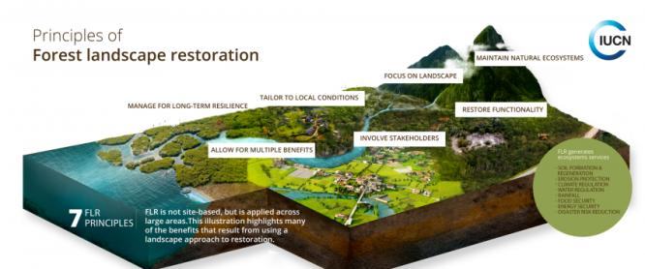

Source: https://www.iucn.org/theme/forests/our-work/forest-landscape-restoration

Green infrastructure (GI):
The 2013 European Commission Communication on Green Infrastructure defines GI as a strategically planned network of natural and semi‑natural areas with other environmental features designed and managed so as to deliver a wide range of ecosystem services. It incorporates green spaces (or blue if aquatic ecosystems are involved) and other physical features in terrestrial (including coastal) and marine areas. On land, GI is present in rural and urban settings.
One of the key attractions of GI is its multifunctionality, i.e. its ability to perform several functions and provide several benefits on the same spatial area. These functions can be environmental, such as conserving biodiversity or adapting to climate change, social, such as providing water drainage or green space, and economic, such as supplying jobs and raising property prices.
Source: https://eur-lex.europa.eu/legal-content/EN/ALL/?uri=CELEX:52013DC0249

Grey infrastructure:
Grey infrastructure usually refers to the traditional methods of managing water and other type of infrastructure, using human-made, constructed assets, most often water tight and designed to avoid any type of ecosystem to grow on it. Modern grey infrastructure such as permeable pavements and some roof water retention systems mimic the natural water retention capacity of the landscape and help to restore more natural patterns of run-off and infiltration. It includes channels, pipes, sewers, and sewage treatment works, ditches, dikes, dams, etc. Grey infrastructure is so-called because it is often constructed of concrete. Unlike green infrastructure, grey infrastructure typically does not deliver multiple benefits. Grey infrastructure such as sewers and sewage treatment works are needed in urban areas but their effectiveness can be enhanced by green engineering measures which help to restore the natural water retention capacity of the landscape.
Source: http://nwrm.eu/node/3837

Integrated landscape management:
Integrated landscape management is the management of production systems and natural resources in an area large enough to produce vital ecosystem services and small enough to be managed by the people using the land and producing those services. Integrated landscape management involves long-term collaboration among different groups of land managers and stakeholders to achieve their multiple objectives and expectations within the landscape for local livelihoods, health and well-being.
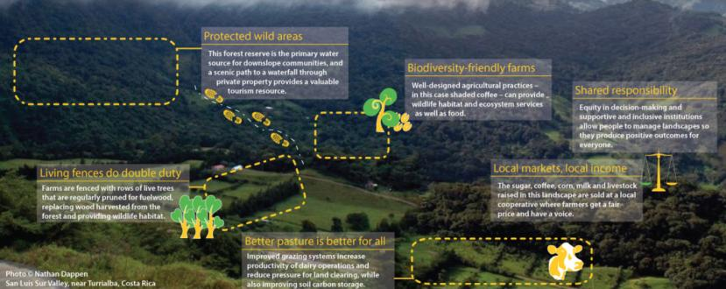
Source: http://www.fao.org/land-water/overview/integrated-landscape-management/en/

Integrated watershed management:
Integrated watershed management (IWM) is the process of managing human activities and natural resources in an area defined by watershed boundaries, taking into account social, economic and environmental issues, as well as local community​ interests and issues such as the impacts of growth and climate change.
Source: http://www.fao.org/3/i8087e/i8087e.pdf

Land degradation:
is defined as the deterioration or loss of the productive capacity of the soils for present and future. Land degradation is a global challenge that affects everyone through food insecurity, higher food prices, climate change, environmental hazards, and the loss of biodiversity and ecosystem services. When land is degraded, soil carbon and nitrous oxide is released into the atmosphere, making land degradation on of the major contributors to climate change. It is happening at an alarming pace, contributing to a dramatic decline in the productivity of croplands and rangelands worldwide.
Source: https://www.thegef.org/topics/land-degradation

Landscape:
A landscape is a social-ecological system that consists of a mosaic of natural and/or human-modified ecosystems, often with a characteristic configuration of topography, vegetation, land use, and settlements that is influenced by the ecological, historical, economic and cultural processes and activities of the area.
- The mix of land cover and use types (landscape composition), their spatial arrangement (landscape structure) and the norms and modalities of its governance contribute to the character and functionality of a landscape, which as a mosaic usually includes agricultural lands, native vegetation, and urban areas.
- Depending on the management objectives of the stakeholders, landscape boundaries may be discrete, fuzzy or nested, and may correspond to watershed boundaries, distinct land features, and/or jurisdictional and administrative boundaries, or cross-cut such demarcations. Because of the broad range of factors a landscape may encompass areas of 100s to 10,000s square kilometers.
Source: http://peoplefoodandnature.org/about-integrated-landscape-management/

Landscape approach:
A Landscape Approach is broadly defined as a framework to integrate policy and practice for multiple land uses, within a given area, to ensure equitable and sustainable use of land while strengthening measures to mitigate and adapt to climate change.
Source: https://conbio.onlinelibrary.wiley.com/doi/full/10.1111/conl.12066

Natural Water Retention Measures:
Natural water retention measures are measures that aim to safeguard and enhance the water storage potential of landscape, soil, and aquifers, by restoring ecosystems, natural features and characteristics of water courses and using natural processes. They support Green Infrastructure by contributing to integrated goals dealing with nature and biodiversity conservation and restoration, landscaping, etc. They are adaptation measures that use nature to regulate the flow and transport of water so as to smooth peaks and moderate extreme events (floods, droughts, desertification, salination). They are a better environmental option for flood risk management. They reduce vulnerability of water resources to climate change and other anthropogenic pressures. They can also improve water quality. They are relevant both in rural and urban areas.
Source: https://ec.europa.eu/environment/water/adaptation/ecosystemstorage.htm

Nature-based solutions (NBS):
Actions to protect, sustainably manage, and restore natural or modified ecosystems, that address societal challenges effectively and adaptively, simultaneously providing human well-being and biodiversity benefits. They can cost-effectively improve the performance of water supply systems, reduce disaster risk, promote climate resilience, and provide multiple benefits to communities.
Source: https://www.iucn.org/theme/nature-based-solutions

Resilient infrastructure:
Resilient infrastructure is about people, households and communities for whom infrastructure is a lifeline to better health, better education, and better livelihood. It affects people’s well-being, their economic prospects, and their quality of life. Resilient infrastructure is, in part, about bridges that can withstand more frequent or stronger floods, water pipes that can resist earthquakes, or electric poles that are sturdier in the face of more intense hurricanes. And it is also about making sure people will not lose their jobs because they cannot get to work, that they can get urgent medical care, and that their children can get to school. The resilience of infrastructure has three levels:
- Resilience of infrastructure assets
- Resilience of infrastructure services
- Resilience of infrastructure users
The resilience of infrastructure is one of the many determinants of high-quality infrastructure.
Source: https://openknowledge.worldbank.org/handle/10986/31805

Sustainable Development Goals (SDGs):
The Sustainable Development Goals (SDGs), also known as the Global Goals, were adopted by the United Nations in 2015 as a universal call to action to end poverty, protect the planet, and ensure that by 2030 all people enjoy peace and prosperity. The 17 SDGs are integrated - they recognize that action in one area will affect outcomes in others, and that development must balance social, economic and environmental sustainability. Countries have committed to prioritize progress for those who're furthest behind. The SDGs are designed to end poverty, hunger, AIDS, and discrimination against women and girls. The creativity, knowhow, technology and financial resources from all of society is necessary to achieve the SDGs in every context.
Source: https://www.undp.org/sustainable-development-goals

Sustainable land management (SLM):
The FAO defines sustainable land management (SLM) as “the use of land resources, including soils, water, animals and plants, for the production of goods to meet changing human needs, while simultaneously ensuring the long-term productive potential of these resources and the maintenance of their environmental functions”. TerrAfrica (2005) defines SLM as “the adoption of land-use systems that through appropriate management practices enable land users to maximize the economic and social benefits from the land while maintaining or enhancing the ecological support functions of the land resources”.
The productivity and sustainability of a land-use system is determined by the interaction between land resources, climate and human activities. Especially in the face of climate change and variability, selecting the right land uses for given biophysical and socio-economic conditions, and implementing SLM, are essential for minimizing land degradation, rehabilitating degraded land, ensuring the sustainable use of land resources (i.e. soils, water and biodiversity) and maximizing resilience.
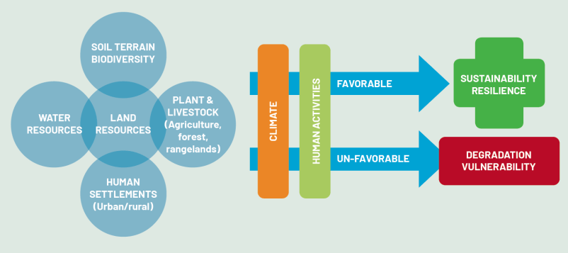
Source: http://www.fao.org/3/i3325e/i3325e.pdf

UN Decade on Ecosystem Restoration:
The UN Decade on Ecosystem Restoration is a rallying call for the protection and revival of ecosystems all around the world, for the benefit of people and nature. It aims to halt the degradation of ecosystems, and restore them to achieve global goals. Only with healthy ecosystems can we enhance people’s livelihoods, counteract climate change, and stop the collapse of biodiversity. The UN Decade runs from 2021 through 2030, which is also the deadline for the Sustainable Development Goals and the timeline scientists have identified as the last chance to prevent catastrophic climate change. Through communications, events and a dedicated web platform, the UN Decade will provide a hub for everyone interested in restoration to find projects, partners, funding and the knowledge they need to make their restoration efforts a success.
Source: https://www.decadeonrestoration.org/about-un-decade

Vulnerability:
In the context of climate change, vulnerability is the degree to which a system is susceptible to, or unable to cope with, adverse effects of climate change, including climate variability and extremes. Vulnerability is a function of the character, magnitude and rate of climate variation to which a system is exposed, its sensitivity and its adaptive capacity. Therefore adaptation would also include any efforts to address these components
Source: https://unfccc.int/resource/cd_roms/na1/v_and_a/index.htm

Prepared by: Amin Emadi, Watershed management specialist Land and Water division FAO, July 2021

