Compendium of Methodologies & Tools for Integrated Landscape Management

Forest Landscape Restoration (FLR) 2
The concept 2
Tools for preparation and assessment: 2
Land Degradation Assessment in Drylands (LADA) 8
The concept 8
Tools for preparation and assessment 9
Nature-Based Solutions (NBS) 13
The concept: 13
Tools for preparation and assessment 13
Natural Water Retention Measures 13
Engineering With Nature (EWN) 13
Participatory-approach tools for Integrated Landscape Management: 19
The concept 19
Tools and methodologies 19

Forest Landscape Restoration (FLR)

The concept
FLR was defined in 2000 by a group of specialists as “a planned process that aims to regain ecological integrity and enhance human wellbeing in deforested or degraded landscapes”. It does not seek to recreate past ecosystems given the uncertainty concerning the “past”, the significantly altered conditions of the present as well as anticipated but uncertain future changes. However, it does seek to restore a forested ecosystem that is self-sustaining and that provides benefits both to people and to biodiversity. For this reason, the landscape scale is particularly important as it provides the opportunity to balance ecological, social, and economic priorities. The emphasis on the landscape also indicates that trees cover is not needed throughout the landscape, but rather the focus of FLR is on restoring functional forest ecosystems within landscapes so that forests can co-exist and subsist in a landscape mosaic together with other land uses.

Tools for preparation and assessment:

Detailed FLR guidelines and tools that emphasize planning and prioritization of restoration activities for given landscapes include:
- Restoration Diagnostic
- Restoration Opportunity Assessment Methodology (ROAM)
- Forest Landscape Assessment Tool (FLAT)
- Mapping, monitoring and planning at landscape scale

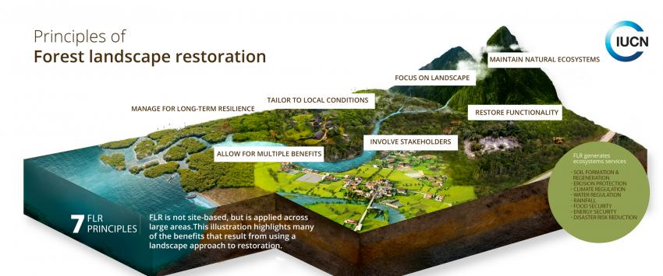

Source: https://www.iucn.org/theme/forests/our-work/forest-landscape-restoration

Restoration Diagnostic
Link to TULIP project: This tool is a structured method for determining the status of enabling conditions within a landscape being considered for restoration and for designing the requisite policies, practices, and measures needed for successful restoration.
Methodology and approach: The Restoration Diagnostic is a tool (or method) developed by the World Resource Institute for developing national or regional strategies for successful FLR based on a three-step process (Fig 1):
1. Users define the scope, jurisdiction or geographic region for analysis. This can be an entire country, a department or state, or a watershed or basin.
2. Users conduct an assessment to identify the success factors that are present and those that are missing within the target area.
3. Users identify particular policies, incentives or practices to address the missing factors.
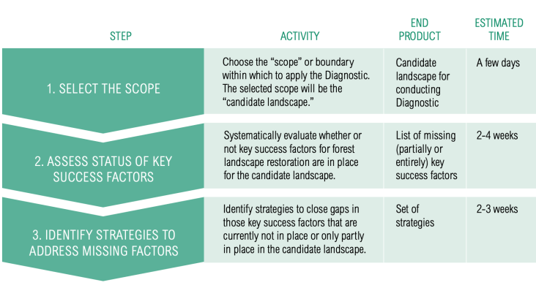
Figure 1. Steps when conducting the restoration diagnostic

The diagnostic is a structured method for identifying which key success factors for forest landscape restoration are already in place, which are partially in place, and which are missing within a country or landscape that has restoration opportunities. When applied prior to a restoration effort, the Diagnostic can help decision makers and restoration supporters focus their efforts on the most important factors to get in place, before large amounts of human, financial, or political capital are invested. When applied periodically every few years once a restoration effort is underway, the Diagnostic can help implementers adjust and refine their policies and practices, as a means of adaptive management.
The diagnostic is a stand-alone tool as well as a component within the Restoration Opportunities Assessment Methodology (ROAM). This tool can be used by many different groups or individuals, including managers of non-governmental
organizations, government agencies, communities or landowners. Development agencies can use the diagnostic to develop ways to enable FLR under financing schemes. Companies can use the diagnostic as a planning tool for their own voluntary or mandated restoration projects. The diagnostic tool can be adapted for use at different jurisdictional scales.
The Restoration Diagnostic tool was utilized by WRI and IUCN in Rwanda, Brazil and Ecuador in 2013, and it highlighted the need to develop strategies to communicate the benefits of restoration through public awareness campaigns, increase native species in plantings, and convene joint sector working groups to coordinate government agencies to prioritize and promote restoration activities.

Source: Hanson, Craig & Buckingham, Kathleen & DeWitt, Sean & Laestadius, Lars. (2015). The Restoration Diagnostic: A Method for Developing Forest Landscape Restoration Strategies by Rapidly Assessing the Status of Key Success Factors. 10.13140/RG.2.1.4914.1846.

Restoration Opportunities Assessment Methodology (ROAM)
Link to TULIP project: ROAM is a tool for assessing Forest Landscape Restoration (FLR) opportunities and approaches at national or sub-national levels. The ROAM process is a multi-stakeholder assessment process that provides an opportunity for collaboration across different agencies, sectors and institutions that may not have worked together previously.
Methodology and approach: The Restoration Opportunity Assessment Methodology (ROAM), is a guideline that contributes to creating a shared understanding of FLR opportunities and the value of multifunctional landscapes among decision-makers and land managers. ROAM represents an approach for countries to rapidly identify and analyse forest landscape restoration potential and locate specific areas of opportunity at national and sub-national levels.
ROAM is often used in combination with the Restoration Diagnostic tool, as both approaches provide key insights into information, technical, and other gaps that must be addressed to plan successful FLR at national and sub-national scales. Nevertheless, the ROAM process, by its very nature, can stimulate efforts to build technical capacity, and to obtain and analyze data for carrying out assessments.
Whether undertaken at a national or sub-national level, a ROAM application will generally involve three main phases of work: (1) preparation and planning; (2) data collection and analysis: and (3) results to recommendations. The individual components within this process, and the order in which these steps are undertaken, may vary to some degree from one assessment to another.
A national-level assessment typically requires 15-30 days of work by the assessment team spread over a two to three month period. It is preferable to allow time for sufficient engagement with public and private sector actors as well as civil society and local stakeholders. Broader participation in the process is likely to lead to a stronger sense of ownership in the results and better prospects for follow-up. For example, the assessments in Ghana, Mexico and Rwanda all required approximately two to five weeks of activity, spread out over two to four months to allow for wider engagement and to fit in with other commitments of the key participants.

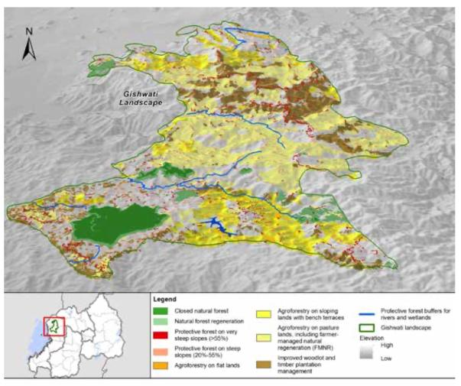

Source: IUCN and WRI (2014). A guide to the Restoration Opportunities Assessment Methodology (ROAM): Assessing forest landscape restoration opportunities at the national or sub-national level. Working Paper (Road-test edition). Gland, Switzerland: IUCN. 125pp
It should be noted that a good deal of information will need to come from local experts and other stakeholders with first-hand knowledge of the landscapes and livelihoods in the areas being assessed. So those carrying out the FLR assessment will need to use a combination of ‘best science’ and ‘best knowledge’ to obtain accurate, realistic solutions.
A ROAM process does not finish with the development of strategic recommendations. It is critical that the assessment report and results are not only disseminated to all those who participated at various stages of the work and any other key stakeholders in the country, but are also translated into briefings and presentations for senior-level decision-makers.

Figure 2: An assessment map produced for one area of Rwanda showing the opportunities for different FLR Interventions

Forest Landscape Assessment Tool (FLAT)
Link to TULIP project: The Forest Landscape Assessment Tool (FLAT) is a set of processes and tools that produces an ecological assessment for environmental land use planning and management. FLAT is a flexible, low-cost tool for rapid ecological field surveys. It enables planners and managers to understand baseline conditions, determine and prioritize restoration needs across a landscape system, and conduct ongoing monitoring to achieve land management goals (Fig 3).
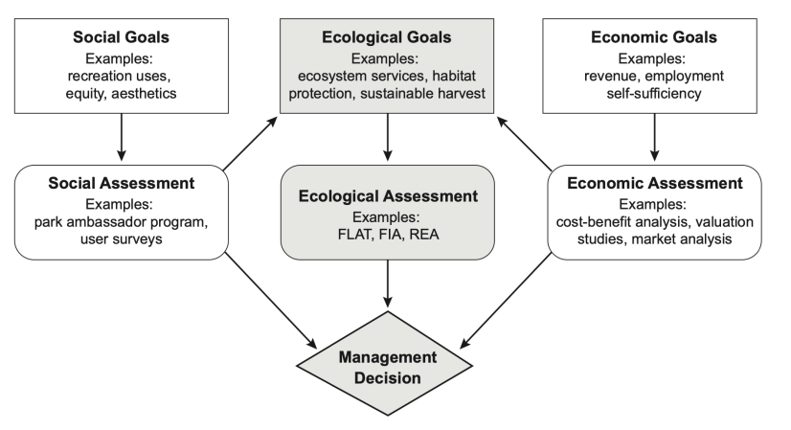
Fig 3. Importance of assessment in the land-management decision process. FIA = Forest Inventory and Analysis, REA = Rapid Ecological Assessment
Methodology and approach: The rapid assessment process presents a cost-effective opportunity for landowners that include local governments, private owners, and nongovernmental organizations to use ecological data to guide decision making and improve environmental outcomes on their lands. FLAT is executed in three sequential phases:
- Phase 1—Forest Cover Type Mapping; Aerial imagery and boundary data are used in a lab or office to divide a project area into management units (MUs), the unit of observation and measurement for the assessment. Data attributes are also developed during this phase based on local conditions and assessment purposes (e.g., species composition, size and age classes, invasive species, tree-canopy vigor, etc.).
- Phase 2—Field Assessment; A trained field team visits the project area to collect estimates of each attribute for each MU. Such teams may include professionals, technicians, and volunteer stewards.
- Phase 3—Management Prioritization; The data, which provide a snapshot of ecological conditions in the project area (within and across all Mus), can be used to classify or rank each MU. The assigned values can be viewed spatially to provide a mapped, visual representation of landscape conditions. These results can then be used to prioritize where on-the-ground management actions would most improve ecological function and health, contributing to long-term sustainability of a forest area.
Overall, FLAT fills an assessment role that traditional forestry assessments and the other methods do not address:
- Uses methods that are simple and adaptable to project-specific goals.
- Provides adequate, reliable, systematic, cost-effective, and local, site-based information.
- Informs decisions about where to initiate healthy forest management, stewardship programs, restoration activities, or stand management for harvest.
- Identifies where additional, more precise data may be needed.
- May be used to monitor conditions and progress over time.
In conclusion, the purpose of FLAT is to provide a systemic survey of forested lands that supports the prioritization of future management actions in a landscape system. This information can be used widely to implement landscape-level planning, unit-specific management, and ecological knowledge building.
Source: Ciecko, Lisa; Kimmett, David; Saunders, Jesse; Katz, Rachael; Wolf, Kathleen L.; Bazinet, Oliver; Richardson, Jeffrey; Brinkley, Weston; Blahna, Dale J. 2016. Forest Landscape Assessment Tool (FLAT): rapid assessment for land management. Gen. Tech. Rep. PNW-GTR-941. Portland, OR: U.S. Department of Agriculture, Forest Service, Pacific Northwest Research Station. 51 p.

Mapping, Monitoring and Planning at the Landscape Scale
Link to TULIP project: Spatial planning and monitoring at the landscape scale serves as a tool for integrating agricultural production, biodiversity conservation and livelihood security in rural landscapes.
Methodology and approach: A guide to spatial planning and monitoring at the landscape scale was designed by EcoAgriculture Partners in collaboration with TerrAfrica, to guide diverse stakeholders in locating, designing and monitoring interventions to improve benefits for people living in rural landscapes. Stakeholders undergo an eight-step process, conducted in five phases shown in the figure below:
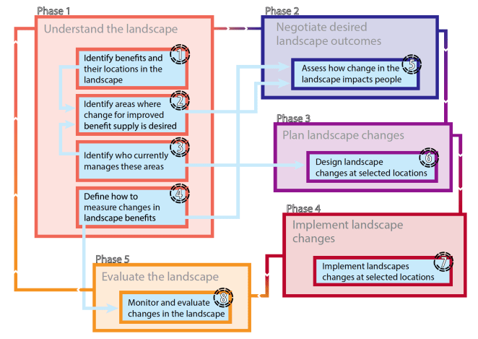

The first phase is devoted to stocktaking, and identifying and locating benefits within the landscape, such as water supply and regulation, habitat provision, crop production, and moderation of extreme climate events. Stakeholders develop a GIS platform composed of global and national scale maps, to identify important areas that correspond to the supply of landscape benefits and to inform planning of place-based interventions. Areas are identified where changes would lead to improvement of landscape benefit flows. A monitoring element is included to guide stakeholders to quantify and describe landscape benefits, so that change can be detected and measures.
Desired landscape changes are then negotiated, planned, and implemented in phases 2–4. Phase 5 involves development of a spatial strategy for monitoring and evaluation of landscape changes that also incorporates adaptive management of landscape interventions.
Source: Willemen, L, Kozar, R, Desalegn, A, & Buck, L.E. (2014). Spatial Planning and Monitoring of Landscape Interventions : Maps to Link People with Their Landscapes : A Users' Guide.

Useful resources and support tools for FLR implementation:

Implementing Forest Landscape Restoration (FLR) – A practitioner’s guide
https://www.iufro.org/science/special/spdc/netw/flr/flr/pract-guide/
Decision support tools for forest landscape restoration (FLR)
https://www.climatelinks.org/sites/default/files/asset/document/2018_CIFOR_Decision-support-tools-for-forest-landscape-restoration.pdf
Restoration Diagnostic Report – WRI
https://www.wri.org/research/restoration-diagnostic
Free E-learning course – Forest Landscape Restoration
https://elearning.fao.org/course/view.php?id=703
Forest Landscape Assessment Tool (FLAT)
https://www.fs.usda.gov/treesearch/pubs/53245
Restoration Opportunities Assessment Methodology (ROAM)
https://www.iucn.org/theme/forests/our-work/forest-landscape-restoration/restoration-opportunities-assessment-methodology-roam
Spatial Planning and Monitoring of Landscape Interventions: Maps to Link People with their Landscapes. A User’s Guide
https://ecoagriculture.org/publication/a-landscape-perspective-on-monitoring-evaluation-for-sustainable-landmanagement/ spatial-planning-and-monitoring-of-landscape-interventions-maps-to-link-people-with-theirlandscapes/
FAO Sustainable Financing for Forest and Landscape Restoration
http://www.fao.org/3/a-i5031e.pdf
IUFRO Forest Landscape Restoration as a Key Component of Climate Change Mitigation and Adaptation
http://www.iufro.org/publications/series/world-series/article/2015/12/01/world-series-vol-34-forest-landscaperestoration-as-a-key-component-of-climate-change-mitigation/

Attracting Private Investment to Landscape Restoration: A Roadmap
http://www.wri.org/publication/attracting-private-investment-to-landscape-restoration
National Forest Monitoring System (NFMS)
http://www.fao.org/redd/areas-of-work/national-forest-monitoring-system/en/
SEPAL – big-data platform for forest and land monitoring
http://www.fao.org/policy-support/tools-and-publications/resources-details/en/c/1382115/
Open Foris software tools for implementation of multi-purpose forest inventories
http://www.fao.org/forestry/fma/openforis/en/

Land Degradation Assessment in Drylands (LADA)

The concept
The Land Degradation Assessment in Drylands project (LADA) executed by FAO with funding from UNEP, GEF and others, assesses the causes and impacts of land degradation at a global, national and local levels in order to detect hotspots and identify remedial measures. LADA approaches land degradation as a biophysical, social, economic and environmental issue that must be dealt with through a combination of geo-informational, scientific and local knowledge tools. LADA is a scientifically-based approach to assessing and mapping land degradation at different spatial scales – small to large – and at various levels – local to global. It was initiated in drylands, but the methods and tools have been developed so as to be widely applicable in other ecosystems and diverse contexts with minimal required adaptation.
LADA’s main objective, using its mapping and assessment tools, is to identify and understand the causes of land degradation and the impacts of land use, including the effectiveness of current/recent responses, thereby enabling adequate and sustainable land management solutions to be devised.
To avoid a negative bias due to a focus only on land degradation, LADA also assesses and maps land improvement or sustainable land management (SLM) using World Overview of Conservation Approaches and Technologies (WOCAT) tools.
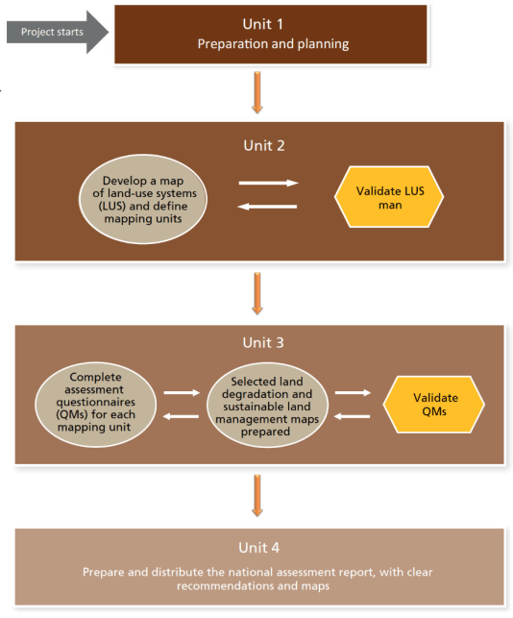
map
Figure 4. Four key-steps in the implementation of the LADA-WOCAT mapping methodology

Tools for preparation and assessment
The LADA-WOCAT set of tools and approaches provides balanced information and mapping capabilities on land resources status and trends in any given area, as well as on their causes, impacts and the actual and potential future responses.
The methodology makes extensive use of existing documents and maps (GIS layers, high resolution satellite images, socio-economic and land use data etc.) to construct a base map of land use systems in a country. The questionnaire itself is completed during workshops that bring together stakeholders, in particular land users, and a wide range of local technical experts. It focuses on:
(1) The types of land degradation (soil erosion by wind and water, chemical and physical soil degradation, water resource degradation, biological degradation) that are assessed for extent, degree and rate of change.
(2) Direct causes of land degradation (soil management, crop and rangeland management, deforestation, overgrazing, mining, urbanization, disturbance of the water cycle, natural causes) are described and rated.
(3) Indirect causes of land degradation (population pressure, consumption patterns, land tenure, poverty, labour (un)availability, war and civil unrest, lack of inputs and infrastructure, insufficient education and awareness, governance and prevailing policies) are identified and their influence rated.
(4) Impact on ecosystem services (productive services, ecological services, socio-cultural services) is assessed.
(5) Responses: land and water conservation and Sustainable Land Management (description and classification).
(6) Linking effect and success of responses with issues addressed and provision of recommendations.

Land Use System (LUS) mapping

Link to TULIP project: An LUS map is an essential part of the LADA–WOCAT methodology because it acts as the base map and provides unique mapping units for the assessment of Land Degradation and Sustainable Land Management variables. The LUS map and assessment outcomes can be used to determine locations for detailed local assessments, among many other uses. The LUS map should not be confused with a land-cover map: an LUS map includes data on land management, inputs and socio-economic conditions, which are not included in land-cover maps.
Methodology and approach: LUS mapping usually does not involve the collection of new data, but access to specific existing data layers is required. Thus, no expertise is required in analysing raw data (e.g. data from remote sensing), although it is necessary to combine spatial data layers and undertake simple data modelling and interpolation.
Step 1. Awareness and agreement on map characteristics; Step 2. Financial support; Step 3. Supporting Structure; Step 4. Existence of baseline data; Step 5. Availability of experienced professionals in LUS mapping and the LADA-WOCAT method; Step 6. Collecting baseline data and making them available for use; Step 7. Secure experts to validate data
The development of a base map or “land-use systems” (LUS) map requires participatory actions with the involvement of various entities within the country. It includes data collection and analysis in a GIS environment, and an iterative field-level validation. The LUS map, with its well-defined mapping units, is used as a basis for the assessment of LD and SLM in Step 3. The preparation of a LUS map can be done by GIS experts in collaboration with other national experts by following the guidance and methodologies set out in FAO.The technical preparation of the LUS map is an inherently GIS exercise that can be done independently by a national GIS unit or with the support of a consultant or an FAO officer.
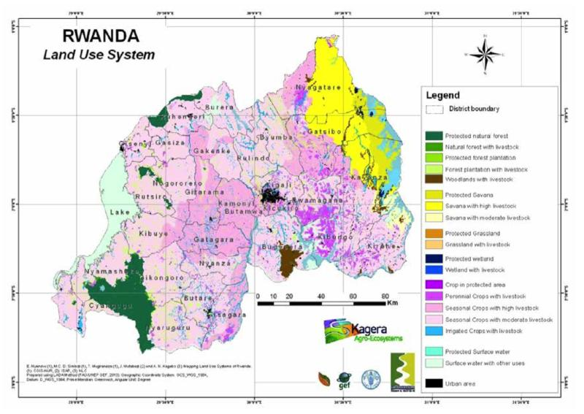
Figure 5. An example of a completed LUS map for Rwanda
More examples of LUS maps can be found on the LADA webpage (https://www.wocat.net/library/media/152/) and the KAGERA TAMP webpage (http://www.fao.org/in-action/kagera/activities/mapping/en/).

Source: Petri, M.; Biancalani, R. and Lindeque, l. 2019. Guidelines for the national assessment and mapping of land degradation and conservation. Rome, FAO. 52 pp. Licence: CC BY-NC-SA 3.0 IGO.

LADA/WOCAT Questionnaire for Mapping (QM) assessment tool
Link to TULIP Project: The Questionnaire for Mapping methodology is scale-independent, in other words, the same methodology can equally be applied nationally and at the scale of a single farm. The QM is a complementary tool for land degradation assessment based on LUS maps.
Methodology and approach: The QM approach is an internationally accepted methodology and was developed over many years with inputs from many countries and institutions. Recently, the United Nations Convention to Combat Desertification identified the QM methodology as “best practice”. The foundation of the QM methodology is the LUS map and cannot be performed without an LUS map with clearly defined, well-recognized mapping units. The amount of information collected through the National Land Uses System and QM inventory associated with it is extremely rich and can be used to construct maps that illustrate the various characteristics, pressures, causes and impacts of each degradation type or of each land use system within an administrative unit or, nationally. It also allows the construction of Driving Forces-Pressures-State-Impacts-Responses (DPSIR) indicators for each of the LUS/admin unit combinations and finally it allows statistical correlations to be determined between, for example, the extent of land degradation and the poverty level or land tenure security. The latter techniques can also be applied to verify the accuracy of the answers to the questionnaire. For instance, if poverty is mentioned as a driver in QM, this should correspond to a similar range in the poverty levels attached to the administrative unit.
Direct maps are prepared by a simple join between GIS and QM results. This is the case of data that have a “one to one” relation with the GIS layer “LUS per administrative units”, i.e. area or intensity trend, % of area degraded or under conservation measures, complete list of degradation types or purpose of conservation measures, start or end year of conservation measures, recommendation. Those data can be used as simple indicators and after the join to the GIS layer, a map can be prepared without any additional input, except eventual reclassification for numerical data (see Figure Below).
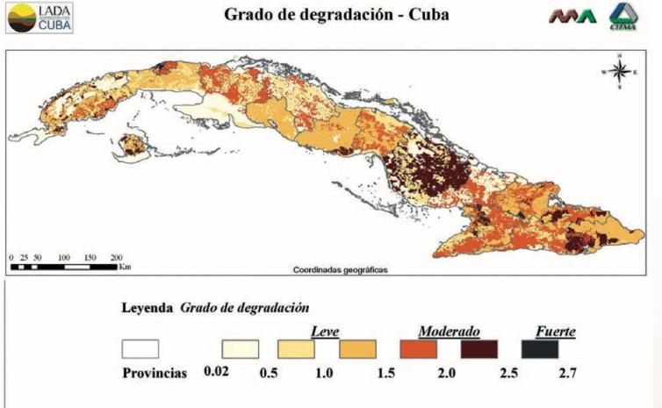
Figure 6. Degree of land degradation in Cuba based on LUS maps integrated with obtained data from QM approach

Source: Petri, M.; Biancalani, R. and Lindeque, l. 2019. Guidelines for the national assessment and mapping of land degradation and conservation. Rome, FAO. 52 pp. Licence: CC BY-NC-SA 3.0 IGO.

Useful resources and support tools for LADA:
FAO-LADA project description (WOCAT)
https://www.wocat.net/en/projects-and-countries/projects/land-degradation-assessment-drylands-fao-lada
LADA-WOCAT QM evaluation tool - FAO
http://www.fao.org/land-water/land/land-governance/land-resources-planning toolbox/category/details/en/c/1197596/
Land degradation assessment in drylands: mapping land use systems at global and regional scales for land degradation assessment analysis.
http://www.fao.org/docrep/017/i3242e/i3242e.pdf
Land degradation assessment in drylands: methodology and results.
http://www.fao.org/3/a-i3241e.pdf
Questionnaire for mapping land degradation and sustainable land management (QM)
http://www.fao.org/docrep/017/i3240e/i3240e.pdf
Global Land Degradation Information System (GLADIS)
http://www.fao.org/sustainable-forest-management/toolbox/tools/tool-detail/en/c/411197/
Earthmap cost-effective tool for investment planning
http://www.fao.org/support-to-investment/our-work/success-story-detail/en/c/1306176/
Hand-in-Hand geospatial platform (HiH GS) investment planning
http://www.fao.org/hih-geospatial-platform/en/

Nature-Based Solutions (NBS)

The concept:
Nature-based solutions (NBS) are “actions to protect, sustainably manage, and restore natural or modified ecosystems, that address societal challenges effectively and adaptively, simultaneously providing human well-being and biodiversity benefits” (IUCN, 2016)

Tools for preparation and assessment

Natural Water Retention Measures
In regards to NBS, the European Commission has developed a methodology to safeguard and enhance the water storage potential of landscape, soil and aquifers, by proposing NBS. Natural Water Retention Measures (NWRM), a type of NBS, as defined in related EU policy documents are: multi-functional measures that aim to protect water resources and address water-related challenges by restoring or maintaining ecosystems as well as natural features and characteristics of water bodies using natural means and processes.
The main focus of applying NWRM is to enhance the retention capacity of aquifers, soil, and aquatic and water dependent ecosystems with a view to improve their status. The application of NWRM supports green infrastructure, improves the quantitative status of water bodies as such, and reduces the vulnerability to floods and droughts. It positively affects the chemical and ecological status of water bodies by restoring natural functioning of ecosystems and the services they provide. The restored ecosystems contribute both to climate change adaptation and mitigation. They support Green Infrastructure by contributing to integrated goals dealing with nature and biodiversity conservation and restoration, landscaping, etc.

Engineering With Nature (EWN)
Engineering With Nature is the intentional alignment of natural and engineering processes to efficiently and sustainably deliver economic, environmental, and social benefits through collaborative processes. Sustainable development of water resources and other types of infrastructure can be supported by solutions that beneficially integrate engineering and natural systems. With recent advances in the fields of engineering and ecology, there is an opportunity to combine these fields of practice into a single collaborative and cost-effective approach for infrastructure development and environmental management.

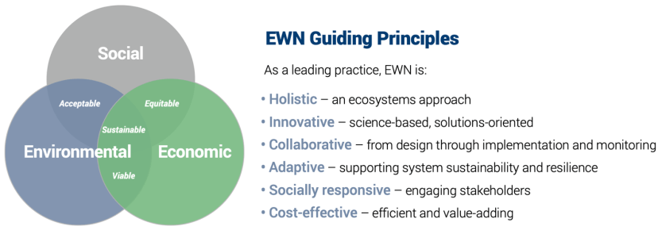

NWRM catalogue (European Commission)
Relevance to TULIP project: a toolbox that utilizes the integration of grey and green (hybrid) infrastructures in urban and rural settings.
Methodology and approach: The catalogue of measures hereunder is sorted by relevant sectors of Agriculture, Forestry, Hydromorphology, and Urban. It has been developed in the NWRM project of the European Commission, and represents a comprehensive but non prescriptive wide range of NWRM measures, as there may be other measures, or similar measures that are called by a different name, that could also be classified as NWRM. When implementing one or more of these 53 measures, it is always necessary to check if they can qualify as NWRM according the definition. It is very important to emphasize that the list of measures is not a list of recommended measures but rather a list used for evaluating the potential (advantages and disadvantages) of using each individual measure as NWRM.

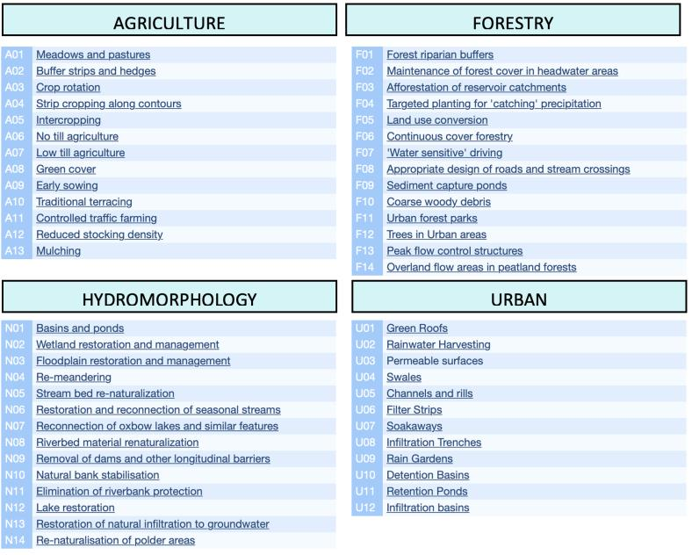
The illustrated catalogue can also be accessed in pdf that includes solely the definition and some illustrations for each of the 53 NWRM. (http://nwrm.eu/sites/default/files/documents-docs/53-nwrm-illustrated.pdf)
Moreover, the catalogue offers NWRM per type of benefit provided. This online-tool, demonstrated below, helps to choose the most appropriate NWRM. As NWRM could have multiple functions and co-benefits, you will find here qualitative links between measures and impacts, benefits and policy objectives.
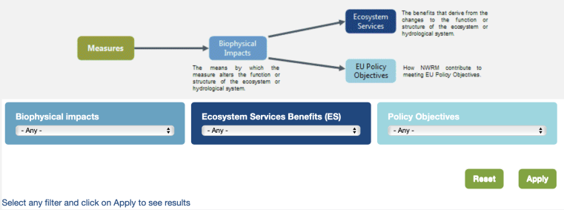
Source: http://nwrm.eu/measures-catalogue

Natural Infrastructure Opportunities Tool (NIOT)
Link to TULIP project: The Natural Infrastructure Opportunities Tool is a public facing viewer that focuses on identifying natural infrastructure and beneficial use opportunities, developed by USA Corps of Engineers (USACE) in collaboration with the Natural Infrastructure initiative.
Methodology and approach: Through map-based visualizations of environmental, geomorphic, and sediment conditions, as well as upcoming USACE projects, and an interface for users to add their resource needs and resource availability, the portal aims to help discover natural infrastructure connections and inspire innovative opportunities.

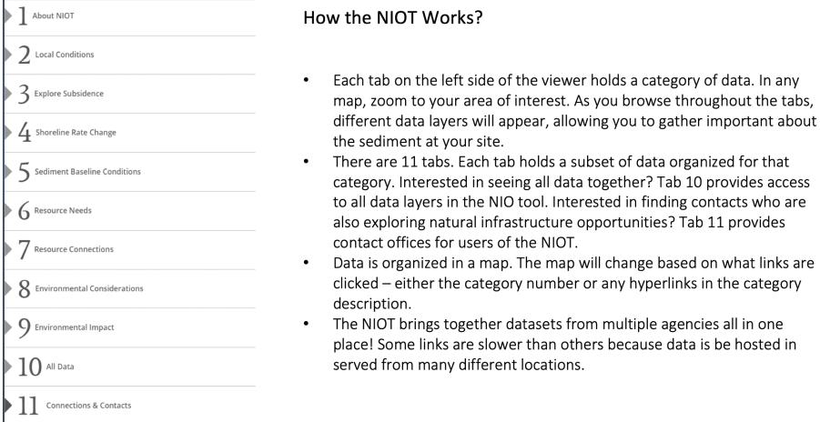
Source: https://ewn.el.erdc.dren.mil/tools/NIOT-UsersGuide.pdf

Mapping and Assessment of Ecosystems and their Services (MAES)

Link to TULIP project: MAES proposes a conceptual framework linking biodiversity, ecosystem condition and ecosystem services to human well-being. Furthermore, this framework provides practical guidance through a common assessment framework, while a selection of indicators is proposed to map and assess ecosystem condition and ecosystem services. The European relevance and value added of EU-level green and blue infrastructure projects can be explained and demonstrated using the MAES methodology, together with the EU approach to restoration prioritization frameworks.

Methodology and approach: The European MAES initiative has developed a coherent analytical framework to ensure that consistent approaches linking biodiversity, ecosystem condition and ecosystem services, are used across Member States and at EU level (1st MAES Report, 2013). The MAES framework includes a typology for ecosystems in EU (based on EUNIS and Corine Land Cover) and promotes a classification of ecosystem services that allows for integration in accounting systems (based on CICES). The common assessment framework was further developed with a selection of indicators and a European map of ecosystems (2nd MAES Report, 2014). The 3rd MAES Report (2016) synthesizes the European Environment Agency's work on ecosystem mapping and provides short assessments of pressures, condition and biodiversity for main ecosystem types mainly based on datasets derived from reporting under EU environmental policies. A fourth report addressed urban ecosystems and green infrastructure (4th MAES Report, 2016). The 5th MAES report further consolidates and enhances the operational guidance on mapping and assessment of ecosystem condition and provides a selection of key indicators across different ecosystems according to a joint framework; it provides the basis for an integrated ecosystem assessment to evaluate the achievements of the EU Biodiversity Strategy(Figure 7).

In its simplest version the conceptual framework links socio-economic systems with ecosystems via the flow of ecosystem services, and through the drivers of change that affect ecosystems either as consequence of using the services or as indirect impacts due to human activities in general.

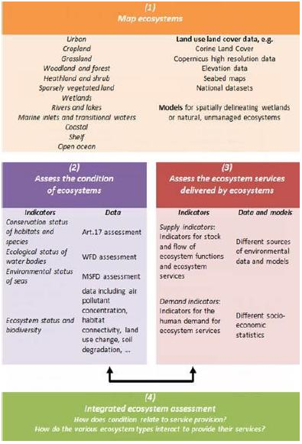
Fig 7. MAES assessment framework for ecosystems

Source: Maes, J. et al., (2013). Mapping and assessment of ecosystems and their services: An analytical framework for ecosystem assessments under Action 5 of the EU Biodiversity Strategy to 2020. 10.2779/12398. See also: https://biodiversity.europa.eu/maes

Compendium of Geospatial methodological guidelines, data and tools

Link to TULIP project: Spatially explicit datasets and methods are available to support the assessment and mapping of Green Infrastructure (GI) and its components. To further develop GI, datasets and methods are also available to identify priority areas for conservation and restoration actions. Some decision support tools also exist to develop scenarios using different land use policy drivers to test their impact on GI in the future.
Methodology and approach: Models for GI development and assessment require the input of spatial datasets at multiple scales, i.e. from the local to pan-European scale. The European CORINE Land Cover (CLC) data set is one of the only harmonised and regularly updated available information that can be used for mapping land use and land cover in the EU, with a spatial resolution of 25 ha. The LUCAS survey as it provides another harmonised data set for land use and land cover at the European scale. The more recent European Copernicus Programme provides new opportunities such as, amongst other data, the local component product Urban Atlas, with a spatial resolution of 0.25 ha for the urban areas and 1 ha for the non-urban classes, and the Copernicus High Resolution layers on forests, grasslands or water.
These tools are presented and analysed in more details in a technical report published alongside this guidance document titled ‘Strategic green infrastructure and ecosystem restoration: geospatial methods, data and tools (see Figure 8).

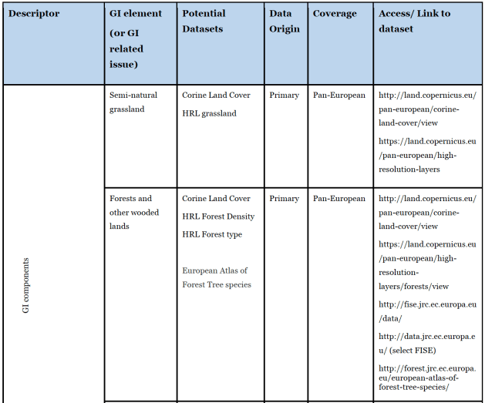

Fig 8. A section of the overview of GI mapping and assessment datasets that could potentially be considered to depict specific GI components for different GI applications. (Adopted from: https://publications.jrc.ec.europa.eu/repository/handle/JRC113815)

This report focuses on data, tools and their application in case studies selected in both rural and urban contexts. Europe-wide data are in certain cases combined with regional data for demonstration purposes ; all data and tools are listed (with a web link to download) specifying the GI element in question. The report provides technical methodological guidance to support strategic policy and decision-making to deploy a well-connected, multi-functional and cross-border GI. It also identifies knowledge gaps. GI mapping is particularly demonstrated to enhance nature protection and biodiversity beyond protected areas, to deliver multiple ecosystem services, to prioritise measures for defragmentation and restoration and find trade-offs of land allocation involving all sectors.

Source: Estreguil, C., Dige, G., Kleeschulte, S., Carrao, H., Raynal, J. and Teller, A., Strategic Green Infrastructure and Ecosystem Restoration: geospatial methods, data and tools, EUR 29449 EN,Publications Office of the European Union, Luxembourg, 2019.
Available at: https://publications.jrc.ec.europa.eu/repository/handle/JRC113815

Useful resources and support tools for Nature-Based Solutions:
A guide to support the selection, design and implementation of NWRM in Europe
http://nwrm.eu/guide/files/assets/basic-html/index.html#2
Catalogue of NWRM case studies in Europe
http://nwrm.eu/list-of-all-case-studies
European Commission NWRM background – Living with Climate Change in Europe
https://ec.europa.eu/environment/water/adaptation/ecosystemstorage.htm
Engineering With Nature: An Atlas Volume 2 – Showcasing EWN principles and practices in action of 62 projects from around the world
https://ewn.el.erdc.dren.mil/atlasv2.html
Engineering With Nature (EWN) Tools
https://ewn.el.erdc.dren.mil/tools.html
Integrating Green and Grey: Creating Next Generation Infrastructure
https://www.wri.org/research/integrating-green-and-gray-creating-next-generation-infrastructure
Mapping and Assessment of Ecosystems and their Services (MAES)
https://ec.europa.eu/environment/nature/knowledge/ecosystem_assessment/pdf/5th%20MAES%20report.pdf
Natural Infrastructure opportunities Tool – Connecting resources to Needs: A decision support tool (USACE Online-Tool)
https://www.arcgis.com/apps/MapSeries/index.html?appid=18079f5b628b4a7bb52acbe089d80886#
Nature-based Solutions: a Cost-effective approach for disaster risk and water resource management
https://www.worldbank.org/en/topic/disasterriskmanagement/brief/nature-based-solutions-cost-effective-approach-for-disaster-risk-and-water-resource-management
Strategic Green Infrastructure and Ecosystem Restoration
https://publications.jrc.ec.europa.eu/repository/handle/JRC113815
Terms, definitions and glossary of NWRM
http://nwrm.eu/glossary
Using the Natural Infrastructure Opportunities Tool (NIOT) – User’s Guide
https://ewn.el.erdc.dren.mil/tools/NIOT-UsersGuide.pdf

Participatory-approach tools for Integrated Landscape Management:

The concept
Integrated landscape initiatives typically aim to strengthen landscape governance by developing and facilitating multi-stakeholder platforms. These are institutional coordination mechanisms that enable discussions, negotiations, and joint planning between stakeholders from various sectors in a given landscape. Multi-stakeholder platforms tend to involve complex processes with diverse actors, whose objectives and focus may be subjected to periodic re-evaluation, revision or reform.
It is widely acknowledged that traditional communities have managed natural resources in a holistic manner for centuries to meet social needs. An integrated approach to managing landscapes is not a new concept, but rather one refined through multiple iterations during attempts to integrate social and economic development with biodiversity conservation and climate change mitigation. In recent decades, the integrated landscape approach has gained increasing interest of scientific community, as well as of organizations active in the field of sustainable development.

Tools and methodologies
The tools and methodologies presented below are integrated landscape management approaches that are based on multi-stakeholder and participatory methodologies.

- Livelihood Mapping Approach to assess agricultural water management
- Integrated approach for Land Use Planning (ILUP)
- Operationalizing an Integrated Landscape Management approach

Livelihood Mapping Approach to assess agricultural water management (AWM)
Link to TULIP project: This approach focuses on addressing the needs of poor rural people, rather than focusing on the development of potentially suitable resources. In so doing, the demand for investments in water drives the assessment process, and its implications in terms of resources use (water, land) is checked against available supply. The demand for investments in water varies according to the needs of the population. In order to capture this demand, a livelihood mapping approach is adopted.
Methodology and approach: Livelihood zones mapping and analysis divides the farm, community, watershed or country, into areas where rural people share relatively homogeneous living conditions that are based on a combination of biophysical and socioeconomic determinants. It describes the rural population’s main sources of livelihood (by category of people), their natural resources base, potential and key constraints to development. It analyses the relation between people and water and assists understanding of the extent and how water can be a factor in development.
The different steps of this methodology followed for carrying out the analysis are:
- Mapping of the main livelihood zones, responding to the following questions:
- What are the different farmer typologies and rural livelihood strategies?
- What are the main water-related constraints and needs in the different rural livelihood contexts?
- Mapping the potential and opportunities for improving smallholders’ livelihood through water interventions.
- Estimation of the number and percentage of rural households that may benefit from AWM interventions.
- Mapping of the suitability and demand for a series of specific AWM solutions, showing where they have the highest potential impact on rural livelihoods.
- Estimation of the potential number of beneficiaries, the potential application area and total investment costs for each AWM solution in each livelihood zone.
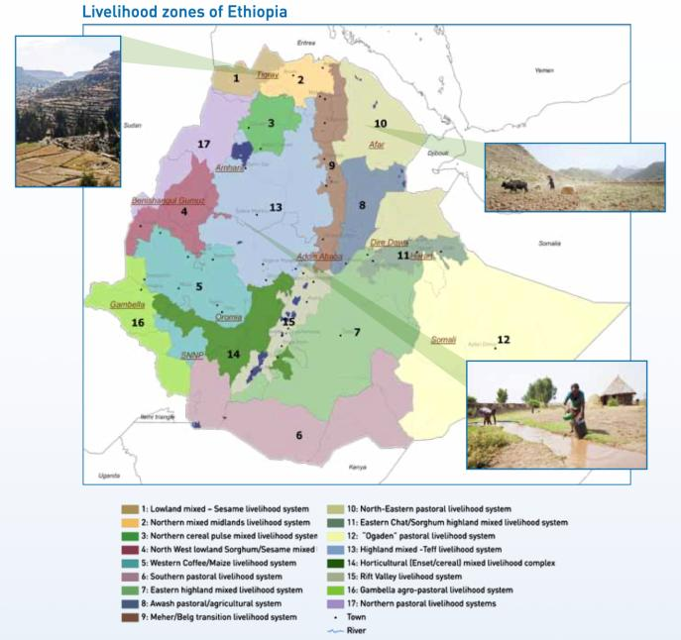

Source: Santini, Guido & Peiser, Livia & Faurès, Jean-Marc. (2012). Assessing the potential for poverty reduction through investments in agricultural water management. A methodology for country level analysis.

Integrated approach for Land Use Planning (ILUP)
Link to TULIP project: The Integrated Land Use Planning (ILUP) approach, developed by FAO Turkey (2020), is a tool to help policy development for harmonizing human activities and environmental sustainability, addressing issues of efficiency, equity and environmental protection on national development plans. Accordingly, ILUP is now included in country-based investment programmes at the national, regional or local scale.
Methodology and approach: Over the last decade, ILUP approaches have been developed in accordance with different priorities at regional and national levels, including: Participatory Land Use Planning, Ecosystem-based Land Use Planning, Regional Land Use Planning, Spatial Land Use Planning, Urban Land Use Planning, Integrated Land Use Planning, Territorial Ecological Planning. Many of these approaches or programmes involve land-based rural development activities that are often deployed in a top-down manner, without the engagement of local communities and stakeholders, or adequate consideration of the characteristics of locally available natural resources.
Integrated land-use planning should aim at incorporating biodiversity conservation, sustainable land management and climate change adaptation into spatial development plans. The planning process for establishing an ILUP in the planning area goes as follows:
- Identification of integrated land use planning objectives;
- Assessing the current situation, gaps and conflicts;
- Integrated planning and negotiation process;
- Implementation;
- Communication strategy and systematization of the process for scaling out.
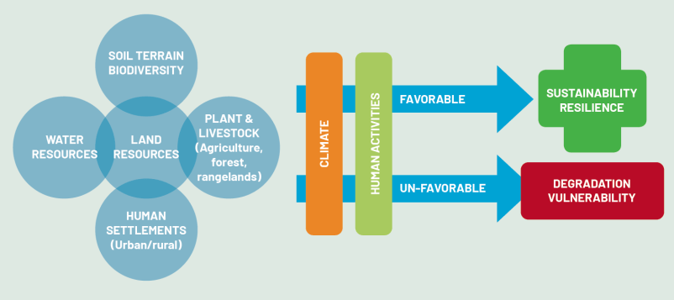
Fig 9. Illustration of the integrated land use planning approach
After the planning process is complete, it should be followed up by designing an evaluation and monitoring system. This step allows for ongoing review, analysis and understanding of the progress and performance of Integrated Land Use Planning at a high level. It establishes a framework to enable correct and accurate reporting, and provides a basis for continuous improvement and mechanisms to evaluate the successes and challenges faced by implementation programmes. A process for iterative planning and stakeholder meetings should go beyond the planning stage and be established on a permanent basis to accompany ILUP planning and implementation.

Source: Erdogan, Emrah & Bastidas, Soledad. (2020). Framework for Integrated Land Use Planning: an innovative approach Acknowledgment.
Available at: http://www.fao.org/publications/card/en/c/CB1170EN/

Operationalizing an Integrated Landscape Management approach
Relevance for TULIP project: In this methodology a framework is presented to operationalize the integrated landscape approach in practice by putting a long-term collaboration between scientists and various stakeholders at center stage.
Methodology and approach: The proposed framework consists of four pillars, which are inter-connected by a circle of output feeding into the subsequent pillars. This structure is interpreted as a circle of joint learning, negotiation and reflection. In the first pillar (P1), a thorough analysis aiming at understanding landscape functioning is conducted, resulting in spatially detailed system knowledge on land use and ecosystem services provided. This knowledge serves as input to Pillar 2 (P2), aiming at exploring the current, but also potential future societal demands under scenarios of landscape transformation and environmental change (i.e., target knowledge). Out of this, spatially-explicit scenario outputs and targets for design and adaptation can be generated resulting in the designing of future landscape options in Pillar 3 (P3) (i.e., transformation knowledge). Comparing the present and desirable future landscape results in land change requirements, i.e., negotiating interventions for transforming landscapes in Pillar 4 (P4), followed by prototyping and implementation. The circle is iterative in character. Prototyping and implementation in a real-world context will shed new insights in the functioning of the landscape and thus feed back into Pillar 1. Reflection on failures and successes in the transformation phase is essential to improve our system understanding and enter into a new round of improved design of potential interventions (see Figure 10).
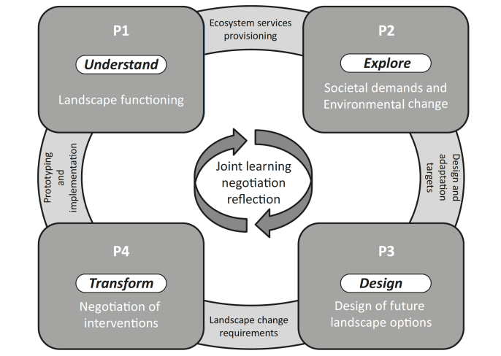
Figure 10. In this methodology it is proposed to operationalize the integrated landscape approach as a process of joint learning, negotiation and reflection, consisting of four pillars to understand, explore, design and transform landscapes to increase their resilience in times of global change and to increase their overall value for society (adopted from: Giller, K.E, Leeuwis, C, Andersson, J.A, Aniesse, W, Brouwer, A, Frost, P.G.H, Windmeijer, P.N. (2008). Competing Claims on Natural Resources. Ecology and Society, 13(2), 34.)
In conclusion, the framework proposed in this methodology attempts to order the different elements into a logical process that optimally combines scientific information and local knowledge in a transdisciplinary process leading from problem identification, the design of solutions to the implementation of these in practice. It is novel in the sense that researchers, decision makers and practitioners have to work together in every of the four pillars distinguished. It is not a sequence of tasks for specific groups, but true collaboration, not only in the first, but also in the subsequent rounds of the circle.
Putting the joint learning process at center stage fosters continuous capacity building, long-term commitment from the core partners and a continuous reflection on how the learning circle relates to the SDGs and the landscape level changes due to the interventions. This involvement in the process of joint learning, negotiation and reflection will result in long-lasting impact on a personal level for all stakeholders involved at the community level to manage natural resources, maintaining ecosystems services and contributing to achieving sustainability through local ownership.
Source: Bürgi, Matthias, Ali, Panna, Chowdhury, Afroza, Heinimann, Aneas, Hett, Cornelia, Kienast, Felix, . . . Verburg, Peter H. (2017). Integrated landscape approach: Closing the gap between theory and application. Sustainability (Basel, Switzerland), 9(8), 1371.

Useful resources and support tools for participatory approaches:

Framework for integrated land use planning – An innovative approach
http://www.fao.org/3/cb1170en/cb1170en.pdf

Assessing the potential for poverty reduction through investments in agricultural water management – A methodology for country level analysis
http://www.fao.org/3/i3056e/i3056e.pdf

Prepared by: Amin Emadi, Watershed management specialist Land and Water division FAO, July 2021

