CONFERENCE ON CLIMATE CHANGE IMPACT ON FORESTS OF CENTRAL ASIA
2-6 August 2021-Antalya-Turkey
Conference Proceedings
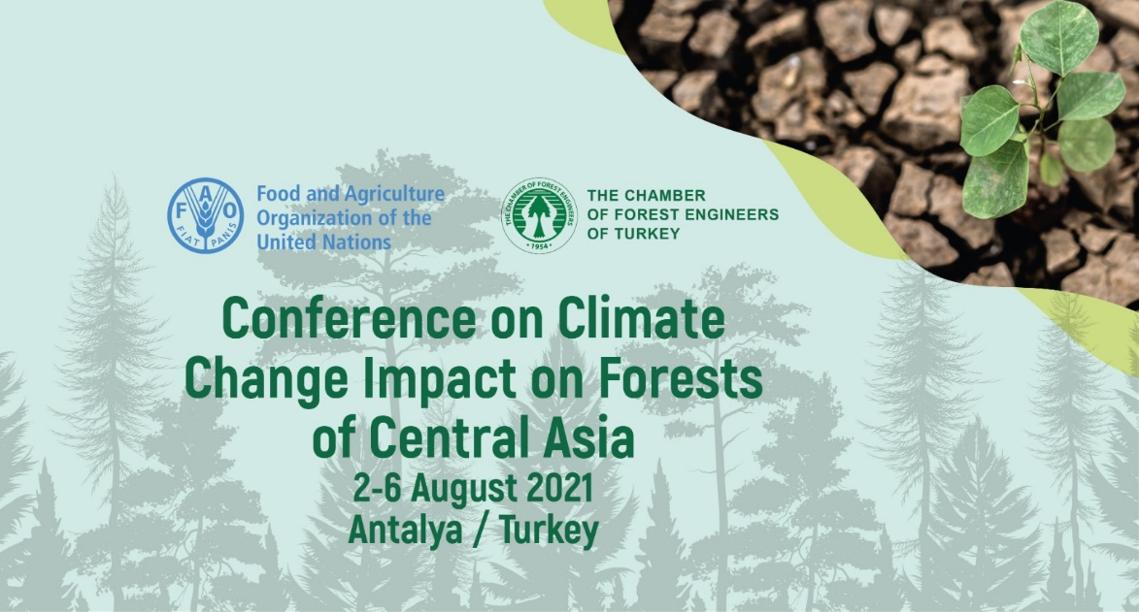
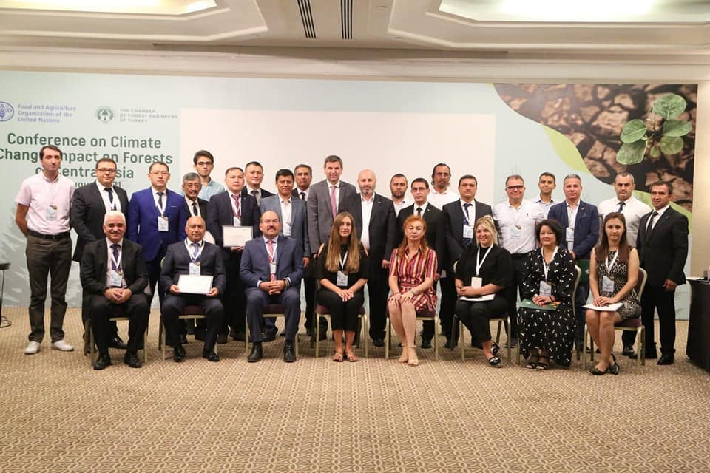
8 September 2021

Prepared by (in alphabetical order):
- Ayhan Akyol (Assoc. Prof. Dr.)
- Çağlar Başsüllü (Dr.)
- Derya Esen (Prof. Dr.)
- Ercan Kaptanoğlu
- İsmail Belen

Content

Content 1
Pictures 2
Abbreviations 3
1. Background 4
2. Conference Implementation 4
3. Conference Discussions 6
3.1. Forest and climate change policies and strategies 8
3.2. Institutional structures related to forestry and climate change 12
3.3. State of forests and greenhouse gases inventory between 1990-2020 12
3.4. Climate projections and scenarios in Central Asia 13
3.5. Observed changes in forests since 1990 14
3.6. SFM and climate change actions 15
3.7. Challenges and gaps for SFM 19
3.8. Proposed SFM measures to enhance climate action 21
4. Conclusions and Recommendations 27
5. Annexes 30
Annex 1: Conference Agenda 30
Annex 2: List of Participants 34
Annex 3: Abstracts of Country Reports/Presentations 37
Azerbaijan 37
Kazakhstan 38
Kyrgyzstan 39
Tajikistan 40
Turkmenistan 42
Turkey 43
Uzbekistan 43

Pictures

Picture 1. Venue and opening session of the Conference 5
Picture 2. Mr. Viorel Gutu of FAO (left) and Mr. Hasan Türkyılmaz of OMO (right) 6
Picture 3. Dr. Peter Pechacek of FAO (lift-online) and İsmail Belen of OMO (right) 6
Picture 4. Representatives of Azerbaijan, Kazakhstan, Kyrgyzstan, Tajikistan, Uzbekistan, Turkmenistan, and Turkey 7
Picture 5. Prof. Dr. Derya Eşen and Assoc. Prof. Dr. Ayhan Akyol 7
Picture 6. Tugai forest 16
Picture 7. Saxaul and tamarix 17
Picture 8. İsmail Hakkı Güney of OMO (left), Burak Avcıoğlu(center) and Evetta Zenina of FAOSEC (right) 25
Picture 9. Dr. Çağlar Başsüllü of OGM 25
Picture 10. Ercan Kaptanoğlu (left), Hasan Türkyılmaz (center) and İsmail Belen of OMO 26
Picture 11. Pictures of field trip 26

Abbreviations

% Percentage
BAU Business As Usual
C&I Criteria & Indicators
CO₂e Carbon Dioxide Equivalent
Conference Conference on Climate Change Impact on Forests of Central Asia
FAO Food and Agriculture Organization of the United Nations
FLR Forest Landscape Restoration
FRA Forest Resources Assessment
GDP Gross Domestic Product
GIZ German Society for International Cooperation
Guidelines Guidelines on Sustainable Forest Management (SFM) under the Impact of Climate Change in Central Asia
INDC Intended Nationally Determined Contributions
k Thousand
LoA Letter of Agreement
LULUCF Land-Use, Land-Use Change and Forestry
NBSs Nature-Based Solutions
NDC Nationally Determined Contributions
NGO Non-Governmental Organization
NTFPs Non-Timber Forest Products
OGM General Directorate of Forestry
OMO Chamber of Forest Engineers of Turkey
REU Regional Office for Europe and Central Asia
RI Regional Initiative
SDGs Sustainable Development Goals
SEC Sub-regional Office for Central Asia
SFM Sustainable Forest Management
UNECE United Nations Economic Commission for Europe
UNFCCC United Nations Framework Convention of Climate Change

Background

Climate change and its impacts on forest resources are already evident throughout the Central Asia region. There is a growing interest among governments and many of their development partners to gain a better understanding of the exposure, sensitivities, and impacts of climate change at the landscape level and to develop and prioritize mitigation/adaptation measures to build resilience to the potentially adverse consequences as well as to mitigate the consequences of the climate change.

To this end, the Food and Agriculture Organization of the United Nations (FAO) Regional Office for Europe and Central Asia (REU) and FAO Sub-regional Office for Central Asia (SEC) agreed under the Regional Initiative (RI) 3, among other things, on delivery of the regional results related to the strengthening of capacities of the technical networks in the region in adoption and promotion of the Nature-Based Solutions (NBS) in the agriculture and forestry sectors supportive of the Sustainable Natural Resource Management (NRM) under a changing climate for the biennium 2020-2021.

The following milestone is, among other things, subject of implementation by FAO SEC in 2021 to deliver on the result under the RI 3:

- Development of Guidelines on Sustainable Forest Management (SFM) under the Impact of Climate Change in Central Asia (Guidelines) - Implications for Practitioners (milestone identification number 13037), including organization of a Conference on Climate Change Impact on Forests of Central Asia, preparation of the Conference proceedings and using the synthesis of the Proceedings to produce the Guidelines.

The milestone aims to provide the FAO Member States with best practices in which the members work together to achieve common development objectives. The milestone is also expected to improve policies to achieve the Sustainable Development Goals (SDGs), enhance progress in reaching common development objectives, and strengthen government officials' capacities in given technical areas of policy and strategy development.

For this aim, FAO and the Chamber of Forest Engineers of Turkey (OMO) have signed a Letter of Agreement (LoA) on 26 April 2021 to deliver the “Conference on Climate Change Impact on the Forests of Central Asia”, prepare the Conference proceeding, and develop “Guidelines on Sustainable Forest Management under the Impact of Climate Change in Central Asia”.

Conference Implementation

The Conference was held at the “Rixos Downtown Hotel” in Antalya/Turkey physically. Besides physical participation, online involvement and broadcasting were also provided. Some country representatives, like Azerbaijan and the FAO representatives, participated virtually.

The language of the conference was English with simultaneous translation to Russian and Turkish. A web page has been prepared at https://ormuhworld.com/ to assist the participants and share up-to-date information regarding the Conference.

Participants checked in on Monday, 2 August 2021, and left the hotel on Friday, 6 August 2021. Meetings were held at the hotel from 3-4 August 2021. A field trip was organized on 5 August 2021. All necessary arrangements, including tickets, visa, airport transportation, accommodation, PCR tests for COVID-19, field trip provided by OMO.
The government officials – including those of the host country - who attended the conference on behalf of their respective governments - were the direct beneficiaries of this capacity-building activity. Thus, the governments of the invited countries benefited from the shared technical expertise and experience, which might be considered for adaptation in their own countries.

Representatives of the host country benefited from the comments obtained during the discussions, which, in turn, promoted a deeper understanding of the needs of the Central Asia region. This combination of the delivered and received feedback will support the achievement of common development objectives by FAO Members.

Picture 1. Venue and opening session of the Conference
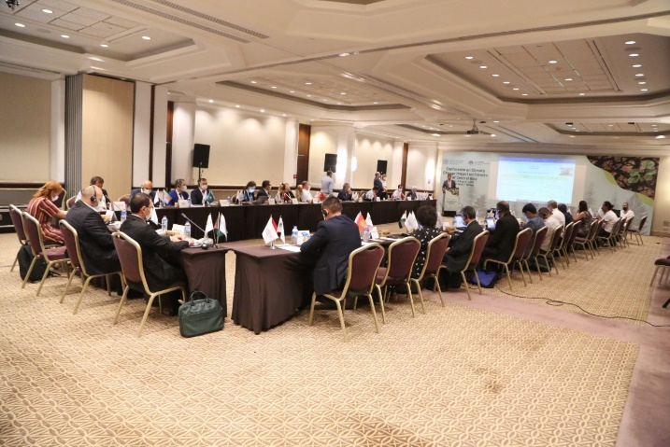

The conference agenda also included background documents shared with participants before the event, such as general information on the host country, expected weather pattern, dress code, transportation, venue, and some of the abstracts of contributions provided by resource persons.

The Conference included:

- Introductory case study presentations of the resource persons on the impacts of climate change on the forests of Central Asia. The case studies provided information on the state of forests and carbon stocks, illustrated experiences on how climate change had affected forests, how forests had changed and adapted to climate change and climate change projections and scenarios for the region, what the best international management practices were for both forests and rural communities, the role of SFM in response to climate change; needs for better adaptation to climate change; improvements in governance, and forest policies and strategies for climate change.
- Group discussions were held during the conference by participants based on the outline. (Please see Annex 1 for the Conference Agenda)

The Conference has brought together 37 participants from the governments of the FAO Members, particularly those of Central Asia, namely, Azerbaijan, Kazakhstan, Kyrgyzstan, Tajikistan, Turkmenistan, Uzbekistan, Turkey and FAO and OMO, academicians, and non-governmental organizations. (Please see Annex 2 for the List of Participants).

The participants shared their country’s experiences and participated actively in panel presentations and discussions. (Please see Annex 3 for the Abstracts/Summary of Country Reports/Presentations).

Conference Discussions

The Conference commenced with the opening statements by Mr. Viorel Gutu, FAO-SEC and Mr. Hasan Türkyılmaz, the President of the OMO.

Picture 2. Mr. Viorel Gutu of FAO (left) and Mr. Hasan Türkyılmaz of OMO (right)
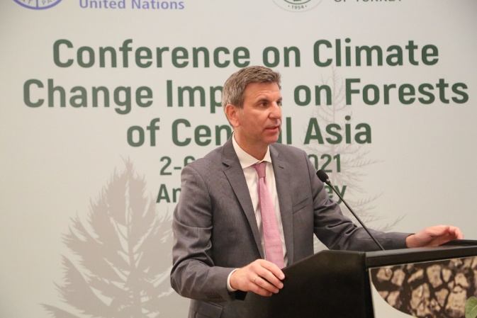 | 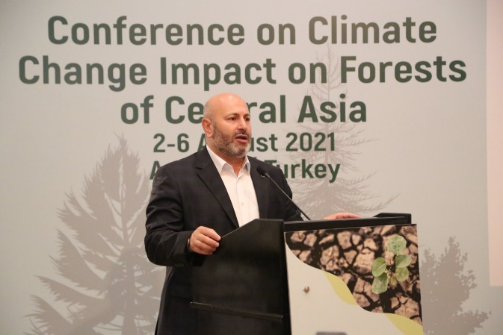

The opening statements were followed by the introductory information provided by Dr. Peter Pechacek, the Forestry Officer, about the concept, background, objectives, purposes, and expected outcomes from the conference. Later on, Mr. İsmail Belen, on behalf of OMO, introduced the conference agenda, logistics, and modalities to the participants.

Picture 3. Dr. Peter Pechacek of FAO (lift-online) and İsmail Belen of OMO (right)
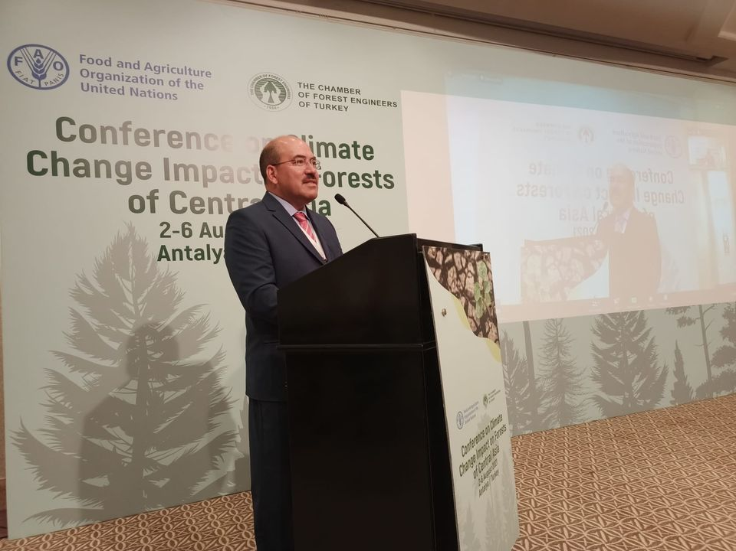

On the first day of the conference, the country representatives delivered country presentations on the impacts of climate change on forests and SFM.

The presentations provided information on various issues, including forest and climate change policies and strategies, institutional structure related to forestry and climate change, state of forests and greenhouse gases inventory between 1990-2020, climate projections and scenarios in Central Asia, changes observed in forests since 1990, SFM and climate change actions, challenges and gaps for SFM, and enabling environment and options for improved SFM.

Picture 4. Representatives of Azerbaijan, Kazakhstan, Kyrgyzstan, Tajikistan, Uzbekistan, Turkmenistan, and Turkey
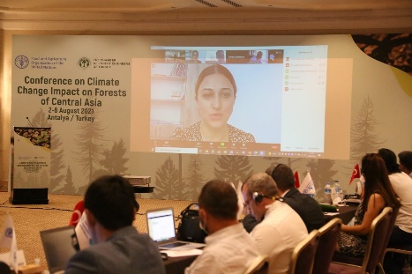 | 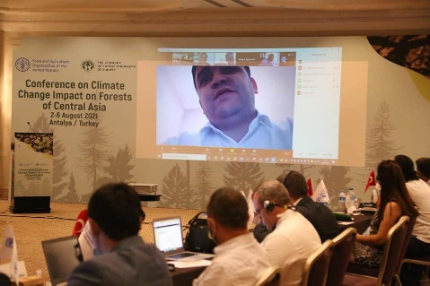 | 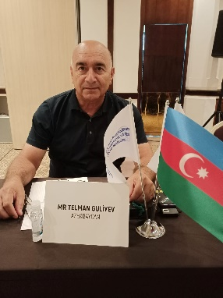
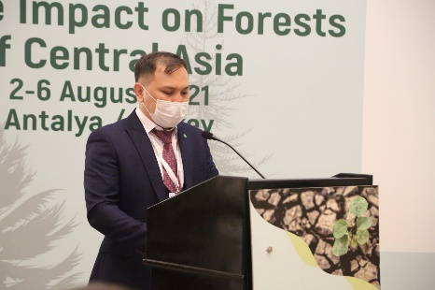 | 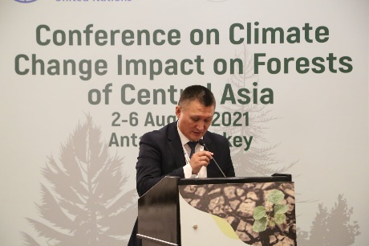 | 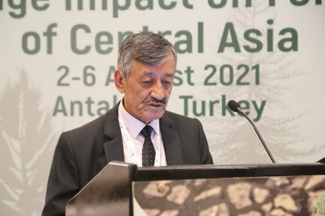
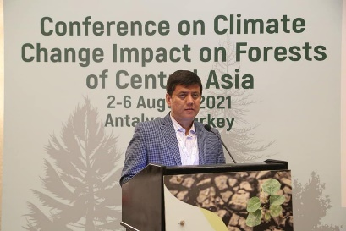 | 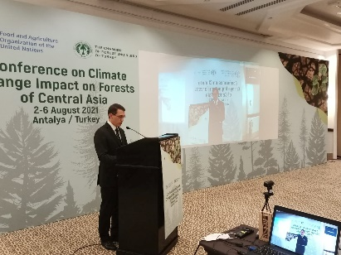 | 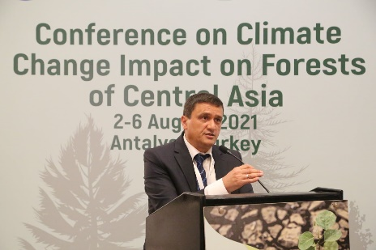

In the afternoon session, a group discussion was facilitated by Prof. Dr. Derya Eşen and Assoc. Prof. Dr. Ayhan Akyol from İzmir Kâtip Çelebi University Faculty of Forestry.

Picture 5. Prof. Dr. Derya Eşen and Assoc. Prof. Dr. Ayhan Akyol
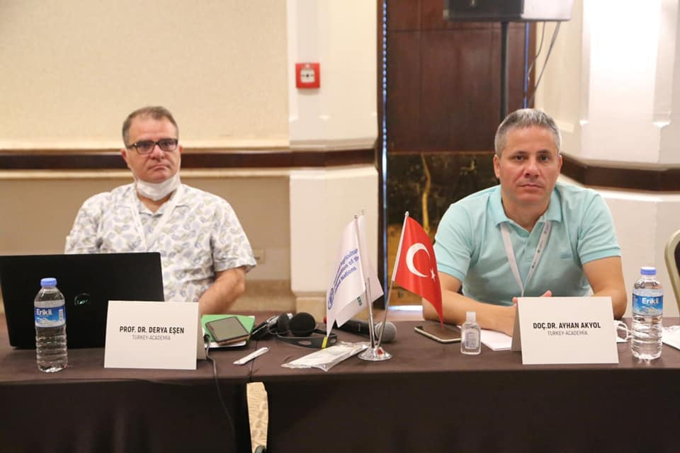 | 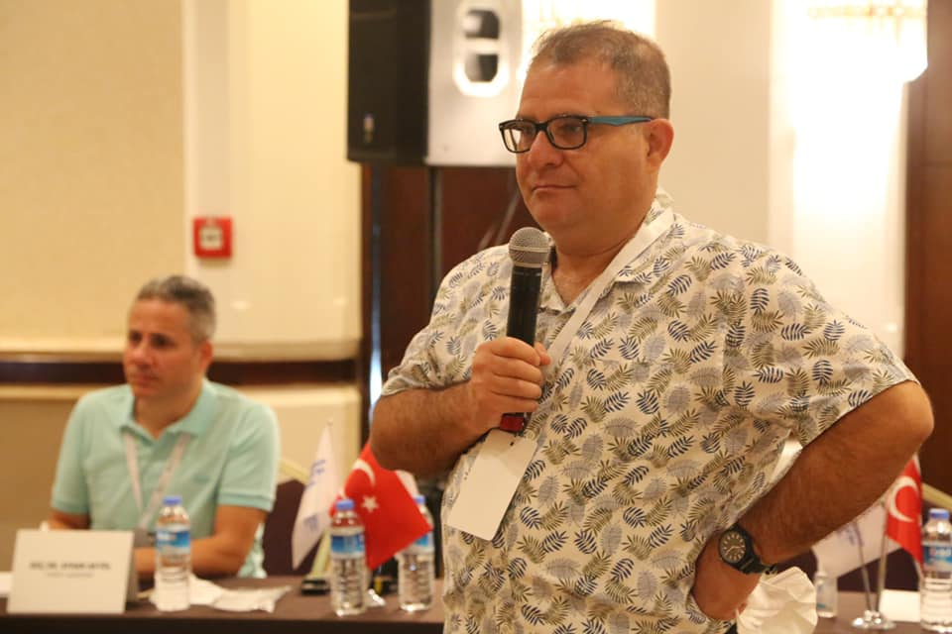

Integrated results of country reports, presentations, and group discussions are presented below.

Forest and climate change policies and strategies

The conference revealed that Central Asia Countries had developed various policies and legislative documents (laws, regulations, strategic documents, action plans) about forests, pastures, environment, soil, hunting, and other land-use types; however, integrating climate change into forest policies and legislation, and other strategic documents is still ongoing.

The forestry policy in Azerbaijan has eight main objectives for regulating forest relations, use, protection, conservation, rehabilitation, and improvement of forests' environmental and resource potential in Azerbaijan.

- Improve forest management through the preparation of long-term development plans for forestry institutions and monitoring forests;
- Improve the forest legislation and reforms in the forest sector;
- Take measures to combat illegal logging;
- Build capacity in the forest sector;
- Apply scientific programs to ensure the connection between science and forest production;
- Register the state forests;
- Increase the capacity of forests for sustainable use through the application of new technologies;
- Assist the local people through more efficient use of forest products.

Azerbaijan has identified social, economic development, and poverty reduction priorities in SFM and climate change reduction. In its Nationally Determined Contributions (NDC), Azerbaijan has committed to reducing greenhouse gas emissions in a range of 35% for all sectors by 2030 through the NDC compared to the base year as its contribution to the global climate change efforts. The NDC targets to plant new forest areas, water and land protecting forest strips (windbreaks), urban roadside greenery, and further improve the management of pastures and agricultural lands.

The country’s climate change mitigation and adaptation strategies are reflected in its long-term government programs such as;
- Strategic Road Map for National Economic Perspectives,
- State Program on Socio-Economic Development of the Regions of the Republic of Azerbaijan for 2014-2018,
- State Program on Socio-Economic Development of the Regions of the Republic of Azerbaijan for 2019-2023,
- National Strategy for the Conservation and Sustainable Use of Biodiversity in the Republic of Azerbaijan for 2017-2020,
- Development Concept Azerbaijan – 2020: Outlook for the Future).

Azerbaijan’s existing policy and legislative framework (Land Code, Forest Code, Environmental Protection Law, Law on Specially Protected Natural Areas and Objects, Law on Animal Welfare, Law on Protection of Green Plantings, Resolution on Measures to Prevent Violations of Forest Legislation, and other laws), including the draft Forestry Programme for 2020-2030, allows climate change actions using a participatory approach. The program promotes and supports sustainable development, expansion, and the management of forests based on the priority objectives of Azerbaijan and represents a sound legal basis for SFM, ensuring the development of institutional capacities.

The Draft Forestry Programme for 2020-2030 aims to achieve the following targets:

- Create institutional capacity and mechanisms for forest management, with a particular focus on changing the requirements and future needs for sustainable development
- Implement specific measures to protect and sustainably manage forests;
- Develop and improve relevant policies and strategies to implement specific measures to protect and sustainable forest management;
- Encourage stakeholders to work closely together, participate in planning, implementation, control, monitoring, and evaluation;
- Strengthen the management of forest resources and their functional use and improve the living standards of the forest-dependent rural population;
- Increase national and international financial support for forestry activities.

Kazakhstan has increased efforts towards integrated forest management. The “Green Kazakhstan Programme” under the “Green Economy” aims to extend the green areas around the cities and other areas in Kazakhstan, increase forest cover, ensure efficient use of resources, adequate waste management, improve air quality, reduce wind/dust storms, halt land degradation, avoid salinity and soil erosion to create resilient settlements. A similar program will be implemented in the Caspian Sea.

Kazakhstan also amended its legislation and increased the penalties for crimes against forests, especially for illegal logging. Moreover, the Special Protected Area Law and the Environment Law were adopted recently in 2020 underlying ecological tourism, the reduction in the long-term use of protected areas from 49 to 25 years, and the methods to build facilities in the protected areas, with a particular focus on the conversion of protected lands into lands for mining. Furthermore, another proposal has been prepared for the collection, use, and export of plants.

Turkmenistan has developed the “Climate Change Programme” and “Forestry Programme” and legislative framework to conserve the environment (i.e., biodiversity conservation, halt desertification, climate change, protection of water resources, ozone protection). In addition, Turkmenistan has signed several international agreements (i.e., RAMSAR) with international forestry organizations and established a centre for climate change. Forest legislation is being revised in coordination with international agreements, and the national policy has been put in place and implemented.

Kyrgyzstan has developed the National Development Strategy of the Kyrgyz Republic for 2018-2040 (the Concept 2040) for all sectors, including the forestry sector reforms in line with SDGs, to extend the forest areas up to 6%, conserve biodiversity by implementing 5-year action plans, ensure the economic and social wellbeing of the people, provide an environmental safety and a favourable environment for the citizens of the Kyrgyz Republic.

The “Concept for the Development of the Forestry Sector” of Kyrgyzstan defines four main priorities for forestry development to achieve this goal. Some of the priority areas are listed below.

- Environmental priorities
  - Conserve forests and increase the country’s forested area up to 6%
    - Improve forest accounting system
    - Strengthen the protection of forests from forest violations and fires
    - Strengthen the protection of forests from pests and diseases
    - Increase the forest area and improve the regeneration of forest resources.
- Social priorities
  - Reduce the poverty level of the rural population in forest areas by 10%.
    - Ensure participatory forest management
    - Diversify income sources
    - Introduce integrated natural resource management
- Economic priorities
  - Increase the contribution of forestry to the Gross Domestic Product (GDP) by up to 1%.
    - Introduce a system of ecological and economic accounting (forest accounts)
    - Create conditions for increasing the economic sustainability of forestry
    - Implement the value chain of forest resources
    - Ensure the rational use of the recreational potential of forest ecosystems.
- Forestry reforms
  - Create favourable conditions for SFM
  - Increase the efficiency of the forest sector

At the moment, the “Concept for the Development of the Forestry Sector” is the crucial document, developed on a bottom-up basis, with the active participation of all stakeholders and contains the goals, objectives and strategic directions of the long-term and medium-term vision for environmental protection, climate change adaptation, and disaster risk reduction. The main objective of Concept 2040 is to increase the contribution of forest resources to total GDP by 1% reduce poverty by 10% in 2040. Revision of the Forest Code is underway to improve the forestry sector and associated legislation. A new version of the regulation on “Procedure for leasing and using forest land plots” was developed and approved by the Government of the Kyrgyz Republic in 2018.

The Resolution on the “Regulations on the organization and implementation of measures to develop directions and approaches to reforming the forest sector of the Kyrgyz Republic” aims to develop approaches and directions for the forestry sector reforms, taking into account the practical experience of new approaches on forest management in pilot areas.

Kyrgyzstan has also developed SFM C&I recently to implement and monitor SFM practices in a systematic way.

However, the legislation regulating the management regimes for pasture and forest resources is inconsistent and contradictory, leading to confusion and instability in management regimes in practice and overexploitation of resources.

Tajikistan has adopted the Law on Specially Protected Natural Areas in 2011 and recently passed new forestry legislation to conserve forest areas, biodiversity, and water resources, rehabilitate degraded forests, and updated the hunting code. In addition, Tajikistan implemented a State program to conserve forests and rehabilitate degraded forests between 2006 and 2015. Moreover, a climate change strategy until 2030 has been adopted to tackle climate change. The incorporation of international agreements such as biodiversity, ozone, desertification, and climate change mitigation are underway. Nevertheless, the legislative system for forestry and specially protected areas needs serious updates and improvement, as it primarily affects the status of forests and forestry in general and the water resources, soils, and fertility.

Uzbekistan has an ongoing process to update the forestry legislation and develop the Forestry Concept 2030 to improve water resources, ensure efficient use of water resources, improve sanitary conditions of forests, increase income, and conserve forest ecosystems. In this context, 60 legislation documents have been prepared between 2017 and 2021 (i.e., Decree on Measures for Further Improvement of Forest Management System, Decree on Approval of Concept for the Development of Forestry in Uzbekistan until 2030). The government prioritizes the following aspects:

- Implement measures to prevent desertification, reforestation, and increase protected forest areas in the country;
- Fulfil international obligations of Uzbekistan to combat desertification and drought;
- Ensure practical cooperation with international and regional organizations to combat desertification and drought;
- Coordinate the work among ministries, departments, and local executive bodies involved in the development and implementation of programs and projects to combat desertification and drought in Uzbekistan;
- Act as the competent national authority of Uzbekistan in the framework of compliance with the requirements of the UNCCD.

Although action plans are available for climate change adaptation, climate change has not been directly integrated into policies and strategies due to the lack of climate change experts and adequate institutional framework.

In addition to the Constitution, Turkey has developed national policy instruments (five-year development plans, medium-term financial plans and programs, annual presidential government programme, national forestry programme), corporate policy instruments (strategic documents and action plans), national, sectoral, and thematic strategies (National Climate Change Strategy and Action Plan, National Climate Change Adaptation Strategy, National Watershed Management Strategy, National Biodiversity Strategy and Action Plan, National Strategy on Combating Desertification and Action Plan), legislation (Forest Law, other laws, regulations) for strategic governance.

Additionally, Turkey updated SFM Criteria & Indicators (C&I) (6 criteria and 45 indicators) in 2018 to enhance forest reporting requirements and monitoring under climate change conditions.

Moreover, Turkey submitted its Intended Nationally Determined Contributions (INDC) in 2015 to achieve an 18-21% greenhouse gas reduction (246 million tonnes CO₂e) by 2030 compared to the Business as Usual (BAU) scenario. Forests are expected to reduce 29.5 million tonnes CO₂e by increasing the forest area from 28% to 30% until 2023 and increasing the average growing stock per hectare by rehabilitation and restoration programs.

Developing SFM C&I has not been initiated in Central Asia countries, including Azerbaijan. However, Kyrgyzstan and Turkey set excellent examples by developing SFM C&I operationalizing policy and strategy documents.

Despite the recognition of the forestry sector as a critical sector for climate action and an actual number of progressive laws, policies, and strategic documents in Central Asia to improve the productivity and sustainability of the forestry sector, this legislation and guiding documents still lack the appropriate systematic mainstreaming of climate change mitigation and adaptation actions. Strategic roadmaps and State programs that incorporate climate change mitigation and adaptation measures cover all the sectors of the economy, and therefore, a sector-specific separation of measures should take place determining the direct contribution of the different sectors.

Moreover, the strategic documents are not synchronized to respond to international commitments, resulting in a short implementation lifespan. Similarly, no specific baseline data or target data for each measure/activity/outcome have been defined in the developed strategic programming documents, making therefore difficult to assess their contribution to climate change implementation; correct recording of these activities under each roadmap and program has critical importance to avoid duplication of the data.

Institutional structures related to forestry and climate change

Country representatives provided information on the institutional framework of forestry and climate change during their presentations. All forest lands are almost exclusively owned and managed by the State through “Forest Agencies” at central, regional, and local levels. Additionally, Tajikistan has community-owned forest areas.

It should be noted that all countries have an institutional framework for forestry and climate change. However, these structures need to be re-organized and strengthened by technical and financial aspects to improve SFM practices and climate change measures.

For example, Azerbaijan established the State Commission on Climate Change in 1997 and Climate Change and Ozone Center in 2000 to contribute to global climate change efforts under UNFCCC. However, no mechanism exists to involve local forestry units and communities in Azerbaijan’s forestry operations, and forestry officers’ livelihood standards and social rights are pretty low.

Turkmenistan is establishing a Climate Change Monitoring Centre to accelerate climate actions. Kazakhstan has established a new technology branch for the development of forest management plans.

Turkey has had a robust institutional framework at the central and local levels in forestry (General Directorate of Water Management, General Directorate of Nature Conservation and National Parks, General Directorate of Combating Desertification and Erosion, General Directorate of Meteorology, General Directorate of State Water Affairs, Turkey Water Institute, General Directorate of Forestry-since 1839) and climate change (General Directorate of Environmental Management).

Moreover, the Climate Change and Air Management Coordination Board are responsible for implementing climate change policies in Turkey, and Land-Use, Land-Use Change and Forestry (LULUCF) sector is one of the members of this Board. The institutional framework includes organizational structures, human and financial resources.

The implementation of forestry and climate change commitments in the forestry sector depends on the leadership and strong push of the agencies, which present limited potential to lead climate action in Central Asia—given inadequate internal institutional structures, limited knowledge, and the limited number of skilled and specialized staff on climate-related issues. In this context, the work of various ministries on climate-related measures has not been implemented to the extent needed, nor the responsible agencies are presented with good opportunities to take decisive actions to accelerate their implementation process due to the limitations mentioned above.

Furthermore, the inter-institutional arrangements established to coordinate forestry and climate change matters have limited operational capacity. In this sense, there is limited coordination among the responsible bodies to ensure climate change measures under international commitments.

State of forests and greenhouse gases inventory between 1990-2020

In Central Asia, forests are located in mountains, valleys, floodplains, and deserts and are unevenly distributed. Forests cover 5.7% of the total land, representing a low forest cover compared to the world’s average.

More specifically, forests cover 1.3% of the total area in Kazakhstan, 6.9% of the total area in Kyrgyzstan, 3.1% of the total area in Tajikistan, 8.8% of the total area in Turkmenistan , and 8.7% of the total area in Uzbekistan.

Azerbaijan and Turkey present different figures from the rest of the Central Asian countries because of the geographic and climate conditions. Forests cover 13.7% of the country area in Azerbaijan and 28.9% in Turkey.

Forest areas in Forest Resources Assessment (FRA) reports and countries’ national statistics may not be comparable due to variable forest definitions in national legislation. For example, Kazakhstan reported 30.1 million ha forest fund area (13.5 million ha covered by trees) in its country report, and however, according to the FRA report, forest cover 3.5 million ha in Kazakhstan in 2020. Similar or contrary examples could be given for Turkey, Kyrgyzstan, Turkmenistan, and Uzbekistan as well.

The region has diverse forest types, including mesic forests in the Black Sea Region of Turkey and along the Georgian border of Azerbaijan in which eastern beech (Fagus orientalis), hornbeam (Carpinus sp.), linden (Tilia sp.), and chestnut (Castanea sp.) are distributed and the xeric forests in arid and semi-arid lands of Central Asia which provide habitat for gymnosperms including juniper (i.e., Juniperus turkestanica), spruce and pines (mainly Pinus elderica), and angiosperms including saxaul (Haloxylon sp.), pistachio, almond, wild pear, wild apple, walnut, oaks, and others.

Saxaul plays a critical role in soil conservation in Central Asia and provides fodder for livestock and firewood. For example, saxaul makes up more than half of the forest cover in Kazakhstan, and the sustainability of saxaul is, therefore, critical to providing various goods and services.

Climate projections and scenarios in Central Asia

According to Intergovernmental Panel on Climate Change (IPCC) climate change projections and scenarios, a 2⁰C to 5.7⁰C increase in annual mean temperature is expected to occur in this century. Moreover, precipitation regimes, including within-year patterns and rainfall distribution, are projected to vary considerably, resulting in less snowfall and glacier melt, especially in mountainous areas.

The number and intensity of extreme weather events (i.e., storm intensity and frequency, permafrost, more dry days, low humidity), drought, wildfires, biodiversity loss, pests, and diseases will significantly occur more in Central Asia. This will increase the vulnerability of forests to climate change resulting in more frequent landslides and floods.

Similar projections and scenarios were developed for Turkey, predicting increased temperature and wildfires, especially in the Mediterranean and floods in the Black Sea region. In general, working conditions will change in forests under increased temperature and limited work power. For example, today’s success rate for afforestation could be different in the future under new climate conditions.

Mountainous forests and pastures are expected to shrink in size and occur in higher elevations. On the other, whether the soil in these higher elevations will support these ecosystems is unknown. Slow-growing juniper forests are expected to replace some mountainous forests with lower levels of species diversity. However, the carbon sequestration rate is expected to increase due to the increased CO₂ rates in the atmosphere.

In general, the following list of potential impacts of climate change on forests in Central Asia is presented:

  - More frequent extreme events and disturbances including wildfires, prolonged dry spells, floods, hurricanes, avalanches, landslides, pest infestations;
  - Critical variations in the abundance and distribution (both vertical and horizontal) of native tree species at the regional level;
  - Decline in the quantity and quality of wood production and critical changes in ecosystems;
  - A decline in biodiversity and loss of endemic species;
  - A decline in NTFP (e.g., mushrooms, berries, almonds, and walnuts) production and ecosystem services (e.g., water quality and quantity);
  - Increased frequency and intensity in natural disasters due to declining in forest functions;
  - Sustainability issues related to the timber supply chain due to changes in the quantity and quality of timber supplied;
  - Changes in land-use types due to increased demand for agricultural land;
  - Impact on other sectors, especially agriculture, energy, and water resources;
  - Critical ecophysiological changes for plant species (e.g., photosynthesis and evapotranspiration, reproduction, pollination, seed propagation, phenology);
  - Deterioration in the livelihoods of the rural population, including forest-dependent people and increased risk of internal and external migration.

Observed changes in forests since 1990

A decline in water resources and increasing water scarcity/shortage is a common problem in Central Asia that will affect forest growth, drought, and soil salinity in the future. Additionally, all countries have reported that average annual temperature, daily minimum temperature, and maximum temperatures increased in the last decades with an increasing number of warm days above 10⁰C (e.g., Azerbaijan). In recent years, summers have been sweltering, and winters have been mild due to climate change.

Natural tree and bush species have shown significant adaptation problems to changing site conditions. For example, regeneration of saxaul in Uzbekistan now faces problems due to water scarcity and temperature increase, and assisted natural regeneration is necessary for successful regeneration. Also, the mean survival rate of saxaul seedlings has recently declined to 2-5% in Kazakistan. Dramatic reductions have also been observed in the natural regeneration rate of the other species in Azerbaijan and Kazakistan. In addition, Azerbaijan mentioned that protected areas had suffered significant biodiversity loss, and changes in the visual landscape have been apparent.

In addition to a dramatic reduction in the mean seedling survival and growth rate of trees and ecosystem services in the last decades, the participant countries have reported an increased frequency and intensity for wildfires, soil erosion, landslides, and floods. Reduction in quality and quantity of available pastures and overgrazing have added more pressure on forestlands. Furthermore, the spread of pests and diseases has increased in forests.

Turkey indicated more frequent and intense wildfires and stressed the critical damage on wood and NTFPs (e.g., honey) production by wildfires, impacting the local communities and economy. The frequency and intensity of floods and landslides have recently increased dramatically in the Black Sea region, requiring an integrated and holistic approach for land-use management (i.e., Turkey Resilient Landscape Integration Project -TULIP).

More extreme weather events (extreame heat, storms, drought, flood, landslides, wildfires), changes in the precipitation regime (e.g., less and erratic annual rainfall volume and distribution, less snowfall), increase in salinization (e.g., after shrinkage of the Aral Sea, a new 5.5 million-ha saline land or Aralkum was formed in Uzbekistan), increased food prices due to natural disasters, increased frequency and intensity of wildfires, pest and diseases occurrences (causing financial losses in walnut forests in Kyrgyzstan, for instance), the spread of invasive species and associated costs for disaster management, migration to urban areas due to low living standards (rural poverty) and adverse effects of climate change, problems in natural regeneration of forests (i.e., saxaul and juniper forests in Uzbekistan), decrease in pistachio (from 60 tons to 20 tons), apricot, fig and pomegranate production due to more frequent dust storms and frost in Tajikistan), extended dry spells, forest degradation, soil erosion, melting glaciers (i.e., Tien Shan and the Mt. Pamir-Alai), varying growing period, and increased CO₂ emissions could be listed as the observed changes reported for Central Asia.

About 45% of all glaciers in Central Asia are in the territory of the Kyrgyz Republic, which is one of the primary sources of water for rivers. Due to global climate change, forecasts for the state of glaciers are of particular concern. According to expert estimates, glaciers are melting due to deforestation in the spurs and local environmental changes. The air over forested mountain slopes has a lower temperature and higher humidity than that above-nonforested slopes. Therefore, research focusing on the effects of alpine forests on glaciers is necessary for the Kyrgyz Republic to understand the influence of forest ecosystems on the dynamics of mountain glaciers.

SFM and climate change actions

The conference showed that the countries had recently implemented various climate change mitigation and adaptation actions in the forestry sector. Substantial efforts have been made to restore and increase forest cover and land as a significant contribution to carbon sequestration. Plantation activities have been launched in partnership with national non-government and private entities. These efforts have been complemented with analytical and capacity development efforts related to the sustainable management of forest resources and land use.

All Central Asia countries are aware of the impacts of climate change on forests, and they are committed to increase forest areas and conserve the existing forests and biodiversity. However, the first step to SFM or forest inventory is outdated in Central Asia, except Tajikistan and Turkey. A few projects have started to update forest inventory at the local level (e.g., Azerbaijan).

Afforestation and natural regeneration have a critical role in extending the forest areas and tackling climate change.

For example, Kazakhistan aims to increase forest areas by 5% by 2025 by planting two billion seedlings with drought-resistant and economically valuable pine, oak, walnut, and linden tree species. Kazakhstan has established 155 new forest nurseries and modernizes the existing nurseries to provide high-quality seedlings to achieve the objectives mentioned above. In addition, Kazakhstan established eight particular plantations with fast-growing tree species in the last decade. Maps will be developed for forest monitoring purposes. Additionally, fire and pest and diseases risks are aimed to be reduced by 20% in 2025.

In addition, wind storms have damaged a 480k ha area in Almati, but restoration work is ongoing. Additional work is being conducted to save the Aral Sea basin from salinity and improve soil fertility through afforestation activities of saxaul species (250k ha). The afforestation area in the Aral Sea will be extended to 1 million ha. Renewable energy (i.e., wind-powered energy) is also of critical importance for Kazakhstan, and some work has been conducted to increase the share of renewable energy in energy production. Kazakhstan has employed 12k employees to conserve the forests and biodiversity. Finally, Kazakhstan has leased some forest areas to the local people to conserve forest areas, improve local livelihoods, and ensure food security

Azerbaijan has signed Memorandums of Cooperation with Denmark and Germany to participate in international and regional programs to increase knowledge in climate change, strengthen the capacity to develop and implement projects to reduce greenhouse gas emissions. Additionally, Azerbaijan has participated in various international programmes (training, technical assistance) about reducing greenhouse gas emissions, implementing climate change commitments, increasing capacity about the Kyoto Protocol mechanisms such as the Clean Development Mechanism.

Azerbaijan has also stressed Tugai forests’ importance in valleys and the need for extensive rehabilitation and reforestation programmes to establish forest strips. Protective forests could be an option for Alpin sites to reduce water erosion under a watershed management approach. An action plan should be developed and implemented based on unique projects to conduct landscaping in ravines and Caspian coastal sands. The washing of saline and re-salinized soils and the establishment of ameliorative forest strips of tree species suitable for the soil and climatic conditions in these areas may allow the return of large areas of decommissioned land for agricultural use in the future. Along with the lands of the state forest fund, planting greenery in large areas around large industrial enterprises is also one of the crucial directions.

Azerbaijan has stressed the need to increase the extent of reforestation activities and establishing protective forest strips, especially in low-forested and non-forested lowland areas (Tugai forests). Moreover, an action plan is needed to restore the ravines and coastal parts of the Caspian Sea.

Picture 6. Tugai forest
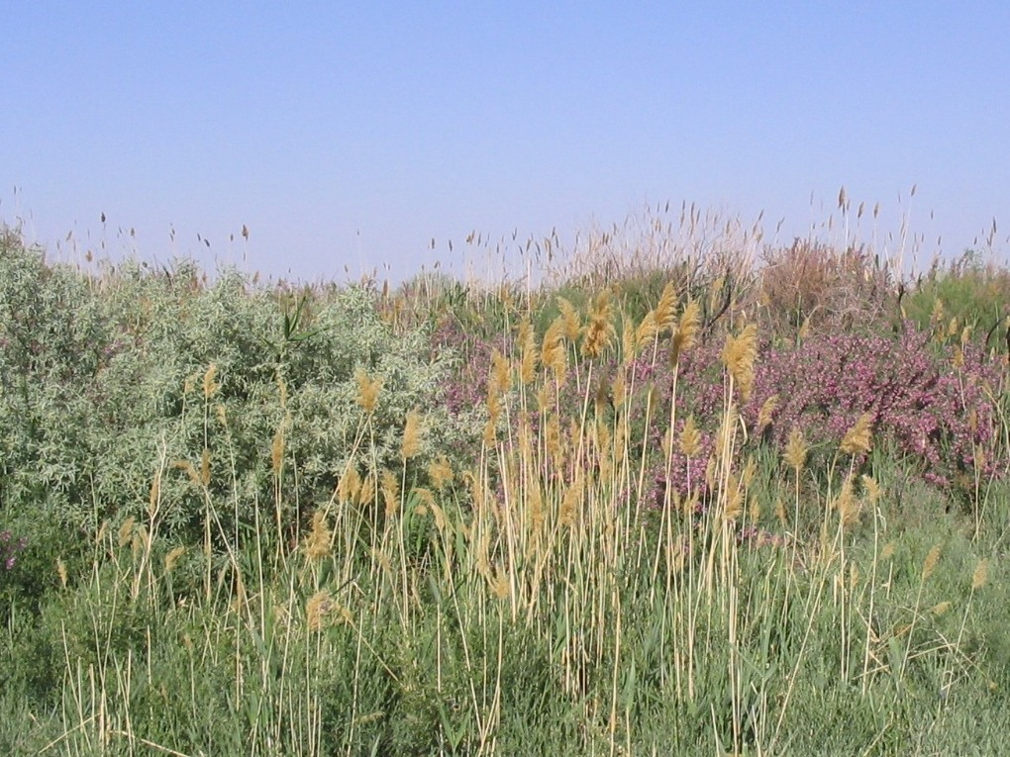

State programs will support the design of forestation and forest restoration projects, plantation of fast-growing trees, restoration and expansion of Tugai forests, and implementation of agroforestry practices.

In this context, high-quality seedlings of forest and fruit trees (i.e. almond, olive, pomegranate, lemon, grape, apple, nuts, citrus) will continue to be propagated to establish new forest areas and fruit tree orchards/gardens.

According to information by the representatives of Azerbaijan, action plans will be prepared for the rehabilitation and restoration of anthropogenically degraded forestlands. These activities will be followed by establishing new forest areas and forest parks and restoring degraded forestlands affected by the major industrial and mining facilities using locally adapted multipurpose and fast-growing tree and bush species and high-quality seedlings. Besides, an economic approach will be followed to protect the environment, which includes using tree species of economic importance (i.e. olive, almond, pistachio, pomegranate, mulberry, and fig). Fruit trees and perennial grass will be planted in the existing terraces to enhance erosion control in mountainous and foothill areas. Economically viable types of plants will be used to create greenery in non-forest lands unsuitable for agriculture.

Additionally, honey forests will be established to support the development of the honey production sector. These measures will be implemented in the forest fund lands, open forest fund lands, and new land plots allocated to the forestry fund using natural regeneration and cultivation methods.

Turkmenistan develops projects for the integrated use of water resources in the Caspian Sea. Moreover, Turkmenistan conducts afforestation activities with drought-resistant plant species and established the “Golden Century Lake” in the Karakum Desert to improve the climate conditions and conserve biodiversity. Turkmenistan has also assigned protected areas for biodiversity conservation.

The environmental disaster in the Aral Sea region of Uzbekistan, formerly abundant in flora and fauna species, has resulted in a sharp decrease in biological diversity in this area. In this sense, Uzbekistan declared the Aral Sea region an environmental protection area and plans to implement afforestation activities for 500k ha until 2030 to create the green cover zone. In total, afforestation activities have been conducted in 1.5 million ha to support climate change mitigation actions with saxaul (Haloxylon aphyllum) and Tamarix ramissossima.

Picture 7. Saxaul and tamarix
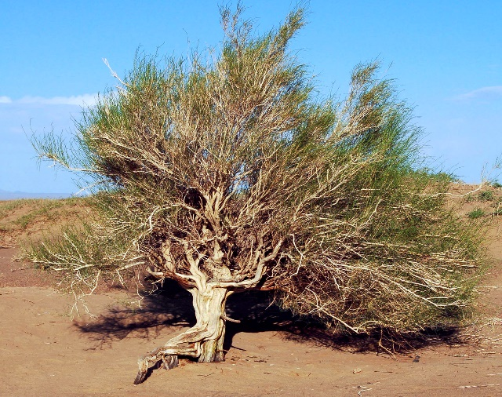 | 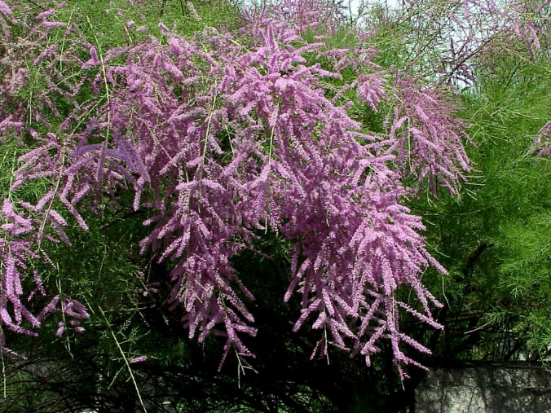

The main ecological task of forests and woodlands in the Aral Sea basin includes greening area, climate change mitigation, carbon sequestration, fixing sand and dust, and water flow regulation. Moreover, Uzbekistan implements international projects related to forestry and climate change.

The most valuable nut species in Uzbekistan is the pistachio. Currently, pistachio plantations cover more than 30k hectares. In recent years, the area under walnuts (pistachios, almonds, walnuts) has increased significantly. In particular, pistachio plantations have been expanded in the low- and non-irrigated areas of the country. There are many opportunities for further development of this sector, such as 7.8 Mln ha land categorized non irrigated area suitable for pistachio plantations. As well, the profitability of the pistachio plantations is higher compared to cotton yields and the same time, the source of mitigating the CO₂ emissions. The pistachio plantations are very resistant to droughts and dry conditions, and pistachio plantations seem to be a possible and probably the only solution for reforestation of the arid foothill zones of the country.

As a result of afforestation activities, the wind speed has decreased by 60%, and salt/dust movement has decreased six times around 3–year old plantations, or from 30 days to 9 days through the plantation activities in cities. In 6-year-old plantations, the wind speed has dropped to 90%, and the salt and dust transfer has almost stopped in Uzbekistan.

Kyrgyzstan has recently developed an action plan under Concept 2040 to extend forest areas by drought-resilient species and conducts activities to conserve biodiversity and tackle climate change. In this sense, Kyrgyzstan planned a 1000-ha annual plantation and expanded the existing protected natural areas to 10%. Moreover, amendments are ongoing to include ecosystem services, payments for ecosystem services, and high conservation value forests in the forestry legislation, mainly the Forest Code, to stimulate the improvement of the forest management system.

Kyrgyzstan has also highlighted that the pasture law should be updated to reduce the pressure on forest areas. However, over the past 17 years, the forestry system has undergone several transformations, which concerned only the republican and regional levels, but these transformations did not positively impact the quality of forestry.

A brand new approach of SFM has been introduced in Tajikistan by applying so-called Joint Forest Management when the locals live around the area of projected activities in forests and the employees of Forest Management Units. They participate in the protection of forests, carrying out work on forest restoration, combating forest pests and diseases, and receiving timber, NTFPs, or the right to use hayfields.

Tajikistan implements annual plantation activities for 2k ha to increase the greenhouse gas mitigation potential through a participatory forestry sector development, leases forest areas to local people to conserve forest areas, improve local livelihoods, and ensure food security. Moreover, Tajikistan focused on the problems related to regeneration activities. According to the latest forest inventory, forest health has had some issues in the last four decades. Tajikistan reported the increased number of floods, landslides, and natural disasters and increased budget for efficient protection. In this sense, Tajikistan will implement containerized seedlings in a 100 ha area for trials with irrigation systems.

Furthermore, Tajikistan has initiated strategic governance to integrate climate change and developed a database for fast-growing species. Tajikistan also develops a new concept for walnut and almond plantations. Tajikistan has also established protected areas, and the new hunting law has been entered into force. Finally, Tajikistan has conducted afforestation activities in 66k ha with mostly saxaul and pistachio.

Turkey presents an excellent example of SFM and climate change actions. Turkey manages its forests with multifunctional forest management plans, including a 6.6 million ha forest area certified to ensure SFM. In addition, Turkey has implemented afforestation activities on 2.51 million ha, rehabilitation activities on 3.25 million ha, erosion control activities on 700k ha, soil conservation activities on 1.58 million ha, pasture rehabilitation on 269k ha, and private afforestation activities on 146k ha.

Turkey also develops forest, carbon, and erosion monitoring systems and watershed management and forest management plan to implement integrated watershed management projects and species-specific action plans for rehabilitation. Turkey improves the product quality, or support the production of NTFPs for food security, organizes capacity building and awareness-raising events, develops master plans for protected areas, establishes industrial plantations on 61k ha for round wood production, implements forest-community projects to support rural development (provision of solar power, water heating systems, insulation), conducts studies on land degradation neutrality, biodiversity inventory, and seed improvement trials.

Moreover, Turkey has developed Watershed Monitoring and Evaluation System, Dynamic Erosion Model and Monitoring System, and National Dynamic Wind Erosion Model Monitoring System for erosion control purposes. In terms of SFM C&I, Turkey has developed a guideline for data collection and reporting.

The forestry sector reforms and climate change actions continue to be implemented under several projects supported by international/national donors and the governments of Central Asia countries. The projects mainly cover policy development, SFM and integrated land management approaches, integrated watershed management, forest management plans, biodiversity conservation, climate change mitigation and adaptation, rural development, capacity development, and awareness-raising involving relevant stakeholders.

In general terms, it is essential to highlight that despite the different incentives and credit lines allocated by the Governments to increase the productivity of the forestry sector, the implementation of climate-related actions is under-budgeted, and institutions require different types of financial and non-financial support, including technical assistance, capacity strengthening and innovative technology solutions to guide efficient climate action and measures.

Challenges and gaps for SFM

The contradictions and collisions of the norms of forest legislation have led in practice to numerous problems in forest legal relations between the subjects, to the loss of institutional balance and the absolute inability of forestry entities to conduct practical activities aimed at the protection, reproduction of forest ecosystems, ensuring the rational use of forest ecosystems, preserving the biological diversity of forest ecosystems, increasing the ecological and economic potential of forests in Central Asia.

The practice of managing forest ecosystems has also shown the ineffectiveness of the simultaneous fulfilment (combination) of forest management and forestry functions by forestry enterprises, which also contradicted the basic requirements of the legislation.

In recent years, many new laws have been adopted in various fields, which have greatly influenced forestry entities’ institutional and financial sustainability, creating conditions that impede sustainable forest management.

In the forest management system, new problems arise in forming mutually beneficial economic relations between the State, the owner of the forest fund, and the business in the field of forest management.

The most critical challenges and gaps for SFM are listed below for Central Asia.

- Lack of a comprehensive legislative framework that directly focuses on climate change,
- The lengthy approval process for strategic documents that delay the implementation of the climate change actions,
- Underestimation of forests and forestry sector in GDP and climate change,
- Inefficient forest management systems,
- Lack of holistic and multi-dimensional (social, environmental, and economical) way of thinking,
- Limited participatory/joint policy development and forest management approaches,
- Lack of integrated management approaches (i.e., overgrazing in pastures increases forests’ pressure and eventually leads to land degradation),
- Lack of effective stakeholder consultation and adaptive management approach based on monitoring results,
- Limited relationship between the forest agencies and the community to analyze the community needs and implement measures,
- Limited coordination between government, academia, non-governmental organizations (NGOs), and private sector,
- An ongoing process on the integration of climate change into forest policies,
- Limited law enforcement,
- Limited financial resources and economic assessments on forests,
- Ineffective financing system and a lack of investments,
- Lack of forest accounting systems,
- Inadequate compliance with commitments originating from international conventions,
- Lack of observations and monitoring on forests and impacts of climate change on forests,
- Lack of vulnerability and risk assessments,
- Lack of SFM C&I,
- Limited certified forests,
- Lack of updated forest inventory,
- Extreme weather events,
- Insufficient number and capacity of technical climate change experts,
- Limited forest fire, pest, and diseases management capacity,
- Lack of regional and national coordination mechanisms,
- Lack of research, especially for determining drought-resilient native species for afforestation activities,
- Lack of modern tools for economic planning, forecasting, and organization of forest use,
- Limited capacity development and awareness-raising activities,
- Lack of quantifiable targets for measurement and reporting,
- Decreased level of income of local people and livelihoods or increased rural poverty,
- Increased demand for wood and wood import due to increased fossil fuel prices,
- Lack of transparency and accountability,
- Disinformation on social media,
- Land degradation, salinization, drought, floods, landslides,
- Lack of water resources management,
- Limited knowledge of rural population about SFM,
- Low salaries,
- Rural poverty-migration,
- Rapid urbanization,
- Population growth and aging,
- Environmental pollution,
- Increased number and frequency of forest fires, pest, and diseases,
- Biodiversity loss,
- Diversity in demand and expectations from forests,
- Differences in socio-cultural and socio-economic approaches,
- Inadequacies within the scope of research and development,
- Global, regional and national instability (wars, terrorism)
- Financial problems,
- Inadequacies in monitoring, evaluation and reporting systems developed based on holistic and holistic approaches,
- Differences between priorities of political decision-makers and priorities of SFM,
- Priority differences between the central government and local governments,
- Property issues,
- Legal permits in forests,
- Conflicts of authority, duty, and responsibility,
- Production pressures due to the extreme increase in demand for wood products in recent years,
- Excessive orientation to non-wood products and services (excessive use of places such as recreation areas, urban forests, deterioration due to capacity violations, irregular use of non-wood products)

Proposed SFM measures to enhance climate action

Beyond acting as a greenhouse gas sink, forests also have social-economic importance. Conference discussions focused on directly Central Asia region to propose local and cost-effective NBSs under the impact of climate change to promote sustainable natural resource (forest) management, facilitate policy and strategy development, guide forest practitioners and contribute to rural development.

In this sense, first, implementing SFM practices and adapting the Green Economy concept to contribute to climate change mitigation and adaptation is highly stressed.

Participatory forest management approach and increased stakeholder consultation, developing SFM C&I, safeguarding native flora and fauna for conservation of genetic biodiversity, especially protection and enhancing of rare and endangered species, increasing the protected area network, conservation of old and stress-resistant forests, genetic research in flora and fauna, selecting native species to local conditions and climate (drought, temperature, pest, and disease-resistant), revising forest inventory with georeferenced database and national forest monitoring system, afforestation activities with native species to extend the forest areas, integrated rehabilitation activities around the Aral Sea and in other degraded lands, increasing carbon storage capacity by extending rotation period, fire management and pest and diseases management, improving eco-tourism, increasing water resources, effective waste management and recycling, effective use of wind power, increased forest research and development, innovative methods to conserve soil resources, implementing capacity building and awareness-raising events for different target groups were offered for Central Asia region.

In forestry, the requirement to develop adaptation measures in forest plans is a progressive step to protect the ecological potential of forests, adapt to climate change and increase the sustainability of forests. However, the analysis of the new forest plans shows that adaptation measures do not meet the consequences and threats of the possible consequences of climate change. A common problem with the new plans is that measures to protect forests from fires or pests are being developed without considering climate change and the lack of consistent forecasts. Climate change is already leading to changing patterns of disruption, including more and more catastrophic fires across the country.

There is an urgent need for a program to adapt forests to future disturbances. Potential vulnerability mitigation strategies include the transition to risk-tolerant, adaptive forest management, aimed at reducing stressors, reducing vulnerability, and increasing the adaptive capacity of the forest sector and forest ecosystems. It requires integrating vulnerability mitigation and risk management into planning processes, selecting reliable, diversified, cost-effective adaptation measures, and adopting an appropriate institutional framework. The improvement of knowledge and operational monitoring is essential for the implementation of adaptive forest management.

Elements of the forest fire protection systems should include analysis of current and future fire regimes, development and implementation of more effective forest fire protection concepts. For this purpose, the adaptation of forest landscapes to future climatic conditions (adapted species composition, vegetation and forest structure, control of forest fuel content), development of effective firefighting systems and creation of mobile firefighting systems, improvement of forest management legislation and institutional structures, as well as expansion of international cooperation is required.

Similarly, changes in the distribution of forest pests pose a threat. Modern scientific approaches allow the detection and prediction of pests. It is necessary to strengthen forest pathological services’ staff and logistical support and develop biological methods against pests. A common problem in existing forest plans is the development of measures for the protection or subsequent restoration of forests, taking into account the scale and size of the forests without considering their expediency. All plans must consider this scale and, at the same time, limited forest infrastructure and the resources to implement these plans.

The spatial features of the impact of climate change require the development of regional adaptation measures for the mountain, valley, and plain forests.

Dilution reduces water consumption and can change the species composition and structure of forests. Given the experience of selecting appropriate genetic sources, new silvicultural strategies are needed to protect dominant tree species under climate change. Facilitating the migration of forest species can assist species change on a local and continental scale. In addition, plans for the capacity and quality of firewood supplied may be changed as natural degradation regimes are strengthened.

The success of adaptation measures depends mainly on the development of reforestation technologies. Reforestation should aim to create more climate-resistant plantations by reducing the risk of forest fires. After deforestation, fires, pests, and diseases, lands that are temporarily not covered by forest cover should be rehabilitated naturally. Natural recovery often leads to the replacement of valuable species with less valuable ones. In reforestation, more tremendous efforts should be made to maintain or increase the forest sector’s species required for wood production.

The underdeveloped infrastructure of the forest sector currently hinders the sustainable management, use, and protection of forests. It is vital to invest in road networks, improve forest protection and reduce the risk of danger. Effective adaptation measures require changes in several rules (forest management rules, service deforestation, reforestation). At the state level, all normative documents need to be revised to identify and edit the most important sections to ensure climate adaptation.

There is a need to improve the monitoring of the condition of forests and ecosystem services, which they provide as a database to reduce the effects of climate change and make decisions on forest management under climate change. For the forest sector, a decision support system and risk management related to State and regional policies for the development of the forest sector can be an essential tool for addressing economic opportunities. In addition, a strategic approach to adaptation requires changes in forestry education. Existing educational standards and higher education programs on the impact of climate change on various sectors of forestry, as well as retraining courses for existing forestry workers, should be organized.

Priority objectives and climate-related activities include improving forest legislation, enhancing institutional and staff capacity through integrated land management and multi-purpose (integrated) management planning, and increasing financial mechanisms.

Biodiversity conservation has critical importance for climate change adaptation. In this context, various measures such as establishing gene banks to protect genetic resources; restoration of vulnerable ecosystems with high genetic and biological diversity value through rehabilitated habitats should be considered. Besides, institutional capacities in the planning, management, and use of biodiversity should be strengthened, including reinforcing and expanding the collaborative management and cooperation between organizations for biodiversity conservation and afforestation, pasture management.

Measures for improving the knowledge and skills of forestry institutions and other related organizations on climate change adaptation should be implemented through conducting scientific studies and sharing their results with relevant international institutions and programs. Moreover, action plans for the adaptation of forests to climate change should be developed.

Moreover, conference participants stressed the importance that the main threat to forests comes from negative anthropogenic pressure on natural resources caused by adverse economic conditions and demographic growth. In these conditions, to preserve forests, the involvement of local people and communities in joint forest management is an important task. To solve this problem, it is necessary to:

      - Involve all stakeholders;
      - Improve intersectoral and interdepartmental interaction;
      - Develop mutually beneficial partnerships between the public and private sectors (rent, transfer of economic functions);
      - Ensure balance between environmental, economic, and social aspects of development;
      - Increase in forest cover and conservation of biodiversity.

For effective management of forest resources, it is necessary to implement an integrated natural resource management approach by considering the impact of climate change. Integrated natural resource management is the unification of all stakeholders to implement sustainable management of forest, land, water, and biological resources. The use of forest resources is integrated with other resources that form a specific productive landscape. At the same time, resources, interests, and goals are integrated based on sustainability principles.

It is necessary to introduce integrated management of natural resources of the state forest fund through the development and implementation of integrated management plans and by strengthening intersectoral cooperation at all levels to tackle climate change. It is essential for forestry to attract investment, promote conditions, and expand opportunities for the production, processing, and marketing of forest products and ecosystem services under climate change. Critical strategies for adapting forestry to climate change include:

  - Legislative initiatives and institutional changes (Forest Code, National Forest Program);
  - Improvement of the forestry management system (forest accounting, long-term plans for the development of forestry enterprises, including taking into account climate change, monitoring, database);
  - Improving the efficiency of forestry operations (realistic work planning, regulation of livestock grazing and anthropogenic pressure);
  - Increasing the personnel potential of the industry (textbooks that take into account the specifics of the country’s forestry, advanced training);
  - Development of applied scientific research.

Additional proposals to ensure SFM under the impact of climate change are listed in Table 1.

Table 1. Proposed SFM measures to enhance climate action

Changes in forest productivity due to changes in average temperature and precipitation | Revision of forest regeneration period and silviculture and techniques taking into account forest productivity
 | Use of drought-tolerant native or potential nonnative species in reforestation and afforestation
 | Take measures to use dry and damaged wood resources
 | Diversification of forest management objectives to obtain forest products and ecosystem services
Changes in the species composition of forests | Focus on growing multi-aged forests
 | Monitoring of successional changes in species composition and use of tree species adapted to predicted climate change in reforestation and afforestation
 | Establishment of natural protected areas for the protection of vulnerable species and habitats
 | Determining and managing invasive tree species
Increase in the frequency of wildfires in forests and fire-prone areas (forests) | Gathering spatial and temporal statistics on wildfires  Delineating forest fire-sensitivity maps,  Revising and increasing training and including the local communities and other authorities into training programs  Focusing first on fire prevention and fire safety measures  Effective monitoring of fire hazards (e.g., weather conditions, fuel load in forests)
 | Adapting forest fire management plans in connection with the frequency of fires in forests and fire-prone areas (forests)
Increasing the frequency of pests in forests | Improving the forest pest monitoring system
 | Improving measures to prevent the spread of pests and diseases
Increase in the frequency of extreme weather events in forests | Regulation of reforestation period to minimize the risk of wind blowing and wind damage in forests
 | Improvement of firewood supply technologies to minimize the risks of wind blowing and wind disturbance in forests
 | Formation of trees of different ages, mixed and different tiers

The first day of the conference was closed by summarising the group discussions and synthesizing the day by Assoc. Prof. Dr. Ayhan Akyol.

The second day of the conference was commenced by recapping the first-day discussion points. The recap of the first day was followed by three presentations about the international and national activities of the OMO by Mr. İsmail Hakkı Güney from OMO, forestry and climate change projects in Central Asia by Mr. Burak Avcıoğlu from FAO SEC and climate change impacts and adaptation & mitigation strategies in Central Asia by Ms. Evetta Zenina from FAO SEC.

Picture 8. İsmail Hakkı Güney of OMO (left), Burak Avcıoğlu(center) and Evetta Zenina of FAOSEC (right)
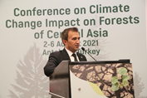

In this sense, Forest Landscape Restoration (FLR) was introduced to the conference participants.

FLR is defined as a process that aims to regain ecological functionality and enhance human wellbeing in deforested or degraded landscapes. Principles of forest and landscape restoration are listed below.

  - Focus on landscapes - FLR takes place within and across entire landscapes, not individual sites,
  - Engage stakeholders and support participatory governance,
  - Restore multiple functions for multiple benefits - FLR interventions aim to restore ecological, social, and economic functions across a landscape,
  - Maintain and enhance natural ecosystems within landscapes - FLR does not lead to the conversion or destruction of natural forests or other ecosystems,
  - Tailor to the local context using various approaches - It draws on the latest science, best practices, and traditional and indigenous knowledge,
  - Manage adaptively for long-term resilience.

In the afternoon session, Dr. Çağlar Başsüllü introduced the framework and the draft Guidelines on SFM under the Impact of Climate Change in Central Asia - Implications for Practitioners.

Picture 9. Dr. Çağlar Başsüllü of OGM
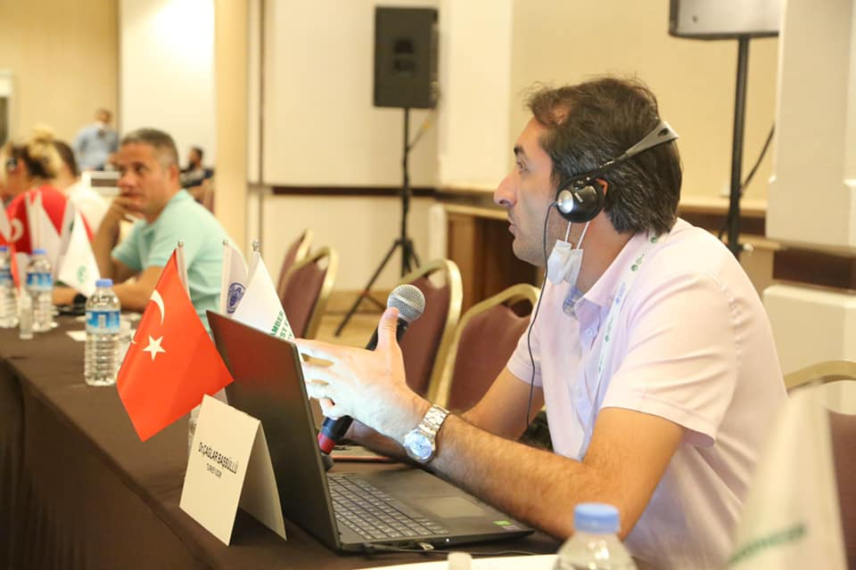

Later on, group discussions took place to scrutinize the strengths and weaknesses of the introduced draft Guidelines. All countries mentioned that the Guidelines should provide a general roadmap to provide some insights into the common problems in the forests of Central Asia, provide the best examples across the region, and support capacity development in this area.

Moreover, the Guidelines should provide some SFM measures/methodologies (i.e., assisted natural regeneration, seed origin trials, seed transfer) under the impact of climate change by considering the geographical locations of forests in Central Asia, including the technology and financial resources transfer. Furthermore, all countries supported establishing a regional partnership and a platform for dialogue, knowledge and information sharing, and finding solutions for common problems.

Last but not least, Mr. Ercan Kaptanoğlu provided brief information about the field excursion. Finally, a general assessment of the conference was done by Mr. Hasan Türkyılmaz and Mr. İsmail Belen on behalf of OMO before the official closure of the Conference.

Picture 10. Ercan Kaptanoğlu (left), Hasan Türkyılmaz (center) and İsmail Belen of OMO
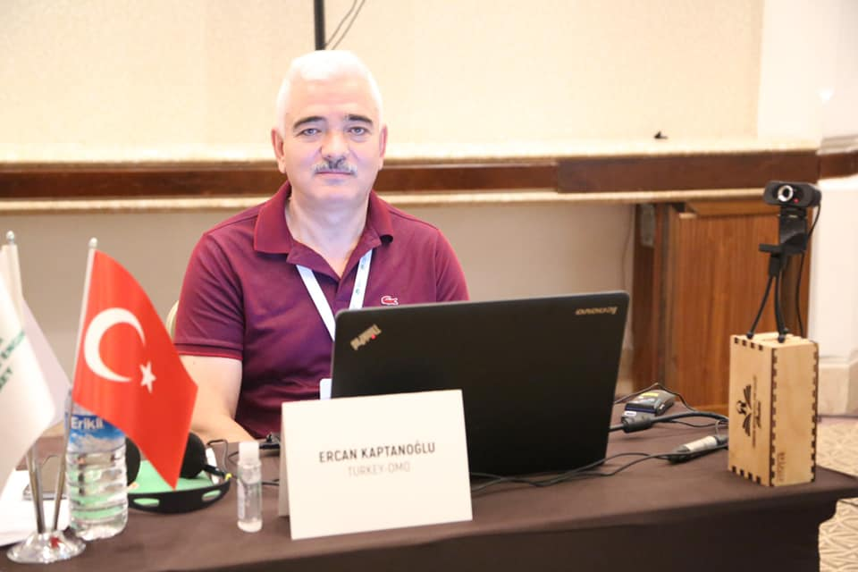 | 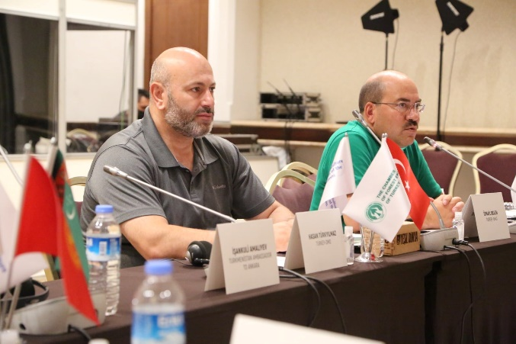

On the third day of the Conference, country representatives visited the International Forestry Training Center of the General Directorate of Forestry (OGM).

Country representatives were provided information about the computer-based forest fire fighting training classes and forest fire fighting training simulation. Participants also visited the heliport and pentathlon training area, forest pest control laboratory, advanced driving techniques training track, and the fire pool.

Picture 11. Pictures of field trip
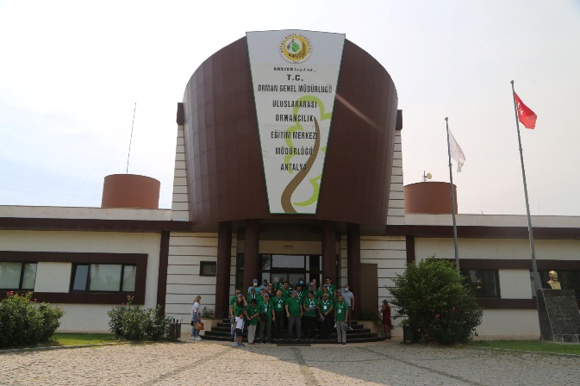 | 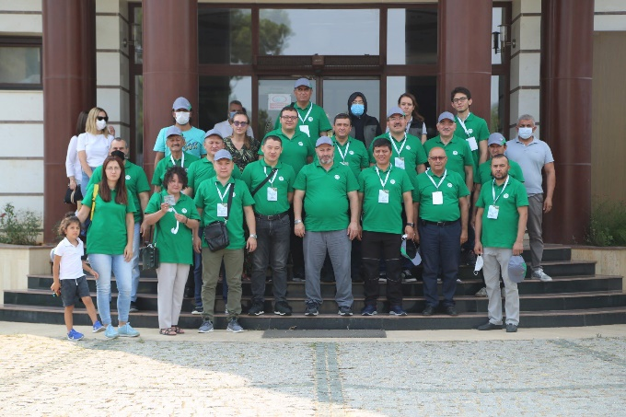
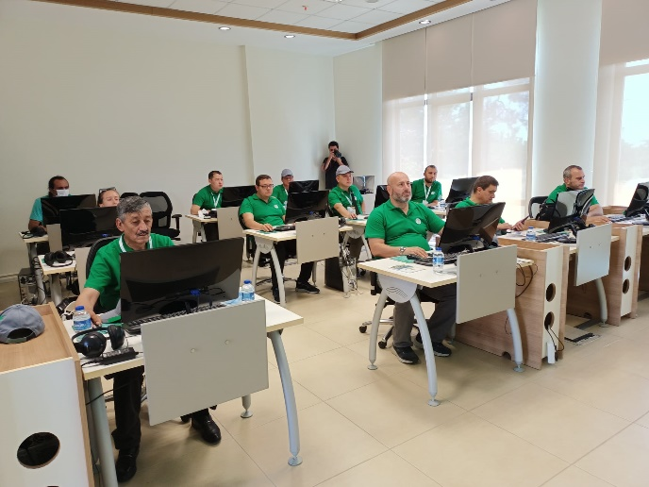 | 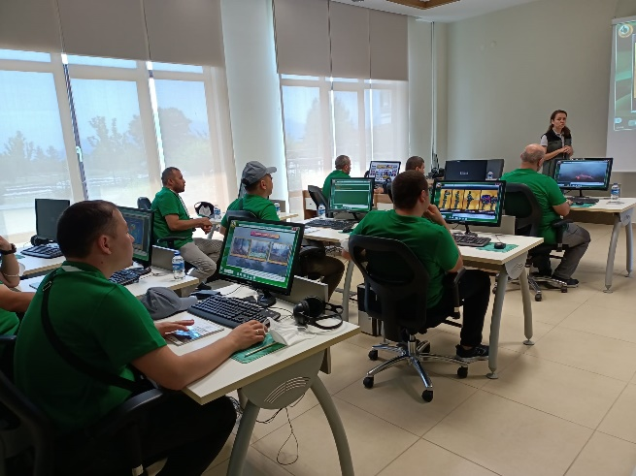
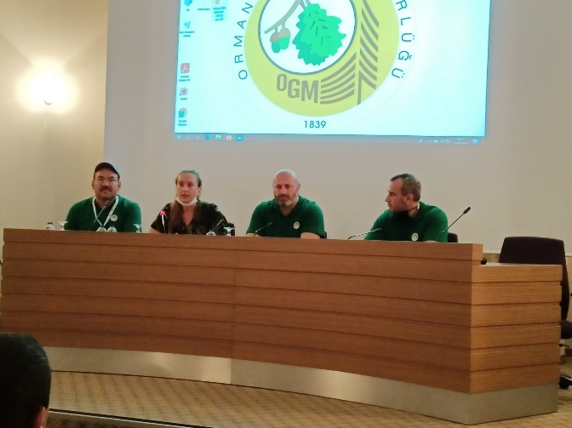 | 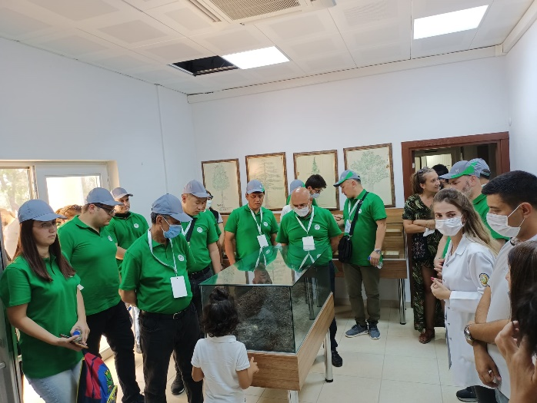

Conclusions and Recommendations

Forestry is a unique sector that has the potential for both adaptation and mitigation of climate change. In this sense, the following proposals were introduced during the Conference discussions for the Central Asia region to offer local and cost-effective NBSs under climate change to promote sustainable natural resource (forest) management, facilitate policy and strategy development and guide forest practitioners.

Proposals introduced by FAO:

- Assess the risk that climate change poses to the achievement of the management objectives of the FMU (i.e. the delivery of desired forest products and environmental services);
- Identify the forest-dependent people and forest areas that are most vulnerable to the likely impacts of climate change;
- Identify forest management measures that would reduce the vulnerability of forest-dependent people and forest areas to climate change or would increase their adaptation capacity, and estimate the cost of implementing those measures in the FMU (i.e. adaptation measures);
- Gather information on policies, institutions, financial and technical incentives, the availability of support for undertaking adaptation measures, and the requirements for obtaining access to such incentives and support;
- Identify the available options at the FMU level for contributing to climate change mitigation, including the actions to be taken;
- Adjust management practices to achieve the specified adaptation and mitigation goals; adjust forest monitoring and evaluation procedures to allow for additional requirements related to the specified adaptation and mitigation measures.

Proposals introduced by the conference participants:

- Strengthen forest policy, legal framework, and law enforcement through strategic management and set quantifiable targets,
- Update forestry and climate change policies by involving gender equality and rural communities,
- Acknowledge and manage climate risks that threaten the long term viability of nature-based solutions,
- Adopt a participatory forest management approach to improve the livelihoods of the local forest-dependent people, vulnerable groups and provide the needs of the forestry sector,
- Conduct vulnerability and risk assessments, and budget analysis,
- Determine drought and salinity resilient native and potential exotic species,
- Update forest inventory (i.e., species, NTFPs, biodiversity, ecosystem services) by analyzing the local conditions, including local people,
- Develop national forest inventory,
- Develop ecosystem-based multifunctional forest management plans,
- Develop SFM C&I,
- Develop national monitoring, evaluation, and reporting systems,
- Protect old and natural forests,
- Establish modern forest nurseries to produce drought and salinity tolerant native and potential exotic species,
- Conduct tree and seed improvement programmes,
- Determine novel silviculture techniques based on forest types or phytogeographic regions, i.e., extended rotation period increased size of carbon sinks),
- Use container seedlings of native income-generating tree species in SFM practices that are adapted to local conditions and climate,
- Avoid using invasive tree species,
- Use assisted natural regeneration for regeneration of saxaul in desert areas and other species,
- Define the afforestation objectives (i.e., industrial wood production, fuelwood production, fruit and nuts production, provision of ecosystem services),
- Establish windbreaks to reduce the impacts of soil/wind storms and reduce soil erosion,
- Establish urban forests and greenbelts around the settlements,
- Establish apiculture forest to support the production of bee products and assist natural regeneration,
- Establish industrial forests with fast-growing native tree species to support industrial wood production and reduce import quantity,
- Establish multifunctional forest to meet the wood demand and reduce the wood import or store carbon for climate change mitigation,
- Increase the certified forest areas,
- Increase the protected area networks,
- Increase afforestation, rehabilitation, and restoration activities,
- Define local and cost-effective preventive measures for wildfire and wildlife management,
- Establish a database for SFM (i.e., biodiversity, silviculture, carbon, disturbances),
- Use digital technologies and e-commerce platforms,
- Conduct joint scientific research on forests and the impact of climate change on forests,
- Define the acceptable survival rate of native tree species per phytogeographic region,
- Develop grazing plans to avoid overgrazing in pastures to reduce pressure on forests,
- Develop socio-economic projects to support rural development and use alternative energy sources (solar, wind, and natural gas) to reduce the social pressure on natural resources,
- Ensure technology and finance transfer through joint projects,
- Develop integrated management/land-use/natural resource management plans to conserve forests, pastures, water resources, croplands, and settlements.
- Develop an inter-sectoral regional platform and coordination mechanism for knowledge and information sharing and finding solutions for the problems,
- Develop incentive (i.e., subsidy, carbon trading, green deals) mechanisms,
- Determine additional financial sources to recover the damages of natural disasters and combat climate change,
- Strengthen the use of information/digital technologies and procurement of modern equipment,
- Conduct capacity building and awareness-raising events,
- Disseminate best practice examples across the region that provide social, environmental and economic benefits,
- Strengthen inter-sectoral cooperation and coordination between the government, public, NGOs, and academia,
- Ensure access to information on climate change,
- Support investment in green value chains with high potential to stimulate economic activities adapted to climate change,
- Develop early warning systems and information systems,
- Develop national and regional technical cooperation projects,
- Revise curriculums of schools and universities by including forest and climate change-related topics.

Annexes

Annex 1: Conference Agenda

The conference agenda was determined in consultation with the stakeholders and participants expected. However, in case of any comments and suggestions, necessary updates were done. A web page has been prepared at https://ormuhworld.com/ to assist the participants and share up-to-date information regarding the Conference. Developments are also announced here.

Conference on Climate Change Impact on Forests of Central Asia Conference Agenda
3-5 August 2021
Antalya/Turkey

Day 1: 3 August 2021, Tuesday, Plenary Sessions

Hours | Activity | Remarks
09:00-09:30 | Registration | OMO
09:30-10:00 | Opening Speeches | FAO-Mr. Viorel Gutu  OMO – Mr. Hasan Türkyılmaz
10:00-10:15 | Introduction of the Conference: Concept, background, objectives, purposes and expected outcomes | FAOSEC  Mr. Peter Pechacek (Online)
10:15-10:30 | - Presentation of Conference agenda, logistics and modalities  - Group Photo | OMO-Mr. İsmail Belen
10:30-11:00 | Coffee Break
11:00-12:45 | - Country presentations: The Impacts of Climate Change on Forests and Sustainable Forest Management (25 minutes per country)  - Questions – answers | - Azerbaijan-Mr. Cabbar Qeribov/Mr. Akif Həbilov (Online)  - Kazakhstan-Mr. Madi Nurpeisov/Mr.Nartay Yegembediyev  - Kyrgyzstan- Mr. Yrsaliev Bakitbek/Ms. Seideeva Siuzanna  - Tajikistan-Mr. Saidzoda Madibron/ Mr.Aziz Nazarov  ==============  Facilitator: OMO-Mr. İsmail Belen
12:45:13:00 | Delivery of Participation Certificates
13:00-14:00 | Lunch
14:00-15:30 | - Country presentations: The Impacts of Climate Change on Forests and Sustainable Forest Management (25 minutes per country)  - Questions – answers | - Turkmenistan- HE Ishankuli Amanlyev  - Uzbekistan- Mr. Abduvokhid Zakhadullaev/Mr. Masudkhon Ismoılov  - Turkey- Mr. Alper Tolga Arslan  ==============  Facilitator: OMO-Mr. İsmail Belen
15:30-16:00 | Coffee Break
16:00-17:00 | Group discussions:  - What are the changes introduced by new forest policies to tackle climate change?  - What are the observed changes in forests introduced by climate change over the past decades?  - What are the challenges, gaps and barriers for SFM under the impacts of climate change?  - What are the required enabling environment and options for SFM?  - What are the climate change mitigation and adaptation measures to increase the resilience of forests in Central Asia?  - What could be the best SFM practices under the impact of climate change?  - Any other matters | Facilitator: OMO  Prof. Dr. Derya Eşen  Assoc. Prof. Dr. Ayhan Akyol
17:00-17:30 | Report of the group discussions and synthesis of the day | Prof. Dr. Derya Eşen  Assoc. Prof. Dr. Ayhan Akyol
17:30-19:30 | Free time
19:30-21:30 | Dinner at the hotel | OMO

Day 2: 4 August 2021, Wednesday, Plenary Sessions

Hours | Activity | Remarks
09:00-09:15 | Recap of the previous day | OMO-Assoc. Prof. Dr. Ayhan Akyol
09:15-09:30 | International and national activities of OMO | OMO-İsmail Hakkı Güney
09:30-09:45 | Forestry and climate change projects in Central Asia | FAOSEC- Mr. Burak Avcıoğlu
09:45-10:05 | Climate change impacts and adaptation & mitigation strategies in Central Asia | FAOSEC- Ms. Evetta Zenina
10:05-10:30 | Group discussions – Setting the scene:  - Potential climate change mitigation and adaptation projects (national & regional) in forestry and cross-cutting sectors to be implemented by FAO and financed under GEF, GCF, and other donors. | Facilitator: OMO  Prof. Dr. Derya Eşen  Assoc. Prof. Dr. Ayhan Akyol
10:30-11:00 | Coffee Break
11:00-13:00 | Group discussions – Conclusions:  - Potential climate change mitigation and adaptation projects (national & regional) in forestry and cross-cutting sectors to be implemented by FAO and financed under GEF, GCF, and other donors. | Facilitator: OMO  Prof. Dr. Derya Eşen  Assoc. Prof. Dr. Ayhan Akyol
13:00-14:00 | Lunch
14:00-14:30 | Introduction of the draft Guidelines on Sustainable Forest Management under the Impact of Climate Change in Central Asia - implications for practitioners | Dr. Çağlar Başsüllü
14:30-16:00 | Group discussions - Improvement of the draft Guidelines:  - Scrutinizing strengths and weaknesses of the introduced draft Guidelines on Sustainable Forest Management under the Impact of Climate Change in Central Asia - implications for practitioners. | Facilitator: OMO  Prof. Dr. Derya Eşen  Assoc. Prof. Dr. Ayhan Akyol
16:00-16:30 | Coffee break
16:30-17:00 | Assessment of the Conference and final remarks | Facilitator: OMO  Prof. Dr. Derya Eşen  Assoc. Prof. Dr. Ayhan Akyol
17:00-17:15 | Information about Field Excursion | OMO-Mr. Ercan Kaptanoğlu
17:15-17:30 | Closure of the Plenary Sessions | OMO-Mr. Hasan Türkyılmaz
17:30-19:00 | Free time
19:00-21:00 | Dinner at hotel | OMO

Day 3: 5 August 2021, Thursday, Field Trip

Hours | Activity | Remarks
09:30-10:00 | Departure from the hotel- arrival to International Forestry Training Center  https://antalyaobm.ogm.gov.tr/Sayfalar/Ormanc%C4%B1l%C4%B1kEgitimMerkezi.aspx | OMO
10:00-10:45 | Introduction of Training Center | OGM  - Ms Nihal ZeybekYüksel- Forest Engineer  - Ms Özlem Keser- Forest Engineer
10:45-11:00 | Coffee Break
11:00-11:30 | Introduction of Computer-Based Forest Fire Fighting Training Classes | - Mr Adil Köseloğlu Electronics Engineer  - Mr. Alper Tolga Arslan Deputy Head of Department  - Ms Nihal Zeybek Yüksel Forest Engineer  - Ms Özlem Keser Forest Engineer  - Mr.Ümit Turhan- Deputy Head of Department
11:30-12:00 | Introduction of Forest Fire Fighting Training Simulation
12:00-12:30 | Investigation of the Heliport and Pentathlon Training Area
12:30-12:45 | Visiting and Introduction of the Forest Pest Control Laboratory | - Mr Gökhan Duymaz-Biologist  - Ms Gülşen Çıkaran-Forest Engineer-Entomologist
12:45-13:00 | Visiting the Advanced Driving Techniques Training Track and the Fire Pool
13:00-13:00 | Back to Hotel
13:00-15:00 | Lunch
15:00-19:00 | Free Time
19:00 | Dinner and Closure of the Conference

Annex 2: List of Participants

No | Country | Title | First name | Family name | Position | Organization
1 | Azerbaijan | Mr | Akif | Həbilov | Forest Measures Center Manager | Ministry of Ecology and Natural Resources of Azerbaijan Republic
2 | Azerbaijan | Ms | Aysel | Rzayeva | Head of Subdivision for International Cooperation | Ministry of Ecology and Natural Resources of Azerbaijan
3 | Azerbaijan | Mr | Cabbar | Qeribov | Head of Forest Management Department | Ministry of Ecology and Natural Resources of Azerbaijan Republic
4 | Azerbaijan | Mr | Telman | Guliyev | President | Natural Resources and Environmental Workers Trade Union
5 | FAO | Ms | Ayşegül | Selışık | Assistant FAO Representative in Turkey | Assistant FAO Representative in Turkey
6 | FAO | Mr | Burak | Avcıoğlu | Junior Forest Officer | FAO Subregional Office for Central Asia
7 | FAO | Mr | Evatta | Zenina | Natural Resource Officer (Climate Change) | FAO Subregional Office for Central Asia
8 | FAO | Mr | Peter | Pechacek | SEC Forestry Officer | SEC Forestry Officer
9 | FAO | Mr | Viorel | Gutu | Subregional Coordinator | Sub-regional Coordinator
10 | Kazakhstan | Mr | Madi | Nurpeisov | Head of Department | Forestry Development Department-Committee for Forestry and Wildlife-The Ministry of Ecology, Geology and Natural Resources of the Republic of Kazakhstan
11 | Kazakhstan | Mr | Nartay | Yegembediyev | Chief Expert | Forestry Development Department-Committee for Forestry and Wildlife-The Ministry of Ecology, Geology and Natural Resources of the Republic of Kazakhstan
12 | Kyrgyzstan | Mr | Baktybek | Yrsaliev | Head of Department | Ministry of Agriculture, Forestry and Water Resources of the Kyrgyz Republic
13 | Kyrgyzstan | Ms | Seideeva | Siuzanna | Chief Expert | Ministry of Agriculture, Forestry and Water Resources of the Kyrgyz Republic
14 | Tajikistan | Mr | Aziz | Nazarov | Head of Department | Forestry Agency under the Government of the Republic of Tajikistan
15 | Tajikistan | Mr | Saidzoda | Madibron | Director-General | Forestry Agency under the Government of the Republic of Tajikistan
16 | Turkey-Academia | Mr | Assoc. Prof. Dr. Ayhan | Akyol | Academician | İzmir Katip Çelebi University
17 | Turkey-Academia | Mr | Prof. Dr. Derya | Eşen | Academician | İzmir Katip Çelebi University
18 | Turkey-ÇEM | Ms | Güleser | Avcıoğlu | Forest Engineer | General Directorate of Combating Desertification and Erosion
19 | Turkey-DKMP | Mr | Yasin | Köycü | Division Director | General Directorate of Nature Conservation and National Parks
20 | Turkey-MoAF | Mr | Yakup | Dağaşan | Forest Engineer | General Directorate of EU-Foreign Relations
21 | Turkey-NGO | Ms | Benül | Sözer | Deputy of International Relations | Öz Orman-İş Trade Union  Agriculture&Forestry Workers Union
22 | Turkey-OGM | Mr | Adil | Köseloğlu | Electronics Engineer | International Forestry Training Center
23 | Turkey-OGM | Mr | Alper Tolga | Arslan | Deputy Head of Department | General Directorate of Forests
24 | Turkey-OGM | Mr | Dr. Çağlar | Başsüllü | Forest Engineer | General Directorate of Forests
25 | Turkey-OGM | Mr | Gökhan | Duymaz | Biologist | International Forestry Training Center
26 | Turkey-OGM | Ms | Gülşen | Çıkaran | Forest Engineer-Entomologist | International Forestry Training Center
27 | Turkey-OGM | Ms | Nihal Zeybek | Yüksel | Forest Engineer | International Forestry Training Center
28 | Turkey-OGM | Ms | Özlem | Keser | Forest Engineer | International Forestry Training Center
29 | Turkey-OGM | Mr | Ümit | Turan | Deputy Head for International Relations Department | General Directorate of Forests
30 | Turkey-OMO | Mr | Ercan | Kaptanoğlu | Expert | Chamber of Forest Engineers - OMO
31 | Turkey-OMO | Mr | Hasan | Türkyılmaz | President | Chamber of Forest Engineers - OMO
32 | Turkey-OMO | Mr | İsmail | Belen | Expert | Chamber of Forest Engineers - OMO
33 | Turkey-OMO | Mr | İsmail Hakkı | Güney | Member of the Steering Committee | Chamber of Forest Engineers - OMO
34 | Turkey-OMO | Mr | Özgür | Balcı | Head of Department | General Directorate of Forests
35 | Turkmenistan | Mr | İsankuli | Amanlyev | Ambassador | Ambassador of Turkmenistan to Turkey
36 | Uzbekistan | Mr | Abduvokhid | Zakhadullaev | Head of Department | State Committee on Forestry of the Republic of Uzbekistan
37 | Uzbekistan | Mr | Masudkhon | Ismoilov | Senior Researcher | State Committee on Forestry of the Republic of Uzbekistan

Annex 3: Abstracts of Country Reports/Presentations

The purpose of "Country Reports/Presentations" is to ensure that the conditions of each country are included in the Guidelines.

The "Resource persons/country representatives" determined by Countries (Azerbaijan, Kazakhstan, Kyrgyzstan, Tajikistan, Turkey, Turkmenistan, Uzbekistan) prepared country reports/presentations about the impacts of climate change on forests in their country before the "Conference". The language of the reports/presentations were English, Russian and Turkish.

The other participants discussed these reports/presentations during the Conference, compiled and published them as the Conference Proceedings.

The synthesis of the Conference Proceedings was used to develop the Guidelines on Sustainable Forest Management under the Impact of Climate Change in Central Asia - Implications for Practitioners.

Abstracts of country reports/presentations are presented below.

Azerbaijan
Mr. Jabbar Garibov and Mr. Akif Habilov

Due to the features of environmental problems, these problems exceed national borders with increasing interdependence between countries. Now, each country's use of environmental resources affects the natural resources of another country. Disputes arising from using available resources within the framework of states' policy to protect their sovereignty and natural resources are regulated by international environmental law. Environmental issues are not limited to one country, and the impact of environmental problems on the whole world requires cooperation between countries. Thanks to this cooperation, the international community has developed many conventions, principles, norms, and protocols to prevent environmental problems, preserve existing values, and pass them on to future generations. As a member of the international community, Azerbaijan seeks to fulfil its obligations to future generations by joining environmental conventions and bringing national environmental legislation into international standards.

Like many countries worldwide, Azerbaijan faces environmental problems at the local, regional, national, and international levels. It takes various initiatives to find solutions to these problems and actively participates in regional and international discussions. After gaining independence, it has ratified various international environmental agreements and is actively involved in research on this issue, participating in projects as an interested party in solving environmental problems related to its region.

Environmental problems exist at the global, regional and local levels. Humanity began to take various measures, realizing that the living conditions of the world's living beings could not continue with long-term limitations if they continued with the rapidly deteriorating environmental pollution, production and consumption balance that emerged as a negative consequence of this situation.

The report provides brief information on the physical-geographical, natural and water resources, climate, and main elements of the Republic of Azerbaijan and notes the natural risks and disasters in the country over the past 30 years. Climate change trends and future climate change issues in the Republic of Azerbaijan have been studied. Predicted climate changes in Azerbaijan were assessed based on various models. The impacts of climate change on various sectors (water resources, agriculture, the Caspian region, human health) have been studied.

Climate and risk monitoring, the results of research in this area in the country, regional climate change and reduction initiatives of disaster risk were also noted. Research has shown that the Republic of Azerbaijan does not have sufficient potential in the face of climate change and natural disasters. Therefore, decision-makers, informal leaders and civil society organizations should work together to adapt to climate change so that our country can continue to develop and prosper in the future.

Kazakhstan
Mr Madi Nurpeisov and Mr Nartay Yegembediyev

The forest fund of Kazakhstan is around 30.1 million hectares and covers 11% of the entire territory of the Republic, of which 13.3 million hectares are forested lands (4.9% of the country's area). The area of the private forests is about 1013 hectares.

Most of the state forest fund (around 74.7%) is under regional "Akimats" jurisdiction, 24.6% is under the Committee for Forestry and Wildlife.

Forests in Kazakhstan are distributed unequally. Saxaul forests grow mainly in desert zones, covering 50.5% of the total forest area, coniferous forests cover 13.5%, soft-leaved - 11.7%.

The normative act on "Specially Protected Natural Areas" was adopted in 2020 specifying ecological tourism, the reduction of the long-term use of protected areas from 49 to 25 years, and the way of construction of facilities on the territories of protected areas, with a focus on the conversion of protected lands into lands for mining.

At the same time, Kazakhstan Government introduced and announced the National Course of transition to the "Green economy", including:

• Capacity building of a network of specially protected natural areas,
• Restoration of natural complexes,
• Increasing the overall forest cover;
• Rational use of resources;
• Proper waste management;
• Wind energy support with an overall target for energy saving.

A National Project – a development strategy – called "Green Kazakhstan" has been approved. One of the significant components of this National Project has become one called "Environment", which will unit 4 tasks:

1. Development of Specially protected natural areas – preserving biodiversity and increasing the area of Protected Areas by 1.5 million hectares through the organizing of 6 new Reserves;
2. Restoration of the quantity of rare, endangered or vulnerable species of wild animals;
3. Conservation of fish resources and other aquatic animals together with the increase of natural population of fish resources by 20% from the baseline.
4. Conservation and expansion of National forests – reforestation of around 2 billion trees, in order to increase the forest cover of the country up to 5%, reduce the average area of a forest fire by 20%, reduce the areas of forest diseases and pests by 20%, increase of forest cover on drainage areas of the river. They were created of many private forest nurseries and plantations of fast-growing trees and shrubs.

During this year spring period, around 81.6 million trees were planted on 21.6 thousand hectares. During the autumn time, another 48.1 million trees will be planted.
Additionally, to mentioned above, another program on creating the green zones around cities and towns has been launched earlier, including developing new and expanding existing forest nurseries and increasing the volume of growing planting material.

Some positive effects have been monitored during the last 20 years by creating green spaces: the average wind speed decreased by 40% from 3.6 m/s to 2.8 m/s. The number of snowstorms has decreased by half, from 27 to 14 days, and dust storms from 11 to 9 days per year.

Thanks to implemented scientific reforestation approach on the steppe zone, the survival rate of new seedlings in the steppe area has increased from 20% to 80%.

Several state programs and international projects in forestry and climate change aimed to solve the Drained Bottom of the Aral Sea are also being implemented in Kazakhstan during the last years.

Currently, the implementation of the following tasks have been already started:

• Assessment of the current situation of the Kazakh part of the drained bottom of the Aral Sea using GIS technologies, remote sensing data and field expeditions;
• Compilation of maps of the modern relief of the drained bottom of the Aral Sea with an assessment of soil, salt, movement of sands, ground and surface waters, vegetation and reforestation suitability;
• Development of innovative methods of saxaul survival improvement on the drained bottom of the Aral Sea;
• Conducting soil surveys and developing working projects for afforestation of the bottom of the Aral Sea on an area of 250 thousand hectares;

A particular interactive map based on the Geoportal of the Ministry of Ecology has been adapted for monitoring forest planting works to monitor the achievements. This map may display all the primary data, coordinates and boundaries where the reforestation has been implemented.

The Kazakhstan government uses ground protection control (filed works) and air patrolling of the territory concerning forest protection. As a part of modern technologies, space monitoring is carried out to detect forest fires and illegal logging.

Kyrgyzstan
Mr Yrsaliev Baktybek Keneshovich and Ms Seideeva Siuzanna Ismatovna

This country report provides a brief overview of the current situation in the forestry sector of the Kyrgyz Republic, information on the state forest policy related to forestry and climate change and the State of forest ecosystems, current and planned actions (measures) for sustainable forest management and climate change mitigation and adaptation. For forests through governance/stakeholder participation. The priority directions for further steps to implement measures to improve the efficiency of forestry management and create the most favorable conditions for sustainable development are noted. Presents data on ongoing projects, including international donors operating in the forestry sector of the republic, in particular piloting the reform of the forestry sector. The report also presents management practices, use of forest lands, problems and recommendations for further effective management of forest resources in the face of increased anthropogenic pressure and changes in forest landscapes due to climate change.

Tajikistan
Mr Aziz Nazarov and Mr Saidzoda Madibron

The natural environment of the mountainous territory of the Republic of Tajikistan is very susceptible to anthropogenic influences. The most vulnerable are mountain-desert landscapes, where the central area of forests is located. Generally, forests cover an area of 421 thousand hectares or 3% of the territory of the Republic.

The richest species diversity of forests in Tajikistan is represented by the forests of Central Tajikistan at altitudes from 1250 to 2500 meters above sea level, which are dominated by deciduous species.

In the North of the Republic, juniper forests mixed with deciduous species prevail in the medium size and high mountains.

Forests located in the mountainous zone perform protective, anti-erosion, soil protection, and water regulation functions.

The total area of the forest fund of Tajikistan is 1.8 million hectares, which are under the jurisdiction of the Forestry Agency. The forested area, including Reserves, is around 423.0 thousand hectares.

At the same time, mountain forests are rich in species diversity, with about 268 species, among which wild fruit trees and shrubs, of which there are more than 50 species, are of particular value. The most common forest stands by species are:

• Juniper stands - 150 thousand hectares.
• Pistachios - 78 thousand hectares.
• Almonds - 12 thousand hectares.
• Hazels – 8 thousand hectares
• Maple forests - 44 thousand hectares
• Saxaul forests - 8 thousand hectares.

The forest fund of the country includes lands, forests, forests around water sources and other natural resources, which are assumed as state property and transferred for permanent use to forestry enterprises.

In recent years, the lease form of land use has become widely practised in forestry. According to the contract, the individual, family, and team use are carried out when part of the harvested goods remains for the leaseholders.

The Concept of the Forestry Policy of Tajikistan is based on three main principles:

• Sustainable forest management;
• Involvement of local society into forest management activities;
• Full control by the State over the forest utilization.

The latest version of the Forest Code issued in Tajikistan and the Law "On Specially Protected Natural Areas" was adopted in 2011.

Nevertheless, the legislative system for forestry and specially protected areas needs serious updates and improvement, as it primarily affects the status of forests and forestry in general and the water resources, soils, and fertility.
It was planned to adapt the Forestry Development Program, including protected areas, which were an integral part of the proposed Draft of Forestry Strategy of the Republic of Tajikistan for 2016 - 2030.

Experts from the United Nations Economic Commission for Europe (UNECE), the German Society for International Cooperation (GIZ), the Food and Agriculture Organization of the United Nations (FAO), as well as ministries and departments of the Republic of Tajikistan, were involved in a process.

However, the government has not accepted the Draft of that Strategy, and it was recommended to develop a draft Forestry Development Program for the period 2022-2031. Currently, the Draft of the Program is under consideration and is undergoing approval procedures.

Concerning inventory projects, it should be mentioned that in 2018-2019, within the framework of the project on "Adaptation to climate change through sustainable forest management in the main drainage basins of Tajikistan", a section on "Provision of forest inventory and forest management planning services" had been implemented in 4 Forest Management Units on the territory of more than 90 thousand hectares of forest lands.

The results of the inventory of greenhouse gas emissions (based on the results for 2016) are also presented and show a constant increase in the absorption of carbon dioxide by forestry. It is also stated that Tajikistan is one of the countries with the lowest emissions in Central Asia and the world in general.

About the Climate Change Projections and Scenarios, future increases in air temperature, variability in precipitation, faster glacier melting and an increase in the frequency and magnitude of extreme weather events caused by climate change are expected. Temperatures are expected to rise at a higher rate in mountainous areas comparing to flat and arid areas.

Climate warming and a decrease in the protective functions of forests in boreal conditions contribute to an increase in outbreaks of pests and their possible spread over significant areas.

The main reasons for the degradation of forest stands are stated as:

• Intensive unregulated cattle grazing;
• Illegal harvesting in forests;
• Lack of monitoring and forest care.

Moreover, as a result, there is a complete absence of natural regeneration of forests.

It is noted that, in general, the Concept of Tajikistan's Forest Policy is based on three principles: sustainable forest management, involvement of the local population in forest management activities and complete control by the State over the use of forest resources.

A brand new approach to sustainable forest management has been introduced by applying so-called Joint Forest Management when locals live around the area of projected activities in forests and the employees of Forest Management Units. They participate in the protection of forests, carrying out work on forest restoration, combating forest pests and diseases, and receiving timber, non-timber forest products or the right to use hayfields.

The Joint Forest Management has covered 280 thousand hectares of forest lands, including 60.3 thousand hectares of pistachio plantations and 124.5 thousand hectares of pasture lands.

The presentation also stops on the Challenges, gaps and obstacles of sustainable forest management in Tajikistan. The programs aimed to improve sustainable forest management are presented as a response.
Among the priority tasks, it is necessary to mention an inventory process of forests and continuous monitoring of forest resources; in the future, it is necessary to establish a regulatory framework, growth of productivity of pastures to reduce pressure on forests and surely intensify reforestation.

Turkmenistan
HE İsankuli Amanlyev

Environment protection has been defined as a priority of the government policy of Turkmenistan. This vector is also specified among the main aspects of the foreign course of the country. Being an active member of international dialogue in this direction, Turkmenistan stands for intensifying and expanding positive cooperation with all interested partners, especially in the United Nations format.

It is necessary to mention the great importance of the constructive initiatives proposed by the President of Turkmenistan at various high-level forums, which received comprehensive support of the world community. Turkmenistan takes specific measures for their practical implementation, first of all, forming a reliable legal base.

Turkmenistan actively expands productive cooperation with all interested partners to solve such important issues as improving the ecology of the Aral Sea region and adapting to climate change. Problems of Aral Sea have particular currency these days. The ecological situation, which came up due to the irrational use of water resources, has affected millions of people living in this region and far beyond its border. At the same time, the danger is represented by air masses from up in this area, making a negative impact on nature, climate and health of people. That is why the efforts of countries in the region on the national level and support of the world community, particularly active and systematic participation of the UN, is vital.

The establishment of a reliable ecological protection system of the Caspian Sea, which is provided by its special status, is among the priority objectives of the natural protection strategy of the Turkmen State. Many representatives of flora and fauna of the Caspian Sea are endemics. Beneficial geographic location, richest hydrocarbon, fish and other resources, favourable climate conditions have made dynamically developing industrial, transport and resort centre from Caspian region, which is given a significant role in the world economy. In the last years, Turkmenistan carries out considerable work in this direction on the national level proposing new approaches in the solution of existing and prevention of possible ecological problems on the Caspian Sea in close cooperation with its neighbours and partners as well as with competent organizations, especially with the United Nations.

Having immense experience in successful farming and water management in the arid zone, Turkmenistan is in the front line of scientific studies in this sphere urging other states to the similar rational use of water resources. In this context, it is essential to mention the significance of the realization of the construction project of Altyn Asyr Turkmen Lake. This unique water facility made in Central Karakums has a favourable effect on the climate improvement of these most extensive deserts, enriching its flora and fauna and supporting positive changes in the entire region's ecology.

Since 1998, Turkmenistan has been implementing a forestry program. The new National Forest Program of Turkmenistan's main objective is to restore degraded forests and forestry to improve the climatic conditions and create optimal conditions for the sustainable development of the country's economy.

Turkey
Mr Alper Tolga Arslan, Mr Ümit Turhan, Mr Cuma Uykun, Ms İffet Deniz Cengiz, Mr Yunus Barış Odabaşı, Mr Yasin Köycü, Prof. Dr. Derya Eşen, Assoc. Prof. Dr. Ayhan Akyol, Ms Benül Topuzoğlu Sözer

Global climate change, desertification/land degradation, and biodiversity loss are critical ecological problems that threaten our future. It is a phenomenon accepted by everyone that seasonal or agricultural drought, which may arise due to global climate change, will be the most important agenda of the world in the coming years. Almost half of the world's surface area (6.1 billion hectares) consists of arid areas, and about a third of the world's population (2 billion) reside in such areas. The Convention on Biological Diversity and the Ecosystem Assessment Millennium states that many areas, including our country, are arid and semi-arid areas.

It is estimated that arid areas, which have increased significantly in the last 60 years, will increase by 10-23% towards the end of the 21st century due to global climate changes. It is among the forecasts that drought will increase significantly in the Mediterranean Region, where our country is also located. It has also been reported that drought caused a 4-8% contraction in national economies. The consequences of climate change are being felt more and more in Turkey and around the world. The average global temperature, currently around 1°C above pre-industrial levels, continues to rise. Many natural processes differ; precipitation regimes change, glaciers are melting, and sea levels rise.

Turkey, which has hosted many different civilizations throughout history, has a Mediterranean climate and climate regimes, including humid, semi-humid, semi-arid, arid, extremely arid and desert belts, due to its location on the world, and it is susceptible to land degradation, erosion and drought. For this reason, the effects of desertification, erosion, drought and biodiversity loss as a result of climate change and human activities are felt more. Forests and the forestry sector have critical importance in the fight against climate change. In this regard, necessary studies have been carried out in Turkey in the last 30 years. Significant progress has been achieved in preventing deforestation and land degradation in line with the United Nations Sustainable Development Goals and reversing the adverse effects of climate change. In the coming years, the impact of climate change will increase due to the lagged effects of past and current greenhouse gas emissions, especially on natural resources. Forests in Turkey play a critical role in reducing greenhouse gas emissions and adapting to the adverse effects of climate change.

Uzbekistan
Mr Abduvokhid Zakhadullaev, Ms Dildora Aralova and Mr Abdusalom Normatov

This chapter tries to estimate ongoing and upcoming climate change evidence in Uzbekistan, especially in the forestry sector. Sustainable forest management in Uzbekistan may help reduce the adverse effects of climate change on forests and forest-dependent people in this area. The impacts of climate change in the forestry sector developed well last 2-3 years intensively. This is related; first of all, the president's initiative is Shavkat Mirziyoyev to extend intensive orchards and forest-related trees in Uzbekistan. As well as, more priority is given to establish desert forest in the dried bottom Aral Sea Basin of Uzbekistan and creating a "green cover zone". For sustainable development until 2030 years in the country, the forests and trees could provide up to 30% of greenhouse gas mitigation in Uzbekistan and improve the environmental situation in the country and mitigate the climate change process.

http://www.fao.org/europe/regional-initiatives/en/
https://all.accor.com/hotel/B1K0/index.tr.shtml
https://of.ikcu.edu.tr/
https://fra-data.fao.org/KAZ/fra2020/home/
https://fra-data.fao.org/KGZ/fra2020/home/
https://fra-data.fao.org/TJK/fra2020/home/
https://fra-data.fao.org/TKM/fra2020/home/
https://fra-data.fao.org/UZB/fra2020/home/
https://fra-data.fao.org/AZE/fra2020/home/
https://fra-data.fao.org/TUR/fra2020/home/
https://tulip.ogm.gov.tr/Sayfalar/Tulip.aspx
By Ю. Данилевский - Own work, Public Domain, https://commons.wikimedia.org/w/index.php?curid=2027977)
http://www.fao.org/in-action/forest-landscape-restoration-mechanism/en/
https://antalyaobm.ogm.gov.tr/Sayfalar/Ormanc%C4%B1l%C4%B1kEgitimMerkezi.aspx

