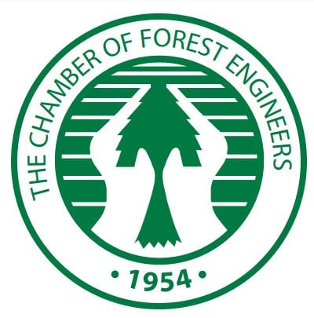
Chamber of Forest Engineers of Turkey
“International Symposium on Forests and Biodiversity”
4-7 November 2021-Rixos Sungate
https://www.rixos.com/en/hotel-resort/rixos-sungate
Beldibi, Kemer, Antalya/Turkey
Concept Note
Contents
Purpose 3
Thematic Topics 3
Location, Accommodation and Transportation 4
Language 5
Field Trip 5

For Contact:
Mr. İsmail Belen,
Mobile Phone: +90 506 222 48 19
Email: ismailbelen52@gmail.com

Concept Note
Biodiversity refers to differences between all living organisms in land, sea, and other aquatic ecosystems and briefly in all kinds of habitats.
While biodiversity includes all life forms on earth, it provides the health, welfare and happiness of human beings; however, it is of vital importance in the position of the basis of life for societies to fulfill their functions.
As nature cannot always tolerate the changes that occur, it can sometimes manifest itself in the form of irreversible reactions. The future of our planet and half of the world's total economic output, approximately 40 trillion euros, depends on biodiversity in nature.
Climate, biodiversity and the future of humanity are interconnected and cannot be considered independently. While climate change has an impact on biodiversity, natural and managed habitats and their biodiversity also play an important role in mitigating and adapting to climate change.
Forests are one of the main elements of biodiversity, and it is impossible to protect biodiversity in the world without preserving biodiversity in forests.
Forests are terrestrial systems that have the largest biomass among terrestrial ecosystems, have reached the highest level of living and non-living organization, contain the richest elements in terms of ecosystems, and affect the carbon and water cycles in the world the most.
Forests are home to 90% of terrestrial biodiversity.
In this context, forest ecosystems are natural assets that can affect all living and non-living beings with their existence or extinction. Naturally, deforestation and degradation of forests constitute one of the most fundamental building blocks of environmental problems.
A healthy forest is more resilient to possible risks. Because forests contain a rich biodiversity, they support adaptation to climate change and make important contributions to reducing natural disasters, improving living conditions, circular economy and rural communities.
The Chamber of Forestry Engineers (OMO), which is one of the most important non-governmental organizations in Turkey with its approximately 18,000 members, plays an important role in the protection and sustainable management of forests and related ecosystems, which are one of the most important elements of nature, with its legal, institutional and technical background.
According to article 6/1/a of the OMO’s Main Regulation, OMO is obliged to carry out all kinds of technical and scientific studies in order to "protect, expand and operate the forests with the forest ecosystem management approach" and to present the "water production, social, cultural and similar functional benefits" of the forests to the society. OMO is expected to make offers and assistance to official authorities and other relevant institutions in these matters.
According to Article 6/1/ç of the same regulation, OMO is obliged to "organize technical congresses, seminars, symposiums, conferences and exhibitions related to the development and promotion of forestry, forestry industry and woodworking industry professions, and to participate in the work of other organizations for this purpose".
Article 6/1/f, on the other hand, has the provision "to spread innovations in the field of forestry, forestry industry and woodworking industry professions, to cooperate with domestic and foreign professional organizations for this purpose, and to represent their members in the country and abroad".
In this context, OMO, among other activities, organized the "International Nature and Forestry Symposiums to 2023".
The fifth of these seminars, with the title of “The Role of NGOs in Achieving SDG and Global Forest Goals” was held on 2-5 December 2018 in Antalya.
As a continuation of this traditional series, an international symposium on 'Forests and Biodiversity Symposium' will be held in November 2021.
OMO took place as a member in the committee established by the Presidential Circular titled "National Biological Diversity Coordination Board" published in the Official Gazette dated August 2, 2019 and numbered 30850.
On the other hand, both the COVID and the fires and floods that occurred in July-August 2021 have once again confirmed the role of forests in biodiversity, integrated landscape management and resilience, health and food security.
“International Symposium on Forests and Biodiversity” is organized within the framework of these developments.
The symposium planned in the first week of November 2021 (4-7 November 2021) will take place for 2 days, excluding the road.

Purpose
The purpose of the "International Symposium on Forests and Biological Diversity" is to examine the role of forests in the conservation and development of biological diversity, to examine international activities and country examples, and to prepare a joint declaration and submit it to policy makers and relevant institutions.

Thematic Topics
The main topics of the symposium will be:
- International and national regulations and processes on forests and biodiversity
- Institutional structures, Country practices,
- The role of biodiversity in sustainable forest management
- Forest fires and biodiversity, restoration of burned areas with an ecosystem approach,
- Forests and disasters, biodiversity and nature-based solutions in integrated disaster management and integrated landscape/watershed management
- Food security, non-wood forest products and biodiversity
- Biodiversity in protected areas, cities and rural areas
- Economics of biodiversity, bio smuggling
- Raising awareness on forests and biodiversity
- The role of non-governmental organizations in the protection of forests and biodiversity, best practices and roadmap

Location, Accommodation and Transportation
The symposium will be held at the Rixos Sungate Hotel in Antalya's Kemer District. https://www.rixos.com/en/hotel-resort/rixos-sungate
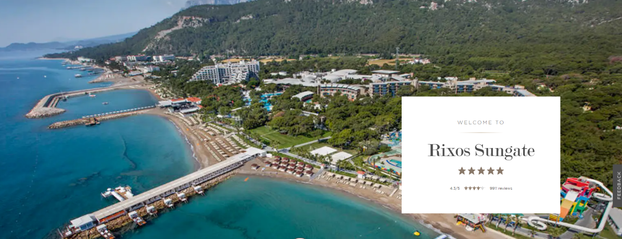
Accommodation and other expenses related to the Symposium of the invited participants will be covered by OMO.
Due to COVID-19, only one person can stay in hotel rooms. In case of additional persons (spouse, children, friends, etc.) accompanying the participants invited by OMO, all their expenses (transportation, accommodation, food, etc.) will be theirs.

Language
The language of the symposium is Turkish with English simultaneous translation.

Field Trip
A half-day field trip was planned during the symposium and the necessary organization will be provided by OMO.

https://ormuh.org.tr/the-chamber-of-forest-engineers-of-turkey
http://www.gonder.org.tr/?p=7268
https://www.resmigazete.gov.tr/eskiler/2019/08/20190802-11.pdf

