Training on Fire Management
19-25 December 2021
Antalya

TRAINING MATERIAL

1 December 2021

Foreword 3
General Information on Forest Fires 4
Overview of Some Legislation on Forest Fires 5
Turkish National Legislation 5
International Legislation 5
Four Pillars of Fire Management 7
1- Prevention 9
Involvement of Locals 9
Community Firebreaks or “asset protection strips” 9
Prescribed Burning 10
2- Preparedness 11
Identification of Incident Management Structures 11
Road and Trail Maintenance 11
Road and Trail Construction 12
Water Supplies 12
Fire Danger Forecasting 12
Early Warning Systems 13
Importance of fire intensity 13
Fuel load management by grazing 13
Physical removal of fire fuel 14
3- Response 14
Fire Operation Centers 14
Fire Coordination and Management Unit 14
Team Leader in Fire Response 16
Vehicles in Fire Response 17
Placing Fire-Hose 17
Line Manager and His Duties in Firefighting 17
Steps in Fire Organization 18
Fire Manager and His Duties in Forest Fires 19
Press & Information Officer 20
Planning Manager 20
Ground Operations Department 20
Air Operations Department 21
Logistics Department 21
Decision Support System Officer 21
Basic Principles of Communication during a fire 22
4- Recovery 23

Foreword

This booklet was prepared by the Chamber of Forest Engineers of Turkey (OMO) partly based on the information initially provided by the General Directorate of Forest (OGM) to give information about what should be done to minimize the damages of fire and thus to be useful for the firefighting personnel within the framework the Letter of Agreement (LoA) signed between the Food and Agriculture Organization of the United Nations (FAO) and OMO on September 30, 2021, for the provision of “Preparation and implementation of training on fire management including preparation of training design and materials”

An internal and unpublished report prepared by the World Bank entitled “Forest Fire Management in Turkey 2021” submitted to OGM in a meeting on 21 October 2021 is also widely used.

The purpose of the LoA is to strengthen the readiness of the FAOSEC countries to properly manage forest fires including their prevention, monitoring, fighting and post-fire rehabilitation through the preparation and implementation of a 5-day training on fire management including preparation of training design and materials.

The training will include, but is not limited to the following aspects of fire management:
- Monitoring network for early forest fire detection
- Forest fire prevention including prescribed burning methods
- Forest fire fighting includes the use of state of the art equipment and technologies, computer simulations and emergency cooperation with other organizations
- Post-fire rehabilitation activities

In this context, this booklet is expected to provide general information about combating forest fires. In this way, the participants will become familiar with the subject before coming to Turkey, which will increase the quality and efficiency of the training.

General Information on Forest Fires

The global surface temperature during 2001-2020 was 0.99 °C higher than 1850-1900 levels. Due to climate change, the area with a high probability of wildfires could increase by up to 110%. Wildfire seasons have already become longer and harsher around the world. In 2019 and 2020, extreme wildfires burned in the Amazon, Alaska, Australia, California, Europe, Indonesia and Russia.

Wildfires cause significant ecological, economic and social damages. They are responsible for 5–8% of the 3.3 million annual premature deaths due to poor air quality are a major source of GHG emissions and forest destruction, and increase the impacts of post-fire floods.

Extreme wildfires are a result of adverse weather conditions (aggravated by climate change), and poor planning and preparedness. It is widely understood that about less than 10% of wildfires result in more than 90% of the total area burned annually. According to the latest IPCC report, temperatures will rise in all European areas at a rate exceeding global mean temperature changes, regardless of future global warming.

The impacts of extreme wildfires can be prevented and/or significantly reduced with the right fire-smart approaches. So this training on fire management has a crucial role in combating to reducing the impact of climate change.

Turkey, a Mediterranean country, is extremely vulnerable to forest fires. In recent years, fires have become one of the most important environmental, social and economic problems of the whole country, including the Black Sea.

However, the forest fires that broke out in our Antalya and Muğla provinces this year, in 2021, have become an unprecedented disaster in the history of forestry and have caused significant loss of life, property and forest. On the other hand, forest fires are seen not only in our country, but also in all Mediterranean countries, in many countries such as the USA, Russia, Canada, Australia, and cause great destruction.

Although forest fires are directly within the scope of the duty of OGM, many sectors such as forest villagers, settlement areas, forest sector, tourism, mining, beekeeping, livestock, health and food are directly affected by fires.

Forests and forest fires are at the center of community life, especially in the Mediterranean and Aegean Regions. For example, 68% of Muğla and 56% of Antalya are covered with forests.

Forest fires are an inevitable reality of countries with forests. First of all, this reality should be accepted and policies/actions should be determined accordingly. Considering the conditions brought by climate change, approaches (Integrated Disaster Risk Management) are required for forest fires, in which forests, agricultural lands, settlements, in other words, the entire landscape (landscape) and institutions are handled as a whole.

The most effective way to combat forest fires is to ensure that all forest-related elements (afforestation, maintenance, protection, grazing, production, fire-related preparations, fire extinguishing, restoration of burned areas, etc.) are to make it compatible with fires and ready for a fire.

Forest fire management in Turkey is the responsibility of the Turkish General Directorate of Forestry (Orman Genel Müdürlüğü, OGM), under the Ministry of Agriculture and Forestry (https://www.ogm.gov.tr/tr). All land classified as forest in Turkey is managed by OGM.

Overview of Some Legislation on Forest Fires

Turkish National Legislation

The basic legislation regarding forest fires is Forest Law No. 6831. Articles 69-75 of the Law cover the regulations regarding forest fires, and Articles 104 and 105 of the Law cover the issues related to penalties.

However, there is no explanation either in Forest Law No. 6831 or in other laws regarding which fires will be considered "forest fires".. “Considering a crime” of an action that is not clearly defined in the law appears as a deficiency.

On the other hand, although “rural area” fires are mentioned in Article 69, secondary legislation related to this has not been established.

When analyzed in terms of the Regulation and Communiqué/Circle, “Regulation on the Work of Officials in the Prevention and Extinguishing of Forest Fires” published in the Official Gazette“ at the date 9.10.1976 and 15729.Numbered contains important points. It is envisaged that this Regulation will be implemented by the Ministries of National Defense, Interior, Transport and Forestry.

Another Fire Regulation “Regulation on Compensation to be Paid to Those Who Died and Injured During the Efforts to Extinguish Forest Fires” published in the Official Gazette" dated 11.12.2004 and 25667 Numbered.
Another Regulation is “Regulation on Volunteers Working in Combating Forest Fires” published in the Official Gazette" dated 11.09.2019 and Numbered30885
The legislation titled “Principles of Practice in the Prevention and Extinguishing of Forest Fires” sets out the main principles of fire extinguishing activities. Communiqué No. 285 defines forest fires as “The fire that tends to spread freely and destroys all living and non-living beings in the forest by burning.”

In addition, the Communique numbered 6976 on “Working Principles of the Rehabilitation of Burnt Forest Areas and the Establishment of Fire-Resistant Forests Project” set out the main principles of recovery activities.

International Legislation
Forest fires are generally considered within the scope of "disaster", but practices are carried out and followed by forest organizations all over the world.
One of the main agenda items of the United Nations Forum on Forestry (UNFF) that will be held on 9-13 May 2022 is "Forests and Global Crises-COVID and the Impact of Forest Fires". A comprehensive working report has been prepared for this Forum under the title “The Impact of Disasters, Especially Forest Fires on Forests”. “UN Forests Strategic Plan-Global Forest Goals and Sustainable Development Goals”, in other words, clearly defines the global approaches.
Considering the fact that forest fires are a disaster, it is considered useful to look at the activities of the United Nations Office for Disaster Risk Reduction-UNDRR and Sendai Disaster Risk Reduction Frame- and integrate them into forest fire-related legislation.
The restoration of burned areas is as important as extinguishing forest fires. In this context, the “UN Ecosystem Restoration Ten Years/ UN Decade on Ecosystem Restoration-UNDER-2021–2030)stands out as an extremely important reference source.

Regarding FAO’s activities, it is possible to reach to the FAO's current forest fires strategy “FAO Strategy On Forest Fire Management” through this link. http://www.fao.org/forestry/firemanagement/strategy/en/
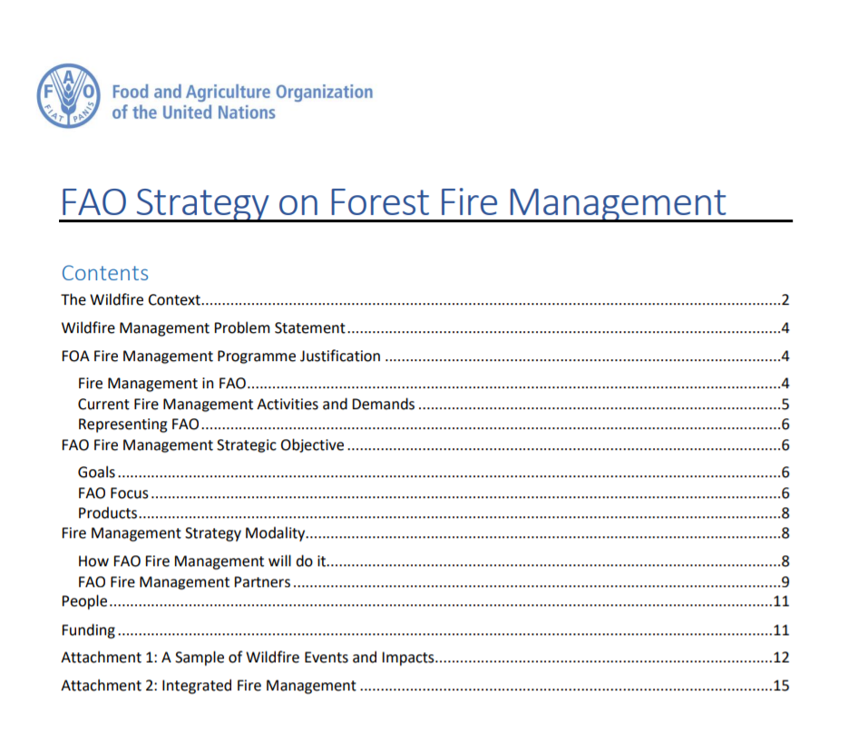
FAO also published several publications including “Wildland Fire Management handbook For Trainers”
As seen in the fires of 2021, forest fires require a very serious international cooperation. It is possible to reach to existing networks via this link. http://www.fao.org/forestry/firemanagement/55838/en/
“Committee on Mediterranean Forestry Questions-Silva Mediterranea, one of FAO's “technical advisory bodies” has a “Working Group on Forest Fire”. Turkey is a member of this working group since its establishment.
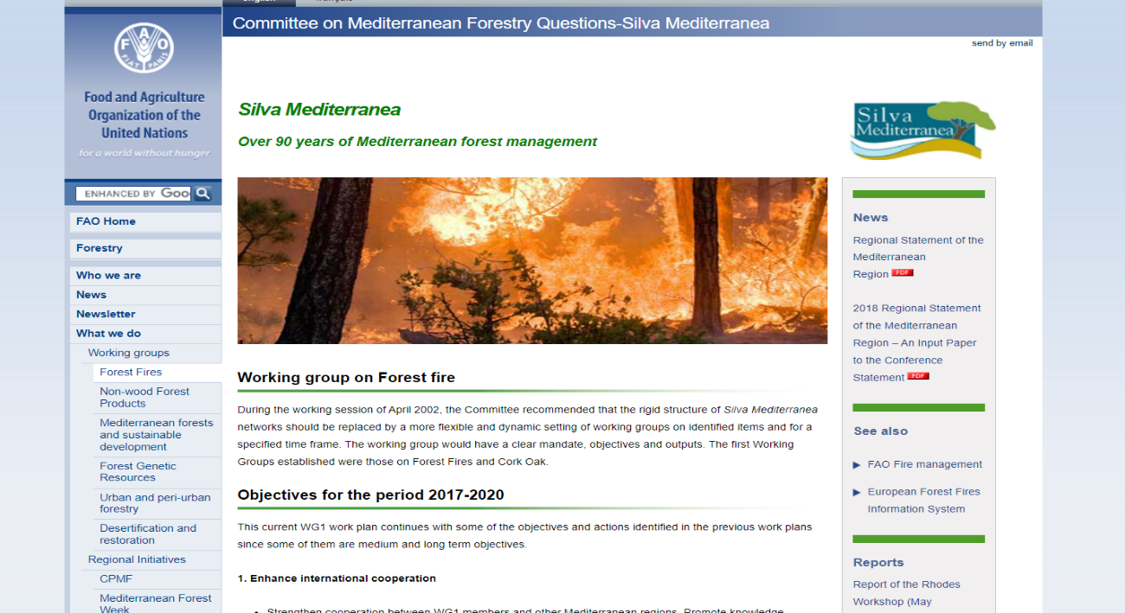
One of the ongoing initiatives on land restoration related to post-fire activities is “The Forest and Landscape Restoration Mechanism” implemented by FAO.

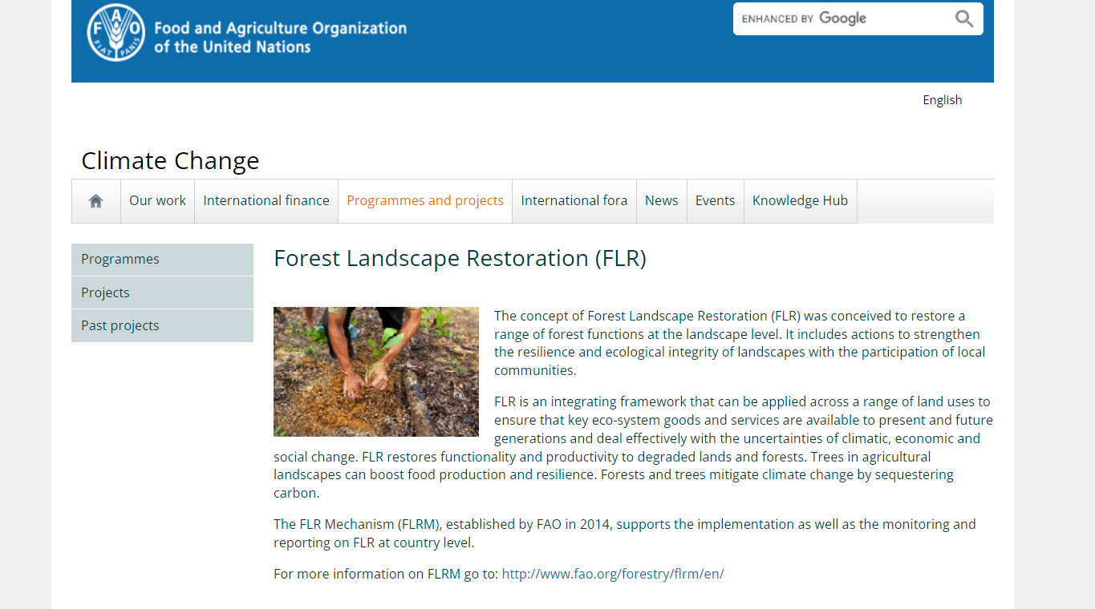

Four Pillars of Fire Management
The whole suite of fire management activities is often divided into four pillars, being Prevention, Preparedness, Response and Recovery, frequently abbreviated to PPRR.

PREVENTION | PREPAREDNESS | RESPONSE | RECOVERY
Fuel load management  - Prescribed fire  - Grazing  - Removal of fuel | Incident Management  Structure - Cross agency | Provision of plant and equipment  - Communities  - OGM  - Municipalities | Rehabilitate burnt areas  - Same species  - Species change  - Watershed management
Community Interaction  - Training  - Education | Fire Danger Rating System |  | Fire cause investigation
 | Early Warning System |  | Post-fire reviews and debriefs
 | Legislation review
Roads and trail maintenance and
Construction
 | Water supplies
 | Community fire strips

Prevention
Prevention is better than the cure!

Involvement of Locals
Given that Turkey is one of the oldest permanently settled regions in the world, there is a very close association between people living in the settled areas and forests. Their actions adjacent to and sometimes within the boundaries of forests are critical in determining whether fires start on very adverse fire days and where they start. This naturally leads to the matter of “Community Involvement” and building local communities into the overall fire management structure.

There must be very close and interactive contact with those communities in fire-prone areas, before the onset of adverse fire conditions. Hence the value of an Early Warning System that heralds the onset of ‘worse-than-normal’, right through to ‘very adverse’ fire conditions in the near future. Residents in and near to fire areas and/or their activities or equipment are likely to start by far the greatest proportion of wildland fires. Long-term statistics reveal that lightning in Turkey comprises about 10% of all fire ignitions, with the remainder being related directly to people, e.g., farmers burning unwanted crop residues or indirectly e.g., faulty power transmission lines.

This raises the question of communities being equipped and trained to deal with the initial attack on fires whilst they are in their initial stages and amenable to direct suppression action. Even on the worst days, fires igniting from a point source require some time to reach the stage where they begin to run at high rates of spread. On very low-risk days, fires burn at low intensity and are easier to control and suppress and can remain in that state for some hours, but on very high-risk days, in even moderate fuel loads, a point ignition can reach the state where it is not amenable to attack, within the first quarter-hour, maybe even less, depending on wind and topography. Hence, a rapid initial attack is vital.

Community Firebreaks or “asset protection strips”
It is desirable, mandated even, that community lands be separated from forest lands by a zone of sufficient width to act as a firebreak. For these zones to be effective, fuels on them should be removed before the onset of the fire season – not later than the time an effective Early Warning System suggests that the fire season is approaching.

Such zones are multi-functional. They can serve to halt the spread of fire from private lands to adjacent forests or in reverse, serve to halt the spread of fire from the forest into private lands. They can also serve as a very effective anchor point from which to mount suppression action against approaching fire. These features are only effective when the strips do exist and have been prepared by removal of all or most of the fuel on them.

Typically, they may exhibit a covering of grass or small shrubs which can be removed before the onset of the fire season by using low-intensity fire, intense grazing when stock can be confined to the protection strip, by cultivation intending to leave the strip in a fallow condition through the fire season or by mechanical means such as mowing.

Although such separation strips ought to be established where terrain permits, in some instances such strips have either not been created or not adequately maintained, thereby allowing easy transfer of fire between forested areas and community land.

Prevention is that suite of activities that can be undertaken in a bid to reduce the incidence and/or severity of fire. If ignitions can be prevented from happening, then fires will not occur to the same extent as they otherwise might. Activities in this classification include Community education and awareness-raising, management of fuel loads by activities such as prescribed fire use, grazing by domestic animals and physical removal of fuel.

Prescribed Burning
In forest areas, preventative burning, variously described as ‘prescribed burning’, ‘control burning’, ‘burning off’ or like terms, is used in many parts of the world to reduce the number of litter fuels on the forest floor and suspended in shrub layers. The objective of preventative burning is to ultimately reduce subsequent fire intensity in the event of a wildfire.

The views on this deliberate burning are very polarized, but there is a growing acceptance that several episodes of carefully implemented, low intensity prescribed burning is far more beneficial to the health of ecosystems and their constituent flora and fauna than less frequent but very high-intensity fires. Careful consideration of the deliberate application of fire and assists in understanding that many parts of the world were exposed to deliberate fire use by indigenous peoples for many thousands of years and their application of fire was not random - they had real purposes behind their activity, using wisdom gathered over lengthy periods up to 60,000 years.

Australia is probably one of the most recently settled countries in the world. Settled by “new settlers” that is – there was already a population of indigenous nations who had been there for up to 60,000 years before European settlement. Those First Nations peoples used fire prolifically and with great skill, for several purposes, including protection of medicinal plants and herbs, to attract grazing animals and to limit the spread of invasive forest types such as rainforest, into woodland and grassland areas, where valuable and culturally significant plants occurred.

Likewise, in the USA, many years of the swift and resolute initial attack on forest fires and very substantial suppression activity, whenever possible, have helped to create a situation whereby forest fuels in many forested areas continued to rise. This has been recognized and the USA is increasingly applying prescribed burning as a management tool to reduce fire intensity and forest damage in subsequent wildfires.

By itself, preventative burning does not stop fires from igniting. If conducted in accord with guiding principles about the intensity of the prescribed fire, and careful identification of the zones targeted for prescribed fire, it does mean that any subsequent wildfire that ignites within the area of concern will burn at a reduced intensity and may be amenable to control.

Reducing the fine fuel load serves to restrict the spread of the fire and gives firefighters more time to access unintended fires. It also means that when firefighters do reach a fire, burning the actual fire intensity will be lower and there is a much greater chance that initial attack efforts will be successful. If suppression action is not successful, a wildfire may burn through the area but at a much lesser intensity because of the significant reduction in available fuel, perhaps as much as 70% of the original fuel load removed.

Prescribed fire use is a very effective way of managing fuel loads in forests. This can occur under forest canopy or on ‘protection zones’ where the intent is to create a fuel-reduced fire break. If used under the canopy, the fire must be of sufficiently low intensity to cause minimal crown scorch. Fires that are too hot will kill leaves that will be shed, thereby reducing the effectiveness of prescription fire. The intent of reducing the fuel load is to reduce the intensity and rate of spread of subsequent wildfires, perhaps enabling suppression resources to reach the fire and extinguish it before it burns out of control. A secondary intent is to reduce the amount of forest damage that is caused by the wildfire.

Critical areas adjacent to communities, and inside forests, where natural features or lack of roads and trails may hinder rapid initial attack are good candidates for treatments. Other areas for strong consideration include those where there is a historically high incidence of ignitions.

In supporting countries to scale up their forest land restoration, the United Nations Economic Commission for Europe (UNECE) and FAO support the concept of prescribed burning to reduce the intensity of subsequent wildfire thereby reducing the overall impact on forests and watersheds (UNECE Media 27 August 2021).

Preparedness

Preparedness is the process of ensuring that all processes required for effective management have been validated and are operational, or able to be operationalized with very minimal notice. Included here are Planning processes, including inter-agency planning and exercising prior to onset of fire activity, ensuring that all contractual and hiring matters have been processed, identifying significant resources that may be hired under contract (whether on permanent hire or ‘call-when-needed’) resources arrangements made for employment and deployment of casual staff, all equipment and facilities checked and tested, supplied, replaced or serviced where required.

There is an expectation and perhaps even a legal obligation under the fire laws for communities who live on or close to the forest areas to participate in fire suppression activities. There does not appear to be any pre-determined structure that enables this process to operate effectively – in essence, there is little preparation

Identification of Incident Management Structures
Coordination between agencies and vertical levels of government (State-Province- Municipal/ Local) and non-government agencies is essential but appeared to be largely lacking. Turkey has enough experience in inter-agency coordination based on related legislation and has ‘Control Centers’ where key incident management personnel will be stationed.

Road and Trail Maintenance
Layout - Roads and access tracks are an essential component of fire management to enable initial attack and later on for other suppression resources to gain access to fire areas. As a general rule of thumb, roads and access trails should be ‘tenure blind’ and should never stop in a “dead end” at a boundary between separate tenures. Roads and trails that traverse the forest and then simply end and do not link into the overall network at that ‘dead-end’, can be very dangerous in severe fires when fire crews, who believe they are retreating to safety are not aware that the road or fire track they are traveling on does not link into the roading network, in the direction they are proceeding, but will simply terminate.

Ideally, forest roads and fire trails ought to have verges free of shrub and tree vegetation to provide a more robust fire break. Untended roads develop regeneration that can eventually encroach into the verge and if left untreated, branches and overhanging canopy greatly reduce the utility of the road and verges as a suitable fire break or control line. There are indications that some roads are in a state that requires the removal of trees from the verges. One method to do this may be to use tree harvesters to cut and process any trees that require clearing. Products can be utilized if of adequate size to be processed or made available to communities, e.g., for firewood or fencing material.

There are indications that some roads were not well maintained concerning clearance along the edges of the roads. Over time, trees encroach closer to the road edge as natural regeneration occurs and eventually the branches and canopy begin to overlap the road. One suggestion was that there is a need to remove a narrow strip of trees from the roadsides, perhaps by use of forest harvesting machines.

Road and Trail Construction
The forests are provided with a road and fire trail network to enable access for all types of forestry operations, including fire management activities. It is critical that roads link directly into communities if those communities are legally obligated to assist in suppression – the community members so involved must be able to easily and speedily access the forest areas near them. All roads that may be used for fire suppression activities should be ‘through’ roads linking into the overall road network at either end of a specific road.

Water Supplies
Water supplies are obviously a paramount need for fire-fighting vehicles. In elevated and dissected terrain, static water supplies (dams, ponds, pools) need to be constructed, with access for fire vehicles. The more frequent these facilities, the less time is lost in traveling to the nearest water supply, to refill and return to the fire. The matter of water supply, especially any perceived inadequacies, is likely to be raised in individual post-fire reviews, if such reviews are held.

There is need for static water supplies from which to replenish fire tankers when they exhaust their supply. The optimum outcome occurs when fire tankers do not need to leave the fireground for a lengthy time period and travel long distances to refill with water.

Field water supplies must be accessible by a road or track that can be traversed fire-fighting vehicles and experience has shown that the more depth in a water supply, the more reliable it will be.

For static water supplies that may be used for water bucketing by helicopters, there are, or should be, defined clearance zones from which all aerial hazards have been removed.

Running streams with suitable ponds are adequate to fill water tankers but as terrain steepens

Fire Danger Forecasting
Fire danger forecasting is an essential component of readiness and actual fire suppression. Fire managers or Incident Controllers, ideally need to understand the nature of impending fire weather and how individual fires are expected to behave.

For this purpose, a Fire Danger Rating System (FDRS) that amalgamates actual or forecast weather conditions to provide a measure of the relative degree of fire danger is utilized. This information is necessary in order to develop and implement safe suppression strategies – managers/controllers need to be satisfied that fire behavior and intensity expected will not exceed the capacity of resources allocated for suppression, or else firefighters may be placed in life-threatening situations. It is also used to provide warnings and alerts to threatened communities.

There is a Europe-wide fire information system that can provide this type of information. It is the European Forest Fire Information System (EFFIS). It has been designed to provide relevant and timely information to forest services and wildland fire management services across Europe and neighboring countries. EFFIS is managed by a “co-operative wildland fire expert group” on which Turkey holds one observer position.

It is a most extensive system that gathers huge quantities of data about fire occurrence and spread, weather information and forecasts, fuels, ignition potential, topography, community development, in short almost any aspect of wildland fire management that a fire manager needs, or ought to be aware of. It can provide a detailed picture of a geographic area, complete with forest areas, cleared/agricultural lands and towns/villages, with the ability to interrogate for data on very broad areas, such as an entire country, to smaller subdivisions (council, province) and right down to very detailed local areas of just a few hectares.

Turkey’s principal information about impending fire danger is provided by the Turkish State Meteorological Service (MGM). It is further noted that OGM has indicated, in the Strategic Plan 2019-2023, that there is an intention to develop a “Turkey specific” fire danger forecasting system.

Early Warning Systems
An Early Warning System (EWS) is an essential component of readiness for forest fire management. An effective EWS relies upon an evaluation of fuel dryness coupled with weather outlook to determine the likely potential for fire ignition and fire behavior at some point in the future.

The OGM has established what is referred to as an Early Warning and Management System. It is reported by OGM … that “an early warning system for forest fire has been established” to meet the goal of “UO2.8.3 Increasing preventative measures in combating forest fires, improving existing early warning systems.” The system relies upon lookout observers locating smoke within a very short time period (15 seconds after the ignition is quoted). As soon as data is collected, it is forwarded to the relevant Fire Operations Center. Response teams then consider the physical factors affecting the fire (topography, weather, fuel type, and location) to decide whether to attempt to control the fire by a direct attack with ground forces, use of aerial appliances, or a combination of both.

Importance of fire intensity
It is widely accepted by many fire management agencies that less than 5% of wildfires cause more than 95% of the damage. It is no surprise either that unless the first responders are almost at the very sight of a fire when it first starts under very adverse weather conditions, that such fires will rapidly burn out of control defying all efforts to bring them under control. Sometimes, there are as little as 5-10 minutes available to mount a resolute initial attack successfully before a fire is off and away.

Once fire intensity exceeds about 3000-4000 kw/m there is no technology capable of control by a direct attack - no amount of fire firefighters, bulldozers, fire trucks or aircraft serve any practical purpose in forests. Fast-moving fires spreading uphill in high fuel loads with a tailwind and burning under conditions of low humidity rapidly exceed nominal control levels and do not lend themselves to suppression unless something significant alters – the weather moderates, fuel conditions alter to very low levels of fuel insufficient to sustain spreading fire, e.g., fire runs into a very low fuel or no fuel areas that are substantial in size, significant rainfall occurs.

Roadside Maintenance

Fuel load management by grazing
Another fuel load management technique is to graze selected areas with domestic stock. It is preferable that stock can be contained to a defined area. The stocking rate determines how effective this is for reducing fuel loads comprising grasses, herbs and other edible plants. Trampling by the stock as they move about in the forest can also serve to ensure that litter suspended in shrub layers may be displaced onto the ground, providing less aeration to the fuel load.

Physical removal of fire fuel
This is a practice sometimes employed where forests carry heavy fuel loads adjacent to housing and other valuable assets, whereby the ground fuel is collected and moved off-site. It is obviously very labor and plant intensive and there is a need to subsequently dispose of any material collected. It is not generally applicable to broad areas and is often confined to narrow strips of forest adjacent to ‘at risk’ assets.

Response
The response includes the reaction to weather forecast/s or onset of adverse weather, provisions for public announcements and warnings about fire potential generally, and for specific ongoing fires in identified geographic locations and advice/warnings to the public. Response to actual fires includes dispatch of resources for initial attack, and later for sustained suppression campaigns. Obviously, there must be suitable resources available to direct to fire locations.

Because communities can often provide the nearest personnel resources available, it is logical to provide training and equipment to them so they possess the wherewithal to mount a concerted initial attack. Under the fire behavior that occurs on extreme fire days, rapid and effective investigation and initial attack is essential. This requires adequate equipment, since tree branches, buckets and household kitchen-style fire extinguishers will never succeed.

Fire Operation Centers

Carrying out works about fires and performing operations on fire calls across the country under the General Directorate of Forestry, FIRE OPERATION CENTER provides necessary support and coordination in cases where the regional directorates fall short and gives information about the fires to the related organizations/institutions and to the public. This unit is under the Department of Combating Forest Fires.

Fire Coordination and Management Unit

Fire Coordination Centers are the units that fire calls and fires are recorded, evaluated, and that coordination, information flow and support in fire management is provided. Technical experts work in these centers. Deputy Regional Director controls the Unit in cases where the fire tends to spread. Subsidiary Units are:

I-Decision Support Unit
II-Communication Unit.

Decision Support Unit
Data, which helps during the fire, is determined from different systems such as Remote Sensing Systems, OYEUS (Forest Fires Early Warning System), Fire Management System, Meteorological Early Warning System and mobile image transmission systems, and is shared with the fireplace management unit. In Fire Coordination Center, audio and video within the whole process (from the fire call till the extinction) and regional meteorological risk maps are recorded and archived.

Communication Unit

Communication Unit provides service 24 hours and necessary equipment and communication instruments (radio, telefax, internet, report line etc.) as well.

Duties; Received fire calls are recorded. First, related Forest District officials get informed about the fire call; and make the necessary amount of vehicles and personnel organized for firefighting. Those concerned are also given information about the fire (Technical staff, conservation) section head, Regional Director of Forests and Deputy Directors, and when required Governorship, Gendarme, Provincial Directorate of Disaster and Emergency etc.).

In order to get reliable information “Decision Support Systems” are used. Charts and tables related to the fires are provided and thus meteorological parameters and expectations are determined. In this context, charts and tables such as Fire Call Chart, Chart for Open Air Fires, Meteorological Data Chart, and Forest Fire Tracking Form are prepared and provided.

First;
- Record fire calls (place, date, reporter etc.),
- Inform the related tower and Forest District and send the closest team,
- Give information to air vehicles and authorized personnel (Airborne radar-airport),
- Give information to the Units (Head of OYM (Conservation) Section, Regional Director and Deputy Directors, GDF, Governorship and Gendarme etc.)
- Move air vehicles when required (by terrestrial coordinates).
- Provide necessary equipment and service for firefighting (Team, dozer, ground-air vehicle, personnel).
- Prepare fire “Message Form” for GDF Fire Operation Center within 15 minutes,
- Specify the coordinates of fire place, the closest water resources and the landing field for air vehicles,
- Monitor the fire (sharing information, making contact),
- Meet the needs in fire place,
- Organize preparations for the water supply and refueling of air vehicles in landing fields,
- Prepare or provide ancillary items/help (fire station, ambulance, private and public institutions, soldiers, Village headman).
- Prepare Fire Tracking Form,
- Give information to the fire place management about the vehicles and personnel on the move,
- Determine the meteorological values and expectations and inform the fire place management,
- Help to meet the fuel needs of ground and air vehicles, construction equipment etc.
- Give information to those concerned about the coordinates of vehicle assembly point; provide and record fire images and photos (both through air vehicles and ground)
- Help, upon request, to the change of crew/vehicles in fire area.

FOREST FIREFIGHTING activities include all the works and procedures like getting a call, controlling and cooling the fire, and leaving the area after extinguishing the fire. All these activities are urgent and require professional organization.

When there is a fire call, the closest teams move first. By taking into consideration the vulnerability of the fire area, strategic position and meteorological values which may lead to spread the fire, the personnel who serve in the organization get ready and the closes vehicles such as first responder vehicle, sprinkler, construction equipment, water tender and air vehicles are organized and send to the area. These vehicles move especially on the days with high fire risk. Authorities and relevant people and institutions are given information in each step. Taking into account the weather conditions and the characteristics of the field, the officer detects the equipment needed and makes a request accordingly. The officer also informs the personnel about the shortest and safest way to the area.

Sub-district forest manager or crew chief (Conservation guard or the most experienced personnel), who arrive at the area first, should provide:

Safety;
- Determining the escape ways and safe routes, and deploying the vehicles accordingly,
- Ensuring safety for the vehicles (closing doors and windows etc.),
- Keeping the roads open, and monitoring the fire and the area,
- Determining convenient locations for fire response and ensuring safety in the working area,
- Providing the personnel with the personal protective equipment and making sure that each of them uses/wears it.
- Determining the most critical location for fire response first and using the resources accordingly,
- Using the available resources efficiently starting from the heart of the fire,
- Reporting the necessary additional equipment for fire response (Crew, Dozer, Ground-Air vehicle, Personnel),
- Planning water supply (Water tender-Water resources),
- Auditing the crew members’ work.

Information in Fire Response
- Reporting the fire area as terrestrial coordinate, giving the shortest directions to the lookout tower or the closest team,
- Giving information about the course of fire and weather conditions in the fire area,
- Reporting the closest settlements and the possibility of damage from fire; reporting the valuable and dangerous areas, if any,
- Determining the types and amount of inflammable matters in the direction of fire,
- Fixing the “Direction Signs” on the ground; reporting the course of fire and the current situation to the superior; and also reporting if the fire can be kept under control.

Team Leader in Fire Response
A team consists of technical personnel, 3 sprinklers and 1 water tender. The components of the team may belong to different regional directorates, forest districts or sub-district forest units. The team that is formed first is called “Team 1”.

The team leader makes the team vehicles (and the personnel) work and move as a whole. The team works in the area of responsibility which is determined by the leaders and NEVER leaves its place. Change of position is only made by the managers. A team leader must have two radios. He/she never leaves the channel assigned. Team leaders should never communicate with anybody else other than team members and his/her superior.

Team leader keeps the record of the vehicles and the personnel in his/her command on the chart. If the team goes to any other regional directorates, the team leader arrives at the “Vehicle Assembly Point” and hands over the chart. The team leader gets information about the radio communication plan, fire map, his/her position in the fire and directions. When the fire is kept under control, the teams of other regional directorates are sent back. These teams are not assigned to cooling or waiting for tasks.

Vehicles in Fire Response

In case of being surrounded by a fire while firefighting, enough water should be reserved for the self-cooling systems in the water tenders. If the fire spreads and poses danger for the people and vehicles around, all the team vehicles must be moved to the safer areas as soon as possible. All these works are decided and implemented by the team leader. In cases where the vehicles do not have the opportunity to drive away, they should be directed to the safer open spaces nearby in the forest areas.

First Responder Vehicle should be deployed between the sprinklers as the front of the vehicle shall be on the opposite direction of the way where fire spreads. The sprinkler should be deployed on the direction of the way where fire spreads (behind other vehicles as a barrier to fire).

There should be a distance of 3 meters between the vehicles. All the personnel wear respiratory protection and get on the vehicles, the doors and windows of which is closed. Meanwhile, the self-cooling systems of the sprinklers should be run.

Equipment should be ready to provide/form foam and water-screen to be used when necessary. If there is enough water in the tanks of the vehicles, personnel inside these vehicles should respond to the fire with foam and water as well. The lane widening works should be carried out in the forest area, in the direction of the way where fire spreads.

Authorities should be informed immediately.

The vehicles of the team should be parked in such a way that they do not tie traffic up. When the vehicles need to make a turn, the vehicle on the back row should turn first and the others turn in order.

Placing Fire-Hose

Remember to use the hydrant valve and cut off the valve in every 100 meters.

- If the fire response distance is approximately 100 meters, each vehicle can respond to fire individually.

- If the fire response distance is 100-300 meters, the vehicles are divided into two groups. One group places the fire hose and the other one gives water support.

- If the fire response distance is over 300 meters, a sprinkler is deployed and it responds to fire. The other three vehicles provide water. Water tender is thought to be the one deployed under favorable conditions. If the sprinkler, which will provide water, pump water to the suction hose of the deployed vehicle, sprinkler’s water is used first. In this case, the pump of the deployed vehicle will not run continually and by the time the other sprinklers come back with water, it could use the water in its tank.

Line Manager and His Duties in Firefighting

Line managers are supported by experienced personnel such as Forest District vice Managers, experts and technical staff. By taking into consideration the measures of safety Line managers organize the fire control and extinguishing works with this personnel and the teams.

Line managers are supported by experienced personnel such as Forest District vice Managers, experts and technical staff. By taking into consideration the measures of safety Line managers manage the fire control and extinguishing works with this personnel and the teams.

Line managers only work under fire manager. Forest District Manager, experts and technical staff work under Line managers as line officers. Each line officer controls three teams in general. “The teams and sprinklers which are not needed/required are sent to the assembly point.”

The basic rules in firefighting are early detection and effective early fire response. Even in the fire response of only one sprinkler or a team, Sub-District Forest Manager (or the deputy manager) needs to be in the area. It’s obligatory that all the managers and vehicles of the Forest District are mobilized in fire-sensitive periods and when there is a fire call related to the fire-sensitive areas.

Steps in Fire Organization
There are 4 steps in fire organization;

Basic Organization: The closest 2 sprinklers (and first responder vehicle, if any) are sent to the fire area. A manager is also required to direct and control these vehicles. Technical staff who arrives at the area (mostly sub-district forest manager) carry out his/her duty as fire manager.

Small-scale Organization: Team-1 is formed with the participation of a third sprinkler and water tender. If needed, dozer, ground team and even air vehicles also take part in firefighting works. In this case, the “team leader” who arrives at the fire area controls and manages firefighting works as “fire manager”. The sub-district forest manager needs an assistant at these stages. At first, this assistant could be a forest conservation officer. This organization is mostly made for the fires which do not tend to spread and to which 1 team is enough to respond. Forming a fire team will be the primary element in the stages of the organization.

Medium-scale Organization: If the fire tends to spread, support teams are required. After the formation of the second team, a superior takes over the responsibility as fire manager. Forest District Manager or deputy manager should take over the management in principle. The fire manager assigns his/her assistant first. Air vehicles are also managed by the fire manager.

It is difficult for a fire manager to manage fully all the works while waiting for support teams and needed equipment.

An assembly point for the firefighting vehicles is required nearby fire area as well as another unit. Taking into account the possibility of fire growth, the assembly point is determined by assessing the criteria such as accessibility, safety and size of the area. The area, in general used as “Operating Base” or “Vehicle Assembly Point”, is indeed a place where the works of LOGISTIC DEPARTMENT are conducted. In this case fire management vehicle should arrive at the fire area. This work is carried out by technical personnel at first. If needed assistant(s) are assigned

If the fire continues, new teams are organized (team3, team4, team5 etc.) and they work under fire manager. Seven teams at most can work under fire manager. This organization is a medium-scale organization in which a logistic department consisting of 5-7 teams (20-28 sprinkler and water tender) also works. Fuel trucks are positioned in a suitable place for the vehicles (air and ground). Due to the potential and area of the fire, authorities and personnel of Regional Directorate of Forestry work in this organization.

In large-scale forest fires, fire managers and line managers working under him/her take charge in the organization. Line managers first assign their assistants. The assistant is chosen from technical personnel who have information and experience on forest fires. These assistants also work as line officers under related line managers. The line manager who has more experience and knows the area most works in more critical line.

STAGE: Responding to a fire with 5 teams (One line)
STAGE: New lines with support teams in addition to 5 teams

Large-scale organizations are made when the Forest District is not able to extinguish the fire with its own means. In spreading fires, essential units should be organized immediately and tasks should be shared among them. Regional Director, Deputy Director, Head of Section and technical personnel who have experience in firefighting should arrive at the fire area as soon as possible. Regional Directorates should state the main units, the chiefs, and alternatives in forest fire organizations in their “Fire Action Plans” in advance.

Arriving at the area, authorities and personnel of the Regional Directorate, Forest District Manager, Deputy Manager and related Sub-district Forest Manager assign 1- Fire manager 2- Line Managers 3- Planning Manager and assistants, and determine the positions and radio codes. Hierarchy should be taken into consideration in the assignment of the chiefs in this planning. However, knowledge, experience, skills and information on the area should be determinant in this choice.

A “Fire Management Center” is established under fire manager or fire management vehicle can be used for this purpose. This special-equipped vehicle is indeed “Mobil Fire Management Center”. Planning Department and Decision Support Systems Unit which will be formed when required take charge in this organization and are situated in this vehicle. When the organization requires two lines there will be 40-56 sprinklers and water tenders.

If the fire spreads to larger areas, senior staff of the Ministry and General Directorate of Forestry, forest fire experts, academicians etc. may arrive at the area apart from the above-mentioned teams and personnel. Since it is a larger area, additional teams and 3-4 lines (or more if necessary) are required to combat fire.

Fire Manager and His Duties in Forest Fires

Especially in large-scale and very-large-scale forest fires Regional Director arriving at the fire area holds a meeting with the Deputy Regional Director, Head of Conservation Section, Senior Fire Protection Engineer, Forest District Manager, Deputy Manager and experienced technical personnel. The hierarchy should be taken into consideration in the assignment of the chiefs in the organization. However, knowledge, experience, skills and information on the area should be determinant in this choice.

The fire manager is in charge of taking all the necessary technical and administrative measures, coordinating activities and controlling the works in the whole firefighting process. He/she is the first-degree authority in firefighting works and thus plays an important role. Fire manager carries out the fire operation and manages the fire response activities.

In principle, Sub-district Forest Manager, Deputy Sub-district Forest Manager or Forest District Manager can be fire manager considering the first person arriving at the area.

An experienced technical worker can also be assigned as fire manager by the regional directorate when necessary.

If Forest District Manager has been recently appointed to the position and does not have much information on that area, he/she can assign the Deputy Manager as fire manager. However, the manager still monitors and controls the in-situ implementation.

Fire manager evaluates the course of fire and the condition of the area with other managers in the organization. He/she determines the strategies to follow in order to keep the fire under control and extinguish it, and coordinates the works immediately. Fire manager carries out firefighting activities jointly with chiefs of the units on duty

Fire manager should have one or more assistants in combating large-scale or very-large-scale fires.

If they arrive at the area, department heads of the General Directorate, experts and academicians constitute a group. This group evaluates the information flow on the course of fire, makes contributions to the strategies developed and helps in fire management and extinguishing works. A place, equipment and personnel should be provided for this group as well. These two main units take part in very-large-scale fire organizations and when required.

Press & Information Officer
The information officer is the General Director of Forestry. Senior managers of the Ministry and General Directorate of Forestry can also assume this responsibility when needed.

Planning Manager

The planning Department is formed mostly in large-scale and very-large-scale fires. The planning manager and Decision Support Systems Officer are generally at the fire management center (or management vehicle.

In very-large-scale fire organizations, Planning Department works directly under the Fire manager. However, the department works coordinately with the heads of the air and ground operations department, the Head of logistics operations and the decision support systems officer. The Planning Department is the most important unit of the fire manager (outside the fire area). The planning manager consults with the fire manager and other units. The planning manager has also experienced assistants.

Duties of Planning Manager

- Preparing firefighting plans and alternative plans,
- Following the preparation process of the communication plan,
- Sharing information with the Logistics Department and providing necessary support,
- Sharing information with the Decision Support Systems Unit and evaluating the data obtained from this unit for forest fires,
- Recording necessary information about the equipment, personnel and chiefs in the fire organization,
- Organizing the preparation of necessary maps or sketches. (Teams and works sites, marked). Recording necessary information.

Ground Operations Department

This unit is under Fire manager, but works in coordination with departments of planning, logistics, decision support systems and air operations. Line managers are subordinate to this department. Ground Operations Department monitors the course of the fire and evaluates the risks. This department provides support to Line managers and carries out inspections in the lines.

Air Operations Department

Regional Director, Deputy Regional Director, Head of Conservation/OYM Section, Forest District Manager of the area, experienced technical worker may carry out this task. The officer in charge manages the air operations in compliance with the directions of fire manager and in line with the evaluations carried out with the officers of Planning and Ground Operations Department.

The department,
- determines the fire response points of air vehicles;
- specifies the need for air vehicles; plans the work of different air vehicles in different lines;
- monitors the firefighting works at certain intervals on flight vehicles when needed, and organizes the fire response work when required;
- controls the fuel needs of air vehicles; maintains continuity for air vehicles in fire response;
- provides effective use of air vehicles

Logistics Department

Logistics Department is required mostly in medium-scale, large-scale and very-large-scale forest fires and works under planning manager in medium-scale and large-scale fires. In very large-scale forest fires this department serves under-fire managers. The department is managed by the director of the machine supply unit and an experienced section head.

- Taking necessary precautions in the working site and controlling the measures; ensuring safety in places where fuel tanks are situated;
- Making a record of the operators of the vehicles and construction equipment arriving at fire area;
- Making a record of the vehicles and machines of the other institutions (public and private);
- By order of a superior, organizing the transportation of vehicles and construction equipment to the area;
- Meeting the fuel needs of ground vehicles and construction equipment;
- Carrying out breakdown maintenance of the ground vehicles and construction equipment in the fire area
- Providing food and water on time and delivering them in a sterile environment;
- Providing ambulances for the fire area (from local health authority);
- Sending the injured and sick people to the hospitals or ambulances; 73
- Organizing the Vehicle Assembly Point and preventing traffic tie-up;
- Providing the personnel with personal protective equipment when required;
- Providing first aid material when required;
- Recording the necessary information

Decision Support System Officer

Decision Support System consists of Heads of Electronics and Communications Unit and the other experts serves under Planning Manager. The officer works at the management vehicle. The department personnel track meteorological data and record it. The officer controls the radio communication plan (channel assignment), provides active and healthy information flow by using information and communication systems, and improves the communication quality by building relay station when necessary. The officer also controls all the systems such as Fire management system, Camera monitoring system, Remote Sensing and fire detection and alarm system informs the planning manager about the data to be useful in the firefighting.

The fire area is divided into two (or more when needed) lines in large-scale and very-large-scale fires. Line manager carries out the fire response works at the lines. Deputy Regional Director of the area or Head of OYM (Conservation) Section can be line manager.

Basic Principles of Communication during a fire

Communication is an activity of transferring information, messages and news from one party (sender) to another (recipient). The term here consists of all the activities related to communication in fire response and the firefighting process. Without communication, it is not possible to make an effective organization, and thus to be successful in firefighting.

On the radio, the message should be delivered slowly, distinctly and clearly. The speaker should use plain language. If the message in sot understood, it should be repeated and the speaker should have it approved. When the channel is used, the recipient should wait for the speaker to finish his/her word before answering (except for emergencies). The microphone should be held at 4-5 cm. to the face.

Since forest fires are urgent and extraordinary situations, communication is very necessary and important in firefighting. There are various communication instruments, but in Turkey, radio is used for communication on fire. To communicate without any problems during firefighting infrastructure should be ready, users should be trained and should follow the determined rules and procedures, and communication plan should be organized with alternatives and it should be fully implemented.

Analog radios, which are common, are used as a base for the introduction of the system. Radio channels are set for existing radio communication systems based on Forest Districts in every Regional Directorate. Relay Channel, stand-by channel (simplex of a related relay) and fire channel (Forest District Fire channel) which are assigned for each Forest District is known in advance and used in communication.

Each fire manager should have two radios on duty. The users in related Forest Districts are in a stand-by channel under normal circumstances (they use relay channel when required), but in special cases such as fire, they use fire channel (Forest District fire channel). The manager (Sub-District Forest Unit Manager, technical worker, conservation officer or team leader) uses stand-by channel of his/her District until he/she arrives at the fire area.

Fire manager communicates with Forest District, Regional Directorate, lookout tower, and vehicle assembly point etc. through stand-by channel of the District using the second radio. When air vehicles give information to the line manager about their positions or any other warnings, line manager also informs the team leader immediately about the situation (50th channel on the example).

Fire manager may communicate with his/her seniors, Forest District, fire operations center, and vehicles in firefighting etc. through stand-by channel (or relay channel when necessary) of the District. Management Vehicle (planning and decision support) is on the same channel with fire manager. Team leaders also share the same channel with line manager. Air vehicles serve under related line manager and use the channel of line manager.

Channel assignment is done in the same way until there are 20 teams. For each new team, a new channel is assigned. Since an officer is required for each five team in firefighting organization, different channels are needed for line managers to be assigned. Besides since line manager will be under a fire manager, another channel will be assigned for fire manager to provide communication. Fire manager communicates with Forest District, Regional Directorate, lookout tower, and vehicle assembly point etc. through stand-by channel of the District using the second radio. When air vehicles give information to the line manager about their positions or any other warnings, line manager also informs the team leader immediately about the situation (50th channel on the example).

Recovery
Recovery includes post-fire restoration of burnt areas including forest regeneration, repair of damaged facilities, equipment replacement. Also included in recovery is a formal analysis of the fire/s to ascertain the level and nature of the damage and fire causes. On occasions ‘recovery,’ activities may be initiated while suppression action remains in progress.

Burnt areas may regenerate naturally without intervention. In that case, the vegetation pattern evident pre-fire is likely, but not guaranteed, to re-establish itself. There are indications that some vegetation types may alter following severe fire with the increased impact of global warming on species succession. It is important to monitor the development of regeneration to ensure that unwanted species (undesirable non-local and highly invasive weed species) do not become dominant in the landscape.

Alternatively, there may be valid reasons to deliberately alter the vegetation type to different tree species, to increase the resilience of the landscape to future fire events. This would necessarily require a concerted replanting and reafforestation process.

Whatever processes are adopted, there is a need to assess each individual fire area and a standardized approach may prove useful. One such approach is “Burned Area Emergency Response”, being the suite of activities necessary to rehabilitate following fire.

Debriefing, or post-fire review, following significant fires, is a useful method to identify and record any ‘lessons learned’. It is important to identify those elements where activities did not proceed as planned, to enable actions to address any shortfalls in standard operating procedures. It is equally productive to also examine those areas where the management activities worked particularly well and to use those experiences to also reframe Standard Operating Procedures (SOPs).

The purpose of such reviews must never be to attempt to apportion ’blame’, but to make a genuine effort to understand how the whole operation proceeded with a view to identifying improvements, Naturally, every person who participated in suppression events cannot participate in such event, but there should be a representative cross-section of attendees from each agency involved.

https://fireecology.springeropen.com/articles/10.1186/s42408-021-00102-7#Tab1
https://www.mevzuat.gov.tr/MevzuatMetin/3.5.712520.pdf
https://www.mevzuat.gov.tr/mevzuat?MevzuatNo=7210&MevzuatTur=7&MevzuatTertip=5
https://www.resmigazete.gov.tr/eskiler/2019/09/20190911-3.htm
https://web.ogm.gov.tr/ekutuphane/Tebligler/Forms/Orman_Yanginlariyla_Mucadele.aspx
https://web.ogm.gov.tr/ekutuphane/Tamimler/6976%20Say%C4%B1l%C4%B1%20Tamim.PDF
https://www.un.org/esa/forests/wp-content/uploads/2021/08/UNFF16-Bkgd-paper-disasters-forest-fires_052021.pdf
http://www.gonder.org.tr/?p=6144
http://uclg-mewa.org/uploads/file/748e86d91ae4409e9188794ddb6c004d/Sendai_TR.pdf
http://www.gonder.org.tr/?p=10626
http://www.fao.org/forestry/firemanagement/strategy/en/
http://www.fao.org/forestry/silva-mediterranea/en/
https://unece.org/media/news/359313
https://effis.jrc.ec.europa.eu/partners
https://www.mgm.gov.tr/arastirma/dogal-afetler.aspx?s=ormanyangin
Strategic Plan for Climate Change Adaptation of Forestry www.ogm.gov.tr
https://www.fs.fed.us/naturalresources/watershed/burnedareas.shtml

