Webex Events Participant Guide

Important notice
If this is the first time you are joining a WebEx meeting, you will be prompted to download the temporary app or browser add-on. Click the installer file to install the app. You can also download the WebEx meeting app manually.
Please ensure to mute your microphone before you join. All participants should keep their mics muted when not speaking.

Tips on the conduct of meetings
Arrive early to test your connection: In order ensure adequate time for participants to test their connection to the Webex platform, test the functionality of their microphones and cameras, and to have any questions they may have resolved before the meeting starts, you are kindly requested to connect to the meeting link in advance.
Mind the mute button: Your microphone should always be muted unless you are speaking. This is to prevent noises that could cause distraction or interruption. The mute button will appear red when muted. Do not multitask: If you use a computer, please close all other apps and browser tabs. When using a cellphone please kindly place it on silent mode and do not send text messages or make phone calls during the meeting.
Ensure the camera is at an ideal distance from you: The camera should be far enough from you so that your upper body can be seen, centered in the camera view.

When you take the floor
- Verify that you can be heard before starting the substance of your intervention. This will also allow participants who need interpretation to change to the relevant channel, bearing in mind that a brief delay occurs when switching channels.
- Position the microphone at a reasonable distance from your mouth (i.e. not so close that your breathing is picked up) and speak directly into it without turning your head away.
- Be aware of and engage with the camera sending your image.
- Speak at a moderate pace and avoid reading from documents. If you must read from a statement etc., documentation should be provided in advance for interpretation purposes only (it will be checked against delivery).
- Turn off your microphone and camera when you have finished speaking.

Joining the meeting
When you’re invited to a Webex meeting, you received an email containing a link to the meeting.
Kindly click the link indicated as the Event address or copy and paste the event address into the browser to join the meeting.
Event address:
You may be asked to enter the following info to join the meeting:
Event number:
Event password:
SIGN-IN: You will be taken to the sign-in page. The event password field will already be filled in and can be retyped if needed. Reference the meeting password above.

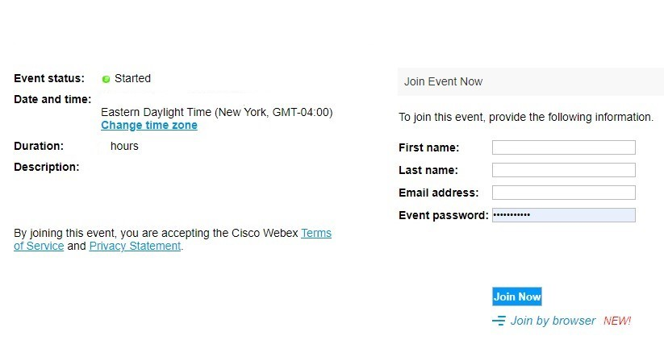
Signing into the meeting

Name of Event/Meeting

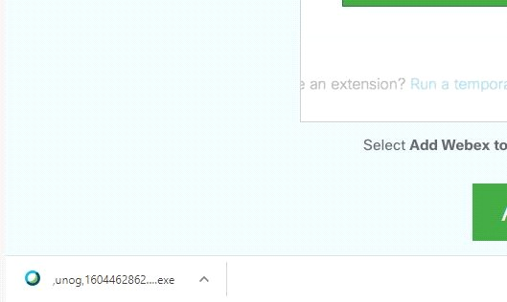
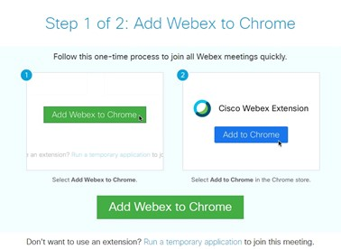
DOWNLOAD: If you do not have the Webex software on your computer please click the “Run a temporary application” option at the bottom of the page for full functionality.
On Chrome the download will appear at the bottom left corner, click and open
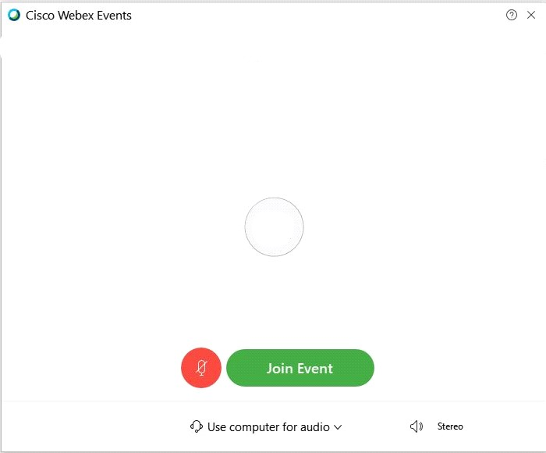
You will then be taken to the screen to join the meeting

Name of Event or Meeting

You will initially have your microphone muted while you await admission by the meeting host.
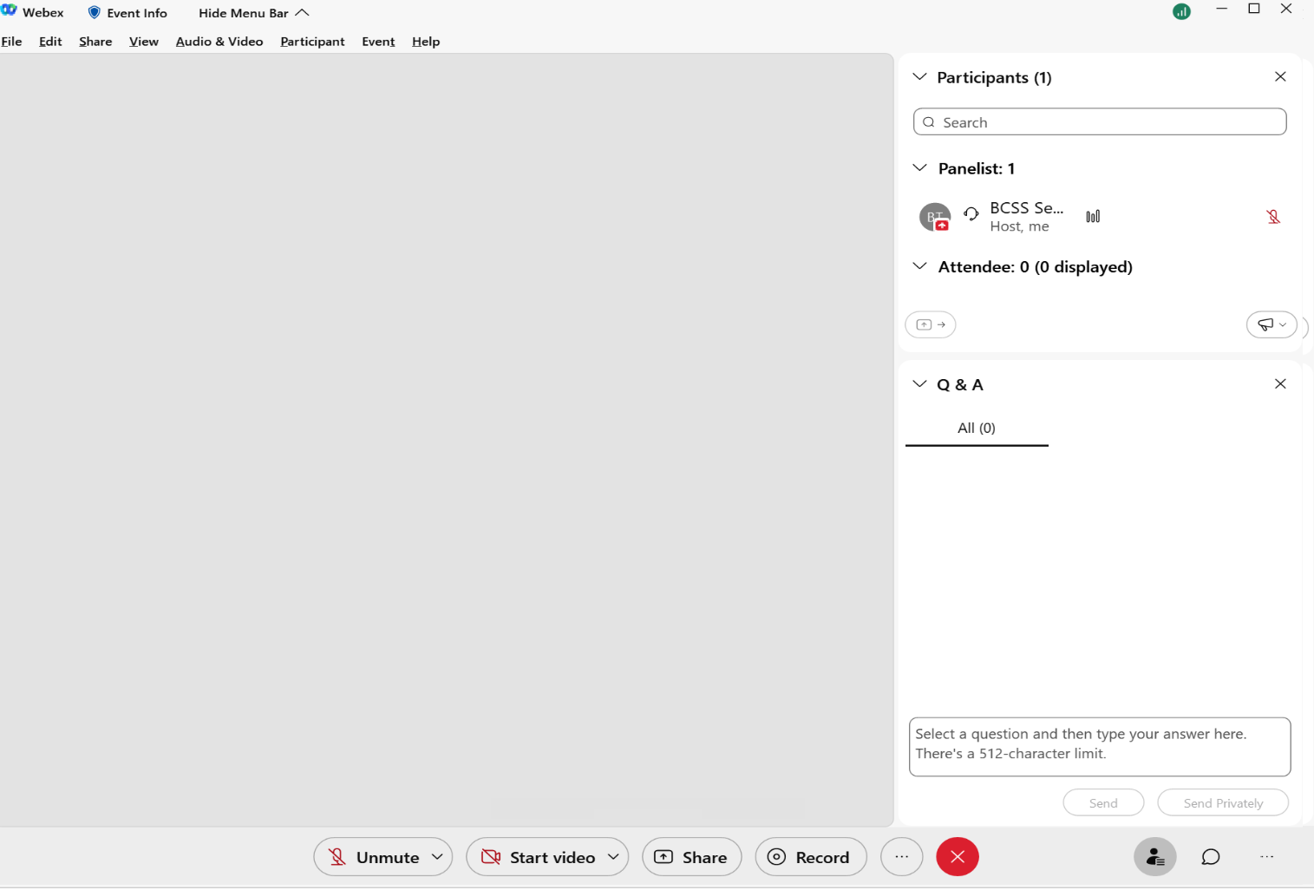
After admission, you will have full functionality. Please turn on your camera to participate in the meeting. Controls are provided at the bottom of the window, including audio mute, video mute, participant list and chat as enabled by the meeting organizers.
Join with a mobile phone
Please click the link for the Webex meeting on your invitation.
You will then be taken to a page containing a JOIN button. Kindly click the button.
Name of Event or Meeting

If you have not previously installed the Webex app, click “Download” to do so. You will then be taken to your app store to complete the download. (NOTE: If you have downloaded the app previously, click “Join via installed app” instead.)
You will next be asked to give a series of permissions to allow the app to have temporary access to your camera and audio for use during the meeting. Click “Allow” for all.
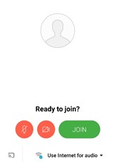
Kindly click JOIN as below to enter the meeting.
In meeting controls
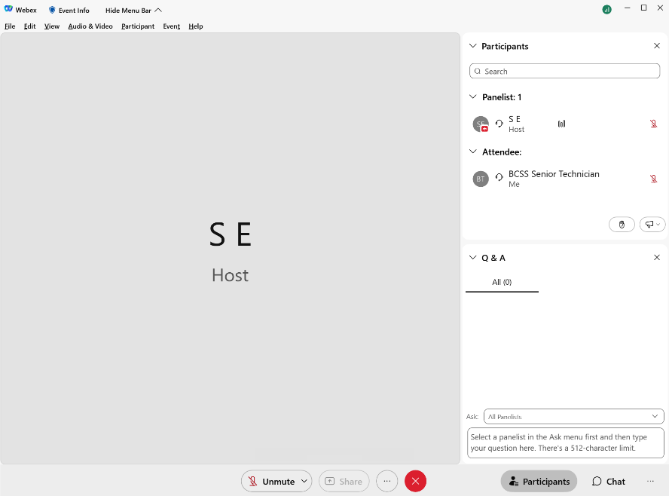
The user interface is simple. Most of the options are in the center and participants and message panels are on the right.
As a presenter you can turn on your camera and microphone. As an attendee you will be able to ask questions using the Q & A on the bottom right of the Webex window using the panel options (…).
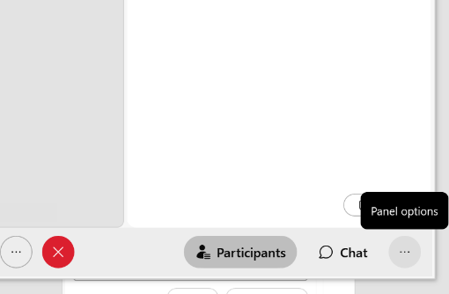
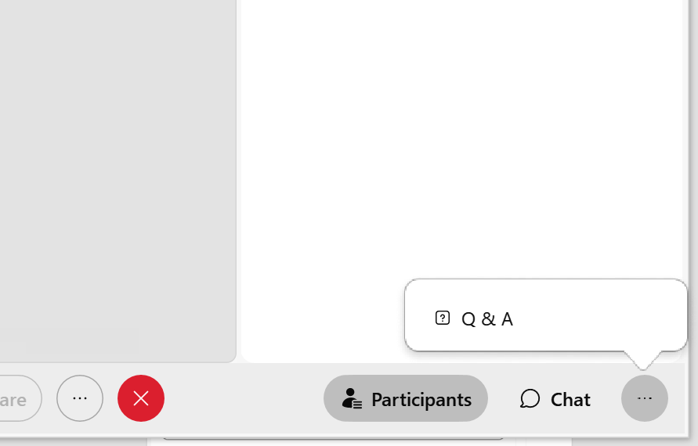
Ask questions
As a meeting or webinar attendee, you can ask questions to hosts, cohosts, and presenters.
- Open the Q&A panel.
- Select who you'd like to ask from the drop-down menu.
- Type your question in the message box.
Questions have a 512-character limit.
- Ask your question publicly by clicking Send or privately by clicking Send Privately.

Troubleshooting
Who to contact if participants have a problem with the connection? Participants should send an email to unvc@un.org with reference to the Webex# along with their phone number and a BCSS technician will contact the participant.
BCSS VNOC can be reached by phone at +(212) 963-8649.

System requirements
A computer (PC or Mac) or mobile device (iOS or Android):
- equipped with a camera and microphone
- video and audio communication ready and connected to a high-speed internet connection (a minimum 25 Mbps)

MOBILE (webex mobile app)
Apple iOS
Android

DESKTOP
Windows 64-bit / Windows 32-bit
Mac
Desktop apps for Windows, Mac iOS, as well as mobile apps for iOS and Android, are available in the links below:

