Narrative Technical Report of
“Nursery Plant and Management, Sapling Production with Closed Root System and Afforestation Techniques Training Program”
20-29 March 2019

Contents
Preface 2
Training Program at Glance 2
Participants 3
Translators, Trainers, Consultants from OMO 3
Daily Programs 3
20th March 2019, Wednesday 3
21st of March, 2019, Thursday 6
22nd of March, 2019, Friday 6
23rd of March, 2019, Saturday 8
24th of March, 2019, Sunday 9
25th of March, 2019, Monday 11
26th of March, 2019, Tuesday 12
27th of March, 2019, Wednesday 14
28th of March,2019 Thursday- 29th of March, 2019, Friday 15
General evaluation of the training program 16

Preface
The Chamber of Forest Engineers of Turkey is a professional organization (NGO) with the status of “public legal entity” established under the "Union of Chambers of Turkish Engineers and Architects (TMMOB)" by relevant law.
A “LETTER OF AGREEMENT” signed at 11th of March, 2019, Between the Food and Agriculture Organization of the United Nations (“FAO”) and Chamber of Forest Engineers of Turkey for provision of trainings on various subjects for the employees of forest enterprises of the State Agency for Environmental Protection and Forestry (SAEPF) in the Kyrgyz Republic, within the project GCP/KYR/010/GFF- “Sustainable Management of Mountainous Forest and Land Resources under Climate Change Conditions”.
According to this LoA the following 3 (three) trainings activities will be organized by the Chamber of Forest Engineers with close cooperation of General Directorate of Forests.
- Training Program of “Nursery Plant and Management, Sapling Production with Closed Root System and Afforestation Techniques.
- Training Program of Forest Pests and Diseases.
- Training Program “Forest Fire”
The first one was organised from 20th of March to 29th of March 2019. According to the LoA signed a “narrative technical report” of this training must be submitted to FAO not later than 10th of April. This report has been prepared and submitted by OMO to FAO in line with that aim.

Training Program at Glance
Date | Activities
11 March 2019 Monday | Letter of Agreement signed between the FAO and the OMO
13 March 2019 Wednesday | Identify experts among the members of chambers and relevant institutions and develop TORs of trainers and training materials to develop the training in technical manner.
13 March 2019 Wednesday | Preparation of the Nursery Plant and Management, Sapling Production with Closed Root System and Afforestation Techniques Training plan and agenda to define overall details and implementation structure of training activities.
20 March Wednesday-29 March Friday 2019 | Implementation of Training activities
10 April 2019 Wednesday | Submission of narrative technical report

Participants
Participants of “Nursery Plant and Management, Sapling Production with Closed Root System and Afforestation Techniques Training Program” as follows:
Sıra No | İsim | Soyisim
1 | Tatiana | Koblitskaia
2 | Aizat | Turuspekova
3 | Abibilla | Temirbaev
4 | Sherali | Melibaev
5 | Kyraly | Nazanov
6 | Zhusupbek | Topchubekov
7 | Baktybek | Esengulov
8 | Ruslan | Abdyldaev
9 | Manap | Talachiev
Dinar Bektursunova, who was on the first list, could not attend the training due to problems in visa procedures.

Translators, Trainers, Consultants from OMO
As stated in the LoA, all training preparations were sent to FAO in time. Maye Yilmaz and Inna Topoeva have been assigned as translators to Russia/Turkish. They been informed in advance about the programme, technical materials and people.
Several trainers from the General Directorate of Forests and universities took part during the programme. On behalf of the General Directorate of Forests, Nihat Karakaya (Forest Engineer from the Headquarter) has been assigned as the coordinator.
From the Chamber of Forest Engineers, Mr. Özgür Balcı (Forest Engineer) Member of the Board of Directors responsible for professional issues and İsmail Belen (Forest Engineer, Msc.) External Relations Consultant were designated as “Consultant”.

Daily Programs

20th March 2019, Wednesday
Participants came to Istanbul from Bishkek by Turkish Airlines were met at the airport by translator and the consultant in the early morning at about 8:00 am at the airport. Then they came to “Divan Istanbul City Hotel” booked and paid by FAO with a minibus rented by OMO.
After check-in formalities participants have been informed about the whole programme in detail.
During this briefing, the bags prepared especially for this training delivered to participants. “Name badges and tags to be put on the table” prepared for the participants.
Kyrgyz, FAO and GEF flags were prepared. Materials such as project posters, roll-ups were prepared and used in all meetings.
WhatsApp group for all team including Kyrgyz attendees, interpreters and OMO staff was formed and developments were immediately shared. Interpreters have the task of translations in this WhatsApp group.
Figure 1 First Day of the Program
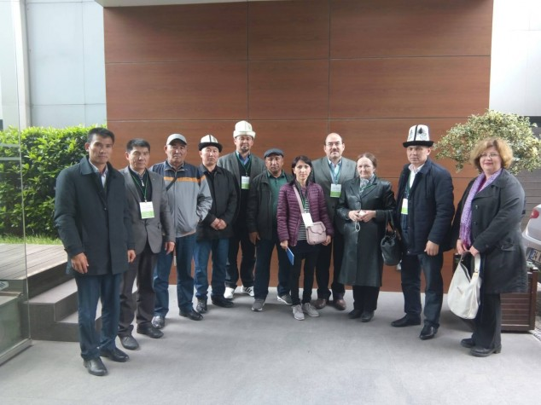
After lunch, the Atatürk Arboretum of the Istanbul Regional Directorate of Forestry, was visited. This arboretum, created with hundreds of domestic and foreign tree species, is considered as a good example for the afforestation studies.
Figure 2 Poster of Training Program  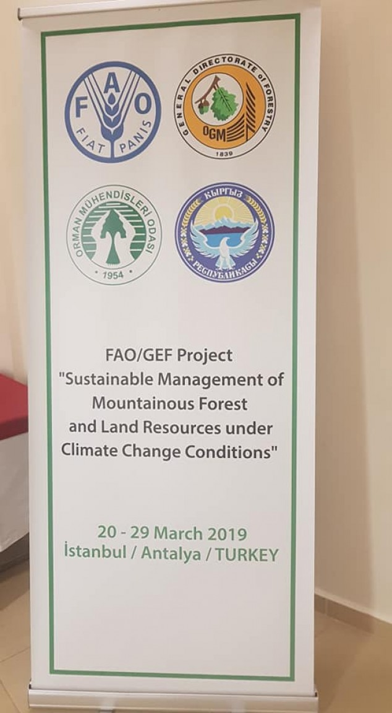 | Figure 3 Some Project Materails  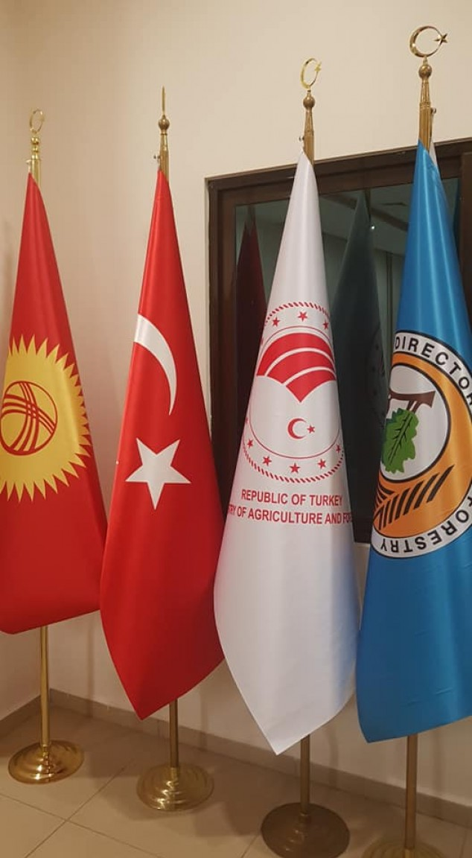

During this visit some presentations were submitted to the participants by the relevant experts and authorities as follows:
- Deputy Regional Director of Istanbul Mr. İlyas Özdemir
- Director of Bahçeköy Forest Directorate Mr. Fatih Altunordu,
- Director of Istanbul Forest Nursery Directorate Nejdet Balcı,
- Chief Engineer of Atatürk Arboretum Ms. Merve Kartaloğlu Sönmez https://istanbulobm.ogm.gov.tr/BahcekoyOIM/Lists/yonetim/ozgecmisli.aspx
Figure 4 Meeting at Istanbul Arboretum  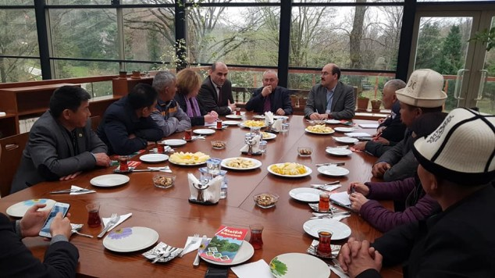 | Figure 5 Field trip at Istanbul Arboretum  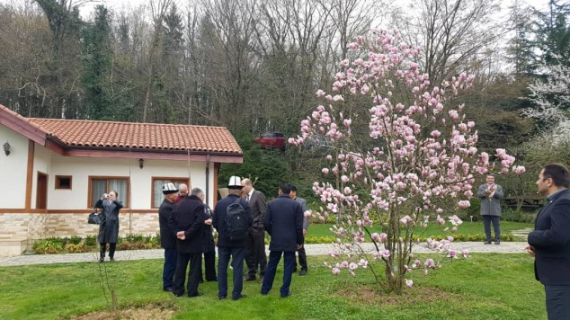

After briefing and presentations, together with officials, participants visited to field.
The continuation of this, participant visited to Istanbul Forest Nursery Directorate. https://istanbulobm.ogm.gov.tr/Sayfalar/Fidanl%C4%B1k%20M%C3%BCd%C3%BCrl%C3%BCkleri/istanbulfidanlik.aspx
During this visit the following people were present and shared their experiences.
- Regional Director of Istanbul Mr. Recep Ateş,
- Deputy Regional Director Mr. İlyas Özdemir,
- Director of Forest Nursery Nejdet Balcı,
- Deputy Director of Nursery Mehmet Kaplan,
- Chief Engineer Murat Güleken
After presentations participants visited the nursery with relevant experts.

Figure 6 Meeting at Istanbul Nursery  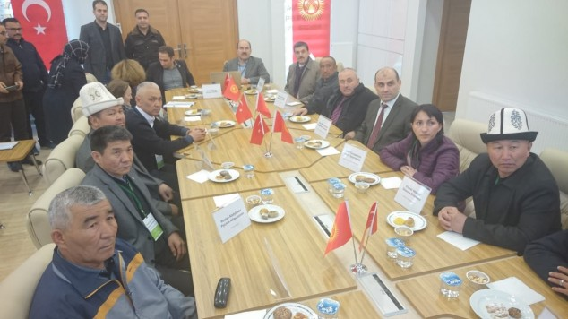 | Figure 7 Field Trip to Istanbul Nursery  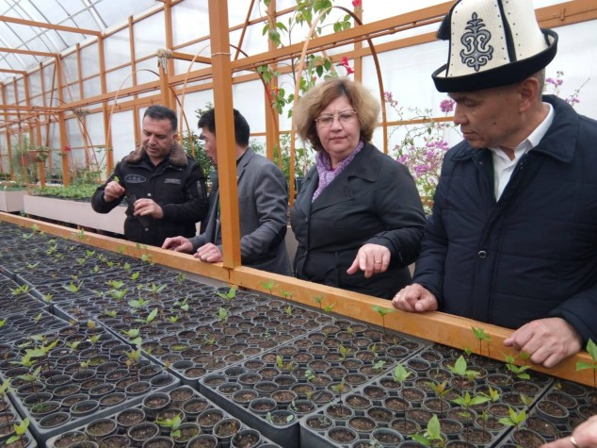
Please visit this link for more information: http://www.gonder.org.tr/?p=7629

21st of March, 2019, Thursday
The Day of 21st of March has been declared by the General Assembly of the United Nations. For this occasion the General Directorate of Forests organises several programs to celebrate this day in overall country.
Figure 8 Ceremony of 21st of March IDF  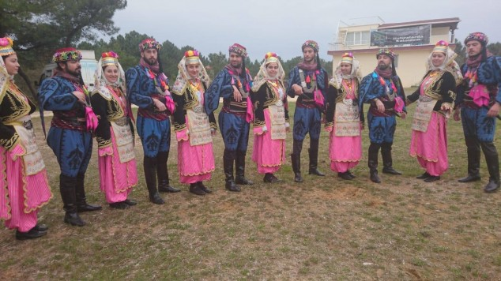 | Figure 9 Ceremony of 21st of March IDF  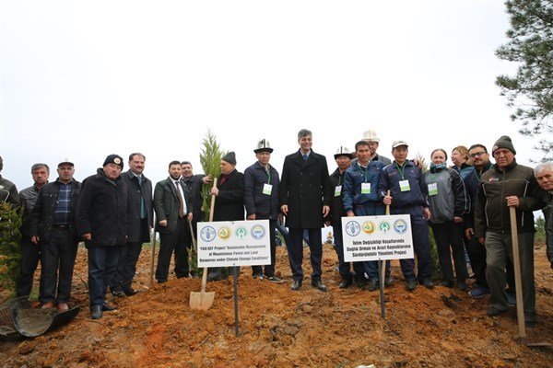

This is a very good opportunity to witness and see the organisation and activities in an ordinary way. For that aim participants join to program organised by Şile Forestry Directorate for "21 March World Forest Day Events". During that program they were able to plant seedlings with children and relative officials.
In the afternoon, a cultural excursion was made in Istanbul in accordance with the program. With this program, the participants were informed about forest-public relations, ensuring and informing citizens about their afforestation and nursery work, and making them interested in forestry studies.

22nd of March, 2019, Friday
At that day participants visited to Istanbul Forestry Faculty and met with academicians. http://orman.istanbulc.edu.tr/en/
Professor Dr. Turgay Akbulut- Dean of Faculty- http://profil.istanbulc.edu.tr/tr/p/takbulut welcomed the participants. Professor Dr. Türker Dündar- Representative of OMO to Faculty- http://profil.istanbulc.edu.tr/tr/p/dundar was also present during this opening ceremony.
Figure 10 Istanbul Faculty of Forestry  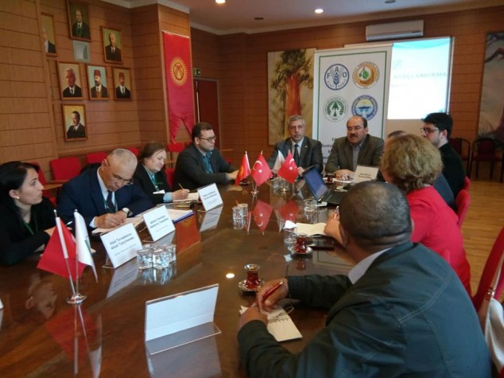 | Figure 11 Facilities of Forestry Faculty  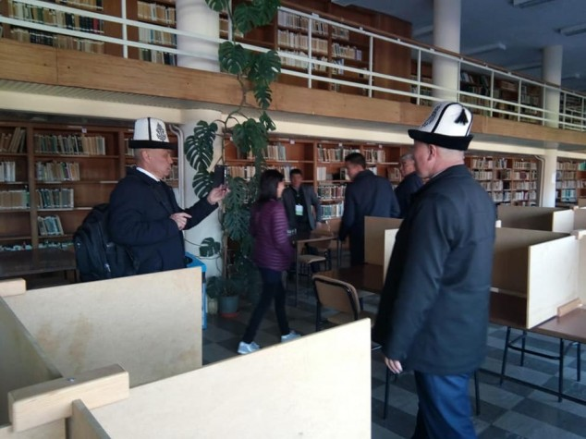

Associate Professor Servet Çalışkan- http://profil.istanbulc.edu.tr/tr/p/servetc and Dr. Safa Balekoğlu http://profil.istanbulc.edu.tr/tr/p/safa.balekoglu gave lessons and shared their theoretical knowledge on “Nursery Plant and Management, Root System and Afforestation Techniques”.
During this program, Deputy Dean Prof. Dr. Vedat Beşkardeş, representatives from General Directorate of Forests as Mr. Nihat Karakaya, Division Director of Istanbul Regional Directorate Ms. Canan Yeşil and photographer Mr. Murat Gümüş were also present.
On this occasion, the participants were able to see closely to Turkey's oldest and most powerful Faculty of Forestry and the opportunity to discuss with the authorities.
Afternoon they visited to the Regional Directorate of Istanbul. Regional Director Mr. Recep Ateş, Deputy Regional Director Mr. Ilyas Özdemir, Istanbul Forestry Director Mr. Veli Altıntaş gave a welcoming speech and shared their experiences verbally. After that Division Director of Afforestation Mr.Talip Kavlak, Division Director of Silviculture Selahattin Eruş and Division Director of Foreign Relations gave presentation on their activities.
Figure 12 Regional Directorate of Istanbul  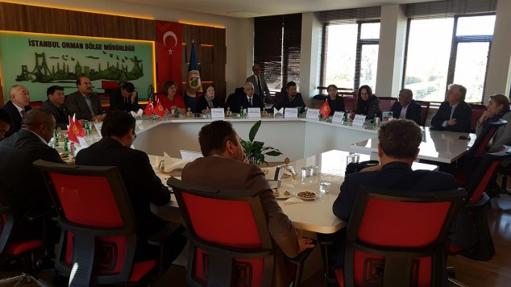 | Figure 13 Presentations by officials from Istanbul RD  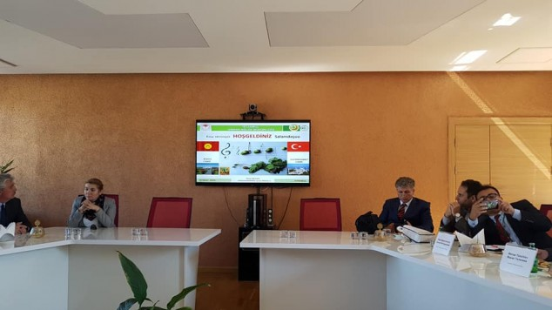

With today's programs participants have been informed about Turkey's theoretical knowledge and its applications.
After that program participants moved to airport for Antalya.

23rd of March, 2019, Saturday
The training program in Antalya started on the morning of Saturday. https://sfm.ogm.gov.tr/
Several presentations made by the following people.
- Regional Director of Antalya Mr. Vedat Dikici, https://antalyaobm.ogm.gov.tr/SitePages/OGM/OGMDefault.aspx
- Deputy Regional Director Mehmet Karabacak,
- Division Director of Foreign Relations Mr. Aydoğan Türedi
- Director of Training Center Mr. Mustafa Ülküdür
- Forest Engineer from OGM’s Headquarte Mr. Nihat Karakaya

In this presentations, detailed information on "Forests and Forestry Activities in Turkey" were shared. On the other hand on behalf of Kyrgyz Foresters, Tatiana Kabliskaia made a presentation on Kyrgyz Forestry.
Figure 14 International Training Center of Antalya  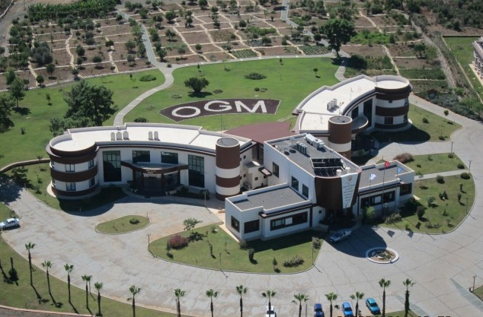 | Figure 15 Starting to Training Program at Antalya  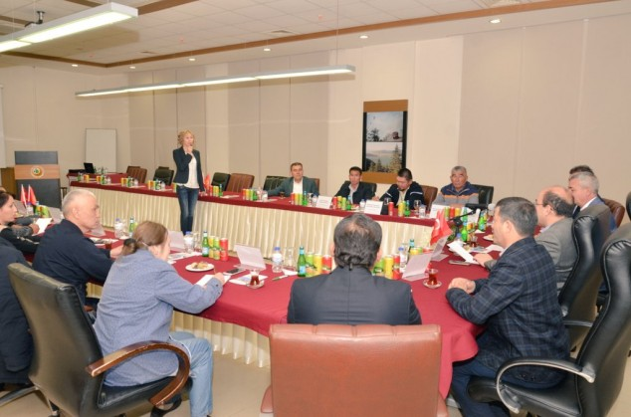
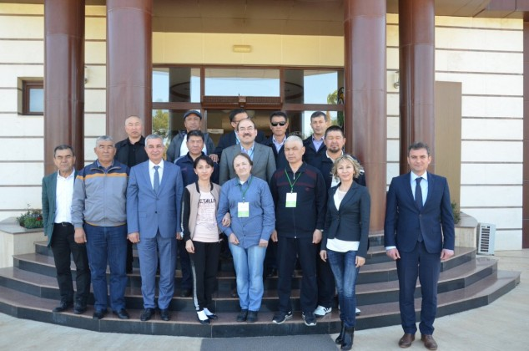 | 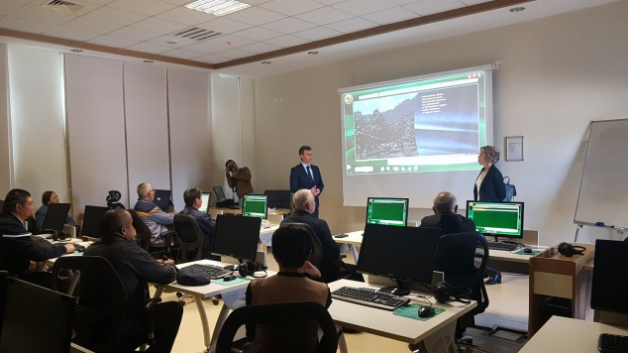

After the presentations, a total of 50 hectare Training Center was visited. It is used as a training center for all forestry issues including forestation and forestation. During this trip, Mustafa Ülküdür, the Director of the Training Center, provided information on different topics including forest fires, afforestation and forest pests.
The afternoon lesson was carried out in Antalya Nursery Directorate. During this programme the following issues shared with participants.
- Nursery Plant and Management
- Sapling Production with Closed Root System
- Seed and Tree Improvement
- Sapling Inspection and Certification
Figure 16 Antalya Forest Nursery-I  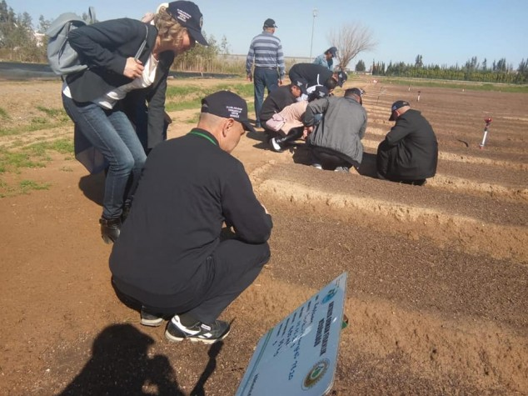 | Figure 17Antalya Forest Nursery-II  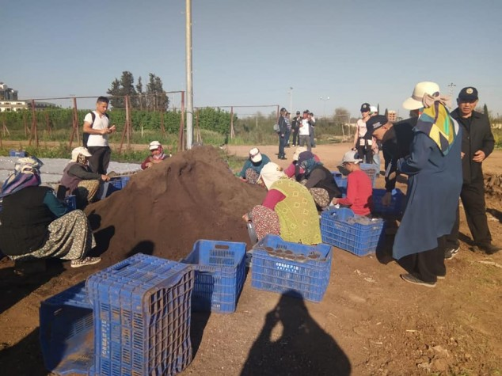

Practical information has been provided by Ayşe Özcan, the Chief of Nursery, and Technician Belkıs Dicle. Mr. Mehmet Koç, The Head of Foreign Relations, Training and Research Department of the General Directorate of Forestry participated in the training in the nursery.

24th of March, 2019, Sunday
Sercan Tunç, Director of Afforestation Branch of Antalya Regional Directorate of Forestry and Hayrullah Yıldırım, Chief Engineer of the Projects, made presentations on 24 March 2019.
The presentation subjects were as follows according to the program.
- Surveying, Project and Afforestation Techniques
- Reforestation carried out by private sector in Turkey
- Afforestation and rehabilitation of susceptible area

Afterwards, participants together with the relevant officials visited to sites. They went to Korkuteli, Bademağacı Village in order to see the works on site. Here, information was received from Chief Forester Mr. Fatih Çetin and Forestry Officer Mehmet Yılmaz on the industrial plantations around Korkuteli Bademağacı Village and walnut plantations made by forest villagers.
Figure 18 Picture of 24th of March  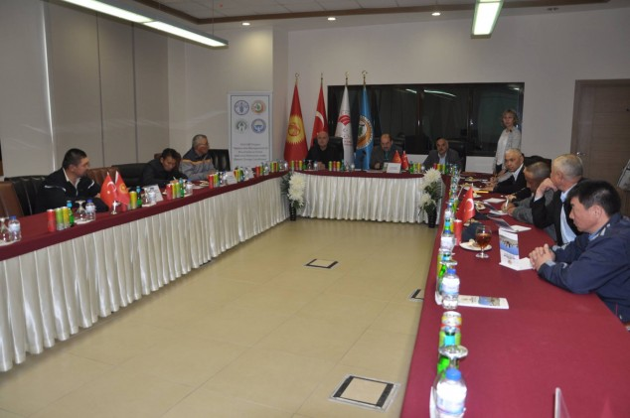 | Figure 19 Field trip to industrial plantation  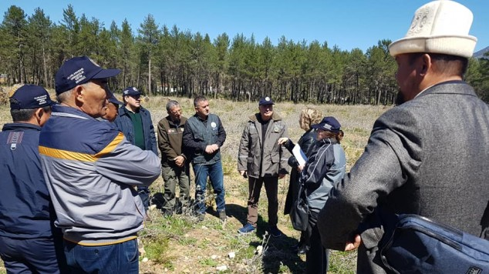

After the field trip, a general evaluation of the program was made by İsmail Belen and then, by Forestry Engineer Nihat Karakaya, from the General Directorate of Forestry, a presentation on international activities of the General Directorate of Forestry were presented.
Following this, our Kyrgyz Colleagues met with representatives of NGOs.
The following people from relavant NGOs were participated to that meeting.
- Ahmet Keser, Head of the Western Black Sea Branch of the Chamber of Forest Engineers and Director of the Marketing Department of the Regional Directorate of Forestry. Branch Treasurer and the Division Director of Non-Wood Forest Products and Services of Regional Directorate of Forestry Abdullah Yüksel, Branch Editor Celal Emir,
- Ramazan Gün, Öz Forest-İş Antalya Branch President, Branch Secretary Ahmet Ali Şişaneci, Branch Financial Secretary Süleyman Koca,
- TOÇBİRSEN Vice Chairman Mehmet Demirkol, Branch Vice Chairman Halil İbrahim Erdem and Orhan Akkaya participated.
Figure 20 Meeting with NGOs  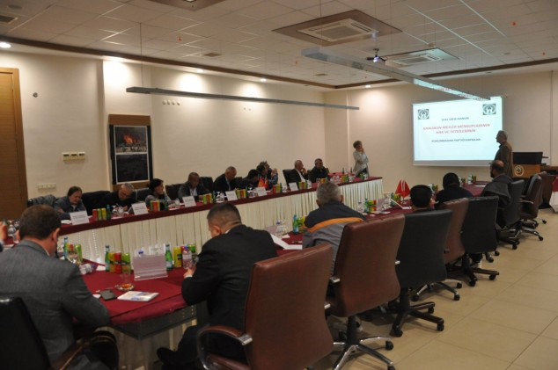 | Figure 21Meeting with NGO-II  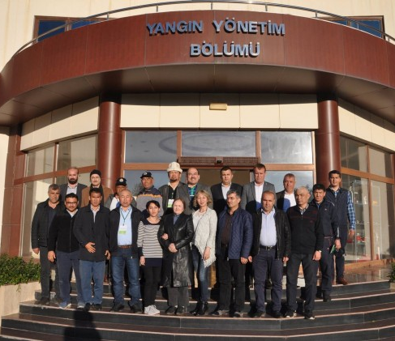

25th of March, 2019, Monday
The program started on Monday, March 25, 2019 with a general overview of İsmail Belen and Nihat Karakaya at 08:30 and the revision of the entire program. In the meantime, the land program of 26 March Tuesday was shared with the participants in detail.
Then the Director of the Training Center Mr. Mustafa Ülküdür and the Deputy Director Ms. Dilek Vursavaş addressed the participants and made a general evaluation.
Figure 22 Director of Training Center Mustafa Ülküdür  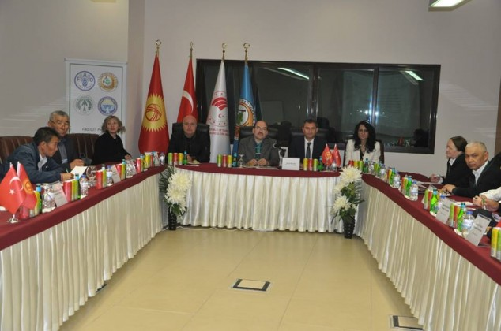 | Figure 23 Participation to OGM's own program  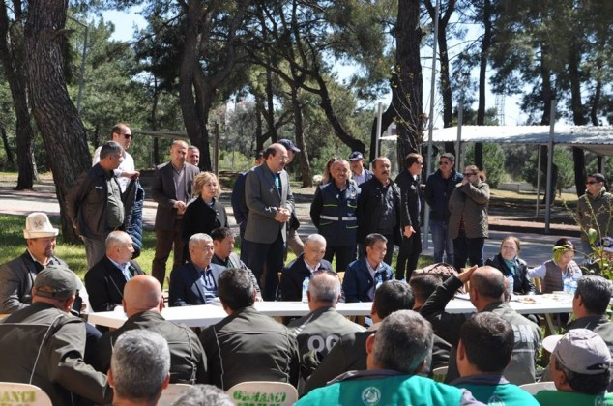

The continuation of this;
- Mr. Abdullah Yüksel, Non-Wood Forest Products and Services Branch Manager of the Antalya Forest Regional Directorate
- Mr. Mitat Uyan Branch Manager of Forest Pests
- Mr. Hayrullah Yıldırım, Chief Engineer of the Survey, made their presentations.
The subjects of presentations were as follows:
- Soil Conservation and Erosion Control Studies
- Integrated Watershed Improvement Studies and Mountain Area Management
- Forestation with Non-Wood Forest Products and Fruity Species
- Melioration of pastures and grazing in forests

After this, the training activities organized by the General Directorate of Forestry within the scope of pre-fire preparations were participated. In this way, the participants had the opportunity to see their internal practices in place.
In the afternoon a field trip was made. In this framework, firstly Korkuteli Forest Management Directorate was visited.. https://antalyaobm.ogm.gov.tr/KorkuteliOIM/Sayfalar/default.aspx
Here, Deputy Director Tuncay Ayhan, Chief Engineer Yakup Su, Ardıçdagi Forest Operation Chief Engin Atli, Hacıbekar Forest Operation Chief Gökhan Gök, and Yazır Operation Chief Fatih Çetin informed the participants about their activities.
Figure 24Field trip to erosion control sites  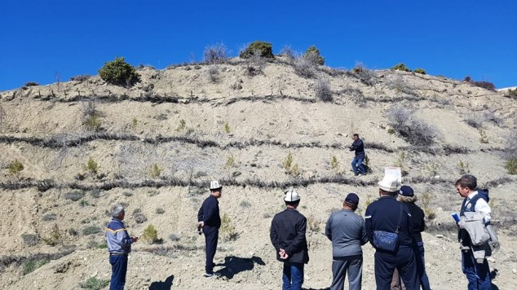 | Figure 25Field trip to Korkuteli  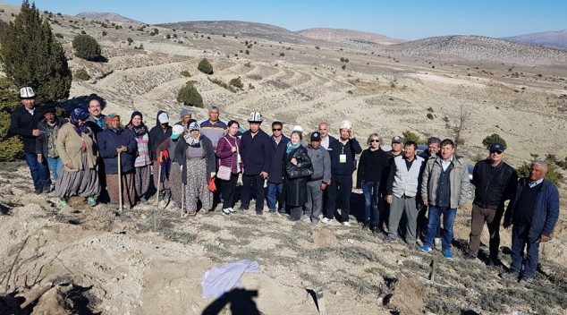

After that, Antalya Korkuteli Erosion and Flood Control Training and Model Implementation Project (2014) area was examined.http://www.cem.gov.tr/erozyon/AnaSayfa/Erozyonyeni/projeler/antalya_erozyon.aspx?sflang=tr
The Project Location is within the boundaries of Korkuteli District of Antalya Province. Founded in 2015. In the project area, there are slope and scales improvement measures.
After this area, the afforestation and erosion control studies carried out in the village of Korkuteli Karabayır were investigated on site. Workers were interviewed here.
http://www.koylerim.com/antalya-korkuteli-karabayir-koyu-60364h.htm

26th of March, 2019, Tuesday
The participants left the Training Center at 08:00 in the morning. At 10:30, the officials of Isparta-Bucak Forestry Directorate met. Here, The Director of Bucak Forest District Mr. Ramazan Kolsuz and the Deputy Director Emin Demir gave information about the post-fire activities. https://ispartaobm.ogm.gov.tr/BucakOIM/Lists/Yonetim/AllItems.aspx
Figure 26 Field trip to Bucak Forest Directorate  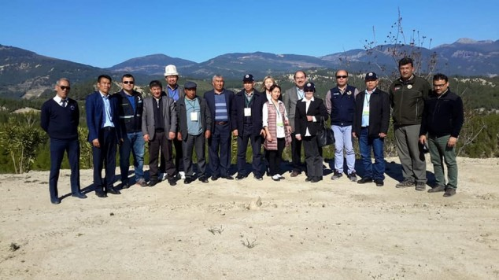 | Figure 27 Officials of the General Directorate of Forest  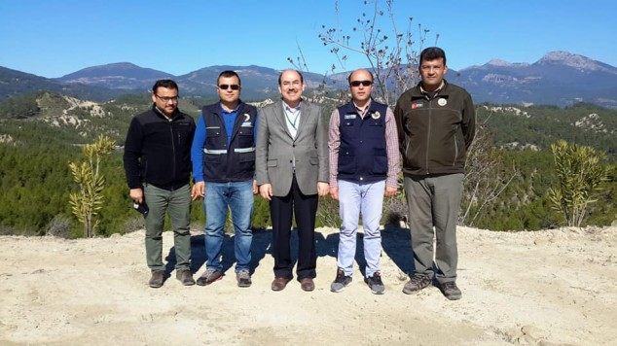

At 11:00 am, the Regional Directorate of Forestry in Isparta was visited. Regional Director Kenan Akduman and other officials were interviewed. Kenan Akduman, Regional Director, made a detailed presentation on all activities carried out by the region.
Figure 28 Regional Director of Isparta, Mr. Kenan Akduman  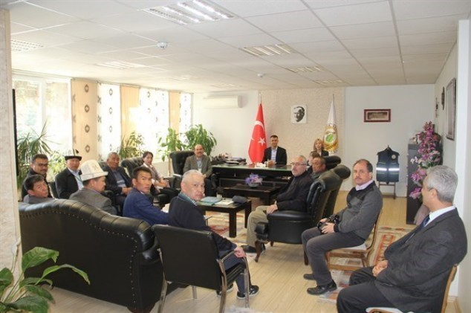 | Figure 29 Regional Directorate of Isparta  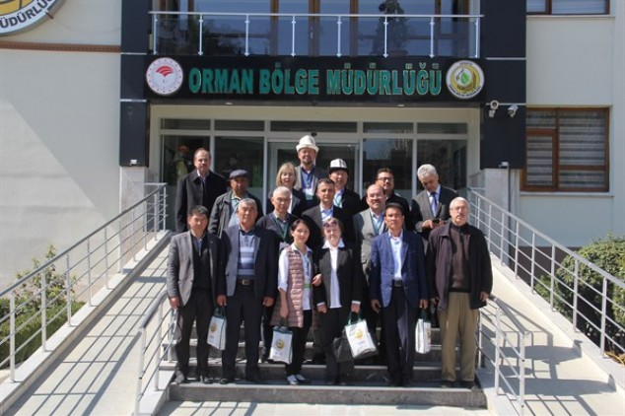

Between 12: 00-14: 00, the Eğirdir Nursery Directorate was visited, and the information about the nursery works was taken, especially juniper seed processing.
During this visit, the following people made presentations.
- Director of Nursery, Mr.İsmet Dokur,
- Deputy Director Ms.Sevim Özbey,
- Chief Engineer Ms.Nazlı Özgü.
Regional Director Kenan Akduman and Regional Directorate, Afforestation and Silviculture Branch Manager Ahmet Şahan also participated in the delegation.
Figure 30 Eğirdir Forest Nursery  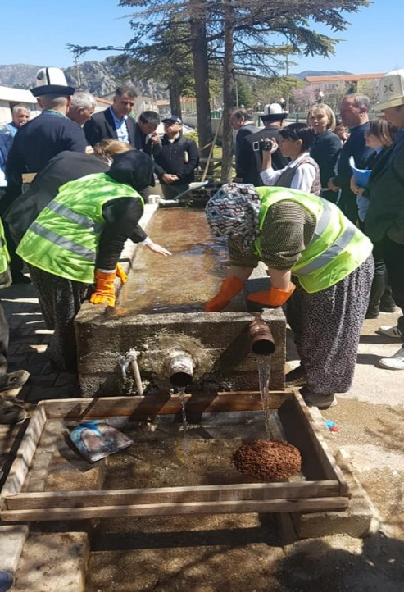 | Figure 31 Seeds of Juniperus  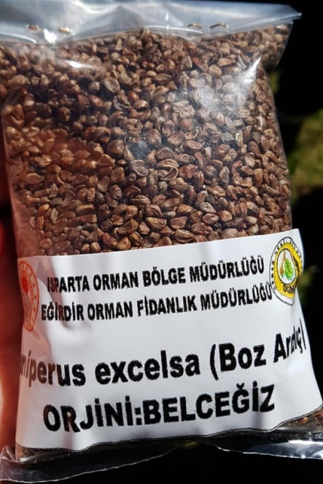

Egirdir Nursery specializes in the production of juniper saplings. In this regard, serious cooperation proposals were made by our Kyrgyz colleagues.
Between 16:00 and 17:00, Burdur Afforestation and Erosion Control studies were examined on site.
Forestry activities in the region of Burdur gives important experiences to the erosion and forestation studies. The General Directorate of Forests (OGM) started to the activities together with State Hydrolic Works and other related institutes in 1962. The studies in the region were carried out in the form of mechanical measures and silvicultural measures for the breeding of flood streams.
https://www.tarimorman.gov.tr/CEM/Belgeler/collesme%20belgeleri%20arsiv/Sayfa02/Burdur_Raporu.pdf
Mehmet Emin Çetin, Forestry Engineer, who was personally involved in the studies, informed to participants.
The following officials also participated to field examination and shared their experinces.
- Deputy Regional Director of Isparta, Mr.Nuri Maraş,
- Branch Director of Afforestation and Silviculture Mr. Ahmet Şahanlı,
- Director of Burdur Forest Directorate Mr.Celal Korkmaz. https://ispartaobm.ogm.gov.tr/BurdurOIM/Sayfalar/default.aspx

Figure 32 Burdur's Afforestation Sites  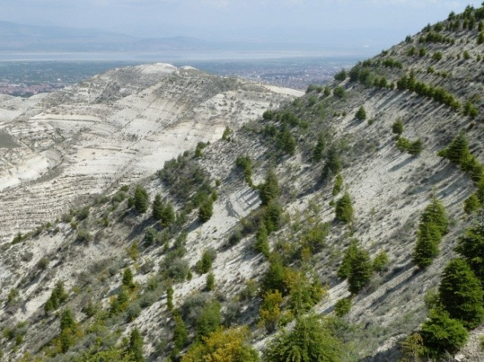 | Figure 33 Field trip to Burdur  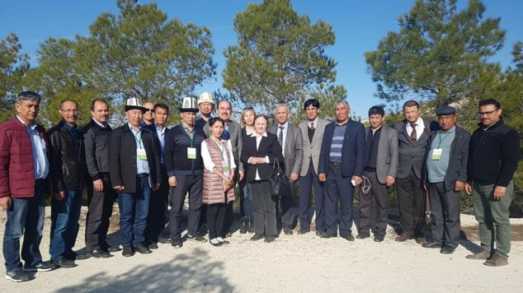

27th of March, 2019, Wednesday
On Wednesday, 27 March 2019, the post-fire forestation activities in Kumluca Forest Directorate were examined.
Here, information was given about the activities carried out after the fire in 2016 by Faik Yılmaz, the Director of Kumluca Forest Directoaret and Mustafa Özdoğan, Chief Engineer of the Ardasan Forest Sub-District.
After that, the “Fire Memory Point” created by Kumluca Forest Directorate in order to train the public and especially to the children for the importance of forest fires was examined. Later on, Ardasan Fire Team was visited.
In the afternoon Beydağları National Park was visited and experiences about the National Park management were conveyed. The training was completed with this visit. http://beydaglari.tabiat.gov.tr/
Figure 34 News on a local newspaper  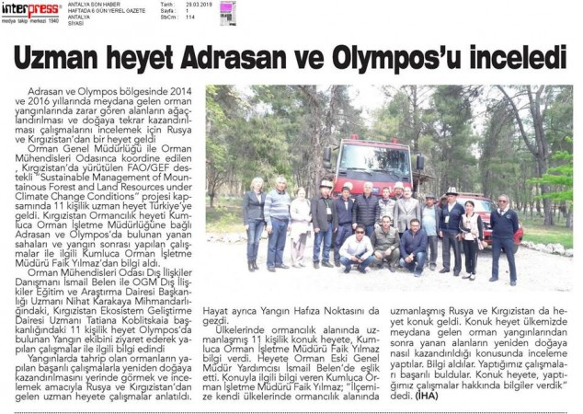 | Figure 35 Field trip to Beydağları National Park  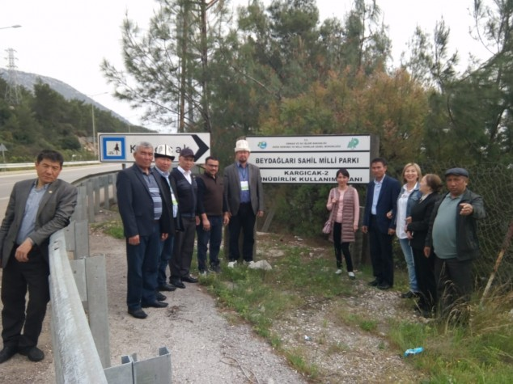

28th of March,2019 Thursday- 29th of March, 2019, Friday
Thursday, March 28, 2019 the delegation has set out from Turkey. First, at 12:35 hours from Antalya to Istanbul, then at 18:35 pm they moved from Istanbul to Bishkek.
Interpreters and other officials assigned by the Chamber of Forest Engineers have assisted the delegation both at the airport of Antalya and at the Istanbul airport.
After the delegation arrived in Bishkek, they visited to the Deputy General Director of the State Forestry Agency of the Kyrgyz Republic, E.Zh. Sheripov and Director A. Rustamov to share their experiences and satisfaction. The WhatsApp group still works actively.
Figure 36 Depart to Bishkek from Istanbul  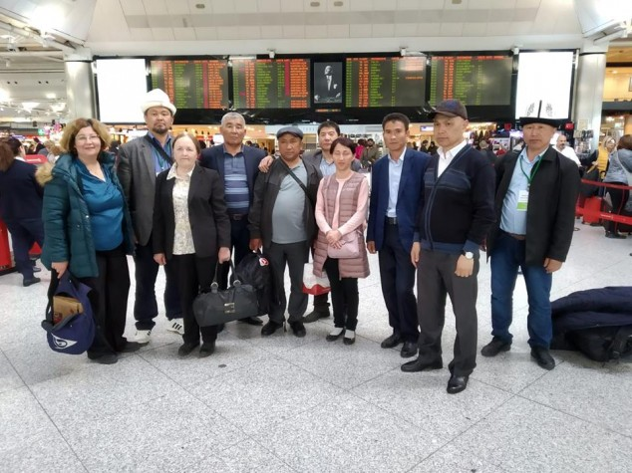 | Figure 37 Briefing to Kyrgyz Authorities after training program  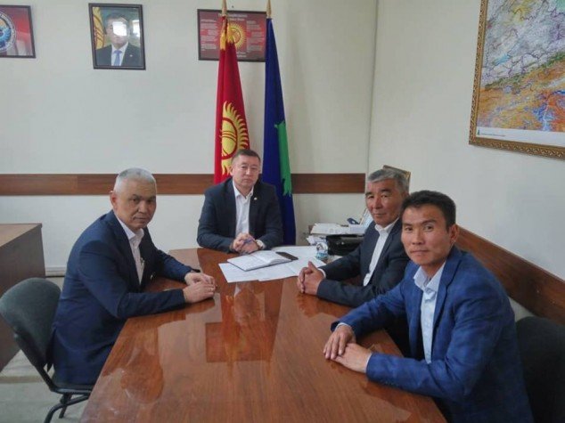

General evaluation of the training program
The program was successfully implemented as planned with the line of LoA signed and budget. Participants have expressed their satisfaction many times.

On behalf of the Chamber of Forest Engineers
Prepared by OMO’s Consultants;
- Mr. Özgür Balcı (Forest Engineer) Member of the Board of Directors responsible for professional issues,
- Mr. İsmail Belen (Forest Engineer, Msc.) External Relations Consultant were designated as “Consultant”.

10 April 2019

