1st Interim Narrative Report of;

1. Training on Nursery Plant and Management, Sapling Production with Closed Root System and Afforestation Techniques for participants
2. Training of Forest Pests and Diseases.

Prepared by;
Hasan Türkyılmaz
Özgür Balcı
İsmail Belen
Nihat Karakaya

29 April 2019

Table of Contents
Figures 4
Text Boxes 5
Preface 6
Training Program of Forest Pests and Diseases at Glance 7
Consultants on behalf of the Chamber of Forest Engineers 7
Participants to Training Program on Forest Pests and Diseases 8
Daily Programmes for Second Training 9
April 13, 2019 Saturday 9
April 14, 2019 Sunday 10
April 15, 2019, Monday 14
April 16, 2019 Tuesday 16
April 17, 2019 Wednesday 22
April 18, 2019 Thursday 24
April 19, 2019 Friday 26
April 20 , 2019 Saturday 28
April 21, 2019 Sunday 29
April 22, 2019, Monday 29
Conclusion for Second Trainig 30
Annex-Narrative Technical Report of “Nursery Plant and Management, Sapling Production with Closed Root System and Afforestation Techniques Training Program” 31
Preface 32
Training Program at Glance 32
Participants 33
Translators, Trainers, Consultants from OMO 33
Daily Programs 33
20th March 2019, Wednesday 33
21st of March, 2019, Thursday 36
22nd of March, 2019, Friday 36
23rd of March, 2019, Saturday 38
24th of March, 2019, Sunday 39
25th of March, 2019, Monday 41
26th of March, 2019, Tuesday 42
27th of March, 2019, Wednesday 44
28th of March,2019 Thursday- 29th of March, 2019, Friday 45
General evaluation of the training program 45

Figures
Figure 1 First Day Meeting 9
Figure 2 Meeting room at the hotel 9
Figure 3 Map of Istanbul's Islands 10
Figure 4 Premises of Adalar (Islands) Forestry Administration 11
Figure 5 Thaumetopoea pityocampa) 12
Figure 6Thaumetopoea pityocampa -II 12
Figure 7 Calosoma sycophanta Production Laboratory 13
Figure 8 Releasing Calosoma sycophanta to forest 13
Figure 9 Opening of the Training-I 14
Figure 10 Opening of the Training-II 14
Figure 11 Opening of the Training-III 14
Figure 12 Opening of the Training-III 14
Figure 13 Forest Pest Control Laboratory 15
Figure 14 Forest Pest Control Laboratory -II 15
Figure 15 Antalya Forest Nursery-I 15
Figure 16 Antalya Forest Nursery-II 15
Figure 17 Mr. Nihat Karakaya from General Directorate of Forest 16
Figure 18 Mr. Mitat Uyan, Director of Forest Pests and Diseases 16
Figure 19 Ms. Durkadın Akın gives information on occupational safety 16
Figure 20 A Kyrgyz Participants follows the presentation! 16
Figure 21 Training Center-I 17
Figure 22 Training Center-II 17
Figure 23 Meeting with OGM’s Technical Staff-Engineers 18
Figure 24 Meeting with OGM’s Technical Staff-Engineers 18
Figure 25 Structure of Forestry Organisation of Turkey 19
Figure 26 Mr.Yaşar Aksu-Biologist 21
Figure 27 Mr. Abdurrahman Çobanoğlu 21
Figure 28 Prof. Dr. Mustafa Avcı and Prof. Dr. H. Tuğba DOĞMUŞ LEHTİJARVİ 23
Figure 29 April 17, 2019 Wednesday 23
Figure 30 Forest Protection Officers 24
Figure 31 Forest Protection Officer -II 24
Figure 32 Forest Fire Simulation Center 25
Figure 33 Forest Fire Simulation Center -II 25
Figure 34 Güllük Dağı National Park 25
Figure 35 Güllük Dağı National Park -II 25
Figure 36 Isparta Regional Directorate 26
Figure 37 Isparta Regional Directorate-II 26
Figure 38 Isparta Faculty of Forestry Entomology Laboratory 27
Figure 39 Isparta Faculty of Forestry Entomology Laboratory-II 27
Figure 40 Isparta Unıversity of Applied Sciences (IUAS): 27
Figure 41 Isparta Unıversity of Applied Sciences (IUAS):-II 27
Figure 42 Isparta Insects Production Laboratory 28
Figure 43 Isparta Insects Production Laboratory 28
Figure 44 Field trip to mountainous area 28
Figure 45 Ant transplantation 28
Figure 46 Isparta Mountains 28
Figure 47 Isparta recreational area 28
Figure 48 Meeting with Hasan Türkyılmaz 29
Figure 49 Meeting with Hasan Türkyılmaz 29

Text Boxes
Text Box 1 The Insect Cause Istanbul’s Forests 11
Text Box 2 Officials from General Directorate of Forest at the opening ceremony 15 April 14
Text Box 3 Staffs of the General Directorate of Forest-16 Aril 2019 18

Preface
The Chamber of Forest Engineers (OMO) of Turkey is a professional organization (NGO) with the status of “public legal entity” established under the "Union of Chambers of Turkish Engineers and Architects” by relevant law.
A “LETTER OF AGREEMENT- LoA” signed at 11th of March, 2019, between the Food and Agriculture Organization of the United Nations (“FAO”) and Chamber of Forest Engineers of Turkey for provision of trainings on various subjects for the employees of forest enterprises of the State Agency for Environmental Protection and Forestry (SAEPF) in the Kyrgyz Republic, within the project GCP/KYR/010/GFF- “Sustainable Management of Mountainous Forest and Land Resources under Climate Change Conditions”.
According to this LoA the following 3 (three) trainings activities are going to be organized by the Chamber of Forest Engineers with close cooperation of General Directorate of Forests.
- Training Program of “Nursery Plant and Management, Sapling Production with Closed Root System and Afforestation Techniques.
- Training Program of Forest Pests and Diseases.
- Training Program “Forest Fire”
The first one was organised from 20th of March to 29th of March 2019. A “Narrative Technical Report” has been prepared and submitted to FAO on time.
The Second Training program on “Forest Pests and Diseases” has been implemented by OMO with close cooperation of the General Directorate of Forest from 13 to 22nd of April, 2019.
According to the LoA, the Service Provider should prepare and submit the Interim Narrative Report for;
- Training on Nursery Plant and Management, Sapling Production with Closed Root System and Afforestation Techniques for participants
- Training of Forest Pests and Diseases.

With this above mentioned training activities The Service Provider produced the following outputs:
- Output 1. The Turkish experience in the nursery plant and management, sapling production with closed root system and afforestation techniques, involving forestry experts introducing these techniques in order to apply them in the Kyrgyz forestry enterprises and project plots is received by participants
- Output 2. Best practices based on Turkey's experience in the successful management and application of methods of prevention of forest pests and diseases to protect against current threats and help trees to be protected from unfamiliar diseases, are presented.

Training Program of Forest Pests and Diseases at Glance

Letter of Agreement signed between the FAO and the OMO | 11 March 2019
Identify experts among the members of chambers and relevant institutions and develop TORs of trainers and training materials to develop the training in technical manner. | 5 April 2019
Preparation of Training Programme of management of forest pests and diseases, plan and agenda to define overall details and implementation structure of training activities. | 5 April 2019
Conduction of Training of Forest Pests and Diseases | 13-22 April 2019
Submission of narrative technical report for Second training and Interim Narrative Report for;  - Training on Nursery Plant and Management, Sapling Production with Closed Root System and Afforestation Techniques for participants  - Training of Forest Pests and Diseases. | 29 April 2019

This “Narrative Technical Report” has been prepared to submit to FAO for that “Second Training Program”

Consultants on behalf of the Chamber of Forest Engineers
Mr. Hasan Türkyılmaz, the President and Mr. İsmail Belen, Adviser for International Relations have been designated as the Consultant for this training programme on behalf of the Chamber of Forest Engineers as stated and required at the LoA.
Beside these two people, Mr. Nihat Karakaya and Mr. Yaşar Aksu have been designated as trainers for whole programme on behalf of the General Directorate of Forest.
Together with these people, a lot of experts supported to the training programs as “trainer”
Ms. Maye Yılmaz and Ms. Inna Topoeva have been commissioned as translators.

Participants to Training Program on Forest Pests and Diseases

No | Name-Surname | Date of Birth | Çalıştığı Yer ve Görevi | Phone, Email
1 | ZHEKSHENBEK ADYRBEKOV | 10.09.1978 | Head of forest ecosystems and protected areas development Department | 03943 6-26-84,
2 | NURALY AKMATOV | 23.10.1962 | Chief forester of Batken forestry | (+996) 776 774 633  Batken_Les@mail.ru
3 | KAMYT ARZYKULOV | 26.10.1955 | Direсtor of station of protection of forest | +996 773-90-19-90
4 | SULTANBAI DAVLIATOV | 02.05.1963 | Chief forester of Uzgen forestry | 0779524735  Davlyatov_63@mail.ru
5 | ALMAZBEK DZHANYBAEV | 15.01.1983 | Chief forester of Talas forestry | 0553-29-64-29  almaz_83_15@mail.ru
6 | BAGYSHBEK MAMATKULOV | 01.05.1965 | Engineer of Phyto pathologist of forest protection station | 996(0554) 95-00-73, 996 (0770) 45-90-91
7 | BAKYTBEK MUSABAEV | 11.11.1956 | Head of the Department of forest protection and legal support of the Department of forest ecosystems development | 0551-15-59-15
8 | TAALAIBEK TOPCHUBEKOV | 04.07.1966 | Chief forester of Kochkor forestry | 0772 41-74-34
9 | BATYRBEK UMETOV | 20. 07 1988 | Chief specialist of Jalal-Abad territorial administration | 0773 52 23 10
10 | SATYBALDY ZHAPAROV | 23.10.1986 | Leading specialist of the Department of conservation, forest protection and legal support of the Department of development of forest ecosystems | +996 550 69 80 69  stakeev87@mail.ru

Daily Programmes for Second Training

April 13, 2019 Saturday
The participants departed from Bishkek with TK 345 at 10: 10 on Saturday, 13 April 2019 and arrived at Istanbul airport at the same day at 13:15 as planned.
Mr. Ismail Belen on behalf of the Chamber of Forest Engineers and Mr. Nihat Karakaya, the representative of the General Directorate of Forestry welcomed the participants at the airport together with the interpreter Ms. Maye Yılmaz. Then they arrived to the “Divan Istanbul City” hotel with a minibus hired by Chamber of Forest Engineers. https://www.divan.com.tr/divan-istanbul-city/t
After check-in the hotel, a detailed information meeting was held with the participation of İsmail Belen and Nihat Karakaya.
In this meeting;
- Participants, consultant, trainer introduced themselves in detail. Also detailed information about Turkey and Turkish culture were provided.
- The Agenda of the Training Program has been reviewed in detail in line with its version published at http://www.gonder.org.tr/?p=7938
- The Agenda prepared in three languages (English, Russian and Turkish) has been distributed to the participants.
- Bags, badges, table cards, flash disks, brochures with Russian language are presented to them.
- The WhatsApp group prepared for this training programme was activated.
- Mobile Wi-Fi was installed and introduced to the participants.
After this meeting, participants were able to visit Istanbul.

Figure 1 First Day Meeting  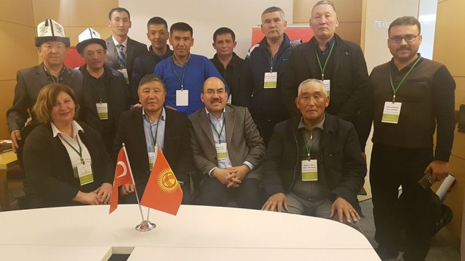 | Figure 2 Meeting room at the hotel  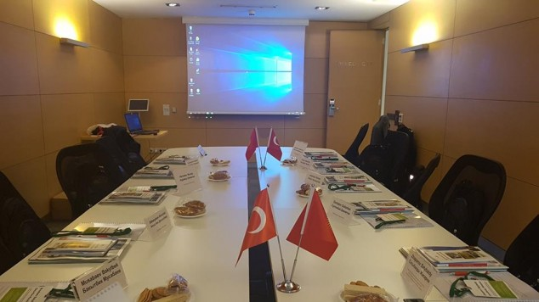

April 14, 2019 Sunday

The participants departed from the hotel at 08:00 am on the second day of Sunday, April 14, 2019.
Due to field trip, they moved to Büyükada (Princes Island) of Istanbul. During the way to ferry they were able to see the cultural and historical places of Istanbul such as Sultanahmet Mosque and Hagia Sofia.
Figure 3 Map of Istanbul's Islands
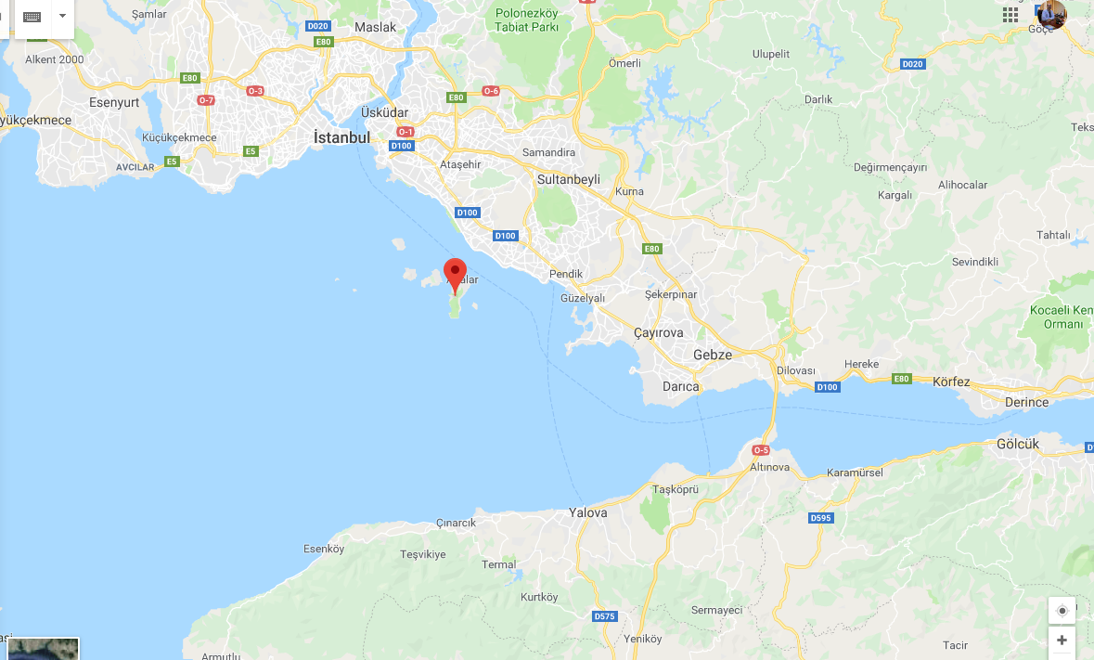

In addition to Kyrgyz participants, İsmail Belen on behalf of OMO and Nihat Karakaya on behalf of OGM joined to field trip. Murat Gümüş from Regional Directorate of Forest of Istanbul also participated.
A team headed by Ms. Hanife Sevinç from State-owned News Agency called Anadolu Agency https://www.aa.com.tr/en joined to field trip.
During the way on ferry, the delegation met by chance with Prof. Dr. Ali Ömer Ömer, the Head of Forest Engineers Department http://www.ktu.edu.tr/ormanmuhendislig-yonetim of the Karadeniz (Black Sea) Technical University, Faculty of Forestry http://www.ktu.edu.tr/rus Herewith it is made useful discussion on forestry education in Turkey.
The delegation was welcomed by the Istanbul Forest Regional Directorate, Forest Pest Control Branch Director Ahmet Yasin Çelen and Kanlıca Forestry Directorate Adalar Forest Chief Ms. Seval Aktaş. In the name of the Chamber of Forest Engineers, Alemdağ Forest Chief Mr. Turgay Deligöz was present.

The delegation first visited the Islands Forest Building. The insect production laboratory in the building was examined. Information is provided by the authorities here.
Figure 4 Premises of Adalar (Islands) Forestry Administration  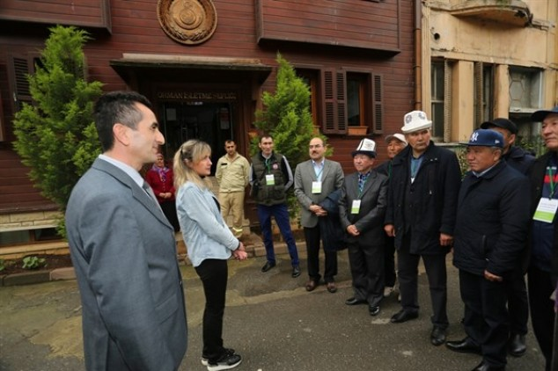 | 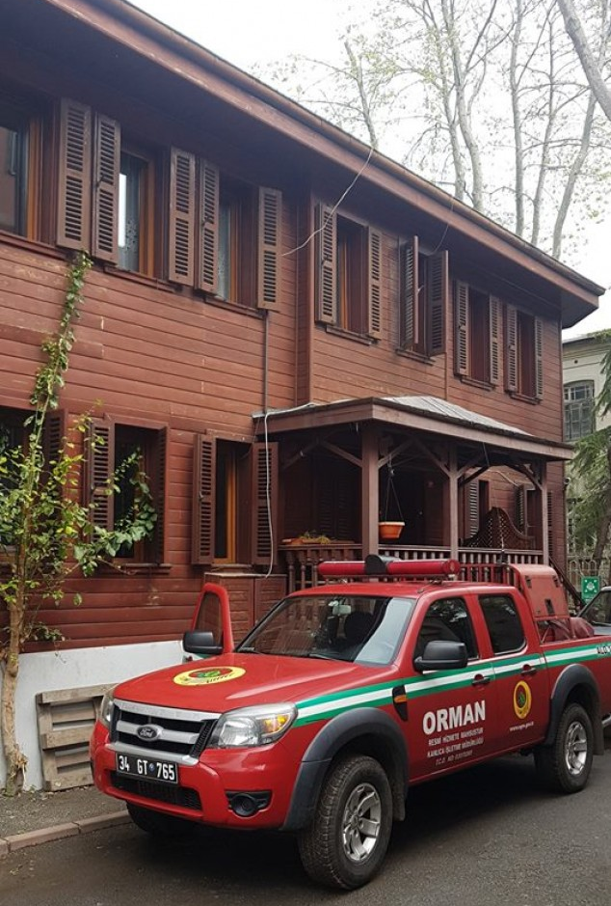

After visiting the laboratory with customised clothes delegation went to inside forest to see how predatory insects are left in the forest.
Then the Island Fire Tower was visited and a detailed presentation was made here by relevant officials.
In this presentation, the activities fight against forest pests and diseases conducted by Istanbul Forestry Regional Directorate introduced. The insects that cause the most damage in Istanbul’s forests “are listed as follows.
Text Box 1 The Insect Cause Istanbul’s Forests
- Thaumetopoea pityocampa (Schiff.)
- Ips sexdentatus (Boern.)
- Ortotomiscus erosus (Germ.)
- Tomicus piniperda
- Tomicus minor
- Cryphonectria parasitica (Murr.)
- Lymantria dispar(L.)
- Tortrix viridana
- Melanophila picta (Pall.)

Figure 5 Thaumetopoea pityocampa)  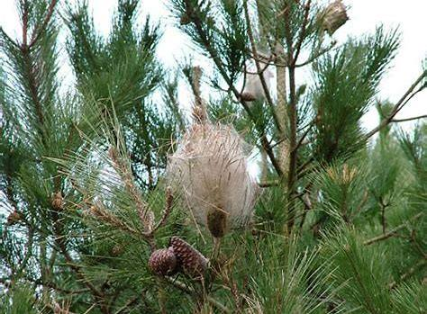 | Figure 6Thaumetopoea pityocampa -II  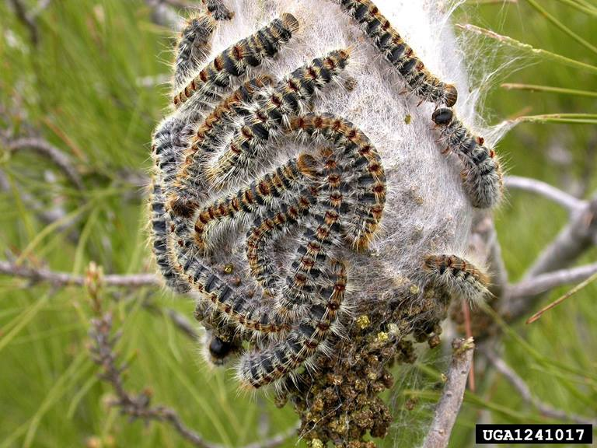

Against the insects that damage our forests;
  - Mechanical,
  - Chemical,
  - Biotechnology (Pheromone),
  - Biological,
  - Combined,
Fighting methods are applied.
The news prepared by the Anadolu Agency participating in the delegation can be reached at https://www.trtavaz.com.tr/haber/tur/yasam/gladyator-bocekler-ormanlik-alanlara-birakiliyor/412077
With this program, Kyrgyz participants had a possibility to Turkish experiences and implementation on forest pests and disease. They also had a chance to discuss forestry education of Turkey.
These Pine Bag Insects (Thaumetopoeo pityocampa) harm by eating in the hands of a pine forest, prevent the growth of trees. These insects do not dry the trees, but cause slowing growth and image pollution. This situation is very closely related to the image and work of the forest organization.
There are various methods to combat this insect. However, the General Directorate of Forestry follows the methods that will not harm the nature and will not destroy the ecosystem.
The insect called Calosoma sycophanta is fed by eating pine beetles but not in nature enough. The General Directorate of Forestry supports to increase the population of this insect which does not have any other damages and produces it in the laboratory and releases it to the forests.
For this purpose, Calosoma sycophanta beetle collected from its natural habitat in Antalya is brought to Istanbul or other places, replicated and left to forests. In this way, natural balance is provided. The official video of the General Directorate of Forestry on the fight against pine-beetle can be found at the following link: https://www.youtube.com/watch?v=1-X-ZbL2Z98
With this link it can be found a scientific articles http://dergipark.gov.tr/download/article-file/223745 That article indicates as follows very briefly:
Biological Struggle Against Pine Bag Insect (Thaumetopoeo pityocampa Schiff)
Abstract:
Major biological threat to forest health in Turkey is insect pests and Pine Bag Insects are the most common ones among these insects. Pine Bag Insects cause damage to pine forests in Mediterranean, Aegean and Marmara region. Predator inspects follow pine bag inspects and leave their eggs at the places where predator inspects are crasited.
In our research we determined that Calosoma Sycophanta (L.) eats both their larval and new pupa. In this study, our different approach to struggle against forest varmint and to nullify them is to use predator hunter insects (Calosoma sycophanta), which is a biological and nature friend method. We believe that our study will preserve and protect our forests against the danger of disappearing at alarming rate and it will be one of the urgent protections that our country needs
Figure 7 Calosoma sycophanta Production Laboratory  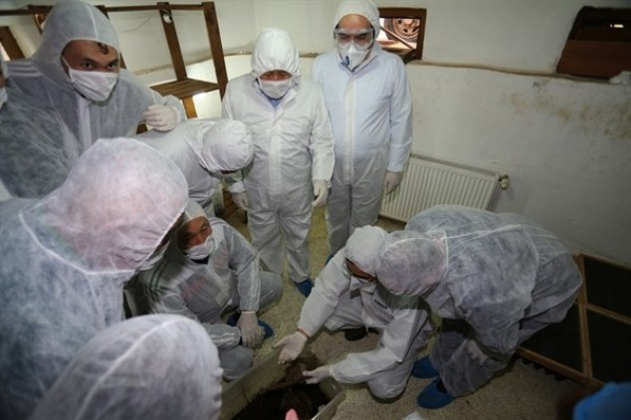 | Figure 8 Releasing Calosoma sycophanta to forest  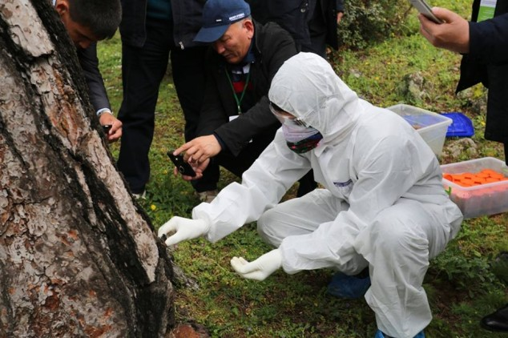
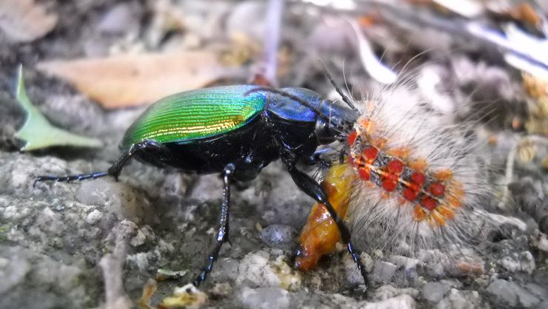

April 15, 2019, Monday
After the program held in Istanbul on April 13 and 14, the delegation came to Antalya. The program at the International Forestry Training Center in Antalya started at 09:00 in the morning. In addition to the Kyrgyz participants in the opening, officials, led by Mustafa Özkaya, Deputy General Manager of Forestry, also participated. These are given in the table below.
Text Box 2 Officials from General Directorate of Forest at the opening ceremony 15 April
- Mustafa Özkaya- Deputy Director General
- Zekeriya Nane- Head of Department for Strategy Development
- Vedat Dikici- Regional Director of Antalya
- Mehmet Karabacak- Deputy Regional Direcyor
- Aydoğan Türedi- Division Director for International Affaires
- Mitat Uyan- Division Director of Forest Pests and Disease
- Dilek Öztekin- Forest District Director of Elmalı
- Mustafa Ülküdür- Director of International Forestry Training Center
- Dilek Ursavaş- Deputy Director of International Forestry Training Center
- Özlem Keser- Chef
- Nihal Zeybek Yüksel-Chief
- Yusuf Bozan- Technician

Figure 9 Opening of the Training-I  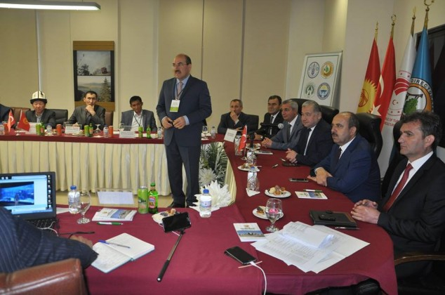 | Figure 10 Opening of the Training-II  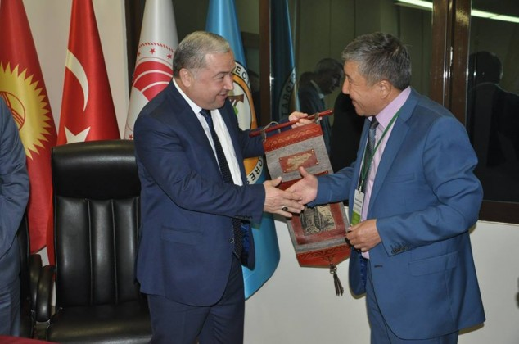
Figure 11 Opening of the Training-III 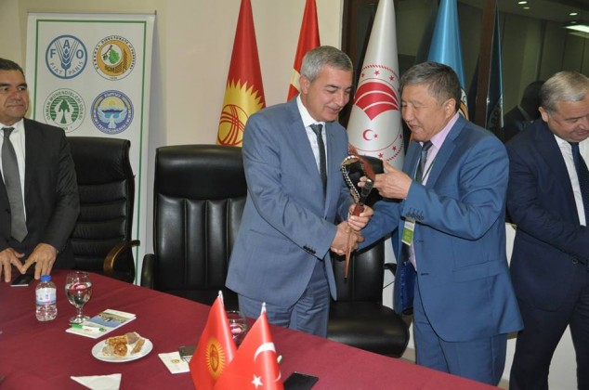 | Figure 12 Opening of the Training-III  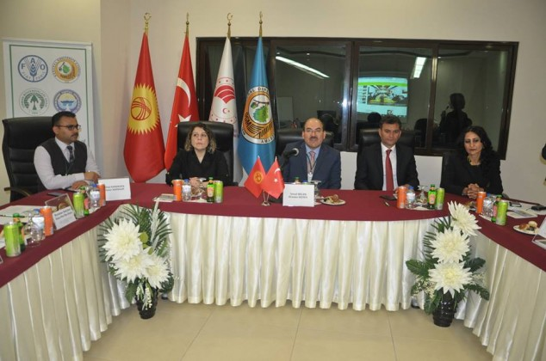

Following the opening speeches and session, until noon general information is given about "Turkey / Turkey Forests and Forestry" and "Forest Pests and Diseases"
In the afternoon, the Forest Pest Control Laboratory was visited.
Division Director/Branch Manager Mitat Uyan and Retired Division Director/Biologist Yaşar Aksu gave detailed information on the subject. The activities here were photographed by the Training Center Electrical Technician Yusuf Bozan.
Figure 13 Forest Pest Control Laboratory  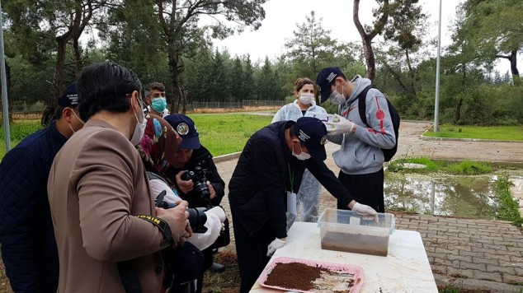 | Figure 14 Forest Pest Control Laboratory -II  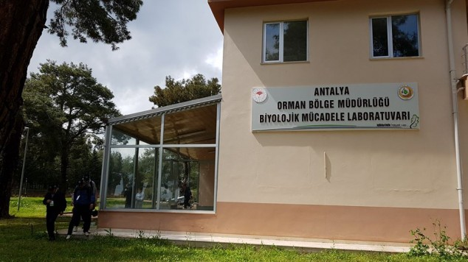

In this laboratory Calosoma sycophanta L. beetle which is used in biological control Pine Bag Insect (Thaumetopoeo pityocampa Schiff) produced. Workers were also interviewed here.
After the laboratory, Antalya Forest Nursery Directorate was visited as planned..
During the visit to the nursery;
- Director of Nursery Mr. Şakir Kumru
- Deputy Director of Nursery Mr.Miraç Demir
- Chief Forester of the Nursery Ms. Ayse Dudu Özcan welcomed and informed the participants about their activities especially related to pests ann diseases affected the seedlings.
Figure 15 Antalya Forest Nursery-I  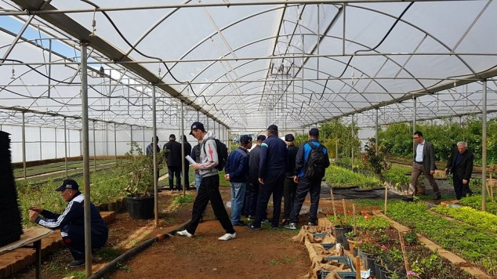 | Figure 16 Antalya Forest Nursery-II  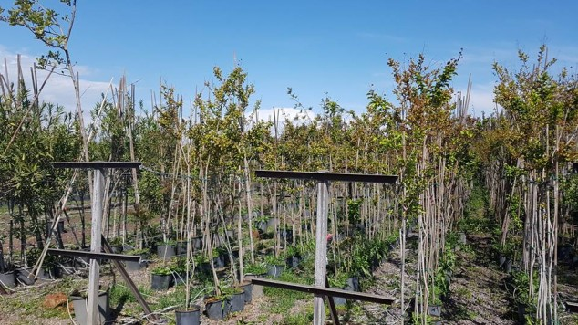

April 16, 2019 Tuesday
On April 16, 2019 Tuesday, presentations at the Training Center were continued and information was shared on the following topics.
  - Protection of forests against biotic pests
  - Forestry Quarantine Activities
  - Avalanche Protection Activities
  - The effects of climate change on the health of forests
  - Monitoring of Forest Ecosystems
  - Occupational health and safety of workers in the fight against diseases and pests
  - Grazing in forests
  - Biological control of insects and other pests in forests
Figure 17 Mr. Nihat Karakaya from General Directorate of Forest  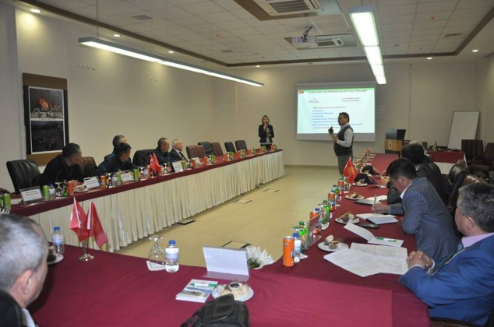 | Figure 18 Mr. Mitat Uyan, Director of Forest Pests and Diseases  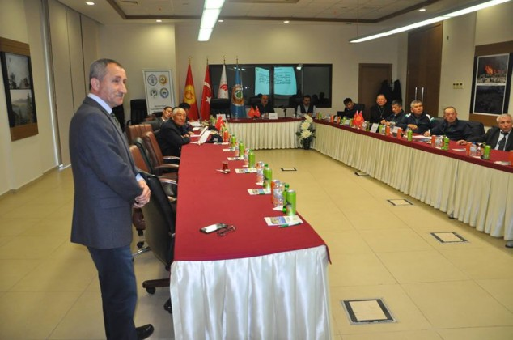

Figure 19 Ms. Durkadın Akın gives information on occupational safety  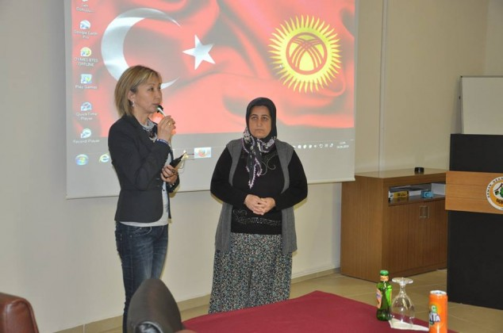 | Figure 20 A Kyrgyz Participants follows the presentation!  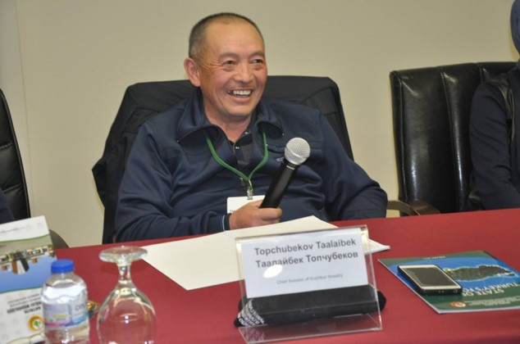

The Training Center Directorate was introduced during the lunch break.
Figure 21 Training Center-I  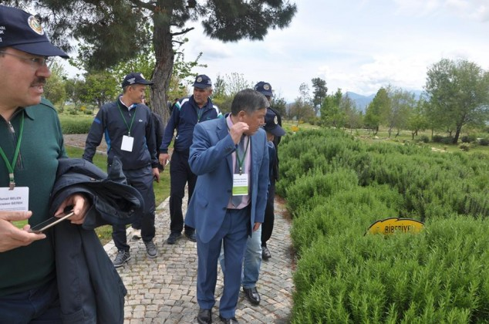 | Figure 22 Training Center-II  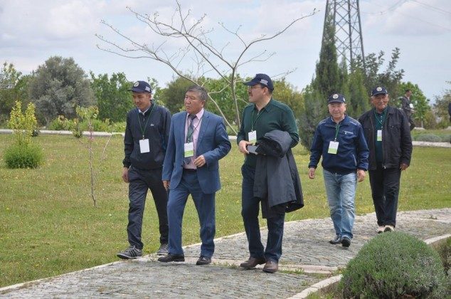
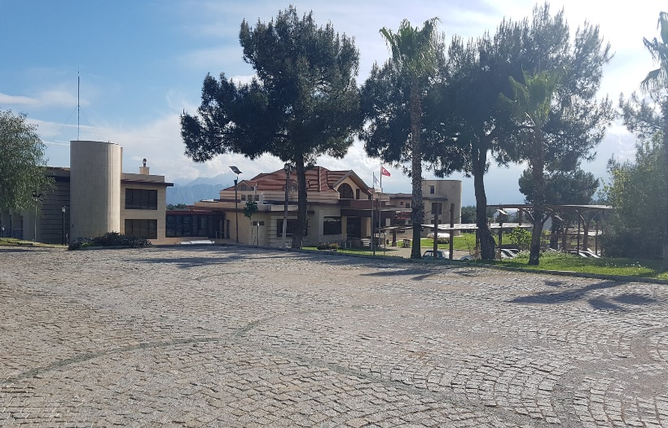 | 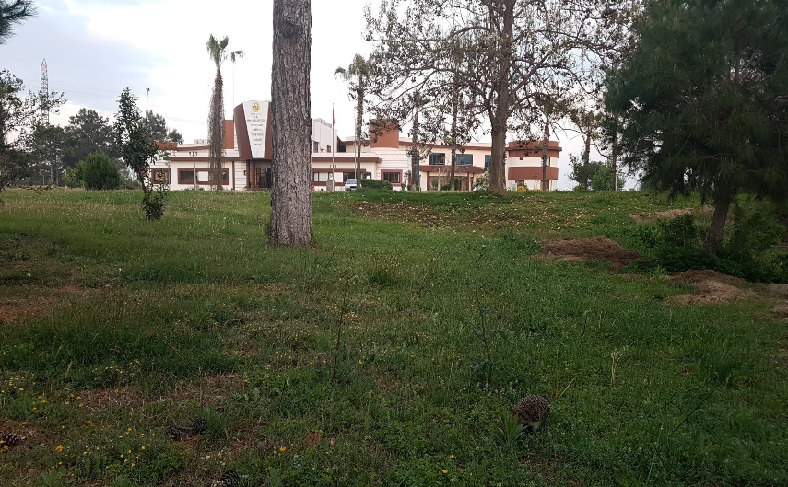
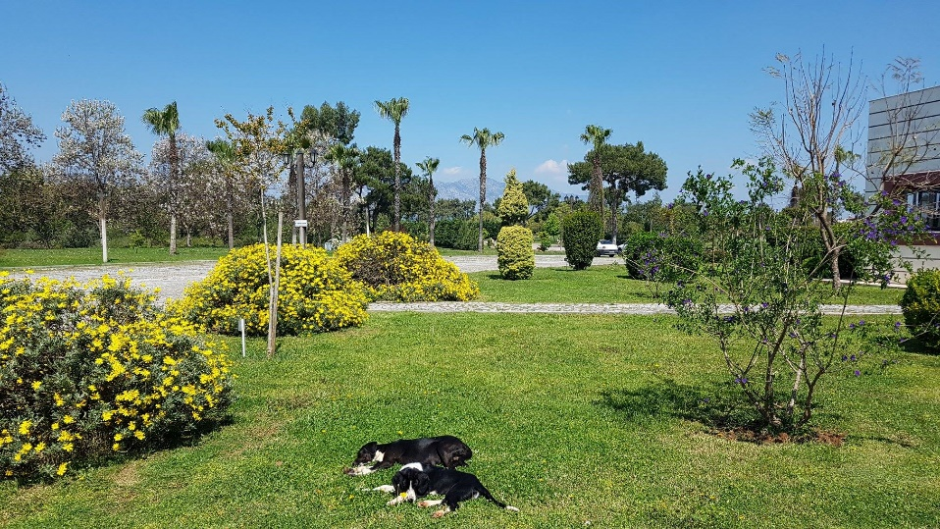 | 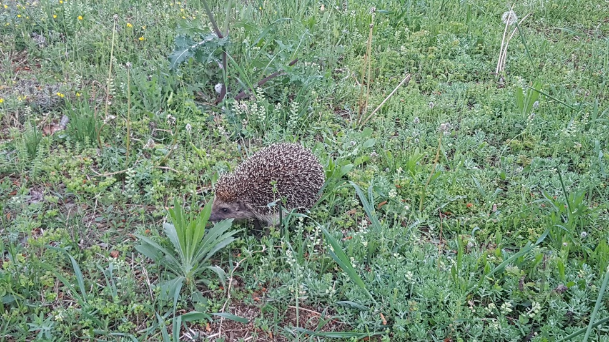
In the afternoon program, a mutual interview was held with the staff of the General Directorate of Forestry who were here for Forest Fire Training programme.

Text Box 3 Staffs of the General Directorate of Forest-16 Aril 2019
- Abdurrahman Çobanoğlu- Forest Research Institute
- Ali Bayındır-Afyon- Chief Engineer of Emirdağ
- Coşkun Okay Güney- Forest Research Institute
- Cüneyt Yıldırım- Chief Engineer of Alucra
- Emre Çakır- Chief Engineer of Şarkışla
- İbrahim Karaman- Chief Engineer of Giresun Akılbaba
- İlker Demir- Chief Engineer of Şanlıurfa Siverek
- Murat Abanazoğlu- Chief Engineer of Gümüşhane
- Murat Etçi- Forest Engineer from Department of Forest Fires
- Müzeyyen Pekmez- Chief Engineer of Konya
- Seda Keleş- Orman Genel Müdürlüğü
- Sezgin Esen- Chief Engineer of Erzurum-Oltu
- Veli Şencan- Chief Engineer of Konya-Ermenek
- Zafer Demir- Chief Engineer of Tunceli-Nazimiye
- Zeki Tuncer- Senior Engineer of Forest-Antalya

Figure 23 Meeting with OGM’s Technical Staff-Engineers  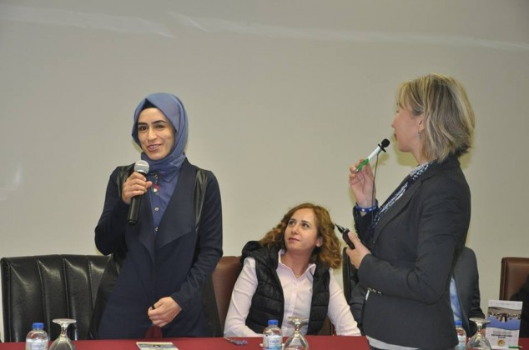 | Figure 24 Meeting with OGM’s Technical Staff-Engineers  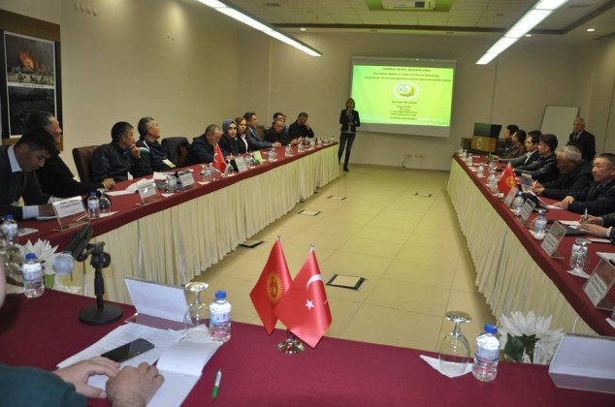

In Turkey, the public institutes for forestry follows this way. At the top, there is Presidency of Turkey. Then The Ministry of Agriculture and Forestry comes. Under the Ministry there is a General Directorate namely General Directorate of Forests. (OGM). OGM has central and regional organisations. At regional level, it has 28 Regional Directorates based on watershed and forests boundaries.

Under the Regional Directorates it has Forest District Directorates. At the field level there are Forest Sub-district Directorates. Every Forest Sub-district Directorates lead by a Forest Chief. This Chief must be a Forest Engineer and must be appointed after several exams both verbal and written examinations. There are some other official reporting to Forest Chiefs as Forest Guardians.

Figure 25 Structure of Forestry Organisation of Turkey

General Directorate of Forest:
- CENTRAL ORGANIZATIONS
  - 1-Advisory and Inspection Units
  - 2-Main Units
  - 3-Supporting Units
- RERGIONAL-PROVINCIAL ORGANIZATIONS
  - 1-Regional Directorates of Forestry
  - 2-Forest District Directorates
  - 3-Forest Nursery Directorates
  - 4-Chief Engineering
  - 5-Forest Sub-district Directorates
  - 6-Other sub-districts
- INSTITUTES
- Western Mediterranean Forest Research Institute
- Western Black Sea Forest Research Institute
- Central Anatolia Forest Research Institute
- Eastern Mediterranean Forest Research Institute
- Eastern Black Sea Forest research Institute
- Eastern Anatolia Forest Research Institute
- Aegean Forestry Research Institute
- South-eastern Anatolia Forest Research Institute
- Poplar and Fast-Growing Forest Trees Research Institute
- Forest Tree Breeding and Seeds Research Institute
- Forest Soil and Ecology Research Institute
- Marmara Forest Research Institute

CENTRAL ORGANIZATIONS  1-Advisory and Inspection Units  - Department of Inspection  - Internal Auditing Unit  - Legal Consultancy  - Strategy Development Department  2-Main Units  - Department of Combating Forest Pest  - Department of Forest Fire Combating  - Department of Forest Cadastre and Ownership  - Forest Management and Planning Department  - Forest Production and Marketing Department  - Department of Silviculture  - Department of Afforestation  - Department of Soil Conservation and Watershed Rehabilitation  - Department of Nursery and Seed  - Department of Non-Wood Forest Products and Services  - Department of Forest-Village Relations  - Department of Construction and Procurement  - Department of Permission and Easement  3-Supporting Units  - Personel Department  Administrative and Financial Affairs Department  - Foreign Relations, Training and Research Department  - Information System Department  - Private Secretariat  - Public Information Department  INSTITUTES | PROVINCIAL ORGANIZATIONS  1-Regional Directorates of Forestry  - Adana Regional Directorate  - Amasya Regional Directorate  - Ankara Regional Directorate  - Antalya Regional Directorate  - Artvin Regional Directorate  - Balıkesir Regional Directorate  - Bolu Regional Directorate  - Bursa Regional Directorate  - Denizli Regional Directorate  - Elazığ Regional Directorate  - Erzurum Regional Directorate  - Eskişehir Regional Directorate  - Giresun Regional Directorate  - Isparta Regional Directorate  - İstanbul Regional Directorate  - İzmir Regional Directorate  - Kahramanmaraş Regional Directorate  - Kastamonu Regional Directorate  - Kayseri Regional Directorate  - Konya Regional Directorate  - Kütahya Regional Directorate  - Mersin Regional Directorate  - Muğla Regional Directorate  - Sakarya Regional Directorate  - Şanlıurfa Regional Directorate  - Trabzon Regional Directorate  - Zonguldak Regional Directorate  2-Forest District Directorates  3-Forest Nursery Directorates  4-Chief Engineering  5-Forest Sub-district Directorates  6-Other sub-districts

After this interviews presentations on forest pests and diseases and forest monitoring made by Mr. Yaşar Aksu http://yasaraksu.com/ and Abdurrahman Çobanoğlu.

Figure 26 Mr.Yaşar Aksu-Biologist  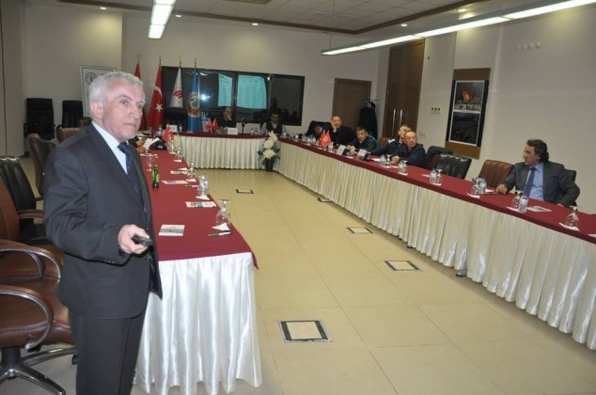 | Figure 27 Mr. Abdurrahman Çobanoğlu  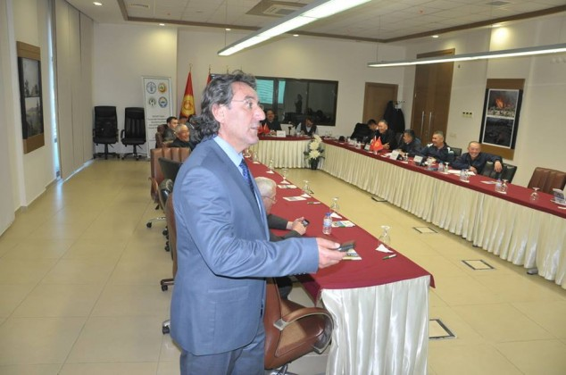

General Directorate of Forestry prepared several training videos for forest pests and diseases. These are Turkish language but it is very easy to follow with pictures and real videos.
Some of them are shown below:
Calasoma Production: https://www.youtube.com/watch?v=Src86VA1S1g
Rhizophagus grandis- https://www.youtube.com/watch?v=NAWBeoHTmS8
Bird Nests: https://www.youtube.com/watch?v=_nePQBx2g-4
Chestnut blight (Cryphonectria parasitica): https://www.youtube.com/watch?v=_XNOvsB-BB8
Ant Transport for Biological Control https://www.youtube.com/watch?v=6tp3V6ZEebo
Thanasimus formicarius https://www.youtube.com/watch?v=BpCrPbaSUNU
Pheromone For Biotechnical Fighting With Insects https://www.youtube.com/watch?v=y10lh7izz14
Thaumetopoea pityocampa: https://www.youtube.com/watch?v=1-X-ZbL2Z98

April 17, 2019 Wednesday
Academicians from Isparta University of Applied Sciences https://www.isparta.edu.tr/ Prof. Dr. Mustafa Avcı https://isparta.edu.tr/personel/01155/prof-dr-mustafa-avci and Prof. Dr. H. Tuğba DOĞMUŞ LEHTİJARVİ https://isparta.edu.tr/personel/01073/prof-dr-hatice-tugba-dogmus-lehtijarvi submitted their presentations whole day.
Presentations made by Prof. Dr. Mustafa Avcı;
  - Overview of Turkey and Kyrgyzstan Forest Health Topics
  - Combat Operations in Turkey with forest pests, species and Important Issues
  - Recommendations for the Future of Kyrgyzstan Forestry
  - Diseases in the forests of Kyrgyzstan
  - Harmful Insects to the Forest
Presentations made by Prof. Dr. Tuğba DOĞMUŞ LEHTİJARVİ
  - Factors Affecting Forest Ecosystem
  - Dothistroma blight
  - Diseases in Seed, Seedlings and Saplings
  - Cylindrocladium buxicola
  - Fungi, fungal diseases and damages
  - Cancer Diseases
  - Root rot
  - Root Diseases
  - Foreign invasive forest pathogens

These two academicians of Turkey's are one of the best scholars worldwide on their subjects. They have been taking part in a number of studies and projects both in Turkey, as well as in other countries.
The presentations at the training center were also enlightening for the visit to the University. Participants had the chance to learn the subject in advance.
Professor Mustafa Avci previously served in Kyrgyzstan and has been involved in projects. In this way, participants had the possibility to compare the activities and forestry in Kyrgyzstan and Turkey.
A set of book prepared by the General Directorate of Forestry on forest pests and diseases also given to the participants.
All of these presentations and videos prepared by the General Directorate of Forestry have been uploaded to flash disks and given to the participants.
Figure 28 Prof. Dr. Mustafa Avcı and Prof. Dr. H. Tuğba DOĞMUŞ LEHTİJARVİ  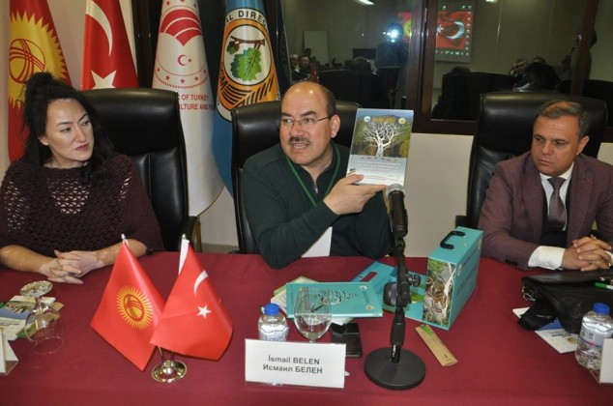 | Figure 29 April 17, 2019 Wednesday  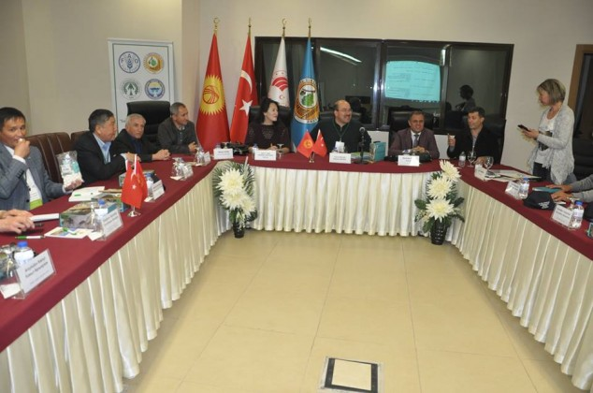
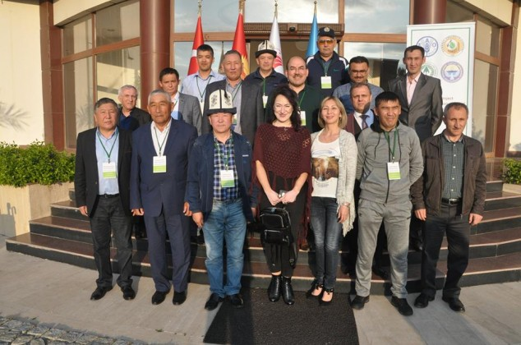 | 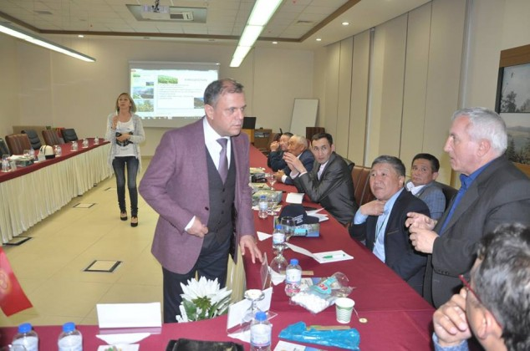
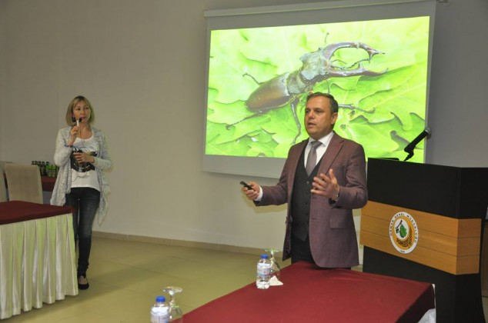 | 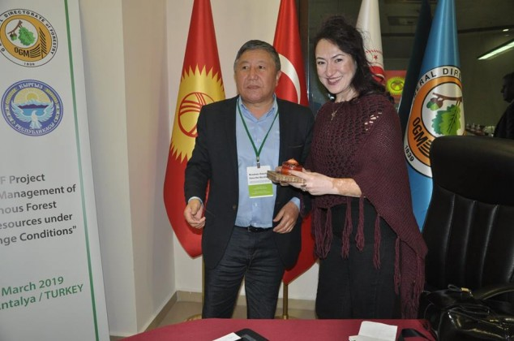

With help of these presentations and active discussion made between the Academicians and participants helped to understand the subject deeply. With this way, participants were able to listen and to see the academicians, officials from the General Directorate of Forestry as well as the workers at the field and laboratories.

April 18, 2019 Thursday

The presentations continued on Thursday, April 18, 2019, the sixth day of the training program. The program started with the opening and evaluation speeches of İsmail Belen, Nihat Karakaya and Mitat Uyan.
On the subject of “Cooperation and collaboration with forest villagers and civil society organisation” the following people and officials shared their experiences and thoughts.
- Mr. Mehmet Demirkol, Sub-district Director- Chief Engineer of Döşemealtı
- Mr. Ahmet Batur, Village Chief-Reeve of Odabaşı Village, Kepez, Antalya
- Mr. Ali Rıza Özçanak, Forest Protection Officer, (Forest Protection Officers and Pensioners Association
- Mr. Mehmet Özer, Forest Protection Officer, (Forest Protection Officers and Pensioners Association
- Mr. İbrahim Şahiner, Forest Protection Officer, (Forest Protection Officers and Pensioners Association
- Mr. Mustafa Kılıç, Retired Head of Department for Silviculture

Figure 30 Forest Protection Officers  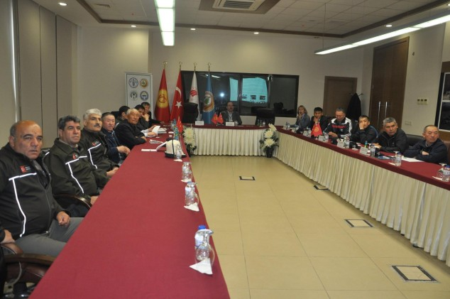 | Figure 31 Forest Protection Officer -II  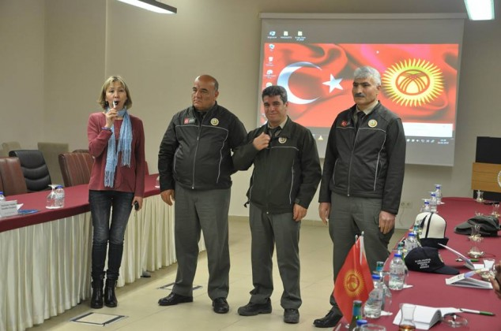

As it was explained previously, the forest management system of Turkey is very well organised with high level educated people and engineers. At the field level, the Forest Protection Officers and other workers play a crucial role for all kind of activities. They have direct contact to the villagers, reeves, shepherds, and other people and as well as all kind of flora and fauna. In Turkish system only the Forest Protection Officers has the right and responsibility to wear special uniform. This is very important responsibility. They also carry private guns to protect themselves against any kind of dangerous situation.
So their engagement and involvement to the procedures and activities have an important role on succeeding the General Directorate of Forests aims. They are also responsible to conduct related activities against forest pests and diseases.
Participants joined to fire training program organized by the General Directorate of Forestry for their own personnel and visited the simulation center.
Figure 32 Forest Fire Simulation Center  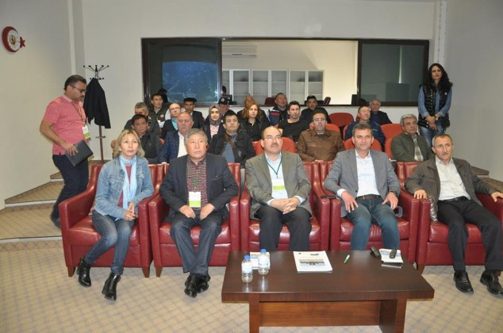 | Figure 33 Forest Fire Simulation Center -II  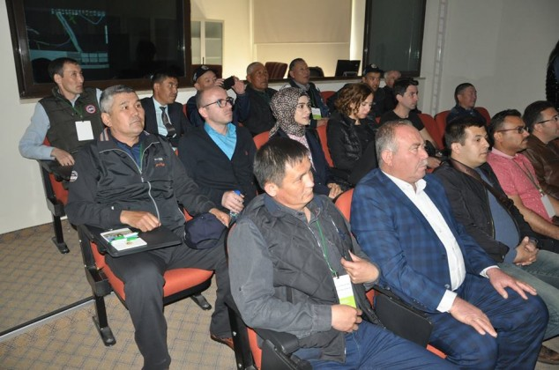

At the afternoon of the same day participants visited to “Güllük Mountain National Park” http://bolge6.ormansu.gov.tr/6bolge/AnaSayfa/milliparklar/gullukdagi_termessos_milliparki.aspx?sflang=tr in order to see the activities carried out in “protected areas”
Figure 34 Güllük Dağı National Park  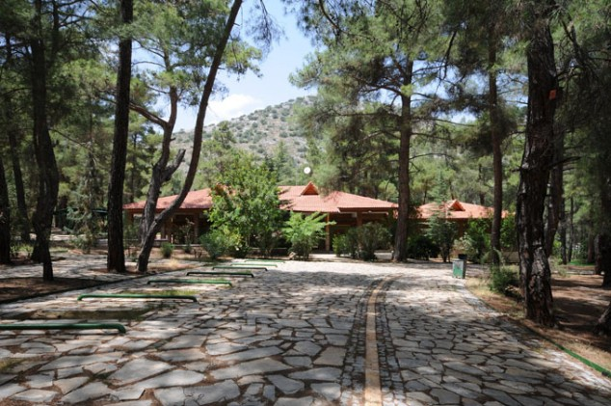 | Figure 35 Güllük Dağı National Park -II  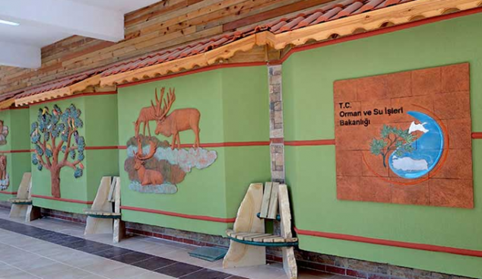
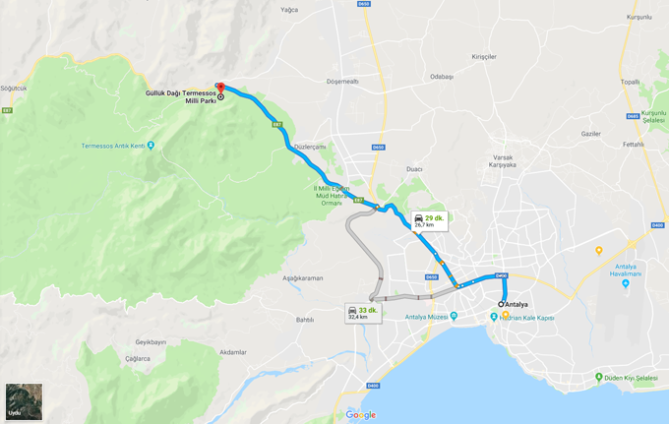 | 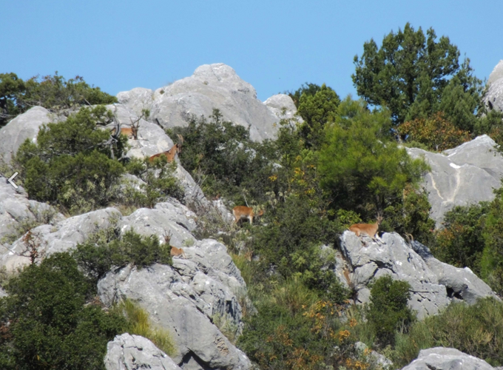

April 19, 2019 Friday
On the seventh day of the training, on April 19, 2019, Thursday at 9:00 am, we set off from Forestry Training Center.
Between 11: 00-12: 30, the Regional Directorate of Forestry of Isparta was visited. Here, a detailed presentation was made by Regional Director of Forest Region Kenan Akduman and other officials on the work of the Regional Directorate.
To the meeting at the Regional Directorate;
  - Forest Regional Director Mr. Kenan Akduman,
  - Deputy Regional Directors Mr. Yasar Ramazan Kartal, Mr. Nuri Maras and Mr. Tahsin Etli
  - Mr. Nevzat Sicimli, Branch Manager of Forest Pests
  - Mr. Niyazi Bayrak, Information Technology and Communication Branch Manager
  - Mr. Hüseyin Divrik, Director of Isparta Forest District
  - Mr Tuncay Eraslan; Chief Engineer of Isparta
Participated.

Figure 36 Isparta Regional Directorate  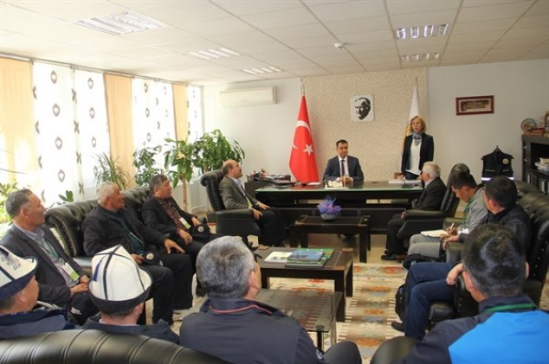 | Figure 37 Isparta Regional Directorate-II  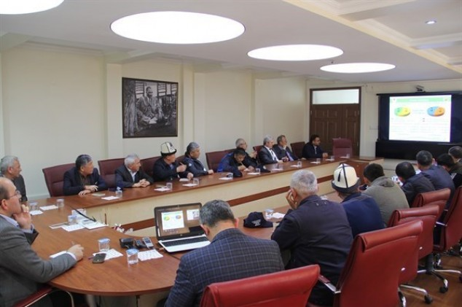

After the meeting in the Regional Directorate, the University of Applied Sciences Isparta was visited. The program was conducted in three sections.
The Faculty of Forestry was visited between 15: 00-16: 00. Here, several examination and visiting condected under the coordination of Forest Entomology and Conservation Department Lecturer. Dr. Mustafa Avci and Forest Botany Department Dr. Prof. Dr. Tuğba DOĞMUŞ LEHTİJARVİ
The following academicians and officials joined to that meeting at the Faculty of Forestry.
- Faculty Dean Prof. Dr. Yılmaz ÇATAL
- Assistant to Dean Dr. Nevzat GÜRLEVİK and Dr. Ayhan AKYOL
- Doç. Dr. Asko Lehtijarvi,
- Academician Dr. Ayşe Gülden ADAY KAYA
- Dr. Şükran OĞUZOĞLU
- Master Students Ceyda Beram andBurak Koparan .

Figure 38 Isparta Faculty of Forestry Entomology Laboratory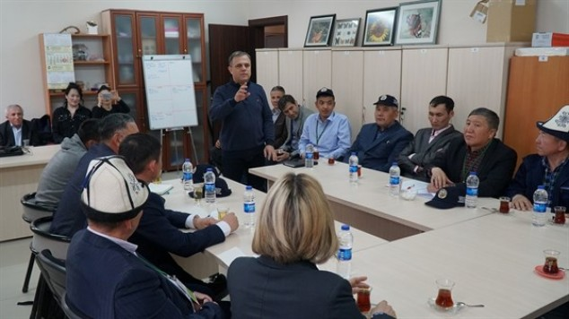 | Figure 39 Isparta Faculty of Forestry Entomology Laboratory-II  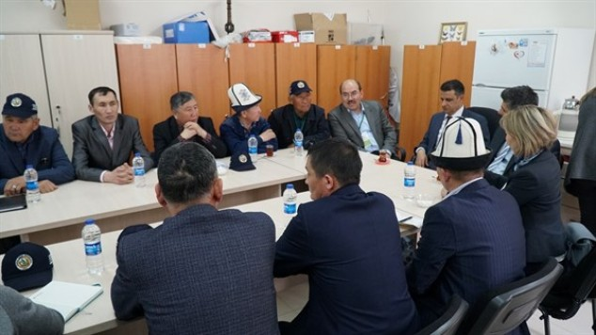

After that, from 16:00 to 17:00, the Rector of the University, Dr. İbrahim DİLER was visited.
- Assistant to Rector Prof. Dr. Hüseyin FAKİR
- Dean of Forestry Faculty Prof. Dr. Yılmaz Çatal
- Regional Director of Isparta Mr. Kenan Akduman and other guests were also participated to this meeteing.

Figure 40 Isparta Unıversity of Applied Sciences (IUAS):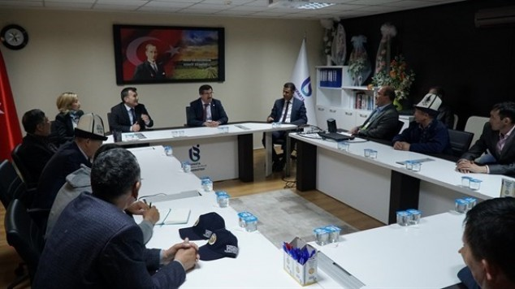 | Figure 41 Isparta Unıversity of Applied Sciences (IUAS):-II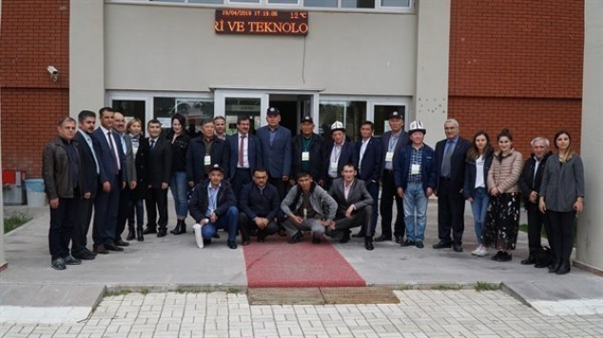

Then the delegation returned to the Faculty of Forestry. In the Entomology Laboratory, academic courses were conducted and insects were studied.
Prof. Dr. Mustafa Avci, Prof.Dr. Prof. Dr. Hatice Tuğba DOĞMUŞ LEHTİJARVİ and Division Director for Forest Pests and Diseases of the Regional Directorate of Forestry Nevzat Sicimli made presentations.

April 20 , 2019 Saturday
On the eighth day of the training, a field trip was organized in Isparta on Saturday, April 20, 2019 and the activities were examined on site.In this framework, the insect production laboratory in Savköy was examined. Information was given by the authorities about the studies. Yaşar Aksu, the subject matter expert, also shared his experience.
Figure 42 Isparta Insects Production Laboratory  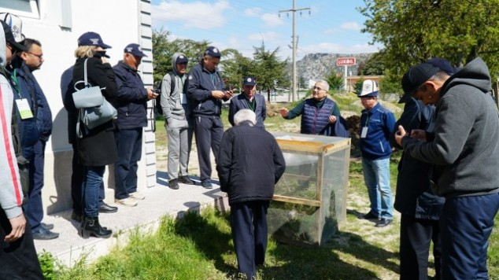 | Figure 43 Isparta Insects Production Laboratory  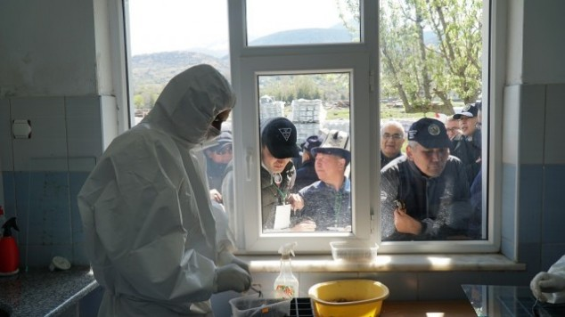

After the laboratory examination, approximately 1600 m high terrain has been visited in order to see the ant transplantation on site.
Figure 44 Field trip to mountainous area  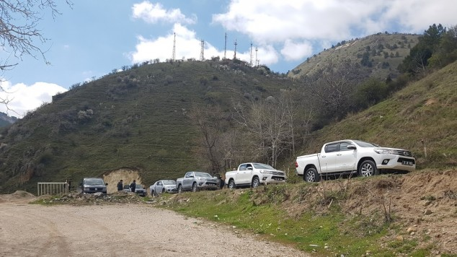 | Figure 45 Ant transplantation  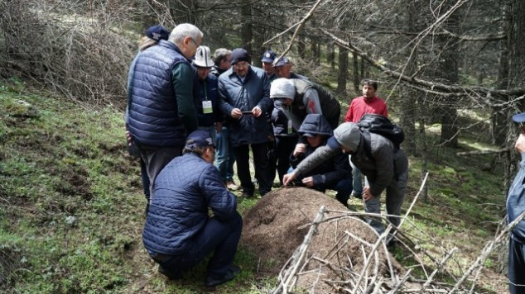
Figure 46 Isparta Mountains  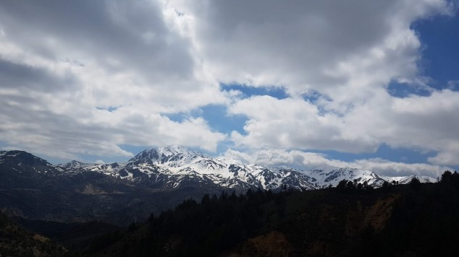 | Figure 47 Isparta recreational area  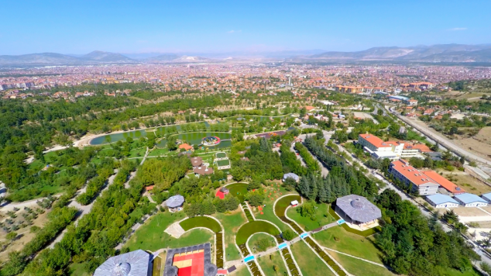
- Video of field trip https://www.youtube.com/watch?v=qOMGhq5WImo
- Video on ant transplantation : https://www.youtube.com/watch?v=80l70042r8E

April 21, 2019 Sunday
On the ninth day of the program, on Saturday, April 20, 2019, the meeting was held with the Chairman of the Chamber of Forests Engineers Mr. Hasan Türkyılmaz.
Figure 48 Meeting with Hasan Türkyılmaz  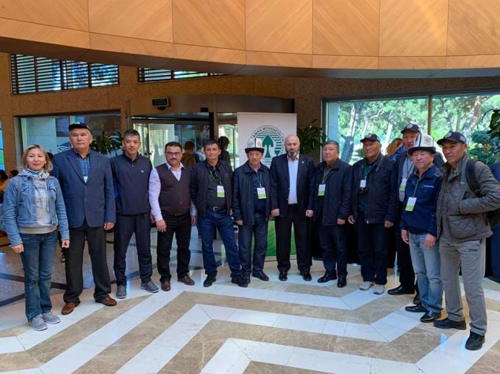 | Figure 49 Meeting with Hasan Türkyılmaz  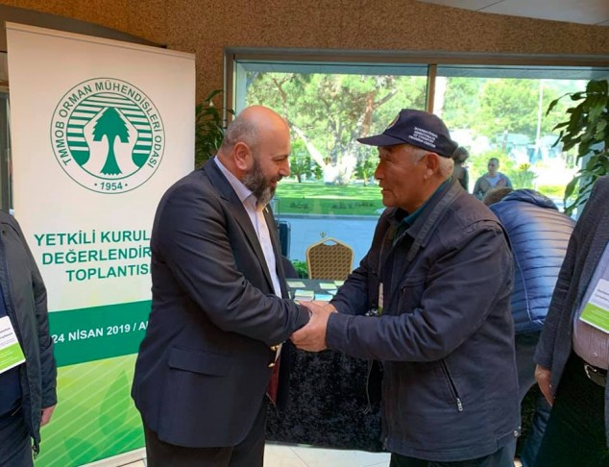

Then, a short city tour was done in Alanya, Antalya. Time 16: 10-17: 50 plane from Antalya Gazipaşa Airport to Istanbul airport.
All works and operations at the airport were followed by the Chamber of Forest Engineers, the participants were put on the aircraft safely and the process to be followed in Istanbul was explained in detail.

April 22, 2019, Monday
On the tenth day, the last day of the program, participants arrived in Bishkek. Developments have been continuously monitored through the created WhatsApp group, and interpreters have also served in correspondence within the group.

Conclusion for Second Trainig
The training was carried out successfully in the planned and given budget.
Participants have found the opportunity to see Turkey's entirely theoretical and practical know-how on forest pests and diseases.
Universities, the General Directorate of Forestry staff, working workers, peasants, all parties including the press were met.
Hasan Türkyılmaz, the President of the Chamber of Forestry Engineers, attended the training and shared the approaches of the Chamber.
The books and videos of the General Directorate of Forestry on the subject were shared with the participants.
Laboratory clothes were given to all participants as a model for occupational health and safety.
When selecting the trainers, academicians who knew Kyrgyzstan were preferred and thus they had the opportunity to compare the two countries. Long-term cooperation opportunities were evaluated.
As a result, the training was carried out very successfully. A consolidated financial report will be prepared and submitted after the third training.
This report was prepared jointly by Hasan Türkyılmaz, Özgür Balcı İsmail Belen and Nihat Karakaya.
April 28, 201928 Nisan 2019

Annex-Narrative Technical Report of “Nursery Plant and Management, Sapling Production with Closed Root System and Afforestation Techniques Training Program”
20-29 March 2019

Contents
Preface 6
Training Program at Glance 32
Participants 33
Translators, Trainers, Consultants from OMO 33
Daily Programs 33
20th March 2019, Wednesday 33
21st of March, 2019, Thursday 36
22nd of March, 2019, Friday 36
23rd of March, 2019, Saturday 38
24th of March, 2019, Sunday 39
25th of March, 2019, Monday 41
26th of March, 2019, Tuesday 42
27th of March, 2019, Wednesday 44
28th of March,2019 Thursday- 29th of March, 2019, Friday 45
General evaluation of the training program 45

Preface
The Chamber of Forest Engineers of Turkey is a professional organization (NGO) with the status of “public legal entity” established under the "Union of Chambers of Turkish Engineers and Architects (TMMOB)" by relevant law.
A “LETTER OF AGREEMENT” signed at 11th of March, 2019, Between the Food and Agriculture Organization of the United Nations (“FAO”) and Chamber of Forest Engineers of Turkey for provision of trainings on various subjects for the employees of forest enterprises of the State Agency for Environmental Protection and Forestry (SAEPF) in the Kyrgyz Republic, within the project GCP/KYR/010/GFF- “Sustainable Management of Mountainous Forest and Land Resources under Climate Change Conditions”.
According to this LoA the following 3 (three) trainings activities will be organized by the Chamber of Forest Engineers with close cooperation of General Directorate of Forests.
- Training Program of “Nursery Plant and Management, Sapling Production with Closed Root System and Afforestation Techniques.
- Training Program of Forest Pests and Diseases.
- Training Program “Forest Fire”
The first one was organised from 20th of March to 29th of March 2019. According to the LoA signed a “narrative technical report” of this training must be submitted to FAO not later than 10th of April. This report has been prepared and submitted by OMO to FAO in line with that aim.

Training Program at Glance
Date | Activities
11 March 2019 Monday | Letter of Agreement signed between the FAO and the OMO
13 March 2019 Wednesday | Identify experts among the members of chambers and relevant institutions and develop TORs of trainers and training materials to develop the training in technical manner.
13 March 2019 Wednesday | Preparation of the Nursery Plant and Management, Sapling Production with Closed Root System and Afforestation Techniques Training plan and agenda to define overall details and implementation structure of training activities.
20 March Wednesday-29 March Friday 2019 | Implementation of Training activities
10 April 2019 Wednesday | Submission of narrative technical report

Participants
Participants of “Nursery Plant and Management, Sapling Production with Closed Root System and Afforestation Techniques Training Program” as follows:
Sıra No | İsim | Soyisim
1 | Tatiana | Koblitskaia
2 | Aizat | Turuspekova
3 | Abibilla | Temirbaev
4 | Sherali | Melibaev
5 | Kyraly | Nazanov
6 | Zhusupbek | Topchubekov
7 | Baktybek | Esengulov
8 | Ruslan | Abdyldaev
9 | Manap | Talachiev
Dinar Bektursunova, who was on the first list, could not attend the training due to problems in visa procedures.

Translators, Trainers, Consultants from OMO
As stated in the LoA, all training preparations were sent to FAO in time. Maye Yilmaz and Inna Topoeva have been assigned as translators to Russia/Turkish. They been informed in advance about the programme, technical materials and people.
Several trainers from the General Directorate of Forests and universities took part during the programme. On behalf of the General Directorate of Forests, Nihat Karakaya (Forest Engineer from the Headquarter) has been assigned as the coordinator.
From the Chamber of Forest Engineers, Mr. Özgür Balcı (Forest Engineer) Member of the Board of Directors responsible for professional issues and İsmail Belen (Forest Engineer, Msc.) External Relations Consultant were designated as “Consultant”.

Daily Programs

20th March 2019, Wednesday
Participants came to Istanbul from Bishkek by Turkish Airlines were met at the airport by translator and the consultant in the early morning at about 8:00 am at the airport. Then they came to “Divan Istanbul City Hotel” booked and paid by FAO with a minibus rented by OMO.
After check-in formalities participants have been informed about the whole programme in detail.
During this briefing, the bags prepared especially for this training delivered to participants. “Name badges and tags to be put on the table” prepared for the participants.
Kyrgyz, FAO and GEF flags were prepared. Materials such as project posters, roll-ups were prepared and used in all meetings.
WhatsApp group for all team including Kyrgyz attendees, interpreters and OMO staff was formed and developments were immediately shared. Interpreters have the task of translations in this WhatsApp group.
Figure 50 First Day of the Program
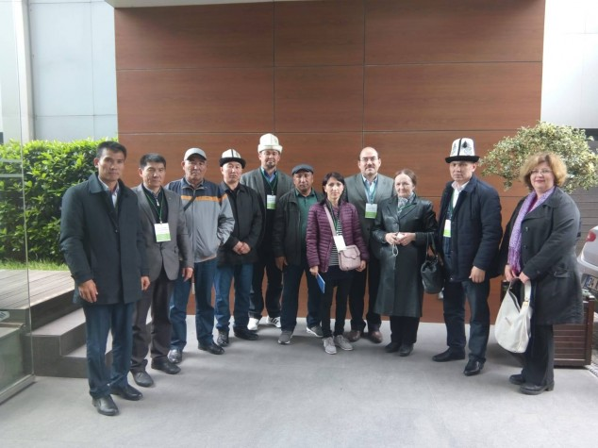
After lunch, the Atatürk Arboretum of the Istanbul Regional Directorate of Forestry, was visited. This arboretum, created with hundreds of domestic and foreign tree species, is considered as a good example for the afforestation studies.
Figure 51 Poster of Training Program  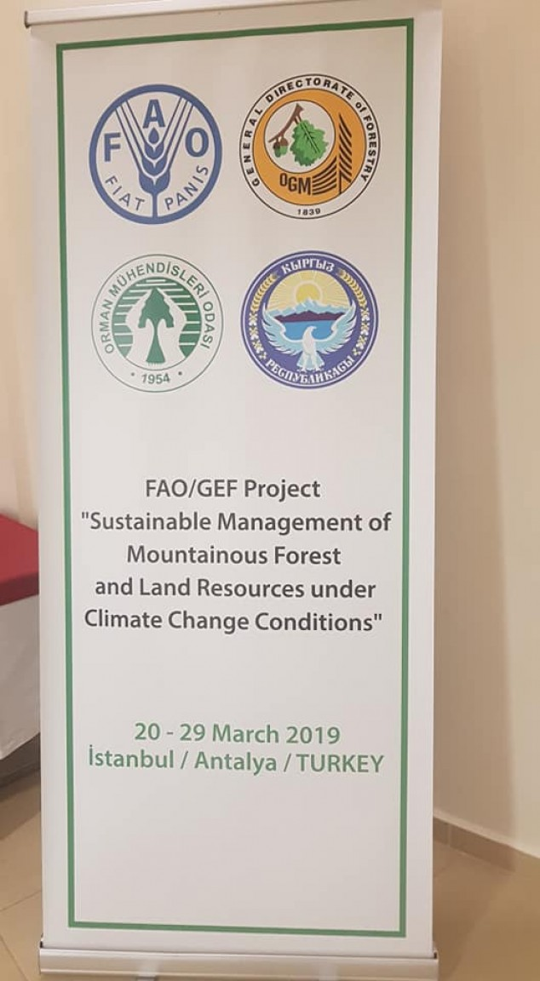 | Figure 52 Some Project Materails  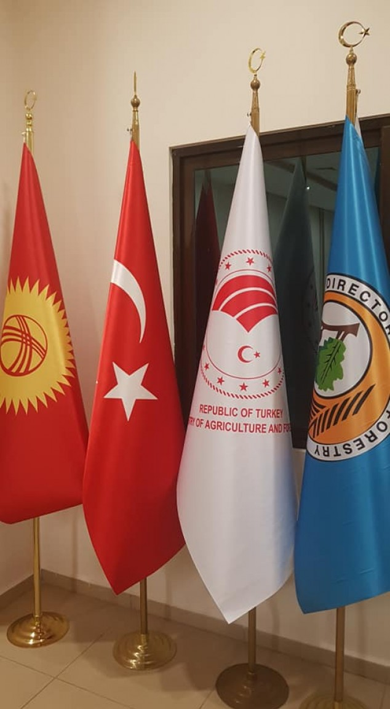

During this visit some presentations were submitted to the participants by the relevant experts and authorities as follows:
- Deputy Regional Director of Istanbul Mr. İlyas Özdemir
- Director of Bahçeköy Forest Directorate Mr. Fatih Altunordu,
- Director of Istanbul Forest Nursery Directorate Nejdet Balcı,
- Chief Engineer of Atatürk Arboretum Ms. Merve Kartaloğlu Sönmez https://istanbulobm.ogm.gov.tr/BahcekoyOIM/Lists/yonetim/ozgecmisli.aspx
Figure 53 Meeting at Istanbul Arboretum  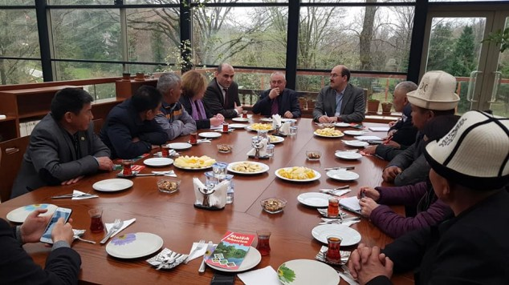 | Figure 54 Field trip at Istanbul Arboretum  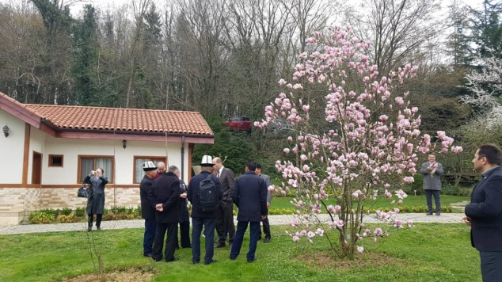

After briefing and presentations, together with officials, participants visited to field.
The continuation of this, participant visited to Istanbul Forest Nursery Directorate. https://istanbulobm.ogm.gov.tr/Sayfalar/Fidanl%C4%B1k%20M%C3%BCd%C3%BCrl%C3%BCkleri/istanbulfidanlik.aspx
During this visit the following people were present and shared their experiences.
- Regional Director of Istanbul Mr. Recep Ateş,
- Deputy Regional Director Mr. İlyas Özdemir,
- Director of Forest Nursery Nejdet Balcı,
- Deputy Director of Nursery Mehmet Kaplan,
- Chief Engineer Murat Güleken
After presentations participants visited the nursery with relevant experts.

Figure 55 Meeting at Istanbul Nursery  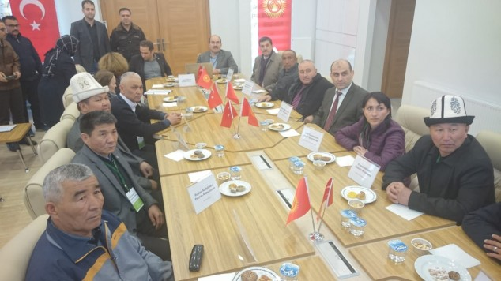 | Figure 56 Field Trip to Istanbul Nursery  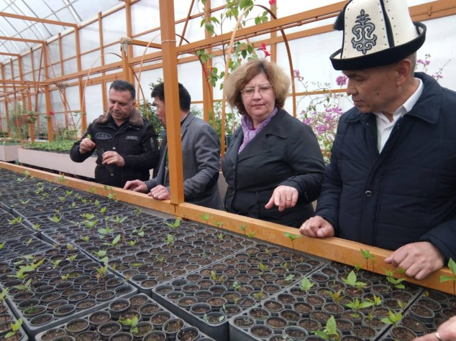
Please visit this link for more information: http://www.gonder.org.tr/?p=7629

21st of March, 2019, Thursday
The Day of 21st of March has been declared by the General Assembly of the United Nations. For this occasion the General Directorate of Forests organises several programs to celebrate this day in overall country.
Figure 57 Ceremony of 21st of March IDF  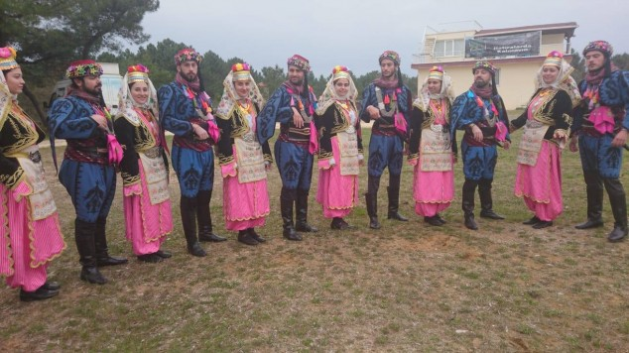 | Figure 58 Ceremony of 21st of March IDF  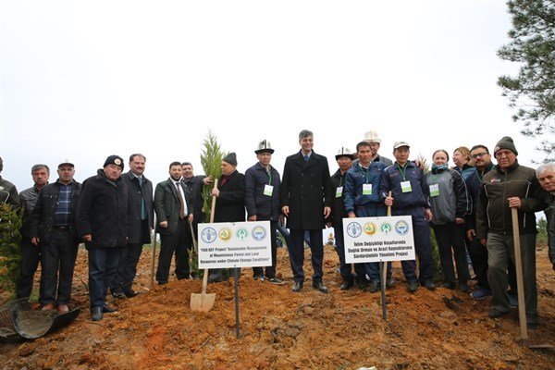

This is a very good opportunity to witness and see the organisation and activities in an ordinary way. For that aim participants join to program organised by Şile Forestry Directorate for "21 March World Forest Day Events". During that program they were able to plant seedlings with children and relative officials.
In the afternoon, a cultural excursion was made in Istanbul in accordance with the program. With this program, the participants were informed about forest-public relations, ensuring and informing citizens about their afforestation and nursery work, and making them interested in forestry studies.

22nd of March, 2019, Friday
At that day participants visited to Istanbul Forestry Faculty and met with academicians. http://orman.istanbulc.edu.tr/en/
Professor Dr. Turgay Akbulut- Dean of Faculty- http://profil.istanbulc.edu.tr/tr/p/takbulut welcomed the participants. Professor Dr. Türker Dündar- Representative of OMO to Faculty- http://profil.istanbulc.edu.tr/tr/p/dundar was also present during this opening ceremony.
Figure 59 Istanbul Faculty of Forestry  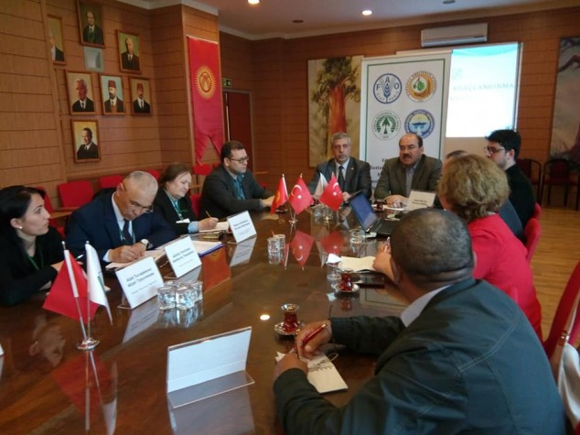 | Figure 60 Facilities of Forestry Faculty  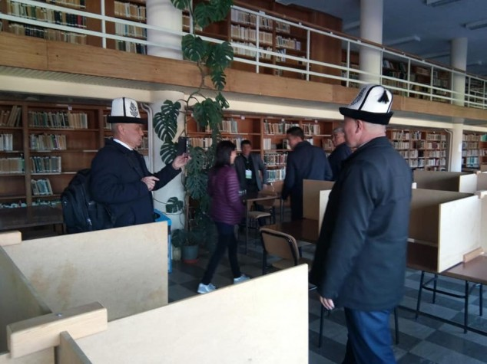

Associate Professor Servet Çalışkan- http://profil.istanbulc.edu.tr/tr/p/servetc and Dr. Safa Balekoğlu http://profil.istanbulc.edu.tr/tr/p/safa.balekoglu gave lessons and shared their theoretical knowledge on “Nursery Plant and Management, Root System and Afforestation Techniques”.
During this program, Deputy Dean Prof. Dr. Vedat Beşkardeş, representatives from General Directorate of Forests as Mr. Nihat Karakaya, Division Director of Istanbul Regional Directorate Ms. Canan Yeşil and photographer Mr. Murat Gümüş were also present.
On this occasion, the participants were able to see closely to Turkey's oldest and most powerful Faculty of Forestry and the opportunity to discuss with the authorities.
Afternoon they visited to the Regional Directorate of Istanbul. Regional Director Mr. Recep Ateş, Deputy Regional Director Mr. Ilyas Özdemir, Istanbul Forestry Director Mr. Veli Altıntaş gave a welcoming speech and shared their experiences verbally. After that Division Director of Afforestation Mr.Talip Kavlak, Division Director of Silviculture Selahattin Eruş and Division Director of Foreign Relations gave presentation on their activities.
Figure 61 Regional Directorate of Istanbul  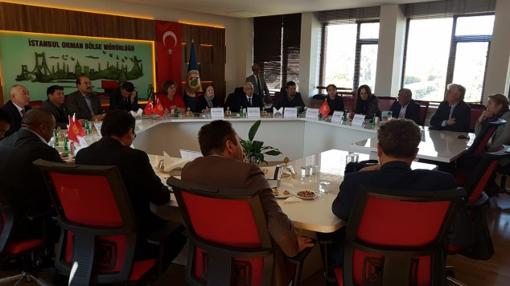 | Figure 62 Presentations by officials from Istanbul RD  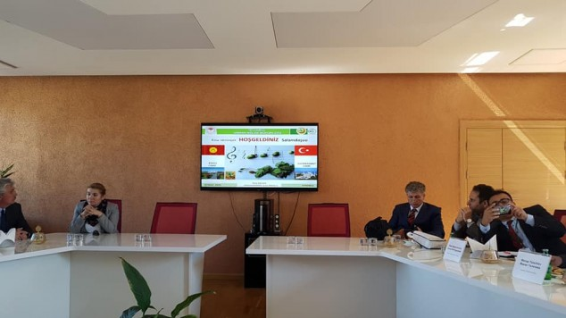

With today's programs participants have been informed about Turkey's theoretical knowledge and its applications.
After that program participants moved to airport for Antalya.

23rd of March, 2019, Saturday
The training program in Antalya started on the morning of Saturday. https://sfm.ogm.gov.tr/
Several presentations made by the following people.
- Regional Director of Antalya Mr. Vedat Dikici, https://antalyaobm.ogm.gov.tr/SitePages/OGM/OGMDefault.aspx
- Deputy Regional Director Mehmet Karabacak,
- Division Director of Foreign Relations Mr. Aydoğan Türedi
- Director of Training Center Mr. Mustafa Ülküdür
- Forest Engineer from OGM’s Headquarte Mr. Nihat Karakaya

In this presentations, detailed information on "Forests and Forestry Activities in Turkey" were shared. On the other hand on behalf of Kyrgyz Foresters, Tatiana Kabliskaia made a presentation on Kyrgyz Forestry.
Figure 63 International Training Center of Antalya  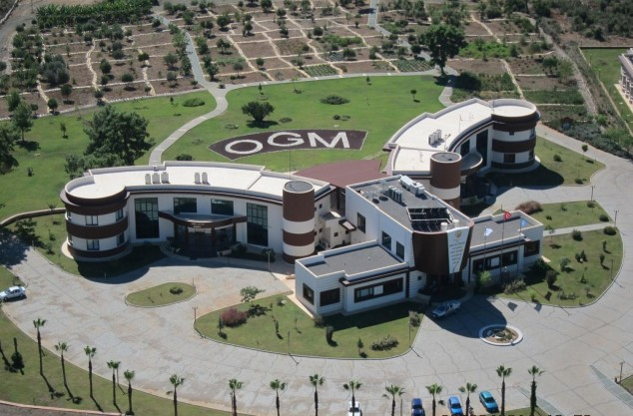 | Figure 64 Starting to Training Program at Antalya  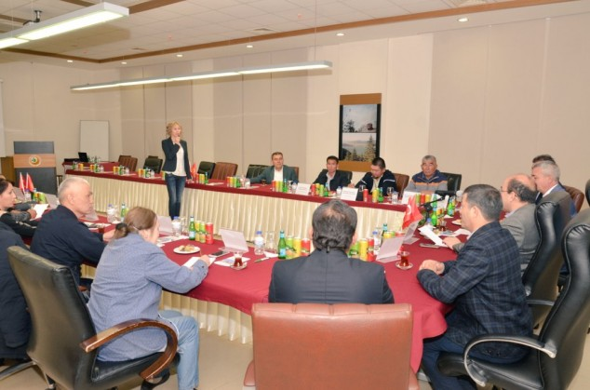
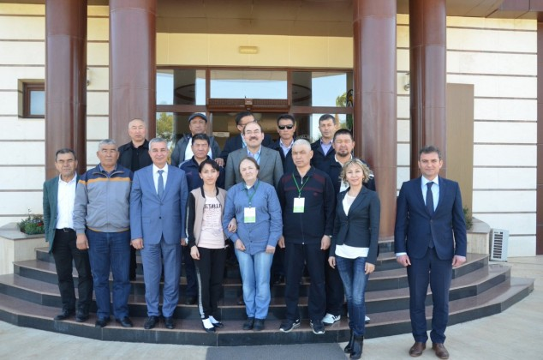 | 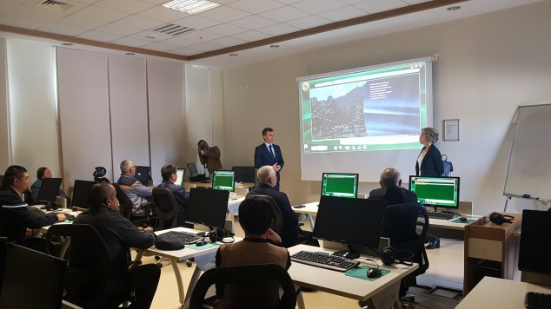

After the presentations, a total of 50 hectare Training Center was visited. It is used as a training center for all forestry issues including forestation and forestation. During this trip, Mustafa Ülküdür, the Director of the Training Center, provided information on different topics including forest fires, afforestation and forest pests.
The afternoon lesson was carried out in Antalya Nursery Directorate. During this programme the following issues shared with participants.
- Nursery Plant and Management
- Sapling Production with Closed Root System
- Seed and Tree Improvement
- Sapling Inspection and Certification
Figure 65 Antalya Forest Nursery-I  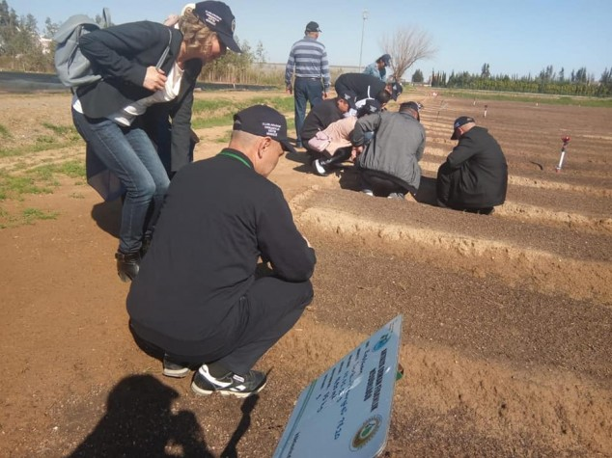 | Figure 66Antalya Forest Nursery-II  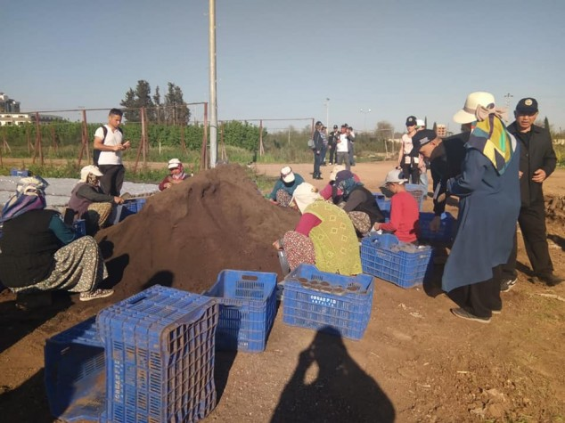

Practical information has been provided by Ayşe Özcan, the Chief of Nursery, and Technician Belkıs Dicle. Mr. Mehmet Koç, The Head of Foreign Relations, Training and Research Department of the General Directorate of Forestry participated in the training in the nursery.

24th of March, 2019, Sunday
Sercan Tunç, Director of Afforestation Branch of Antalya Regional Directorate of Forestry and Hayrullah Yıldırım, Chief Engineer of the Projects, made presentations on 24 March 2019.
The presentation subjects were as follows according to the program.
- Surveying, Project and Afforestation Techniques
- Reforestation carried out by private sector in Turkey
- Afforestation and rehabilitation of susceptible area

Afterwards, participants together with the relevant officials visited to sites. They went to Korkuteli, Bademağacı Village in order to see the works on site. Here, information was received from Chief Forester Mr. Fatih Çetin and Forestry Officer Mehmet Yılmaz on the industrial plantations around Korkuteli Bademağacı Village and walnut plantations made by forest villagers.
Figure 67 Picture of 24th of March  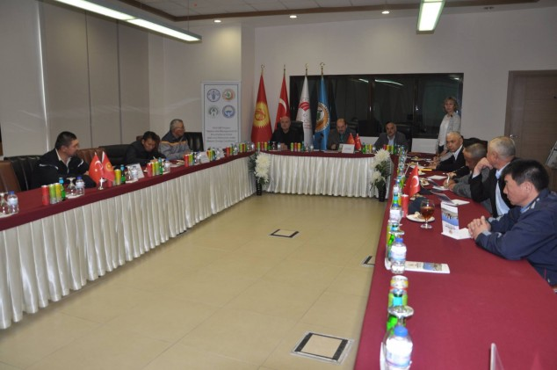 | Figure 68 Field trip to industrial plantation  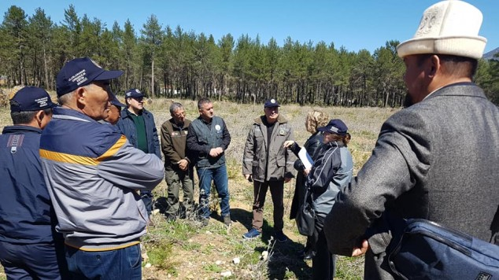

After the field trip, a general evaluation of the program was made by İsmail Belen and then, by Forestry Engineer Nihat Karakaya, from the General Directorate of Forestry, a presentation on international activities of the General Directorate of Forestry were presented.
Following this, our Kyrgyz Colleagues met with representatives of NGOs.
The following people from relavant NGOs were participated to that meeting.
- Ahmet Keser, Head of the Western Black Sea Branch of the Chamber of Forest Engineers and Director of the Marketing Department of the Regional Directorate of Forestry. Branch Treasurer and the Division Director of Non-Wood Forest Products and Services of Regional Directorate of Forestry Abdullah Yüksel, Branch Editor Celal Emir,
- Ramazan Gün, Öz Forest-İş Antalya Branch President, Branch Secretary Ahmet Ali Şişaneci, Branch Financial Secretary Süleyman Koca,
- TOÇBİRSEN Vice Chairman Mehmet Demirkol, Branch Vice Chairman Halil İbrahim Erdem and Orhan Akkaya participated.
Figure 69 Meeting with NGOs  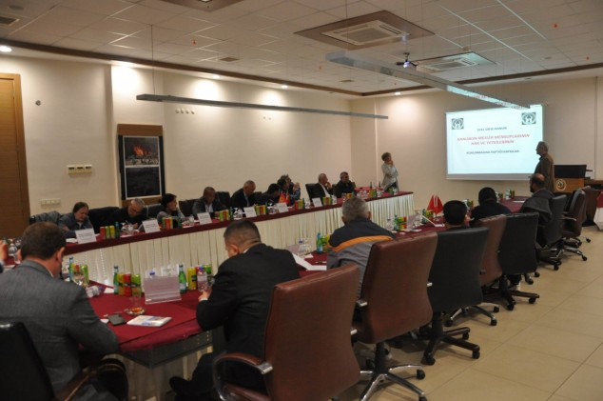 | Figure 70Meeting with NGO-II  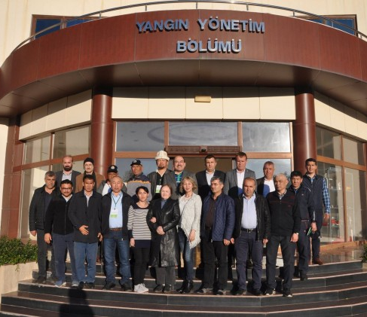

25th of March, 2019, Monday
The program started on Monday, March 25, 2019 with a general overview of İsmail Belen and Nihat Karakaya at 08:30 and the revision of the entire program. In the meantime, the land program of 26 March Tuesday was shared with the participants in detail.
Then the Director of the Training Center Mr. Mustafa Ülküdür and the Deputy Director Ms. Dilek Vursavaş addressed the participants and made a general evaluation.
Figure 71 Director of Training Center Mustafa Ülküdür  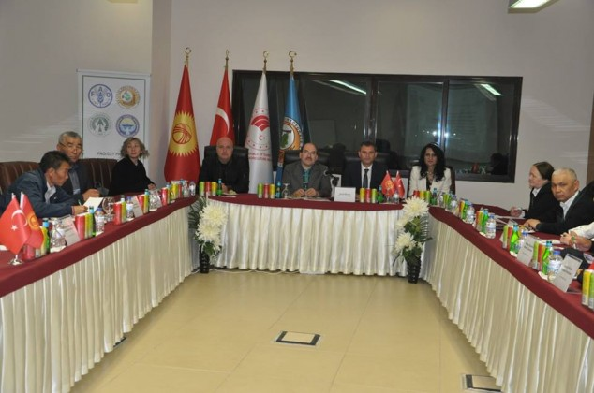 | Figure 72 Participation to OGM's own program  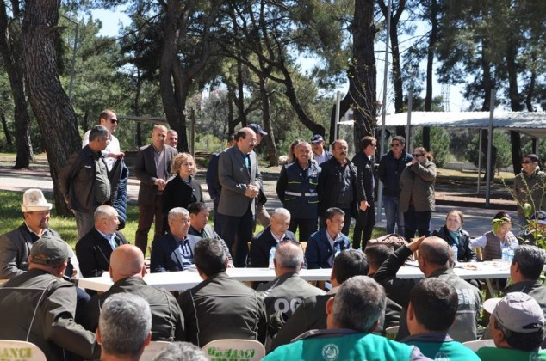

The continuation of this;
- Mr. Abdullah Yüksel, Non-Wood Forest Products and Services Branch Manager of the Antalya Forest Regional Directorate
- Mr. Mitat Uyan Branch Manager of Forest Pests
- Mr. Hayrullah Yıldırım, Chief Engineer of the Survey, made their presentations.
The subjects of presentations were as follows:
- Soil Conservation and Erosion Control Studies
- Integrated Watershed Improvement Studies and Mountain Area Management
- Forestation with Non-Wood Forest Products and Fruity Species
- Melioration of pastures and grazing in forests

After this, the training activities organized by the General Directorate of Forestry within the scope of pre-fire preparations were participated. In this way, the participants had the opportunity to see their internal practices in place.
In the afternoon a field trip was made. In this framework, firstly Korkuteli Forest Management Directorate was visited.. https://antalyaobm.ogm.gov.tr/KorkuteliOIM/Sayfalar/default.aspx
Here, Deputy Director Tuncay Ayhan, Chief Engineer Yakup Su, Ardıçdagi Forest Operation Chief Engin Atli, Hacıbekar Forest Operation Chief Gökhan Gök, and Yazır Operation Chief Fatih Çetin informed the participants about their activities.
Figure 73Field trip to erosion control sites  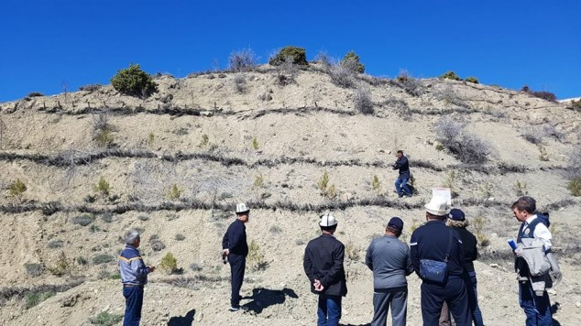 | Figure 74Field trip to Korkuteli  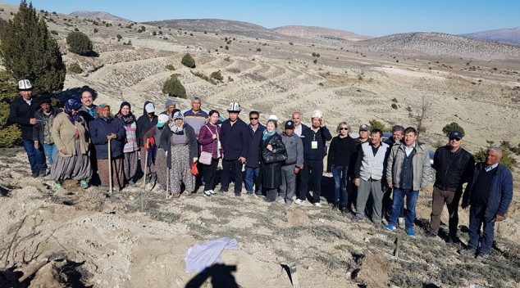

After that, Antalya Korkuteli Erosion and Flood Control Training and Model Implementation Project (2014) area was examined.http://www.cem.gov.tr/erozyon/AnaSayfa/Erozyonyeni/projeler/antalya_erozyon.aspx?sflang=tr
The Project Location is within the boundaries of Korkuteli District of Antalya Province. Founded in 2015. In the project area, there are slope and scales improvement measures.
After this area, the afforestation and erosion control studies carried out in the village of Korkuteli Karabayır were investigated on site. Workers were interviewed here.
http://www.koylerim.com/antalya-korkuteli-karabayir-koyu-60364h.htm

26th of March, 2019, Tuesday
The participants left the Training Center at 08:00 in the morning. At 10:30, the officials of Isparta-Bucak Forestry Directorate met. Here, The Director of Bucak Forest District Mr. Ramazan Kolsuz and the Deputy Director Emin Demir gave information about the post-fire activities. https://ispartaobm.ogm.gov.tr/BucakOIM/Lists/Yonetim/AllItems.aspx
Figure 75 Field trip to Bucak Forest Directorate  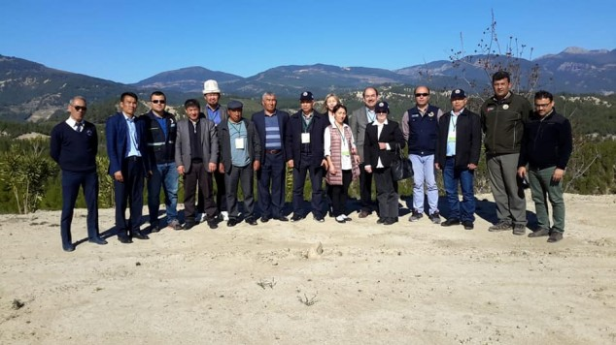 | Figure 76 Officials of the General Directorate of Forest  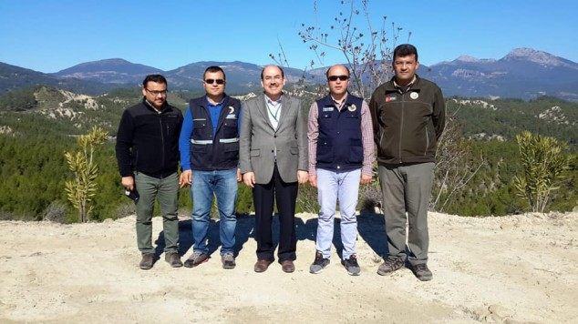

At 11:00 am, the Regional Directorate of Forestry in Isparta was visited. Regional Director Kenan Akduman and other officials were interviewed. Kenan Akduman, Regional Director, made a detailed presentation on all activities carried out by the region.
Figure 77 Regional Director of Isparta, Mr. Kenan Akduman  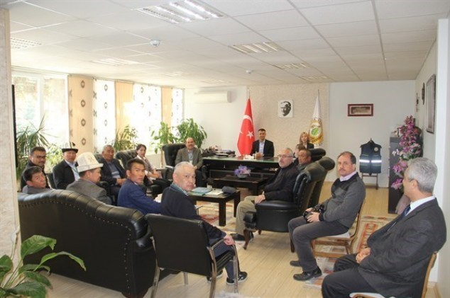 | Figure 78 Regional Directorate of Isparta  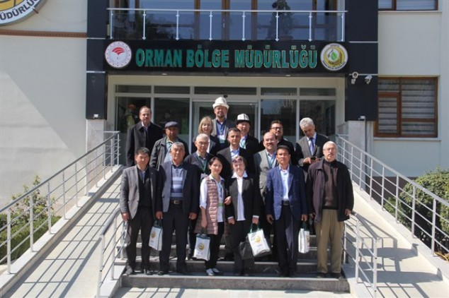

Between 12: 00-14: 00, the Eğirdir Nursery Directorate was visited, and the information about the nursery works was taken, especially juniper seed processing.
During this visit, the following people made presentations.
- Director of Nursery, Mr.İsmet Dokur,
- Deputy Director Ms.Sevim Özbey,
- Chief Engineer Ms.Nazlı Özgü.
Regional Director Kenan Akduman and Regional Directorate, Afforestation and Silviculture Branch Manager Ahmet Şahan also participated in the delegation.
Figure 79 Eğirdir Forest Nursery  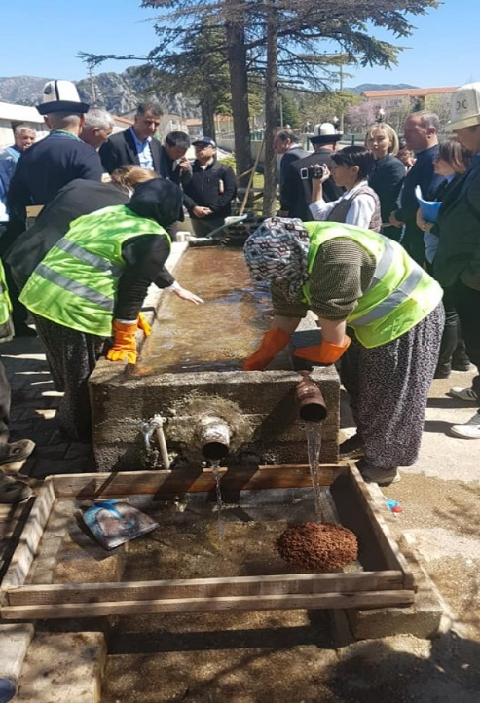 | Figure 80 Seeds of Juniperus  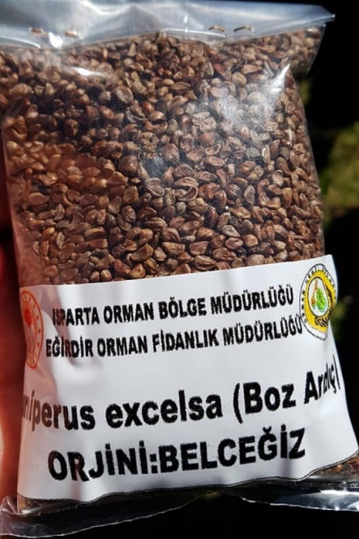

Egirdir Nursery specializes in the production of juniper saplings. In this regard, serious cooperation proposals were made by our Kyrgyz colleagues.
Between 16:00 and 17:00, Burdur Afforestation and Erosion Control studies were examined on site.
Forestry activities in the region of Burdur gives important experiences to the erosion and forestation studies. The General Directorate of Forests (OGM) started to the activities together with State Hydrolic Works and other related institutes in 1962. The studies in the region were carried out in the form of mechanical measures and silvicultural measures for the breeding of flood streams.
https://www.tarimorman.gov.tr/CEM/Belgeler/collesme%20belgeleri%20arsiv/Sayfa02/Burdur_Raporu.pdf
Mehmet Emin Çetin, Forestry Engineer, who was personally involved in the studies, informed to participants.
The following officials also participated to field examination and shared their experinces.
- Deputy Regional Director of Isparta, Mr.Nuri Maraş,
- Branch Director of Afforestation and Silviculture Mr. Ahmet Şahanlı,
- Director of Burdur Forest Directorate Mr.Celal Korkmaz. https://ispartaobm.ogm.gov.tr/BurdurOIM/Sayfalar/default.aspx

Figure 81 Burdur's Afforestation Sites  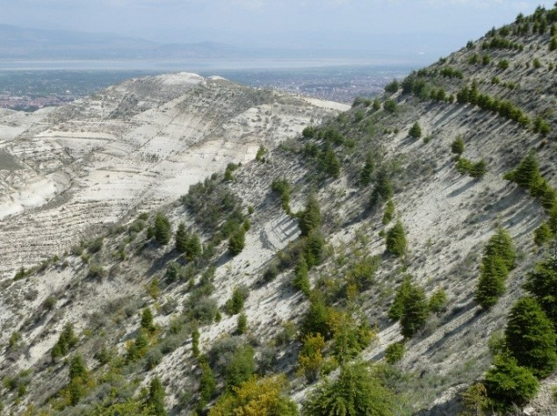 | Figure 82 Field trip to Burdur  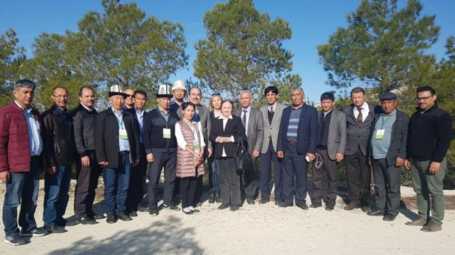

27th of March, 2019, Wednesday
On Wednesday, 27 March 2019, the post-fire forestation activities in Kumluca Forest Directorate were examined.
Here, information was given about the activities carried out after the fire in 2016 by Faik Yılmaz, the Director of Kumluca Forest Directoaret and Mustafa Özdoğan, Chief Engineer of the Ardasan Forest Sub-District.
After that, the “Fire Memory Point” created by Kumluca Forest Directorate in order to train the public and especially to the children for the importance of forest fires was examined. Later on, Ardasan Fire Team was visited.
In the afternoon Beydağları National Park was visited and experiences about the National Park management were conveyed. The training was completed with this visit. http://beydaglari.tabiat.gov.tr/
Figure 83 News on a local newspaper  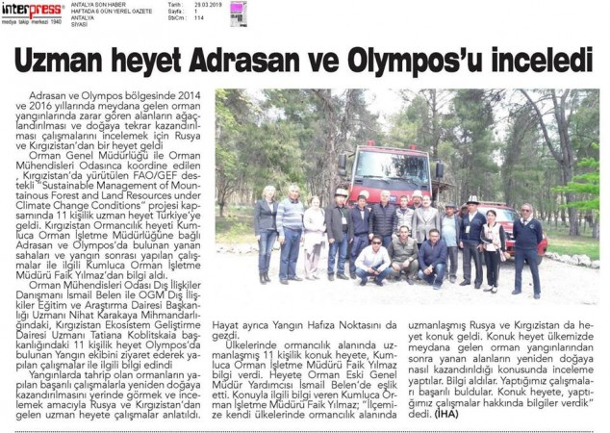 | Figure 84 Field trip to Beydağları National Park  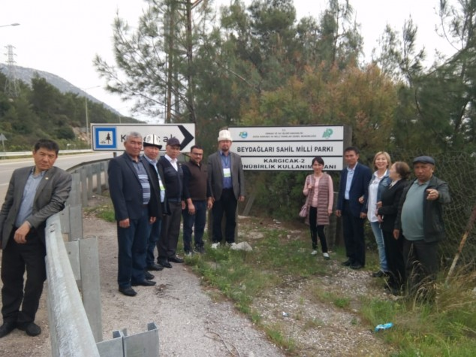

28th of March,2019 Thursday- 29th of March, 2019, Friday
Thursday, March 28, 2019 the delegation has set out from Turkey. First, at 12:35 hours from Antalya to Istanbul, then at 18:35 pm they moved from Istanbul to Bishkek.
Interpreters and other officials assigned by the Chamber of Forest Engineers have assisted the delegation both at the airport of Antalya and at the Istanbul airport.
After the delegation arrived in Bishkek, they visited to the Deputy General Director of the State Forestry Agency of the Kyrgyz Republic, E.Zh. Sheripov and Director A. Rustamov to share their experiences and satisfaction. The WhatsApp group still works actively.
Figure 85 Depart to Bishkek from Istanbul  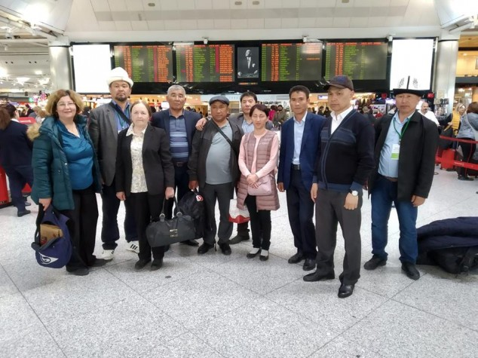 | Figure 86 Briefing to Kyrgyz Authorities after training program  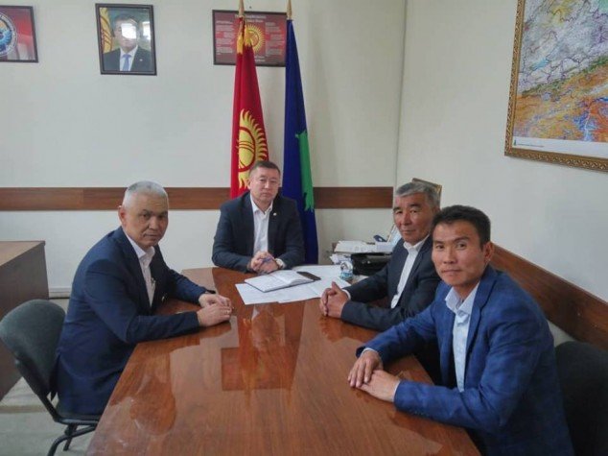

General evaluation of the training program
The program was successfully implemented as planned with the line of LoA signed and budget. Participants have expressed their satisfaction many times.

On behalf of the Chamber of Forest Engineers
Prepared by OMO’s Consultants;
- Mr. Özgür Balcı (Forest Engineer) Member of the Board of Directors responsible for professional issues,
- Mr. İsmail Belen (Forest Engineer, Msc.) External Relations Consultant were designated as “Consultant”.

10 April 2019

