Training on the Guidelines on Nature-based Solutions (NbSs) to combat negative impact of climate change on forestry for FAOSEC

26-30 September
Antalya

Information Notes for the Participants

Content
Purpose 2
Daily Program 2
Venue: 2
Accommodation: 3
Transportation 3
Funding 3
Dress Code 3
Field Visit-28 September 2023, Thursday 4
Weather Patterns 4
General Information on Türkiye 4
General Information on Antalya 4
For Contact: 5

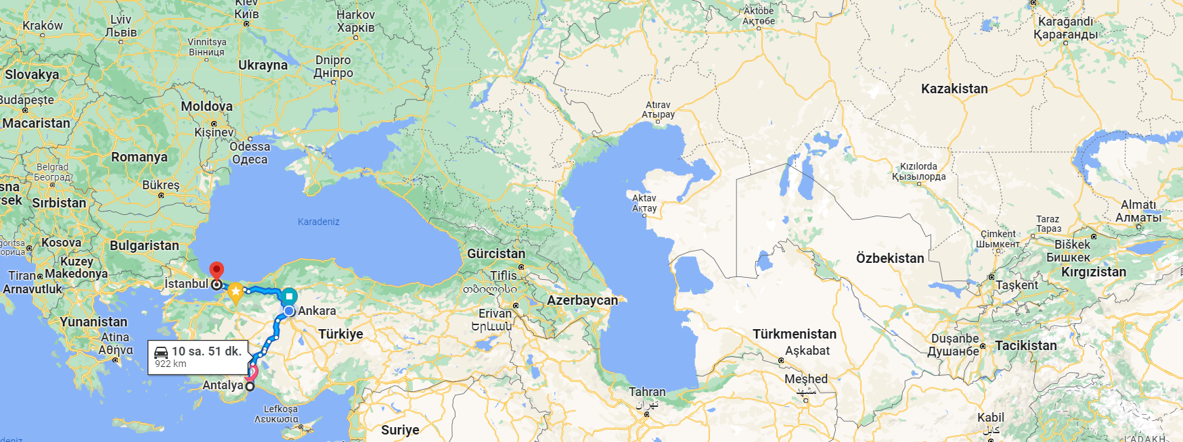

Purpose

The Food and Agriculture Organization of the United Nations (FAO) and Chamber of Forest Engineers of Türkiye (OMO) signed a Letter of Agreement (LoA) on February 16, 2023, to develop “Guidelines on the Implementation of NbSs to Combat the Negative Impact of Climate Change on Forestry,” including related Training on the Guidelines.

As the Service Provider OMO drafted the Guidelines in close cooperation with the respective countries of FAOSEC.

The related training is going to be held in Antalya, Türkiye, between 26 to 30 of September, 2023 in five days including the days for transportation.

Daily Program
Training Program will be implemented as a five days program as follow:
- D1 Arrival to Antalya- 26 September 2023 Tuesday
- D2 Indoor lecture- 27 September 2023 Wednesday
- D3 Outdoor lecture- Field Visit 28 September 2023 Thursday
- D4 Indoor lecture – 29 September 2023 Friday
- D5 Departure from Antalya- 30 September 2023 Saturday

Venue:
The venue is the “International Forestry Training Center- IFTC” in Antalya. Address:
Sedir Mahallesi Vatan Bulvarı Muratpaşa / ANTALYA/Türkiye For Google Map please visit this link

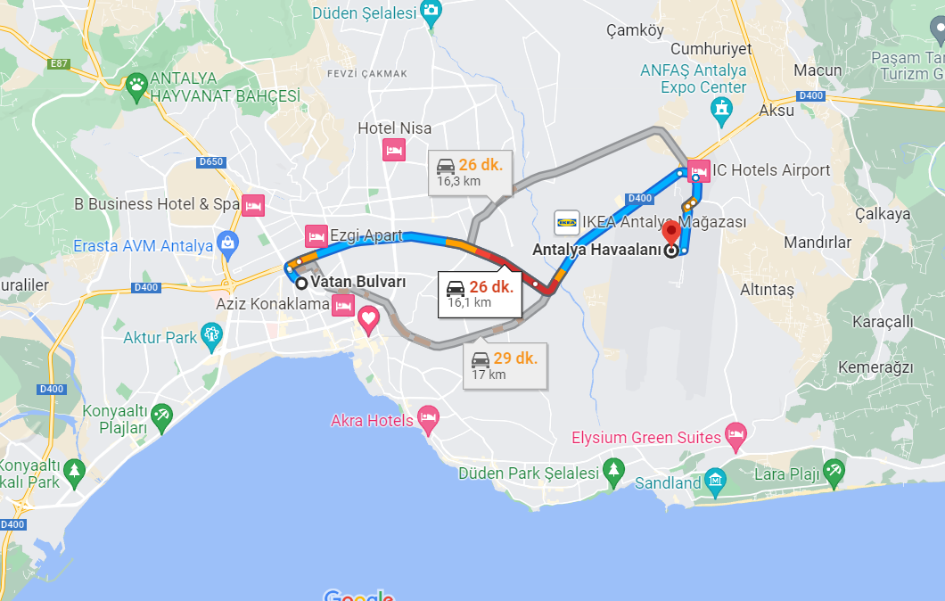

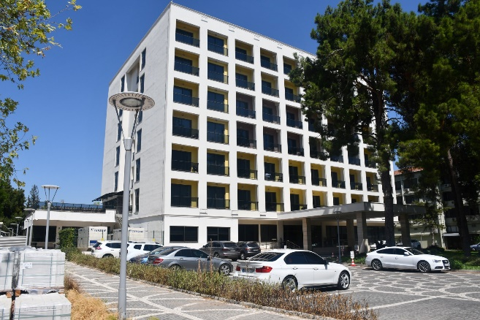 | 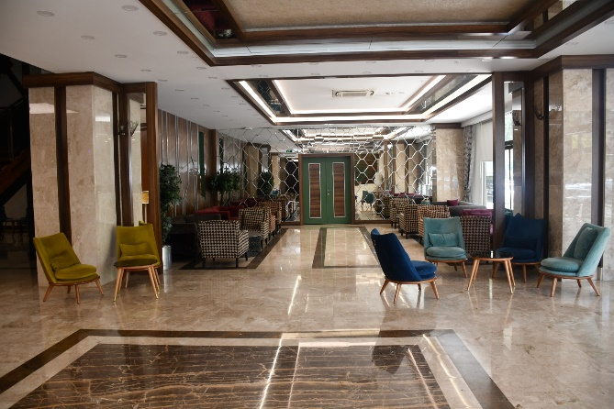
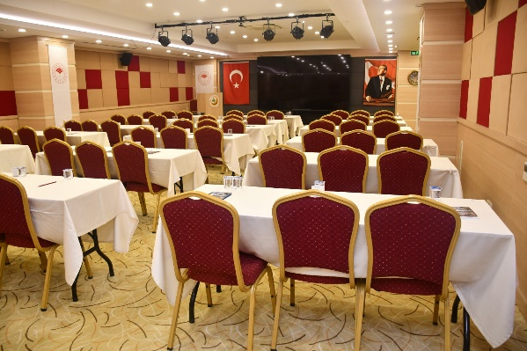 | 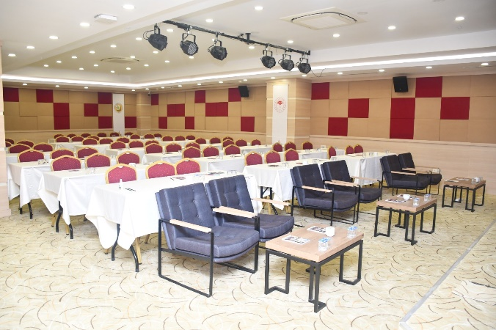

Accommodation:
All participants will stay in the Social Facilities of Antalya Regional Directorate of Forestry. (International Forestry Training Center)

Transportation
Air tickets for the participants will be provided by OMO. Traveling from the airport to the accommodation and from there to the training center will be provided by OMO. Dedicated staff or a driver with name of the participant will be waiting at the respective arrival hall. Departure times from the hotel will be shared with the participants in advance

Necessary arrangements will also be made for the field trip.

Funding
All training-related expenses will be covered by OMO.

Dress Code
Casual comfortable clothing is recommended during the indoor lectures. It would be appropriate to wear sports clothes and be prepared for the possibility of rain during outdoor lectures and field excursion.

Field Visit-28 September 2023, Thursday
A field visit will be organised to share the experiences at the field on 28th of September , Wednesday to discuss the post-fire NbS implementations with guidiance of local forestry experts.

Transportation and other requirements will be provided by OMO.

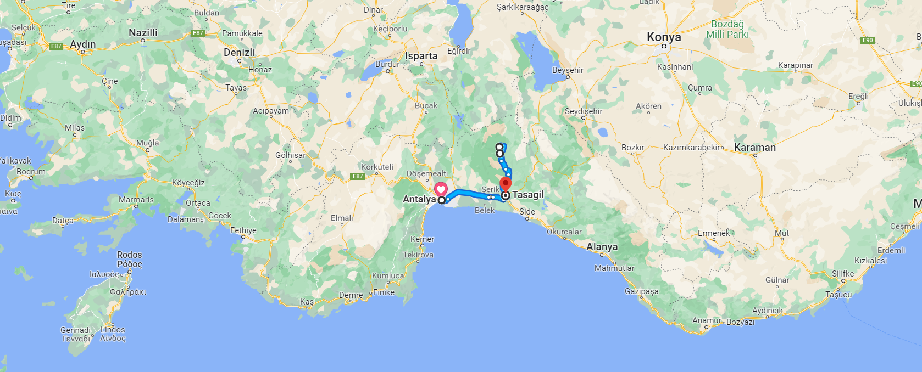

Weather Patterns
The weather can be observed via this link: https://www.mgm.gov.tr/tahmin/il-ve-ilceler.aspx?il=Antalya

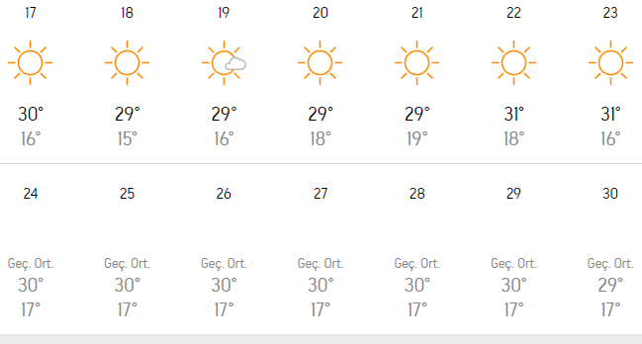

General Information on Türkiye
The most updated information on Türkiye could be reached through the web page of the Ministry of Foreign Affairs of Turkey: https://www.mfa.gov.tr/

For travel, information participants are encouraged to visit Turkish Airlines’ Web page: https://www.turkishairlines.com/

General Information on Antalya

It is also proposed to visit the following links for the most updated information:

- Antalya Governorate: http://www.antalya.gov.tr/
- Antalya Metropolitan Municipality: https://www.antalya.bel.tr/
- Antalya Regional Directorate of Forest: https://antalyaobm.ogm.gov.tr/SitePages/OGM/OGMDefault.aspx
- Chamber of Forest Engineers: https://www.ormuh.org.tr/
- Turkish State Meteorological Service: https://www.mgm.gov.tr/tahmin/il-ve-ilceler.aspx?il=Antalya

Hosting more than 10 million tourists a year, Antalya is one of the safest cities in the world. Nevertheless, our participants are advised to take their own precautions. In case of any situation, it will be appropriate to call the contact numbers.

Since we will be traveling as a group, our guests are advised to follow the program and not to act independently.

For Contact:
Please contact Mr. Ercan Kaptanoğlu, the Coordinator for any issue through email or mobile phone:

Email: ercank028@gmail.com
Mobile Phone: +90 505 771 11 50

