Speech Text- Closing Remarks
İsmail Belen
16 November 2023
Samarkand
Gender Caucus session 2: 16 November, 13:00 to 15:00, location MET 09
Panel led by FAO: “How can we utilize local knowledge and women's empowerment to create more drought-resilient dryland forests and silvopastoral ecosystems?”
Final review and discussion of CRIC recommendations

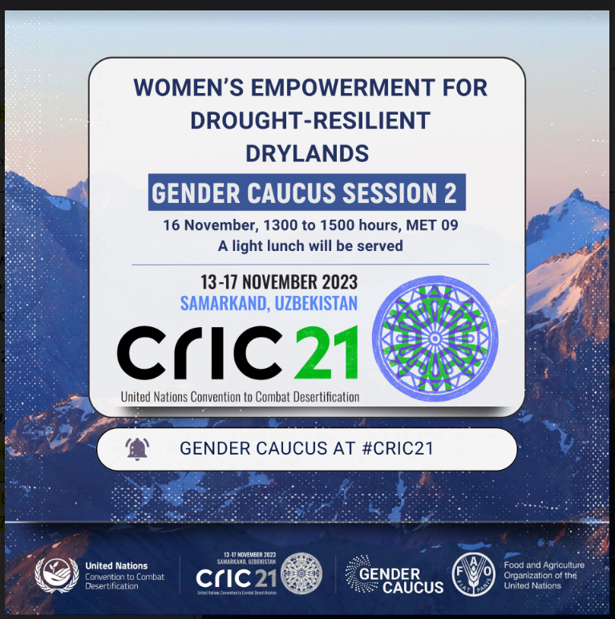

Thank you, Fidaa, for the brief introduction.
Dear colleagues, as our session today comes to a close let us reflect on some of the important lessons learned and takeaways.
My name is İsmail Belen. I am the Vice-Chair and Reporter of the United Nations Forum on Forest which is a subsidiary body of the Economic and Social Council of the United Nations (ECOSOC) with the main objective to promote “… the management, conservation and sustainable development of all types of forests and to strengthen long-term political commitment to this end…”
UNFF works in close cooperation with FAO trough the Collaborative Partnership on Forest (CPF) and with UNCCD. Pleased to share that The UN Forum on Forests Secretariat and the UN Convention to Combat Desertification entered into a new Memorandum of Understanding (MoU) very recently on September 2023, on the margins of the 78th session of the UN General Assembly
Currently I am working as the Chief Inspector, at the General Directorate of Forests, Ministry of Agriculture and Forest of Türkiye.
I am also working with the Chamber of Forest Engineers of Türkiye, an NGO with public nature and public legal entity.
Today we have heard from our excellent panelists the myriad techniques being applied within dryland forests and agrosilvopastoral regions to create more drought-resilient landscapes.
It goes without question that the knowledge of local communities, and in particular women, that is why my wife is here with me, and Indigenous Groups, hold the key understanding of the land, and only with their expertise and skills can we all hope for a more prosperous and climate-resilient future.
We have heard from the women directly on the ground in Malawi, whose efforts in community forest management and beekeeping have not gone unnoticed by their very own government.
In the Kingdom of Saudi Arabia, acknowledging the critical significance of increasing women's involvement in addressing Land Degradation, their focus is on the pivotal role of education and training in Natural Resource Management. Additionally, they are encouraging women land-owners to seek funding for land development actively. This ensures a coherent and integrated approach that addresses both the recognized and valued involvement of women and the broader challenges posed by Land Degradation.

Mongolia has shared their own experiences, and has leaders of the FAO Committee on Forestry Working Group on Dryland Forests and Agrosilvopastoral Systems COFO WG, we are very excited to see what developments will unfold over the next two years.
In my country, Türkiye, women work with great devotion both in public institutions, non-governmental organizations and in their own businesses, and protect themselves and their lands and soils for their own future. As the famous Turkish folk poet Aşık Veysel said, "My faithful lover is black soil".
Around 120 thousand tons of honey is produced annually in Türkiye, and our women work together with their husbands in beekeeping. Happy to share with you that more than 85% of honey production comes from forest areas.
Again, around 700 thousand tons of hazelnuts are produced annually, and approximately 2 billion USD of export income is obtained from this. Most of the hazelnut harvest is done by women. One of them is my own mother.
Nevertheless, let us remember that the parties have proposed several action points take into consideration at different levels, including at the convention level, to address the local and traditional knowledge and the engagement of women as well.
The recognition and protection of all applicable tenure rights, in accordance with the Voluntary Guidelines on the Responsible Governance of Tenure (VGGT) principles, with special attention and resources provided to guaranteeing equal use and ownership rights of land for women, is critical in order to make significant progress on land degradation neutrality.
First, Parties are urged to work towards the recognition and protection of all applicable tenure rights, in accordance with the Voluntary Guidelines on the Responsible Governance of Tenure VGGT principles, with special attention and resources provided to guaranteeing equal use and ownership rights of land for women and the enhancement of women’s equal access to land and land tenure security, as well as the promotion of gender-responsive measures to combat desertification /land degradation and drought and achieve land degradation neutrality, taking into account the national context.
Parties should submit, on a voluntary basis, reports on the implementation of key national-level activities contained in the Gender Action Plan.
The secretariat is requested to compile such information on a regular basis, including monitoring the level of gender parity across the Convention and its bodies and working groups, and produce a public report on its findings;
The Secretariat, subject to availability of resources, should also continue organizing the Gender Caucus and other awareness-raising activities for the promotion of gender-responsive land restoration policies and programmes worldwide.
In addition, it is important to have stronger language on gender throughout formal documents, the inclusion of gender parity in all UNCCD entities as well as improved mandatory reporting on gender parity across the Convention.
The Secretariat specifically proposed to follow-up on policy frameworks and thematic issues related to sand and dust storms, drought, land tenure and gender, improved living conditions for affected populations, and continue to support the development of the capacity of country Parties to improve intersectoral coordination with relevant sectors, policies and plans, particularly the engagement with focal points for project financing.
Until women are fully engaged and empowered in land management activities, we will not be able to meet the goals of the Convention.
I thank you for your attention and being with us.
Sure my special thanks to the Government of Uzbekistan for hosting this CRIC session in perfect way.

