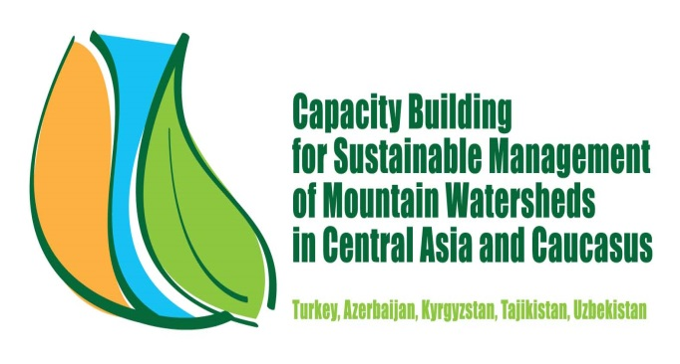

Capacity Building for Sustainable Management of Mountain Watersheds
In Central Asia and the Caucasus
GCP/SEC/002/TUR

Inception report including work plan and methods of study for

TCDC Consultant of Awareness Creation and Training

Ismail BELEN
26 March 2014

Contents
1. About this report and the Consultancy 3
1.1. Aim of this report 3
1.2. Content of the Report and Links to Others 3
1.3. Contributions to be provided by TCDC Consultant Awareness Creation and Training in the Project 3
1.4. Required Competences 4
1.5. Duration and the Place 4
2. Method of Study 5
3. Suggested Work Plan 6

About this report and the Consultancy

Aim of this report

Mr. Ismail Belen, a Forest Engineer with MSc by training and a Public Management Expert, started to work for the Project entitled “Capacity Building for Sustainable Management of Mountain Watersheds in Central Asia and the Caucasus-GCP/SEC/002/TUR” as the “TCDC Consultant of Awareness Creation and Training” at the date of 17th of March, 2014.

This “Inception report” including work plan and methods of study has been prepared by Ismail Belen, the TCDC Consultant, with the framework of the Project and submitted to FAO SEC Forestry Officer.

Content of the Report and Links to Others
With the framework of the Project, the Consultant shall prepare;
- Inception report including work plan and methods of study
- Draft consultant report compliant including preliminary results
- Final consultancy report with findings and recommendations
Current inception report has been prepared as a first step of the above mentioned reports.

Contributions to be provided by TCDC Consultant Awareness Creation and Training in the Project
According to the project text ; Under the overall supervision of the FAO Sub-regional Coordinator for Central Asia (SEC), the technical supervision of the Chief FAO FOMC, and the direct technical supervision of the SEC Forestry Officer, and in collaboration with the Regional Project Coordinator, the national project coordinators, consultants, and the Assistant FAO Representatives and FAO technical officers, the TCDC Consultant for Awareness Creation and Training will carry out the following tasks:
- Assist the review of the institutional setup and mechanisms related to watershed management, in particular public awareness and training development needs in the project countries;
- Establish contacts for raising interest and commitment among the high level decision makers to support testing and expansion of the holistic (integrated) participatory (collaborative) watershed management approach, integrating rehabilitation and livelihood works in the project countries.
- Provide suggestions and take initiatives for establishment useful and sustainable communication networks among the key watershed agencies of the project countries;
- Participate in the trainings in Turkey and provide practical training to concerned participants on awareness creation and interest raising for participatory integrated watershed projects;
- Assist preparation/elaboration of awareness creation materials (CDs, brochures etc.) and programmes/campaigns in the project countries;
- Work closely with the other TCDC experts and national consultants for the planning and contacting of the participatory integrated watershed management trainings;
- Conduct other tasks as required that are within sphere of competence;
- Prepare and submit a report on “The role of training and awareness creation for development of watershed rehabilitation and management: Turkish experiences and recommendations for the Central Asian countries”.
- Prepare and submit a final report including main comments and recommendations.

Required Competences
The Consultant must have;
- University degree in natural resource management/economic studies with at least five years’ experience in public awareness/rural extension and participatory watershed management practice,
- Proven experience and expertise in overall public awareness creation and watershed training,
- Working knowledge of English.

Duration and the Place

According to the Project Text; the Consultant is supposed to stay in Ankara and work as “home station”. He is also supposed to pay an official visit to 1-2 project countries in 15 days.
He is expected to work 30 working days in 5 months when actually employed basis. The expected start day of assignment is 17th of March, 2014 and required completion date is 30 July 2014

Method of Study

I am planning to undertake the following actions during my assignment in order to achieve the best results.
- Review of all activities carried out up to date and all relevant reports prepared.
- Meeting with the all people relevant to this project, including;
  - the FAO Sub-regional Coordinator for Central Asia (SEC),
  - the Chief FAO FOMC,
  - the SEC Forestry Officer,
  - the Regional Project Coordinator,
  - the national project coordinators,
  - Other TCDC Consultants,
  - and the Assistant FAO Representatives and FAO technical officers
- Meeting the other officials and peoples of relevant institutes, universities and NGO’s as well as individuals and private sector and report them accordingly.
- Review of the institutional setup and mechanisms related to watershed management in Turkey.
- Read the related web page, including below mentioned.
  - http://www.fao.org/forestry/watershedmanagementandmountains/en/-FAO’s web page of Watershed management and mountains
  - http://www.geo.fu-berlin.de/en/v/iwm-network/projects/kyrgyzstan/index.html -Integrated Watershed Management in Central Asia - Implementing an Educational and Research Concept for Capacity Building in Kyrgyzstan
  - http://www.adb.org/projects/46441-001/main -Climate Resilience and Green Growth in Critical Watersheds
  - http://www.swiss-cooperation.admin.ch/centralasia/en/Home/Activities_in_Tajikistan/Disaster_Risk_Reduction/Natural_Disaster_Risk_Reductioin_and_Integrated_Watershed_Management_MuminabadNatural Disaster Risk Reduction and Integrated Watershed Management: Muminabad (Tajikistan)
  - http://www.fao.org/docrep/017/ap784e/ap784e.pdf- FAO’s External concept not for Good practices at FAO: Experience capitalization for continuous learning
  - http://www.fao.org/docrep/009/a0644e/a0644e00.htm - The new generation of watershed management programmes and projects
  - http://www.fao.org/docrep/008/a0032e/a0032e00.HTM-Negotiation and mediation techniques for natural resource management- Trainer’s Guide
- Participating at the training program to be held in Turkey (Eskişehir) between 7-12 April, 2014, and provide practical training to the concerned participants on awareness creation and interest raising for participatory integrated watershed projects.
- Mission to Azerbaijan (for assessment of the current conditions and development needs of watershed development, with particular attention on raising awareness and interest among the decision makers and the stakeholders, identification of policy and institutional capacity development needs, exchange of lessons learnt from the previous watershed rehabilitation/management projects and).
- Mission to Uzbekistan (similar to the Azerbaijan mission program).
- Prepare the Draft consultant report compliant including preliminary results
- Assist preparation/elaboration of awareness creation materials (CDs, brochures etc.) and programmes/campaigns in the project countries
- Share the draft report with relevant people and take the feedback and make comments and suggestions.
- Prepare the Final consultancy report with findings and recommendations
- Together with other TCDC Consultant, prepare and submit a report on “The role of training and awareness creation for development of watershed rehabilitation and management: Turkish experiences and recommendations for the Central Asian countries”.

Suggested Work Plan

Date | Works to be done
17- March 2014 | Start
17- 31 March 2014 | Meet and report all relevant people
17-31 March 2014 | Read and report all relevant documents and web pages listed above  Review of the institutional setup and mechanisms related to watershed management in Turkey
27- March 2014 | Official Submission of the inception report including work plan and methods of study
1-4 April 2014 | Prepare practical training materials (posters, presentation etc.) and presentation for the participants of training program
7-12 April 2014 | Participate at the training course about “Seed, Nursery and Arid Zone Afforestation Techniques” to be held in Turkey (Eskişehir)
20-26 April 2014 | Visit to Azerbaijan
5-9 May 2014 | Prepare the Draft consultant report compliant including preliminary results
18-22 May 2014 | Visit to Uzbekistan
26-30 May 2014 | Assist preparation/elaboration of awareness creation materials (CDs, brochures etc.) and programmes/campaigns in the project countries
- June 2014 | Prepare and submit the Final consultancy report with findings and recommendations
1-18 July 2014 | Together with the other TCDC Consultant; Prepare and submit a report on “The role of training and awareness creation for development of watershed rehabilitation and management: Turkish experiences and recommendations for the Central Asian countries
20-28 July 2014 | Final Checks
30 July 2014 | Completion of the Assignment

Report of Activities Completed Up To 26th of March
After starting officially I met with;
- Mr. Ekrem Yazıcı, FAOSEC Forestry Officer,
- Mr. Muzaffer Doğru, Senior Forester and Independent International Expert,
- Mr. Erdoğan Özevren, Regional Project Coordinator,
- Ms. Sibel Nihal Tekin and Ms. Elçin Acar, Experts from General Directorate of Combating Desertification,
- Mr. Cafer Orhan, Head of Department coordinating the Project on behalf of Turkey
- Mr. İbrahim Yamaç, JPO, FAOSEC,
- Mr. Gérard Marquis, Watershed Management and Mountains Team, Forestry Department, through email.
I started to read the publications, reports and web sites listed below;
- Negotiation and mediation techniques for natural resource management- Trainer’s Guide- http://www.fao.org/docrep/008/a0032e/a0032e00.HTM
- http://www.giz.de/en/worldwide/asia.html
- http://www.worldbank.org/projects/P077454/community-agriculture-watershed-management-project?lang=en
- http://maps.worldbank.org/content/country?tid=&=Go
- http://www.unccd.int/COP%20Side%20Event%20Documents/1%20Mariya%20Genina%20PPT_Chon%20Aksu_problem%20description.pdf
- http://www.worldbank.org/projects/P077454/community-agriculture-watershed-management-project?lang=en&tab=overview
- http://operations.ifad.org/web/ifad/operations/country/projects/tags/azerbaijan

I collected information about the activities done starting from 2012 and read the reports
- 5-9 November 2012 -Antalya- Inception Workshop
- 27 May - 2 June 2013 Mersin : International Training
- 30 September- 6 October 2013: High Level Visit to Kyrgyzstan and Tajikistan-
I also prepared a draft poster for the partners and participants and I am planning to complete it before April starts.
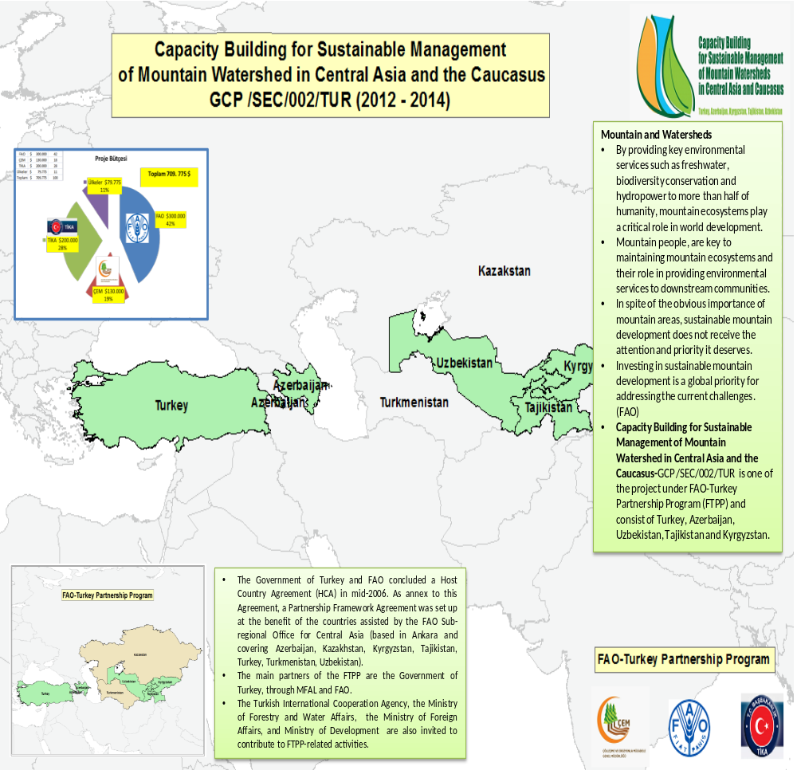With my regards.

http://www.cem.gov.tr/erozyon/anasayfa/resimlihaber/13-10-10/GENEL_M%C3%9CD%C3%9CRL%C3%9C%C4%9E%C3%9CM%C3%9CZCE_KIRG%C4%B0Z%C4%B0STAN_ve_TAC%C4%B0K%C4%B0STAN%E2%80%99A_TEKN%C4%B0K_Z%C4%B0YARET_GER%C3%87EKLE%C5%9ET%C4%B0R%C4%B0LD%C4%B0%E2%80%A6.aspx?sflang=tr

