

Scoping Mission Plan to AZERBAIJAN for
“Restoration of Degraded Forests and Other Lands” Project under
FAO-Turkey Forestry Partnership Programme (FTFP)
(16-20 September 2019)

FAO-Turkey Forestry Partnership Programme (FTFP)

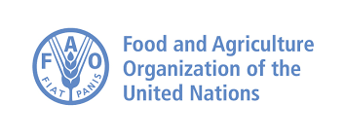 |  | 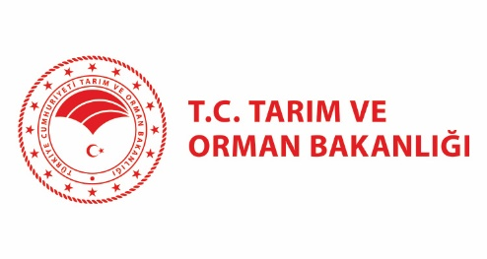

For Contact: 3
1. Background 4
2. Concept of the Scoping missions 5
3. Obtaining the feedback and pre-endorsement 8
4. Draft Programme of the Scoping Mission to Azerbaijan 8
5. Expert Team of the Chamber of Forest Engineers 9
6. Issues to be discussed and decided during the scoping mission 9
7. Outline of the Concept Note 10
7.1. Outcome / Goals 10
7.2. Major outputs 10
7.3. Main activities foreseen 10
7.4. Key inputs 11
8. Project Outputs and Activities 12
9. Issues in the Action Plan for the implementation of the National Forestry Program 13
10. Visits to Country Officials 14
11. Related Documents for Reading and Preparation 14
12. Turkey-Azerbaijan Relations on Forestry 14
13. Dağlık Havzaların Yönetimi GCP/SEC/002/TUR Projesi Görev Raporu-2014 17
1. Proje Hakkında Kısa Bilgi 17
Ziyaret Planı ve Yapılan Görüşmeler 18
22 Temmuz 2014 Salı 18
23 Temmuz 2014 Çarşamba 18
24 Temmuz 2014 Perşembe 19
2. Azerbaycan-Türkiye Ormancılık İlişkileri 19
3. Bundan Sonra Yapılabilecekler-Öneriler 22
Azerbaycan Ulusal Orman Programı Kapsamında Yapılabilecek Projeler 22
FAO Orta Asya Alt Bölge Ofisi (FAOSEC ) Kapsamında Yapılabilecek Projeler 23
Haydar Aliyev Kent Parkı 23
Türk Dünyası Orman Bakanları Kongresi 23
Ortak Kurumsal Eğitimler 24
Fakültelerde Ortak Eğitimler 24

For Contact:
- For FAO:
  - Mr Ahmet Senyaz- National FTFP Programme Coordinator, Turkey,(+90) 312 307 90 00, Ahmet.Senyaz @fao.org
  - Ms Yasemen Aslı Karataş- Forestry Expert-(FAO)-Ankara, Turkey,(+90) 312 307 95 36 Yasemen.Karatas@fao.org
- For the Chamber of Forest Engineers –
  - Mr İsmail Belen, Forestry Specialist for Central Asia, Mobile Phone: +90 506 222 48 19 Email: ismailbelen52@gmail.com
  - Mr. Özgür Balcı, Forestry Specialist for Turkey, Mobile Phone +90 505 775 73 54
- For Azerbaijan
  - Ms Gulnare Mammadova- FTFP focal point of Azerbaijan: Ministry of Ecology and Natural Resources, Forest Development Department, http://www.eco.gov.az/ Phone: 0099455455344 Email: gmgulnare@gmail.com
  - Mr. Bariz Mehdiyev, Natural Resources Programme Leader, FAO Partnership and Liaison Office in Azerbaijan, 8th micro-district Quarter 3123, AZ 1115, Baku, Azerbaijan, Skype: barizmehdiyev, Mobile: 00994502241167, Bariz.Mehdiyev@fao.org

Background
In June 2014, the FAO Subregional Office has signed Partnership Agreement “FAO-Turkey Forestry Partnership Programme (FTFP)” with Turkey. The Agreement is focusing on the forestry sector and foresees that FAO provides technical assistance in the fields of sustainable natural resources management, sustainable development and improvement of livelihoods with a view to contribute to the development of sustainable forest management, sustainable land and natural resource management including land degradation neutrality, and enhance national capacities.
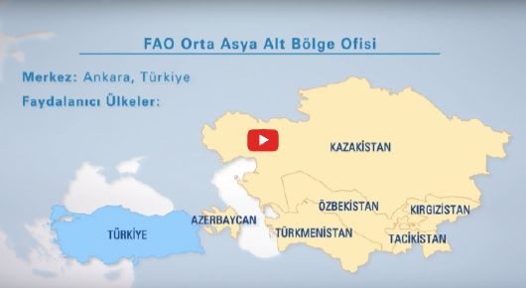
The Second Steering Committee meeting of the Programme was held on 26 November 2018 and Committee endorsed the concept note on ‘Restoration of Degraded Forests and Other Lands’.
A Letter of Agreement has been signed between the Chamber of Forest Engineers (i.e. Service Provider) and FAO at the date of 2 September 2019 in support of the development of the full-fledged project document with all its mandatory annexes.
The Chamber of Forest Engineers, as The Service Provider (SP), benefiting from its pool of experts, using its extensive capacity on various fields of forestry sector as well as project development will draft the full-fledged project document through scoping missions including stakeholder workshops, meetings with government representatives and field visits. The Service Provider in close coordination with FAO will ensure the pre-endorsement of the draft of the full-fledged project document by the governments of the concerned beneficiary countries and the donor. The Service Provider will work under the overall technical guidance of FAO in line with the envisioned work plan, outputs and budget.

Concept of the Scoping missions
According to the LoA signed, The Chamber of Forest Engineers will undertake necessary travels to the focal countries. The scoping missions will be attended by a team to be established by the SP. The team should be established in close coordination with FAO and allow FAO participation.
The objectives of the scoping missions to the countries are to
(a) coordinate identification of the technical sub-activities (in addition to main activities reflected in the concept note) with the governments and other stakeholders
(b) assess the situation on the ground by visiting pilot sites suggested by the countries,
Hence, the agenda of the scoping missions will include
(1) inception meetings with respective government representatives and other relevant parties to inform about upcoming work,
(2) stakeholder workshops to obtain feedback on proposed works and agreement on the pilot sites and
(3) field visits to the pilot sites in the countries.
An information email has been sent by FAOSEC to FAO SEC Country Offices on 5 September, 2019.
Subject: FAO-Turkey Forestry Partnership Programme (FTFP) – Country Scoping Missions

Dear Colleagues,

I have the pleasure to inform you that starting from next week there will be scoping missions to your countries within the framework of the full project document preparations under FTFP. I would like to take this opportunity to thank all of you for your kind support and interest during the concept note development process, namely “Restoration of Degraded Forests and Other Lands” (attached).

Please kindly note that a Letter of Agreement is signed with Chamber of Forest Engineers of Turkey in support of the development of the draft of the full-fledged project document. During the scoping missions to countries, a team of experts of the Service provider will; (a) coordinate identification of the technical sub-activities (in addition to main activities reflected in the concept note) with the governments and other stakeholders, (b) assess the situation on the ground by visiting pilot sites suggested by the countries.

The agenda of the scoping missions will include (1) inception meetings with respective government representatives and other relevant parties to inform about upcoming work, (2) stakeholder workshops to obtain feedback on proposed works and agreement on the pilot sites and (3) field visits to the pilot sites in the countries. The travel programme can be found attached. Detailed country agendas will be shared soon.

The team of experts of the service provider will be composed of ;
1. A Team Leader- İsmail Belen
2. A Forestry Expert from Turkey- Özgür Balcı, and
3. One Local Forestry Expert from countries

In this regard, I would highly be appreciated if you could inform focal points (given below), provide a name as a local forestry expert and confirm the concerned departments and ministries’ participation to the Scoping Missions. You may contact with Ms Yasemen Asli Karatas for further information.

P.S Below given names were provided from your Offices during the concept note preparation phase.

Azerbaijan: Gulnare Mammadova, FTFP focal point, Ministry of Ecology and Natural Resources, Forest Development Department, gmgulnare@gmail.com, 0099455455344

Kazakhstan: NN, Kazakh Research Institute for Forestry and Agroforestry (Almaty Branch), los-almaty@mail.ru, 87272393931, 87771164037; NN, Badam State Agency for forest protection of Turkestan Oblast

Kyrgyzstan: NN, Government of the Republic of Kyrgyzstan, State Agency of Environmental Protection and Forestry, Department of Forest Ecosystems, E-mail :departmentlesa@mail.ru,
Tel: +996312537452, +99631254991

Uzbekistan: Abduvokhid Zakhadullaev, Head of Department, State Committee on Forestry of the Republic of Uzbekistan, miyon2001uz@mail.ru, +998977732991;

With best regards,
Mr Fazil Dusunceli
SEC OIC

From: | SEC-SRC <SEC-SRC@fao.org>
To: | "Cakmak, Melek (FAOAZ)" <Melek.Cakmak@fao.org>,  "Abbas, Dinara (FAOAZ)" <Dinara.Abbas@fao.org>,  "Nazhmidenov, Kairat (DPIC)" <Kairat.Nazhmidenov@fao.org>,  "Rakhmanova, Dinara (FAOKG)" <Dinara.Rakhmanova@fao.org>,  "Shukurov, Alisher (FAOUZ)" <Alisher.Shukurov@fao.org>
cc: | "ormuh@ormuh.org.tr" <ormuh@ormuh.org.tr>,  "Gutu, Viorel (FAOSEC)" <Viorel.Gutu@fao.org>,  "Selisik, Aysegul (FAOTR)" <Aysegul.Selisik@fao.org>,  "Ahaduzzaman, Sheikh (FAOTR)" <Sheikh.Ahaduzzaman@fao.org>,  "Pechacek, Peter (FAOSEC)" <Peter.Pechacek@fao.org>,  "Senyaz, Ahmet (FAOSEC)" <Ahmet.Senyaz@fao.org>,  "Temerit, Nilgun (FAOSEC)" <Nilgun.Temerit@fao.org>,  "Bassullu, Caglar (FAOSEC)" <Caglar.Bassullu@fao.org>,  İsmail Belen <ismailbelen52@gmail.com>,  Özgür Balci-Bitkisel Ürünler Sube Müdürlügü <ozgurbalci@ogm.gov.tr>,  "Huseynova, Gullu (FAOAZ)" <Gullu.Huseynova@fao.org>,  "Basaran, Kaan (FAOAZ)" <Kaan.Basaran@fao.org>,  "Dusunceli, Fazil (AGPM)" <Fazil.Dusunceli@fao.org>,  "Mehdiyev, Bariz (FAOAZ)" <Bariz.Mehdiyev@fao.org>

Obtaining the feedback and pre-endorsement

FAO, in close coordination with the SP, will submit the cleared first version of the document to the beneficiary countries through official letters for feedback. Based on the feedback received from the beneficiary countries, the SP will revise the document and FAO will re-submit the second version of the document for pre-endorsement by beneficiary countries. Following successful pre-endorsement, SP will organize donor debriefing in coordination with FAO. The aim of the debriefing is to introduce the pre-endorsed second version of the document to the donor. The ultimate objective of the debriefing is to obtain donor’s pre-endorsement for the proposed works in the project.

Draft Programme of the Scoping Mission to Azerbaijan

Date | Time | Action | Notes
Monday,  September 16, 2019 | 18:30-21:50 | Flight to Baku from Ankara | TK8448  Azerbaijan Airlines
Monday,  September 16, 2019 |  | Overnight in Baku
Tuesday,  September 17, 2019 | 10.00 -11.00 | Meeting at FAO Partnership and Liaison Office in Azerbaijan | FAO office
Tuesday,  September 17, 2019 | 11.00 – 12.00 | Meeting with Deputy Minister and Head of Forestry Development Services | Ministry of Ecology  http://eco.gov.az/
Tuesday,  September 17, 2019 | 14.30 – 16.30 | Meeting with related forestry experts to discuss key elements of the concept | Ministry of Ecology
Wednesday,  September 18, 2019 | 10.00 -12.00 | Stakeholder Workshop to obtain feedback on proposed works and agreement on the pilot sites | Ministry of Ecology
Wednesday,  September 18, 2019 | 14.30 – 17.00 | Visit to Turkish Embassy and TIKA Country Office | Baku
Thursday,  September 19, 2019 | Day-Long | Field visit to the pilot sites for nursery Unit, reforestation and forest rehabilitation (to be decided by the Ministry) | Pilot site
Friday,  September 20, 2019 | 10:00-12:00 | Debriefing mission results with related forestry stakeholders and discuss next steps | Ministry of Ecology
Friday,  September 20, 2019 | 16:00-17:30 | Flight to Ankara from Baku | TK8447  Azerbaijan Airlines

Expert Team of the Chamber of Forest Engineers
- Mr. Hasan Türkyılmaz, President of the Chamber of Forest Engineers,
- Mr. İsmail Belen, Forestry Specialist for Central Asia – Team leader of the FAO-Turkey Forestry Partnership Programme (FTFP) Project “Restoration of Degraded Forests and Other Lands”
- Mr. Özgür Balcı, Forestry Expert for Turkey of the FAO-Turkey Forestry Partnership Programme (FTFP) Project “Restoration of Degraded Forests and Other Lands”
In addition, given experts took part during the preparation of the project concept note. The contact details are given below.
FAO SEC:
- Peter Pechacek, Forestry Officer, FAO SEC, peter.pechacek@fao.org , +90 3123079533;
- Çağlar Başsüllü, Consultant, FAO SEC, caglar.bassullu@fao.org , +90 3123079532;
- Yasemen Aslı Karataş, JTO for Forestry, FAO SEC, yasemen.karatas@fao.org , +90 3123079536
Turkish Government:
- Ahmet Yalvaç, Deputy Head of Department/Branch Manager, General Directorate of Forestry, Afforestation Department, ahmetyalvac@ogm.gov.tr , +90 5052168511
- Murat Masun, Director of the Denizli Forest Nursery Directorate, General Directorate of Forestry, + 90 258 361 08 05
- Beytullah Fidan, Head of Survey and Design Department, General Directorate of Combating Desertification and Erosion, bfidan99@gmail.com , +90 312 2075684

Issues to be discussed and decided during the scoping mission
The purpose of this scoping is to determine the works and procedures to be carried out in Azerbaijan within the scope of the “Restoration of Degraded Forests and Other Lands” project. This will be based on the concept note already prepared and approved by the FAO-Turkey Forestry Partnership Programme (FTFP) Steering Committee.
In addition to the priorities of the National Forestry Program of Azerbaijan, below given outcome/goals, major outputs, main activities foreseen and key inputs are determined in the concept note.

Outline of the Concept Note

7.1. Outcome / Goals
Enhanced capacity and improved knowledge for sustainable forest/land management including specifically plantation and restoration techniques, assessment and monitoring of forest lands, drought impact mitigation, combating desertification and counteract impact of climate change through forest management.

7.2. Major outputs
- Identification of degraded forest and other lands in need of restoration
- Restoration of degraded forests and other lands
- Provision of technical capacity building and contribution to awareness raising on sustainable use of forests and other lands through trainings, workshops, study tours, etc.

7.3. Main activities foreseen
- Identification of degraded forests and other lands in need of restoration
- Assessment of land degradation in pilot sites via Collect Earth
- Assessment of degradation drivers and suitability of degraded lands for rehabilitation through reforestation to achieve land degradation neutrality (LDN)
- Spatially and temporary explicit prioritization of rehabilitation activities (prioritization list)
- Identification of native species which are well adapted to local conditions and have potential for income generation for rehabilitation activities including fast growing species, medicinal/aromatic plants and IUCN Red List species
- Restoration of degraded forests and other lands
- Selection of demo sites for rehabilitation
- Establishment/modernization of nurseries/storage banks/NWFP and ornamental trees gardens/poplar plantations/seed gardens including mechanization and equipment to supply high quality seeds/seedlings for rehabilitation activities (i.e. Black Saxual seeds) through for example procurement of equipment such as walnut processing machine, cold storage depot, etc. and other investments
- Performing actual rehabilitation of degraded forests by showcasing primary means for erosion/desertification control and water conservation through reforestation according to the prioritization list
- Performing demo activities for showcasing supplementary erosion/ desertification control through barrier constructions in drylands
- Support local communities with incentives that prevent relapse into behaviors that originally lead to degradation; and taking precautions for improved living conditions (e.g. providing solar power equipment, demonstrating grafting techniques for pistachio, etc.)
- Provision of technical capacity building and contribution to awareness raising on sustainable use of forests and other lands through trainings, workshops, study tours, etc.
- Introduction to Collect Earth, assessment and monitoring of degradation and its drivers, and prioritization of restoration activities
- Seed collection, seed storage, germination and nursery infrastructure/techniques
- Technologies for combatting erosion and desertification and cultivation of restored lands
- Enabling environment to prevent illegal activities and overgrazing
- Fundaments and techniques for conservation and reproduction of IUCN Red List species (i.e. Populus pruinosa)
- Technical study tours to share experience and witness best practices on rehabilitation
- Grassroots level (gender sensitive) awareness raising activities, meetings with villagers, income generation, harvesting, processing and storing of NWFP etc.
- PR strategy and visibility materials

7.4. Key inputs
- Financial support (if possible also co-financing by respective governments)
- Human Resources (experts from Turkey, FAO and the countries)
- Infrastructure of countries including office and work facilities, equipment, etc.

Project Outputs and Activities

Output 1: Identification of degraded forests and other lands in need of restoration
- Assessment of land degradation in pilot sites via Collect Earth
- Assessment of degradation drivers and suitability of degraded lands for rehabilitation through reforestation to achieve land degradation neutrality (LDN)
- Spatially and temporary explicit prioritization of rehabilitation activities (prioritization list)
- Identification of native species which are well adapted to local conditions and have potential for income generation for rehabilitation activities including fast growing species, medicinal/aromatic plants and IUCN Red List species
Output 2: Restoration of degraded forests and other lands
- Selection of demo sites for rehabilitation
- Establishment/modernization of nurseries/storage banks/NWFP and ornamental trees gardens/poplar plantations/seed gardens including mechanization and equipment to supply high quality seeds/seedlings for rehabilitation activities (i.e. Black Saxual seeds) through for example procurement of equipment such as walnut processing machine, cold storage depot, etc. and other investments.
- Performing actual rehabilitation of degraded forests by showcasing primary means for erosion/desertification control and water conservation through reforestation according to the prioritization list
- Performing demo activities for showcasing supplementary erosion/ desertification control through barrier constructions in drylands
- Support local communities with incentives that prevent relapse into behaviours that originally lead to degradation; and taking precautions for improved living conditions (e.g. providing solar power equipment, demonstrating grafting techniques for pistachio, etc.)

Output 3: Provision of technical capacity building and contribution to awareness raising on sustainable use of forests and other lands through trainings, workshops, study tours, etc.
- Introduction to Collect Earth, assessment and monitoring of degradation and its drivers, and prioritization of restoration activities
- Seed collection, seed storage, germination and nursery infrastructure/techniques
- Technologies for combating erosion and desertification and cultivation of restored lands
- Enabling environment to prevent illegal activities and overgrazing
- Fundaments and techniques for conservation and reproduction of IUCN Red List species (i.e. Populus pruinosa)
- Technical study tours to share experience and witness best practices on rehabilitation
- Grassroots level (gender sensitive) awareness raising activities
- PR strategy and visibility materials

Issues in the Action Plan for the implementation of the National Forestry Program

Very recently a – “National Forest Program on the protection and sustainable development of forests in the Republic of Azerbaijan (2020-2030)” was drawn up in accordance with “Strategic Roadmap for the production and processing of agricultural products in the Republic of Azerbaijan” approved pursuant to Presidential Decree dated 6 December 2016, “Approval of the Strategic Roadmaps on the national economy and on the main sectors of the economy” and to the Forest Code of the Republic of Azerbaijan which ensures the continuous development of forestry in the country, efficient use of the potential opportunities, enhancement of the governmental support and increase in the interests towards the forestry.
The National Forest Program emphasizes the importance of participation of citizens and other interested parties in the development of national forest resources, comprehensive analysis of existing situation regarding these resources, as well as development of policy and strategies on forests. The Program also covers important issues, such as protection of environment and biodiversity, adaptation to climate change and rural development in the context of sustainable management of forests.
This NFP has an “Action Plan for the implementation” for the first stage covering the years of “2020-2025”
This action plan at all levels, outcome/goals, major outputs, main activities (like below), corresponds with the foreseen activities of the “Project Concept Note”. This will be taking into account during the scoping mission and project formulation process.

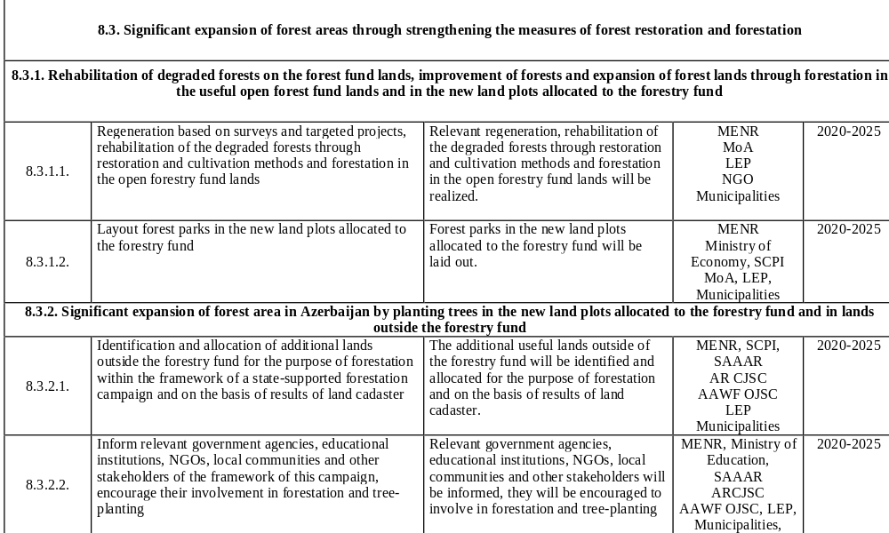

Country Forestry Profiles
Country | Challenges And Development Needs | Country Priorities | Reference Document
AZERBAIJAN | - Development of policy and legislation frameworks, strengthening institutional structures and capacities  - of forestry  - Strengthening public awareness and stakeholders’ participation for sustainable forest management .  - Strengthening inter-sectoral linkages of forestry  - Development of forest planning and monitoring  - Prevention of illegal logging and other destructive interventions, strengthening protection and  - conservation of forests  - Improvement of existing forests and expansion of forest areas  - Strengthening sustainable use and utilization of forests, with special focus on securing environmental and protective functions as well as for meeting needs and demands of the society and local communities for  - Social and economic services and benefits of the forests.  - Climate change adaptation  - Development of research and education | - Forest policy is well integrated with the national, regional and sectoral policies and is put high in the national development agenda.  - Given the first priority to preservation of ecological and protective functions of forests, sustainable  - management and use of forest resources is contributing to a better satisfaction of the needs of society at large and rural population in particular.  - Negative impacts on forests are reduced and forest resources and biodiversity are effectively protected and conserved.  - Forest areas and tree cover are significantly expanded through afforestation on suitable lands and restoration of degraded forest areas.  - Forests are managed in line with integrated multipurpose management plans, elaborated based on reliable information and modern methodologies for forest resource inventory, and assessment.  - People of Azerbaijan are aware of the benefits of forests and actively involved in sustainable forest management.  - Institutional capacity, financial mechanisms and regulatory (legal) framework for sustainable forest management are improved and strengthened.  - Enhanced forest education and research is providing essential backstopping to sustainable forest management.  - Climate change adaptation and mitigation concerns are integrated into forest management decisions and implementations. | National Forest Program (Forest Policy Statement And The Action Plan)  2015-2030
TAJIKISTAN | - Erosion and desertification,  - Lack of conservation  - Increasing use of water resources,  - Number of livestock  - Lack of legislation, methods and new directions of information  - Marketing and processing of forest products | - The purpose of the Program is to protect, reinstate, and recover, sustainable and effective use of forest resources  - Environmental protection and the establishment of a clean environment;  - Establishing additional jobs, providing citizens with work and reduction of the poverty rate especially in the mountainous regions;  - Development of legislation  - Combating erosion and in turn, yielding pastures;  - Creating forest protection zone  - Pest control  - Development and promotion of advanced methods of forest management;  - Development of action plans for forest pests  - Development of NWFP  - Ensuring forest protection from violations;  - Do not allow illegal hunting of animals in the land | National Forest Program 2015
KYRGYZSTAN | - Annual amount of timber received by the leshozes makes about 50 000 cubic meters. The harvested timber is processed locally in a traditional way and it is obvious that this amount cannot satisfy the needs of the country.  - Human pressure, considerably increased over the recent past, caused by illegal fellings and firewood cutting, and also uncontrolled cattle grazing, has inflicted substantial damages to the forests, as a result, the forest covered area has almost a 1\3 decrease, comparing to the 1930s.  - Forest legislation of the past decades which banned forest regeneration fellings in the forests, did not promote forestry development.  - Low interest in conservation of forest plantations, lack of creation of industrial plantations with fast growing species, insufficient nurseries development and planning, badly organized collection and processing of forest fruit and berries together with medicinal herbs, resulted in the restriction of forestry contribution in the economy of the country. | - Ensure protection of all the forests and biodiversity in the country  - Definition of technical norms for sustainable forest management  - Transfer of productive activities to the private sector  - Improve the system of collaborative forest management and leasing relations  - Rationalize forest service structure at territorial and national levels  - Implementation of economic reform of structural management units  - Improve the status of Forest Service personnel  - Improvement of forest research and education  - Improve efficiency of funding system for forestry sector  - Raise public awareness on forestry-related issues | Decree  Of The Government Of The Kyrgyz Republic  On approval of the Concept  Of forestry development in Kyrgyz Republic
UZBEKISTAN | - Land degradation  - Capacity building need for government agencies | - Improving the Government's capacity in forestry  - Rehabilitation of degraded land resources,  - Saving resource for land use practices and application of innovative approaches | FAO- Drafted Country Framework for 2018 to 2022
KAZAKHSTAN | - Salinity  - Lack of harmonization of legislation related to natural resources and coordination among institutions  - Lack of forest monitoring and assessment.  - Capacity development need for national and local authorities to use more effective mechanisms and promote cross-sectoral dialogue that enable them to prepare, respond, and recover from natural disasters such as drought.  - Capacity enhancement need for national institutions, natural resources managers for sustainable natural resources management  - Capacity need for climate-friendly water use and halting land degradation  - Need for development of a national forestry program  - Need for assessment and monitoring forest and tree resources, reforestation and watersheds. | - Assessment of land degradation and enhancing Sustainable Land Management (SLM) for increasing resilience of production systems to climate change  - Mapping land degradation as a support for planning SLM best practices  - Development of national forestry program (NFP) s  - Monitoring and assessment of forest  - Capacity building for biodiversity conservation  - Capacity development of Government staff  - Providing higher quality seedlings  - Improving policies, regulatory frameworks and public goods enhance inclusiveness and efficiency of food, agriculture and forestry systems | FAO- Drafted Country Framework for 2014-2017

Visits to Country Officials

During this scoping mission, the following officials and institutions will be visited;
- FAO
FAO Representative, Cakmak, Melek (FAOAZ) Melek.Cakmak@fao.org
Mehdiyev, Bariz (FAOAZ) Bariz.Mehdiyev@fao.org
- The Ministry of Ecology and Natural Resources of Azerbaijan http://www.eco.gov.az/ (http://www.gonder.org.tr/?p=2871)
FTFP focal point; Gulnare Mammadova, Ministry of Ecology and Natural Resources, Forest Development Department, gmgulnare@gmail.com , 0099455455344
Forestry Department http://www.eco.gov.az/az/nazirlik/tabeli-qurumlar/meselerin-inkisafi-departamenti
Reforestation Department http://www.eco.gov.az/az/nazirlik/tabeli-qurumlar/azerbaycan-yasillasdirma-ve-landsaft-qurulusu-aciq-sehmdar-cemiyyeti/rehberlik
- The Embassy of Turkey to Baku http://baku.emb.mfa.gov.tr/Mission
- TIKA Baku Coordination Office

Related Documents for Reading and Preparation
- Concept note on Restoration of Degraded Forests and Other Lands
- Work plan for Concept Note Restoration of Degraded Forests and Other Lands
- NFP Action Plan final version-in English
- NFP main final version in English

Turkey-Azerbaijan Relations on Forestry
This chapter provides information about the relationships between Turkey and Azerbaijan on forestry. This information is obtained from the General Directorate of Forestry as of 11 September 2019.
AZERBAYCAN BİLGİ NOTU
Azerbaycan Cumhuriyetinin 3. Cumhurbaşkanı merhum Haydar Aliyev’in anısına Ankara’nın Batıkent Semtinde Haydar Aliyev Parkı tesis edilmiş olup 2004 yılında Genel Müdürlüğümüz tarafından parkın hemen dışında bir hatıra ormanı kurulmuştur.

2004 tarihinde Ülkemiz ile Azerbaycan Cumhuriyeti Hükümeti arasında iklim değişikliği, orman yönetimi ve ağaçlandırma konularını kapsayan çevre koruma alanında bir işbirliği anlaşması imzalanmıştır.

26 Temmuz 2006 tarihinde Azerbaycan Çevre ve Doğal Kaynaklar Bakanı ve beraberindeki bir heyet, Bakanımızın daveti üzerine ülkemizi ziyaret etmiştir. Bu ziyaret esansında 2006-2007 yıllık çalışma programı hazırlanmıştır. İmzalanan söz konusu çalışma programı çerçevesinde Azerbaycan’dan beş kişilik bir heyet, ormanların korunması, orman ekosistemi ve orman yangınlarıyla mücadele çalışmalarını yerinde görmek ve teknik bilgi edinmek amacıyla ülkemize gelmiştir.

Ormanların korunması, orman ekosistemi ve orman yangınları ile mücadele tekniklerini ve çalışmalarını yerinde görmek ve incelemelerde bulunmak amacıyla 26-30 Mart 2007 tarihleri arasında Azerbaycan’dan bir heyet Türkiye’ye gelmiştir.

2011 yılında Türkiye-Azerbaycan Ormancılık İşbirliği Antlaşması imzalanmış ve 2014 yılında onaylanarak Resmi Gazete’de yayımlanmıştır (7.5.2014 tarih 29003 sayılı ).

Coğrafi Bilgi Sistemleri ve Uzaktan Algılama Teknikleri Kullanarak Ekosistem Tabanlı Fonksiyonel Amenajman Planlamada Kapasite Geliştirme” projesi kapsamında Azerbaycan ile ülkemizin ekosistem tabanlı fonksiyonel orman amenajman planı yapma konusundaki deneyimlerini paylaşmak üzere Genel Müdürlüğümüzden 3 yetkili 5-8 Mart 2013 tarihleri arasında Azerbaycan’a bir teknik inceleme gezisinde bulunmuşlardır.

Finansmanının FAO’nun sağladığı OGM tarafından Azerbaycan’da yürütülen “Ulusal Orman Programı ve Orman Kanununun Geliştirilmesinin Desteklenmesi” projesi kapsamında Azerbaycan’dan bir heyet 11-18 Ocak 2014 tarihleri arasında Ankara, Eskişehir, Bursa, İstanbul orman Bölge Müdürlükleri’ndeki orman fidanlıklarında incelemelerde bulunmuşlardır.

Azerbaycan’dan 6 kişilik bir heyet 02-08 Kasım 2014 tarihleri arasında ÇEM Genel Müdürlüğü’nün koordinasyonunda ülkemizi ziyaret etmiş ve Kastamonu Orman Bölge Müdürlüğünce yürütülen ormancılık faaliyetlerini incelemek üzere Kastamonu’ya gitmişlerdir.

11-15 Nisan 2016 tarihinde 5 kişilik Azeri heyete Antalya da orman yangınları yönetim sistemine ilişkin eğitim programı düzenlenmiştir.

2017 Mart ayında nakliyesi onlara ait olmak üzere Azerbaycan’a 8.657 adet çeşitli türlerde fidan hibe edilmiştir.

3-7 Temmuz 2017 tarihleri arasında 3 kişilik Azeri heyete Antalya’da orman yangın yönetim sistemi eğitimi verilmiştir.

Azerbaycan Orman Genel Müdürü ve beraberinde 2 kişi ile birlikte 3 kişilik heyet 16.05.2018 günü temaslarda bulunmak üzere Ankara’ya 3 günlük bir ziyaret gerçekleştirmiştir. İlk olarak Orman Genel Müdürümüz Sayın Bekir Karacabey’i ziyaret etmişlerdir. 3 günlük süre zarfında özellikle Azerbaycan ormanlarının planlanması konusunda işbirliği konusunda görüşmeler yapılmış, yol haritası belirlenmiş, yapılacak işler için zaman çizelgesi oluşturulmuştur.

Azerbaycan ormancılık kuruluşlarının yeniden yapılandırılması projesi kapsamında 11-12 Temmuz 2018 tarihlerinde Bakü’de gerçekleştirilen toplantıya ülkemiz tecrübelerinin aktarılması maksadıyla 4 kişilik bir heyet ile katılım sağlanmıştır.

Azerbaycan Ekoloji ve Tabi kaynaklar Bakanlığının daveti doğrultusunda Azerbaycan ormanlarının orman amenajman planlarının yapımı hakkında arazide ve büroda incelemelerde bulunmak üzere 9-13 Temmuz 2018 tarihlerinde 4 kişilik bir heyet ile Azerbaycan'a ziyaret gerçekleştirilmiştir.

Azerbaycan’dan gelen 10 kişilik heyete 27.08-07.09/2018 tarihleri arası Bolu’da Bilgi Sistemleri Dairesi Uzmanları tarafından Foto yorumlama, CBS ve Mikrosoft-Access konularında; Orman İdaresi ve Planlama Dairesi Uzmanları tarafından da Envanter, Planlama ve veri girişi konusunda eğitim verilmiştir.

Bu ziyaretin ardından "Azerbaycan Sürdürülebilir Orman Yönetim Projesi" kapsamında FAO Azerbaycan Ofisi işbirliği ile Azerbaycan Cumhuriyeti Ekoloji ve Tabii Kaynaklar Bakanlığından 10 uzmana 27 Ağustos 2018- 7 Eylül 2018 tarihleri arasında Bolu’da “orman amenajman plan yapımı, coğrafi bilgi sistemleri ve hava fotoğrafı yorumlama” konularında eğitim verilmiştir.

Genel Müdürlüğümüz ile Azerbaycan Orman Genel Müdürlüğü arasında Oax ve Ağdaş bölgelerinde pilot olarak yapılacak orman amenajman planlarına yönelik 19.09.2018 tarihinde işbirliği protokolü imzalanmıştır.

Foto yorumlama, meşçere taslak haritası yapımı, amenajman planı yapım programı ve CBS ile ilgili olarak 1-5 Ekim 2018 tarihleri arasında 5 kişilik bir heyet Azerbaycan'a görevlendirilmiştir.

Bolu eğitimi sonrası Oax ve Ağdaş bölgelerinde olmak üzere Türk uzmanlarca ülkemizin deneyimlerinin aktarılması maksadıyla 1 Ekim-27 Kasım 2018 tarihleri arasında ekosistem tabanlı fonksiyonel orman amenajman planı yapılması maksadıyla arazi çalışması gerçekleştirilmiştir. Yapılan bu işler FAO projesi olan "Azerbaycan Güçlendirilmiş Orman Politikası ve Bilgi Çerçevesi Kapsamında Orman Kaynaklarının Değerlendirilmesi ve İzlenmesi" (GCP/AZ/007/GFF) çerçevesinde finanse edilmektedir.

1-5 Nisan 2019 tarihleri arasında Azerbaycan'dan 4 kişiden oluşan bir heyet fidanlıklar hakkında yerinde tespit ve inceleme yapmak üzere Genel Müdürlüğümüzü ziyaret etmiştir.
2-6 Nisan tarihleri arasında Orman İdaresi ve Planlama Dairesi Başkanlığı'ndan bir uzman Bakü'de Amenajman Planı Yapımı konusunda bir eğitim vermiştir.

28.07-03.08.2019 tarihleri arasında, Orman İdaresi ve Planlama Dairesi Başkanlığı uzmanlarından oluşan 3 kişilik bir heyet, ormancılık yönetimi konusunda önerilerde bulunmak ve FAO desteğiyle yapılan mevcut pilot yönetim planı hazırlıklarına ilişkin istişarelerde bulunmak amacıyla Azerbaycan'a teknik ziyarette bulunmuşlardır.

Dağlık Havzaların Yönetimi GCP/SEC/002/TUR Projesi Görev Raporu-2014

İçindekiler

1. Proje Hakkında Kısa Bilgi 3
Ziyaret Planı ve Yapılan Görüşmeler 3
22 Temmuz 2014 Salı 3
23 Temmuz 2014 Çarşamba 4
24 Temmuz 2014 Perşembe 5
2. Azerbaycan-Türkiye Ormancılık İlişkileri 5
3. Bundan Sonra Yapılabilecekler-Öneriler 8
Azerbaycan Ulusal Orman Programı Kapsamında Yapılabilecek Projeler 8
FAO Orta Asya Alt Bölge Ofisi (FAOSEC ) Kapsamında Yapılabilecek Projeler 8
Haydar Aliyev Kent Parkı 9
Türk Dünyası Orman Bakanları Kongresi 9
Ortak Kurumsal Eğitimler 10
Fakültelerde Ortak Eğitimler 10

Proje Hakkında Kısa Bilgi
“Orta Asya ve Kafkaslardaki Dağlık Havzaların Sürdürülebilir Yönetimi için Kapasite Geliştirme Projesi- GCP/SEC/002/TUR”; FAO Orta Asya Alt Bölge Ofisi (FAOSEC) tarafından yürütülen projelerden birisidir. Bu Proje TİKA ve Türkiye Cumhuriyeti Orman ve Su İşleri Bakanlığı tarafından desteklenmekte olup, FAOSEC Ofisi de Ankara’da kurulu durumdadır. Proje 2012-2014 yılları arasında uygulanmaktadır. Projenin gayesi; Dağlık havza uygulamaları, rehabilitasyonu ve sürdürülebilir yönetimine yönelik katılımcı ve entegre yaklaşımlar konusunda kamu oyunun, politikacıların ve karar vericilerin farkındalıklarının arttırılması ile ormancılık ve diğer ilgili kuruluşların bilgi ve deneyimlerinin güçlendirilmesidir.

Ziyaret Planı ve Yapılan Görüşmeler

22 Temmuz 2014 Salı
Ziyaret kapsamında ilk olarak 22 Temmuz 2014 tarihinde Azərbaycan Respublikası Ekologiya və Təbii Sərvətlər Naziri Sayın Hüseynqulu Bağırov ile görüşülmüş, seyahat planı arz edilmiştir.
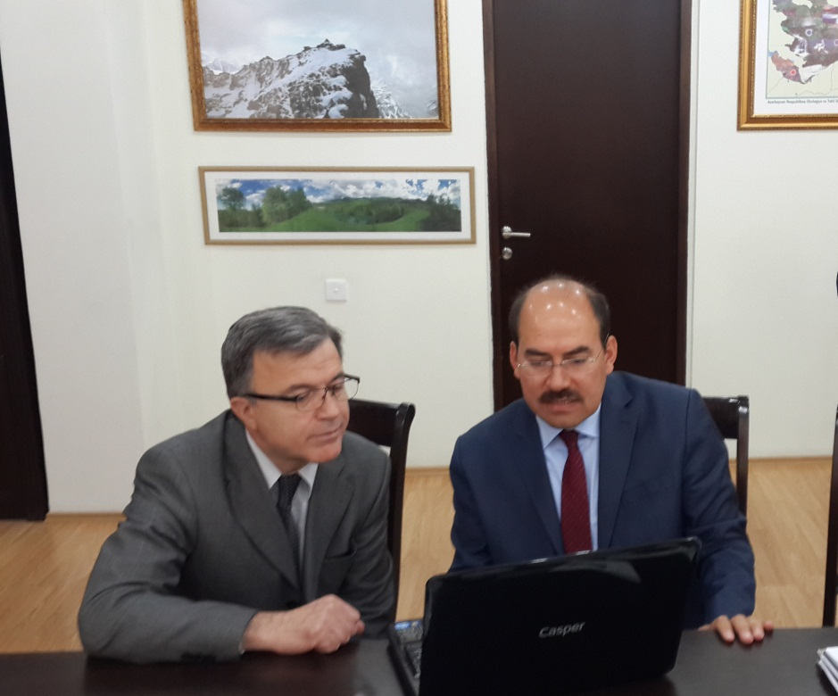
Bunu takiben Shakir Ismayilov, Aytan Yusifova, Sadig Salmanov ve Rahim İbrahimov ile görüşmeler yapılmıştır. Ardından FAO Azerbaycan Ofisi ziyaret edilmiş ve ilgililerle görüşülmüştür.

23 Temmuz 2014 Çarşamba
Sayın Bakanın talimatları çerçevesinde 23 Temmuz 2014 Çarşamba günü arazi incelemeleri gerçekleştirilmiştir. Bu kapsamda;
- Azərbaycan Yaşıllaşdırma və Landşaft Quruluşu” Açıq Səhmdar Cəmiyyəti 6 saylı Yaşıllaşdırma İdarəsi,
- Gilazi Regional Meşe Salma Müesiesi
- Xızı Rayonu Altıağaç Milli Parkı
- Quba Regional Meşe Tingiligi Müesiesi
- Şahdağ Milli Parkı
- Quba Regional Meşe Müseiesi (Quba Orman Bölge Müdürlüğü) ziyaret edilmiştir.

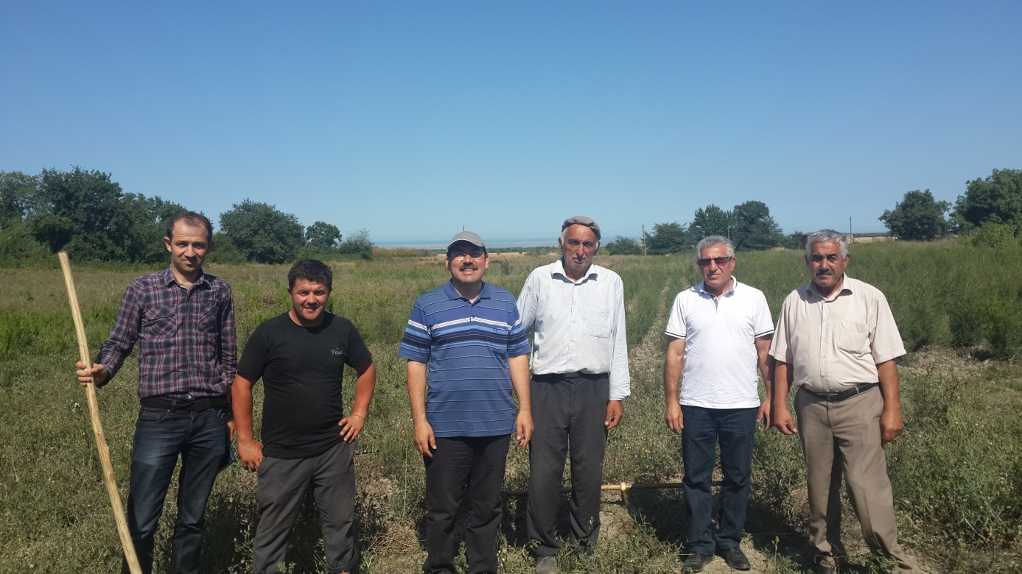

24 Temmuz 2014 Perşembe
Bakanlık’ta yapılan değerlendirme toplantısını takiben saat 14:00’de TİKA Bakü Ofisi, saat 16:00’da ise Türkiye Cumhuriyeti Baku Büyükelçiliği Ziyaret edilecek ve Büyükelçi Sayın Apler Coşkun ile görüşülecektir.

Azerbaycan-Türkiye Ormancılık İlişkileri
Bu bölümde daha çok Azerbaycan-Türkiye Ormancılık ilişkilerine kısaca değinilmiş ve gelişmelere dayalı olarak “kişisel görüşlerim” aktarılmıştır.

Türkiye-Azerbaycan Diplomatik ilişkileri 1992 yılında, ormancılıkla ilişkili faaliyetler ise 1998 yılında başlamıştır. 1998 yılında 6 Azerbaycanlı Orman Mühendisi Bolu’da “orman amenajman planı” eğitimine katılmışlardır.

15 Nisan 2004 tarihinde; Bakanlığımız tarafından Atatürk Orman Çiftliğinde tesis edilen “Haydar Aliyev Şehir Ormanı” Azerbaycan Cumhurbaşkanı İlham Aliyev ve Eşinin teşrif ettiği bir törenle açılmıştır. Bu alan bilahare tamamen Azerbaycan Hükümetine devredilmiş ve “Haydar Aliyev Parkı” halini almıştır.

9 Temmuz 2004 tarihinde Bakü’de “çevre koruma alanında” işbirliği anlaşması imzalanmış, ormancılıkla ilgili hususlar da bu anlaşma içinde yer almıştır. Bu vesile ile Türkiye Cumhuriyeti Çevre ve Orman Bakanı Sayın Osman Pepe Bakü’yü ziyaret etmiştir.

26 Temmuz 2006 tarihinde Azerbaycan Ekoloji ve Doğal Kaynaklar Bakanı Hüseyngulu BAGIROV ve beraberindeki bir heyet, Çevre ve Orman Bakanı Osman Pepe’nin daveti üzerine ülkemizi ziyaret etmiştir.

25 Ekim 2011 tarihinde "Türkiye Cumhuriyeti Hükümeti İle Azerbaycan Cumhuriyeti Hükümeti Arasında Ormancılık Alanında İşbirliğine İlişkin Mutabakat Zaptı" imzalanmıştır.

10-13 Nisan 2013 tarihleri arasında Orman ve Su İşleri Bakanı Prof. Dr. Veysel EROĞLU, Azerbaycan’da düzenlenen “Uluslararası Hazar Su Teknolojileri Konferansı”na iştirak etmiştir.

4-5 Haziran 2014 tarihlerinde Türk Dili Konuşan Ülkeler İşbirliği Konseyi IV. Zirvesi Türkiye’de yapılmış olup Türkiye Cumhuriyeti Cumhurbaşkanı Abdullah Gül’ün evsahipliğinde Bodrum’da düzenlenen Zirve’ye Türk Konseyi üyeleri Azerbaycan, Kazakistan ve Kırgızistan Cumhurbaşkanlarının yanısıra Cumhurbaşkanı Gül’ün davetlisi olarak Türkmenistan Devlet Başkanı Berdimuhamedov da katılmıştır.

11 Temmuz 2014 tarihide Türkiye-Azerbaycan Hükümetler arası Karma Ekonomik Komisyonu (KEK) VII. Dönem Toplantısı gerçekleştirilmiş olup, ormancılıkla ilgili gelişmeler bu komisyon raporunda yer almıştır.

Bu ikili işbirliğine ilaveten Türkiye; Azerbaycan, Özbekistan, Türkmenistan, Kazakistan, Kırgızistan ve Tacikistan’ ın yer aldığı “FAO Orta Asya Bölge Ofisine” ev sahipliği yapmaktadır. Bununla ilgili işbirliği anlaşması ve Bakanlar Kurulu 16 Şubat 2009 tarihli Resmi Gazete’de yayımlanmıştır.

4 Haziran 2014 tarihinde FAO-Türkiye Ormancılık Ortaklık Program Anlaşması imzalanmıştır. Anlaşma kapsamında Türkiye Cumhuriyeti Orman ve Su İşleri Bakanlığınca, FAO'ya ilk 5 yıllık dönemde toplam 10 milyon dolar katkıda bulunulacak olup bu sayede Azerbaycan, Kazakistan, Kırgızistan, Özbekistan, Tacikistan, Türkiye ve Türkmenistan’dan oluşan FAO Orta Asya Alt-Bölge Ofisinin kapsadığı ülkelerde ikili ve çok taraflı projeler desteklenecektir.

Türkiye-FAO işbirliği kapsamında başlatılan “Orta Asya ve Kafkaslardaki Dağlık Havzaların Sürdürülebilir Yönetimi için Kapasite Geliştirme Projesi”; Azerbaycan, Türkiye, Özbekistan, Kırgızistan ve Tacikistan arasında uygulanmaktadır. 709.775 Dolar bütçesi olan bu proje kapsamında TİKA ve FAO ile birlikte üç uluslararası eğitim yapılmıştır. Bu proje ÇEM Genel Müdürlüğü tarafından koordine edilmektedir. Bu görev bu proje kapsamında gerçekleştirilmekte olup, ilerleyen bölümlerde tekrar değinilecektir.

FAOSEC çerçevesinde geliştirilen diğer bir proje; Azerbaycan, Türkmenistan, Kırgızistan ve Kazakistan’a yönelik “Coğrafi Bilgi Sistemi ve Uzaktan Algılama Teknikleri Kullanarak Ekosistem Tabanlı Fonksiyonel Orman Amenajman Planı Yapımında Kapasite Geliştirme Projesi” dir. Orman Genel Müdürlüğü Orman İdaresi ve Planlama Dairesi Başkanlığınca koordine edilen bu proje TİKA’ nın desteği ile uygulanmakta olup karşılıklı ziyaretler gerçekleştirilmiştir.

Bunlara ilaveten doğrudan Türkiye tarafından olmamakla birlikte, Türkiyeli Uzmanlarca desteklenen projeler bulunmaktadır.

Bunlar;
- Şahdağ Milli Parkının kurulması ve Ordubad Milli Parkının Genişletilmesi Projesi. 2008-2011 yıllarında uygulanan Proje Dünya Bankası ile Azerbayan Ekoloji ve Doğal Kaynaklar Bakanlığı tarafından takip edilmiştir. www.ekodenge.com
- 2013 yılında FAO tarafından yürütülen “Azerbaycan Ulusal Orman Programı ve Eylem Planı”nda Türkiyeli uzmanlar görev almıştır. http://www.fao.org/forestry/82979/en/ Bu Program ve Eylem Planı tüm sektörü kapsayan bir çalışma olmuştur.

Bundan Sonra Yapılabilecekler-Öneriler

Azerbaycan Ulusal Orman Programı Kapsamında Yapılabilecek Projeler
- FAO tarafından hazırlanan Azerbaycan Ulusal Orman Programının resmi kabulü tamamlanıp burada dile getirilen projeler hayata geçirilebilir. 22 Temmuz 2014 tarihinde Bakanlık ve FAO Azerbaycan Ofisinde yapılan görüşmelerde bu programın FAO tarafından Bakanlığa iletilmediği tespiti yapılmıştır.
- Bakanlık tarafından uygun görülmesi halinde FAO’dan resmi olarak istenip onaylanması için iç prosedürler başlatılabilir diye düşünülmektedir.
- Öneri:
  - Bu program kapsamında önerilen projelerden, Sayın Bakanın da uygun görüp üzerinde çalışılmasını talimatladığı “Quba Regional Meşe Tingiligi Müesiesi” nin rehabilitasyonu için bir proje teklifi hazırlanabilir. Burası için öncelikle projenin hazırlanması, ardından hazırlanan bu projenin uygulanması gerekmektedir. Proje hazırlığı için Türkiye-FAO Ormancılık Anlaşması kapsamında FAOSEC ile işbirliği yapılabileceği düşünülmektedir. Hazırlanan bu projenin uygulanması için Azerbaycan Hükümeti, Asya Kalkınma Bankası, GEF, İslam İşbirliği Teşkilatı gibi kurumlardan destek bulunabilir. Bu saha 23 Temmuz 2014 tarihinde ziyaret edilmiştir.

FAO Orta Asya Alt Bölge Ofisi (FAOSEC ) Kapsamında Yapılabilecek Projeler
- FAO ile daha önce yapılan anlaşma ağırlıklı olarak Tarım konularına yoğunlaşmıştı. 4 Haziran 2014 tarihinde FAO-Türkiye Ormancılık Ortaklık Program Anlaşması imzalanmıştır. Anlaşma kapsamında Türkiye Cumhuriyeti Orman ve Su İşleri Bakanlığınca, FAO'ya ilk 5 yıllık dönemde toplam 10 milyon dolar katkıda bulunulacak olup bu sayede Azerbaycan, Kazakistan, Kırgızistan, Özbekistan, Tacikistan, Türkiye ve Türkmenistan’dan oluşan FAO Orta Asya Alt-Bölge Ofisinin kapsadığı ülkelerde ikili ve çok taraflı projeler desteklenecektir.
- Öneri:
  - Halen yürütülmekte olan “Orta Asya ve Kafkaslardaki Dağlık Havzaların Sürdürülebilir Yönetimi için Kapasite Geliştirme Projesi” nin ana hedeflerinden birisi “entegre havza yönetimi” konusunda politika geliştirmektir. Türkiye Cumhuriyeti Orman ve Su İşleri Bakanlığı koordinasyonunda hazırlanıp, 4 Temmuz 2014 tarihli Resmi Gazetede yayımlanan “Yüksek Planlama Kurulu” kararı ile yürürlüğe giren “Türkiye Ulusal Havza Yönetim Stratejisi (2014-2023)” benzeri bir çalışma Azerbaycan tarafınca da yapılabilir. Bunun için FAOSEC’ le işbirliği yürütülebilir.

Haydar Aliyev Kent Parkı
- 2004 yılında zamanın Çevre ve Orman Bakanlığının girişimi ile Ankara’da Atatürk Orman Çifliğinde kurulan “Haydar Aliyev Parkı” nın benzeri aynı şartlarda Bakü’de tesis edilebilir. Bu park Türkiye Cumhuriyeti Çevre ve Orman Bakanlığı tarafından başlatılmış, ilk fidan dikimine Azerbaycan Cumhurbaşkanı İlham Aliyev’ de teşrif etmiştir. Bilahare saha Azerbaycan Hükümetine devredilmiş ve Azerbaycan tarafından burada büyük bir kompleks oluşturulmuştur.

Türk Dünyası Orman Bakanları Kongresi
- Azerbaycan ve Türkiye’ nin kurucu üyeleri olduğu ve Cumhurbaşkanları seviyesinde takip edilen Türk Dili Konuşan Ülkeler İşbirliği Konseyi işbirliği için son derece uygun bir platform olarak değerlendirilmektedir.
- 4-5 Haziran 2014 tarihlerinde Türk Dili Konuşan Ülkeler İşbirliği Konseyi IV. Zirvesi Türkiye’de yapılmış olup Türkiye Cumhuriyeti Cumhurbaşkanı Abdullah Gül’ün evsahipliğinde Bodrum’da düzenlenen Zirve’ye Türk Konseyi üyeleri Azerbaycan, Kazakistan ve Kırgızistan Cumhurbaşkanlarının yanısıra Cumhurbaşkanı Gül’ün davetlisi olarak Türkmenistan Devlet Başkanı Berdimuhamedov da katılmıştır.
- Bu seneki toplantının gündemi “Turizm” olarak belirlenmiş olup, bir dahaki Zirvenin “orman teması” ile toplanması için Azerbaycan tarafı liderlik üstlenebilir. Bunun için FAOSEC ve TİKA ile işbirliği yapılabilir. FAOSEC Ülkelerinin büyük bölümü aynı zamanda Türk Konseyine de üye durumdadır.

Ortak Kurumsal Eğitimler
- Türkiye ve Azerbaycan’da yapılan “mesleki eğitimler” ortak düzenlenebilir. Türkiyeli ormancılar Azerbaycan’ daki hizmet içi eğitimlere, Azeri meslektaşlarımız ise Türkiye’ de yapılan hizmetiçi eğitimlere rahatlıkla katılım sağlayabilir. Bu husus zaten ikili anlaşmalarda ve Karma Ekonomik Komisyonu Mutabakat Zabıtlarında yer almış durumdadır.

Fakültelerde Ortak Eğitimler
- Türkiye’de bulunan toplam 12 adet Orman Fakültesine daha fazla Azeri Öğrenci katılabilir. Bu konuda İstanbul Üniversitesi Orman Fakültesi öncülük yapabilir. Bu konuda Türkiye Burslarından istifade edilebilir. http://www.turkiyeburslari.gov.tr/
- Uygun görülmesi halinde, halen başkanlığını yürüttüğüm “Geleceği Önemseyenler Derneği www.gonder.org.tr ” olarak bu konuda rol almaya hazır olduğumu ifade etmek isterim.

Biz gerçekten “bir Millet, iki Devletiz”. Birlikte güçlüyüz!
Şahsım adına bir damla da olsa katkı vermekten onur duyacağımı tekrar arz ederek Saygılarımın kabulünü dilerim.

http://www.fao.org/europe/sec/sec/en/
http://www.eco.gov.az/azeryasland-melumat.php
http://www.baku.be.mfa.gov.tr/
http://www.gonder.org.tr/wp-content/uploads/2014/03/2004-Haydar-Aliyev-Basın-Bülteni-13-Nisan-2004.pdf
http://haydaraliyevparki.com/
http://www.cem.gov.tr/erozyon/AnaSayfa/faaliyetlerimiz/dis_iliskiler/ikili_isbirligi/asya/orta_asya_kafkaslar.aspx?sflang=tr
http://www.mfa.gov.tr/turk-dili-konusan-ulkeler-isbirligi-konseyi-iv_-zirvesi-bodrum_da-gerceklestirildi.tr.mfa
http://www.ormansu.gov.tr/osb/haberduyuru/guncelhaber/14-06-05/%E2%80%9CFAO-T%C3%BCrkiye_Ormanc%C4%B1l%C4%B1k_Ortakl%C4%B1k_Program_Anla%C5%9Fmas%C4%B1%E2%80%9D_%C4%B0mzaland%C4%B1%E2%80%A6.aspx?sflang=tr
https://www.devex.com/projects/tenders/rural-environment-project-in-azerbaijan-design-and-supervision-of-park-infrastructure-for-ordubad-national-park/27858
http://www.ormansu.gov.tr/osb/haberduyuru/guncelhaber/14-06-05/%E2%80%9CFAO-T%C3%BCrkiye_Ormanc%C4%B1l%C4%B1k_Ortakl%C4%B1k_Program_Anla%C5%9Fmas%C4%B1%E2%80%9D_%C4%B0mzaland%C4%B1%E2%80%A6.aspx?sflang=tr
http://www.resmigazete.gov.tr/main.aspx?home=http://www.resmigazete.gov.tr/eskiler/2014/07/20140704.htm&main=http://www.resmigazete.gov.tr/eskiler/2014/07/20140704.htm
http://www.mfa.gov.tr/turk-dili-konusan-ulkeler-isbirligi-konseyi-iv_-zirvesi-bodrum_da-gerceklestirildi.tr.mfa

