FAO Stabdardına Göre Hazırlanacak

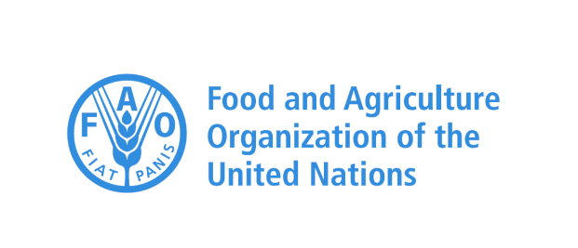

Provision of Technical Guidelines on sustainable management of NWFPs and the Status Reports on specific selected products

MID-TERM PROGRESS REPORT

Service Provider/Partner | Chamber of Forest Engineers (CFE/OMO)
The Agreement Reference Number | 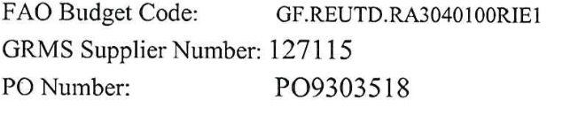
The Effective Date of Agreement | 20 December 2019
The End Date of Agreement | 31 December 2020
Reporting Period | 20 December 2019-7 December 2020
Date of Report | 8 December 2020
Responsible Personnel | İsmail Belen-Coordinator

- Progress in project activities in the reporting period
Project activities reflected in the Letter of Agreement are as follow:
- Identify, select and showcase Non-Wood Forest Products (NWFPs) that have economic impact on rural and national economies and environmental importance in the sense of biodiversity-
  - D1- NWFPs Assessment Report- Cleared by FAO.
- Review the existing national policies and action plans related to specific NWFPs in Turkey and provide recommendations to strengthen governance.
  - D2-NWFPs Policy Report- Cleared by FAO
- Analyse and map out the selected NWFPs taking into account the potential impact on rural workforce, in particular women and youth.
  - D3- Detailed Analyses of Selected NWFPs- Five Reports for i) Chestnut, ii) Pine Honey, iii) Resin, iv) Truffle, v) Bay Leaf- Submitted to FAO
- Conduct consultation meetings on the findings of the review with relevant stakeholders (local, national and private) to enhance their inputs.
  - D4- Deliverable 4: Photo Report About the Events Including a Brief Summary and List of Participants- Submitted to FAO
- Prepare guidelines on sustainable management, production and marketing of NWFPs in line with international standards and market requirements.
  - D5-Guidelines- Will be prepared
- Prepare Status Update Reports on the selected NWFPs along with recommendation in the value chain.
  - D6-Status Update Reports- Will be prepared
- Consolidate the findings with other ongoing projects in REU or Mediterranean Region.
  - D7- Done as part of D4, and independently
- Prepare a final report of the agreed tasks (including a financial report)
  - D8-Final Report-Will be prepared
- Difficulties/ Challenges
- COVID-19 has seriously affected studies. That's why two extensions were made. According to the first agreement, the delivery time of the work ended on 30 July 2020. With the first change, this period was extended until 30 November 2020, and with the second change until 31 December 2020.
- However, all technical requirements were met.
- Identified risks for the next reporting period and support needed from FAO
- No risk is anticipated.
- Partnership and collaboration progress
- We work in close cooperation with GDF and other relevant institutions and non-governmental organizations.

- Visibility and publicity
No special work has been done for this. However, the visits, meetings and interviews were posted on the relevant web pages.
- Work plan
No changes were foreseen in the previously shared work plan.
- Other issues
+++

ANNEXES
- D1- NWFPs Assessment Report- Cleared by FAO.
- D2-NWFPs Policy Report- Cleared by FAO
- D3- Detailed Analyses of Selected NWFPs- Five Reports for i) Chestnut, ii) Pine Honey, iii) Resin, iv) Truffle, v) Bay Leaf- Submitted to FAO
- D4/D7- Deliverable 4/7: Photo Report About the Events Including a Brief Summary and List of Participants- Submitted to FAO
- Mid-Term Financial Report

