

Status Update Reports on the Selected NWFPs Along With Recommendations in the Value Chain

13 Mayıs 2021

Contents
List of Acronyms 4
Introduction 5
1. Process related to LoA 6
2. Value chain 7
2.1. Conceptual description of value chain 7
2.2. Examples of studies on value chain 8
2.2.1. Examples of studies conducted by FAO 8
2.2.2. INCREDIBLE Project conducted with the support of the European Commission 8
2.2.3. Turkey's legislation and studies conducted to date 8
2.2.4. Overall assessment of stakeholders in Turkey in the value chain of NWFPs 9
3. Assessment of Value Chains of Selected NWFPs 10
3.1. Pine honey 10
3.2. Bay Leaf 13
3.3. Chestnut 15
3.4. Resin 19
3.5. Truffle Mushrooms 21
4. Recommendations 23
References 25

Figures
Figure 1. Public institutes of Turkey dealing with NWFPs 10
Figure 2 Resin value chain (EC, 2018) 19
Figure 3. Truffle value chain (EC, 2018) 22

Pictures
Picture 1. Marchalina hellenica insects on red pine trees (Photo: Y. Yanmadık) 10
Picture 2. Bay leaves and oil (Photo I. Belen) 13
Picture 3. Bay leaf harvesting area (Photo İ. Belen) 14
Picture 4. A scale used to measure bay leaves (Photo I. Belen) 14
Picture 5. A handmade soap with laurel olive (Photo: İ. Belen) 15
Picture 6. Chestnut fruits almost ready to be harvested 16
Picture 7. Distance between areas where chestnut harvesting and processing 17
Picture 8. Candied chestnut (Photo: İ. Belen) 17
Picture 9. Chestnut honey (Photo: İ. Belen) 18
Picture 10. A resin collecting training program (Photo: OMO) 20
Picture 11. Truffle (Source: http://trufder.org/) 21

List of Acronyms

Communiqué of NWFPs Communiqué on Inventory and Planning of NWFPs and Production and Sales Principles
DNWPS Department of Non-Wood Products and Services of GDF
FAO Food and Agriculture Organization of the United Nations
FV Forest Villagers
GDARP General Directorate of Agricultural Research and Policies
GDF General Directorate of Forestry of Turkey
GDFC General Directorate of Food and Control
GDL General Directorate of Livestock
GDPP General Directorate of Plant Production
INCREDIBLE Innovation Networks of Cork, Resins and Edibles in the Mediterranean Basin
ISO International Organization for Standardization
LoA Letter of Agreement
MH Marchalina hellenica
MoAF Ministry of Agriculture and Forestry of Turkey
NGO Non-Governmental Organization
NWFP Non-Wood Forest Product
OG Official Gazette of Turkey
OMO Chamber of Forest Engineers of Turkey
PDoAF Provincial Directorate of Agriculture and Forestry
TAB Turkish Association of Beekeepers
TSE Turkish Standard Institutions
TURKSTAT Turkish Statistical Institute

Introduction
This report titled as "Status Update Reports on the Selected NWFPs along with Recommendations in the Value Chain”" has been prepared by the Chamber of Forest Engineers of Turkey (OMO) within the scope of the Letter of Agreement (LoA) namely “Provision of Technical Guidelines on Sustainable Management of Non-Wood Forest Products (NWFPs) and the Status Reports on Specific Selected Products” signed with the Food and Agriculture Organization of the United Nations (FAO) on December 20, 2019.
In line of this LoA, firstly “NWFPs Assessment Report" followed by the "NWFPs Policy Report” were prepared. Then detailed reports were prepared for pine honey, bay leaf, chestnut, resin and truffle mushroom. After that "Technical Guidelines of NWFP" were prepared in which the information and findings obtained were appropriately included. Preparation of these reports included examination and interviews conducted in the field, update meeting and a national workshop attended by all partners including universities, non-governmental organizations (NGOs), producers, mukhtars, and public institutions, specifically with the General Directorate of Forestry (GDF) of the Ministry of Agriculture and Forest (MoAF).
"Status Update Reports on the Selected NWFPs Along with Recommendations in the Value Chain" was prepared in close cooperation with Prof. Dr. Sezgin AYAN, from Kastamonu University Forestry Faculty of Turkey. This report gives information about the value chains of pine honey, bay leaf, chestnut, resin and truffle mushroom and also shortly summarizes the activities carried out since the beginning of LoA.

Process related to LoA
The LoA signed by Mr. Vladimir Rakhmanin, FAO Regional Representative for Europe and Central Asia, and Mr. Hasan Türkyılmaz, the President, on behalf of OMO, entered into force on 20 December 2019 and was completed as of 31 December 2020.
A team consist of Hasan Türkyılmaz, Özgür Balcı, Mesut Güler, Prof. Dr. Hüseyin Fakir, and İsmail Belen (the Coordinator) took part on behalf of OMO. From FAO side Dr. Shiroma Sathyapala as the responsible officer and Horvath Kitti as forestry specialist supported the work.
In Turkey, all the forests are managed by GDF on behalf of the State. In this context, a working group consisting of the following experts was established in the Department of NWPs and Services (DNWPS).
- Galip Çağtay Tufanoğlu, Deputy Head of Department,
- Zafer Filiz, Division Director of Plant Production,
- Dr. Özlem Dostbil, Agricultural Engineer
- Tarık Durmuş, Forest Engineer (Msc.)
At the end, the following deliverables submitted to FAO.
- NWFPs Assessment Report of Turkey.
- NWFP Policy Report of Turkey
- Detailed Analyses of Selected NWFPs
- Pine honey
- Bay leaf
- Chestnut
- Resin
- Truffle mushroom
- Photo Report About the Events Including a Brief Summary and List of Participants
- Consultation Meetings in three different regions- 5-20 September 2020
- Update Meeting with responsible national institutions- 1 October 2020
- Consultation Workshop- Organized virtually- 21 October 2020
- Technical Guidelines
- Status update reports in selected NWFPs with recommendations in the value chain
- Final Report with Financial Report and Expenditure Documents

Value chain

Conceptual description of value chain
Throughout history, agricultural products or NWFPs had been produced, collected and used by people locally. Growing population and agricultural advances let people to be able to produce more product and also store and transport them. After many years of development in the agrarian production sector, a great chain has been established that distributes the products to places that people do not have to grow or collect. This established chain is a closely related network that one activity change affects the other steps of the chain, and this is system is simply called “value chain”

According to academic sources, the value chain describes the full range of activities that are required to bring a product or service from conception, through the different phases of production (involving a combination of physical transformation and the input of various producer services), delivery to final consumers, and final disposal after use. (PORTER, 1985)
In addition to academic terminology, similar definitions used by FAO are also examined. The publication named “Developing sustainable food value chains: Guiding principles” defines the sustainable food value chain as “the full range of farms and firms and their successive coordinated value-adding activities that produce particular raw agricultural materials and transform them into particular food products that are sold to final consumers and disposed of after use, in a manner that is profitable throughout, has broad-based benefits for society, and does not permanently deplete natural resources”(FAO, 2014).
The term “all farms and firms" refers to both the value chain actors who directly own the product and the various commercial service providers (banks, producers, wholesalers, transporters, etc.).
Chestnut could be used as an example to understand the value chain concept more easily. In Turkey chestnut is harvested both from state-owned chestnut forests and chestnut orchards belonging to private individuals. In these cases, the chestnut value chain starts with GDF, which is responsible for managing state-owned forests, or the farmers who are the owner of the orchards.
On the other hand, natural (climate, precipitation, temperature, etc.) and human-induced factors (infrastructure, transportation, facilities, etc.) affecting the forests or orchards could be considered a part of the value chain.
The term “value-added actions” covers different meanings. For example, transforming a chestnut fruit into "chestnut sugar" is an added value action. Similarly, ensuring that the product is stored in a suitable place/store and offering it to the market when the supply decreases/demand increases is another value-added action (value increasing over time). Likewise transporting the product to the places where it is not found, although there is no change in its form, is still an added value action (value increase over space). (FAO, 2014)
A "value chain" consisting of interconnected processes can be handled in four sections as follows: production/harvesting, aggregation, processing and distribution.
Production refers to producing or harvest/collect of any product in raw form. Chestnut is harvested in Turkey either from state-owned forests or from private orchards by forest villagers (FV), owners of the orchards or workers hired by the farmers.
Aggregation is the gathering/transporting of products produced/harvested in different places and by different people to a place where the products constitute an economic value. In terms of NWFPs, "aggregation" becomes more important.
The consumption and sale of non-wood forest products where they are harvested is generally low. If we take a village as an example, most of the households in the village harvest the same crop at the same periods. Therefore, the same product can be found in everyone's home and there is no need to buy it. Continuing with the chestnut example; 15-20 kg of chestnut fruit can be harvested from a single tree by a forest village household, which alone does not have a country-wide economic contribution. Chestnuts collected need to be brought together and ready to be transported to markets and processing industry. Distribution and processing are important especially as “value-added actions”. As explained in more detail in the relevant sections, in the village of Yaylapınar, Nazilli district of Aydın province, 1 kg chestnut fruit was sold for about 2 USD in November, 2020. Approximately 3 months later (on 19 February 2021), it was seen that a 1 kg chestnut was put up for sale in a market in Ankara at a price of 5 USD without any processing (added value over time and place). On the other hand, it was determined that 1 kg of "chestnut sugar" was put up for sale for 47 USD at the same market (added value over-processing). (BELEN, 2020)

Examples of studies on value chain

Examples of studies conducted by FAO
There are various publications prepared by FAO on the value chains of NWFPs. A few of these are listed below:
- Potentials of NWFPs for Value Chain Development, Value Addition and Development of NWFP-Based Rural Microenterprises in Sudan (FAO, 2016a)
- Potentials of NWFPs For Value Chain Development, Value Addition and Development Of NWFP-Based Rural Micro Enterprises: Tunisia (FAO, 2016b).

INCREDIBLE Project conducted with the support of the European Commission
The report titled “A Road Map for Innovating NWFPs Value Chains” was prepared (EC, 2018) within the scope of the "Innovation Networks of Cork, Resins and Edibles in the Mediterranean Basin-INCREDIBLE" and value chain studies were carried out for cork oak, resin, medicinal and aromatic plants, truffles and wild-nut fruits.

Turkey's legislation and studies conducted to date
"Value chain" is not included in any legislation related to forestry as the word itself. However, the value chain has a very close connection with many concepts implemented, such as "strategic plans" and "action plans".
Articles 333-344 of Presidential Decree No. 4, published in the Official Gazette (OG) dated 15 July 2018 determine the duties of GDF (OG, 2018). Accordingly, GDF is responsible for duties such as;
- to ensure the continuity of forest products and services, to market in the country and abroad,
- to work in close cooperation with the private sector, NGOs and universities that produce, process, market, import and export all kinds of forest products,
- to make inventory, promotion, production and marketing of NWFPs,
- to ensure the development of the NWFPs industry.
Besides the legislation, value chain studies were conducted for bay leaf, carob and thyme by GDF in 2016 in cooperation with the United Nations Development Program (UNDP) within the scope of the Mediterranean Integrated Forest Management Project (UNDP, 2019). GDF states that “value chain" studies will be carried out for sage, rosemary, chestnut and stone pine in 2021
Certification studies, in which value chains are also assessed have been started in 2010 based on Forest Stewardship Council (FSC) system and as the end of 2019, about 7 million hectare of forest area, about 31% of forests in Turkey, were certified. (Sivacioglu, Ahmet, 2020) . The certification process continues. However, criticisms that the FSC system focuses more on wood production are also increasing. It has been observed that the DNWPS is not actively participating in certification studies at present.

Overall assessment of stakeholders in Turkey in the value chain of NWFPs
Although GDF of MoAF is the main responsible and authorized institution, many public institutions are involved in NWFPs related issues as shown in the Figure 1.
"National Development Plans" play a vital role in determining public policies. These plans are prepared by the Presidency (Strategy and Budget Office) and approved by the Parliament. "Council of Health and Food Policies" and "Council of Local Administration Policies", two of the Presidential Policy Councils, are actively involved in determining policy recommendations on forestry and agriculture.
Several ministries, specifically the MoAF, are dealing with NWFPs policy and implementations. Beside the GDF, several agencies of the MoAF like the GD of Plant Production, GD of Animal Husbandry, GD of Food and Control have some responsibilities.
GD of Exportation and GD of Customs of the Ministry of Trade are responsible especially for trade-related regulations. Turkish Statistical Institute of Ministry of Treasury and Finance gathers information and released as country account.
Turkish Standards Institution and Turkish Patent and Trademark Office of the Ministry of Industry and Technology are responsible for releasing the standards and trademarks in line with international arrangements. Small and Medium Enterprises Development Organization of Turkey also works under this ministry responsible to support small and medium sized enterprises which are very relevant to NWFPs.
Department of Traditional, Complementary and Functional Medicine of Ministry of Health works under the GD of Health Services. As stated by the United Nations Forum on Forests (UNFF) many of the medicines we rely on today come from forests. 25 per cent of medicinal drugs used in developed countries are plant-based, while in developing countries, it can be as much as 80 per cent. (UNFF, 2021)

Figure 1. Public institutes of Turkey dealing with NWFPs

Assessment of Value Chains of Selected NWFPs
In this report the value chains of pine honey, bay leaf, chestnut, resin and truffles were evaluated.

Pine honey
Pine honey is a unique honey produced by bees, not from flower pollen, but from honeydew which is produced by the giant pine scale (Marchalina hellenica, MH) which lives in the body of some pine tree species. (AYAN, 2017) Most of the world's pine honey (about 90%) is produced in the South-West region of Turkey, particularly in Muğla province (FAO, 2020). As of 2019, 66 305 hectares of the forest area has been reserved for pine honey production officially in Turkey.
Picture 1. Marchalina hellenica insects on red pine trees (Photo: Y. Yanmadık)
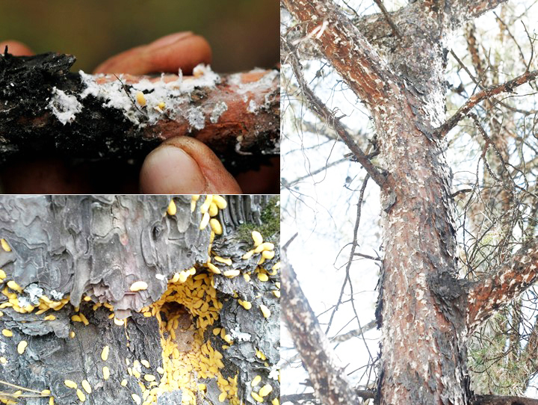
Different elements in the pine honey value chain.
Pine honey is produced by honey bees using a special honeydew in the red pine forests. Therefore, the prominent factors in production are red pine forests, MH and bees. Forests are owned by GDF on behalf of the State. The GDF can be considered as the owner of MH because of their existence on the trees. The beekeepers are the owners of bees that produce honey. For a good production, forests, insects and bees need to be managed in coordination.

- MH: The main factor in pine honey production is MH which generally spreads in red pine forests in the coastal area from Antalya to Istanbul. The most important limiting factor on the biology and activity is extreme summer temperature and drought. In 2020, the extreme heat and drought seen in Muğla province caused widespread deaths in the giant pine scale, as a result, only 5-10% of the expected production in 2019 was produced.

- Wood-based sector: Wood production in areas where the insect spreads is an important factor. One of the most important issues that beekeepers stand against is the cutting down of red pine trees relatively at an early age for wood production. The conflict lies between the different interest of honey production and wood production. The annual increment of red pine starts to decrease after 50-60 years of age, whereas , the most suitable age of trees for pine honey production starts after 50.

- Provincial Directorate of Agriculture and Forestry (PDoAF): The main authority related to beekeeping and honey production in Turkey is the General Directorate of Livestock (GDL). The representative of GDL in the provinces is PDoAF.

- Beekeepers: Honey produced in forests and it is collected by beekeepers and delivered to the market. Beekeepers must abide by the rules set by GDF in the forest. PDoAFs regulate the other procedures such as marketing. Even though the phrase of PDoAF has “forestry” in its name, all of the works related to the forests are carried out by GDF and its local branches.

- Forest Villagers: Whichever village the pine honey production area is located in, beekeepers have to agree with GDF, PDoAF, and the mukhtar. The places where the beehives will be placed are determined accordingly. Beekeepers pay an amount to the mukhtars. The lack of a regulation for this payment causes some disputes and difficulties in practice. Beekeeping also affected by agricultural activities of forest villagers such as pesticides and other chemicals used for agricultural purposes.

- NGOs: Although not compulsory, due to various support provided by the government, all beekeepers who are producing for the market, are expected to be a member of the Beekeepers/Honey Producers Associations established in line with “the Law on Veterinary Services, Plant Health, Food and Feed” and the Law on “Agricultural Producers Unions”.

- Mining and Tourism Sectors: Forests where pine honey is produced are also important areas for tourism and mining. The destruction, fragmentation and consequently degradation of the integrity of the forests due to the mining activities, the construction of roads, noise pollution caused by heavy tonnage trucks, dust from roads and mines, pollution in water resources have negative impact on MH and honey bees. Some areas suitable for pine honey production, could be declared as "Culture and Tourism Protection and Development Zones” and “Tourism Centers” in line with the Tourism Incentive Law No. 2634 by the Ministry of Tourism. In this case there can be some restriction and limitation for beekeeping. On the other hand, tourism could have positive contributions to pine honey production. Tourists who come to forests see the production there and buy directly. In addition, by seeing the conditions, tourists can become a voluntary advocate of forests and pine honey production.

- Academics / Researchers: Pine honey production is a highly complex process,. As seen in 2020, it is severely affected by drought and possibly other environmental factors. It is necessary to investigate the biology of the insect, its resistance to other environmental factors, especially to climate change, its ability to move elsewhere and adapt to new conditions. There is not enough awareness in the society about pine honey and its health / nutritional values.

- Sales and marketing companies: There are no problem in the sale of pine honey. The price is formed according to the free-market conditions and all honey produced can be sold easily. However, frequent and sharp fluctuations in prices can also be seen. Therefore, it is considered extremely important to consider the sector as a whole and to switch to "certified production". In addition, cooperating with national institutions such as Turkish Grain Board, and Agricultural Credit Cooperatives of Turkey, which make wholesale purchases, contribute to beekeepers to predict the future more comfortably.

- Standardization Organizations: For pine honey, which has a different structure than flower honeys, a separate standard should be developed by Turkish Standard Institutions (TSE) and International Organization for Standardization (ISO).

- Trademark, Geographical Indication (GI), Certification and Labelling Organizations: As the production areas are under control, it is very easy to determine from which forest area, by which beekeeper the pine honey is produced. Therefore, a model should be developed for the labelling by GDF with other stakeholders such as Turkish Association of Beekeepers (TAB), TSE, Turkish Patent and Trademark Office and marketing firms. For pine honey there are two geographical indication provided by Turkish Patent and Trademark Office namely “Muğla Pine Honey” and “Marmaris Pine Honey”.

- Export Companies: A significant portion of pine honey is exported to countries such as Germany, England and Italy. It has been observed that there is a potential to improve cooperation between export companies and beekeepers, NGOs, GDF and other relevant institutions.

Bay Leaf
Bay leaf is obtained from the laurel tree (Laurus nobilis L.). The branches of bay trees are cut, brought to the facilities where the leaves are separated from the branches, dried and packaged.
Picture 2. Bay leaves and oil (Photo I. Belen)
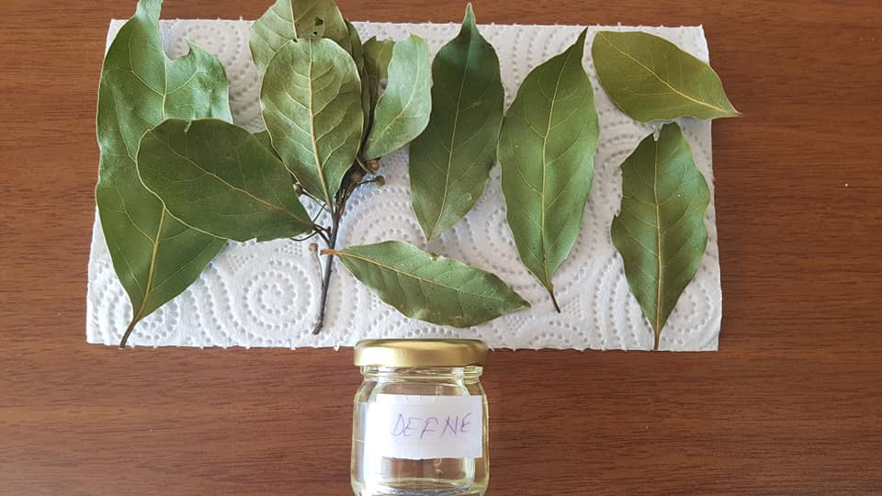
According to GDF, there were a total of 180 400 hectares of laurel tree fields in Turkey as of the end of 2019. Laurel spreads usually with other Maquis plant species such as Phillyrea latifolia, Quercus cocciferae, Smilax aspera, Olea europaea, Pinus brutia, Pistacia terebinthus etc. Bay leaf production in 2019 was 32 600 tons in total and the contribution of all products obtained from laurel to the national economy was calculated as 264 million USD.
Bay leaf value chain research was conducted by GDF in 2019 (UNDP, 2019). The findings are still up-to-date. The actors included in the bay leaf value chain could be listed as follows.
- Forest managers: Bay leaf is mainly based on the area located within the state forests, owned and managed by the GDF and limited privately owned areas. The determining factor for bay leaf is GDF. Land-based "utilization plans" are prepared by GDF for bay leaf harvesting.

Picture 3. Bay leaf harvesting area (Photo İ. Belen)

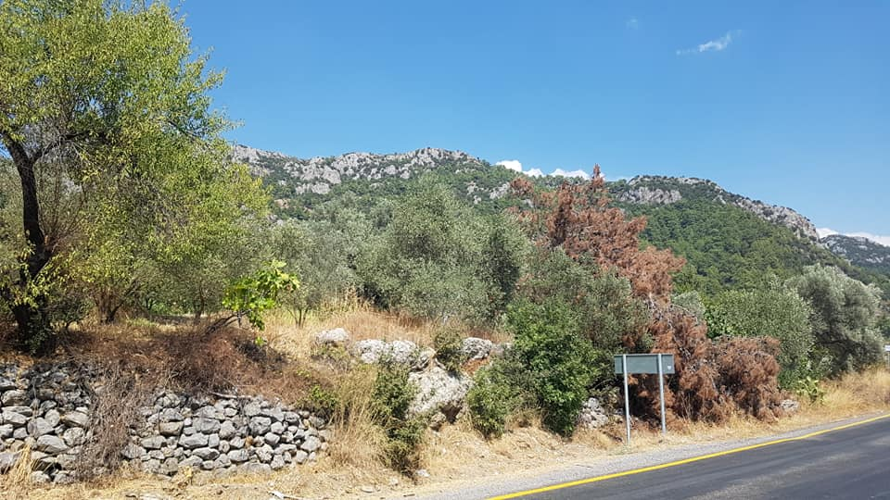

- FVs and Mukhtars: FVs harvest the leafy branches from their private land or from state-owned forest areas by paying a tariff fee to GDF. Mukhtars are the actors who organize the first step of the procurement process, namely the collection phase, and act as intermediaries in some regions.

- Horses: In places where land conditions are not suitable for vehicles (usually too steep slopes), the villagers carry out the transportation business. In some cases, horses can be used. However, in the case of using horses, the quality of the leaves decreases due to the excessive shaking during the transportation.

- Weighers and loaders generally work for the intermediary or the trader. A fee is charged to the trader or intermediary for this work. Officers working for GDF prepare a transport certificate for laurels loaded on vehicles. The rent, fuel and driver fee of the vehicle carrying out the transportation work are covered by the drying facility.

Picture 4. A scale used to measure bay leaves (Photo I. Belen)
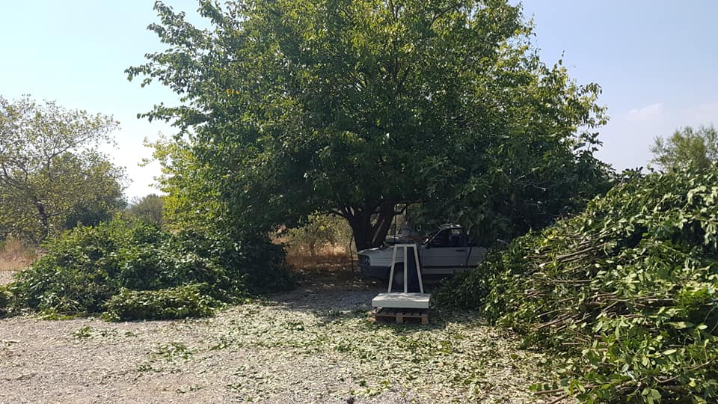

- Trader / Broker: They are the people who contact the FVs who will collect the laurel, and carry out the loading and transportation of the bay shoots after cutting. They work directly with export companies as well as with the drying facilities where they take the product.

- Drying Plants: They act mainly in line with the demands of export companies. It is observed that the drying plants can reach the laurel through merchants or mukhtars, as well as directly from the villagers.

- Sellers: Bay leaves are generally exported but also sold within the country in different forms such as spice or in processed form (sauces, soups, daubes and stews).

Picture 5. A handmade soap with laurel olive (Photo: İ. Belen)
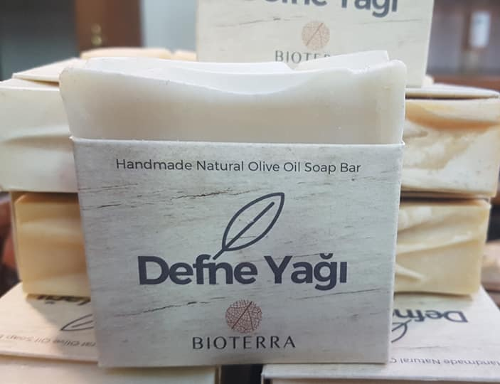
- Export companies: Turkey meets more than 90% of the world demand for laurels. However, most of the time, export companies complain about not being able to meet the demands due to the shortage of raw materials and the disruptions in the procurement process. So, there is a need to establish a network, meaning a sustainable value chain framework, starting from the field to final market including laboratories and certification units. Countries such as United States of America, Poland, Japan, Germany demand various qualities of bay leaves. The highest demand comes from Vietnam, and it is sold to China through this country. In 2019, China started making direct purchases from Turkey.

- The flowers of laurel trees are preferred by bees. So, beekeepers are also become stakeholders in some cases.

Chestnut
Chestnuts (Castanea sativa) is one of the natural forest trees of Turkey covering 262 045 hectares area. Chestnut fruit is harvested in 74 897 hectares of these state-owned chestnut forests. The remaining areas are reserved for traditional forestry activities.
In addition to the chestnuts in the state-owned forests, chestnut orchards are also established by the private sector where most of the harvesting obtained. In 2019 the total chestnut harvesting in Turkey amounted to 72 655 tons, 33% was from state-owned forests and 67% from privately owned chestnut orchards.
Turkey's total chestnut harvest in the year of 2000 was 68 652 tons, a total of 116 million USD contribution to the national economy, the export revenue was approximately 7 million USD (BELEN, 2001). In 2019, total harvesting increased to 72 655 tons and exports to 14 225 tons. Direct export income of 2019 was approximately 36 million USD.
When the chestnut value chain is examined, the following actors and processes emerge.
- Policy makers: Chestnut orchards where fruit is produced are predominantly owned by the private sector, more precisely by the villagers. In these areas, the General Directorate of Plant Production (GDPP) of MoAF stands out as a policy maker. On the other hand, chestnut fruit is also produced in state-owned forests. The policy-making authority in state-owned forests is GDF. After the chestnut fruit is produced, it becomes a "food". At this stage, the General Directorate of Food and Control (GDFC) of MoAF becomes authorized and policy-setting institution. A significant part of the chestnut fruit produced is exported, and the Ministry of Trade plays a role in the export process.

- Forest managers: As of 2019, a significant part of the chestnut fruit is produced from state-owned forests. The determining institute and actor for forest related policy on chestnut is the GDF. "Utilization Plans" are prepared for chestnut fruit harvesting in state-owned forests and fruit harvesting/collection is permitted accordingly. For the collection permit, FVs have to pay a so-called "tariff fee" to the GDF.

- FVs: FVs collect the chestnut fruit from their private land or state-owned places specified by the GDF. The FVs pay a so-called "tariff fee" to GDF for the chestnuts they collect from state-owned forests. The tariff price is very low. FVs are the people with the least income in the chain of collection, processing and sale of chestnut fruit. On the other hand, FVs need capacity building activities in the collection, storage and marketing of chestnut fruits.

Picture 6. Chestnut fruits almost ready to be harvested
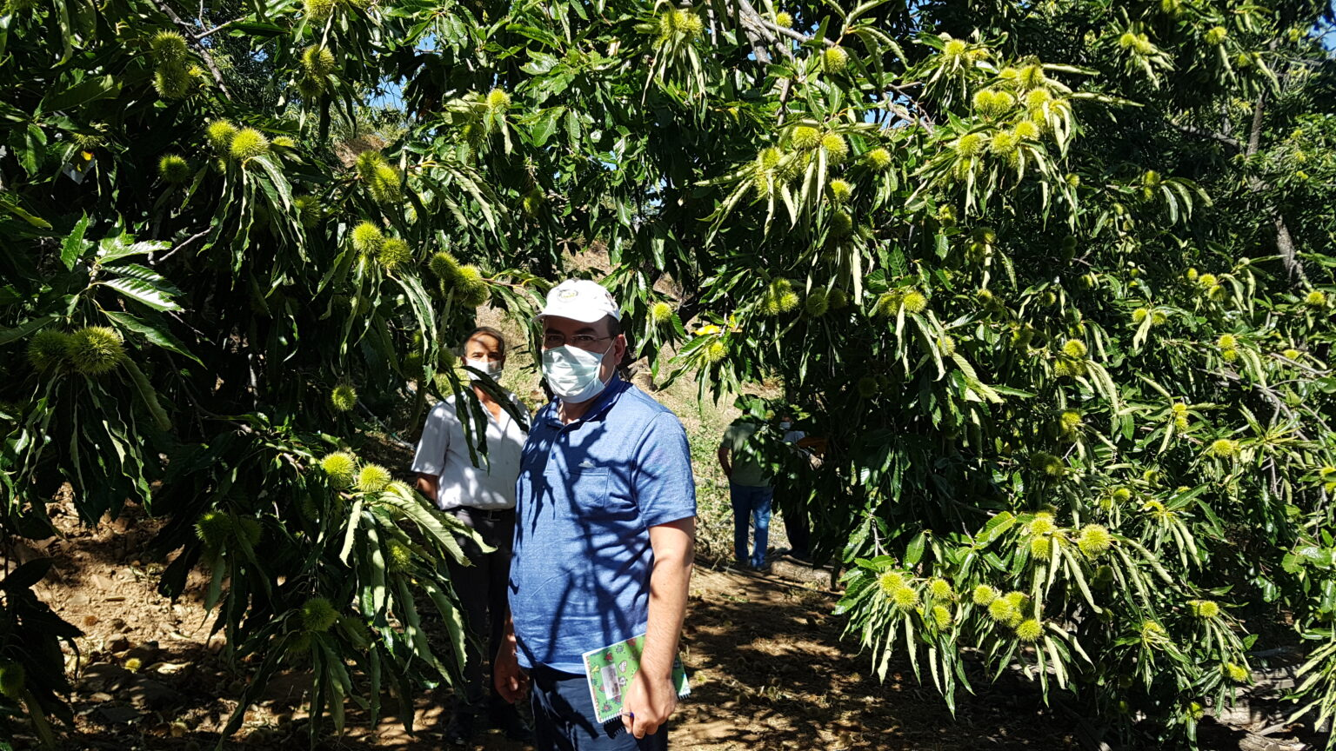

- Mukhtars play a key role between the villagers and GDF and they are the actors who organize the harvesting and collection phase, and act as intermediaries in some regions.

- Trader / Broker: They are the people who contact the FVs who will collect the chestnuts, and carry out the loading and transportation of the fruits to the vehicle after the fruits are removed from their shells. Since they are in the position of intermediaries and have the task of reaching an agreement with the villager, the merchants/intermediaries determine who the villager will give the fruit to. To give an example, in the autumn of 2020, a total of 1 500 tons (1 500 000 kg) of chestnut fruit was produced in the Yaylapınar Village of the Nazilli district of Aydın province. Yaylapınar Village has generated an income of approximately 3 million USD only from chestnut harvesting (1 500 000 kg * 2 USD = 3 million USD). These chestnuts were purchased by intermediaries for about 2 USD per kilogram and loaded on trucks and transported to Bursa, approximately 500 km away. Bursa province is famous for the chestnut industry.

Picture 7. Distance between areas where chestnut harvesting and processing
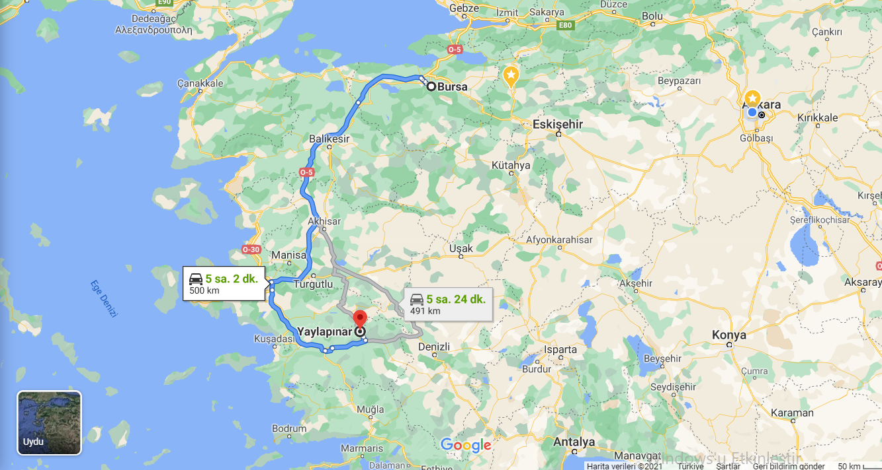

- Chestnut fruit has an important place in Turkish culture. Chestnut fruit can be eaten after freshly roasted. In addition, various desserts such as chestnut sugar, chestnut puree, chestnut paste are made and these products can be consumed alone or used in cakes. Chestnut sugar is one of the important elements of the food and confectionery industry.

Picture 8. Candied chestnut (Photo: İ. Belen)
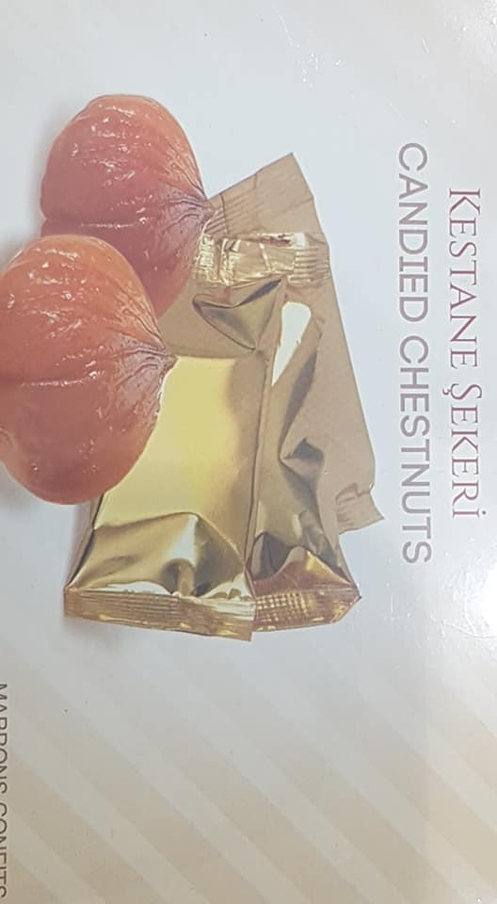

- Export companies: Chestnut fruit is usually exported raw. Chestnut fruit is both exported and imported. In 2019, approximately 14 thousand tons of export and 2 thousand tons of imports were made. While most of the exports are made to Italy, all of the imports come from China.

- Beekeepers: While the chestnut trees in the state forests are mostly in the Black Sea region, the chestnut orchards belonging to the private sector are concentrated in the Aegean region. In addition to the fruit and timber of chestnut trees, chestnut flowers are an important resource for beekeeping. In particular, the state-owned chestnut forests in the Black Sea region contribute greatly to chestnut honey production. Beekeepers oppose the use of any pesticides for chestnut trees and fruits. Compared to other honey, chestnut honey can find buyers at very high prices. In a market research conducted in Ankara on February 19, 2021, it was seen that 1 kg of chestnut honey was sold in markets for approximately 30 USD. On the other hand, 1 kg of pine honey was about 16 USD in the same market.

Picture 9. Chestnut honey (Photo: İ. Belen)
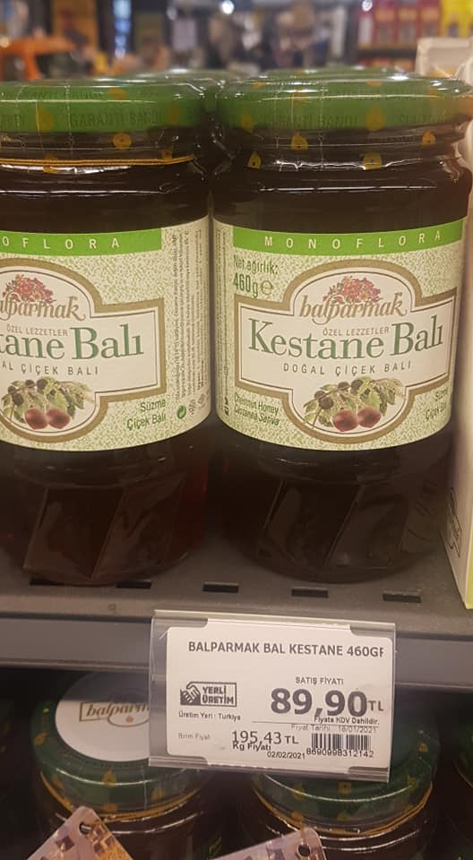

- Universities, Research Institutions, Academicians and Researchers: Public-university-private sector cooperation is not sufficient for chestnuts. There is a need for a common action plan and work schedule covering all units of MoAF, rather than work and action plans belonging only to the general directorates separately and independently from each other. There are many academicians working individually on chestnut in universities. Institutionally, Ondokuz Mayıs University (Ali Nihat Gökyiğit Chestnut Research Station), Uludağ University, Adnan Menderes University are working intensively on chestnuts.

- NGOs: As of 2021, there is no NGO operating in chestnut. An association / platform structuring with representatives from the university-public-private sector (producer, trader, exporter, etc.) will be extremely beneficial.

Resin
In Turkey, resin is collected mainly from Pinus brutia and Pinus pinaster. In addition to these two trees, a little amount of resin is collected from Pinus nigra roots. The total potential area suitable for resin production is around 100 000 hectares. Currently, Turkey’s resin demand is largely met through imports. In 2019, around 11 000 tons of resin was imported annually and around 20 million USD was paid in return.
Regarding the value chain, it is considered that the scheme – presented below – produced within the scope of the INCREDIBLE project could be a good reference for Turkey.
Figure 2 Resin value chain (EC, 2018)
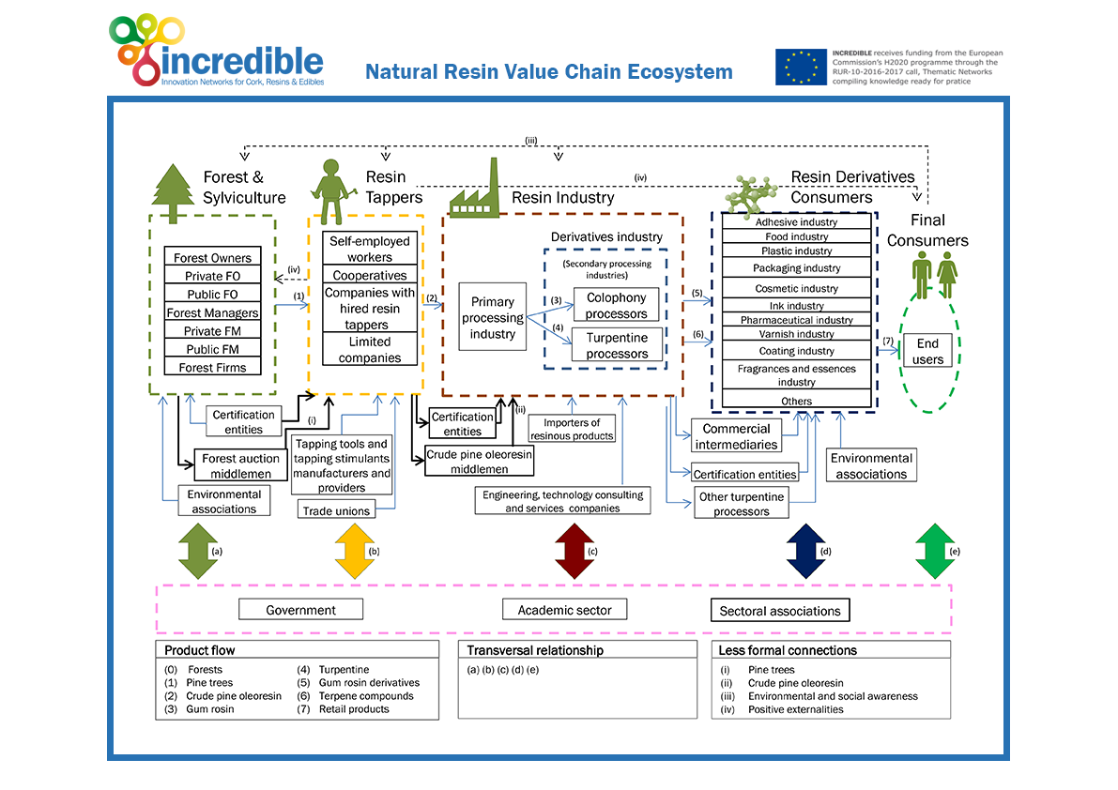
- Government/Policy Makers: as resin is obtained from forests owned by the state, GDF is both the landowner, and the policy maker on behalf of the government. Beside the general policy, GDF is also the authority in the silvicultural maintenance of the forest. The areas where resin produced are determined in line with “Utilization Plans” prepared by GDF and developed according to Communiqué of NWFPs and the "Resin Action Plan” prepared by GDF. Communiqué of NWFPs was published in 2016 by GDF. Then, the "Resin Action Plan-2017/2021" was put into practice. Within the framework of this action plan, it is aimed to increase the resin production, which was around 290 tons in 2019, to 5 000 tons per year until 2023.

- Resin Tappers: After utilization plans are prepared and announcement is done for harvesting, “resin tappers” enter to the value chain. FVs have the priority through the cooperatives established in line with Forest Law or through the village legal entity represented by mukhtars. If there is no demand from cooperatives and village legal entity then self-employed workers or private companies can do the harvesting in line with free market circumstances. Resins produced from trees are either sold directly by producers or through intermediaries to the facilities that will use the product. The most difficult stage in resin collecting is finding qualified workers (resin tappers). As the resin production was interrupted for many years, because of the artificial resin import mainly from China, natural resin harvesting was reduced or not produced in some parts, the trained workforce remained very little. Furthermore, there is a strong tendency to move to cities/urban areas from rural areas. By the end of 2020, 93% of Turkey's population lived in cities and district centers (TURKSTAT, 2021). A big proportion of rural people are elderly and they are not capable to work physically.
Picture 10. A resin collecting training program (Photo: OMO)
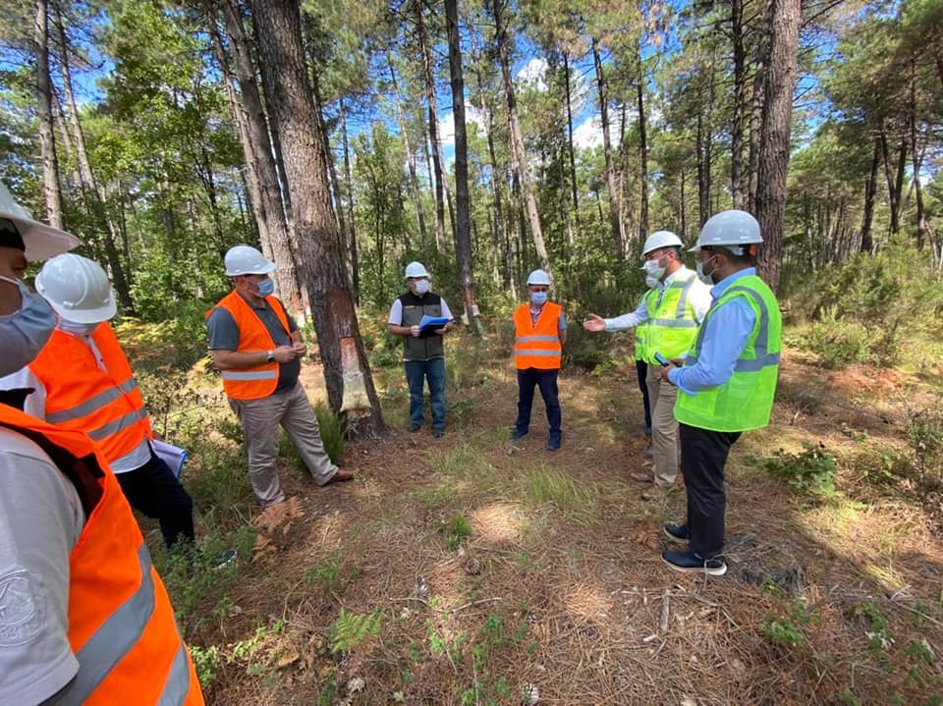

- Infrastructure: terrain conditions in the forest, play a decisive role in resin production. Workers need to move from their villages to the forests/nearby villages. Since resin production is not concentrated in one area, frequent movement of the workers can be necessary. Meeting the daily needs of workers (food, cleaning, workplace safety, etc.) is an important issue. On the other hand, the resins obtained from trees must be collected in an area and loaded into trucks. For this, the forest road network must be sufficient.

- Transportation to facilities: There are hundreds of kilometers distance between the forests where the resin is harvested / produced and the settlements where the resin industry is located. This transport distance makes a serious contribution to the cost.

- Resin industry: There is no problem in selling resins that are tapped/made ready for sale. However, there is not enough cooperation between the GDF, industry and FVs/harvesters. The materials required for resin tapping (acid-paste, special knives, vehicle, worker wage, etc.) are quite expensive, and it is difficult for FVs to meet these costs. For this reason, companies that play a role in the sector are required to make "contractual production", make prepayment to the workers who will work in the production business and give a purchase / price guarantee.

- NGOs: Pine forests where resin production is made are generally close to settlements, easily accessible by local and foreign tourists. In some cases, the production activities and the injured images of the trees can disturb the citizens and a serious counter-campaign is carried out. On the other hand, there is a lack of NGO that will coordinate resin production and explain the environmental and employment contributions of natural resin to the public. For example, "Pine Chemicals Association International (PCA)” could be a good example for Turkey to inform the public and to unite the sector as a whole.

- Academic sector: As of 2021, there are 12 Forestry Faculty in different universities having the departments of Forest Engineering, Forest Industrial Engineering and Woodworking Engineering and 5 Faculty of Technology in Turkey. The Departments of Forest Industrial Engineering are specifically working on issues such as resin. There are also some academicians who have expertise specifically on resin. But due to a lack of general coordination and a comprehensive value chain management approach the cooperation between the stakeholders is not sufficient.

- Importer Firms: While the domestic production was about 290 tons in 2019, around 11 000 tons of resin was imported annually meaning there are plenty of companies dealing with import. The problem is that the importer companies are working with the Ministry of Trade and they don’t have any connection with GDF.

Truffle Mushrooms
Truffles are the most valuable mycorrhizal fungi found in most forest ecosystems. While there are more than 180 species recognized around the world, about 10 of them are considered commercially important. Truffles have started to gain value in Turkey in the last decade, and Tuber aestivum and Tuber borchii hunting has become very popular.

Picture 11. Truffle (Source: http://trufder.org/)
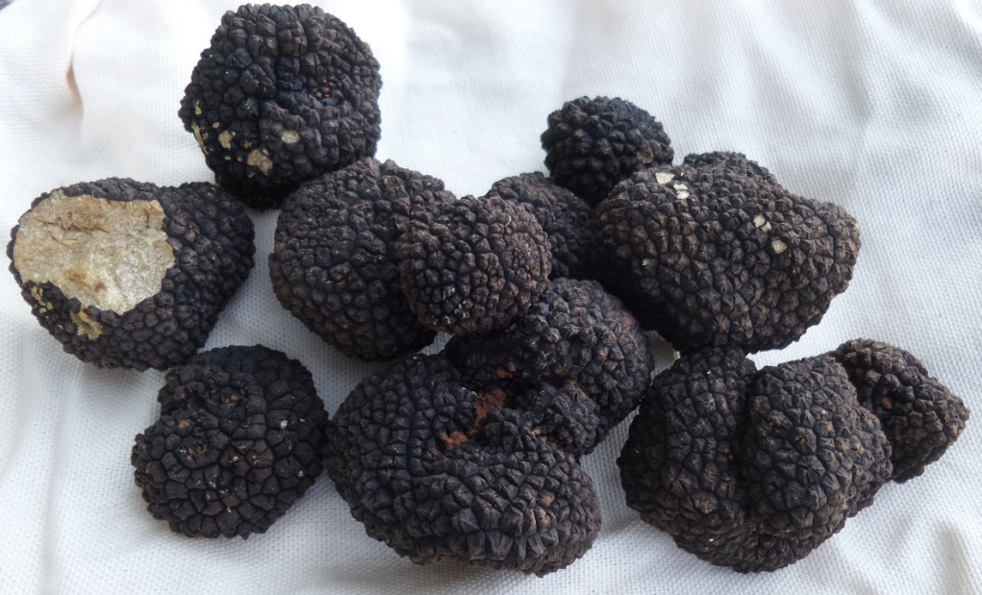
The scheme produced by INCREDIBLE project could be a good reference for truffle mushrooms value chain in Turkey with a few small differences.
Figure 3. Truffle value chain (EC, 2018)
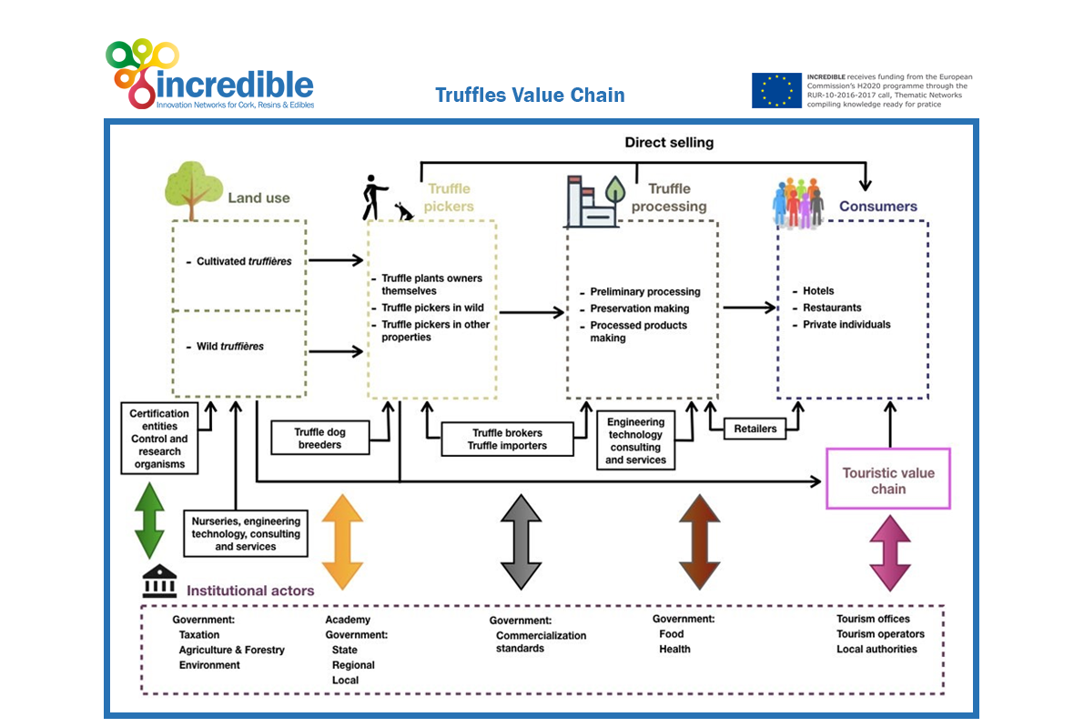

- Policymakers/ Institutional Actors: The main actor for mushrooms, in general, is MoAF. The General Directorate of Plant Production (GDPP) of MoAF is responsible to issue the general regulations for production. After the mushrooms are processed, they become food, and at this stage, the General Directorate of Food and Control (GDFC) comes into play. GDF is responsible for mushrooms that grow naturally in forests. "Truffle Forest Action Plan" was prepared by GDF in 2014. The "Truffle Orchard (Cultivated Truffières) Plant Project Feasibility Report and Investor Guide” and Circular on "Truffle Harvesting and Sales Procedures and Principles" was published in 2020.

- Wild Truffières/ Cultivated Truffières (Truffle fields): Forests managed by GDF act as "Wild Truffières". Truffle species makes ectomycorrhiza with Populus, Ostrya, Salix, Cistus, Fagus, Quercus, Corylus, Tilia, Carpinus, Castanea and Pinus species. Especially degraded oak forests are suitable areas for truffles. But degraded oak forests are also suitable for grazing, so there is a competition between grazing and mushrooming which GDF deal with. Cultivated Truffières are very new in Turkey. They are established for truffle production by planting. As of the end of 2019, there is only one cultivated truffière established by a private company in line with standards determined by GDF.

- Truffle seedlings producers/nurseries: Especially for cultivated truffières, it is essential to have saplings with truffle spores. Currently GDF produces truffle grafted saplings such as chestnut, hazelnut and plant them in the areas that are declared as truffle forests. In some cases, during some special ceremonies like international day of forest, GDF gives the truffle grafted saplings to the FVs free of charge.

- Truffle pickers/hunters: It is estimated that 1-2 thousand tons truffles grow per year in Turkey's state-owned forests managed by GDF. However, as the end of 2019, only 40 tons of truffles were harvested by truffle pickers/hunters. In this context, GDF conducts legislative arrangements (for example the species that can be collected, collection time, collection areas, the amount of mushrooms can be collected, even suitable outerwear for collection) and capacity building activities to create enabling environment for "truffle pickers / hunters", which are vital for both the best protection of truffles and their ecosystems and for the inclusion of truffles to economy.

- Truffle dogs and truffle dog breeders: Existing truffles in forests are mostly detected by trained dogs. It was estimated that, as of 2019, there were around 150 dogs trained for truffle. One dog can be purchased and sold for around 2 000 USD. While some of the truffle dogs are imported from countries such as Spain and Bulgaria, some of them are bred and trained within the country.

- Consumers: As the current truffle harvest is very limited, it is either consumed directly by pickers or sold directly to restaurants.

- NGOs: Although their number is limited, NGOs operating in the field of truffle exist and they work closely with GDF. “Truffle Mushroom Promotion and Research Association-TRUF-DER” and “Truffle Mushroom Hunters Association” are examples of these associations.

- Academic sector: There are research and implementation centers in different universities related to mushrooms in general listed below. One of them is directly works for truffle.

- Kastamonu University Mushrooms Research and Implementation Center https://www.kastamonu.edu.tr/index.php/tr/arastirma-ve-uygulama-merkezleri/mantaruygarsmerkezi
- Muğla Sıtkı Koçman University Truffle Implementation and Research Center https://trufmer.mu.edu.tr/
- Selçuk University Mushroom Application and Research Center https://www.selcuk.edu.tr/Hakkinda/mantarcilik_uyg_ve_ars_mrz_mud
- Van Yüzüncü Yıl University Mushroom Researches and Implementation Center https://www.yyu.edu.tr/Birimler/953/iletisim

Recommendations
In COVID-19 conditions, NWFPs gained more importance in many aspects, especially food safety.
For the sustainable management of NWFPs, it is vital that all stakeholders be evaluated in a sustainable value chain framework. But it is considered that more comprehensive and long-term studies are needed for this aim.
For food safety purposes, it is recommended that every step of the value chain is evaluated separately for each species.
Certification of the production process of NWFPs needs to be completed so that consumers can track the steps of the value chain for an NWFP. Also, certification would reduce the unreported harvesting of NWFPs, by doing so, it would increase the reliability of official reports on NWPF production and trade. However, transparent reporting may have negative effects, such as the imposition of additional taxes. For this reason, measures should be taken to completely remove or reduce the additional tax liabilities that may come especially for forest villagers and small and medium sized enterprises.
Sustainability is the key factor in NWFP production. In order to ensure that the amount of products produced is not damaging the environment, new techniques of forest use can be introduced to first producers/forest villagers. Agroforestry systems (forest farming, silvopastoral, agrosilvopastoral etc.) are crucial and successful systems that have been taking over the idea of forest use throughout the world. Training programs for these systems can be developed in cooperation with stakeholders and applied in the NWFP production areas.
Along with the introduction of the agroforestry systems, research studies on the application of these systems in Turkey can be conducted or supported by the stakeholders.
NWFPs generally spread in natural habitats. The existence, harvest and trade of NWFPs are closely related to the "traditional knowledge" of the people living around. On the other hand, NWFPs are also important in terms of medicine and aromatics. They are an important part of people's daily life, health and culture.
So, application of quality schemes such as Protected Designation of Origin (PDO), Protected Geographical Indication (PGI), Geographical Indication (GI) and Traditional speciality guaranteed (TSG), aim at protecting the names of specific products to promote their unique characteristics, linked to their geographical origin as well as traditional know-how are important. (EC2021). Likewise, ecolabelling could a good option for sustainability and traceability of NWFPs at international and national as well as local markets.
There are several stakeholders in the value chain of NWFPs as described in relevant sections from the Presidency Policy Councils to forest villagers. However, the cooperation and coordination between these stakeholders is not at the required level.
On the other hand, the number of NGOs related to NWFPs is quite low. It would be highly accurate for GDF to be more active in both strengthening the coordination between stakeholders and support to establishing NGOs that will help each stakeholder be heard.

References

ASCM. 2021. The Association for Supply Chain Management (ASCM). [Çevrimiçi] 2021. https://www.ascm.org/.
AYAN. 2017. Some Forest Trees for Honeydew Honey Production in Turkey. basım yeri bilinmiyor : Siberian Journal of Forest Science, 2017. Ünal S., Ayan S., Karadeniz M., Yer E. N. Some forest trees for honeydew honey production in Turkey // Sibirskij Lesnoj Zurnal (Sib. J. For. Sci.). 2017. N. 4: 101–110 (in English with Russian abstract).
BELEN. 2001. 2001. BELEN. (2001). Utilisation from chestnut as non wood forest product in the World and Turkey. .
EC. 2018. Brenko A., Buršić D., Zgrablić Z & Martinez de Arano I. (2018). A Road Map for innovating NWFPs value chains, Deliverable D1.3. H2020 project no.774632 RUR-10-2016-2017 European Commission, 44 pp. 2018.
FAO. 2016a. 2016a. Potentials of non-Wood Forest Products for Value Chain Development, Value Addition and Development of NWFP-Based Rural Microenterprises in Sudan.
—. 2014. Developing sustainable food value chains – Guiding principles. 2014.
—. 2016b. Potentials Of Non-Wood Forest Products For Value Chain Development, Value Addition And Development Of NWFP-Based Rural Micro Enterprises: Tunisia. 2016b.
—. 2020. The buzz around Turkish pine honey. Ankara : yazarı bilinmiyor, August 2020.
OG. 2018. Presidential Decree No 4. 2018.
TURKSTAT. 2021. The Results of Address Based Population Registration System, 2020. 2021.
UNDP. 2019. Non-Wood Forest Products: Laurel Value Chain Analysis. 2019.

Mukhtar refers to village and neighborhood headmen who is elected during local elections for five years. Political parties are not permitted to stand candidates for these posts
https://www.ci.gov.tr/cografi-isaretler/detay/37982
https://www.ci.gov.tr/cografi-isaretler/detay/38243
The “Cooperatives” established in forest villages and “forest villages” are different from each other. There may not be a cooperative in every village. Or not everyone in the village is a member of the cooperative. Like municipalities, villages also have an institutional structure called “village legal entity". The representatives of the villages are the mukhtars in front of laws.
http://trufder.org/

