Information Notes for the Participants of
the Training Workshop on Conservation of Native Tree Species for Conservation of Genetic Biodiversity in Central Asia
25-29 October 2021

Content
In General 1
Objective 2
Venue 2
Training Format/Method 2
Languages 2
Accommodation, Transportation and Funding 2
Expected Weather Pattern 3
Drees Code 3
General Info About Kyrgyzstan 3
Information About Bishkek 5
For Contact 6

In General
- The date of the workshop: 25-29 October 2021.

- The Venue: "Ramada by Wyndham Bishkek Centre" https://www.wyndhamhotels.com/ramada/bishkek-kyrgyzstan/ramada-by-wyndham-bishkek-centre/overview (Picture from Hotel Web Page)



- For practical training: Ala Archa National Park (Picture: https://www.flickr.com/photos/qardash/7268179290)

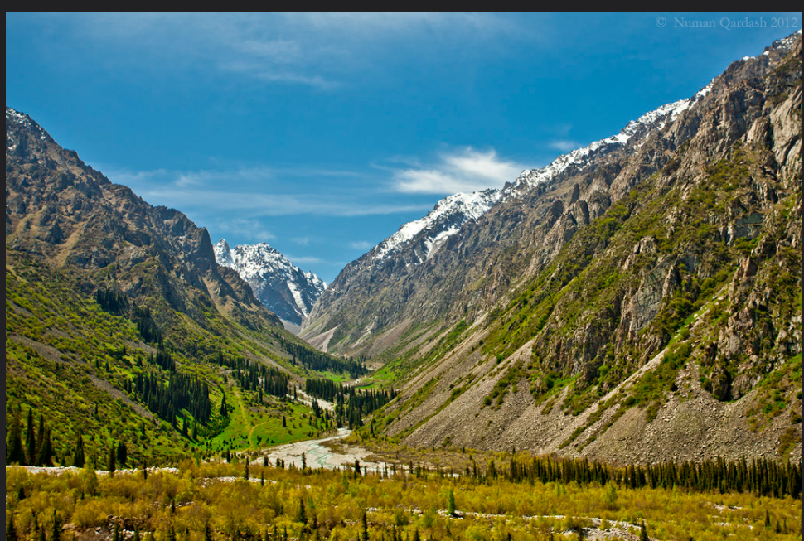

Objective

The objectives of the "Training Workshop on Conservation of Native Tree Species for Conservation of Genetic Biodiversity in Central Asia” are;
- To inform the “resource persons” and “other participants” of the seminar about “The Guidelines On Safeguarding Native Tree Species For Conservation Of Genetic Biodiversity In Central Asia”.
- To encourage the resource persons for preparing country presentations in line with findings and proposals determined by the Guidelines including status and distribution of native tree species, conservation of native tree species and seed harvesting.
- To change to experiences, best practices and lessons learned on techniques and technologies used in the conservation of genetic biodiversity during the seminar and field excursions by interactive participation.
- To examine the field implementations during the field excursions.

For this aim, the agenda has been developed by the involvement of resource persons. The Guidelines, both in English and Russian languages have been shared with the participants.

Venue
"Ramada by Wyndham Bishkek Centre" https://www.wyndhamhotels.com/ramada/bishkek-kyrgyzstan/ramada-by-wyndham-bishkek-centre/overview has been defined as the workshop venue.

Training Format/Method
The Training Workshop is going to be organized physically. Online participation will be also possible through the Zoom Platform.

Languages
Training workshop language will be English with simultaneous interpretation in Russian and Turkish.

Accommodation, Transportation and Funding
All registered participants including the resource persons will be provided with required visa (if needed), and vouchers for international/national travel and accommodation (i.e. prepaid return tickets and adequate hotel accommodation with full board – i.e. considering reduced DSAs) in line with UN rules. Dedicated assistance to all participants prior and during both Conference and Training workshop implementation should be ensured.

The transportation of the participants from the airport to the hotel, from the hotel to the airport and the field trip will be covered by SP.

Expected Weather Pattern
The weather and temperature conditions in Bishkek, where the workshop will be held, are shown in the table. The temperature is expected to be 15-18 degrees during the day and 4-5 degrees at night.

Since the altitude of the Ala Archa National Park, where the land survey will be conducted, is high, it is predicted that the temperature will be lower.

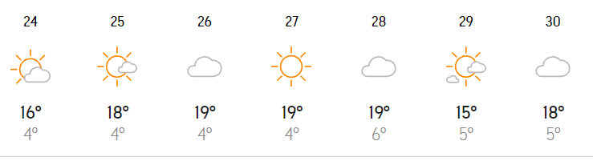

Drees Code
The dress code of the workshop will be casual. However, formal dress is proposed, especially until noon on the first day of the opening programs.

It is recommended to wear comfortable shoes, to wear sports clothes, and to take precautions against cold and wind during the field excursion.

General Info About Kyrgyzstan
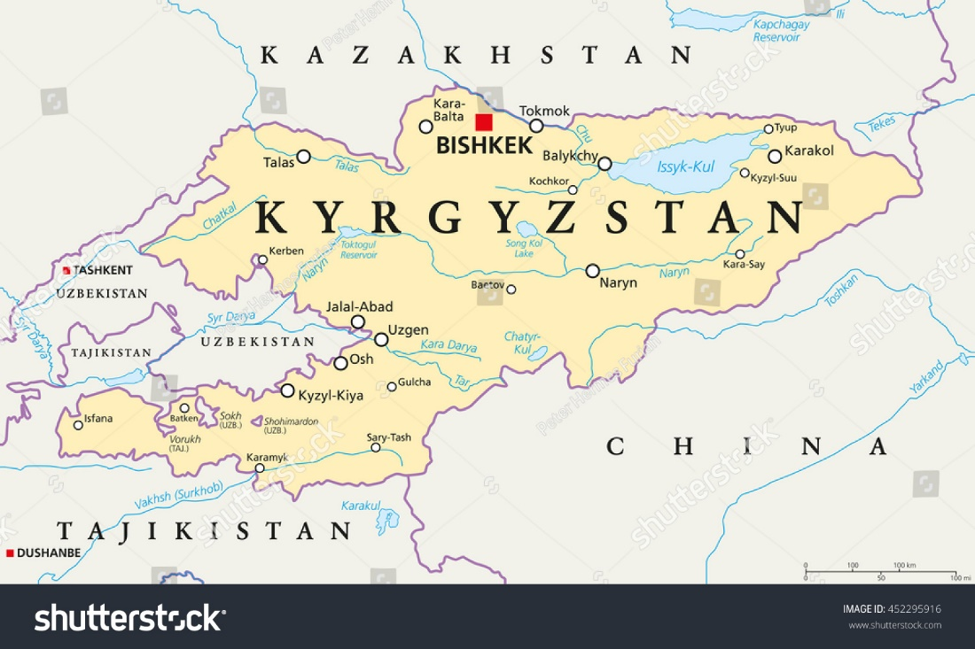
Location: Central Asia, west of China, south of Kazakhstan

Area
- total: 199,951 sq km
- land: 191,801 sq km
- water: 8,150 sq km

Border countries (4): China 1063 km, Kazakhstan 1212 km, Tajikistan 984 km, Uzbekistan 1314 km

Climate: dry continental to polar in high Tien Shan Mountains; subtropical in southwest (Fergana Valley); temperate in northern foothill zone

Terrain: Peaks of the Tien Shan mountain range and associated valleys and basins encompass the entire country

- Elevation: Highest point: Jengish Chokusu (Pik Pobedy) 7,439 m
- Lowest point: Kara-Daryya (Karadar'ya) 132 m
- Mean elevation: 2,988 m

Natural resources: Abundant hydropower; gold, rare earth metals; locally exploitable coal, oil, and natural gas; other deposits of nepheline, mercury, bismuth, lead, and zinc

Land use
- Agricultural land: 55.4% (2018 est.)
- Arable land: 6.7% (2018 est.)
- Permanent crops: 0.4% (2018 est.)
- Permanent pasture: 48.3% (2018 est.)
- Forest: 5.1% (2018 est.)
- Other: 39.5% (2018 est.)

Population distribution: The vast majority of Kyrgyzstanis live in rural areas; densest population settlement is to the north in and around the capital, Bishkek, followed by Osh in the west; the least densely populated area is the east, southeast in the Tien Shan mountains

Natural hazards: Major flooding during snow melt; prone to earthquakes

Population: 6,018,789 (July 2021 est.)

Languages: Kyrgyz (official) 71.4%, Uzbek 14.4%, Russian (official) 9%, other 5.2% (2009 est.)

Environment: Water pollution; many people get their water directly from contaminated streams and wells; as a result, water-borne diseases are prevalent; increasing soil salinity from faulty irrigation practices; air pollution due to rapid increase of traffic

Climate: Dry continental to polar in high Tien Shan Mountains; subtropical in southwest (Fergana Valley); temperate in northern foothill zone

Economic overview:
Kyrgyzstan is a landlocked, mountainous, lower middle income country with an economy dominated by minerals extraction, agriculture, and reliance on remittances from citizens working abroad. Cotton, wool, and meat are the main agricultural products, although only cotton is exported in any quantity. Other exports include gold, mercury, uranium, natural gas, and - in some years - electricity. The country has sought to attract foreign investment to expand its export base, including construction of hydroelectric dams, but a difficult investment climate and an ongoing legal battle with a Canadian firm over the joint ownership structure of the nation’s largest gold mine deter potential investors. Remittances from Kyrgyz migrant workers, predominantly in Russia and Kazakhstan, are equivalent to more than one-quarter of Kyrgyzstan’s GDP.

Following independence, Kyrgyzstan rapidly implemented market reforms, such as improving the regulatory system and instituting land reform. In 1998, Kyrgyzstan was the first Commonwealth of Independent States country to be accepted into the World Trade Organization. The government has privatized much of its ownership shares in public enterprises. Despite these reforms, the country suffered a severe drop in production in the early 1990s and has again faced slow growth in recent years as the global financial crisis and declining oil prices have dampened economies across Central Asia. The Kyrgyz government remains dependent on foreign donor support to finance its annual budget deficit of approximately 3 to 5% of GDP.

Agricultural products: Milk, potatoes, sugar beet, maize, wheat, barley, tomatoes, watermelons, onions, carrots/turnips

Industries: Small machinery, textiles, food processing, cement, shoes, lumber, refrigerators, furniture, electric motors, gold, rare earth metals.

Information About Bishkek

Bishkek is the capital of the Kyrgyz Republic and sits in the Tien Shan mountain range in the Chui Valley. Bishkek was founded when the Uzbek khan of Kokand built a small clay fort by a settlement on a tributary of the Chuy River in 1825, to connect up several stop-off points on the Silk Road through the Tian Shan mountains.

Bishkek Manas International Airport (FRU IATA) (20 km north of city centre). International flights, which mostly come and go at very early hours of the morning, connect Moscow SVO & DME, St Petersburg, Krasnoyarsk, Novosibirsk, Yekaterinburg, Istanbul IST & SAW, Ulaanbaatar, Almaty, Dushanbe, Tashkent, Ürümqi, Tehran, Isfahan, Mashad, Delhi, Dubai, and Islamabad. Domestic flights serve Batken, Jalal-Abad, Kazarman, Kerben and Osh. http://www.airport.kg/

For Contact

Please contact with followings for any matters

Name | Country | Organisation | Email | Mobile Phone
Mr. İsmail Belen- | Turkey | Chamber of Forest Engineers | ismailbelen52@gmail.com | +90 506 222 48 19
Mr. Bakytbek YRSALYEV | Kyrgyzstan | Ministry of Agriculture, Water Resources and Regional Development of Kyrgyz State | bakytforest@mail.ru | +996 779 322 808
Ms. Siuzanna Seideeva | Kyrgyzstan | Ministry of Agriculture, Water Resources and Regional Development of Kyrgyz State | seydeevas@mail.ru | +996 705 479 265
Ms. Cholpon Alibakieva | Kyrgyzstan | FAO Kyrgyzstan | cholpon.alibakieva@fao.org | +996 770 040 233
Mr. Aitkul Burkhanov | Kyrgyzstan | General Director of the Association of Forest and Land Users of the Kyrgyz Republic | a.burkhanov58@gmail.com | +996 555 704 878
Mr. Özer Arcan | Kyrgyzstan | Chamber of Forest Engineers | ozer24@mail.ru | +996 702 460 000

https://www.accuweather.com/tr/kg/bishkek/222844/october-weather/222844?year=2021
https://www.cia.gov/the-world-factbook/countries/kyrgyzstan/#geography
https://en.wikivoyage.org/wiki/Bishkek

