22 March 2022 2 30 PM

Title: RESILIENT LANDSCAPES, SAFE COMMUNITIES: Innovative Practices for Integrated Fire Management in the Mediterranean.

Proponent
Name of the contact person:
Eduard Mauri;
Elena Hernandez Paredes;
Ilhami Aydin;
Ana Morgado Souto;
İsmail Belen.

Organization: European Forest Institute/EFIMED, in collaboration with Barcelona Provincial Council, and Silva Mediterranea Forest Fires Working Group (WG1), coordinated by the Ministry for the Ecological Transition and Demographic Challenge (Spain) and the General Directorate of Forestry-OGM (Turkey), in collaboration with The Chamber of Forest Engineers of Turkey.

Content and format: Case presentations & round table

Time | Content | Speaker | Expected result
Innovative Integrated Fire Management (IFM) approaches in the Mediterranean
- 10 minutes presentation each case (30 minutes)  - 15 minutes for interaction | 1st case: Strategic forest management programme for forest fire prevention in Barcelona province (Spain) | ES: Ana Morgado Souto morgadosa@diba.cat | 1. Extract lessons from innovative IFM from across the Mediterranean regions.  2. Promote networking and knowledge sharing, involving key stakeholders from science and practice
 | 2nd case: Innovative Action for Forest Fire Prevention in Kythira Island, Greece, through Mobilization and Cooperation of the Population | GR: Gavriil Xanthopoulos gxnrtc@fria.gr  ---  on-line
 | 3rd case: Racing to Integrated Fire Management through undertaking a series of resilience projects: a case study from Lebanon | LB: George Mitri george.mitri@balamand.edu.lb  ---  in-person, own-covered
Position paper on wildfire prevention in the Mediterranean
1:15 h | Survey results presentation | EFIMED  representative | Identification of the main topics of interest to set the basis for the new position paper on wildfire prevention in the Mediterranean
1:15 h | Round table  4 panelists from different countries**: | PT: Mário Monteiro mario.monteiro@agif.pt  ---  in-person | 1. Agreement on the main topics (first index draft) of the new position paper on wildfire prevention in the Mediterranean  2. Definition of next steps for the work ahead
1:15 h | Round table  4 panelists from different countries**: | DZ: Mohamed Abes mohamedabes42@yahoo.fr  ---  in-person,
1:15 h | Round table  4 panelists from different countries**: | BA: Azer Jamakovic azer.jamakovic@hotmail.com  ---  in-person
* We have prepared a survey (https://www.surveymonkey.com/r/9HSJHFY) to distribute among EFIMED and Silva Mediterranea contacts. Case studies will be identified after the results analysis.
** Countries to be identified in the following weeks. We will consider a balanced representation of western and eastern Mediterranean countries.
Moderator: Elena Hernandez Paredes
Rapporteur: Eduard Mauri

References:
Profiles: please provide a short biopic (< 100 words) and a photo of all panelists of your session, including the chair/moderator, the rapporteur and all speakers.

Moderator:
Elena Hernández Paredes
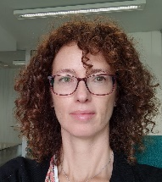
Forestry engineer. Service manager at the Wildfire Management Service of the Ministry for the Ecological Transition and Demographic Challenge of Spain since 2009. Responsible for international affairs and relationships along with national prevention, preparedness and suppression strategies and actions. Coordination of Silva Mediterranea working group on forest fires (FAO). Participation in the European Commission expert groups on forest fires (DG ENV-JRC; DG ECHO), the Global Wildland Fire Network, its Wildland Fire Advisory Group and the Fire Aviation Working Group (UNISDR). Member of the International Liaison Committee (ILC) for the International Wildfire Conferences (WILDFIRE).

Rapporteur:
Eduard Mauri

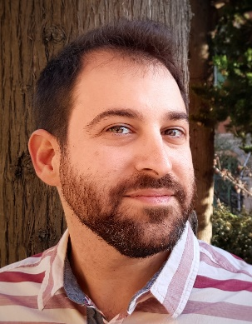
Eduard Mauri is junior researcher at the European Forest Institute’s Mediterranean Facility since 2018. He holds a degree in Forest Management and M.Sc.A. in Forest Sciences from Laval University (Quebec City, Canada). For more than ten years he has developed applied research and knowledge transfer projects in silviculture and sustainable forest management in Canada, Spain and France. He is the main author of the Handbook of good practices in post-wildfire management, published by the University of Girona (Spain). He also develops activities supporting innovation in forest circular bioeconomy at the Bioregions Facility of the European Forest Institute.

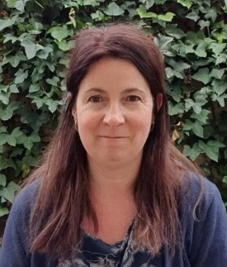
Speakers (1st part):
Ana Morgado Souto is the Head of the Forest Restoration and Improvement Section of the Technical Office for Municipal Forest Fire Prevention and Agrarian Development (OTPMIFDA) of Barcelona Provincial Council, Spain. She coordinates the drafting of strategic forest management projects for fire prevention and initiatives for the revitalization of agroforestry spaces through collaboration with municipalities and the promotion of forest associations. She is a forestry engineer from the University of Lleida, Spain. She started working on fire extinction and nowadays her work is focused on prevention.

Dr. Gavriil Xanthopoulos
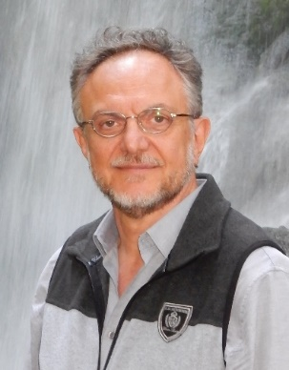
Hellenic Agricultural Organization "Demeter"
Institute of Mediterranean Forest Ecosystems
Terma Alkmanos, 11528, Athens, Greece
Phone: +30 2107793142
e-mail: gxnrtc@fria.gr

Dr. Gavriil Xanthopoulos holds a B.Sc. degree in Forestry from the Aristotelian University of Thessaloniki, Greece, and M.Sc. and Ph.D. degrees in Forestry with specialization in Forest Fire Science from the University of Montana, U.S.A. He has been active in European forest fire research for 30 years, with participation in more than 30 research projects. He also has extensive experience in forest fire management training and post-graduate university teaching and has produced numerous scientific publications. He currently serves as research director on forest fires and head of the Forest Fire Laboratory at the Institute of Mediterranean Forest Ecosystems of the Hellenic Agricultural Organization "Demeter".

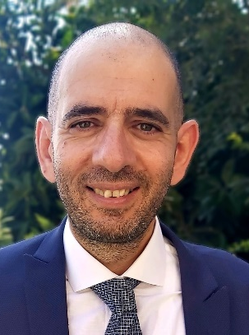
George Mitri is Professor of Environmental Sciences and director of the Land and Natural Resources Program at the Institute of the Environment, University of Balamand, Lebanon. He has more than 20 years of international and national research experiences in forest and wildfire risk management, Earth Observation and Geo-Information Analysis, drought and land degradation assessment, and impact of climate change on terrestrial ecosystems. Dr. Mitri coordinated a national project for preparing Lebanon’s national strategy for forest fire management. He conceptualized and developed a first of its kind fire danger forecast system in Lebanon. Currently, he is member of the European Commission Expert Group on Forest Fires and member of the task force on Economic Drivers of Global Wildland Fire Activity.

Panelists (2nd part):
Mario Monteiro (National Commission for the Integrated Management of Rural Fires, Portugal)

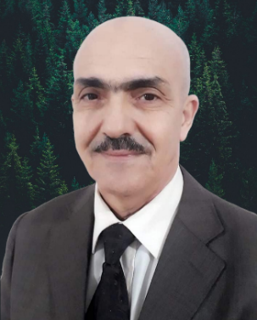
Monsieur Mohamed Abes, Ingénieur des forêts depuis 1987, spécialiste en Aménagement forestiers, ayant dirigé plusieurs études d’aménagement en Algérie, et occupé plusieurs postes de responsabilités au niveau local, et actuellement Directeur de la Gestion du Patrimoine Forestier et Alfatier au niveau de la Direction Générale des Forêts, Ministère de l’Agriculture et du Développement Rural Algérie, directeur national du projet de coopération « Réhabilitation et développement durable intégré des paysages de la production forestière de chêne liège en Algérie », point focal Silva-Mediterranea, et responsable du volet 1 « définition et mise en place d’une stratégie de valorisation du patrimoine et des produit forestiers » du Jumelage institutionnel (P3A) « Appui au renforcement des capacités de la DGF dans la mise en œuvre de la stratégie forestière », avec le Consortium européen Franco-italien et suédois.

Mr. Mohamed Abes, Forest Engineer since 1987, specialist in forest management, having directed several management studies in Algeria, and held several positions of responsibility at the local level, and currently Director of the Management of Forest and Alfa Heritage at the General Directorate of Forests, Ministry of Agriculture and Rural Development Algeria, National director of the cooperation project "Rehabilitation and integrated sustainable development of the cork oak forest production landscapes in Algeria", Silva-Mediterranea focal point, and responsible for component 1 "definition and implementation of a strategy for the valorization of the forest heritage and products" of the Institutional Twinning (P3A) "Support to the reinforcement of the capacities of the DGF in the implementation of the forestry strategy", with the European (Franco-Italian and Swedish) Consortium.

Azer Jamakovic (General Secretary of Association of Forestry Engineers and Technicians of the Federation of Bosnia and Herzegovina)

İffet Deniz Cengiz (FAO Turkey) TBC

Partners
List for each partnering organization of the event:
Name of the contact person: Eduard Mauri
Organization: European Forest Institute (EFI) – Mediterranean Facility
Address: St. Antoni M. Claret 167, 08025 Barcelona, Spain
Email: eduard.mauri@efi.int

Name of the contact person: Elena Hernández Paredes
Organization: Spanish Ministry for Ecological Transition and Demographic Challenge (MITECO)
Address: C/Gran Vía de San Francisco nº 4-6, 5ª planta. 28005 Madrid
Email: ehparedes@miteco.es

Name of the contact person: Ilhami Aydin
Organization: General Directorate of Forestry-OGM
Address: Beştepe, Söğütözü Cd. 8/1, 06560 Yenimahalle/Ankara, Turkey.
Email: ilhamiaydin@ogm.gov.tr

Name of the contact person: Ana Morgado Souto
Organization: Diputació de Barcelona (Barcelona Provincial Council)
Address: Rambla de Catalunya, 126, 08008 Barcelona, Spain
Email: morgadosa@diba.cat

Name of the contact person: İsmail Belen
Organization: The Chamber of Forest Engineers of Turkey
Address: Beştepe Mah. 31. Sk. No: 3 Beştepe Yenimahalle - ANKARA
Email: ismailbelen52@gmail.com

Practical arrangements
Language of the event: English
Need for interpretation
X Between Turkish, French and English

