Narrative Report of Training Programme of “Forest Fire preparation, early warning, firefighting, post-fire rehabilitation, computer-based fire management system” with visit to “SIMULATION CENTER” by training participants. (17-26 June 2019)
10th July, 2019

İsmail Belen
İsmail Hakkı Güney

Contents
Figures 3
Preface 4
Training Program at Glance 5
Participants from Kyrgyzstan 8
Translators 9
Consultants from the Chamber of Forest Engineers 9
Coordinator on Behalf of the General Directorate of Forests 9
Trainers 9
Daily Programmes 10
Day1- June 17, 2019, Monday 10
Day 2-June 18, 2019 Tuesday 12
Day 3-June 19, 2019, Wednesday 15
Day 4- June 20, Thursday 17
Day 5-June 21, Friday 17
Day 6-June 22, Saturday 18
Day 7-June 23, Sunday 20
Day 8-June 24, Monday 20
Day 9-June 25, Tuesday 22
Day 10- June 26, Wednesday 23
Conclusion 24

Figures
Figure 1 First Day of the Training Program 11
Figure 2 First Day Meeting 12
Figure 3 Meeting room at the hotel 12
Figure 4 Map of Istanbul's Islands 13
Figure 5 Presentation about Turkey's Activities of Forest Fires 13
Figure 6 Example of Turkey's Activities at the fiel 14
Figure 7 The participants were informed in detail about Turkey's applications. 14
Figure 8 Official Opening Ceremony of Third Training Program in Antalya 15
Figure 9 News on third training program 16
Figure 10 Simulation Center 18
Figure 11 Simulation Center 19
Figure 12 Field Exercise in Antalya 21
Figure 13 Forest Fire Tracks 22
Figure 14 Farewell at the Airport 23

Preface
A “LETTER OF AGREEMENT- LoA” signed at 11th of March, 2019, between the Food and Agriculture Organization of the United Nations (“FAO”) and Chamber of Forest Engineers of Turkey for provision of trainings on various subjects for the employees of forest enterprises of the State Agency for Environmental Protection and Forestry (SAEPF) in the Kyrgyz Republic, within the project GCP/KYR/010/GFF- “Sustainable Management of Mountainous Forest and Land Resources under Climate Change Conditions”.
According to this LoA the following 3 (three) trainings activities are going to be organized by the Chamber of Forest Engineers with close cooperation of General Directorate of Forests.
- Training Program of “Nursery Plant and Management, Sapling Production with Closed Root System and Afforestation Techniques.
- Training Program of Forest Pests and Diseases.
- Training Program of “Forest Fire preparation, early warning, fire fighting, post-fire rehabilitation, computer-based fire management system” with visit to “SIMULATION CENTER” by training participants. ”
The first training program was organised from 20th of March to 29th of March 2019. A “Narrative Technical Report” has been prepared and submitted to FAO on time. The Second Training program on “Forest Pests and Diseases” has been implemented by OMO with close cooperation of the General Directorate of Forest from 13 to 22nd of April, 2019.
For the third one on “Training Programme of “Forest Fire preparation, early warning, fire fighting, post-fire rehabilitation, computer-based fire management system” with visit to “SIMULATION CENTER” by training participants” , as the Service Provider, the Chamber of Forest Engineers proposed to reschedule the time from 20-29 April to 17-26 June 2019. Upon the approval of the proposal submitted by OMO, a new agreement was signed in addition to the agreement dated 11 March 2019.
According to the LoA and the Amendment to the LoA, the Service Provider should prepare and submit the Interim Narrative Report for “Training Programme of “Forest Fire preparation, early warning, firefighting, post-fire rehabilitation, computer-based fire management system” with visit to “SIMULATION CENTER” by training participants”
With this above mentioned training activity, The Service Provider produced the following output: Output 3. The trainings for sharing with experiences and best practices and technologies in several fields of forestry issues, such as prevention of forest fires and computer-based fire management system, identifying opportunities and challenges is conducted for participants.

Training Program at Glance

Day | Date | Time | Activities | Overnight
1 | 17 June 2019 Monday | 08:30 | Departure from Bishkek by PC 703 | İstanbul
1 | 17 June 2019 Monday | 11:05 | Arrival to Sabiha Gökçen Airport | İstanbul
 | 17 June 2019 Monday | 12:30 | Lunch | İstanbul
1 | 17 June 2019 Monday | 14:00-17:00 | Visiting Istanbul's historical and cultural sites | İstanbul
1 | 17 June 2019 Monday | 17:15 | Arrival to Hotel in Istanbul booked by FAO (Divan İstanbul City Hotel) | İstanbul
1 | 17 June 2019 Monday | 18:30-20:00 | Acquaintance/ Program Review | İstanbul
1 | 17 June 2019 Monday | 20:00 | Dinner | İstanbul
1 | 17 June 2019 Monday | Night | Accommodation in the hotel booked by FAO (Divan İstanbul City Hotel) | İstanbul
2 | 18 June 2018 Tuesday | 07:00-08:00 | Breakfast | İstanbul
2 | 18 June 2018 Tuesday | 08:00-10:00 | Depart for Sea Bus | İstanbul
2 | 18 June 2018 Tuesday | 10:10-11:45 | Depart and arrival to Adalar District of Istanbul from Eminönü with Sea Bus | İstanbul
 | 18 June 2018 Tuesday | 12:00-13:00 | Meeting with the Officials of OGM in Adalar Forest Office
2 | 18 June 2018 Tuesday | 13:00-14:00 | Lunch | İstanbul
2 | 18 June 2018 Tuesday | 14:00-16:00 | Visit to Fire watch Tower of Adalar-Field Trip | İstanbul
2 | 18 June 2018 Tuesday | 16:00-18:00 | Depart for Sabiha Gökçen airport | İstanbul
2 | 18 June 2018 Tuesday | 19:20-20:35 | Flight to Antalya by TK7526 from Sabiha Gökçen Airport | Antalya
2 | 18 June 2018 Tuesday | 21:00-22:00 | Dinner in a restaurant in Antalya | Antalya
2 | 18 June 2018 Tuesday | 23:00 | Arrival to International Forestry Training Center  https://sfm.ogm.gov.tr/ | Antalya
2 | 18 June 2018 Tuesday | Night | Accommodation in the Center | Antalya
3 | 19 June 2019 Wednesday | 09:00-10:00 | Breakfast | Antalya
3 | 19 June 2019 Wednesday | 10:00-11:00 | Opening Session of the training | Antalya
3 | 19 June 2019 Wednesday | 11:00:-12:00 | Turkish Forests and Forestry | Antalya
3 | 19 June 2019 Wednesday | 12:00-14:00 | Lunch | Antalya
3 | 19 June 2019 Wednesday | 14:00-16:00 | Computer Based Training Module | Antalya
3 | 19 June 2019 Wednesday | 16:00-16:30 | Coffee Break | Antalya
3 | 19 June 2019 Wednesday | 16:30-18:30 | Computer Based Training Module | Antalya
3 | 19 June 2019 Wednesday | 19:00 | Dinner | Antalya
3 | 19 June 2019 Wednesday | Night | Accommodation in the Center | Antalya
4 | 20 June 2019 Thursday | 08:00-09:00 | Breakfast | Antalya
4 | 20 June 2019 Thursday | 09:00-10:30 | Computer Based Training Module | Antalya
4 | 20 June 2019 Thursday | 10:30-11:00 | Coffee Break | Antalya
4 | 20 June 2019 Thursday | 11:00-12:30 | Computer Based Training Module | Antalya
4 | 20 June 2019 Thursday | 12:30-14:00 | Lunch | Antalya
4 | 20 June 2019 Thursday | 14:00-16:00 | Computer Based Training Module | Antalya
4 | 20 June 2019 Thursday | 16:00-16:30 | Coffee Break | Antalya
4 | 20 June 2019 Thursday | 16:30-18:30 | Computer Based Training Module | Antalya
4 | 20 June 2019 Thursday | 19:00 | Dinner | Antalya
4 | 20 June 2019 Thursday | Night | Accommodation in the Center | Antalya
5 | 21 June 2019 Friday | 08:00-09:00 | Breakfast | Antalya
5 | 21 June 2019 Friday | 09:00-10:30 | Computer Based Training Module (Simulation Center) | Antalya
5 | 21 June 2019 Friday | 10:30-11:00 | Coffee Break | Antalya
5 | 21 June 2019 Friday | 11:00-12:30 | Computer Based Training Module (Simulation Center) | Antalya
5 | 21 June 2019 Friday | 12:30-14:00 | Lunch | Antalya
5 | 21 June 2019 Friday | 14:00-16:00 | Computer Based Training Module (Simulation Center) | Antalya
5 | 21 June 2019 Friday | 16:00-16:30 | Coffee Break | Antalya
5 | 21 June 2019 Friday | 16:30-18:30 | Computer Based Training Module (Simulation Center) | Antalya
5 | 21 June 2019 Friday | 19:00 | Dinner | Antalya
5 | 21 June 2019 Friday | Night | Accommodation in the Center | Antalya
6 | 22 June 2019 Saturday | 08:00-09:00 | Breakfast | Antalya
6 | 22 June 2019 Saturday | 09:00-10:30 | Computer Based Training Module (Simulation Center) | Antalya
6 | 22 June 2019 Saturday | 10:30-11:00 | Coffee Break | Antalya
6 | 22 June 2019 Saturday | 11:00-12:30 | Computer Based Training Module (Simulation Center) | Antalya
6 | 22 June 2019 Saturday | 12:30-14:00 | Lunch | Antalya
6 | 22 June 2019 Saturday | 14:00-16:00 | Computer Based Training Module (Simulation Center) | Antalya
6 | 22 June 2019 Saturday | 16:00-16:30 | Coffee Break | Antalya
6 | 22 June 2019 Saturday | 16:30-18:30 | Computer Based Training Module (Simulation Center) | Antalya
6 | 22 June 2019 Saturday | 19:00 | Dinner | Antalya
6 | 22 June 2019 Saturday | Night | Accommodation in the Center | Antalya
7 | 23 June 2019 Sunday | 07:00-08:00 | Breakfast | Antalya
7 | 23 June 2019 Sunday | 08:00-13:00 | Field Trip | Antalya
7 | 23 June 2019 Sunday | 13:00-15:00 | Lunch | Antalya
7 | 23 June 2019 Sunday | 15:00-19:00 | Field Trip | Antalya
7 | 23 June 2019 Sunday | Night | Accommodation in the Center | Antalya
8 | 24 June 2019 Monday | 09:00 | Breakfast | Antalya
8 | 24 June 2019 Monday | 10:00-12:00 | Field Trip | Antalya
8 | 24 June 2019 Monday | 12:00-13:00 | Lunch | Antalya
8 | 24 June 2019 Monday | 14:00-19:00 | Field trip-Post-fire rehabilitation activities- | Antalya
8 | 24 June 2019 Monday | 20:00 | Dinner | Antalya
8 | 24 June 2019 Monday | Night | Accommodation in the Center | Antalya
9 | 25 June 2019 Tuesday | 09:00 | Breakfast | Antalya
9 | 25 June 2019 Tuesday | 10:00-12:00 | Evaluation meeting at the training center | Antalya
9 | 25 June 2019 Tuesday | 12:00-13:00 | Lunch
9 | 25 June 2019 Tuesday | 13:00 | Check Out from Training Center | Antalya
9 | 25 June 2019 Tuesday | 13:30-15:30 | City tour in Antalya
9 | 25 June 2019 Tuesday | 16:00 | Arrival to Antalya Airport
9 | 25 June 2019 Tuesday | 17:000-18:10 | Flight to Sabiha Gökçen from Antalya with TK7529
9 | 25 June 2019 Tuesday | 22:55 | PC 702 ISTANBUL SAW - ISHKEK FRU 2255 0700+1
9 | 25 June 2019 Tuesday | Night | Partly at the airport, partly at the plane | On the board
10 | 26 June 2019 Wednesday | 05:40 | Arrival to Bishkek Airport with TK 348 | Bishkek

Letter of Agreement signed between the FAO and the OMO | 11 March 2019
Amendment to the Letter of Agreement
Preparation of Training Programme | 5 April 2019
Conduction of Training | 17-26 June 2019
Submission of narrative technical report | 10th July 2019

Participants from Kyrgyzstan

- ALYBEK ASAMBAEV
- ANARBEK SOLTOEV
- KUBATBEK ALYMKULOV
- MAKHMUD KOSHNAZAROV
- MAKSATBEK ZHEENALIEV
- MAMASAIT AITBAEV
- MIRBEK BEKMURZAEV
- SOVETBEK MAMYTKANOV
- TAALAIBEK AZHYGULOV
- TALAIBEK ABDRAEV
- TURARBEK IBRAIYMOV

Translators
- Inna Topoeva (OMO)
- Maye Yılmaz (OMO)
- Ülker Demir (OGM)

Consultants from the Chamber of Forest Engineers
- İsmail Belen
- İsmail Hakkı Güney

Coordinator on Behalf of the General Directorate of Forests
Nihat Karakaya- Forest Engineer from OGM

Trainers
- Abdullah SARI – Forest Engineer
- Adil KÖSELOĞLU- Electirical-Electronics Engineer
- Coşkun Okan GÜNEY- Forest Engineer
- Dilek URSAVAŞ- Deputy Director of the International Forestry Training Center
- Erol KARABULUT-Mechanical Engineer
- İkram Çelik- Division Director of Forest Fires/İstanbul
- Mahmut Aydın-Forest Engineer (Retired Head of Department)
- Mustafa SONGÜR- Division Director of Forest Fire
- Mustafa ÜLKÜDÜR-Director of the International Forestry Training Center
- Nihal ZEYBEK YÜKSEL- Chief Engineer
- Nurettin Doğan- Forest Engineer (Retired Deputy General Director)
- Önder ASLANGİRAY –Electirical-Electronics Engineer
- Orhan AKSOY - Forest Engineer
- Seval Aktaş- Chief Engineer of Adalar
- Tekin KAÇAR- Electirical-Electronics Engineer
- Tolga YILMAZ-Forest Engineer
- Zeki TUNCER- Forest Engineer

Daily Programmes
This training program was implemented as follows as planned.

Day1- June 17, 2019, Monday

Day | Date | Time | Activities | Overnight
1 | 17 June 2019 Monday | 08:30 | Departure from Bishkek by PC 703 | İstanbul
1 | 17 June 2019 Monday | 11:05 | Arrival to Sabiha Gökçen Airport | İstanbul
 | 17 June 2019 Monday | 12:30 | Lunch | İstanbul
1 | 17 June 2019 Monday | 14:00-17:00 | Visiting Istanbul's historical and cultural sites | İstanbul
1 | 17 June 2019 Monday | 17:15 | Arrival to Hotel | İstanbul
1 | 17 June 2019 Monday | 18:30-20:00 | Acquaintance/ Program Review | İstanbul
1 | 17 June 2019 Monday | 20:00 | Dinner | İstanbul
1 | 17 June 2019 Monday | Night | Divan İstanbul City Hotel | İstanbul

The participants departed from Bishkek with PC703 at 08:30 on Monday, 17 June 2019 and arrived to Sabiha Gökçen Airport at the same day at 11:05 as planned.
Mr. Ismail Belen on behalf of the Chamber of Forest Engineers and Mr. Nihat Karakaya, the representative of the General Directorate of Forestry welcomed the participants at the airport together with the interpreter Ms. Maye Yılmaz.
Also a minibus with the driver hired by the Chamber of Forest Engineers were ready.
After the formalities at the airport, the participants had lunch in a place close to airport. During the lunch, Director of Kanlıca Forest Sub-Regional Directorate https://istanbulobm.ogm.gov.tr/KanlicaOIM/Sayfalar/default.aspx Mr. Erdinç Kurt accompanied the delegation. Mr. Turgay Deligöz, the Vice Representative of the Chamber of Forest Engineers to İstanbul also joined.
Figure 1 First Day of the Training Program
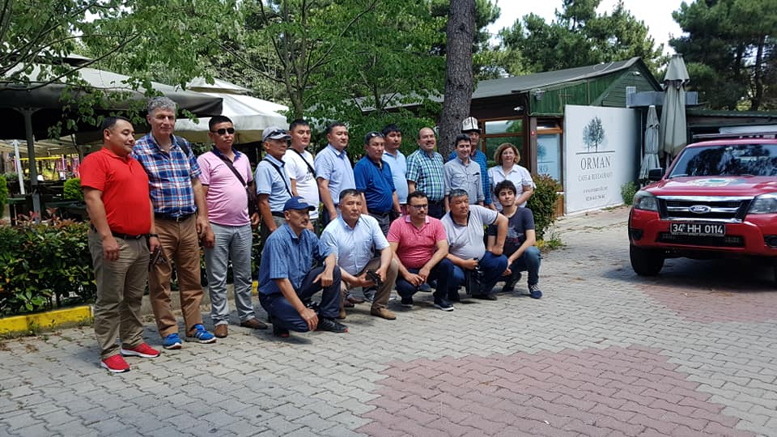
After lunch, with the line of the program approved by FAO, participants visited to historical and cultural sites of Istanbul.
Then they arrived to the “Divan Istanbul City” hotel.https://www.divan.com.tr/divan-istanbul-city/t
After check-in the hotel, a detailed information meeting was held with the participation of İsmail Belen and Nihat Karakaya.
In this meeting;
- Participants, consultant, trainer introduced themselves in detail. Also detailed information about Turkey and Turkish culture were provided.
- The Agenda of the Training Program has been reviewed in detail in line with its version published at http://www.gonder.org.tr/?p=8496
- The Agenda prepared in three languages (English, Russian and Turkish) has been distributed to the participants.
- Bags, badges, table cards, flash disks, brochures with Russian language are presented to them.
- The WhatsApp group prepared for this training programme was activated.
- Mobile Wi-Fi was installed and introduced to the participants.
Please see these videos for more ınformation:
- The meeting room prepared at the hotel : https://www.youtube.com/watch?v=XjUADRnLn0U
- Meeting records in Turkish and Russian https://www.youtube.com/watch?v=05EN9EZPXxM
- Video records of Kyrgyz participants https://www.youtube.com/watch?v=vQ3e0TReK7s
After this meeting, participants were able to visit Istanbul and had dinner

Figure 2 First Day Meeting  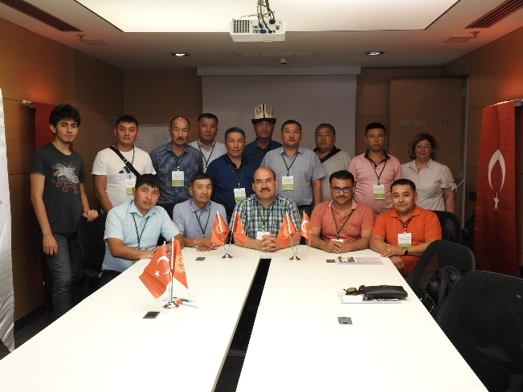 | Figure 3 Meeting room at the hotel  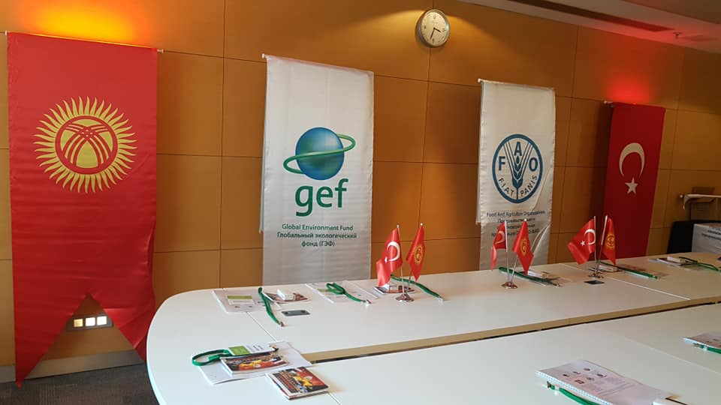

Day 2-June 18, 2019 Tuesday
The second day program was implemented as follows.

2 | 18 June 2018 Tuesday | 07:00-08:00 | Breakfast | İstanbul
2 | 18 June 2018 Tuesday | 08:00-10:00 | Depart for Sea Bus | İstanbul
2 | 18 June 2018 Tuesday | 10:10-11:45 | Depart and arrival to Adalar District of Istanbul from Eminönü with Sea Bus | İstanbul
 | 18 June 2018 Tuesday | 12:00-13:00 | Meeting with the Officials of OGM in Adalar Forest Office
2 | 18 June 2018 Tuesday | 13:00-14:00 | Lunch | İstanbul
2 | 18 June 2018 Tuesday | 14:00-16:00 | Visit to Fire watch Tower of Adalar-Field Trip | İstanbul
2 | 18 June 2018 Tuesday | 16:00-18:00 | Depart for Sabiha Gökçen airport | İstanbul
2 | 18 June 2018 Tuesday | 19:20-20:35 | Flight to Antalya by TK7526 from Sabiha Gökçen Airport | Antalya
2 | 18 June 2018 Tuesday | 21:00-22:00 | Dinner in a restaurant in Antalya | Antalya
2 | 18 June 2018 Tuesday | 23:00 | Arrival to International Forestry Training Center  https://sfm.ogm.gov.tr/ | Antalya
2 | 18 June 2018 Tuesday | Night | Accommodation in the Center | Antalya

The participants departed from the hotel at 08:00 am on the second day .Due to field trip, they moved to Büyükada (Princes Island) of Istanbul. During the way to ferry they were able to see the cultural and historical places of Istanbul.
Figure 4 Map of Istanbul's Islands
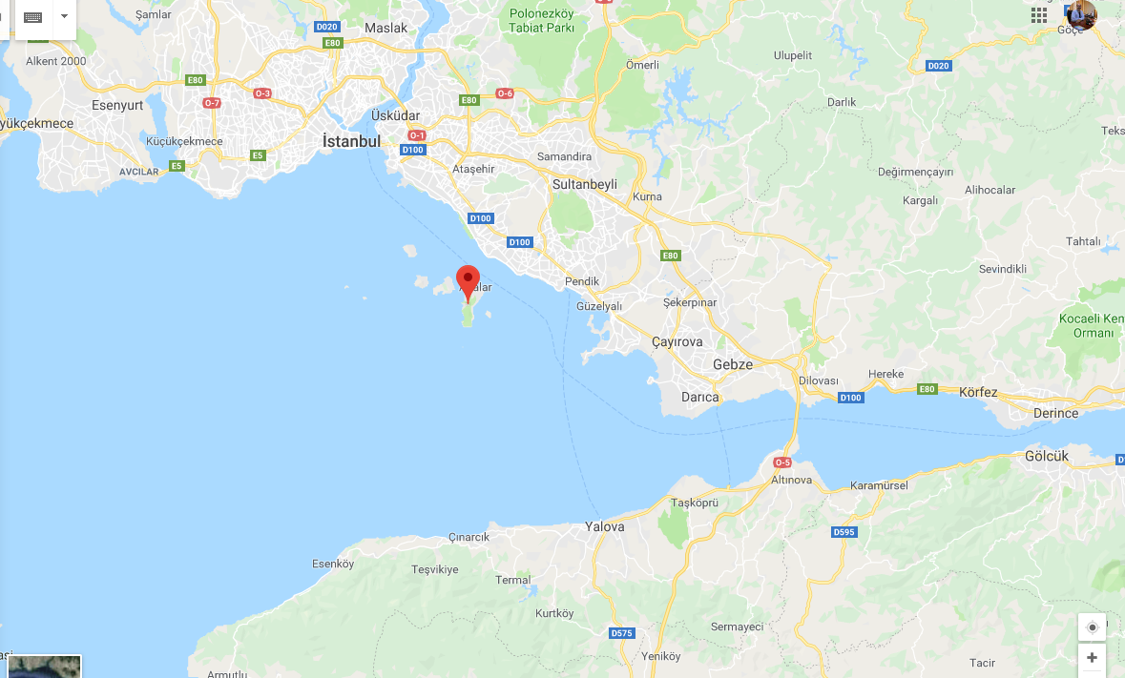

In addition to Kyrgyz participants, İsmail Belen on behalf of OMO and Nihat Karakaya on behalf of OGM joined to field trip. The delegation was welcomed by the Istanbul Forest Regional Directorate, Forest Fire Branch Director İkram Çelik and Kanlıca Forestry Directorate Adalar Forest Chief Ms. Seval Aktaş. They gave a detailed information about the islands and wildfires and activities carried out by Turkish Foresters.
Figure 5 Presentation about Turkey's Activities of Forest Fires
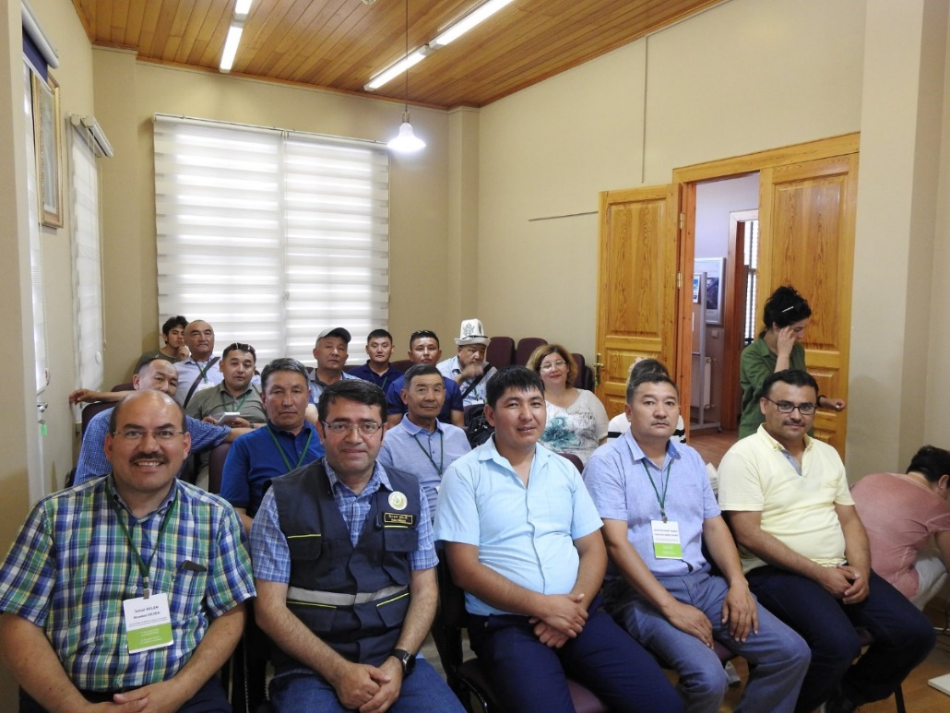
After presentations the Island Fire Tower was visited and a detailed information given by relevant officials.
Figure 6 Example of Turkey's Activities at the fiel
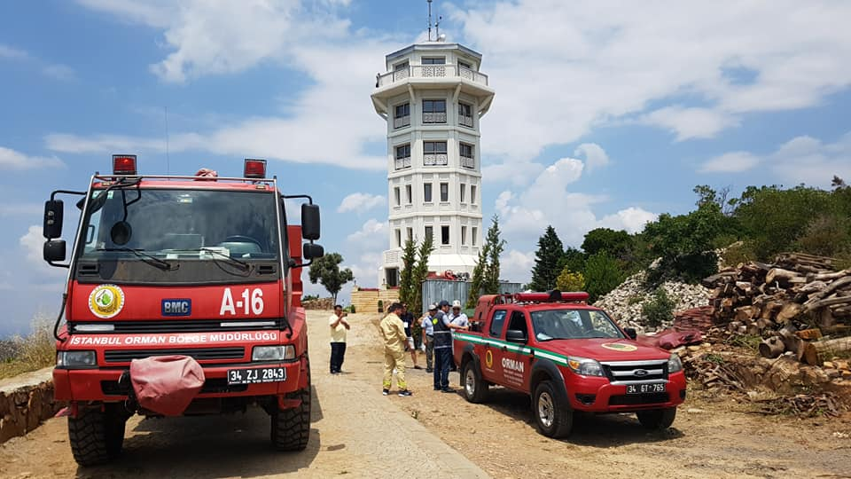
Figure 7 The participants were informed in detail about Turkey's applications.
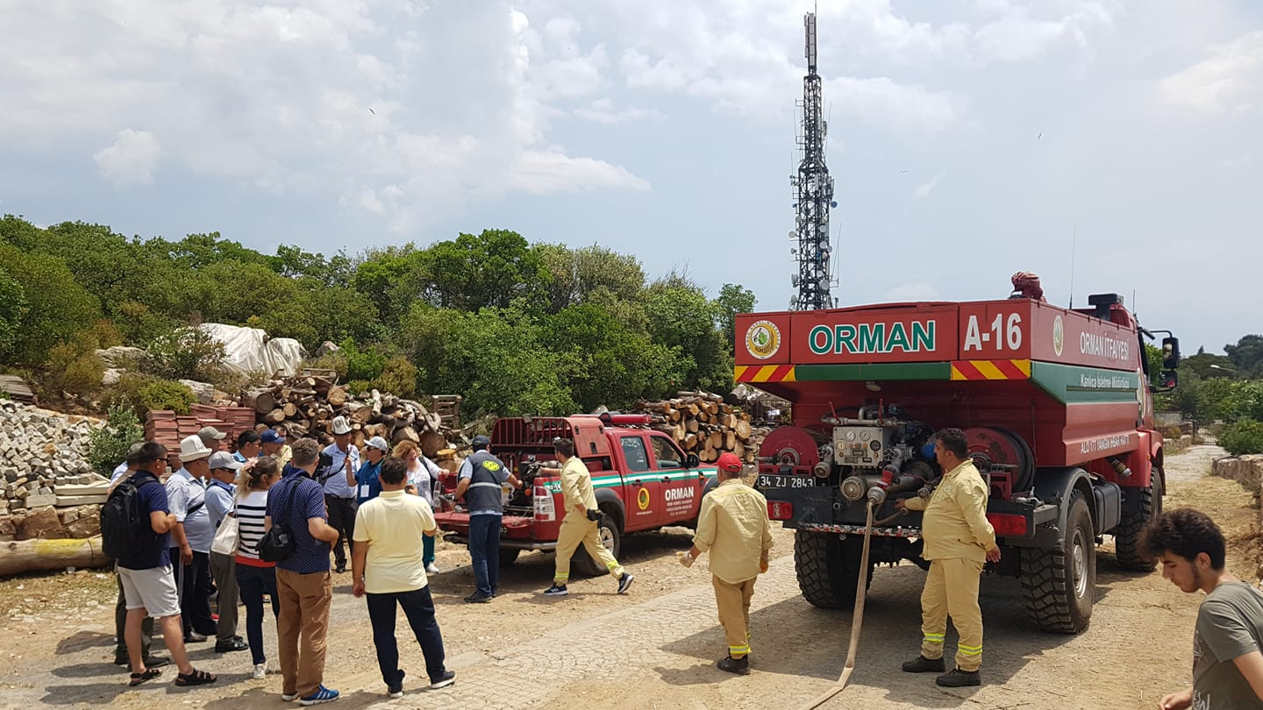

Web coverage of the second day can be found here at this following link: http://www.gonder.org.tr/?p=8572
Also the video is here: https://www.youtube.com/watch?v=vq8YLyBWWUw
https://www.facebook.com/ismail.belen2/videos/pcb.1978407748930193/1978624528908515/?type=3&theater

Day 3-June 19, 2019, Wednesday
The third day of the program has been implemented as follows:
3 | 19 June 2019 Wednesday | 09:00-10:00 | Breakfast | Antalya
3 | 19 June 2019 Wednesday | 10:00-11:00 | Opening Session of the training | Antalya
3 | 19 June 2019 Wednesday | 11:00:-12:00 | Turkish Forests and Forestry | Antalya
3 | 19 June 2019 Wednesday | 12:00-14:00 | Lunch | Antalya
3 | 19 June 2019 Wednesday | 14:00-16:00 | Computer Based Training Module | Antalya
3 | 19 June 2019 Wednesday | 16:00-16:30 | Coffee Break | Antalya
3 | 19 June 2019 Wednesday | 16:30-18:30 | Computer Based Training Module | Antalya
3 | 19 June 2019 Wednesday | 19:00 | Dinner | Antalya
3 | 19 June 2019 Wednesday | Night | Accommodation in the Center | Antalya

After the program held in Istanbul, delegation came to Antalya. The program at the International Forestry Training Center in Antalya started at 10:00 in the morning. In addition to the Kyrgyz participants, officials, led by Vedat Dikici, the Regional Director of Antalya also participated. Representatives from provincial and national news agencies were also present.
Figure 8 Official Opening Ceremony of Third Training Program in Antalya
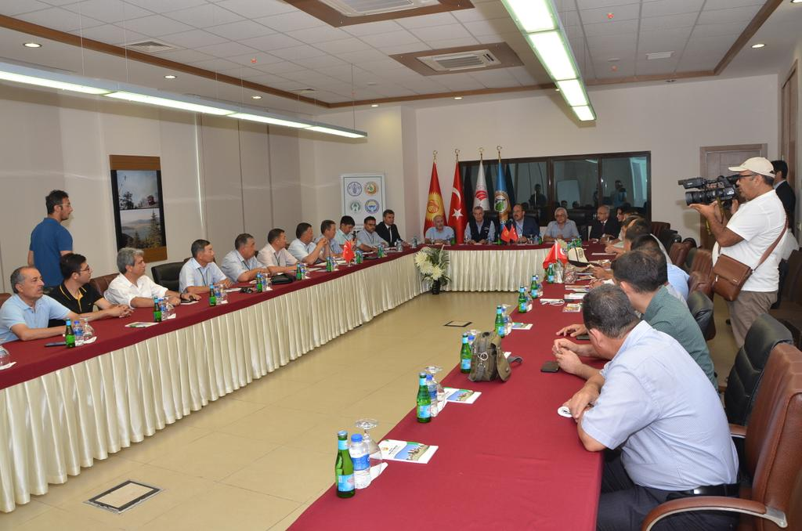

News related to the training program and its opening ceremony published at regional gazettes and web pages.
Figure 9 News on third training program
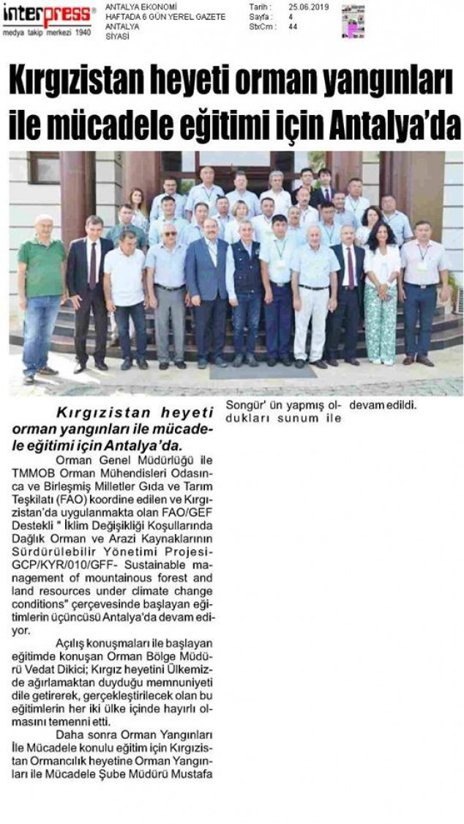
Web coverage of this day can be found at this following link: http://www.gonder.org.tr/?p=8590
During this day participants were able to understand Turkish strategy and system on forest fires and got familiar computer based training module.

Day 4- June 20, Thursday
At the fourth day of the training program, the trainers gave detailed information about Turkish experiences and system for combating forest fires. During this day several presentations and videos have been used to explain all details. They also used “computer based training modules”

4 | 20 June 2019 Thursday | 08:00-09:00 | Breakfast | Antalya
4 | 20 June 2019 Thursday | 09:00-10:30 | Computer Based Training Module | Antalya
4 | 20 June 2019 Thursday | 10:30-11:00 | Coffee Break | Antalya
4 | 20 June 2019 Thursday | 11:00-12:30 | Computer Based Training Module | Antalya
4 | 20 June 2019 Thursday | 12:30-14:00 | Lunch | Antalya
4 | 20 June 2019 Thursday | 14:00-16:00 | Computer Based Training Module | Antalya
4 | 20 June 2019 Thursday | 16:00-16:30 | Coffee Break | Antalya
4 | 20 June 2019 Thursday | 16:30-18:30 | Computer Based Training Module | Antalya
4 | 20 June 2019 Thursday | 19:00 | Dinner | Antalya
4 | 20 June 2019 Thursday | Night | Accommodation in the Center | Antalya

Day 5-June 21, Friday
After theoretical information provided by trainers, at the fifth day of the program participants started to use simulation center and special room decorated for this aim with the highly qualified trainers and translators who are familiar with forestry.
Here, firstly, how the simulation works, how it is used and its logic are explained. Afterwards, the whole team was divided into three groups and a small forest fire was started and the separate teams were intervened in their own fires and the simulation system was explained and applied. In the afternoon part of the program, the simulation continued with the intervention of forest fire.
5 | 21 June 2019 Friday | 08:00-09:00 | Breakfast | Antalya
5 | 21 June 2019 Friday | 09:00-10:30 | Computer Based Training Module (Simulation Center) | Antalya
5 | 21 June 2019 Friday | 10:30-11:00 | Coffee Break | Antalya
5 | 21 June 2019 Friday | 11:00-12:30 | Computer Based Training Module (Simulation Center) | Antalya
5 | 21 June 2019 Friday | 12:30-14:00 | Lunch | Antalya
5 | 21 June 2019 Friday | 14:00-16:00 | Computer Based Training Module (Simulation Center) | Antalya
5 | 21 June 2019 Friday | 16:00-16:30 | Coffee Break | Antalya
5 | 21 June 2019 Friday | 16:30-18:30 | Computer Based Training Module (Simulation Center) | Antalya
5 | 21 June 2019 Friday | 19:00 | Dinner | Antalya
5 | 21 June 2019 Friday | Night | Accommodation in the Center | Antalya

Day 6-June 22, Saturday
The sixth day of the training continued at the simulation center. Today, a big forest fire was launched on the simulation. Kyrgyz participants were divided into a small number of teams as applied in real forest fires.
Figure 10 Simulation Center
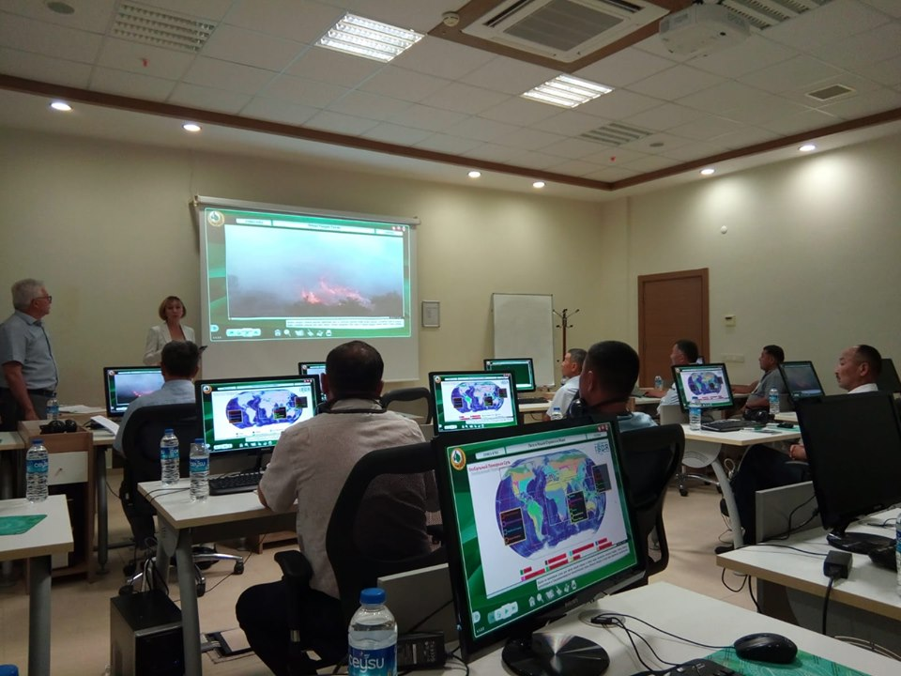
Also, a fire supervisor was identified in accordance with the system applied in real fires. Before the simulation started, the fire supervisor and the teams discussed in detail how to respond to the fire.
Then, with the commands of the fire supervisor, teams deployed in different parts of the forest were transferred to the fire. The fire lasted about 2 hours and was successfully put out. Then all the teams gathered, how to intervene in the fire, what they should do, what should not do by the trainers were explained one by one.
Figure 11 Simulation Center
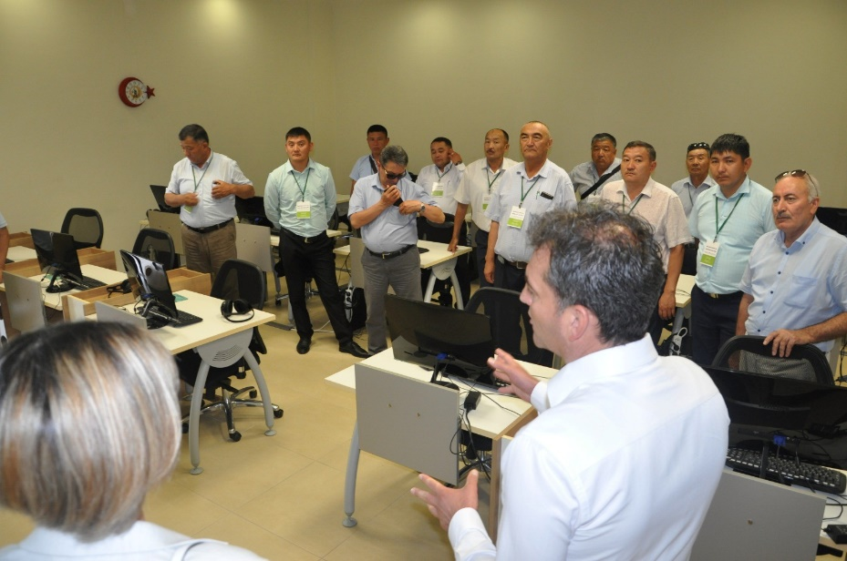
Finally, the actual photographs related to forest fires in Turkey and videos were shown. How to intervene in fire was explained one by one. The training was completed by discussing the lessons learned from the interventions.
6 | 22 June 2019 Saturday | 08:00-09:00 | Breakfast | Antalya
6 | 22 June 2019 Saturday | 09:00-10:30 | Computer Based Training Module (Simulation Center) | Antalya
6 | 22 June 2019 Saturday | 10:30-11:00 | Coffee Break | Antalya
6 | 22 June 2019 Saturday | 11:00-12:30 | Computer Based Training Module (Simulation Center) | Antalya
6 | 22 June 2019 Saturday | 12:30-14:00 | Lunch | Antalya
6 | 22 June 2019 Saturday | 14:00-16:00 | Computer Based Training Module (Simulation Center) | Antalya
6 | 22 June 2019 Saturday | 16:00-16:30 | Coffee Break | Antalya
6 | 22 June 2019 Saturday | 16:30-18:30 | Computer Based Training Module (Simulation Center) | Antalya
6 | 22 June 2019 Saturday | 19:00 | Dinner | Antalya
6 | 22 June 2019 Saturday | Night | Accommodation in the Center | Antalya

Day 7-June 23, Sunday

7 | 23 June 2019 Sunday | 07:00-08:00 | Breakfast | Antalya
7 | 23 June 2019 Sunday | 08:00-13:00 | Field Trip | Antalya
7 | 23 June 2019 Sunday | 13:00-15:00 | Lunch | Antalya
7 | 23 June 2019 Sunday | 15:00-19:00 | Field Trip | Antalya
7 | 23 June 2019 Sunday | Night | Accommodation in the Center | Antalya

On Sunday, June 23rd, the seventh day of the program, a field survey was conducted around and inside the Training Center. Participants were allowed to observe and evaluate on their own. Then, the historical and cultural places of Antalya were visited.
For web page coverage: http://www.gonder.org.tr/?p=8598

Day 8-June 24, Monday

8 | 24 June 2019 Monday | 09:00 | Breakfast | Antalya
8 | 24 June 2019 Monday | 10:00-12:00 | Field Trip (Possible Fire Areas) | Antalya
8 | 24 June 2019 Monday | 12:00-13:00 | Lunch | Antalya
8 | 24 June 2019 Monday | 14:00-19:00 | Field trip-Post-fire rehabilitation activities- | Antalya
8 | 24 June 2019 Monday | 20:00 | Dinner | Antalya
8 | 24 June 2019 Monday | Night | Accommodation in the Center | Antalya

On June 24, 2019, which is the eighth day of the program, the field survey and implementation was conducted again. In this context, we went to the land early in the morning. In 2016, the fire in the town of Kumluca in Antalya, extinguishing the fire and post-fire the studies were examined.
https://www.haberturk.com/gundem/haber/1259038-kumlucadaki-yangin-kontrol-altina-al
In 2016, a total of 1350 ha area was damaged in this fire in Kumluca. The fire resulted from the electrical lines lasted about a week. This fire was intervened with 4 amphibious aircraft, 9 helicopters, 60 fire tracks and 500 workers.
During this training, the participants were explained in detail how this intervention was done and how coordination was provided. Lessons learned are explained. In this way, the participants had the opportunity to compare what they saw in the simulation center and those applied in the field.
Then, the burning forest area in Adrasan, in 2014, was visited.
http://www.hurriyet.com.tr/gundem/adrasan-yangini-16-5-saatte-kontrol-altina-alindi-125-hektar-orman-yandi-26703798
Adrasan Region has been evaluated as a very dangerous fire because of its tourism potential and being close to settlements, especially hotels.
The fire was intervened within 12 minutes of receiving the notification. However, due to weather and terrain conditions, the struggle took a long time.
Here, silviculture (forest maintenance) studies after fire were explained to the participants one by one. The questions were answered. Then the fire area of ​​Olympus was examined. Here, "Fire Memory Point" created after the fire was visited.
Figure 12 Field Exercise in Antalya
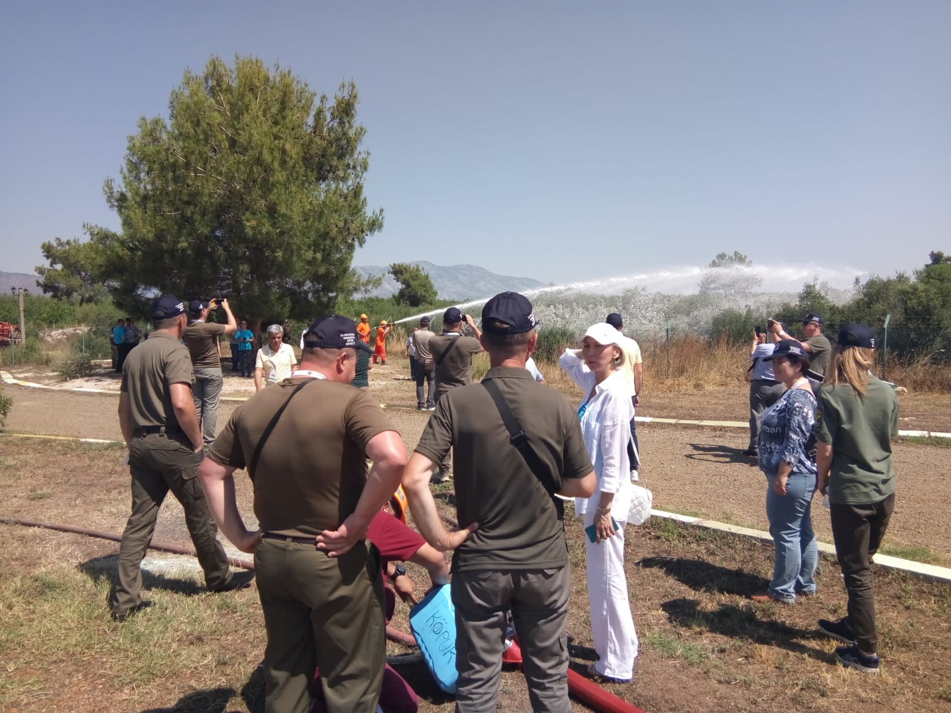
With the help of this field trip and land examination held on June 24, 2019 Kyrgyz participants had opportunity to see Turkey’s field studies.
http://www.gonder.org.tr/?p=8600

Day 9-June 25, Tuesday

9 | 25 June 2019 Tuesday | 09:00 | Breakfast | Antalya
9 | 25 June 2019 Tuesday | 10:00-12:00 | Evaluation meeting at the training center | Antalya
9 | 25 June 2019 Tuesday | 12:00-13:00 | Lunch
9 | 25 June 2019 Tuesday | 13:00 | Check Out from Training Center | Antalya
9 | 25 June 2019 Tuesday | 13:30-15:30 | City tour in Antalya
9 | 25 June 2019 Tuesday | 16:00 | Arrival to Antalya Airport
9 | 25 June 2019 Tuesday | 17:000-18:10 | Flight to Sabiha Gökçen from Antalya with TK7529
9 | 25 June 2019 Tuesday | 22:55 | PC 702 ISTANBUL SAW - ISHKEK FRU 2255 0700+1

Theoretical and practical trainings continued on Tuesday, June 25, 2019, which is the ninth day of the training.
In this context, a field exercise was organized. In this exercise, clothing and equipment used by workers in forest fires are shown. In Turkey a great attention is given to safety in fire. In this context, personal protective equipment is provided to the officials. During field exercise, personal protective equipment is shown and explained one by one.
Figure 13 Forest Fire Tracks
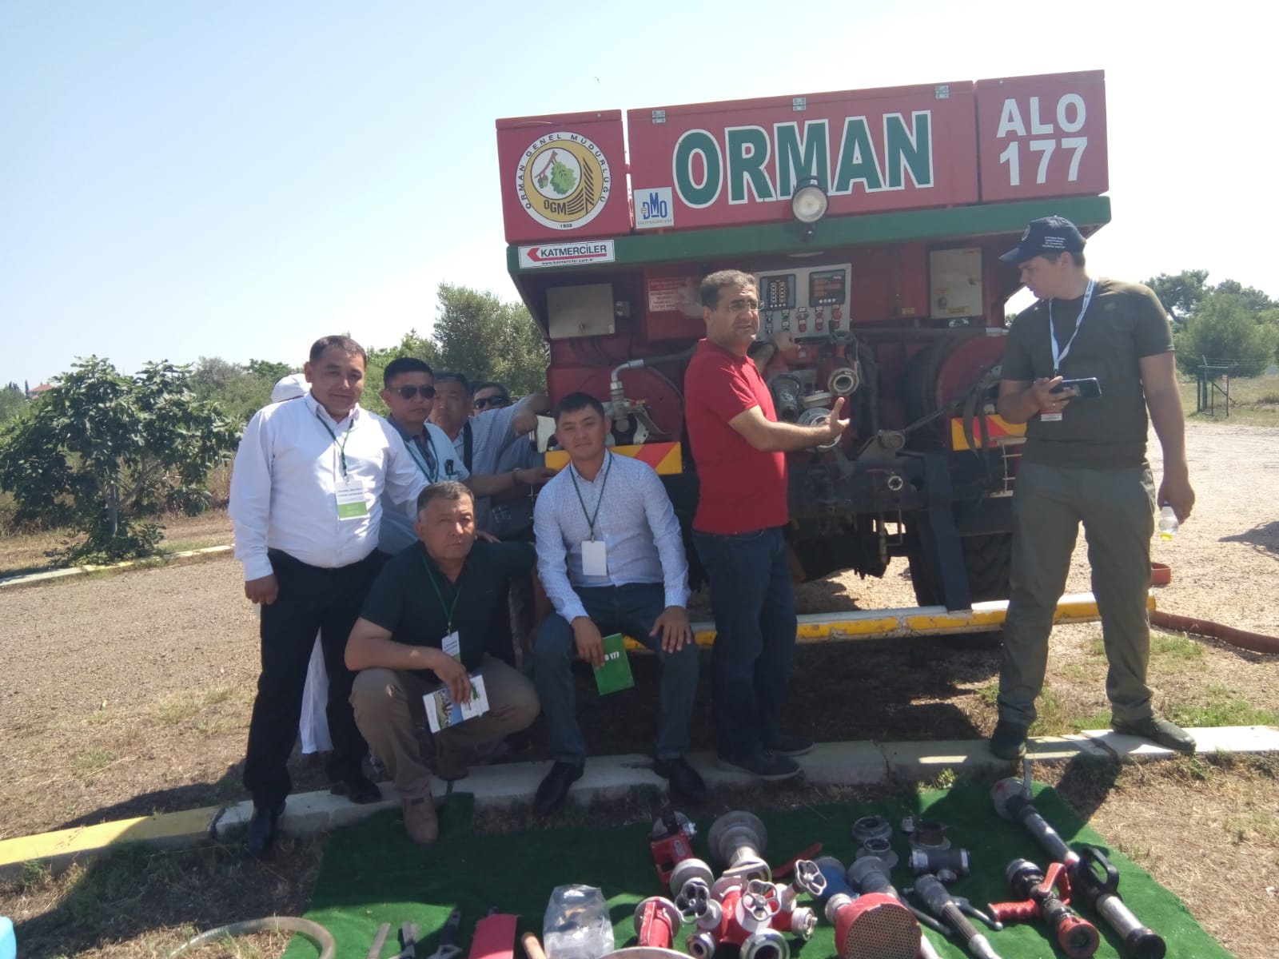
When an alert received about any forest fire, reaching to area as soon as possible is very important. For that reason Turkey uses small vehicles called first responders equipped for that aim. Than fire tracks come. Exercises were also held to introduce this vehicles.

After that field exercise, Ilhami Aydın, Deputy Head of Forest Fires Department, General Directorate of Forestry, made a presentation. In this presentation, electronic systems, unmanned aerial vehicles and software used by Turkey in combating forest fires are introduced.

Figure 14 Farewell at the Airport
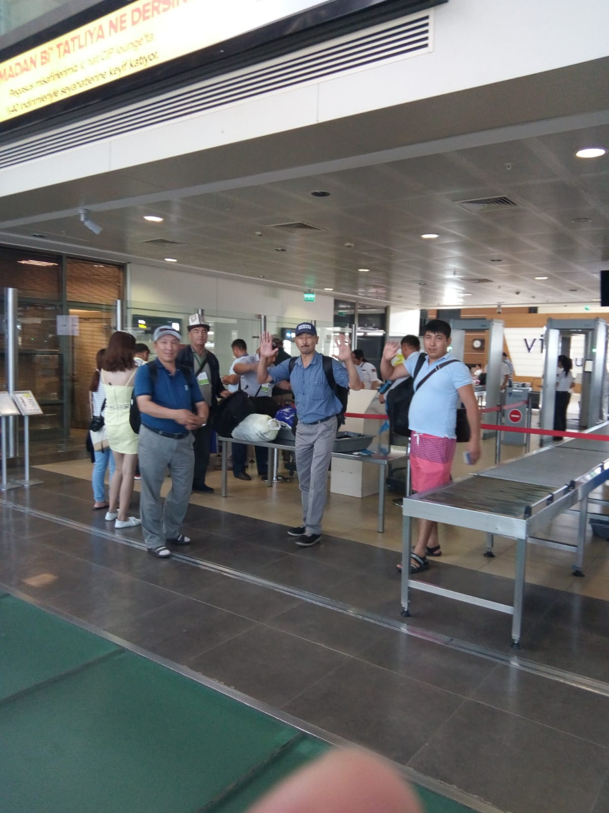
Following the completion of the training, the Kyrgyz participants were taken to the Antalya airport. They were boarded without any problem. In Istanbul, measures were taken in the same way and the transition from domestic lines to international lines was ensured. The interpreter assigned by the Forest Engineers assisted the passport process of the participants and the delegation was boarded safely.
http://www.gonder.org.tr/?p=8602

Day 10- June 26, Wednesday
10 26 June 2019 Wednesday 05:40 Arrival to Bishkek Airport with TK 348 Bishkek
http://www.gonder.org.tr/?p=8604

Conclusion
This training, which was planned in cooperation with the United Nations Food and Agriculture Organization and the Chamber of Forest Engineers, was implemented in accordance with its schedule and budget.
Participants has seen the theoretical and practical applications of Turkey. The participants personally monitored and implemented how a real fire could be managed in the simulation center. They also examined all the details in the field.
Pre-fireworks, fire extinguishing works and post-fireworks are shown in all aspects.
As a result, a highly successful training program was realized.
The interest of participants, to follow the program was welcomed by Turkey. It is considered that highly accurate and interested people have participated in the program.
We would like to take this opportunity to thank the FAO Kyrgyzstan team and the Kyrgyzstan Forest Organization. Also, as the Chamber of Forest Engineers we would like to thank to the General Directorate of Forests of Turkey.

