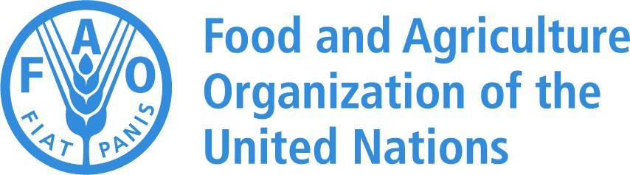

Guidelines on the Implementation of Nature-Based Solutions (NbSs) to Combat the Negative Impact of Climate Change on Forestry for the FAO-SEC Countries



Guidelines on the Implementation of Nature-Based Solutions (NbSs) to Combat the Negative Impact of Climate Change on Forestry for the FAO-SEC Countries

FOOD AND AGRICULTURE ORGANIZATION OF THE UNITED NATIONS
Ankara, 2023
Required citation:
Bassullu C., Belen, I. Kaptanoglu, E., 2023. Guidelines on the Implementation of Nature-Based Solutions (NbSs) to Combat the Negative Impact of Climate Change on Forestry for the FAO-SEC Countries. Ankara. [Add full DOI link will be provided by OCCP]

The designations employed and the presentation of material in this information product do not imply the expression of any opinion whatsoever on the part of the Food and Agriculture Organization of the United Nations (FAO) concerning the legal or development status of any country, territory, city or area or of its authorities, or concerning the delimitation of its frontiers or boundaries. The mention of specific companies or products of manufacturers, whether or not these have been patented, does not imply that these have been endorsed or recommended by FAO in preference to others of a similar nature that are not mentioned.

The views expressed in this information product are those of the author(s) and do not necessarily reflect the views or policies of FAO.

ISBN [it will be provided later]
© FAO, 2023



Some rights reserved. This work is made available under the Creative Commons Attribution-NonCommercial-ShareAlike 3.0 IGO licence (CC BY-NC-SA 3.0 IGO; https://creativecommons.org/licenses/by-nc-sa/3.0/igo/legalcode).

Under the terms of this licence, this work may be copied, redistributed and adapted for non-commercial purposes, provided that the work is appropriately cited. In any use of this work, there should be no suggestion that FAO endorses any specific organization, products or services. The use of the FAO logo is not permitted. If the work is adapted, then it must be licensed under the same or equivalent Creative Commons licence. If a translation of this work is created, it must include the following disclaimer along with the required citation: "This translation was not created by the Food and Agriculture Organization of the United Nations (FAO). FAO is not responsible for the content or accuracy of this translation. The original [Language] edition shall be the authoritative edition."

Disputes arising under the licence that cannot be settled amicably will be resolved by mediation and arbitration as described in Article 8 of the licence except as otherwise provided herein. The applicable mediation rules will be the mediation rules of the World Intellectual Property Organization http://www.wipo.int/amc/en/mediation/rules and any arbitration will be conducted in accordance with the Arbitration Rules of the United Nations Commission on International Trade Law (UNCITRAL).

Third-party materials. Users wishing to reuse material from this work that is attributed to a third party, such as tables, figures or images, are responsible for determining whether permission is needed for that reuse and for obtaining permission from the copyright holder. The risk of claims resulting from infringement of any third-party-owned component in the work rests solely with the user.

Sales, rights and licensing. FAO information products are available on the FAO website (www.fao.org/publications) and can be purchased through publications-sales@fao.org. Requests for commercial use should be submitted via: www.fao.org/contact-us/licence-request. Queries regarding rights and licensing should be submitted to: copyright@fao.org.

Contents

Contents iii
Acknowledgements v
Abbreviations and acronyms vi
Currency, units, and symbols vi
Glossary vii
Executive summary ix

1. Introduction 1
1.1. Objectives of the guidelines 2
1.2. Target groups 3
2. Forests in the sub-region 3
3. Climate change in the sub-region 3
3.1. Observed impacts of climate change on forests 4
3.2. Anticipated impacts of climate change on forests 4
4. Nature-based solutions for forests 5
4.1. Definition of nature-based solution 5
4.2. Global frameworks promoting nature-based solutions 8
4.2.1. The Bonn Challenge 8
4.2.2. The New York Declaration on Forests 8
4.2.3. Sendai Framework for Disaster Risk Reduction 2015–2030 8
4.2.4. Land Degradation Neutrality Target Setting Programme 8
4.2.5. United Nations Strategic Plan for Forests 2030 9
4.2.6. UNCCD 2018-2030 Strategic Framework 9
4.2.7. The United Nations Decade on Ecosystem Restoration 9
4.2.8. Post-2020 Global Biodiversity Framework 9
4.2.9. Glasgow Leaders’ Declaration on Forests and Land Use 9
4.3. Global and regional initiatives, platforms, projects, and examples 9
4.3.1. Nature-based Solutions Policy Platform 9
4.3.2. Nature-based Solutions Evidence Platform 9
4.3.3. The Nature-based Solutions Initiative 10
4.3.4. The Global Program on Nature-based Solutions 10
4.3.5. Nature-based Solutions for Adaptation 10
4.3.6. Nature-based Solutions 10
4.3.7. Nature-based Solutions Investment 10
4.3.8. Nature Based Solutions Institute 10
4.3.9. Trees in Cities Challenge 11
4.3.10. Nature-based Solutions 2022 Project 11
4.3.11. Issue-Based Coalition on Environment and Climate Change in Europe and Central Asia Region 11
4.3.12. Critical Ecosystem Partnership Fund 12
4.3.13. Other initiatives 12
4.4. Current NbS implementation: Examples from the sub-region 14
4.4.1. Nationally Determined Contributions 14
4.4.2. Field implementation 14
5. Suitable nature-based solution approaches for sub-region forests under climate change 17
5.1. Ecosystem restoration approaches 17
5.1.1. Ecological (ecosystem) restoration 17
5.1.2. Forest landscape restoration 18
5.1.3. Ecological engineering 19
5.2. Infrastructure-related approaches 20
5.2.1. Green infrastructure 20
5.2.2. Natural infrastructure 21
5.2.3. Trees outside forests 23
5.3. Ecosystem-based management approaches 23
5.3.1. Improved forest management 23
5.3.2. Natural forest management and improved plantations 23
5.3.3. Adaptive forest management 24
5.3.4. Integrated (sustainable) natural resource/land management 24
5.3.5. Natural regeneration and assisted natural regeneration 24
5.4. Issue-specific ecosystem-related approaches 25
5.4.1. Ecosystem-based adaptation 25
5.4.2. Ecosystem-based mitigation 26
5.4.3. Ecosystem-based disaster risk reduction 26
5.4.4. Climate adaptation services 26
5.5. Ecosystem protection and conservation approaches 26
5.5.1. Area-based conservation and protected area management 26
5.5.2. Assisted migration of native tree species 28
5.5.3. Improved fire management 28
5.5.4. Pest and disease management 29
5.5.5. Conservation of old forests 29
6. Applicability of NbSs in the sub-region 29
7. Investments in nature-based solutions 31
8. Conclusion 31
9. References 32
10. Annex: FAO NbS resources 38

Acknowledgements

The Chamber of Forest Engineers of Türkiye (OMO) compiled the "Guidelines on the Implementation of Nature-Based Solutions (NbSs) to Combat the Negative Impact of Climate Change on Forestry for the FAO-SEC Countries" in close cooperation with the Food and Agriculture Organization of the United Nations (FAO) Subregional Office for Central Asia (SEC).

The authors of these Guidelines are Dr Caglar Bassullu, Mr Ismail Belen, and Mr Ercan Kaptanoglu. The document was developed under the supervision of Dr Peter Pechacek, Forestry Officer at FAO-SEC, and in consultation with Mr Burak Avcioglu and Mr Cuma Uykun, Junior Technical Officers at FAO-SEC, Ankara/Türkiye.

The Guidelines aim at compiling and systematizing relevant and up-to-date information on nature-based solutions (NbSs) to combat the negative impact of climate change on forestry for the FAO-SEC sub-region.

OMO would like to express its gratitude to the FAO-SEC for its leadership and guidance during the development of the Guidelines and the resource persons, namely, Mr Akif Habilov (Azerbaijan), Mr Madi Nurpesiov (Kazakhstan), Mr Aitkul Burkhanov (Kyrgyzstan), Mr Saidjamolov Naimjon (Tajikistan), Mr Hasan Yılmaztürk (Türkiye), Mr Özgür Balcı (Türkiye), Mr İsmail Hakkı Güney (Türkiye), Mr İbrahim Ergüven (Türkiye), Ms Fevziye Aslan (Türkiye), Ms Hande Bilir (Türkiye), Dr Hülya Kılıç Hernandez (Türkiye), Mr Handurdy Turayev (Turkmenistan), and Mr Abduvokhid Zakhadullaev (Uzbekistan). They also shared their thoughts and contributions with the OMO team on implementing NbSs to combat the negative impact of climate change on forestry for the FAO-SEC countries.

OMO would like to thank Mr Aykut İnce for providing unique photographs for the Guidelines.

The views expressed in this information product are those of the authors and do not necessarily reflect the views or policies of FAO.

Abbreviations and acronyms

AFoCO Asian Forest Cooperation Organization
ANR assisted natural regeneration
CAS climate adaptation services
CBD Convention on Biological Diversity
CEPF Critical Ecosystem Partnership Fund
EbA ecosystem-based adaptation
EbM ecosystem-based mitigation
Eco-DRR ecosystem-based disaster risk reduction
FAO Food and Agriculture Organization of the United Nations
FLR Forest Landscape Restoration
GHG greenhouse gas
ICRAF World Agroforestry
IFM improved forest management
INRM integrated natural resource management
IUCN International Union for Conservation of Nature
LDN land degradation neutrality
LULUCF Land Use, Land Use Change, and Forestry
NbS nature-based solution
NBSI Nature Based Solutions Institute
NCS natural climate solution
NDC nationally determined contribution
NYDF New York Declaration on Forests
OECD Organisation for Economic Cooperation and Development
OMO Chamber of Forest Engineers of Türkiye
REDD+ Reducing emissions from deforestation and forest degradation, and the role of conservation, sustainable management of forests, and enhancement of forest carbon stocks in developing countries
SDG Sustainable Development Goal
SEC FAO Subregional Office for Central Asia
SFM sustainable forest management
UN United Nations
UNCCD United Nations Convention to Combat Desertification
UNDP United Nations Development Programme
UNECE United Nations Economic Commission for Europe
UNEP United Nations Environment Programme
UNFCCC United Nations Framework Convention on Climate Change
UNFF United Nations Forum on Forests
UN-Habitat United Nations Human Settlements Programme
WRI World Resources Institute

Currency, units, and symbols

CO₂ carbon dioxide
CO₂e carbon dioxide equivalent
°C degree Celsius
ha hectare
USD United States dollar

Glossary

Adaptive forest management is a fundamental, flexible, reactive, and anticipatory approach to reducing forest vulnerability and maintaining forest productivity (FAO, 2010c).

An urban forest is a group of trees and other woody vegetation in and around human settlements (McLean et al., 2020).

Assisted migration of native tree species includes managing species to areas where they are not yet present and introducing better-suited populations within species (FAO, 2015).

Assisted natural regeneration could be defined as rehabilitating clear-cut forest lands by taking advantage of trees growing in the surrounding area (Department of Environment and Natural Resources, 2023).

Climate change means “a change of climate which is attributed directly or indirectly to human activity that alters the composition of the global atmosphere and which is in addition to natural climate variability observed over comparable time periods” (UN, 1992).
Climate change adaptation refers to changes in management practices and interventions to decrease the vulnerability of forests and people to climate change (FAO, 2010a).

Climate change mitigation refers to reducing emissions from deforestation, reducing emissions from forest degradation, enhancing forest carbon sinks, and product substitution (FAO, 2010a).

Ecological engineering encompasses creating and restoring sustainable ecosystems that have value for humans and nature (Mitsch and Jørgensen, 2004).

Ecological (ecosystem) restoration is the process of assisting the recovery of a degraded, damaged, or destroyed ecosystem to reflect values regarded as inherent in the ecosystem and to provide goods and services that people value (Martin, 2017).

Forest Landscape Restoration is a process to retrieve deforested or degraded landscapes' ecological functionality and integrity and improve human well-being (Mansourian et al., 2005; Maginnis and Jackson, 2012).

Ecosystem-based Adaptation is the “sustainable management, conservation and restoration of ecosystems, as part of an overall adaptation strategy that considers the multiple social, economic and cultural co-benefits for local communities” (CBD, 2010).

Ecosystem-based Disaster Risk Reduction is ″the sustainable management, conservation, and restoration of ecosystems to reduce disaster risk, intending to achieve sustainable and resilient development" (Estrella and Saalismaa, 2013).

Ecosystem-based Mitigation focuses on carbon sequestration and storage and avoiding GHG emissions in ecosystems to ensure ecosystem functionality, human health, and socio-economic security.

Green infrastructure is “a strategically planned network of natural and semi-natural areas with other environmental features, designed and managed to deliver a wide range of ecosystem services while also enhancing biodiversity” (European Commission, 2013).

Improved fire management includes fuel management (i.e. maintenance, weeding, and litter control), fire occurrence prediction, fire prevention, fire detection, initial attack and suppression, and forest restoration.

Improved forest management is a practical methodology under NbS approaches, particularly NCSs, covering several silvicultural activities that enhance carbon stocks in carbon pools and reduce GHG emissions to improve the climate change mitigation potential of forests (Griscom et al., 2017; Fargione et al., 2018; Drever et al., 2021; Kaarakka et al., 2021).

Integrated natural resource management or integrated (sustainable) land management is the coordination and cooperation among stakeholders to implement sustainable forest, land, water, and biological resource and watershed/micro catchment management to combat the negative impacts of climate change holistically.

Land Degradation Neutrality is “a state whereby the amount and quality of land resources, necessary to support ecosystem functions and services and enhance food security, remains stable or increases within specified temporal and spatial scales and ecosystems” (UNCCD, 2019).
Nature-based solutions are ″actions to protect, conserve, restore, sustainably use and manage natural or modified terrestrial, freshwater, coastal and marine ecosystems which address social, economic and environmental challenges effectively and adaptively, while simultaneously providing human well-being, ecosystem services, resilience, and biodiversity benefits″ (UNEP, 2022).

Natural climate solutions target climate change mitigation beyond business-as-usual (i.e. carbon sequestration and storage and GHG emissions reduction) (Teo et al., 2021).

Natural forest management refers to the reduced logging/harvest impact, designation of set-aside areas for protection from logging activity, and extended timber harvest cycles in natural forests under extractive management (Fargione et al., 2018; Roe et al.., 2021).

Natural regeneration is the process by which forests are restocked by trees that develop from seeds falling from the mother trees and germinating in situ or sprouting from stumps and roots (Forest Research, 2023).

REDD+ refers to reducing emissions from deforestation and forest degradation and the role of conservation, sustainable management of forests, and enhancement of forest carbon stocks in developing countries (UNFCCC, 2010).

Sustainable forest management is "a dynamic and evolving concept that aims to maintain and enhance the economic, social and environmental values of all types of forests, for the benefit of present and future generations" (UN, 2016).

Executive summary

Climate change is one of the most critical social and environmental concerns and the biggest threat to economic stability in human history. Türkiye, Azerbaijan, and Central Asia countries, namely Kazakhstan, Kyrgyzstan, Tajikistan, Turkmenistan, and Uzbekistan, are vulnerable to the negative impacts of climate change. Although average forest cover is only 10.2 percent of these countries (FAO-SEC countries), they play an essential role in climate change mitigation and adaptation, including human well-being and biodiversity co-benefits.

The NbS concept has gained attention since the late 2000s. Its practical contribution to global climate change mitigation and adaptation efforts has found significant implementation opportunities in forestry to support the protection and conservation, restoration and expansion, and sustainable management of forests under the impact of climate change.

Globally, implementing NbSs to combat the negative impact of climate change on forestry is promoted by the United Nations Forum on Forests (UNFF), United Nations Framework Convention on Climate Change (UNFCCC), the Paris Agreement, United Nations Convention to Combat Desertification (UNCCD), Convention on Biological Diversity (CBD), the United Nations Human Settlements Programme (UN-Habitat), and the 2030 Agenda for Sustainable Development.

Regionally, implementing NbSs to combat the negative impacts of climate change on forestry has been included in the forest policy initiatives of the countries in the sub-region recently. As a result, governments have implemented NbSs through national strategies and programs to address societal challenges by enhancing ecosystem services and promoting human well-being and biodiversity co-benefits. For example, Azerbaijan has implemented afforestation, reforestation, rehabilitation, and restoration activities in forest fund lands on an average of 9 727 hectares (ha) annually since 2000. Kazakhstan aims to save the Aral Sea basin from salinity and improve soil fertility through afforestation activities of saxaul species on 0.25 million ha, and the afforestation area in the Aral Sea will be extended by 1 million ha till 2025. Kyrgyzstan has planned a 1 000-ha annual plantation program to expand protected natural areas to 10 percent. Tajikistan implements 2 000 ha of annual plantation activities to increase the greenhouse gas (GHG) mitigation potential through participatory forestry sector development. Türkiye implemented afforestation, soil conservation, forest rehabilitation, pasture rehabilitation, private afforestation, artificial regeneration, and establishment of energy forests activities on 9.62 million ha from 1946 to 2022. Turkmenistan conducts afforestation activities with drought-resistant plant species and established the "Golden Century Lake" in the Karakum Desert to improve the climate conditions and conserve biodiversity. Uzbekistan declared the Aral Sea region an environmental protection area and plans to implement afforestation activities on 0.5 million ha until 2030 to create the green cover zone.

The theoretical part of these Guidelines is intended to serve as a reference to provide brief information on forest cover and climate change trends in the sub-region, improve understanding of the NbS concept for forests, and facilitate NbS implementation to enhance climate change mitigation and adaptation. The practical part of the Guidelines is centered around six topics:

- Global frameworks promoting the implementation of NbSs;
- Global and regional initiatives, platforms, projects, and examples;
- Current NbS implementation in the sub-region;
- Suitable NbS approaches for sub-region forests under climate change;
- Applicability of NbSs in the sub-region; and
- Investments in NbSs.

The broad global frameworks promoting the implementation of NbSs are Nationally Determined Contributions (NDCs), the Bonn Challenge, the New York Declaration on Forests, the Sendai Framework for Disaster Risk Reduction 2015–2030, Land Degradation Neutrality (LDN) Target Setting Programme, United Nations (UN) Strategic Plan for Forests, UNCCD 2018-2030 Strategic Framework, the United Nations Decade on Ecosystem Restoration, Post-2020 Global Biodiversity Framework, and the Glasgow Leaders’ Declaration on Forests and Land Use, executed by the UN agencies and national governments, supported by non-governmental organizations and the private sector. Several platforms, initiatives, projects, and examples have been established and developed globally and regionally to implement NbSs. Worldwide and sub-regional NbS implementation primarily focuses on three primary strategies: forest protection and conservation, forest ecosystem restoration and expansion, and sustainable management of forest resources. Forest protection and conservation mainly include protected area management, biodiversity conservation (i.e. in-situ and ex-situ conservation methodologies), existing forest protection (avoided forest conversion), improved fire management, and pest and disease management. Forest ecosystem restoration and expansion include revegetation, afforestation, reforestation, restoration, rehabilitation, and invasive species removal. Sustainable forest management covers improved forest management, adaptive forest management, avoided fuelwood, natural regeneration, and assisted natural regeneration. Suitable NbSs for sub-region forests under climate change are synthesized and categorized under the selected NbS approaches. To support regional and national efforts, these Guidelines offer selected NbSs to combat the negative impact of climate change. The selected NbS approaches include:
- Ecosystem restoration approaches;
- Infrastructure-related approaches;
- Ecosystem-based management approaches;
- Issue-specific ecosystem-related approaches; and
- Ecosystem protection and conservation approaches.

- Ecological (ecosystem) restoration approaches

Ecological restoration can extend forest area and tree coverage in the sub-region through revegetation, afforestation, reforestation, restoration, rehabilitation practices, and invasive species removal. These activities enhance the carbon sequestration and storage capacity of forests and strengthen the forest structure under the negative impacts of climate change. Similarly, Forest Landscape Restoration aims to regain ecological functionality and enhance human well-being in deforested or degraded landscapes.

- Infrastructure-related approaches

Urban trees, public open green spaces, green corridors, botanical gardens, arboretums, gardens, and parks are integral to green infrastructure, including ecosystem ponds, detention ponds, and detention pockets for flood control. Urban and peri-urban forests are natural infrastructures that play a critical role in climate change mitigation and adaptation and provide various forest ecosystem goods and services, such as wood, non-wood forest products, recreation, ecotourism, carbon sequestration and storage, soil and water conservation, and biodiversity conservation.

- Ecosystem-based management approaches

Improved forest management is a practical methodology covering several silvicultural activities that enhance carbon stocks in carbon pools and reduce GHG emissions to improve the climate change mitigation potential of forests. Adaptive forest management is fundamental to reducing forest vulnerability and maintaining forest productivity. Adaptation measures might include the selection of heat-tolerant and drought-tolerant species, using planting stock from a range of provenances, underplanting using tree varieties adapted to expected climatic conditions, and the assisted natural regeneration of adapted species and varieties. Integrated natural resource management or integrated (sustainable) land management involves coordination and cooperation among stakeholders to implement sustainable forest, land, water, and biological resource management. The use of forest resources is integrated with the use of other resources that form a specific productive landscape. Natural regeneration is the process whereby forests are restocked by trees germinating from seeds falling from nearby standing mother trees. It can also include regeneration from stumps and roots. Assisted natural regeneration can be defined as the process of rehabilitating clear-cut forest lands by taking advantage of trees already growing in the surrounding area.

- Issue-specific ecosystem-related approaches

Ecosystem-based adaptation is one of the subsets of NbS approaches developed to address the role of ecosystem services in facilitating the adaptation of humans to climate change. Ecosystem-based mitigation focuses on carbon sequestration and storage and avoiding GHG emissions in ecosystems to ensure ecosystem functionality, human health, and socio-economic security. Climate adaptation services aim to complement the ecosystem services concept and contribute to developing options for climate change adaptation, focusing on understanding the vital ecological mechanisms and characteristics that support the ecosystem capacity. Ecosystem-based disaster risk reduction approach focuses on minimizing the impacts of hazards by enhancing the capacity of communities to better manage and recover from the effects of hazards.

- Ecosystem protection and conservation approaches

NbS implementation generates biodiversity co-benefits. Biodiversity conservation is essential to combat the negative impacts of climate change, and NbSs that conserve and restore biodiversity lead to more resilient forests and ecosystem services. In this regard, area-based conservation and protected area management ensure the conservation of particular areas and species with significant importance. Establishing protected areas to conserve particular areas and species is one of the best examples of area-based conservation. Assisted migration of native tree species and populations inside the native range is recognized as a potentially critical response to climate change. Old-growth forests must be strictly protected. Old-growth forests store significant carbon stocks and remove carbon from the atmosphere while being of paramount importance for biodiversity and the provision of critical ecosystem services. Improved fire management is essential to climate change adaptation and mitigation strategies. It includes fuel management, fire occurrence prediction, fire prevention, fire detection, initial attack and suppression, and forest restoration. Pest and disease management and preventing their spread will help ensure that forests remain healthy in the face of climate change.

Introduction

Climate change is a scientifically evident social, economic, and environmental challenge for humans and natural ecosystems. Forests are critical natural ecosystems contributing to climate change mitigation and adaptation, supporting human health and well-being, and providing biodiversity and ecosystem services co-benefits.

Forests are a prime example of natural ecosystems that can be utilized as NbSs to address climate change challenges (Donatti et al., 2022).

The NbS concept has gained attention internationally in research, policy, and practice since the late 2000s (MacKinnon et al., 2008; IUCN, 2009; Cohen-Shacham et al., 2016; Welden et al., 2021). The awareness about the complementary and protective role of NbSs on the negative impacts of climate change has been growing (Seddon et al., 2020a). Its practical contribution to global climate change mitigation and adaptation efforts has found significant implementation opportunities in forestry through protection and conservation, restoration and expansion, and sustainable management of forests under the impact of climate change. NbSs, such as ecosystem protection and conservation (i.e. protected area management and improved fire management), restoration (i.e. forest restoration and reforestation), and sustainable forest management (SFM) (i.e. improved forest management and natural forest management), reduce global GHG emissions and support the objectives of the Paris Agreement to keep the global temperature increase below 2 °C (Griscom et al., 2017). NbSs can reduce a minimum of 5 gigatonnes of carbon dioxide equivalent (CO₂e) by 2030 and up to 15 gigatonnes of CO₂e by 2050 annually to limit temperature increase at 1.5 °C, among which 62 percent of the mitigation is derived from forest ecosystems (Griscom et al., 2017; Girardin et al., 2021; Roe et al., 2021; UNEP and IUCN, 2021; UNEP, 2022b).

Globally, implementing NbSs to combat the negative impact of climate change on forestry is promoted by UNFF, UNFCCC, the Paris Agreement, UNCCD, CBD, UN-Habitat, and the 2030 Agenda for Sustainable Development owing to the recognized role of forests in climate change and mitigation. Besides, NDCs, the Bonn Challenge, the New York Declaration on Forests, the Sendai Framework for Disaster Risk Reduction 2015–2030, LDN Target Setting Programme, UN Strategic Plan for Forests, UNCCD 2018-2030 Strategic Framework, the United Nations Decade on Ecosystem Restoration, Post-2020 Global Biodiversity Framework, and the Glasgow Leaders’ Declaration on Forests and Land Use are the global frameworks to implement NbSs. Several platforms, initiatives, and projects have been established and developed globally and regionally to implement NbSs. In this sense, NbSs can contribute to achieving the objectives of the international conventions, agreements, and initiatives (Springgay, 2019; IUCN, 2020b), particularly Sustainable Development Goals (SDGs) (Sonneveld et al., 2018; Gómez Martín et al., 2020; Arnés García and Santivañez, 2021; Anderson and Gough, 2022).

NbSs is a promising concept that merges the goals related to forests, climate change, biodiversity, ecosystem services, desertification, land degradation, disaster risk reduction, human health, and well-being. NbS approaches address climate change as a societal challenge to combat its negative impacts on forestry, support climate change mitigation and adaptation, and provide multiple benefits. These benefits are improved public health and human well-being, reduced disaster risk, increased climate resilience, reduced vulnerabilities and sensitivity to climate change, diversified income (Seddon et al., 2020a), biodiversity conservation, improved environmental quality, and ecosystem services (Roe et al., 2021). Nevertheless, only sustainable, healthy, functional (Esperon-Rodriguez et al., 2022), and tree-diverse (Mori et al., 2021) forests can provide fast (Dinerstein et al., 2019) and cost-effective (Griscom et al., 2017; Seddon et al., 2019) NbSs.

NbSs embody a comprehensive and integrative paradigm for forest management, encompassing a range of strategies and practices. The successful implementation of NbSs necessitates the adoption of robust and evidence-based methodologies rooted in sound scientific principles, both at the national and local levels. Regardless of management's objectives, NbSs can be applied in all forest types. NbS is a sound foundation for the responses of forest managers and practitioners to climate change as a standard solution.

Implementing forest-related NbSs is crucial in contributing to national mitigation and adaptation targets to tackle climate change and reduce its adverse impacts on forestry in the FAO-SEC sub-region. Forests in Türkiye, Azerbaijan, and Central Asia countries, namely Kazakhstan, Kyrgyzstan, Tajikistan, Turkmenistan, and Uzbekistan, are vulnerable to the negative impacts of climate change. Although average forest cover is only 10.2 percent of FAO-SEC countries (FAO, 2020), they play an essential role in climate change mitigation and adaptation, including human well-being, biodiversity, and ecosystem services co-benefits. The main threats to forests in the sub-region come from the negative impacts of climate change and increasing anthropogenic pressure on forest resources caused by adverse economic conditions and demographic growth. In these conditions, implementing NbSs is a critical task.

Regionally, implementing NbSs to combat the negative impacts of climate change on forestry has been included in the forest policy initiatives of the FAO-SEC countries recently. As a result, the governments have implemented some NbSs through national strategies and programs to address societal challenges by improving forest structure, enhancing ecosystem services, and promoting human health and well-being and biodiversity co-benefits.

The forestry sector plays a critical role in mitigating and adapting to the impacts of climate change. The NbS implementation in the sub-region is gaining importance. However, the systematic integration of NbSs into climate change mitigation and adaptation actions is constrained by limited financial mechanisms, availability of human resources, and past experiences in implementing NbSs. In this context, strengthened NbS implementation could be a tool to combat the negative impacts of climate change, improve technical capacity, and support decision-making processes and national commitments.

NbS is a complementary concept for forest ecosystems in achieving forest-related development goals. At the field level, implementing NbSs in forestry can facilitate addressing the social, economic, and environmental challenges. Adjustments to forest management plans and practices are required to avoid the negative impacts of climate change. When adjusting forest management plans and implementing NbSs, forest managers and practitioners should consider financial and human resources availability. Under the uncertain climate change conditions and impacts on the forests of the sub-region, the NbS concept can contribute to avoiding the negative impacts of climate change, ensuring the sustainability of forest ecosystems, and sustainable provision of forest ecosystem services, including biodiversity benefits. NbSs can also reduce the vulnerability of forests to climate change, increase the resilience of forests and communities, ensure adaptation of forests to climate change, and support climate change mitigation through forest protection/conservation, forest restoration, expansion, and sustainable management of forest ecosystems.

FAO Guidelines introduced NbS approaches focusing on forest protection/conservation, forest restoration, expansion (creation of natural or green infrastructure), and sustainable management of forest ecosystems (Eggermont et al., 2015; Cohen-Shacham et al., 2019) to reveal the climate change mitigation (Boisvenue et al., 2022) and adaptation potential of forests. NbS implementation could also provide social benefits by creating employment opportunities (Kooijman et al., 2021). However, to mobilize this potential, NbS approaches should be mainstreamed and scaled up in forestry and climate change policy initiatives, management decisions, planning, and strategic management actions.

Objectives of the guidelines

The “Guidelines on the Implementation of Nature-Based Solutions (NbSs) to Combat the Negative Impact of Climate Change on Forestry for the FAO-SEC Countries” primarily consider the negative impacts of climate change on forests and support the strengthening of capacities of regional technical networks in implementing NbSs in the FAO-SEC sub-region under climate variability.

The Guidelines will support FAO Member States in the sub-region, providing NbS examples to combat the negative impact of climate change on forestry and contribute to joint development objectives for promoting local, cost-effective, and proven solutions. Such solutions can be helpful for capacity development for the other FAO Member States. Additionally, the Guidelines will encourage FAO-SEC countries to cooperate for the NbSs implementation. The results of the NbS implementation will assist in improving policy and strategies toward achieving the SDGs; outcomes would enhance progress in reaching common development objectives; and outputs will strengthen government officials’ capacities in given technical areas on policy and strategy development and contribute to upscaling and mainstreaming of good practices on NbSs at the regional and national levels.

The Guidelines will be a guidance document to support informed and evidence-based policy and strategy development. In this sense, the Guidelines aim to assist FAO-SEC countries as a baseline document to implement NbSs. The Guidelines will serve as a valuable resource for countries seeking to improve their understanding of forestry-based NbSs, integrate NbSs into forestry and climate change policies and strategies, and adjust SFM and climate-smart forestry (CSF) practices considering the best NbS examples to enhance climate change mitigation and adaptation.

Countries should consider their common but differentiated responsibilities and respective capabilities while planning and implementing NbSs to combat the negative impact of climate change on forestry. When using the Guidelines, countries are encouraged to consider gender equality, women’s empowerment, and the role of local farmers and forest villagers in implementing NbSs. The Guidelines should not be perceived as a static final product; instead, they are intended to be adaptable and responsive to evolving needs and circumstances. Thus, the Guidelines could be expanded by including additional NbS examples based on future scientific developments on climate change and increased related capacity and knowledge in the FAO-SEC sub-region.

Target groups

The Guidelines aim to facilitate progress in implementing NbSs to combat the negative impacts of climate change on forestry in the sub-region to ensure enhanced technical capacity on climate actions in the forestry sector by proposing NbS examples under climate change conditions. In this sense, the Guidelines mainly target policy and decision-makers, forest managers and practitioners, natural resource managers, technical staff related to the forestry sector and climate change from different ministries, and other stakeholders from academia, civil society organizations, local governments, and the private sectors. The Guidelines aim to provide good quality analytical inputs for NbS implementation under the adverse impacts of climate change on forestry in the FAO-SEC sub-region.

Forests in the sub-region

Climate change stands as a paramount challenge with far-reaching implications for society, the economy, and the environment throughout human history. Moreover, countries, including Türkiye, Azerbaijan, and the Central Asia region, comprising Kazakhstan, Kyrgyzstan, Tajikistan, Turkmenistan, and Uzbekistan, are particularly susceptible to the adverse effects of climate change.

In the sub-region, forests are located in mountains, valleys, floodplains, coasts, and deserts and are unevenly distributed. Forests cover 5.7 percent of the total land in Kazakhstan, Kyrgyzstan, Tajikistan, Turkmenistan, and Uzbekistan, representing a low forest cover compared to the world’s average. More specifically, forests cover 1.3 percent of the total area in Kazakhstan, 6.9 percent of the total area in Kyrgyzstan, 3.1 percent of the total area in Tajikistan, 8.8 percent of the total area in Turkmenistan, and 8.7 percent of the total area in Uzbekistan. Azerbaijan and Türkiye present different figures from the Central Asian countries because of the geographic structure and climate conditions. Forests cover 13.7 percent of the country’s area in Azerbaijan and 28.9 percent in Türkiye. On average, forests cover 10.2 percent of land in the sub-region, essential in climate change mitigation and adaptation, including human well-being and biodiversity co-benefits.

The sub-region has diverse forest types, including mesic forests in the Black Sea Region of Türkiye and along the Georgian border of Azerbaijan in which eastern beech (Fagus orientalis), hornbeam (Carpinus sp.), linden (Tilia sp.), chestnut (Castanea sp.), oak (Quercus sp.) and other species, and various conifer species, such as pines (i.e. Pinus brutia, Pinus nigra, Pinus sylvestris), cedar (Cedrus libani), spruce (Picea orientalis), and fir (Abies sp.). The xeric forests in arid and semi-arid lands of Central Asia provide habitat for gymnosperms, including juniper (i.e. Juniperus semiglobosa, Juniperus seravschanica, Juniperus turkestanica), spruce (Picea schrenkiana) and pines (mainly Pinus elderica), and angiosperms, including saxaul (Haloxylon sp.), pistachio (Pistacia vera), almond (Prunus sp.), wild pear (i.e. Pyrus korshinskyi, Pyrus tadshikistanica), wild apple (i.e.., Malus niedzwetkyana, Malus sieversii), walnut (Juglans regia), oaks (Quercus sp.), and others (Akyol et al., 2021).
For example, Beech (Fagus orientalis) and Hornbeam (Carpinus sp.) forests in Azerbaijan provide climate regulation services, biodiversity co-benefits, and other ecosystem services. Saxaul (Haloxylon sp.) is critical in soil conservation in Central Asia and provides fodder for livestock and firewood. Saxaul (Haloxylon sp.) makes up more than half of the forest cover in Kazakhstan, and the sustainability of saxaul is critical to providing various goods and services. Kyrgyzstan's unique walnut (Juglans regia) forests contribute to the national economy. The juniper (Juniperus sp.) forests have a significant role in soil conservation and environmental protection in Tajikistan. Turkish pine (Pinus brutia) is a fire-resistant species adapted to the Mediterranean climate, and Turkmen maple (Acer tucomanicum) is adapted to arid conditions. Fruit and nut trees – i.e. apricot (Prunus armeniaca) and pistachio (Pistacia vera) – play an essential role in human health and well-being in Uzbekistan.

Climate change in the sub-region

Climate change and its negative impacts on forest resources are already evident throughout the sub-region. There is a growing interest among governments to understand better the impacts of climate change at the forest ecosystem level, and this understanding can lead to implementing NbSs to combat the negative impacts of climate change on forestry.

Observed impacts of climate change on forests

Türkiye, Azerbaijan, and Central Asia countries have experienced the negative effects of climate change in various conditions and seasons. Signs of climate change are evident in the sub-region due to an increase in average annual temperature, a decline in water resources, and increasing water scarcity, which are the common problems affecting forest growth, drought, and soil salinity. Native tree species are indicators to understand the significant adaptation problems because of changing climate conditions. For example, saxaul’s natural regeneration and survival rate suffer from water scarcity and temperature increase in Kazakhstan. The mean survival rate of saxaul seedlings has recently declined by 2-5 percent. Dramatic reductions have also been observed in the natural regeneration rate of other species (i.e. juniper) in Azerbaijan, Kazakhstan, and Uzbekistan. In addition, protected areas have suffered from severe biodiversity loss (in terms of endemic species and forest genetic resources), and changes in the visual landscape have been apparent in Azerbaijan (Akyol et al., 2021).

Moreover, increases in the number, frequency, and intensity of forest fires, soil erosion, landslides, wind/storm, and floods have been reported, as well as the spread of pests and diseases throughout the sub-region. Türkiye indicated more frequent and intense forest fires in the Mediterranean region and stressed the critical damage to wood and non-wood forest products (i.e. honey) production by forest fires, impacting human well-being, ecosystem services resilience, biodiversity, and economy. The frequency and intensity of floods and landslides have recently increased dramatically in the Black Sea region, requiring an integrated and holistic approach to land-use management. Furthermore, extreme weather events, changes in the precipitation regime, an increase in salinization in Uzbekistan, the spread of invasive species, decrease in pistachio, walnut, apricot, fig, and pomegranate production due to frequent dust storms and frost in Kyrgyzstan and Tajikistan, extended dry spells, forest degradation, and varying growing period are among the observed changes on forests under climate variability (Akyol et al., 2021).

Anticipated impacts of climate change on forests

Warm and long growing seasons and increased carbon sequestration rate are expected to increase tree productivity while the production of non-wood forest products could be reduced, and structural changes in forest functions could hamper the sustainable provision of ecosystem services (Akyol et al., 2021).

Mountainous forests are expected to shrink in size and occur at higher elevations resulting in critical variations in the abundance and distribution (both vertical and horizontal) of native tree species at the regional and local levels. On the other hand, whether the soil at higher elevations will support these ecosystems is unknown. Migration and changes in the distribution of native tree species are also expected. For example, slow-growing juniper forests are expected to replace some mountainous forests with lower levels of species diversity. Additionally, critical ecophysiological changes for plant species (i.e. photosynthesis and evapotranspiration, reproduction, pollination, seed propagation, and phenology) could be observed in the future (Akyol et al., 2021).

Moreover, precipitation regimes, including within-year patterns and rainfall distribution, are projected to vary considerably, resulting in less snowfall and glacier melt, especially in mountainous areas. The number and impact of disturbances (i.e. storm intensity and frequency and low humidity), disasters (i.e. avalanches, landslides, and floods), and prolonged dry spells are expected to increase in the sub-region (Akyol et al., 2021).

Furthermore, the number and intensity of extreme weather events (i.e. permafrost and hot and dry days), biodiversity loss, and pest and disease outbreaks would significantly occur more in the sub-region. This will increase the vulnerability of forests to the negative impacts of climate change, such as more frequent forest fires, landslides, and floods. For example, projections and scenarios were developed for Türkiye, predicting increased temperature and forest fires, especially in the Mediterranean region, and landslides and floods in the Black Sea region (Akyol et al., 2021).

In addition to the above observed and anticipated impacts of climate change, the potential negative impacts of climate change on forests in the sub-region are listed below:

- More frequent extreme events and disturbances, including wildfires, prolonged dry spells, floods, hurricanes, avalanches, landslides, and pest infestations;
- Critical variations in the abundance and distribution (both vertical and horizontal) of native tree species at the regional level;
- A decline in the quantity and quality of wood production and critical changes in ecosystems;
- A decline in biodiversity and loss of endemic species;
- A decline in NWFPs (i.e. mushrooms, berries, almonds, and walnuts) production and ecosystem services (i.e. water quality and quantity);
- Increased frequency and intensity of natural disasters due to declining in forest functions;
- Sustainability issues related to the timber supply chain due to changes in the quantity and quality of timber supplied;
- Changes in land-use types due to increased demand for agricultural land and urbanization;
- Impact on other sectors, especially agriculture, energy, transportation, and water resources;
- Critical ecophysiological changes for plant species (i.e. photosynthesis and evapotranspiration, reproduction, pollination, seed propagation, phenology); and
- Deterioration in the livelihoods of the rural population, including forest-dependent people, and increased risk of internal and external migration (Akyol et al., 2021).

Nature-based solutions for forests

Definition of nature-based solution

Societal challenges (i.e. climate change, food insecurity, water insecurity, natural disasters, risks for human health, economic and social regression and decline, disaster risk, ecosystem degradation, and biodiversity loss (IUCN, 2020a)) have increased significantly worldwide in recent decades, and new concepts have emerged to address these challenges. NbS concept is one of these environmental and nature conservation concepts, which uses ecosystems and ecosystem services to address social, economic, and environmental challenges (Cohen-Shacham et al., 2016). The concept of NbS is presented in Figure 1.

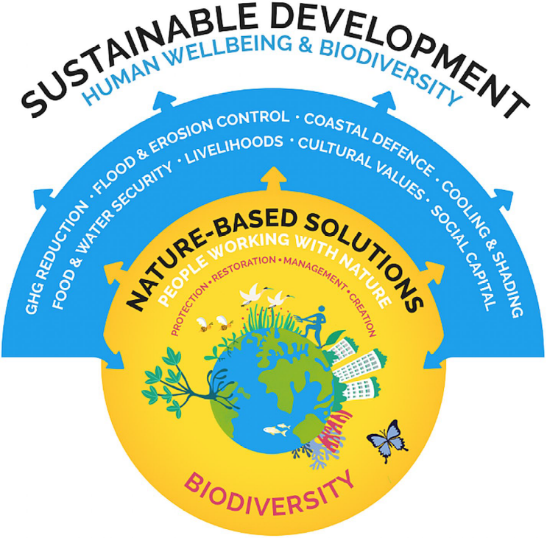
Figure 1. The NbS concept (Seddon et al., 2021).

The relevance and vitality of NbSs in sustainable environmental actions are growing (Cohen-Shacham et al., 2019). Hence, various international organizations and scientists focused on the NbS concept to develop an NbS definition for better understanding.

The origin of the NbS term dates back to a World Bank report in 2008 on the climate change mitigation and adaptation co-benefits of biodiversity conservation (MacKinnon et al., 2008; Seddon et al., 2021). Subsequently, in its position paper submitted to the UNFCCC, the International Union for Conservation of Nature (IUCN) referred to the NbS concept (IUCN, 2009), and its concept was defined, and core principles were formulated, including differentiation from other concepts, (IUCN, 2012; Cohen-Shacham et al., 2016). After that, the NbS concept gained serious attention and was used in scientific papers and policy documents and reports (Kabisch et al., 2016; Nesshöver et al., 2017; Albert et al., 2019; Cohen-Shacham et al., 2019; IPBES, 2019; IPCC, 2019; WEF, 2020; Arnés García and Santivañez, 2021; Hallstein and Iseman, 2021; UNECE, 2021; WB, 2021a; UNEP, 2022a). However, multiple definitions of the NbS concept are available in the literature (Table 1) due to countless studies to find a precise definition and clarification of NbS (Sowińska-Świerkosz and García, 2022).

Table 1. The definitions of NbSs
NbSs are | Reference
“actions inspired by, supported by or copied from nature and which aim to help societies address a variety of environmental, social and economic challenges in sustainable ways.” | European Commission (2015)
″actions to protect, sustainably manage, and restore natural or modified ecosystems that address societal challenges effectively and adaptively, simultaneously providing human well-being and biodiversity benefits.″ The definition does not cover nature-derived (i.e. use of wind, wave, and solar energy) or nature-inspired solutions (design of materials modeled on biological processes). | IUCN (2016)  Cohen-Shacham et al. (2016)  IUCN (2020b)
“any transition to a use of ecosystem services with decreased input of non-renewable natural capital and increased investment in renewable natural processes.” | Maes and Jacobs (2017)
“multi-functional green interventions delivering upon the social, economic and environmental pillars of sustainable development.” | Van der Jagt et al. (2017)
“soft engineering approaches that are aimed at increasing the resilience of territories and societies affected by meteorological events and therefore reducing the economic, functional, cultural, and social damage disruption that such events cause.” | Short et al. (2018)
“a pure nature-based solution is a solution (to a certain issue) that is completely based on elements and direct inputs from nature, thus not managed by mankind nor containing any human/industrial element. ” | Schaubroeck (2018)
“actions that alleviate a well-defined societal challenge (challenge-orientation), employ ecosystem processes of spatial, blue and green infrastructure networks (ecosystem processes utilization), and are embedded within viable governance or business models for implementation (practical viability).” | Albert et al. (2019)
″measures that protect, sustainably manage or restore nature, with the goal of maintaining or enhancing ecosystem services to address a variety of social, environmental and economic challenges.″ | OECD (2020)
″complementary or alternative solutions to “grey infrastructures” (traditionally made with cement) aimed at conserving and regenerating the functionality of natural and semi-natural ecosystems.″ | Turconi et al. (2020)
“solutions that are inspired and supported by nature, which are cost-effective, simultaneously provide environmental, social and economic benefits and help build resilience. Such solutions bring more, and more diverse, nature and natural features and processes into cities, landscapes and seascapes, through locally adapted, resource-efficient and systemic interventions. Nature-based solutions must there-fore benefit biodiversity and support the delivery of a range of ecosystem services” | European Commission (2021a)
″solutions to societal challenges that involve working with nature″  ″actions that are broadly categorized as the protection, restoration or management of natural and semi-natural ecosystems; the sustainable management of aquatic systems and working lands such as croplands or timberlands; or the creation of novel ecosystems in and around cities or across the wider landscape.″ | Seddon et al. (2021)
″actions to protect, conserve, restore, sustainably use and manage natural or modified terrestrial, freshwater, coastal and marine ecosystems which address social, economic and environmental challenges effectively and adaptively, while simultaneously providing human well-being, ecosystem services, resilience, and biodiversity benefits.″ | UNEP (2022)

Although the NbS term is comparatively new and used as an umbrella concept (Hallstein and Iseman, 2021), it represents various interventions that may have been implemented for decades under different names. These interventions or terms, namely, natural infrastructure (Benedict and McMahon 2006), green infrastructure (Tzoulas et al. 2007), ecosystem-based adaptation (EbA) (CBD, 2009), ecosystem-based mitigation (EbM) (CBD 2010), ecological engineering (Mitsch, 2012), nature-based infrastructure, natural and nature-based feature (Bridges et al., 2015), urban forestry, ecosystem services (Escobedo et al., 2019), ecological (ecosystem) restoration, forest landscape restoration (FLR), REDD+, ecosystem-based disaster risk reduction (Eco-DRR), natural climate solutions (NCSs) (Seddon et al., 2021) are considered as the subsets of NbS in the present day (Jordan and Fröhle, 2022). These actions are based on ecosystem approaches, aiming at working with nature to provide social, economic, and environmental benefits. NbSs focus on the protection/conservation, restoration/creation, and management of ecosystems (Eggermont et al., 2015; Seddon et al., 2021). Influenced by the ecosystem services concept, NbSs also link humans with nature (Hanson et al., 2020). Under this framework, NbS is an overarching concept covering five approaches, including:

- Ecosystem restoration approaches;
- Infrastructure-related approaches;
- Ecosystem-based management approaches;
- Issue-specific ecosystem-related approaches; and
- Ecosystem protection and conservation approaches (Cohen-Shacham et al., 2016; Nesshöver et al., 2017; Cohen-Shacham et al., 2019; Seddon et al., 2020a; Parker et al., 2020).
Since several NbS definitions are available in the literature, Cohen-Shacham et al. (2016) developed eight principles to clarify NbS and facilitate its implementation.

- NbSs embrace nature conservation norms;
- NbSs can be implemented alone or in an integrated manner with other solutions to societal challenges;
- NbSs are determined by site-specific natural and cultural contexts involving traditional, local, and scientific knowledge;
- NbSs produce societal benefits fairly and equitably, promoting transparency and broad participation;
- NbSs maintain biological and cultural diversity and the ability of ecosystems to evolve;
- NbSs are applied at a landscape scale;
- NbSs recognize and address the trade-offs between the production of a few immediate economic benefits for development and future options for the production of the full range of ecosystem services; and
- NbSs are an integral part of the overall design of policies, and measures or actions, to address a specific challenge (Cohen-Shacham et al., 2016; Cohen-Shacham et al., 2019).

Recently, IUCN (2020a) developed a global standard for NbSs to ensure the application of NbSs is consistent and grounded since NbSs are integrated into the policies and implemented through projects. The Standard aims to provide a robust framework to design and verify NbSs to achieve expected outcomes in solving social, economic, and environmental challenges.

Similarly, IUCN (2020b) provides guidance and a global framework to design, verify, and scale up NbSs. The Standard established globally consistent 8 Criteria and 28 Indicators in line with the principles for NbSs to measure the effectiveness of NbS interventions (Figure 2). Criteria and Indicators assess the extent to which a proposed solution qualifies as an NbS and identify specific actions to be taken to strengthen the robustness of the intervention further; and enable a targeted design of an NbS to adhere to the Criteria and Indicators while building in adaptive management mechanisms to maintain the relevance and robustness of the NbS through its lifespan. IUCN defined the following Criteria:

Figure 2. NbS criteria (IUCN, 2020a; 2020b).

In summary, NbSs refer to actions/interventions/approaches incorporating four core ideas. NbSs are (i) inspired and powered by nature, (ii) address societal challenges or resolve problems, (iii) provide multiple services/benefits, including biodiversity gain, and (iv) are highly effective and economically efficient (Sowińska-Świerkosz and García, 2022). NbS approaches could be implemented in three categories: (i) minimum or no intervention, close to the nature protection concept; (ii) management approaches, involving limited interventions; (iii) extensive and intrusive ecosystem management, including creating new ones (Eggermont et al., 2015).

Teo et al. (2021) highlighted that NbSs targeting climate change mitigation beyond business-as-usual (i.e. carbon sequestration and storage and GHG emissions reduction) are referred to as NCSs (Griscom et al., 2017; Fargione et al., 2018; Griscom et al., 2020; Drever et al., 2021; Kaarakka et al., 2021; Schulte et al., 2022).

NbSs provide opportunities to guide the current development into a more sustainable path with eco-friendly technologies in line with nature (Arnés García and Santivañez, 2021).

Global frameworks promoting nature-based solutions

NbSs mainly focus on land management targeting forestlands, croplands, grasslands, and wetlands for protection, restoration, and management purposes (Griscom et al., 2017). Besides, NbSs also support settlements on solving global challenges (Teo et al., 2021). Many NbS examples by the UN agencies (i.e. FAO, United Nations Development Programme (UNDP), United Nations Environment Programme (UNEP), World Bank, United Nations Economic Commission for Europe (UNECE)) and governments, supported by non-governmental organizations and the private sector mainly focus on ecosystem restoration. This section provides brief information on global and regional initiatives implementing forestry-based NbSs.

The Bonn Challenge

The Bonn Challenge was launched by the Government of Germany and IUCN in 2011. The Bonn Challenge is a global effort to restore 350 million ha of deforested and degraded land by 2030 through the FLR approach. The main objective of the Bonn Challenge is to restore ecological integrity and improve human well-being through multi-functional landscapes. In this context, achieving the 350 million ha goal will generate about USD 170 billion/year net benefits from watershed protection, improved crop yields, and forest products, including climate change mitigation co-benefits that restoration activities could sequester up to 1.7 gigatonnes of CO₂e per year. So far, 61 countries have pledged 210.12 million ha (Bonn Challenge, 2023). ECCA30 is a regional initiative established by the European, Caucasian, and Central Asian governments and investors to bring 30 million ha of land under restoration through FLR by 2030. Türkiye is also a participatory country to the Agadir Commitment, which aims to restore 8 million ha by 2030 in Algeria, France, Iran, Israel, Lebanon, Morocco, Portugal, Spain, Tunisia, and Türkiye to achieve LDN (Seddon et al., 2021). In this sense, the pledges of sub-region countries are given in Table 2.

Table 2. Pledges by country till 2030
Country | Pledge (ha)
Azerbaijan | 270,000
Kazakhstan | 1,500,000
Kyrgyzstan | 323,000
Tajikistan | 66,000
Türkiye | 2,300,000
Turkmenistan | -
Uzbekistan | 500,000
Total | 4,959,000

The New York Declaration on Forests

The New York Declaration on Forests (NYDF) is a voluntary and non-binding international declaration to act to halt global deforestation. It was first endorsed at the UN Climate Summit in September 2014. Refreshed in 2021, NYDF provides a renewed framework for forest action by considering climate change. NYDF aims to stop natural forest loss by 2030, restore 350 million ha of degraded landscapes and forestlands, improve governance and the rights of forest communities, increase financial flows to forests, and reduce carbon emissions from deforestation and forest degradation to tackle the climate and biodiversity crises. Türkiye is an endorser of the NYDF from the sub-region.

Sendai Framework for Disaster Risk Reduction 2015–2030

The Sendai Framework for Disaster Risk Reduction 2015–2030 aims to reduce disaster risk and losses in lives, livelihoods, health, and the economic, physical, social, cultural, and environmental assets of persons, businesses, communities, and countries. The goal is to prevent new disasters and reduce disaster risks by implementing measures that prevent and reduce hazard exposure and vulnerability to disaster, increase preparedness for response and recovery, and strengthen resilience (UN, 2015).

Land Degradation Neutrality Target Setting Programme

Land Degradation Neutrality (LDN) is “a state whereby the amount and quality of land resources, necessary to support ecosystem functions and services and enhance food security, remains stable or increases within specified temporal and spatial scales and ecosystems.” LDN represents a concept that counterbalances the expected loss of productive land with the recovery of degraded areas. The LDN Target Setting Programme was established in 2015 to achieve SDG Target 15.3. The program includes the definition of national baselines, targets, and associated measures to achieve LDN by 2030 (UNCCD, 2019).

United Nations Strategic Plan for Forests 2030

The UNFF adopted the United Nations Strategic Plan for Forests 2030 in 2017, which provides a global framework for action at all levels to manage all types of forests and trees outside forests sustainably and halt deforestation and forest degradation. At the heart of the Strategic Plan are six Global Forest Goals and 26 associated targets to be achieved by 2030. The main output is to increase the global forest area by 3 percent or 120 million ha by 2030 (UN, 2017a). UNFF promotes NbSs and ecosystem-based approaches, which is a subset of NbSs.

UNCCD 2018-2030 Strategic Framework

The UNCCD 2018-2030 Strategic Framework aims to improve the condition of affected ecosystems and populations, combat desertification/land degradation, promote sustainable land management and contribute to LDN; mitigate, adapt to, and manage the effects of drought to enhance the resilience of vulnerable populations and ecosystems; generate global environmental benefits through effective implementation of the UNCCD; and mobilize substantial and additional financial and non-financial resources to support the implementation of the UNCCD through establishing partnerships at various levels.

The United Nations Decade on Ecosystem Restoration

The UN General Assembly declared 2021–2030 as the United Nations Decade on Ecosystem Restoration to halt, prevent and reverse ecosystem degradation, and restore degraded terrestrial, freshwater, and marine ecosystems worldwide to benefit people and nature (UN, 2021). Its goal is to restore over 1 billion ha of degraded land by 2030. The objectives of the UN Decade on Ecosystem Restoration will be achieved by building political momentum for restoration and initiatives in the field to achieve a sustainable future (UN, 2021). An action plan has been developed to define targets and guide the implementation of future restoration activities together to achieve the goals of the UN Decade (FAO and UNEP, 2022a). The UN Decade on Ecosystem Restoration could be an opportunity to scale up NbSs by sharing lessons learned and promoting best practices to maximize climate, biodiversity, and development benefits from forests.

Post-2020 Global Biodiversity Framework

The Post-2020 Global Biodiversity Framework was developed in 2021 to support the objectives of CBD and associated Protocols and other biodiversity-related initiatives. The Post-2020 Global Biodiversity Framework targets to ensure forestry is managed sustainably to meet people’s needs. This will be achieved by conservation and sustainable use of biodiversity, increasing the productivity and resilience of the forestry production system, and benefit-sharing.

Glasgow Leaders’ Declaration on Forests and Land Use

Forests received exquisite attention in 2021. In this respect, sustainable management and conservation of forests were addressed during the UN Climate Change Conference in 2021, in which 145 countries are committed to working together to halt and reverse forest loss and land degradation by 2030, including delivering sustainable development and promoting an inclusive rural transformation through the Glasgow Leaders’ Declaration on Forests and Land Use (UK, 2021).

Global and regional initiatives, platforms, projects, and examples

Nature-based Solutions Policy Platform

The Platform provides open-access information on global climate change adaptation planning by analyzing countries’ adaptation components of NDCs under the Paris Agreement, highlights the prominence of NbSs to climate change impacts in global policy, and links pledges to the underlying evidence.

Nature-based Solutions Evidence Platform

The Platform is an interactive map linking NbSs to climate change adaptation outcomes through a systematic review of the peer-reviewed literature to (i) explore evidence on how effective different nature-based interventions are to address the impacts of climate change, (ii) compare social, economic, and ecological effects of different nature-based interventions, (iii) filter by region, country, ecosystem type, intervention type, or type of outcome, (iv) generate maps, and graphs, and download data, (v) directly link from science to national climate policy.

Some of the worldwide NbS examples in the platform for the protection/conservation, restoration, and sustainable management of ecosystems are the conservation of old-growth forests, riparian habitat conservation, forest protection, forest restoration, natural revegetation of degraded lands, FLR, grassland restoration with trees, restoring degraded mangroves, restoration of riparian ecosystems, natural forest management, improved forest management, adaptive forest management, establishing protected areas, multi-functional forest management, afforestation, natural regeneration, improved fire management.

The Nature-based Solutions Initiative

The Nature-based Solutions Initiative is an interdisciplinary program of research, education, and policy advice based in the Department of Biology at the University of Oxford. Its mission is to enhance understanding of the potential of NbSs to address multiple global challenges while supporting the health of ecosystems and respecting the rights of Indigenous Peoples and local communities.

The Global Program on Nature-based Solutions

The Global Program on Nature-Based Solutions for Climate Resilience is a cross-sectoral effort at the World Bank Group to increase investments in solutions that integrate and strengthen natural systems across regions and sectors. The program involves many World Bank Global Practices, such as (i) urban, disaster risk management, resilience, and land, (ii) water, (iii) environment, natural resources, and the blue economy.

Nature-based Solutions for Adaptation

World Resources Institute (WRI) is working to support governments and multilateral institutions in understanding the value of nature for climate change adaptation, strengthening the impact of existing nature-based initiatives, identifying appropriate metrics, and catalyzing investment in NbSs. WRI aims to accelerate the uptake of NbSs for climate change adaptation by countries and cities. WRI assesses how existing platforms and initiatives that support NbSs have addressed adaptation and contributed to adaptation outcomes. WRI also identifies new opportunities for these platforms to support scaling up NbS for adaptation.

Nature-based Solutions

IUCN provides a platform for a better understanding of NbSs by topics. IUCN works to advance practical NbSs for climate mitigation and adaptation, centered on better conserving, managing, and restoring the world’s ecosystems. IUCN supports the acceleration of financing for NbSs for climate change through multiple grant mechanisms, including the Global EbA Fund, the Blue Natural Capital Financing Facility, the Subnational Climate Finance initiative, and the Nature+ Accelerator Fund, which collectively represent USD 200 million in available funding for NbSs.

Nature-based Solutions Investment

Capital for Climate, in collaboration with the High-Level Champions and Race to Zero, developed the Nature-based Solutions Investment Platform. The Platform is designed to enable allocators to see the landscape of climate opportunity in one place - to inform strategy, navigate, source, and execute investments aligned with science-based net zero pathways.

Nature Based Solutions Institute

In 2020, Johan Östberg and Cecil Konijnendijk founded the Nature Based Solutions Institute (NBSI), resulting from a solid wish to support the greening of cities with the best available knowledge and practice. NBSI strives to be an internationally recognized institute for research, development, training, and policy advice in urban forestry and NbSs. NBSI introduced the 3-30-300 rule for developing urban forests and creating greener and healthier cities. This means that everyone should be able to see three trees from their home, live in a neighborhood with at least 30 percent tree canopy (or vegetation) cover, and be no more than 300 meters from the nearest green space that allows for multiple recreational activities.

Trees in Cities Challenge

Cities are responsible for around 75 percent of global carbon dioxide (CO₂) emissions. However, they are vulnerable to the negative impacts of climate change. Since 70 percent of humanity is projected to live in urban areas by 2050 (UN, 2018), as a low-cost NbS, urban forests and trees can help settlements reduce vulnerabilities and increase resilience to the impacts of climate change, including higher temperatures, pandemics, extreme weather events, and natural disasters. Urban forests and trees in and around settlements could also play a key role in achieving SDGs and provide co-benefits such as the provision of ecosystem services and conservation of biodiversity as well as improved public health and well-being, reduced temperatures, increased energy efficiency, green job creation, opportunities for urban food production and decreasing risks of floods, landslides, and other natural hazards.

In this context, the United Nations Economic Commission for Europe (UNECE) launched the "Trees in Cities Challenge" in 2019. This initiative invites mayors and local governments worldwide to make a tree-planting pledge and set objectives to ensure cities are greener, more resilient, and more sustainable.

Over 70 cities have pledged, including Ashgabat, Balykchy, Batken, Cholpon-Ata, Jalal-Abad, Kadamjay, Karakol, Kara-Kul, Kara-Suu, Kyzyl-Kiya, Naryn, Osh, Razzakov, Sulukta, and Talas from the sub-region.

For example, Ashgabat, the capital of Turkmenistan, aims to address rapid urbanization in the project "Sustainable Cities in Turkmenistan: Integrated Green Urban Development in Ashgabat and Awaza" led by UNEP and UNDP in cooperation with the Ministry of Environment of Turkmenistan. The project will facilitate sustainable urban development in Ashgabat and the development of city-wide sustainability plans. Ashgabat pledged to plant 1.6 million new trees under the "Trees in Cities Challenge" in line with the "National Forest Program," which aims to plant 10 million trees nationwide.

UNECE also published the ‶Advancing Sustainable Urban and Peri-Urban Forestry″ highlighting the role of sustainable urban and peri-urban forestry as an integrative and strategic NbS to develop healthier, more sustainable, and climate-resilient cities (UNECE, 2021). The study strongly advises increasing the forest cover in urban areas, and it emphasizes that sustainable long-term management objectives shall support afforestation and tree planting to optimize the benefits of urban forests and trees.

Nature-based Solutions 2022 Project

The objective of the NbS 2022 Project is to develop an Asian component of urban NbSs in the Urban Nature Atlas, a global database of 1 100 urban NbSs from European cities and other cities worldwide. The project includes identifying and analyzing up to 100 NbSs in selected Asian countries, and examples from Kazakhstan, Kyrgyzstan, and Türkiye are listed below. Selected NbSs are blue infrastructure, green areas for water management, and grey infrastructure featuring greens, parks, and urban forests.

- Green belt of Nur-Sultan city – Nur Sultan/Kazakhstan
- Eco Park project – Bishkek/Kyrgyzstan
- Ecosystem-based adaptation planning Osh/Kyrgyzstan
- River rehabilitation and creation of green corridor – Eskisehir/Türkiye

Issue-Based Coalition on Environment and Climate Change in Europe and Central Asia Region

Martonakova (2021) recommended pathways to recover more inclusive, environmentally sustainable, and resilient COVID-19. The study provided guidance and tools for assisting countries in integrating environmental and climate change issues into their COVID-19 recovery strategies and supporting a "building back better" approach – a green recovery. In this regard, Measure 8 acknowledges the role of forests for human health and well-being and integrates the health and nutrition aspects in forest management planning (Case study: Inspiring fruit tree cultivation and use in Central Asia).

Critical Ecosystem Partnership Fund

Climate change negatively impacts humans, natural ecosystems, and biodiversity in the sub-region. These impacts were addressed at the Climate Change in Central Asia Conference between 3 and 4 April 2019 in Tashkent, Uzbekistan.

In this regard, the Critical Ecosystem Partnership Fund (CEPF) plans to invest in the Mountains of Central Asia Biodiversity Hotspot to conserve wild lands and biodiversity to increase resilience and reduce the vulnerability of ecosystems and people to climate change. CEPF aims to achieve these goals through implementing EbA to climate change that integrates the conservation and restoration of biodiversity and ecosystem services into broader climate change adaptation strategies. The EbA approach uses main NbSs such as conservation, restoration of ecosystems, and improved management to address social, economic, and environmental challenges and benefit humans, natural ecosystems, and biodiversity to adapt to climate variability.

The investment period is from 2019 to 2024, with a budget of USD 8 million. In this regard, in its conservation strategy, CEPF identified 25 biological corridors and 167 key biodiversity areas in the Mountains of Central Asia. Five biological corridors and 28 key biodiversity areas have been identified as a priority for the CEPF investment. By doing so, CEPF will financially support seven countries of the Mountains of Central Asia Biodiversity Hotspot for increased and improved natural ecosystem management to avoid the negative impacts of climate change.

Other initiatives

Since the afforestation and reforestation programs are the pioneers in NbS implementation (Fargione et al., 2018; Chausson et al., 2020), remarkable examples of tree plantation programs are also available for forests and cities worldwide. These initiatives, listed below, provide excellent examples of NbS implementation under projects and funding opportunities through financial partners.

- Active Giving
- African Forest Landscape Restoration Initiative (AFR100)
- Arbor Day Foundation
- Asian Forest Cooperation Organization (AFoCO)
- Botanic Gardens Conservation International
- Brettacorp Inc.
- Cassinia Environmental
- Climate ADAPT
- Climate Impact Partners
- COMMONLAND
- Conservation International
- Earth Day
- Ecologi
- Ecosia
- EcoRestoration Alliance
- ENFORLAR
- Forest Information System for Europe
- Global EverGreening Alliance
- Global Forest Generation
- Grain for Green Program (Xu et al., 2022)
- Green Legacy Programme
- Green World
- Greening Commodities
- Initiative 20x20
- International Model Forest Network
- International Tree Foundation
- JUSTDIGGIT
- Million Trees in New York (McPhearson et al., 2011)
- Million Trees in Los Angeles (McPherson et al., 2008)
- National Greening Program
- Norway's International Climate and Forest Initiative
- One Billion Trees Programme
- ONETREEPLANTED
- Oppla
- Panorama
- Plant with Purpose
- Rainforest Alliance
- Say Trees
- Society for Ecological Restoration
- Sustainable Harvest International
- Terra Match
- The Global Partnership on Forest and Landscape Restoration
- The Forest Declaration Platform
- The Forgotten Solution
- The Great Green Wall (Goffner et al., 2019)
- The Nature Conservancy
- ThinkNature
- Tree Aid
- TREES FOR THE FUTURE
- Trillion Trees
- Trillion Tree Campaign
- Trillion Tree Platform
- Tropenbos International
- WeForest
- Wildlife Works
- World Agroforestry (ICRAF)
- 1t.org
- 1% FOR THE PLANET
- 3 billion trees in the European Union (European Commission, 2021b)
- 50 million trees in Beijing (Yao et al., 2019)

More examples related to the implementation of forestry-based NbS approaches are available in Cohen-Shacham et al. (2016), Chausson et al. (2020), Kehayova et al. (2020), and Liu et al. (2021).

For example, Chausson et al. (2020) reviewed the global distribution of studies, including Türkiye and Uzbekistan, examining the effectiveness of NbSs to combat the negative impacts of climate change. Most studies focus on created ecosystems, restoration, and management; the remaining studies include protection or a combination. The most represented ecosystems in the studies were forests and mountain ecosystems. The study revealed that NbS implementations have positive, negative, mixed, or no effects.

Kehayova et al. (2020) offered forest-based NbSs for Kazakhstan, Kyrgyzstan, and Tajikistan to achieve or support meeting NDC commitments. NbSs include afforestation with fast-growing species (i.e. poplar), natural forest management, and SFM in Kazakhstan; afforestation with fast-growing species, agroforestry, and joint forest management in Kyrgyzstan; and joint forest management (i.e. reforestation and rehabilitation) in Tajikistan. The study also calculated the climate change mitigation benefits of implementing NbSs. Afforestation with fast-growing species would sequester 11.9 tonnes CO₂/year/ha, SFM sequesters 6.6 tonnes CO₂/year/ha, and joint forest management sequesters 7.0 tonnes CO₂/year/ha.

Liu et al. (2021) reviewed the different NbS types and searched the benefits of NbSs implemented in Europe. The study categorized NbSs and highlighted the key methods, criteria, and indicators to identify and assess the impacts, co-benefits, and trade-offs related to the NbSs. The study showed that several NbS projects use hybrid approaches to addressing societal challenges. The study provides evidence that NbSs provide benefits in climate change mitigation and adaptation.

Current NbS implementation: Examples from the sub-region

Nationally Determined Contributions

The Paris Agreement introduced NDCs as the implementation tool for the post-2020 period to achieve the Agreement's long-term goals. In this context, NDCs define a roadmap for the countries to set and strengthen their efforts and contributions to tackling climate change, including adaptation communications.

As evidence strengthens, NbSs are increasingly prominent in climate change policy, particularly in developing countries (Seddon et al., 2020b). Four countries (Kyrgyzstan, Tajikistan, Türkiye, Uzbekistan) included NbSs in their mitigation and adaptation components of NDCs, and two countries (Azerbaijan and Turkmenistan) included them as part of their mitigation plans. Finally, Kazakhstan included NbSs in the adaptation component of its NDC. In other words, all sub-region countries have committed to working with ecosystems, particularly forests, and the commitments focus more on managing and restoring than protecting forest ecosystems. However, NDCs lack quantified targets.

In this regard, NbS implementation in the NDCs of FAO-SEC countries focuses on protection and conservation (i.e. Kyrgyzstan, Tajikistan, Turkmenistan, and Uzbekistan), restoration and expansion of forests (i.e. all countries), and sustainable management of forests (i.e. Tajikistan and Türkiye) contributing climate change mitigation and adaptation and other co-benefits.

More specifically, Azerbaijan aims to establish new forest areas and water and land-protecting forest strips (windbreaks) and implement urban and roadside greening activities. Kazakhstan includes the Land Use, Land Use Change, and Forestry (LULUCF) sector to combat the negative impact of climate change on forestry; however, no specific targets were listed. Kyrgyzstan offers to protect and increase forests and expand the perennial plantations, as well as increase adaptive capacity, strengthen climate resilience, and reduce vulnerability to the adverse effects of climate change.

Tajikistan proposed the following measures to combat the negative impact of climate change on forestry: (i) implement afforestation/reforestation, natural regeneration, and active regeneration for erosion stabilization/prevention and reduce land degradation, (ii) promote NbSs, FLR, and other relevant approaches to improve forest conditions, (iii) promote forest protection, SFM, and provision of ecosystem services, and (iv) promote crosscutting actions such as integrated land management. Türkiye targets to increase the sink capacity of forests through SFM, CSF, afforestation, reforestation, restoration, rehabilitation, and regeneration, and encourage nature and/or technology-based solutions, protect agricultural lands, improve grasslands, prevent, control, and reduce desertification and land degradation, and increase the number of protected areas. Turkmenistan aims to protect and improve the quality of forests for climate change mitigation, implement reforestation and afforestation activities, and establish new woodlands. Finally, Uzbekistan aims to reforest the foothills of mountains, safeguard native plant species in semi-deserts and deserts, and protect, restore, and maintain ecological balance in protected areas.

Including the forestry-based NbSs in the NDCs presents opportunities to achieve global goals related to climate change and the corresponding need for international support.

Field implementation

All sub-region countries are aware of the negative impacts of climate change on forests, and they are committed to protecting, conserving, restoring, sustainably managing, and using forest ecosystems. Significant protection and conservation approaches include conserving the existing forests and biodiversity in protected areas and improved fire management; restoration approaches include increasing forest areas through afforestation and reforestation and restoration/rehabilitation of degraded forests; SFM includes natural regeneration and assisted natural regeneration. Additionally, avoided forest conversion, improved forest management, and avoided fuelwood and trees outside forests are common practices in the sub-region (Schulte et al., 2022).
Substantial efforts have been made to implement NbSs to combat the negative impact of climate change on forestry in the sub-region. Plantation activities have been launched using native tree species for extending forest areas and restoring/rehabilitating degraded forests and for carbon sequestration and storage and soil conservation (i.e. erosion control, flood control, and avalanche control). Area-based conservation methodologies, improved fire management, and pest and disease control activities are critical in conserving the existing forests and biodiversity. Natural and assisted natural regeneration are critical in tackling climate change's negative impacts on forests and providing ecosystem services.

For example, Azerbaijan has implemented afforestation, reforestation, rehabilitation, and restoration activities in forest fund lands on an average of 9 727 ha since 2000. In total, 214 200 ha of degraded forestland has been afforested, reforested, rehabilitated, and restored since 2000 (GoA, 2022). Liu et al. (2021) reviewed NbS implementation across Europe, and NbSs in Azerbaijan were categorized as ecological engineering. Azerbaijan aims to increase forest cover to 20 percent by rehabilitating forests and establishing new forest areas in 593 000 ha by 2030. Azerbaijan had three national parks covering 84 500 ha in 2003, and the number of national parks has increased to 10, covering 421 400 ha in 2021. Additionally, Azerbaijan had 12 state natural reserves covering 186 500 ha in 1990; however, the number of state natural reserves has decreased to 10, covering 120 700 ha in 2021 (GoA, 2022).

Kazakhstan aims to increase forest areas by 5 percent by 2025 by planting two billion seedlings of drought-resistant and economically valuable pine, oak, walnut, and linden tree species. In addition, Kazakhstan has established eight particular plantations with fast-growing tree species in the last decade. Additional work is being conducted to save the Aral Sea basin from salinity and improve soil fertility through afforestation activities of saxaul species on 0.25 million ha, and the afforestation area in the Aral Sea will be extended to 1 million ha. Kazakhstan cooperated with Korean Forest Service to rehabilitate the Aral Sea beds through afforestation (Kim et al., 2021). In this regard, 3 759 400 saxaul trees (Haloxylon aphyllum) were planted in 10 800 ha on the eastern Aral Sea bed in the Kyzylorda region from 2018 to 2019 (Korea Forest Service, 2020). Moreover, Kazakhstan has established 155 new forest nurseries and modernized existing nurseries to provide high-quality seedlings to achieve the abovementioned objectives. Furthermore, there is an aim to reduce fire, pest, and disease risks by 20 percent in 2025.

Kyrgyzstan has planned a 1 000-ha annual plantation program to expand protected natural areas to 10 percent. Kyrgyzstan has implemented reforestation (planting and seed sowing) activities on 28 860 ha between 2008 and 2021 (GoK, 2023). Protected areas provide excellent opportunities for biodiversity conservation, protection of the environment, and climate change mitigation and adaptation. The total number of state reserves and natural parks has reached 23, covering 1 305.4 thousand ha (State reserves: 578 600 ha and natural parks: 726 800 ha) in 2021 (GoK, 2023). Moreover, Kyrgyzstan has 64 nature sanctuary/zakaznik (complex, botanical, zoological, and forest), natural monuments, botanic gardens, and zoological parks. Furthermore, Sary-Chelek State Natural Park (1979) and the Issyk-Kul Biosphere Reserve (2001) were included in the UNESCO World Network of Biosphere Reserves based on the Law on Biosphere Territories in the Kyrgyz Republic (1999) (Burzhubaev et al., 2019). In total, protected areas cover 1 463 242 ha (7.38 percent) in the country (GoK, 2019).

Tajikistan implements 2 000 ha of annual plantation activities to increase the GHG mitigation potential through participatory forestry sector development. Leasing forest areas to local people ensures these areas' conservation, improves local livelihoods, and ensures food security. Tajikistan has also developed a new concept for walnut and almond plantations. In addition, Tajikistan has initiated strategic governance to integrate climate change and has developed a database for fast-growing species. Tajikistan has also established protected areas and conducted afforestation activities on 66 000 ha under the Bonn Challenge, mostly saxaul and pistachio.

Türkiye recently initiated the ″National Afforestation and Erosion Control Mobilization Action Plan″ and ″Breath to the Future″ afforestation campaigns and other programs to contribute to climate change mitigation, including raising awareness on forests. Türkiye implemented natural regeneration (1 454 472 ha), maintenance (12 896 051 ha), and conversion of coppice forests to high forests (1 406 404 ha) activities on over 15.75 million ha since 1988. Afforestation, soil conservation, forest rehabilitation, pasture rehabilitation, private afforestation, artificial regeneration, and establishment of energy forests activities were implemented on 2 577 508 ha, 1 646 619 ha, 3 394 374 ha, 294 256 ha, 157 986 ha, 923 805 ha, and 622 878 ha, respectively since 1946. Erosion, avalanche, and flood control measures under soil conservation were implemented on 1 604 996 ha, 1 015 ha, and 40 608 ha since 1946. Türkiye has increased forest areas from 20.2 million ha to 23.25 million ha between 1973 and 2022. Besides, 6.6 million ha of forest area were certified to ensure SFM. Türkiye has also implemented forest pest and disease control measures on 1 779 232 ha from 2013 to 2022 to protect and increase forest resilience. Various protected area categories are available in Türkiye, which covers 3 666 573 ha. The protected areas include national parks, nature parks, monuments, conservation areas, wildlife development sites, wetlands, Ramsar areas, protection forests, gene conservation forests, seed stands, seed orchards, and urban forests. Moreover, 19 special environmental protection areas cover 3 834 213 ha, and 3 279 natural sites cover 2 136 638 ha in Türkiye. On the other hand, forest fires affect the sustainability of forests. For example, on average, Türkiye faces more than 2 193 forest fires per year; in total, 498 104 ha of forests have been burnt since 1988 in Türkiye. Facts revealed that forest fires had affected 1 864 275 ha since 1937. The number of annual forest fires has an increasing trend since the 1960s. However, according to the Constitution, these forests were reforested (OGM, 2023).
Turkmenistan conducts afforestation activities with drought-resistant plant species and established the "Golden Century Lake" in the Karakum Desert to improve the climate conditions and conserve biodiversity.

The environmental disaster in the Aral Sea region of Uzbekistan, formerly abundant in flora and fauna species, has sharply decreased biological diversity. In this sense, Uzbekistan declared the Aral Sea region an environmental protection area and plans to implement afforestation activities on 0.5 million ha until 2030 to create the green cover zone. Afforestation activities have been conducted on 1.5 million ha to support climate change mitigation actions with saxaul (Haloxylon aphyllum) and Tamarix ramissossima through Climate Adaptation and Mitigation Program for Aral Sea Basin and other programs. The main ecological task of forests and woodlands in the Aral Sea basin includes greening area, carbon sequestration and storage, fixing sand and dust, and water flow regulation. The most valuable nut species in Uzbekistan is the pistachio. Currently, pistachio plantations cover more than 30 000 ha. The area under nuts (pistachios, almonds, walnuts) has increased significantly recently. In particular, pistachio plantations have been expanded in the country's low- and non-irrigated areas. In Uzbekistan, 7.8 million ha of land were categorized as non-irrigated areas suitable for pistachio plantations. The pistachio plantations are very resistant to droughts and dry conditions, and pistachio plantations seem to be a possible and probably the only solution for reforestation of the arid foothill zones of the country. In Uzbekistan, legally protected areas cover less than 1.5 million ha or 3.31 percent of the country’s territory (UN, 2020). Uzbekistan has seven state reserves, one wildlife sanctuary, and three national natural parks (GoU, 2018).

Roe et al. (2021) investigated countries' land-based mitigation potentials and feasibility, where afforestation, reforestation, forest protection, and improved forest management (IFM) are critical in climate change mitigation. For example, while the median feasibility score of Türkiye is between 25-50th percentiles in terms of cost-effectiveness (Figure 3), it is below the 25th percentile in Tajikistan and Turkmenistan and between 25-50th percentiles in Azerbaijan, Kazakhstan, Kyrgyzstan, and Uzbekistan. However, the forest-based mitigation potential in the sub-region is limited (Figure 4).

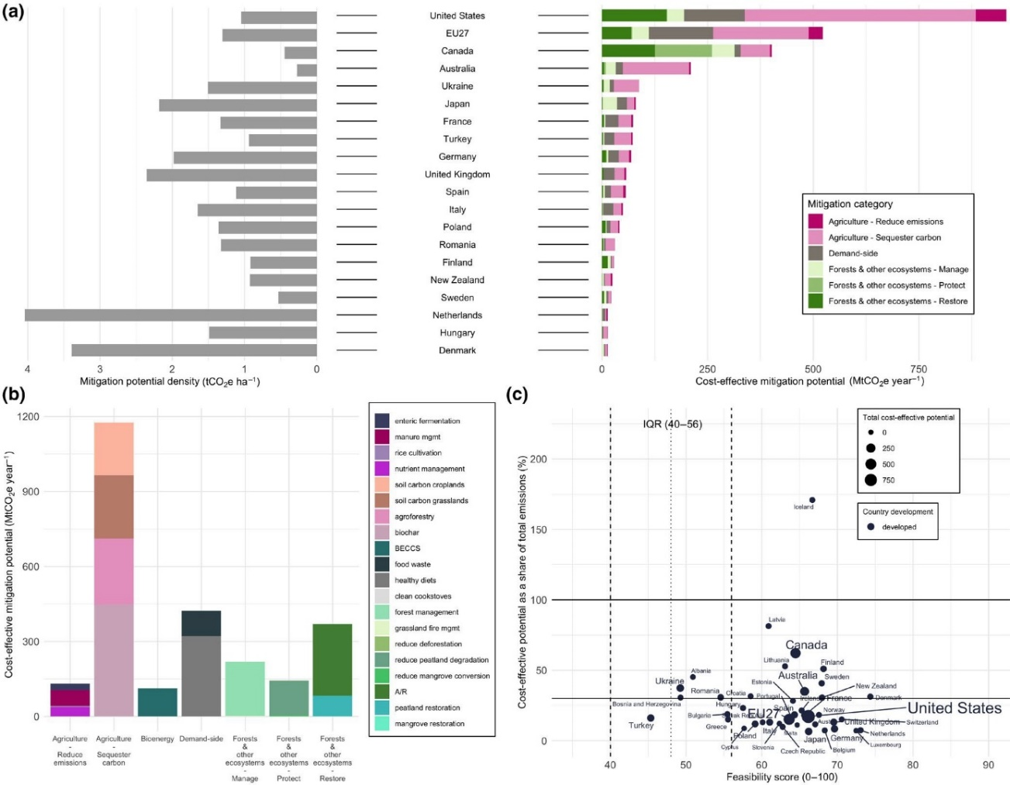
Figure 3. Land-based mitigation potentials and feasibility in developed countries. (a) Total cost-effective mitigation potential by mitigation category (colored bars) and mitigation density of cost-effective potentials (gray bars). (b) Total cost-effective mitigation potential by mitigation category and measure. (c) Feasibility score by cost-effective mitigation potential as a share of total country GHG emissions (percent) (Roe et al., 2021).
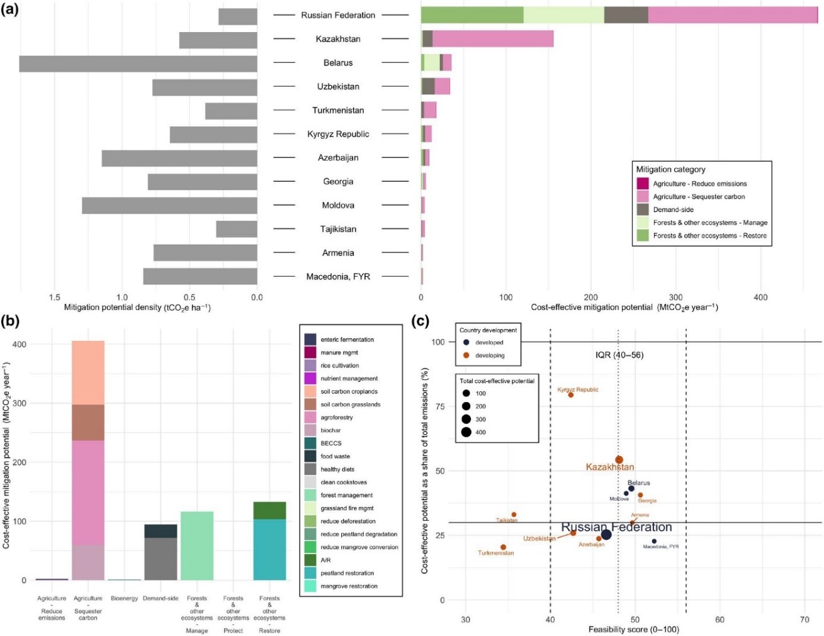
Figure 4. Land-based mitigation potentials and feasibility in Eastern Europe and West-Central Asia. (a) Total cost-effective mitigation potential by mitigation category (colored bars) and mitigation density of cost-effective potentials (gray bars). (b) Total cost-effective mitigation potential by mitigation category and measure. (c) Feasibility score by cost-effective mitigation potential as a share of total country GHG emissions (percent) (Roe et al., 2021).

Suitable nature-based solution approaches for sub-region forests under climate change

The Guidelines aim to support forest managers and practitioners in their efforts to scale up NbS implementation to combat the negative impacts of climate change on forestry in the FAO-SEC countries. In framing NbSs and considering their applications, an umbrella concept (Hallstein and Iseman, 2021) covering a range of ecosystem-related approaches that address societal challenges is beneficial (IUCN, 2020a; 2020b). These approaches can be placed into five main categories, as presented below.

Ecosystem restoration approaches

Ecological (ecosystem) restoration

Ecological (ecosystem) restoration is the process of assisting the recovery of a degraded, damaged, or destroyed ecosystem to reflect values regarded as inherent in the ecosystem and to provide goods and services that people value (Martin, 2017). The NbS implementation of UN organizations, governments, and non-governmental organizations primarily focuses on ecosystem restoration, such as planting trees (Seddon et al., 2021). Ecological restoration can be implemented in minefields in forests, river basins, watersheds (catchments/micro catchments), desertified lands, and degraded forests (Figure 5). Besides, extending forest area, tree coverage, and green space in the sub-region is possible through afforestation, reforestation, and revegetation activities (planting, seeding, assisted natural regeneration, natural succession, and invasive species removal). This concerns urban, peri-urban, and rural areas (including urban forests, greenbelts, windbreaks, urban parks, trees on other land-use types, urban gardens, riparian planting, rural plantations, and energy forests for fuelwood production to reduce fossil fuel consumption), grasslands, and agricultural areas (such as abandoned croplands, agroforestry, and ecological corridors). Ecological restoration efforts provide biodiversity co-benefits (Wang et al., 2021), intercept and slow floodwater in uplands of watersheds (i.e. detention ponds and pockets) (WB, 2021b; Çeler and Serengil, 2023), and increase carbon sequestration and storage (Fargione et al., 2018; Lewis et al., 2019). Ecological (ecosystem) restoration is essential to solving environmental problems (Holl and Brancalion, 2020); however, other NbS approaches, such as green/natural infrastructure, improved forest management, and ecosystem-based mitigation, should also be considered for success.

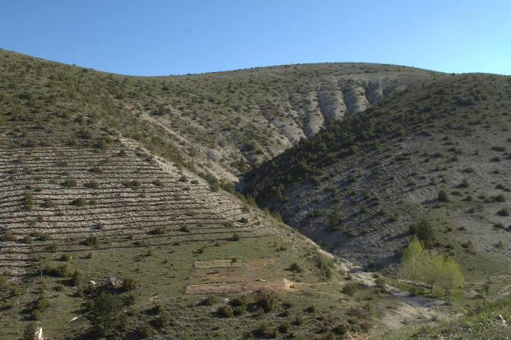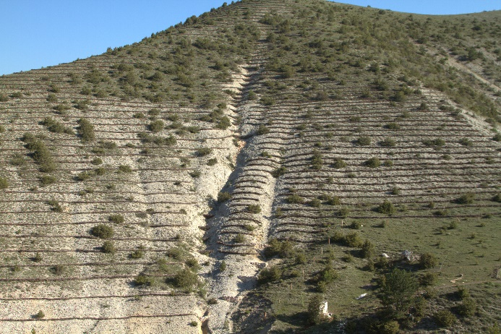
Figure 5. Ecological restoration in Kastamonu, Türkiye (Photo by Mr. Aykut İnce).

Rehabilitation and restoration should aim to create more climate-resistant plantations by reducing the risk of forest fires. After deforestation, fires, pests, and diseases, lands that are temporarily not covered by forest should be rehabilitated and restored naturally. Rehabilitation and restoration of degraded areas reduce erosion and increase slope stability and resilience to natural hazards, contributing to the provision of a regulated water flow (FAO, 2013). A more precautionary approach will facilitate long-distance dispersal by restoring scattered forest stands and riparian corridors with native tree species in extensively converted landscapes. This technique will reduce the dispersal distance required by seeds to reach suitable habitat conditions to grow. The restoration and management of riparian forests and stream corridors will play multiple outstanding functions, as they will improve habitat quality for wildlife, enrich biodiversity, reduce channel erosion, enhance aquatic biota, ameliorate water quality by filtering sediments, nutrients, and pollutants, increase carbon stocks (Çeler and Serengil, 2023) and act as corridors in the migration of species and help improve water infiltration, groundwater recharge, and the filtration of pollutants. Riparian forests can also reduce the temperature of watercourses and act as barriers that prevent the spread of fire over the landscape.

Forest landscape restoration

FLR is a process to retrieve deforested or degraded landscapes' ecological functionality and integrity and improve human well-being (Mansourian et al., 2005; Maginnis and Jackson, 2012). The FLR concept has evolved and focuses on restoring ecosystem functions (Maginnis et al., 2014). The concept extends beyond the forests, including agricultural lands, protective lands, and buffers, and FLR includes the following principles (McBreen and Jewell, 2023):

  - Focus on landscapes – FLR occurs within and across entire landscapes, not individual sites.
  - Engage stakeholders and support participatory governance.
  - Restore multiple functions for multiple benefits – FLR interventions aim to restore ecological, social, and economic functions across a landscape.
  - Maintain and enhance natural ecosystems within landscapes – FLR does not lead to the conversion or destruction of natural forests or other ecosystems.
  - Tailor restoration to the local context using various approaches – FLR draws on the latest science, best practices, and traditional and indigenous knowledge.
  - Manage adaptively for long-term resilience.
  - Revegetation and natural regeneration of landscapes – FLR supports the revegetation of landscapes and natural regeneration of forests.

Ecological restoration and FLR should select and use drought-tolerant, heat-, salinity- and/or pest-resistant, fast-growing, and income-generating native tree species produced in modern forest nurseries (Figure 6). Selected native tree species could include fruit and nut tree species, fast-growing species for industrial plantations, and other species supporting the production of honey, resin, truffle, and linden. Diversifying native tree species with different life strategies (i.e. resprouting species, fruit and nut trees that attract seed-dispersal fauna, or nitrogen-fixing trees) at landscape and forest stand levels helps diversify the forest responses to climate stressors and disturbances (Regato et al., 2010). Restoration should be supported by monitoring activities (i.e. forestry operations such as timber production, boundary delineation, and demarcation, implementation of forestry measures such as restoration, afforestation and reforestation, forest health, the state of regeneration, implementation of maintenance activities, and budget) to ensure the sustainability of trees and other biodiversity elements. Improved monitoring of the condition of forests and ecosystem services provides a database to reduce the impacts of climate change and make decisions on forest management under climate change. Robust forest monitoring and reporting systems are vital aspects of forest-based responses to climate change (FAO, 2010b) to inform the international community of the actual status of forests. These systems will provide timely warnings of extreme events and climate change impacts and helpful information on the effectiveness of management responses.

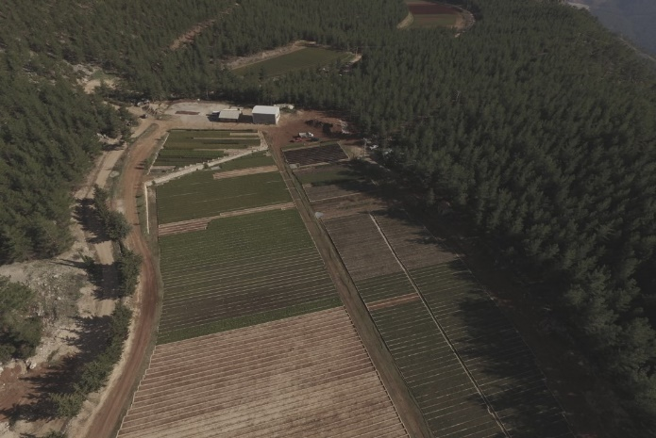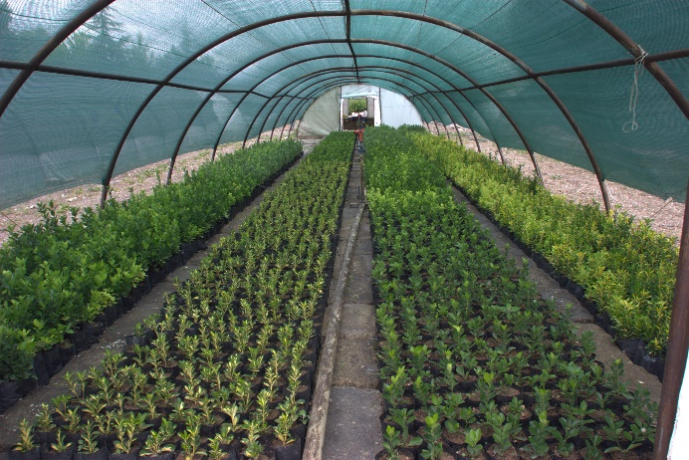
Figure 6. Example of a modern forest nursery in Ermenek, Karaman, Türkiye (Photo by Mr. Aykut İnce).

Ecological engineering

Ecological engineering encompasses creating and restoring sustainable ecosystems that have value for humans and nature (Mitsch and Jørgensen, 2004). Ecological engineering aims to restore ecosystems degraded due to intense human interventions and establish new sustainable ecosystems cost-efficiently that have both human and ecological values (Levis III, 2005; Mitsch, 2012). Figure 7 presents demonstrations of ecological engineering.

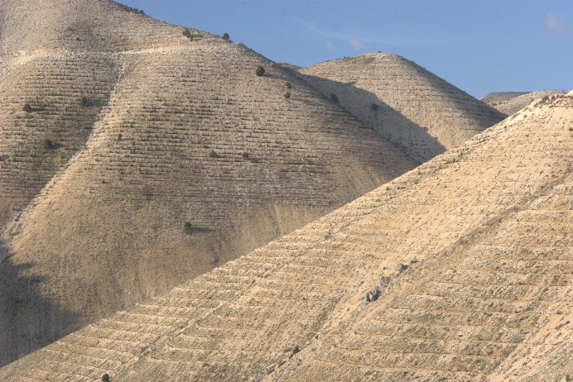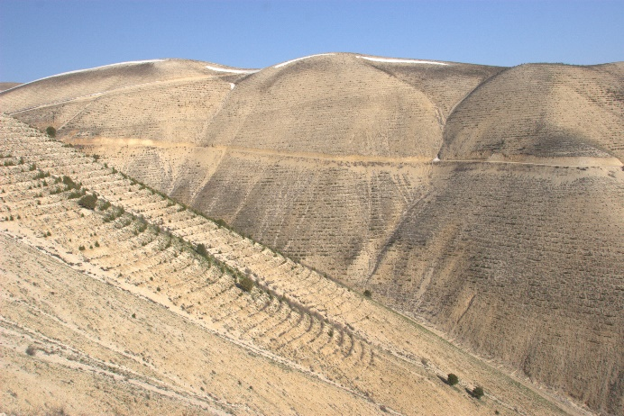
Figure 7. Ecological engineering in Kahramanmaraş (Photo by Mr. Aykut İnce).

Ecological engineering uses three main strategies to restore degraded ecosystems. The strategies are:

- Slope Rehabilitation Facilities
  - Soil Cultivation
    - Terraces
      - Sloping (Flowing) Terraces
      - Unsloped Terraces (Gradoni Type Terrace)
      - Fascine Terrace
  - Line Weed Sowing
  - Natural Knitted Fence
  - Stone Cordon
- Gully Rehabilitation Facilities
  - Diversion Ditch (Diversion Canal)
  - Drainage Canals (Waterways)
  - Industrial Facilities (Transverse Structures)
    - Dry Wall Thresholds
    - Bagged Earth Levee
    - Biological Structures
      - Masonry-type Shrub Thresholds
      - Shrub Thresholds with Fascine
- Stream Bed (Streamcourse) Rehabilitation Facilities
  - Dwarf Walls
  - Ground Sills
  - Check Dams (Treatment Dam - Effusive Dam)
  - Permeable and Filtrating Structures (CEM, 2013a; 2013b).

Infrastructure-related approaches

Green infrastructure

Nauman et al. (2011) define green infrastructure as “the network of natural and semi-natural areas, features and green spaces in rural and urban, and terrestrial, freshwater, coastal and marine areas, which together enhance ecosystem health and resilience, contribute to biodiversity conservation and benefit human populations through the maintenance and enhancement of ecosystem services.” On the other hand, the European Commission defines green infrastructure as “a strategically planned network of natural and semi-natural areas with other environmental features, designed and managed to deliver a wide range of ecosystem services while also enhancing biodiversity” (European Commission, 2013).

Green and natural infrastructure are often used conversely (UNEP, 2014). Although both NbS actions have paired principles and objectives, differences exist in planning, context, and the scale of the work. For example, natural infrastructure aims to restore ecosystems' structure, function, and composition to provide ecosystem services. On the other hand, green infrastructure aims to improve these ecosystem aspects for enhanced ecosystem service provision.

Urban trees, public open green spaces, green corridors, gardens, and parks are essential NbSs to create more liveable, healthy, and resilient cities (UNECE, 2021). A practical implementation of green infrastructure is a common NbS approach in Europe for climate change mitigation and adaptation, enhancing sustainable urbanization, restoring ecosystems and their functions, and providing other multiple benefits (Capotorti et al., 2015; Bona et al., 2023). More green areas with trees (i.e. public open green spaces, gardens, and parks) mean more infiltration capacity and less urban heat island effect (UNECE, 2021; WB, 2021b). Similarly, linear trees along the roads, railways, and green corridors in settlements reduce heatwaves and connect habitats for biodiversity (WB, 2021b). Besides, botanical gardens and arboretums could also support climate change mitigation and adaptation. In general, urban trees, public open green spaces, green corridors, botanical gardens, arboretums, gardens, and parks (Figures 8-9) in settlements avoid air pollution, support recreation, and public health by protecting citizens from floods and landslides (UNECE, 2021), and provide a healthy environment, contribute to climate change mitigation through carbon sequestration and storage, and reduce city noise.

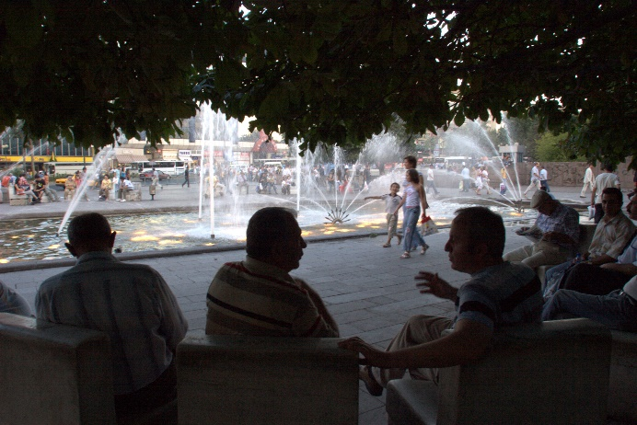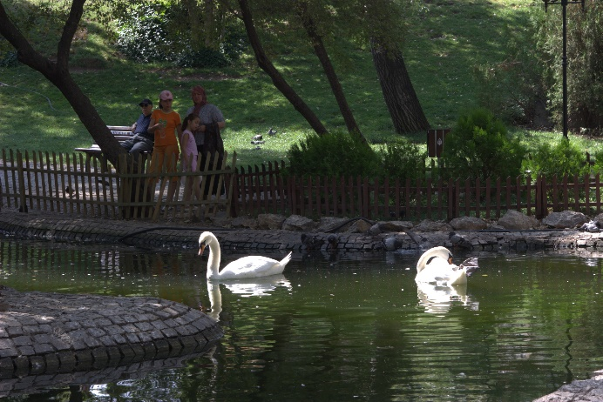
Figure 8. City parks with trees in Ankara, Türkiye (Photo by Mr. Aykut İnce).

Additionally, UN Habitat III's “New Urban Agenda” aims to integrate NbSs into urban and territorial development and planning processes (UN, 2017b), and SDG 11 aims to "provide universal access to safe, inclusive and accessible, green and public spaces, in particular for women and children, older persons and persons with disabilities″. Therefore, urban trees, public open green spaces, green corridors, botanical gardens, arboretums, gardens, and parks are critical to achieving the SDGs by 2030.
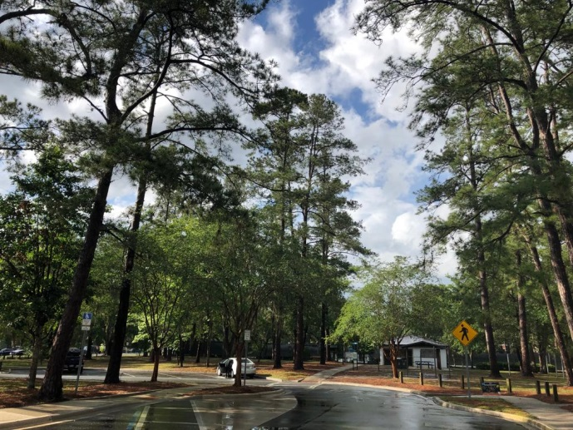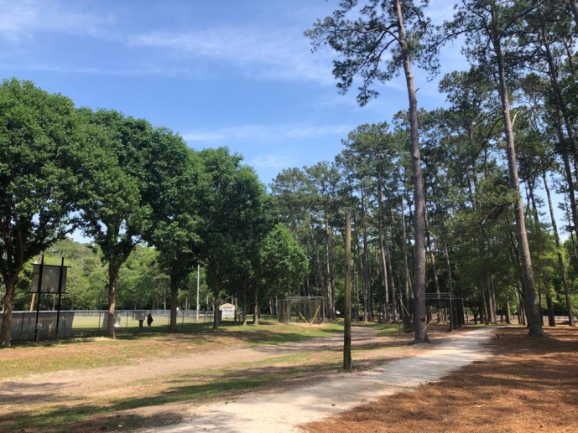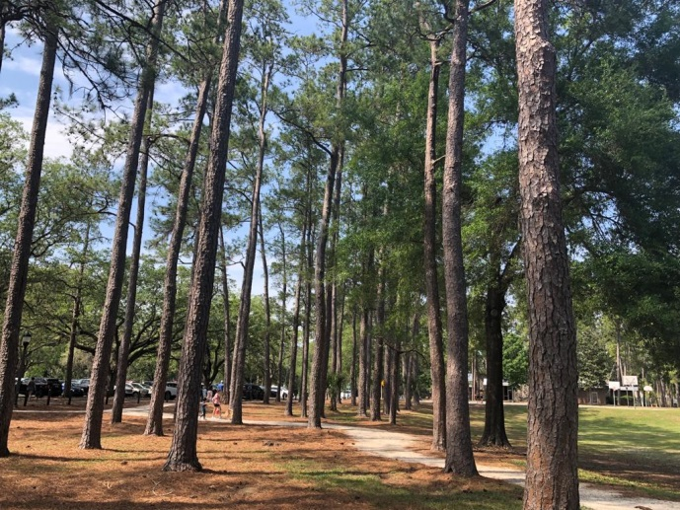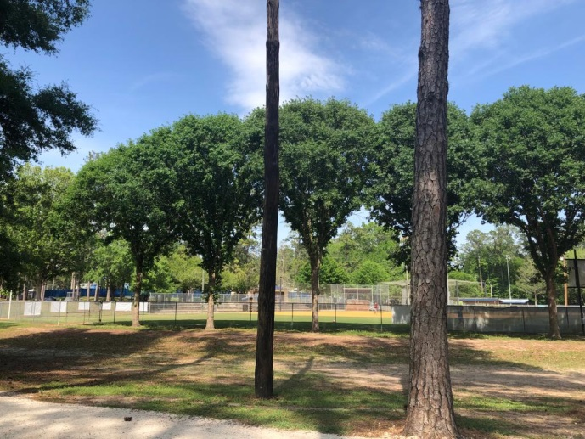
Figure 9. Westside Recreation Center, Park, and Playground, Gainesville, FL, USA (Photo by Dr Caglar Bassullu).

Natural infrastructure

Climate change influences the frequency and intensity of extreme weather events, natural hazards, and disasters (i.e. floods, precipitation patterns and their distribution, erosion, landslides, heatwaves, drought, and avalanches) in cities (WB, 2021b). These challenges reduce the resilience of cities under climate variability and make cities more vulnerable, considering the expected increase in the urban population in the future. According to estimates, the population of cities will reach 6.6 billion people, or 70 percent of the population, by 2050 (UN, 2018). Therefore, the role of the urban and peri-urban forests in disaster risk reduction, flood control, public health, and well-being will attract more attention in the future, including meeting the objectives of the UNFCCC, the Paris Agreement, SDGs, and other initiatives. Urban and peri-urban forests are widely used in Europe (Bona et al., 2023) and Türkiye as NbSs.

NbSs could be critical in addressing and solving climate change-related problems in urban and peri-urban areas (Kabisch et al., 2015; Raymond et al., 2017). Urban and peri-urban forests are cost-effective, integrative, and strategic NbSs to address city problems and develop green, sustainable, and resilient cities (UNECE, 2021). Establishing or restoring urban and peri-urban forests (Figure 10) can be an excellent natural infrastructure for climate change mitigation and adaptation to combat the negative impacts of climate change (Bastin et al., 2019; Cimburova and Pont, 2021). For example, a study on the global potential and extent of urban reforestation found that 17.6 percent of 7 595 city areas covering 10.9 ± 2.8 million ha are suitable for reforestation, offsetting 82.4 ± 25.7 million tonnes CO₂e of GHG emissions annually through the aboveground biomass growth (Teo et al., 2021).

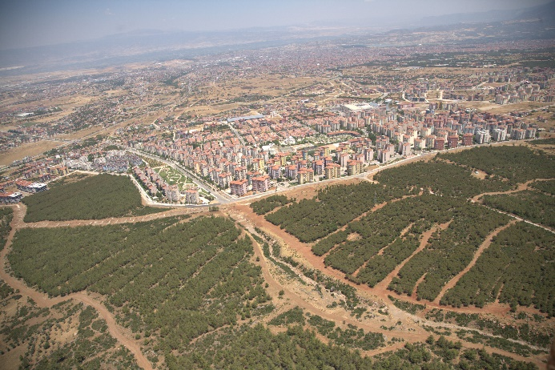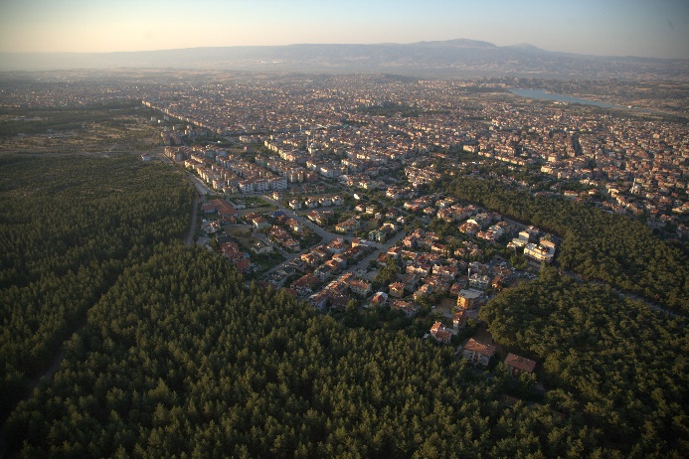
Figure 10. Urban forest in Denizli, Türkiye (Photo by Mr. Aykut İnce).

Additionally, establishing or restoring urban and peri-urban forests could improve ecosystem services such as habitats for biodiversity conservation, reducing heatwaves, and draining stormwater (Kabisch et al., 2015; Keeler et al., 2019), recreation, eco-tourism, and reducing the impacts of extreme weather events and drought, and improving air quality (Samson et al., 2017). Moreover, urban and peri-urban forests, including riparian or floodplains, are critical for settlements to reduce natural disasters and hazards such as floods, storms, and landslides by reducing water speed, delaying runoff, reducing wind speed, and conserving soil (WB, 2021b). Furthermore, urban and peri-urban forests (i.e. therapy forests) could improve public health and human well-being, reduce air temperature, avoid pollution (Song et al., 2018; Richards et al., 2020), regulate heat, and lower noise (Hartig et al., 2014) in settlements. However, only sustainable, healthy, and functional urban and peri-urban forests provide ecosystem services (Esperon-Rodriguez et al., 2022), contribute to public health and human well-being (Colfer et al., 2006; Stolton and Dudley, 2009), serve as NbSs, and combat the negative impacts of climate change. In this sense, Figure 11 presents the benefits of urban and peri-urban forests.

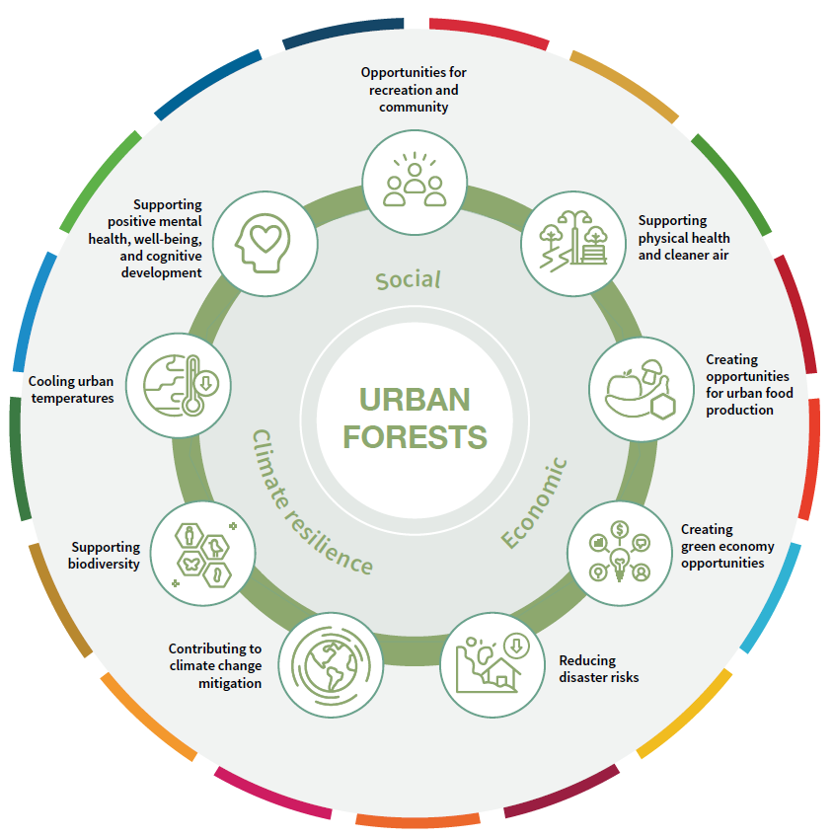
Figure 11. The benefits of urban and peri-urban forests (UNECE, 2021).

An excellent and practical example of combating the negative impacts of climate change in the settlements and making cities greener, healthier, and more resilient could be the 3-30-300 rule. The rule offers that everyone should see three mature trees/vegetation from their residence, tree/vegetation canopy cover in neighborhoods should be 30 percent, and the longest distance to the closest public green space should be 300 meters. This rule could be adapted to the local context based on the structure and population of cities in the sub-region.

Trees outside forests

Trees outside forests, such as trees in croplands, grasslands, and wetlands, are essential in climate change mitigation and adaptation, providing ecosystem services and supporting production landscapes. For example, riparian forests/trees in croplands and wetlands, shelterbelts and windbreaks in croplands, agroforestry, ally/intercropping, woodlots for fuelwood, scattered individual trees in grasslands, greenbelts around settlements, trees in cemeteries, gardens of public buildings and family homes, and trees along the roads are examples of trees outside forests. They provide habitats for biodiversity, contribute to climate change mitigation and adaptation, provide forage for livestock, produce renewable wood resources and non-wood forest products, and increase agricultural and livestock production. Additionally, trees outside forests improve soil structure (i.e. fertility, moisture), reduce erosion, facilitate the sustainability of landscapes, regulate microclimate, prevent air pollution, reduce dust storms and noise, and provide many other goods and ecosystem services (Chakravarty et al., 2019; Skole et al., 2021).

Ecosystem-based management approaches

Improved forest management

IFM is a practical methodology under NbS approaches, particularly NCSs, covering several silvicultural activities that enhance carbon stocks in carbon pools and reduce GHG emissions to improve the climate change mitigation potential of forests (Griscom et al., 2017; Fargione et al., 2018; Drever et al., 2021; Kaarakka et al., 2021). These silvicultural activities include (i) maintenance (i.e. thinning for stand improvement and fuel management, use of animal power to extract harvested woods and NWFPs to reduce the impact on soil) and reducing harvest intensity, (ii) promoting uneven-aged forest structure and selective harvesting, (iii) establishing mixed forest stands and strengthening secondary species (Figure 12), (iv) minimizing soil disturbance and extensive soil damage, (v) retain coarse woody debris (stumps, downed trees, snags) in stands (Kaarakka et al., 2021), (vi) site preparation, (vii) herbaceous weed and woody control, (viii) fertilization, (ix) harvested wood products (Shephard et al., 2022). IFM allows sequestering and storing additional carbon in biomass, deadwood, and soil compared to the business-as-usual scenario. IFM could also be a useful strategy for involvement in forest carbon markets to earn offset credits and improve forest revenues. For example, in the existence of carbon payment systems (i.e. forest carbon markets and payments for ecosystem services), deferring harvesting operations could increase forest returns. A study revealed that land expectation value could increase by 56-92 percent if harvesting is delayed ten years in slash pine forests in the southern United States (Koirala et al., 2022).

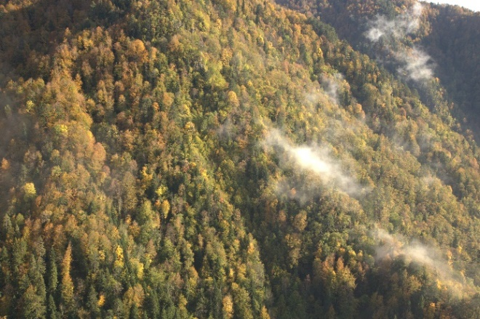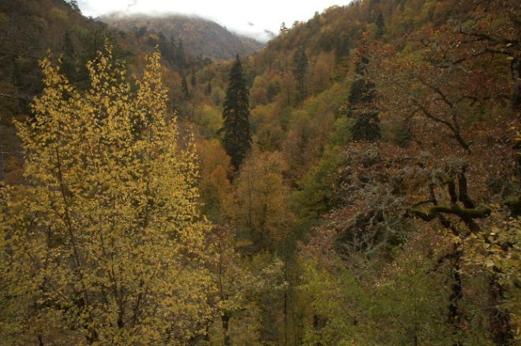
Figure 12. Natural mixed forests in Yenice, Türkiye (Photo by Mr. Aykut İnce).

Natural forest management and improved plantations

Natural forest management refers to the reduced logging/harvest impact, designation of set-aside areas for protection from logging activity, and extended timber harvest cycles in natural forests under extractive management (Fargione et al., 2018; Roe et al.., 2021). Reducing the logging impact and extending the harvest cycles provide substantial climate change mitigation potential (Fargione et al., 2018). Improved plantations encompass extended rotation length in even-aged managed forests to enhance the carbon stocks in living biomass (Figure 13). For example, rotation length could be shifted from economic rotation to biological rotation age when annual biomass growth reaches its maximum capacity for harvesting.

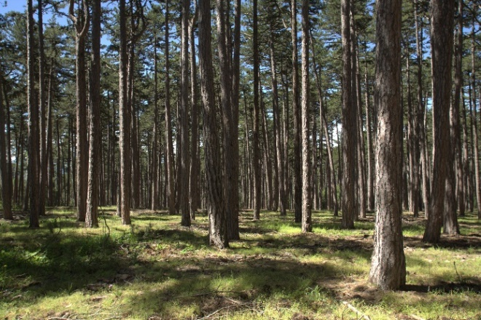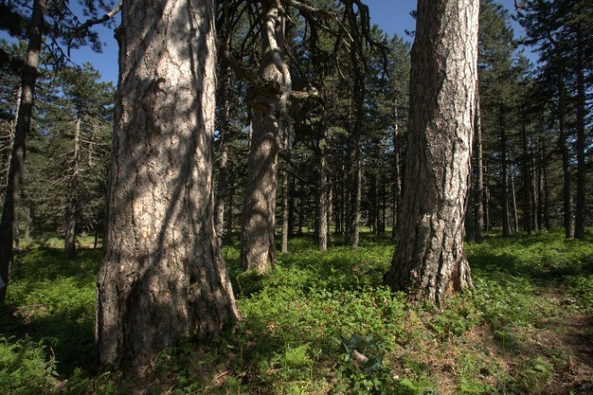
Figure 13. Extended rotation length/harvest cycle in even-aged forests (Photo by Mr. Aykut İnce).

Adaptive forest management

The spatial variation of the impacts of climate change requires developing adaptation measures for mountain, valley, floodplain, coastal, and desert forests. Adaptive forest management, supported by national/local monitoring systems, is a fundamental, flexible, reactive, and anticipatory approach to reducing forest vulnerability and maintaining forest productivity. Management decisions could include:

- Changes in rotation lengths considering the changing precipitation and temperature risk;
- Changes in planting seasons to improve survival rates of seedlings;
- Enhancing natural regeneration through enrichment planting;
- Planting native tree species and varieties to minimize vulnerability to the impacts of climate change; and
- Assessing forests' vulnerability to forest fire, pests, and pathogens and devising strategies for protection (FAO, 2010c).

Integrated (sustainable) natural resource/land management

Integrated natural resource management (INRM) or integrated (sustainable) land management is the coordination and cooperation among stakeholders to implement sustainable forest, land, water, and biological resource and watershed/micro catchment management to combat the negative impacts of climate change holistically. The use of forest resources is integrated with the use of other resources that form a specific productive landscape. For example, trees could be integrated into other land-use types (i.e. croplands, grasslands, wetlands, and settlements) to support production landscapes, ecosystem services, and biodiversity and reduce disaster risk. At the same time, resources, interests, and goals are integrated based on sustainability principles. INRM improves the condition of watersheds and poor rural livelihoods, reduces land degradation and deforestation, improves sustainable climate-smart agriculture, and generates tangible economic benefits.

Natural regeneration and assisted natural regeneration

Natural regeneration (Figure 14) is the process by which forests are restocked by trees that develop from seeds falling from the mother trees and germinating in situ or sprouting from stumps and roots (Forest Research, 2023). Natural regeneration is more cost-efficient than plantation (Crouzeilles et al., 2020), delivering more resilient and biodiverse forests (Chazdon and Uriarte, 2016). Assisted natural regeneration (ANR) could be defined as rehabilitating clear-cut forest lands by taking advantage of trees growing in the surrounding area (Department of Environment and Natural Resources, 2023). ANR is a simple, low-cost restoration method that effectively enhances deforested or degraded lands' productivity and ecosystem functions. The method aims to accelerate, rather than replace, natural successional processes by removing or reducing barriers to natural regeneration, such as soil degradation, competition with weedy species, and recurring disturbances (such as fire, grazing, and wood harvesting) (FAO, 2023). Natural regeneration and ANR can also be supplemented with enrichment planting in cases with insufficient natural seedlings, which is more cost-efficient than relying solely on planting and has a higher success rate because the root system is already in place. This supports climate resilience and carbon sequestration, reduces land degradation, and improves above and below-ground biodiversity (Sohlo, 2017).

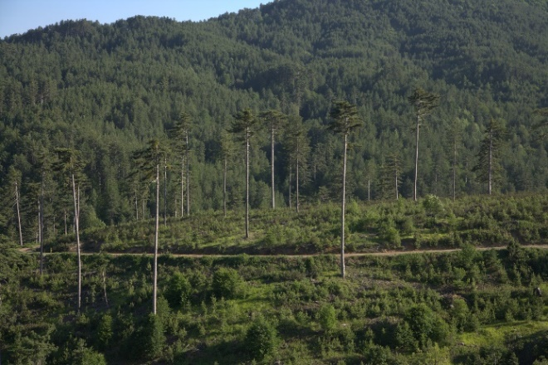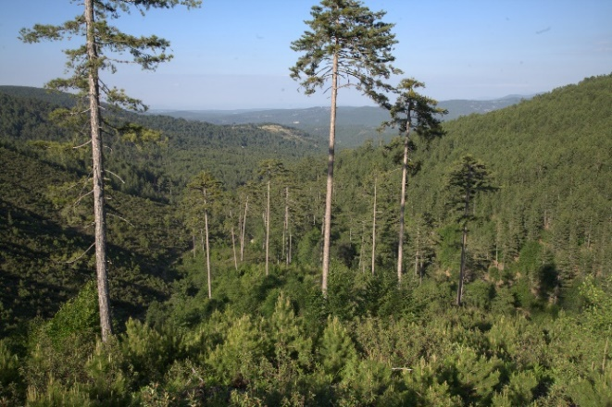
Figure 14. Natural regeneration, Dursunbey, Balıkesir, Türkiye (Photo by Mr. Aykut İnce).

Issue-specific ecosystem-related approaches

Ecosystem-based adaptation

EbA is one of the subsets of NbS approaches developed to address the role of ecosystem services in facilitating the adaptation of humans to climate change (Staudinger et al., 2012; Locatelli et al., 2011). EbA is the "use of biodiversity and ecosystem services as part of an overall adaptation strategy to help people to adapt to the adverse effects of climate change" (CBD, 2009). Another definition of EbA is the “sustainable management, conservation and restoration of ecosystems, as part of an overall adaptation strategy that considers the multiple social, economic and cultural co-benefits for local communities” (CBD, 2010). EbA examples include protecting/restoring forests in upper catchments to reduce the impacts of floods, erosion, landslides, and avalanches; restoring coastal forests to protect communities and infrastructure from storm surges and reduce coastal erosion; and intercropping to increase landscape production under climate variability (Seddon et al., 2020a). Figure 15 presents examples of protection forests for EbA.

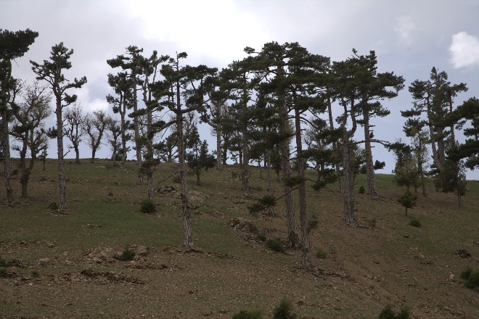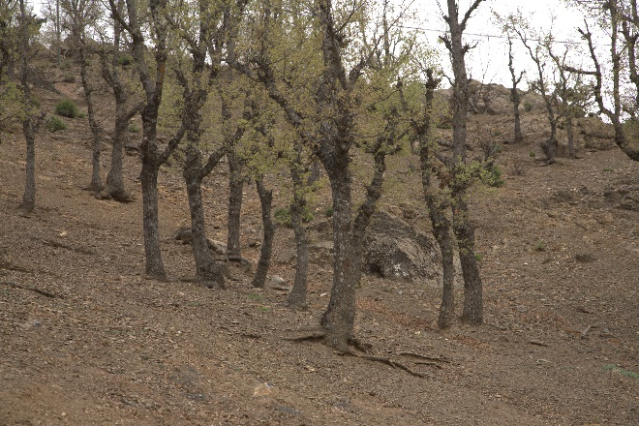
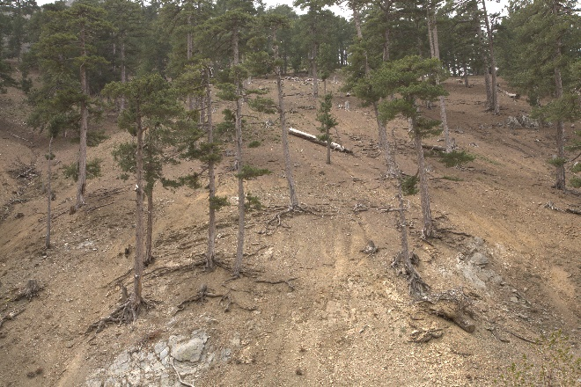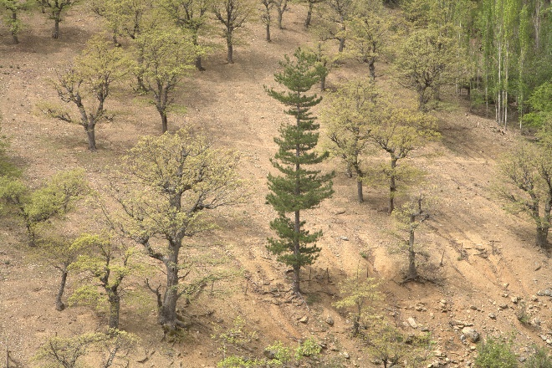
Figure 15. Protection forests to reduce soil erosion impacts in Isparta, Türkiye (Photo by Mr. Aykut İnce).

Ecosystem-based mitigation

EbM focuses on carbon sequestration and storage and avoiding GHG emissions in ecosystems to ensure ecosystem functionality, human health, and socio-economic security (Figure 16). EbM aims to reduce emission sources, increase sink areas, provide global benefits, and avoid the long-term impacts of climate change (Locatelli et al., 2011; Staudinger et al., 2012). For example, EbM as an NbS includes avoided forest conversion (i.e. protecting natural ecosystems and plantations from loss and degradation), restoring degraded ecosystems, SFM, and CSF to enhance carbon sinks, reduce GHG emissions and facilitate carbon sequestration and storage (UNEP and IUCN, 2021; Shephard et al., 2022). Avoided forest conversion maintains carbon stored in existing forests from human-induced forestland conversion (Fargione et al., 2018). Additionally, reduced deforestation and REDD+ are excellent examples of EbM aiming to reduce emissions from deforestation and forest degradation and the role of conservation, sustainable management of forests, and enhancement of forest carbon stocks in developing countries. Conservation, restoration, and sustainable management of forests are critical to ensure the healthy functioning of the carbon cycle and global climate regulation (Cohen-Shacham et al., 2016).

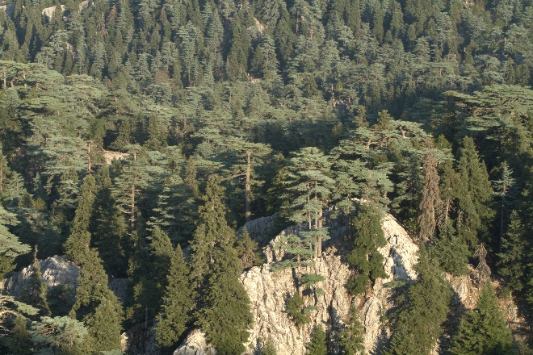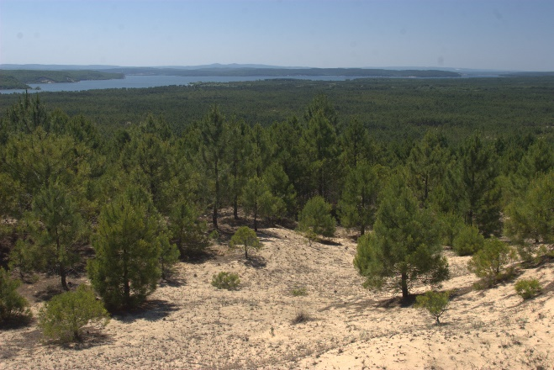
Figure 16. Conserving natural forests in Burdur, and plantations in Istanbul, Türkiye for EbM (Photo by Mr. Aykut İnce).

Ecosystem-based disaster risk reduction

Eco-DDR is ″the sustainable management, conservation, and restoration of ecosystems to reduce disaster risk, intending to achieve sustainable and resilient development" (Estrella and Saalismaa, 2013). The Eco-DRR approach focuses on minimizing the impacts of hazards by enhancing the capacity of communities to better manage and recover from the effects of hazards (Renaud et al., 2013). Eco-DDR is a policy and practical approach having connections with EbA and EbM, explicitly focusing on particular hazard events, such as floods, landslides, fires, and avalanches. Unlike EbA and EbM, the Eco-DRR approach addresses hazards unrelated to climate change or climate variability, such as earthquakes (Renaud et al., 2013). Examples of the Eco-DRR approach include the restoration of watersheds to protect from floods, landslides, avalanches, and erosion and using fire-resistant native tree species to avoid large-scale forest fires. Eco-DDR supports natural resource-dependent vulnerable communities to adapt to climate change and become more resilient to the negative impacts of climate change, including extreme weather events and climate-related disasters (Cohen-Shacham et al., 2016).

Climate adaptation services

Climate adaptation services (CAS), a broader concept than EbA, aims to complement the ecosystem services concept and contribute to developing options for climate change adaptation, focusing on understanding the vital ecological mechanisms and characteristics that support the ecosystem capacity. CAS supports the additional value of healthy ecosystems in enabling these ecosystems to combat the negative impacts of climate change (Lavorel et al., 2015), particularly ecosystem resilience.

Ecosystem protection and conservation approaches

Area-based conservation and protected area management

Biodiversity conservation is essential for climate change adaptation. Establishing protected areas is one of the best examples of NbSs providing habitats for biodiversity conservation, combating the negative impacts of climate change, and facilitating more resilient forests and ecosystem services (Figure 17). In this regard, area-based conservation and protected area management ensure the conservation of particular areas and species with significant importance (Figure 18).

Specific applications of NbSs that support area-based conservation include establishing protected areas, establishing ecosystem bridges across the highways to avoid habitat fragmentation, enhancing tree planting, implementing riparian buffer zones, and providing food/forage support for wildlife. Well-managed conservation areas can maintain watershed functionality, protect the natural environment, and provide opportunities for people to connect with nature. Tree planting supports the provision of essential food, shade, habitat, and corridors for pollinators and various species. In addition, it can stabilize areas surrounding waterways, prevent erosion, and filter sediment (Dropkin et al., 2017; USDA, 2023).

Ecosystem and landscape-based conservation approaches provide a holistic perspective to safeguard different native tree species and their genetic biodiversity in natural habitats. The ecosystem and landscape-based conservation approach is well suited to lowland areas with high tree species diversity by ensuring the existence and sustainability of local populations of native tree species with social, cultural, environmental, and economic functions.

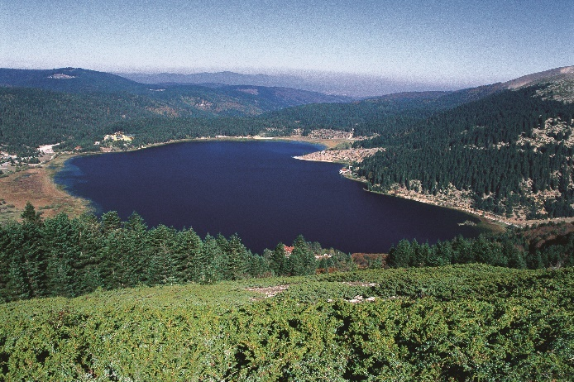
Figure 17. Abant Lake National Park, Bolu, Türkiye (Photo by Mr. Aykut İnce).

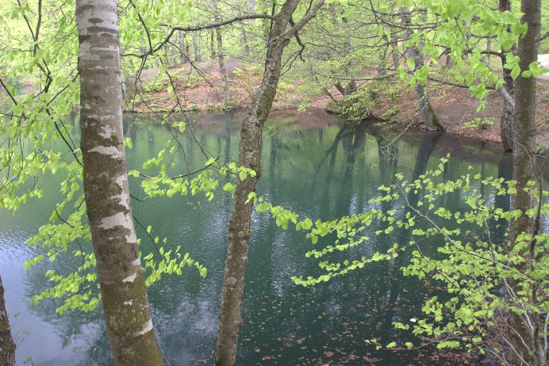
Figure 18. Yedigöller National Park, Bolu, Türkiye and Yazılı Kanyon Nature Park, Isparta, Türkiye (Photo by Mr. Aykut İnce).

A targeted species-specific conservation approach is intra-specific conservation of different populations based on various criteria such as their natural distribution ranges, rareness and endangered level, endemicity, plantation programs, economic contribution, and social and environmental values (Figure 19 and Figure 20).

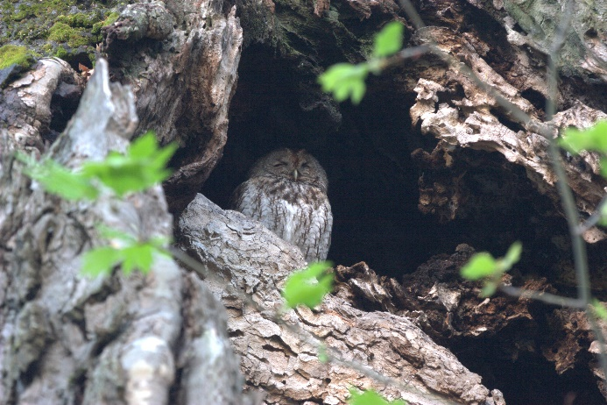
Figure 19. Anatolian wild sheep (Photo by Mr. Aykut İnce). Figure 20. Owl, Datça, Muğla, Türkiye (Photo by Mr. Aykut İnce).

Assisted migration of native tree species

Natural forests are unlikely to migrate sufficiently quickly to "follow" climates to which they are well adapted and will have to rely on genetic adaptation or plasticity, at least in the short term. Natural forests could be supported by broadcasting seeds or pollen in areas where current populations are expected to become maladapted under future climatic conditions. On the other hand, trees grown in plantations can be moved by humans, either as seeds or seedlings, to sites where the future climate is expected to match their requirements. This also includes seed storage and development for climate variability in the future. Assisted migration of native tree species and populations within species is recognized as a potentially critical response to climate change. Assisted migration includes managing species to areas where they are not yet present and introducing better-suited populations within species. Moving well-adapted populations is likely a better strategy in many species with sizeable genetic variability than moving species. Assisted migration requires moving increased germplasm (forest reproductive material) across national boundaries for planting with an appropriate monitoring system (FAO, 2015).

Improved fire management

Improved fire management is essential to climate change adaptation and mitigation strategies (Figure 21). It includes fuel management (i.e. maintenance, weeding, and litter control), fire occurrence prediction, fire prevention, fire detection, initial attack and suppression, and forest restoration. Promoting fire-smart forests resistant to fire spread and resilient to its occurrence is integral to improved fire management. This may be done, for example, by treating fuels in fire-prone vegetation types or by decreasing the importance of those vegetation types in forests (FAO, 2013). Moreover, forest fire protection systems should include analysis of current and future fire regimes, development and implementation of more effective forest fire protection concepts such as adapted species composition, vegetation, and forest structure, development of effective and mobile firefighting systems, the establishment of water (ecosystem) ponds close to forests to support fire suppression, biodiversity, and flood control, and cooperation with all stakeholders and locals. Furthermore, using prescribed fire methodology reduces the risk of high-intensity wildfires on treated lands for two decades, offsetting GHG emissions in the long term. The primary carbon benefit of improved fire management is to avoid decreasing net ecosystem production from tree-killing fires (Fargione et al., 2018).

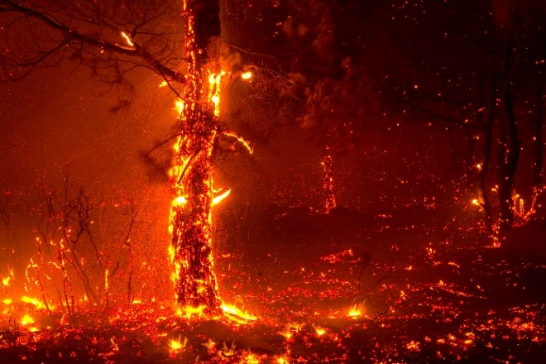
Figure 21. Improved fire management in Izmir and Muğla, Türkiye (Photo by Mr. Aykut İnce).

The Landscape Fire Governance Framework was developed recently, specifying the guiding principles for adjusting strategies, policies, and management to global change.

Pest and disease management

Changes in the distribution of forest pests and diseases pose a threat. Managing pests and diseases and preventing their spread will help ensure that forests remain healthy in the face of climate change. The most effective approach is integrated pest management, a combination of ecologically and economically efficient and socially acceptable prevention, observation, and suppression measures designed to maintain pest populations at acceptable levels. Prevention measures may include:

- The selection of species and varieties to suit site conditions;
- Using natural regeneration;
- Planting and thinning practices that reduce pest populations;
- Favoring natural enemies;
- Developing biological methods against pests; and
- Monitoring pest populations through visual inspection and using trapping systems to determine when control activities are needed (FAO, 2013); and
- Ensure cooperation with locals and relevant stakeholders.

Conservation of old forests

Old-growth forests must be strictly protected. Old-growth forests have significant carbon stocks and remove carbon from the atmosphere while being of paramount importance for biodiversity and the provision of critical ecosystem services. Given their exceptionally high and unique biodiversity value, there is still a need to map old-growth forests and establish their protection regime (Figure 22). Moreover, standing or lying dead or dried trees should also be protected for biodiversity conservation. Furthermore, open spaces adjacent to forests or in forests should be reserved for biodiversity conservation and water production.

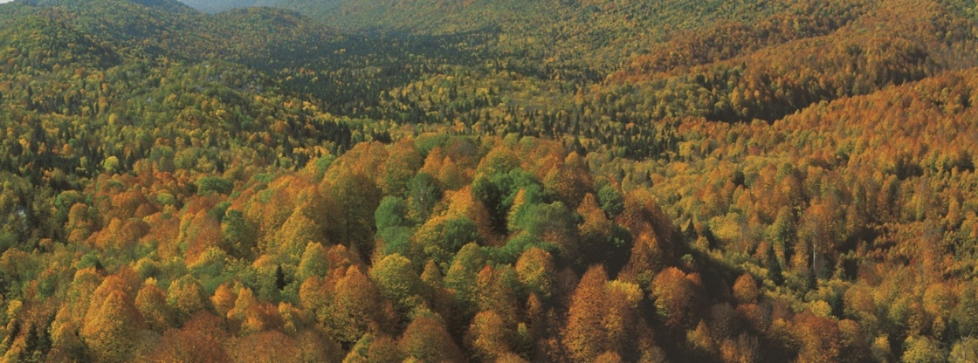
Figure 22. Kürecik forests (Photo by Mr. Aykut İnce).

Applicability of NbSs in the sub-region

The Guidelines provide various global NbS examples for the sub-region. However, not all NbSs are applicable in each country. Table 3 presents the existing global NbS actions per country. For example, ecosystem restoration, ecological engineering, green infrastructure, natural infrastructure, trees outside forests, EbM, and area-based conservation and protected area management are the most common NbSs in the sub-region countries. Besides, Türkiye also implements natural regeneration and ANR, EbA, improved fire management, and pest and disease management. On the contrary, additional efforts are needed to implement FLR, improved forest management, natural forest management and improved plantations, adaptive forest management, INRM, natural regeneration and ANR, EbA, Eco-DDR, climate adaptation services, assisted migration of native tree species, improved fire management, pest and disease management, and conservation of old forests.

Table 3. Applicable global NbSs in the sub-region
 |  |  | Existing NbSs in the sub-region
Global NbS Approach | Global NbS Action | Adaptation Need for NbS Action | Azerbaijan | Kazakhstan | Kyrgyzstan | Tajikistan | Türkiye | Turkmenistan | Uzbekistan
Ecological (ecosystem) restoration | - Ecosystem restoration (1)  - FLR (2)  - Ecologıcal engineering (3) | 2 | 1, 3 | 1, 3 | 1, 3 | 1, 3 | 1, 3 | 1, 3 | 1, 3
Infrastructure-related | - Green infrastructure (3)  - Natural infrastructure (4)  - Trees outside forests (5) | - | 3. 4, 5 | 3. 4, 5 | 3. 4, 5 | 3. 4, 5 | 3. 4, 5 | 3. 4, 5 | 3. 4, 5
Ecosystem-based management | - Improved forest management (6)  - Natural forest management and improved plantations (7)  - Adaptive forest management (8)  - INRM (9)  - Natural regeneration and ANR (10) | 6, 7, 8, 9, 10 | - | - | - | - | 10 | - | -
Issue-specific ecosystem-related | - Ecosystem-based adaptation services (11)  - Ecosystem-based mitigation services (12)  - Ecosystem-based disaster risk reduction (13)  - Climate adaptation services (14) | 11, 13, 14 | 12 | 12 | 12 | 12 | 11, 12 | 12 | 12
Ecosystem protection and conservation | - Area-based conservation and protected area management (15)  - Assisted migration of native tree species (16)  - Improved fire management (17)  - Pest and disease management (18)  - Conservation of old forests (19) | 16, 17, 18, 19 | 15 | 15 | 15 | 15 | 15, 17, 18 | 15 | 15

Additional efforts to implement the remaining NbSs are listed below:

- Develop projects for the application of NbSs;
- Conduct gaps, barriers, and needs assessments to implement NbS;
- Conduct demo activities through farmer field schools related to NbSs, which are not yet available in the country;
- Conduct technical study tours to other countries where the best practices are available;
- Conduct scientific research and systemize NbSs in forestry;
- Include NbSs into university curriculums;
- Implement capacity-building and awareness-raising activities for all stakeholders at all levels;
- Improve knowledge of forest ecosystems, forest functions, and ecosystem services;
- Update forest policy initiatives by including NbSs and its subset of activities;
- Apply participatory and bottom-up approaches to improve the ownership of NbS actions;
- Disseminate the knowledge and experience of NbS implementation throughout the FAO Member States;
- Conduct economic analysis related to NbS implementation;
- Allocate additional financial resources; and
- Mobilize international funding through projects and agreements.

Moreover, the following roadmap should be applied to improve NbSs actions and scale up NbS implementation:

- Identify problematic actors and their interests;
- NbS value proposition and alignment to social engagement and needs;
- Identify NbS actions and related business models;
- Implement NbSs, following a management plan; and
- Ensure participatory monitoring, evaluate NbS actions, and penalize abusive interventions (Sonneveld et al., 2018).

In this regard, forest managers and practitioners are invited to select applicable NbS examples by carefully considering local conditions such as geography and climate, available financial resources, current and future human capacity, and forest types in diverse landscapes in the context of the ecological conditions of the sub-region. By implementing selected NbSs, forest managers can help reduce the negative impact of climate change on forestry, mitigate greenhouse gas emissions, support human well-being, retain forest functions, improve the resilience of ecosystem services, ensure that forests continue to deliver goods and ecosystem services, and provide biodiversity benefits in the sub-region.

Investments in nature-based solutions

While addressing societal challenges, NbSs also avoid additional financial costs due to the negative impacts of climate change. Recent reports revealed that global investments in NbSs are USD 154 billion annually (83 percent public and 17 percent private funds), which is limited now and needs substantial improvement to meet biodiversity, climate change, and land restoration ambitions under the CBD, UNFCCC, UNCCD, the Bonn Challenge, and other initiatives (UNEP, 2021; 2022b). The required annual investments in NbSs are a minimum of USD 384 billion by 2025, USD 484 billion by 2030, and USD 674 billion by 2050 or cumulatively USD 11 trillion from 2022 to 2050 to limit global temperature increase at 1.5 °C, stop biodiversity loss, and achieve LDN (UNEP, 2022b). Forest-based NbSs (i.e. establishing forests and forest management) alone would amount to USD 203.5 billion annually (UNEP, 2021). In other words, approximately two-thirds of the investment in NbSs is required for reforestation and agroforestry. Protected areas require USD 1.3 trillion (12 percent), and avoided deforestation needs USD 290 billion (UNEP, 2022b).

Conclusion

The "Guidelines on the Implementation of Nature-Based Solutions (NbSs) to Combat the Negative Impact of Climate Change on Forestry for the FAO-SEC Countries" provided the NbS concept, global and regional frameworks, initiatives, platforms, projects, and examples promoting NbS implementation, current global, regional, and national NbS examples, suitable NbS approaches to combat the negative impact of climate change on forestry, the applicability of NbSs in the sub-region, and investment needs to implement NbSs. The Guidelines are based primarily on scientific papers, policy documents, reports, global, regional, and local NbS examples, and the available knowledge and experience by resource persons from the countries in the sub-region that described their social, economic, and environmental challenges and envisioned solutions. The Guidelines allow policymakers, decision-makers, and forest managers to access existing evidence on NbSs, mainly through scientific papers. Local, cost-effective, and proven NbSs listed in the Guidelines can only be applied if based on thorough planning and responsible preparation of implementation actions. Forest managers and practitioners are invited to choose selected NbS examples by carefully considering local conditions such as geography and climate, available financial resources, current and future human capacity, and forest types in diverse landscapes in the context of the ecological conditions of the sub-region. Climate change provides forest managers and practitioners with a significant and potentially formidable challenge. By implementing selected NbSs, forest managers and practitioners can help reduce the negative impact of climate change on forestry, mitigate greenhouse gas emissions, support human well-being, retain forest functions, improve the resilience of ecosystem services, ensure that forests continue to deliver goods and ecosystem services, and provide biodiversity benefits in the sub-region.

References

Akyol, A., Bassullu, C., Esen, D., & et al. 2021. Conference Proceedings of the Conference on Climate Change Impact on Forests of Central Asia. Food and Agriculture Organization of the United Nations and Turkish Chamber of Forest Engineers.
Albert, C., Schröter, B., Haase, D. & et al. 2019. Addressing societal challenges through nature-based solutions: How can landscape planning and governance research contribute? Landscape and Urban Planning. 182:12–21. https://doi.org/10.1016/j.landu rbplan.2018.10.003
Anderson, V., Gough, W.A. 2022. A Typology of Nature-Based Solutions for Sustainable Development: An Analysis of Form, Function, Nomenclature, and Associated Applications. Land. 11, 1072. https://doi.org/10.3390/land11071072
Arnés García, M., Santivañez, T. 2021. Hand in hand with nature – Nature-based solutions for transformative agriculture. A revision of Nature-based solutions for the Europe and Central Asia region, supported by Globally Important Agricultural Heritage System (GIAHS) examples. Budapest, FAO. https://doi.org/10.4060/cb4934en
Bastin, J.F., Finegold, Y., Garcia, C., & et al. 2019. The global tree restoration potential. Science. 365 (6448), 76–79.
Benedict, M.A., McMahon, E. 2006. Green infrastructure: Linking landscapes and communities. 299pp. Island Press, Washington, DC.
Boisvenue, C., Paradis, G., Eddy, I.M.S., & et al. 2022. Managing forest carbon and landscape capacities. Environ. Res. Lett. 17, 114013.
Bona, S., Silva-Afonso, A., Gomes, R., & et al. 2023. Nature-Based Solutions in Urban Areas: A European Analysis. Appl. Sci. 13, 168. https://doi.org/10.3390/app13010168
Bonn Challenge. 2023. The Bonn Challenge Restore Our Future Web Site. Cited 27 March 2023. https://www.bonnchallenge.org/
Bridges, T.S., Wagner, P.W., Burks-Copes, K.A., & et al. 2015. Use of natural and nature-based features (NNBF) for coastal resilience. Final report. Engineer Research and Development Center. ERDC-S-R-15-1.
Burzhubaev, T., Joldubaeva, L., Gaile, B., & et al. 2019. Environmental Finance Policy and Institutional Review in the Kyrgyz Republic. BIOFIN. Bishkek, 100p. ISBN 978-9967-9147-5-9.
Capotorti, G., Mollo, B., Zavattero, L., & et al. 2015. Setting Priorities for Urban Forest Planning. A Comprehensive Response to Ecological and Social Needs for the Metropolitan Area of Rome (Italy). Sustainability. 2015, 7, 3958-3976. doi:10.3390/su7043958
Carroll, C., Ray, J.C. 2021. Maximizing the effectiveness of national commitments to protected area expansion for conserving biodiversity and ecosystem carbon under climate change. Global Change Biology. 27(15), 3395–3414. https://doi.org/10.1111/gcb.15645
CBD. 2004. The Ecosystem Approach. CBD Guidelines, Secretariat of the Convention on Biological Diversity, Montreal. 50 p. Cited 27 April 2023. https://www.cbd.int/doc/publications/ea-text-en.pdf
CBD. 2009. Connecting biodiversity and climate change mitigation and adaptation: Key messages from the report of the Second Ad Hoc Technical Expert Group on Biodiversity and Climate Change. Cited on 17 April 2023. https://www.cbd.int/doc/publications/ahteg-brochure-en.pdf
CBD. 2010. X/33 biodiversity and climate change: Decision adopted by the conference of the parties to the convention on biological diversity at its tenth meeting. UNEP/CBD/COP/DEC/X/33.
CEM. 2013a. Yukarı Havza Sel Kontrolu Eylem Planı 2013-2017. The Ministry of Forestry and Water Affairs of Türkiye. Ankara. 113p.
CEM. 2013b. Baraj Havzaları Yeşil Kuşak Ağaçlandırma Eylem Planı 2013-2017. The Ministry of Forestry and Water Affairs of Türkiye. Ankara. 114p.
Chakravarty, S., Pala, N.A., Tamang, B., & et al. 2019. Ecosystem Services of Trees Outside Forest. In: Jhariya, M., Banerjee, A., Meena, R., Yadav, D. (eds) Sustainable Agriculture, Forest and Environmental Management. Springer, Singapore. https://doi.org/10.1007/978-981-13-6830-1_10
Chausson, A., Turner, B., Seddon, D., & et al. 2020. Mapping the effectiveness of Nature-based Solutions for climate change adaptation. Glob Change Biol. 26: 6134–6155. https://doi.org/10.1111/gcb.15310
Chazdon, R.L., Uriarte, M. 2016. Natural regeneration in the context of large-scale forest and landscape restoration in the tropics. Biotropica. 48(6), 709-715. doi: 10.1111/btp.12409
Cimburova, Z., Pont, M.B. 2021. Location matters. A systematic review of spatial contextual factors mediating ecosystem services of urban trees. Ecosystem Services. 50, 101296.
Cohen-Shacham, E., Walters, G., Janzen, C., & et al. 2016. Nature-based Solutions to address global societal challenges. IUCN, Gland, Switzerland, p. xiii + 97. http://dx.doi.org/10.2305/IUCN. CH.2016.13.en
Cohen-Shacham, E., Andrade, A., Dalton, J., & et al. 2019. Core principles for successfully implementing and upscaling Nature-based Solutions. Environmental Science and Policy. 98:20–29. https://doi.org/10.1016/j.envsci.2019.04.014
Colfer, C.J., Sheil, D., & Kishi, M. 2006. Forests and human health: assessing the evidence. Bogor, Indonesia: Center for International Forestry Research.
Crouzeilles, R., Beyer, H.L., Monteiro, L.M., & et al. 2020. Achieving cost-effective landscape-scale forest restoration through targeted natural regeneration. Conservation Letters. 13(3), 1-9. doi: 10.1111/conl.12709
Çeler, E., Serengil, Y. 2023. A review on the methodological basis of nature-based solution (NBS) applications in basin restoration projects. SilvaWorld. 2(1), 50-59. https://doi.org/10.29329/silva.2023.518.06
Department of Environment and Natural Resources. 2023. Glossary of terms. Assisted natural regeneration. In: Foreign-assisted and special projects service. Department of Environment and Natural Resources [online]. Quezon City, Philippines. Cited 12 April 2023. https://fasps.denr.gov.ph/index.php/resources/glossary-of-terms/assisted-natural-regeneration.
Dinerstein, E., Vynne, C., Sala, E., & et al. 2019. A global deal for nature: guiding principles, milestones, and targets. Sci. Adv. 5, eaaw2869.
Donatti, C.I., Andrade, A., Cohen-Shacham, E., & et al. 2022. Ensuring that nature-based solutions for climate mitigation address multiple global challenges. One Earth. 493-504. https://doi.org/10.1016/j.oneear.2022.04.010
Drever, C.R., Cook-Patton, S.C., Akhter, F., & et al. 2021. Natural climate solutions for Canada. Sci. Adv. 7, eabd6034. DOI: 10.1126/sciadv.abd6034
Dropkin, E.M., Bassuk, N., & Signorelli, S. 2017. Woody Shrubs for Stormwater Retention Practices, 2nd ed.; Cornell University: Ithaca, NY, USA. Cited 1 May 2023. http://www.hort.cornell.edu/uhi/outreach/pdfs/woody_shrubs_stormwater_hi_res.pdf
Eggermont, H., Balian, E., Azevedo, J.M.N., & et al. 2015. Nature-based solutions: New influence for environmental management and research in Europe. Gaia. 24, 243–248.
Escobedo, F.J., Giannico, V., Jim, C., & et al. 2019. Urban forests, ecosystem services, green infrastructure and nature-based solutions: Nexus or evolving metaphors? Urban For. Urban Green. 37, 3–12. ttps://doi.org/10.1016/j.ufug.2018.02.011.
Esperon-Rodriguez, M., Rymer, P.D., Power, S.A., & et al. 2022. Assessing climate risk to support urban forests in a changing climate. Plants, People, Planet. 4(3), 201–213. https://doi.org/10.1002/ppp3.10240
Estrella, M., Saalismaa, N. 2013. Ecosystem-based disaster risk reduction (Eco-DRR): An overview. In the Role of Ecosystems in Disaster Risk Reduction, edited by: Renaud, F. G., Sudmeier- Rieux, K., and Estrella, M., United Nations University Press, Tokyo, Newyork, Paris, 26–54.
European Commission. 2013. Green Infrastructure (GI) — Enhancing Europe’s Natural Capital. Communication from the Commission to the European Parliament, the Council, the European Economic and Social Committee and the Committee of the Regions., Brussels, Belgium.
European Commission. 2015. Towards an EU research and innovation policy agenda for nature-based solutions & re-naturing cities: Final report of the Horizon 2020 expert group on Nature-based solutions and re-naturing cities: (full version). Publications Office of the European Union, Luxembourg, ISBN 978-92-79-46051-7.
European Commission. 2021a. Evaluating the Impact of Nature-based Solutions. A Summary for Policy Makers.34pp.Cited 25 April 2023. https://op.europa.eu/en/web/eu-law-and-publications/publication-detail/-/publication/aeb73167-0acc-11ec-adb1-01aa75ed71a1
European Commission. 2021b. The 3 Billion Tree Planting Pledge for 2030. European Commission, Brussels, Belgium.
FAO. 2010a. Forests and climate change in the Near East Region. Forests and Climate Change Working Paper 9. 71 pp. Rome. Cited 12 June 2023. http://www.fao.org/3/k9769e/k9769e00.pdf
FAO. 2010b. Forests and climate change in Eastern Europe and Central Asia. Forests and Climate Change Working Paper 8. 189 pp. Rome. Cited 12 June 2023. http://www.fao.org/3/k9589e/k9589e.pdf
FAO. 2010c. Guidelines on sustainable forest management in drylands of sub-Saharan Africa. Arid Zone Forests and Forestry Working Paper No. 1. Rome. Cited 26 April 2023. https://www.fao.org/3/i1628e/i1628e00.pdf
FAO. 2013. Climate change guidelines for forest managers. FAO Forestry Paper No. 172. Rome. Cited 12 April 2023. http://www.fao.org/3/i3383e/i3383e.pdf
FAO. 2015. Coping with climate change – the roles of genetic resources for food and agriculture. 110 pp. Rome. Cited 12 April 2023. http://www.fao.org/3/i3866e/I3866E.pdf
FAO. 2020. Global Forest Resources Assessment 2020. In: FAO Global Forest Resources Assessment [online]. Rome. Cited 5 April 2023. https://fra-data.fao.org/assessments/fra/2020
FAO. 2023. Assisted natural regeneration. In: FAO Forestry Programme [online]. Rome. Cited 12 April 2023. https://www.fao.org/forestry/anr/en/
FAO & UNEP. 2022. Global indicators for monitoring ecosystem restoration – A contribution to the UN Decade on Ecosystem Restoration. Rome, FAO. Cited 27 March 2023. https://doi.org/10.4060/cb9982en
Fargione, J.E., Bassett, S., Boucher, T., & et al. 2018. Natural climate solutions for the United States. Sci. Adv. 4 (11), eaat1869. DOI: 10.1126/sciadv.aat1869
Forest Research. 2023. Publications & research. Natural regeneration of broadleaved trees and shrubs. In: Forest Research [online]. Farnham, UK. Cited 12 April 2023. https://www.forestresearch.gov.uk/research/lowland-native-woodlands/natural-regeneration-of-broadleaved-trees-and-shrubs/
Girardin, C.A.J., Jenkins, S., Seddon, N., & et al. 2021. Nature-based solutions can help cool the planet — if we act now. Nature. 593, 191-194. doi: 10.1038/d41586-021-01241-2
GoA. 2022. Environment in Azerbaijan. The State Statistical Committee of the Republic of Azerbaijan. Statistical yearbook (Official publication). 135p. Cited 28 March 2023. https://www.stat.gov.az/?lang=en
Goffner, D., Sinare, H., & Gordon, L.J. 2019. The Great Green Wall for the Sahara and the Sahel Initiative as an opportunity to enhance resilience in Sahelian landscapes and livelihoods. Regional Environmental Change. 19:1417–1428. https://doi.org/10.1007/s10113-019-01481-z
GoK. 2019. Sixth National Report. The Clearing-House Mechanism of the Convention on Biological Diversity. 125p.
GoK. 2023. National Statistical Committee of the Kyrgyz Republic. Cited 28 March 2023. http://www.stat.kg/en/opendata/category/10/
Goldstein, A., Turner, W.R., Spawn, S.A., & et al. 2020. Protecting irrecoverable carbon in Earth’s ecosystems. Nature Climate Change. 10(4), 287–295. https://doi.org/10.1038/s4155 8-020-0738-8
GoU. 2018. Sixth National Report of the Republic of Uzbekistan on the Conservation of Biological Diversity. 207p, Tashkent.
Gómez Martín, E., Giordano, R., Pagano, A., & et al. 2020. Using a system thinking approach to assess the contribution of nature based solutions to sustainable development goals. Science of the Total Environment. 738, 139693. https://doi.org/10.1016/j.scito tenv.2020.139693
Griscom, B.W., Adams, J., Ellis, P.W., & et al. 2017. Natural climate solutions. PNAS. Vol. 114, No. 44, 11645-11650. PMID: 29078344, DOI: 10.1073/pnas.1710465114
Griscom, B.W., Busch, J., Cook‐Patton, S.C., & et al. 2020. National mitigation potential from natural climate solutions in the tropics. Phil.Trans. R. Soc. B375: 20190126. http://dx.doi.org/10.1098/rstb.2019.0126
Hallstein, E., Iseman, T. 2021. Nature-based solutions in agriculture – Project design for securing investment. Virginia. FAO and The Nature Conservancy. https://doi.org/10.4060/cb3144en
Hanson, H.I., Wickenberg, B., & Olsson, J.A. 2020. Working on the boundaries—How do science use and interpret the nature-based solution concept? Land Use Policy. 90, 104302. https://doi.org/10.1016/j.landu sepol.2019.104302
Hartig, T., Mitchell, R., de Vries, S, & et al. 2014. Nature and Health. Annual Review of Public Health. 35: 207–28.
Holl, K.D., Brancalion, P.H.S. 2020. Tree planting is not a simple solution. Science. 368(6491), 580–581. https://doi.org/10.1126/science.aba8232
IPBES. 2019. Summary for policymakers of the global assessment report on biodiversity and ecosystem services of the Intergovernmental Science-Policy Platform on Biodiversity and Ecosystem Services. S. Díaz, J. Settele, E. S. Brondízio, H. T. Ngo, M. Guèze, J. Agard, A. Arneth, P. Balvanera, K. A. Brauman, S. H. M. Butchart, K. M. A. Chan, L. A. Garibaldi, K. Ichii, J. Liu, S. M. Subramanian, G. F. Midgley, P. Miloslavich, Z. Molnár, D. Obura, A. Pfaff, S. Polasky, A. Purvis, J. Razzaque, B. Reyers, R. Roy Chowdhury, Y. J. Shin, I. J. Visseren-Hamakers, K. J. Willis, and C. N. Zayas (eds.). IPBES secretariat, Bonn, Germany. 56 pages. https://doi.org/10.5281/zenodo.3553579
IPCC. 2019. Climate change and land: An IPCC special report on climate change, desertification, land degradation, sustainable land management, food security, and greenhouse gas fluxes in terrestrial ecosystems [P. R. Shukla, J. Skea, E. Calvo Buendia, V. Masson-Delmotte, H.-O. Pörtner, D. C. Roberts, P. Zhai, R. Slade, S. Connors, R. van Diemen, M. Ferrat, E. Haughey, S. Luz, S. Neogi, M. Pathak, J. Petzold, J. Portugal Pereira, P. Vyas, E. Huntley, K. Kissick, M. Belkacemi, & J. Malley (Eds.)]. Geneva, Switzerland: Intergovernmental Panel on Climate Change.
IUCN. 2009. No time to lose – make full use of Nature-based Solutions in the post-2012 climate change regime. The fifteenth session of the Conference of the Parties to the United Nations Framework Convention on Climate Change (COP15). 7–18 December 2009, Copenhagen, Denmark.
IUCN. 2012. The IUCN Programme 2013–2016. Adopted by the IUCN World Conservation Congress, September 2012. International Union for Conservation of Nature, Gland, Switzerland.
IUCN. 2016. Resolution 69 on Defining Nature-based Solutions (WCC-2016-Res-069). IUCN Resolutions, Recommendations and Other Decisions. World Conservation Congress, 6–10 September 2016, Honolulu, Hawaii, USA. Cited 25 March 2023. https://portals.iucn.org/library/sites/library/files/resrecfiles/WCC_2016_RES_069_EN.pdf
IUCN. 2020a. Global Standard for Nature-based Solutions. A user-friendly framework for the verification, design and scaling up of NbS. First edition. Gland, Switzerland: IUCN. https://doi.org/10.2305/IUCN.CH.2020.08.en
IUCN. 2020b. Guidance for using the IUCN Global Standard for Nature-based Solutions. A user-friendly framework for the verification, design and scaling up of Nature-based Solutions. First edition. Gland, Switzerland: IUCN. https://doi.org/10.2305/IUCN.CH.2020.09.en
Jordan, P., Fröhle, P. 2022. Bridging the gap between coastal engineering and nature conservation? Journal of Coastal Conservation. 26: 4. https://doi.org/10.1007/s11852-021-00848-x
Kaarakka, L., Cornett, M., Domke, G., & et al. 2021. Improved forest management as a natural climate solution: A Review. Ecol Solut Evid. 2: e12090. https://doi.org/10.1002/2688-8319.12090
Kabisch, N., Qureshi, S., & Haase, D. 2015. Human-environment interactions in urban green space. A systematic review of contemporary issues and prospects for future research. Environ. Impact Assess. Rev. 50, 25–34.
Kabisch, N., Frantzeskaki, N., Pauleit, S., & et al. 2016. Nature-based solutions to climate change mitigation and adaptation in urban areas—Perspectives on indicators, knowledge gaps, barriers and opportunities for action. Ecology and Society 21: 39. https://doi.org/10.5751/ES-08373-210239
Keeler, B.L., Hamel, P., McPhearson, T., & et al. 2019. Social-ecological and technological factors moderate the value of urban nature. Nature Sustainability, 2(1), 29–38. https://doi.org/10.1038/s41893-018-0202-1
Kehayova, E., Mislimshoeva, B., Abdurasulova, G., & et al. 2020. Report on Options for Nature-based Solutions to Enhance NDC Commitments in Three Countries (Kazakhstan, Kyrgyzstan and Tajikistan): Technical and financial analysis of promising nature-based solutions for climate change. Deutsche Gesellschaft für Internationale Zusammenarbeit (GIZ) GmbH. 43p.
Kim, G., Kim, J., Ko, Y., & et al. 2021. How Do Nature-Based Solutions Improve Environmental and Socio-Economic Resilience to Achieve the Sustainable Development Goals? Reforestation and Afforestation Cases from the Republic of Korea. Sustainability. 13, 12171. https://doi.org/10.3390/su132112171
Koirala, U., Adams, D.C., Susaeta, A., & et al. 2022. Value of a Flexible Forest Harvest Decision with Short Period Forest Carbon Offsets: Application of a Binomial Option Model. Forests. 13, 1785. https://doi.org/10.3390/f13111785
Kooijman, E.D., McQuaid, S., Rhodes, M.L., & et al. 2021. Innovating with nature: From nature-based solutions to nature-based enterprises. Sustainability. 13, 1263.
Korea Forest Service. 2020. Investigation Report on Korea—Kazakhstan Forestry Cooperation. Korea Forest Service, Daejeon, Korea. (In Korean).
Lavorel, S., Colloff, M.J., McIntyre, S., & et al. 2015. Ecological mechanisms underpinning climate adaptation services. Global Change Biology. 21(1): 12–31. https://doi.org/10.1111/gcb.12689
Lewis III, R.R. 2005. Ecological engineering for successful management and restoration of mangrove forests. Ecological Engineering. 24, 403–418. doi:10.1016/j.ecoleng.2004.10.003
Lewis, S.L., Wheeler, C.E., Mitchard, E.T.A., & et al. 2019. Restoring natural forests is the best way to remove atmospheric carbon. Nature. 568(7750), 25–28. https://doi.org/10.1038/d41586-019-01026-8
Liu, H.Y., Jay, M., & Chen, X. 2021. The Role of Nature-Based Solutions for Improving Environmental Quality, Health and Well-Being. Sustainability. 13, 10950. https://doi.org/10.3390/su131910950
Locatelli, B., Evans, V., Wardell, A., & et al. 2011. Forests and climate change in Latin America: Linking adaptation and mitigation. Forests. 2: 431–450. https://doi.org/10.3390/f2010431
MacKinnon, K., Sobrevila, C., & Hickey, V. 2008. Biodiversity, Climate Change and Adaptation. Washington, DC, IBRD/World Bank. Cited 27 March 2023. https://openknowledge.worldbank.org/bitstream/handle/10986/6216/467260WP0REPLA1sity1Sept020081final.pdf
Maes, J., Jacobs, S. 2017. Nature-Based Solutions for Europe’s Sustainable Development. Conserv. Lett. 10, 121–124. https://doi.org/10.1111/conl.12216
Maginnis, S., Jackson, W. 2012. What is FLR and how does it differ from current approaches? Forest Landscape Restoration Handbook. https://doi.org/10.4324/97818 49773 010-8
Maginnis, S., Laestadius, L., Verdone, M., & et al. 2014. Assessing forest landscape restoration opportunities at the national level: A guide to the Restoration Opportunities Assessment Methodology (ROAM). IUCN, Gland, Switzerland.
Mansourian, S., Vallauri, D., & Dudley, N. (eds.). 2005. Forest Restoration in Landscapes: Beyond Planting Trees. (In cooperation with WWF International), Springer, New York.
Martin, D.M. 2017. Ecological restoration should be redefined for the twenty-first century. Restoration Ecology Vol. 25, No. 5, pp. 668–673. doi: 10.1111/rec.12554
Martonakova, H. 2021. Measures to Green the Post-Pandemic Recovery. Issue-based Coalition on Environment and Climate Change. 48p.
McBreen, J., Jewell, N. 2023. Forest landscape restoration interventions. Mano River Union. Gland, Switzerland: IUCN.
McLean, D.C., Koeser, A.K., Hilbert, D.R., & et al. 2020. Florida’s Urban Forest: A Valuation of Benefits. ENH1331, Environmental Horticulture Department, UF/IFAS Extension.
McPhearson, P.T., Feller, M., & Felson, A. 2011. Assessing the Effects of the Urban Forest Restoration Effort of MillionTreesNYC on the Structure and Functioning of New York City Ecosystems.Cities and the Environment (CATE): Vol. 3: Iss. 1, Article 7.
McPherson, E.G., Simpson, J.R., Xiao, Q., & et al. 2008. Los Angeles 1-Million Tree Canopy Cover Assessment. United States Department of Agriculture, Forest Service, Pacific Southwest Research Station. General Technical Report PSW-GTR-207.
Mitsch, W.J., Jørgensen, S.E. 2004. Ecological Engineering and Ecosystem Restoration. John Wiley and Sons, Inc., Hoboken, NJ. ISBN: 978-0-471-33264-0. 424p.
Mitsch, W.J. 2012. What is ecological engineering? Ecological Engineering. 45, 5– 12. http://dx.doi.org/10.1016/j.ecoleng.2012.04.013
Mori, A.S., Dee, L.E., Gonzalez, A., & et al. 2021. Biodiversity–productivity relationships are key to nature-based climate solutions. Nature Climate Change. Vol 11, 543–550. https://doi.org/10.1038/s41558-021-01062-1
Naumann, S., McKenna, D., Kaphengst, T., & et al. 2011. Design, implementation and cost elements of Green Infrastructure projects, Final report to the European Commission, DG Environment. Contract no. 070307/2010/577182/ETU/F.1, Ecologic institute and GHK Consulting.
Nesshöver, C., Assmuth, T., Irvine, K.N., & et al. 2017. The science, policy and practice of nature-based solutions: An interdisciplinary perspective. Sci. Total Environ. 579, 1215–1227. https://doi.org/10.1016/j.scito tenv.2016.11.106
Organisation for Economic Co-operation and Development (OECD). (2020). Nature-Based Solutions for Adapting to Water-Related Climate Risks. OECD Environment Policy Papers. Paris. https://doi.org/10.1787/2257873d-en
OGM. 2023. Orman Genel Müdürlüğü 2022 Yılı İdare Faaliyet Raporu (In Turkish). Strateji Geliştirme Dairesi Başkanlığı. Ankara. 82p.
O'Brien, P., Gunn, J.S., Clark, A., & et al. 2023. Integrating carbon stocks and landscape connectivity for nature-based climate solutions. Ecology and Evolution. 13, e9725. https://doi.org/10.1002/ece3.9725
Parker, J., Simpson, G.D., & Miller, J.E. 2020. Nature-Based Solutions Forming Urban Intervention Approaches to Anthropogenic Climate Change: A Quantitative Literature Review. Sustainability. 12, 7439; doi:10.3390/su12187439
Raymond, C.M., Berry, P., Breil, M., & et al. 2017. An Impact Evaluation Framework to Support Planning and Evaluation of Nature-based Solutions Projects. Report Prepared by the EKLIPSE Expert Working Group on Nature-based Solutions to Promote Climate Resilience in Urban Areas. Centre for Ecology & Hydrology, Wallingford, United Kingdom.
Regato, P., Murti, R., Valderrabano, M. & et al. 2010. Reducing fire disasters through ecosystem management in Lebanon (IUCN). In: Demonstrating the role of ecosystems-based management for disaster risk reduction. Prepared for the Partnership for Environment and Disaster Risk Reduction (PEDRR) Workshop, September 2010, UNU Campus in Bonn.
Renaud, F., Sudmeier-Rieux, K., & Estrella, M. eds. 2013. The Role of Ecosystems in Disaster Risk Reduction. Tokyo, Japan: United Nations University Press.
Roe, S., Streck, C., Obersteiner, M., & et al. 2019. Contribution of the land sector to a 1.5 °C world. Nature Climate Change. 9, 817-828. doi: 10.1038/s41558-019-0591-9
Roe, S., Streck, C., Beach, R., & et al. 2021. Land-based measures to mitigate climate change: Potential and feasibility by country. Global Change Biology. 27, 6025–6058. https://doi.org/10.1111/gcb.15873
Samson, R., Grote, R., Calfapietra, C., & et al. 2017. Urban trees and their relation to air pollution. In: Pearlmutter, D., Calfapietra, C., Samson, R., O'Brien, L., Krajter Ostoić, S., Sanesi, G., Alonso del Amo, R. (Eds.). The Urban Forest. Cultivating Green Infrastructure for People and the Environment. Vol. 7. Springer, Future City, pp. 21–30.
Schaubroeck, T. 2018. Towards a general sustainability assessment of human/industrial and nature-based solutions. Sustainability Science. 13:1185–1191. https://doi.org/10.1007/s11625-018-0559-0
Schulte, I., Eggers, J., Nielsen, J.Ø., & et al. 2022. What influences the implementation of natural climate solutions? A systematic map and review of the evidence. Environ. Res. Lett. 17, 013002. https://doi.org/10.1088/1748-9326/ac4071
Seddon, N., Turner, B., Berry, P., & et al. 2019. Grounding nature-based climate solutions in sound biodiversity science. Nature Climate Change. 9(2), 84–87.
Seddon N., Chausson A., Berry, P., & et al. 2020a. Understanding the value and limits of nature-based solutions to climate change and other global challenges. Phil. Trans. R. Soc. B. 375: 20190120. http://dx.doi.org/10.1098/rstb.2019.0120
Seddon, N., Daniels, E., Davis, R., & et al. 2020b. Global recognition of the importance of nature-based solutions to the impacts of climate change. Global Sustainability. 3, e15, 1–12. https://doi.org/10.1017/sus.2020.8
Seddon, N., Smith, A., Smith, P., & et al. 2021. Getting the message right on nature-based solutions to climate change. Glob Change Biol. 27: 1518–1546. https://doi.org/10.1111/gcb.15513
Seymour, F. 2020. Seeing the Forests as well as the (Trillion) Trees in Corporate Climate Strategies. One Earth. 2, 390–393. https://doi.org/10.1016/j.oneear.2020.05.006
Shephard, N.T., Narine, L., Peng, Y., & et al. 2022. Climate Smart Forestry in the Southern United States. Forests. 13, 1460. https://doi.org/10.3390/f13091460
Short, C., Clarke, L., Carnelli, F., & et al. 2018. Capturing the multiple benefits associated with nature-based solutions: Lessons from a natural flood management project in the Cotswolds, UK. L. Degrad. Dev. 30, 241–252. https://doi.org/10.1002/ldr.3205
Skole, D.L., Mbow, C., Mugabowindekwe, M., & et al. 2021. Trees outside of forests as natural climate solutions. Nature Climate Change. Vol 11, 1006–1016. https://doi.org/10.1038/s41558-021-01230-3
Sohlo, I. 2017. Concept proposal for ecosystem-based rehabilitation and management of dryland forests and afforested areas. FAO-GEF Sustainable Land Management and Climate-Friendly Agriculture Project.
Sonneveld, B.G.J.S., Merbis, M.D., Alfarra, A., & et al. 2018. Nature-based solutions for agricultural water management and food security. FAO Land and Water Discussion Paper No. 12. Rome, FAO. 66 pp. Licence: CC BY-NC-SA 3.0 IGO. http://www.fao.org/3/CA2525EN/ca2525en.pdf
Sowińska-Świerkosz, B., García, J. 2022. What are Nature-based solutions (NBS)? Setting core ideas for concept clarification. Nature-Based Solutions. 2, 100009. https://doi.org/10.1016/j.nbsj.2022.100009
Springgay, E., 2019. Forests as nature-based solutions for water. Unasylva. 251, Vol. 70, 2019/1, pp. 3-13.
Staudinger, M.D., Grimm, M.B., Staudt, A., & et al. 2012. Impacts of Climate Change on Biodiversity, Ecosystems, and Ecosystem Services: Technical Input to the 2013 National Climate Assessment. Cooperative Report to the 2013 National Climate Assessment. 296 p. Cited 30 April 2023. https://downloads.globalchange.gov/nca/technical_inputs/Biodiversity-Ecosystems-and-Ecosystem-Services-Technical-Input.pdf
Stolton, S., Dudley, N. 2009. Vital Sites: The contribution of protected areas to human health. WWF International, Gland, Switzerland.
Teo, H.C., Zeng, Y., Sarira, T.V., & et al. 2021. Global urban reforestation can be an important natural climate solution. Environ. Res. Lett. 16, 034059. https://doi.org/10.1088/1748-9326/abe783
Turconi, L., Faccini, F., Marchese, A. & et al. 2020. Implementation of nature-based solutions for hydro-meteorological risk reduction in small Mediterranean catchments: the case of portofino natural regional park. Sustainability. 12, 1240. doi:10.3390/su12031240
Tzoulas, K., Korpela, K., Venn, S., & et al. 2007. Promoting ecosystem and human health in urban areas using green infrastructure: A literature review. Landscape and Urban Planning. 81(3):167–178. https://doi.org/10.1016/j.landurbplan.2007.02.001
UK. 2021. Glasgow Leaders’ Declaration on Forests and Land Use. Cited 26 April 2023. https://ukcop26.org/glasgow-leaders-declaration-on-forests-and-land-use/
UN. 1992. United Nations Framework Convention on Climate Change. FCCC/INFORMAL/84, GE.05-62220 (E) 200705. Cited 12 June 2023. https://unfccc.int/resource/docs/convkp/conveng.pdf
UN. 2015. Sendai Framework for Disaster Risk Reduction 2015 – 2030. Geneva, Switzerland. 36p. Cited 27 April 2023. https://www.undrr.org/publication/sendai-framework-disaster-risk-reduction-2015-2030.
UN. 2016. Non-legally binding instrument on all types of forests. Cited 12 June 2023. https://undocs.org/en/A/RES/62/98
UN. 2017a. United Nations Strategic Plan for Forests, 2017-2030. 16p. Cited 26 April 2023. https://www.un.org/esa/forests/wp-content/uploads/2016/12/UNSPF_AdvUnedited.pdf
UN. 2017b. New Urban Agenda. Quito Declaration on Sustainable Cities and Human Settlements for All. United Nations Habitat III Secretariat. United Nations Conference on Housing and Sustainable Urban Development (Habitat III), 20 October 2016, Quito, Ecuador.
UN. 2018. The world's cities in 2018. Department of Economic and Social Affairs, Population Division, World Urbanization Prospects, 1–34.
UN. 2020. Environmental Performance Reviews: Uzbekistan. Third Review Synopsis. United Nations Economic Commission For Europe. 76pp, Geneva.
UN. 2021. United Nations Decade on Ecosystem Restoration. Cited 26 March 2023. https://www.decadeonrestoration.org/
UNCCD. 2019. United Nations Convention to Combat Desertification (UNCCD) Web Site. Cited 26 April 2023. https://www.unccd.int/actions/achieving-land-degradation-neutrality.
UNECE. 2021. Sustainable Urban and Peri-urban Forestry: An Integrative and Inclusive Nature-Based Solution for Green Recovery and Sustainable, Healthy and Resilient Cities. Policy Brief, 21p, Geneva, Switzerland.
UNEP. 2014. Green Infrastructure Guide for water management: Ecosystem-based management approaches for water-related infrastructure projects. UNEP, UNEP-DHI, IUCN and TNC.
UNEP. 2021. State of Finance for Nature 2021. Nairobi.
UNEP. 2022a. Nature-based solutions for supporting sustainable development. Resolution adopted by the United Nations Environment Assembly of the United Nations Environment Programme on 02 March 2022. UNEP/EA.5/Res.5. 3p.
UNEP. 2022b. State of Finance for Nature. Time to act: Doubling investment by 2025 and eliminating nature-negative finance flows. Nairobi. https://wedocs.unep.org/20.500.11822/41333
UNEP & IUCN. 2021. Nature-based solutions for climate change mitigation. Nairobi and Gland.
UNFCCC. 2010. Decision 1/CP.16: The Cancún Agreements: Outcome of the Work of the Ad Hoc Working Group on Long–term Cooperative Action under the Convention. 31pp. Cited 10 June 2023, http://unfccc.int/resource/docs/2010/cop16/eng/07a01.pdf#page=2
USDA. 2023. Riparian Forest Buffers. Cited 1 May 2023. https://www.fs.usda.gov/nac/practices/riparian-forest-buffers.php.
van der Jagt, A.P.N., Szaraz, L.R., Delshammar, T., & et al. 2017. Cultivating nature-based solutions: The governance of communal urban gardens in the European Union. Environ. Res. 159, 264–275. https://doi.org/10.1016/j.envres.2017.08.013
Wang, C., Zhang, W., Li, X., & et al. 2021. A global meta-analysis of the impacts of tree plantations on biodiversity. Global Ecology and Biogeography. 31, 576–587. https://doi.org/10.1111/geb.13440
WB. 2021a. Climate Change Action Plan 2021-2025. 2021-2025 Supporting Green, Resilient, and Inclusive Development. 49p. Washington, DC World Bank Group.
WB. 2021b. A Catalogue of Nature-based Solutions for Urban Resilience. Washington, DC World Bank Group.
WEF. 2020. Nature risk rising: Why the crisis engulfing nature matters for business and the economy. New Nature Economy series. Geneva, Switzerland: World Economic Forum.
Welden, E.A., Chausson, A., & Melanidis, M.S. 2021. Leveraging Nature-based Solutions for transformation: Reconnecting people and nature. People Nat. 3: 966–977. https://doi.org/10.1002/pan3.10212
Xu, T., Niu, X., & Wang, B. 2022. The Grain for Green Project in Contiguous Poverty-Stricken Regions of China: A Nature-Based Solution. Sustainability. 14, 7755. https://doi.org/10.3390/su14137755
Yao, N., Konijnendijk van den Boschb, C.C., Yang, J., & et al. 2019. Beijing's 50 million new urban trees: Strategic governance for large-scale urban afforestation. Urban Forestry & Urban Greening. 44, 126392. https://doi.org/10.1016/j.ufug.2019.126392.

Annex: FAO NbS resources

FAO Publications where NbSs are Specifically the Subject:

- Hand in hand with nature – Nature-based Solutions for transformative agriculture (fao.org)
- Nature-based solutions in agriculture: Project design for securing investment (fao.org)
- Nature-based solutions in agriculture: Sustainable management and conservation of land, water and biodiversity (fao.org)
- Forests: Nature-based Solutions for Water (fao.org)
- Nature-Based Solutions for agricultural water management and food security (fao.org)
- Nature-based solutions in agriculture: The case and pathway for adoption (fao.org)

NbS in Livestock Production:

- Five practical actions towards low-carbon livestock (fao.org)
- Biodiversity and the livestock sector - Guidelines for quantitative assessment (fao.org)
- World Livestock: Transforming the livestock sector through the Sustainable Development Goals (fao.org)
- The economics of pastoralism in Argentina, Chad and Mongolia (fao.org)
- Developing sustainable value chains for small-scale livestock producers (fao.org)
- Creating employment potential in small-ruminant value chains in the Ethiopian Highlands (fao.org)
- Water use in livestock production systems and supply chains. Guidelines for assessment (fao.org)
- Reducing enteric methane for improving food security and livelihoods (fao.org)
- Options for low emission development in the Uganda dairy sector (fao.org)
- Options for low emission development in the Tanzania dairy sector - reducing enteric methane for food security and livelihoods (fao.org)

NbS in Coastal Ecosystems:

- Report of the FAO/TCF workshop on fish passage design at cross-river obstacles – experiences from different countries, with potential relevance to Mongolia.
- Marine protected areas: Interactions with fisheries livelihoods and food security (fao.org)
- Dynamic development, shifting demographics, changing diets: the story of the rapidly evolving food system in Asia and the Pacific and why it is constantly on the move (fao.org)
- Impacts of climate change on fisheries and aquaculture: synthesis of current knowledge, adaptation and mitigation options (fao.org)
- Ecosystem approach to fisheries management training course (Inland fisheries) – Volume 1: Handbook for trainees (fao.org)
- Planning for aquaculture diversification: the importance of climate change and other drivers (fao.org)
- Adaptive fisheries management in response to climate change (fao.org)
- Ecosystem-based adaptation in the agriculture sector - A nature-based solution (NbS) for building the resilience of the food and agriculture sector to climate change (fao.org)
- Guidance on spatial technologies for disaster risk management in aquaculture: A Handbook (fao.org)
- Disaster response and risk management in the fisheries sector (fao.org)
- Protocol on Climate Change Adaptation and Disaster Risk Management in Fisheries and Aquaculture in the Caribbean (fao.org)
- Opportunities to promote the climate change resilience of Saint Lucia’s pelagic fisheries and value chains through sustainable and efficient resource use (fao.org)
- The risks and vulnerability of the sardine fisheries sector in the Republic of the Philippines to climate and other non-climate processes (fao.org)
- Guide of good practices for Caribbean pelagic longline fishers (fao.org)
- Participatory monitoring and evaluation in marine protected areas: experiences from North and West Africa (fao.org)
- Developing an Environmental Monitoring System to Strengthen Fisheries and Aquaculture Resilience and Improve Early Warning in the Lower Mekong Basin (fao.org)
- Building Climate-Resilient Fisheries and Aquaculture in the Asia-Pacific Region (fao.org)
- Disaster risk management and climate change adaptation in the CARICOM and wider Caribbean region (fao.org)
- FAO Regional Training Workshop on Innovative Integrated Agro-Aquaculture for Blue Growth in Asia-Pacific,
- Improving feed conversion ratio and its impact on reducing greenhouse gas emissions in aquaculture (fao.org)
- Report of the FAO Expert Workshop on Strategies and Practical Options for Greenhouse Gas Reductions in Fisheries and Aquaculture Food Production Systems,
- An ecosystem approach to promote the integration and coexistence of fisheries within irrigation systems (fao.org)
- Lessons Learnt in Water Accounting (fao.org)
- The State of World Fisheries and Aquaculture 2022- Towards Blue Transformation (fao.org)
- Habitat rehabilitation for inland fisheries (fao.org)
- Mediterranean coastal lagoons: sustainable management and interactions among aquaculture, capture fisheries and the environment (fao.org)

NbS and Forestry:

- A guide to forest–water management (fao.org)
- Watershed management in action (fao.org)
- The State of the World's Forest Genetic Resources Thematic Study (fao.org)
- State of Mediterranean Forests 2018 (fao.org)
- Advancing the forest and water nexus - A capacity development facilitation guide (fao.org)
- The State of the World’s Forests 2022 (fao.org)
- Agroforestry for landscape restoration (fao.org)
- Final evaluation of 'Conservation and sustainable use of biodiversity, forests, soil and water to achieve Good Living/Sumac Kawsay in the Napo Province (FSP)'' (fao.org)
- Forest & Landscape Water Ecosystem Services (FL-WES) Tool | Food and Agriculture Organization of the United Nations (fao.org)
- The key role of forest and landscape restoration in climate action
- Standards of practice to guide ecosystem restoration: A contribution to the United Nations Decade on Ecosystem Restoration. Summary report.
- Principles for ecosystem restoration to guide the United Nations Decade 2021–2030
- The road to restoration: A guide to identifying priorities and indicators for monitoring forest and landscape restoration
- Forest-based adaptation: transformational adaptation through forests and trees
- Grazing with trees - A silvopastoral approach to managing and restoring drylands
- Grazing with trees - A silvopastoral approach to managing and restoring drylands with trees: Policy brief
- Building climate-resilient dryland forests and agrosilvopastoral production systems (fao.org)
- Valuing, restoring and managing “presumed drylands”: Cerrado, Miombo–Mopane woodlands and the Qinghai–Tibetan Plateau
- Deploying a humanitarian-development-peace nexus approach: Exploring, strengthening and reviving dryland ecosystems

NbS in Montane Ecosystems:

- Mountain farming systems – seeds for the future (fao.org)
- Mountain women of the world – Challenges, resilience and collective power (fao.org)
- Mountain tourism – Towards a more sustainable path (fao.org)
- Understanding and protecting mountain soils (fao.org)
- Mountain Farming Is Family Farming (fao.org)
- Highlands and Drylands (fao.org)
- Building resilience into watersheds (fao.org)
- Investing in Sustainable Mountain Development; Opportunities, Resources and Benefits | HimalDoc (icimod.org)
- Mountain Partnerships Products: Labelling Mountain products for an ethical, fair and organic future (fao.org)

Conservation:

- The economics of conservation agriculture (fao.org)
- The international treaty on plant genetic resources for food and agriculture. Conservation and sustainable use under the international treaty (fao.org)
- Green manure/cover crops and crop rotation in Conservation Agriculture on small farms (fao.org)
- Nature & Faune Vol. 24, Issue 1: Climate change implications for Agricultural Development and Natural Resources Conservation in Africa (fao.org)
- Inland fisheries resource enhancement and conservation in Asia (fao.org)
- Conservation Agriculture and Sustainable Crop Intensification in Lesotho (fao.org)

Soil Management:

- Voluntary Guidelines for Sustainable Soil Management (fao.org)
- Recarbonizing global soils – A technical manual of recommended management practices (fao.org)
- Peatlands- guidance for climate change mitigation through conservation, rehabilitation and sustainable use (fao.org)
Land Management:

- Land resource planning for sustainable land management (fao.org)

Journal Articles:

- NBS Framework for Agricultural Landscapes (frontiersin.org)
- The 10 Elements of Agroecology: enabling transitions towards sustainable agriculture and food systems through visual narratives (tandfonline.com)
- Lessons learned and public policy recommendations on adaptation to climate change in artisanal fisheries and small-scale aquaculture in Chile. Policy brief. (fao.org)
- Frontiers | The International Year of Sustainable Mountain Development 2022: an opportunity to promote action for mountains (frontiersin.org)
- Promoting Mountain Biodiversity Through Sustainable Value Chains (bioone.org)
- FAO Assists in Enhancing the Resilience of Mountain Communities and Environments (bioone.org)
- Restoring the Earth - The next decade (Unasylva 252)
- Unasylva issue 245 on Forest and landscape restoration

FAO Resources:

- Agroecology Knowledge Hub (fao.org)
- Globally Important Agricultural Heritage Systems (GIAHS) (fao.org)
- Mountain Partnership: Home (fao.org)
- A common framework for agriculture and land use in the nationally determined contributions (fao.org)
- Forest and Landscape Restoration Mechanism (fao.org)

Bioeconomy:

- Sustainable and circular bioeconomy in the biodiversity agenda Opportunities to conserve and restore biodiversity in agrifood systems through bioeconomy practices
- Sustainable and circular bioeconomy in the climate agenda: Opportunities to transform agrifood systems
- How to mainstream sustainability and circularity into the bioeconomy? A compendium of bioeconomy good practices and policies
- The soil microbiome: a game changer for food and agriculture - Executive summary for policymakers and researchers
- Aspirational principles and criteria for a sustainable bioeconomy
- Sustainable bioeconomy and FAO, Project Brief. Rome

Energy:
Urban Ecosystems:
Indigenous People/Communities:
NbS and Pollinators:

- FAO (2009a) Guidelines for the Economic Valuation of Pollination Services at a National Scale
- FAO (2009b) Tool for Valuation of Pollination Services at a National Level.
- FAO (2011a) Potential Effects of Climate Change on Crop Pollination
- FAO (2014) Pollinator safety in Agriculture
- FAO (2015) Crops, Weeds and Pollinators: Understanding Ecological Interactions for Better Management.
- FAO (2016b) Conservation and Management of pollinators for sustainable agriculture, through an Ecosystem approach. Project findings and recommendations. FAO, GEF, UNEP 2016.
- FAO (2018b) The pollination of cultivated plants: A compendium for practitioners. Volumes I & II.
- FAO (2020) Towards sustainable crop pollination services – Measures at field, farm and landscape scales. Rome.
- FAO (2022) Protecting pollinators from pesticides – Urgent need for action. Rome.

https://fra-data.fao.org/KAZ/fra2020/home/
https://fra-data.fao.org/KGZ/fra2020/home/
https://fra-data.fao.org/TJK/fra2020/home/
https://fra-data.fao.org/TKM/fra2020/home/
https://fra-data.fao.org/UZB/fra2020/home/
https://fra-data.fao.org/AZE/fra2020/home/
https://fra-data.fao.org/TUR/fra2020/home/
Strategy for the integrated management of land, water, and living resources that promotes conservation and sustainable use in an equitable way (CBD, 2004).
https://www.nbspolicyplatform.org/
https://www.naturebasedsolutionsevidence.info/
https://www.naturebasedsolutionsinitiative.org/
https://naturebasedsolutions.org/
https://www.wri.org/initiatives/nature-based-solutions-adaptation
https://www.iucn.org/our-work/nature-based-solutions
https://nbs.capitalforclimate.com/
https://nbsi.eu/
https://treesincities.unece.org/
https://asef.org/projects/nature-based-solutions-2022/
https://una.city/
https://una.city/nbs/nur-sultan/green-belt-nur-sultan-city
https://una.city/nbs/bishkek/eco-park-project
https://una.city/nbs/osh/ecosystem-based-adaptation-planning-osh
https://una.city/nbs/eskisehir/river-rehabilitation-and-creation-green-corridor
https://unece.org/issue-based-coalition-environment-and-climate-change
https://www.cepf.net/stories/biodiversity-part-central-asias-climate-solution
https://www.activegiving.de/
https://afr100.org/
https://www.arborday.org/
https://afocosec.org/
https://www.bgci.org/
https://www.brettacorp.org.au/
https://cassinia.com/
https://climate-adapt.eea.europa.eu/
https://www.climateimpact.com/
https://commonland.com/
https://www.conservation.org/home
https://www.earthday.org/
https://ecologi.com/
https://www.ecosia.org/
https://bio4climate.org/era/
https://landrestorationalliance.org/
https://forest.eea.europa.eu/
https://www.evergreening.org/
https://www.globalforestgeneration.org/
https://www.wellington.ca/en/discover/greenlegacyprogramme.aspx
https://greenworld.org/
https://greeningcommodities.com/
https://initiative20x20.org/
https://imfn.net/
https://www.internationaltreefoundation.org/
https://justdiggit.org/
https://treecanada.ca/our-programs/national-greening-program/
https://www.regjeringen.no/en/topics/climate-and-environment/climate/climate-and-forest-initiative/id2000712/
https://www.mpi.govt.nz/forestry/funding-tree-planting-research/one-billion-trees-programme/
https://onetreeplanted.org/
https://oppla.eu/
https://panorama.solutions/en
https://plantwithpurpose.org/
https://www.rainforest-alliance.org/
https://saytrees.org/
https://www.ser.org/
https://www.sustainableharvest.org/
https://www.terramatch.org/
https://www.forestlandscaperestoration.org/
https://forestdeclaration.org/
https://www.theforgottensolution.org/
https://www.nature.org/en-us/
https://www.think-nature.eu/
https://www.treeaid.org/
https://trees.org/
https://trilliontrees.org/
https://www.trilliontreecampaign.org/
https://www.1t.org/
https://www.tropenbos.org/
https://www.weforest.org/
https://www.wildlifeworks.com/
https://www.worldagroforestry.org/
https://www.1t.org/
https://onepercentfortheplanet.org/
https://unfccc.int/sites/default/files/NDC/2022-06/INDC%20Azerbaijan.pdf
https://unfccc.int/sites/default/files/NDC/2022-06/INDC%20Kz_eng.pdf
https://unfccc.int/sites/default/files/NDC/2022-06/%D0%9E%D0%9D%D0%A3%D0%92%20ENG%20%D0%BE%D1%82%2008102021.pdf
https://unfccc.int/sites/default/files/NDC/2022-06/NDC_TAJIKISTAN_ENG.pdf
https://unfccc.int/sites/default/files/NDC/2023-04/T%C3%9CRK%C4%B0YE_UPDATED%201st%20NDC_EN.pdf
https://unfccc.int/sites/default/files/NDC/2023-01/NDC_Turkmenistan_12-05-2022_approv.%20by%20Decree_Eng.pdf
https://unfccc.int/sites/default/files/NDC/2022-06/Uzbekistan_Updated%20NDC_2021_EN.pdf
https://www.fao.org/in-action/forest-landscape-restoration-mechanism/en/
https://www.wildfire2023.pt/conference/framework

