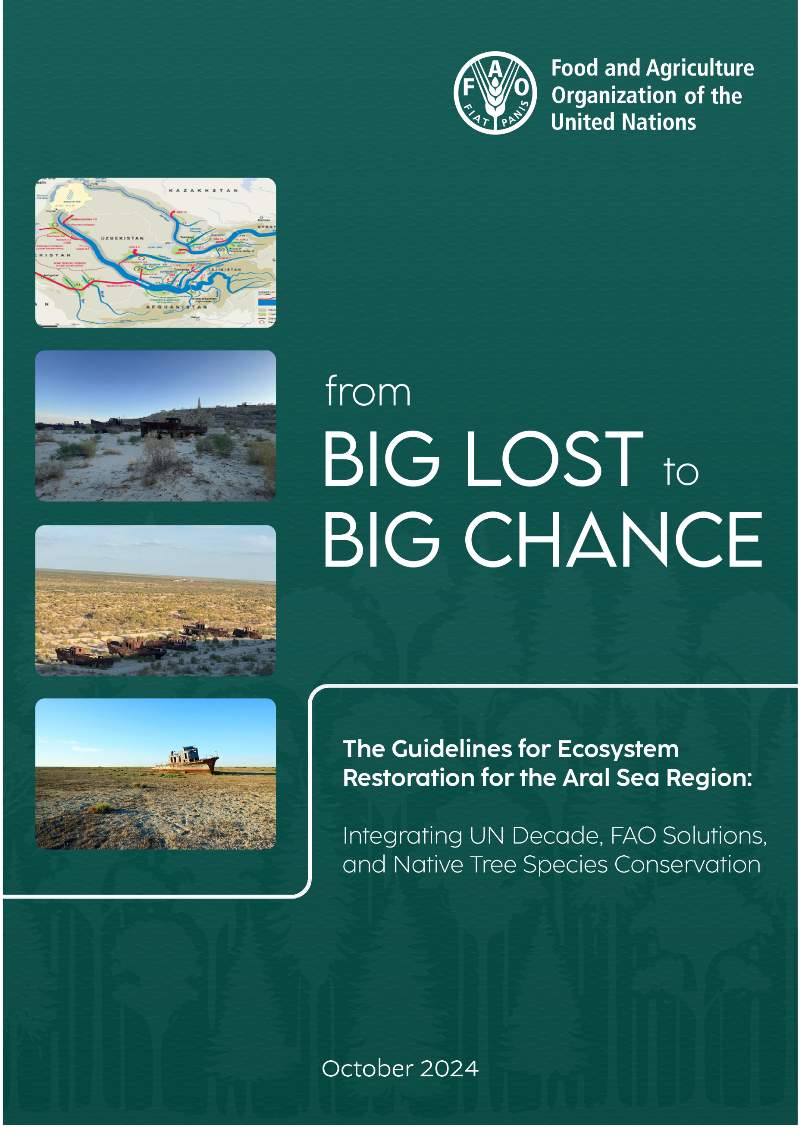

The Guidelines for Ecosystem Restoration for the Aral Sea Region Integrating UN Decade, FAO Solutions, and Native Tree Species Conservation

FOOD AND AGRICULTURE ORGANIZATION OF THE UNITED NATIONS
Ankara, 2024
Required citation:
İsmail Belen, The Guidelines for Ecosystem Restoration for the Aral Sea Region: Integrating UN Decade, FAO Solutions, and Native Tree Species Conservation. Ankara.
[Add full DOI link will be provided by OCCP]

The designations employed and the presentation of material in this information product do not imply the expression of any opinion whatsoever on the part of the Food and Agriculture Organization of the United Nations (FAO) concerning the legal or development status of any country, territory, city or area or of its authorities, or concerning the delimitation of its frontiers or boundaries. The mention of specific companies or products of manufacturers, whether or not these have been patented, does not imply that these have been endorsed or recommended by FAO in preference to others of a similar nature that are not mentioned.

The views expressed in this information product are those of the author(s) and do not necessarily reflect the views or policies of FAO.

ISBN [it will be provided later]
© FAO, 2024



Some rights reserved. This work is made available under the Creative Commons Attribution-NonCommercial-ShareAlike 3.0 IGO licence (CC BY-NC-SA 3.0 IGO; https://creativecommons.org/licenses/by-nc-sa/3.0/igo/legalcode) .

Under the terms of this licence, this work may be copied, redistributed and adapted for non-commercial purposes, provided that the work is appropriately cited. In any use of this work, there should be no suggestion that FAO endorses any specific organization, products or services. The use of the FAO logo is not permitted. If the work is adapted, then it must be licensed under the same or equivalent Creative Commons licence. If a translation of this work is created, it must include the following disclaimer along with the required citation: "This translation was not created by the Food and Agriculture Organization of the United Nations (FAO). FAO is not responsible for the content or accuracy of this translation. The original [Language] edition shall be the authoritative edition."

Disputes arising under the licence that cannot be settled amicably will be resolved by mediation and arbitration as described in Article 8 of the licence except as otherwise provided herein. The applicable mediation rules will be the mediation rules of the World Intellectual Property Organization http://www.wipo.int/amc/en/mediation/rules and any arbitration will be conducted in accordance with the Arbitration Rules of the United Nations Commission on International Trade Law (UNCITRAL).

Third-party materials. Users wishing to reuse material from this work that is attributed to a third party, such as tables, figures or images, are responsible for determining whether permission is needed for that reuse and for obtaining permission from the copyright holder. The risk of claims resulting from infringement of any third-party-owned component in the work rests solely with the user.

Sales, rights and licensing. FAO information products are available on the FAO website (www.fao.org/publications) and can be purchased through publications-sales@fao.org. Requests for commercial use should be submitted via: www.fao.org/contact-us/licence-request. Queries regarding rights and licensing should be submitted to: copyright@fao.org.

CONTENTS
List of Figures 8
List of Pictures 8
Foreword 9
Authors and Contributors Hata! Yer işareti tanımlanmamış.
Abbreviations 10
Glossary 13
Ecosystem 13
IUCN Global Ecosystem Typology 13
IUCN Red List of Ecosystems 13
What is Ecosystem Restoration? 14
Types of Ecosystem Restoration 15
Nature-based Solutions 15
Executive Summary 16
1. Introduction of the Guidelines 21
1.1. Why guidelines 21
1.2. Objectives of the Guidelines 21
1.3. The process 23
1.4. The structure 24
1.5. Target Groups 25
2. Intrroduction of the Study Area-ASB and DSAS 26
2.1. Republic of Uzbekistan 26
2.2. Republic of Karakalpakstan 29
2.2. Aral Sea Basin 30
2.3. Dried Seabed of Aral Sea (DSAS) 34
2.4. The region around the base of the dried up Aral Sea 43
2.5. Ecosystem Types in the Aral Sea Basin and Dried Aral Seabed According to IUCN 44
3. Problem and Objectives 47
4. National, Regional and International Policy and technical Documents Supporting Objectives 50
4.1. National Policy Documents 50
4.1.1. Updated Nationally Determined Contribution-2021 50
4.1.2. The UN Multi-Partner Human Security Trust Fund for the Aral Sea region in Uzbekistan (MPHSTF) 52
4.2. Regional Policy Documents 53
4.2.1. Guidelines on the Implementation of Nature-Based Solutions (NbSs) to Combat the Negative Impact of Climate Change on Forestry for the FAO-SEC Countries-2023 53
4.2.2. Guidelines on Safeguarding Native Tree Species for Conservation of Genetic Biodiversity in Central Asia-2021 54
4.2.3. Guidelines on Sustainable Forest Management under the Impact of Climate Change in Central Asia – Implications for Practitioners 54
4.3. International Policy Document 55
4.3.1. The United Nations Decade on Ecosystem Restoration 2021–2030 55
4.3.2. United Nations Decade on Combating Sand and Dust Storms (2025-2034) 55
4.3.3. IUCN Global Standard for Nature-based Solutions 56
5. Region-specific guidance for restoring ecosystems in the Aral Sea Region 58
5.1. Recommandations for policymakers 58
5.1.1. Addressing the drivers of land degradation- current situation assessment 58
Output 1. Current situation assessment and future projections 58
Activity 1.1: Study of the decrease in snowfall and melting of glaciers in the upper basins of the Amu Darya and Syr Darya, two important rivers of the Aral Sea Basin, in all countries, especially in Tajikistan and Kyrgyzstan. Define other possible reasons and their impact on the water regime, and determination of the measures to be taken. 58
Activity 1.2: Identification of existing irrigation canals, dams and ponds, domestic and industrial uses throughout the Aral Sea Basin, assessment of their impacts, prevention of losses and leakages, development of principles and procedures to ensure that new construction is carried out according to predetermined standards. 59
Activity 1.3: Reporting on agricultural and livestock practices throughout the Aral Sea Basin and developing recommendations and strategies to support their adaptation to arid conditions and the ecosystem approach. 59
Activity 1.4. To prepare a report on the legal and administrative structuring of the entire basin, taking into account IFAS, United Nations General Assembly resolutions, international legislation on transboundary waters, the legislation and institutional structures of the countries within the basin boundaries, and the European Commission's Water Directive. 59
Activity 1.5: Prepare future projections for the ASB, DSAS, each of the countries and priority sites deemed appropriate, taking into account the current situation assessment, and prioritize actions according to these projections. 60
Activity 1.6. Evaluation of existing afforestation taking into account the issues included in this Guidelines. 62
Activity 1.7. Establishing seed gardens and nurseries, improving the capacities of existing ones. 62
Activity 1.8. Making trial plantations with species such as Robinia pseudoacacia and Capparis spinosa 62
Activity 1.9. Developing training programs and country visits to increase the capacity of technical staff, local people and administrators’/policy makers 62
5.1.2 Planning for the future in line with baseline reports, agreed priorities and planning principles 62
Output 2: Plans 63
Activity 2.1. Define the "Planning Principles" that will be the basis for all planning, obtain permission or approval from the competent authorities in accordance with the legislation of the countries, and publish them in official platforms (Official Gazette, etc.) in a way that will be legally binding on all relevant parties. 63
Activity 2.2. Preparation of the " the Aral Sea Basin (174 million hectares, 6 countries) Management Stratety” based on the priorities ve rules identified in this Guidelines, to be implemented by IFAS. 63
Activity 2.3. Preparation of River Basin Management Plans (RBMPs) for the Amu Darya and Syr Darya Rivers based on the Aral Sea Basin Management Strategy Document. 63
Activity 2.4. Preperation of Rehabilitation and Management Plans (both for Uzbekistan and Kazakhistan sides) for the Dried Seabed of the Aral Sea. 63
5.1.4. Creating the enabling environmet for investment and resource mobilization for restoration 63
Activity 2.5. Preparation of an “economic plan” with special incentives and tax conditions for the region, in particular for “The Dried Seabed of the Aral Sea” region. 64
Activity 2.6. Preperation of a promotion strategy and action plan to promote the advantages of the” Dried Seabed of the Aral Sea” region to international investors, development organizations and the private sector. 64
Activity 2.7. Preparation of a strategy document and action plan for the establishment of a “National Emissions Trading System” and utilization of “Voluntary Carbon Mechanisms” in relation with carbon sequestration. 64
5.3. Recommendations for Restoring Ecosystems in the ASB and DSAS 64
Output 3: Identification of ecosystems in ASB and DSAS Regions 65
Activity 3.1. Identification and mapping of ecosystems in ASB and DSAS regions and preparation of rehabilitation plans within the framework of IUCN criteria and UN Decade principles within the scope of a project to be prepared and implemented together with IUCN. 65
6. Case Studies 66
6.1. Sand Dune Stopping Works in in Türkiye 66
6.2. Utilization of low-quality soils and marginal lands- Hungary 68
7. Recommendations for the Implementation of the Guidelines 71
8. Monitoring and evaluation 71
9. References, further reading, tools and guidelines, other case studies and websites 71
10. Annexes 73
Annex 1: UNDP-FAO Joint Program 2024 73
Annex 2: The Multi-Partner Human Security Trust Fund for the Aral Sea region (MPHSTF) 76
Annex 3: Ecosystem Types in the Aral Sea Basin and Dried Aral Seabed According to IUCN 76
2.5.1. Functional Groups of “T5 Deserts and semi-deserts biome” of “Terresterial Realm” 77
2.5.1.1. T5.1 Semi-desert steppe 77
2.5.1.2. T5.4 Cool deserts and semi-deserts 78
2.5.2. Functional Groups of T7-Intensive land-use biome of of “Terresterial Realm” 79
2.5.2.1. T7.1 Annual croplands 80
2.5.2.2. T7.2 Sown pastures and fields 81
2.5.2.3. T7.3 Plantations 82
2.5.2.4. T7.4 Urban and industrial ecosystems 83
2.5.2.5. T7.5 Derived semi-natural pastures and old fields 85
2.5.3. Functional Groups of “F1 Rivers and streams biome” of the “Freshwater Realm” 86
2.5.3.1. F1.1 Permanent upland streams 86
2.5.3.2. F1.2 Permanent lowland rivers 87
2.5.3.3. F1.5 Seasonal lowland rivers 88
2.5.3.4. F1.6 Episodic arid rivers 89
2.5.3.5. F1.7 Large lowland rivers 90
2.5.4. Functional Groups of “F2 Lakes biome” of the “Freshwater Realm” 91
2.5.5. Functional Groupf of “F3 Artificial wetlands biome” of the “Freshawater Realm” 91
Annex 4: Executive summary of the FAO’s NBs Guidelines 92
Annex 5: Executive Summary of the Guidelines on Safeguarding Native Tree Species for Conservation of Genetic Biodiversity in Central Asia 94
Annex 6: Executive Summary of the Guidelines on Sustainable Forest Management under the Impact of Climate Change in Central Asia – Implications for Practitioners 95
Annex 7: Principles of UN Decade on Ecosystem Restoration 98
Principle 1: Ecosystem Restoration Contributes to The Un Sustainable Development Goals and The Goals of the Rio Conventions 98
Principle 2: Ecosystem Restoration Promotes Inclusive And Participatory Governance, Social Fairness And Equity From The Start And Throughout The Process And Outcomes 98
Principle 3: Ecosystem Restoration Includes A Continuum Of Restorative Activities 98
Prıncıple 4: Ecosystem Restoratıon Aıms To Achıeve The Hıghest Level Of Recovery For Bıodıversıty, Ecosystem Health And Integrıty, And Human Well-Beıng 99
Prıncıple 5 Ecosystem Restoratıon Addresses The Dırect And Indırect Causes Of Ecosystem Degradatıon 99
Prıncıple 6 Ecosystem Restoratıon Incorporates All Types Of Knowledge And Promotes Theır Exchange And Integratıon Throughout The Process 99
Prıncıple 7 Ecosystem Restoratıon Is Based On Well-Defıned Short-, Medıum- And Long-Term Ecologıcal, Cultural And Socıo-Economıc Objectıves And Goals 100
Prıncıple 8 Ecosystem Restoratıon Is Tailored to The Local Ecologıcal, Cultural and Socıoeconomıc Contexts, Whıle Consıderıng The Larger Landscape Or Seascape 100
Prıncıple 9 Ecosystem Restoratıon Includes Monıtorıng, Evaluatıon And Adaptıve Management Throughout And Beyond The Lıfetıme Of The Project Or Programme 101
Prıncıple 10 Ecosystem Restoratıon Is Enabled By Polıcıes And Measures That Promote Its Long-Term Progress, Fosterıng Replıcatıon And Scalıng-Up 101
Annex 8: IUCN Global Standard for Nature-based Solutions 102
Criterion 1: NbS effectively address societal challenges 102
Criterion 2: Design of NbS is informed by scale 102
Criterion 3: NbS result in a net gain to biodiversity and ecosystem integrity 103
Criterion 4: NbS are economically viable 104
Criterion 5: NbS are based on inclusive, transparent and empowering governance processes 105
Criterion 6: NbS equitably balance trade-offs between achievement of their primary goal(s) and the continued provision of multiple benefits 106
Criterion 7: NbS are managed adaptively, based on evidence 106
Criterion 8: NbS are sustainable and mainstreamed within an appropriate jurisdictional context 107

List of Figures
Figure 1. Defining the Objective of the Guidelines 22
Figure 2. The Area Visited During the Field Visit 12-18 August 2024 24
Figure 3. Main components of ERG for Aral 25
Figure 4. Map of Uzbekistan 26
Figure 5. Forest Resources in Central Asia 27
Figure 6. Aral Sea River Basin 31
Figure 7. General situation of Dried Seabed of Aral Sea-DSAS 36
Figure 8. IUCN Global Ecosystem Typlogy 44
Figure 9. Planing of ASB, Lower Part of/Subbasin of ASB and DSAS 49
Figure 10. Updated Nationally Determined Contribution of Republic of Uzbekistan-2021 52
Figure 11. Web Page of MPHSTF 53
Figure 12. FAO Guidelines on NBs 53
Figure 13. Hierarchical levels ecosystems 65

List of Pictures
Picture 1. Project team visiting Kungrat Forestry Directorate 23
Picture 2. A tugai forest on the road side to Moynak (Photo: İsmail Belen) 28
Picture 3. Streets of Nukus, Capital of Karakalpakstan 29
Picture 4. Central Asia in ancient time 31
Picture 5. Animated Map of Aral Basin 32
Picture 6. Dried Seabed of Aral Sea-DSAS 35
Picture 7.Dried Seabed of the Aral Sea (DSAS) 37
Picture 8. Fishing boats left on the Dried Seabed of the Aral Sea (Photo İsmail Belen) 38
Picture 9. A saxsaul seedling on the Dried Seabed of the Aral Sea 39
Picture 10. In spite of salty soil condition Tamarix ssp are very succesful in the buffer zone 43
Picture 11. Sand dune afforestation in Fethiye, Muğla, Türkiye-1970s 66
Picture 12. General view of the working field 67
Picture 13. Current status of the study area as of 2024 67
Picture 14. 9 year old Robinia pseudoacacia ‘Turbo Obelisk’ industrial wood production plantation in Csemő, Hungary 69
Picture 15. 3-year-old flowering Robinia pseudoacacia ‘Turbo Obelisk’ industrial wood production plantation in Csemő, Hungary 70

Foreword

The environmental challenges faced by the Aral Sea Basin are among the most pressing and complex in the region. Decades of ecological degradation, driven by unsustainable water management and climatic changes, have transformed the landscape and jeopardized the livelihoods of millions. In response, the Guidelines for Ecosystem Restoration for the Aral Sea Region represent a significant step forward, offering a comprehensive, region-specific framework to address these challenges and guide future restoration efforts.
Developed under the Letter of Agreement (LoA) signed on 30 July 2024 between the Food and Agriculture Organization of the United Nations (FAO) and the Chamber of Forest Engineers of Türkiye (OMO), this document reflects a collaborative effort to leverage international expertise and local knowledge. The guidelines integrate the principles of the UN Decade on Ecosystem Restoration (2021-2030), FAO’s proven solutions, and the conservation of native tree species, providing a pathway for the regeneration of the Aral Sea Basin’s ecosystems.
I would like to express my deepest appreciation to Mr. İsmail Belen, who served as the Guideline Designer. His dedication, extensive knowledge, and unwavering commitment have been pivotal in the preparation of this document. His work ensures that the guidelines are not only scientifically grounded but also practical and adaptable to the specific needs of the region.
This initiative would not have been possible without the valuable contributions of local experts, national authorities, and the FAO Subregional Office for Central Asia. Their insights and collaboration have been instrumental in shaping a holistic approach to ecosystem restoration in the Aral Sea region.
As we move forward, these guidelines will serve as a cornerstone for regional cooperation and sustainable development. I am confident that with the continued support of all stakeholders, the vision of restoring the Aral Sea Basin can be realized, bringing hope and resilience to the communities that depend on its revival.
Evetta Zenina
Natural Resources Officer
FAO Subregional Office for Central Asia (FAO-SEC)

Authors and Contributors
The Chamber of Forest Engineers of Türkiye (OMO), in close collaboration with the Food and Agriculture Organization of the United Nations (FAO) Subregional Office for Central Asia (FAO-SEC), has developed the Guidelines for Ecosystem Restoration for the Aral Sea Region: Integrating UN Decade, FAO Solutions, and Native Tree Species Conservation. This document reflects a joint effort to address the pressing environmental challenges facing the Aral Sea Basin through ecosystem restoration and sustainable land management practices.
The primary authors of this guideline are:
- İsmail Belen – Guidelines Designer / International Consultant
- Abduvokhid Zakhadullaev – Local Expert for Ecosystem Restoration in the Aral Sea Region
- Hasan Türkyılmaz – LoA Coordinator
The development of this document was carried out under the supervision of Evetta Zenina, Natural Resources Officer, FAO Subregional Office for Central Asia (FAO-SEC). Valuable input and consultation were provided by:
- Abdumalik Namozov – National Project Coordinator, FAO Uzbekistan
- Jakhongir Babadjanov – National Technical Coordinator
- Dildora Aralova – Forestry Agency of Uzbekistan
- Özgür Balcı – Head of Forest Ecosystem Department, General Directorate of Forestry of Türkiye
- Ahmet Yalvaç – Advisor to the Forestry Agency of Uzbekistan
The design and layout of this publication were completed by:
- Furkan Belen – Graphic Designer
- Ercan Kaptanoğlu – IT Expert
The views and opinions expressed in this publication are those of the authors and do not necessarily reflect the policies or positions of FAO.

Abbreviations

Abbreviation | Full Name
ANR | assisted natural regeneration
ASBP | The Aral Sea Basin Assistance Program
CAS | climate adaptation services
CBD | Convention on Biological Diversity
CEPF | Critical Ecosystem Partnership Fund
EbA | ecosystem-based adaptation
EbM | ecosystem-based mitigation
Eco-DRR | ecosystem-based disaster risk reduction
FAO | Food and Agriculture Organization of the United Nations
FLR | Forest Landscape Restoration
GHG | greenhouse gas
ICRAF | World Agroforestry
ICWC | Interstate Commission for Water Coordination of Central Asia
IFAS | International Fund for Saving the Aral Sea
IFM | improved forest management
IICAS | The International Institute for Central Asian Studies
INRM | integrated natural resource management
IUCN | International Union for Conservation of Nature
LDN | land degradation neutrality
LULUCF | Land Use, Land Use Change, and Forestry
NbS | nature-based solution
NBSI | Nature Based Solutions Institute
NCS | natural climate solution
NDC | nationally determined contribution
NYDF | New York Declaration on Forests
OECD | Organisation for Economic Cooperation and Development
OMO | Chamber of Forest Engineers of Türkiye
SDG | Sustainable Development Goal
SEC | FAO Subregional Office for Central Asia
SFM | sustainable forest management
UN | United Nations
UNCCD | United Nations Convention to Combat Desertification
UNDP | United Nations Development Programme
UNECE | United Nations Economic Commission for Europe
UNEP | United Nations Environment Programme
UNFCCC | United Nations Framework Convention on Climate Change
UNFF | United Nations Forum on Forests
UN-Habitat | United Nations Human Settlements Programme
USSR | The Union of Soviet Socialist Republics
WRI | World Resources Institute
LFCC | Low Forest Cover Country
FRA | Forest Resources Assessment of FAO

Glossary

Ecosystem
An ecosystem is a geographic area where plants, animals, and other organisms, as well as weather and landscape, work together to form a bubble of life. Ecosystems contain biotic or living, parts, as well as abiotic factors, or nonliving parts. Biotic factors include plants, animals, and other organisms. Abiotic factors include rocks, temperature, and humidity. Every factor in an ecosystem depends on every other factor, either directly or indirectly. A change in the temperature of an ecosystem will often affect what plants will grow there, for instance. Animals that depend on plants for food and shelter will have to adapt to the changes, move to another ecosystem, or perish. The whole surface of Earth is a series of connected ecosystems. As human populations have grown, however, people have overtaken many ecosystems.

IUCN Global Ecosystem Typology
Ecosystems are critically important components of Earth’s biological diversity and as the natural capital that sustains human life and well-being. Yet all of the world’s ecosystems show hallmarks of human influence, and many are under acute risks of collapse, with consequences for habitats of species, genetic diversity, ecosystem services, sustainable development and human well-being.
The IUCN Global Ecosystem Typology which is considered one of the main source on ecosystem management comprises six hierarchical levels, with the three upper levels– realms, functional biomes and ecosystem functional groups – classify ecosystems based on their functional characteristics (such as structural roles of foundation species, water regime, climatic regime or food web structure), rather than based on which species live in them. The three lower levels of classification – biogeographic ecotypes, global ecosystem types and sub global ecosystem types – are often already in use and incorporated into policy infrastructure at national levels and can be linked to these upper levels. This is crucial, as important conservation action occurs at local levels, where most ecosystem-specific knowledge and data reside.

IUCN Red List of Ecosystems
The IUCN Red List of Ecosystems Categories and Criteria is a global standard for how we assess the conservation status of ecosystems, applicable at local, national, regional and global levels. The Red List of Ecosystems evaluates whether ecosystems have reached the final stage of degradation (a state of Collapse), whether they are threatened at Critically Endangered, Endangered or Vulnerable levels, or if they are not currently facing significant risk of collapse (Least Concern). It is based on a set of rules, or criteria, for performing evidence-based, scientific assessments of the risk of ecosystem collapse, as measured by reductions in geographical distribution or degradation of the key processes and components of ecosystems.
The central goal of the IUCN Red List of Ecosystems Categories and Criteria is to support conservation in resource use and management decisions by identifying ecosystems most at risk of biodiversity loss. To meet this goal, a balance of four qualities was sought in the design of the RLE protocol: generality, precision, realism, and simplicity (Keith et al. 2013). The IUCN Red List of Ecosystems will support three major products:
A global assessment of the ecosystems of the world by 2025. Partial results, focusing on specific regions, will become available from 2015 onwards.
Technical support will be provided for stakeholders to carry out finer scale assessments at national and regional levels. These may be led by government agencies, NGOs, academic institutions, IUCN national and regional offices and their networks of collaborators.
The Red List criteria may be applied to assess individual ecosystems of particular interest to stakeholders.

What is Ecosystem Restoration?
Ecosystem restoration means assisting in the recovery of ecosystems that have been degraded or destroyed, as well as conserving the ecosystems that are still intact. Healthier ecosystems, with richer biodiversity, yield greater benefits such as more fertile soils, bigger yields of timber and fish, and larger stores of greenhouse gases.
Restoration can happen in many ways – for example through actively planting or by removing pressures so that nature can recover on its own. It is not always possible – or desirable – to return an ecosystem to its original state. We still need farmland and infrastructure on land that was once forest, for instance, and ecosystems, like societies, need to adapt to a changing climate.
Between now and 2030, the restoration of 350 million hectares of degraded terrestrial and aquatic ecosystems could generate US$9 trillion in ecosystem services. Restoration could also remove 13 to 26 gigatons of greenhouse gases from the atmosphere. The economic benefits of such interventions exceed nine times the cost of investment, whereas inaction is at least three times costlier than ecosystem restoration.
All kinds of ecosystems can be restored, including forests, farmlands, cities, wetlands and oceans. Restoration initiatives can be launched by almost anyone, from governments and development agencies to businesses, communities and individuals. That is because the causes of degradation are many and varied, and can have an impact at different scales.
For instance, degradation may result from harmful policies such as subsidies for intensive farming or weak tenure laws that encourage deforestation. Lakes and coastlines can become polluted because of poor waste management or an industrial accident. Commercial pressures can leave towns and cities with too much asphalt and too few green spaces.
Restoring ecosystems large and small protects and improves the livelihoods of people who depend on them. It also helps to regulate disease and reduce the risk of natural disasters. In fact, restoration can help us achieve all of the Sustainable Development Goals.
https://www.decadeonrestoration.org/what-ecosystem-restoration

Types of Ecosystem Restoration
From forests and farmlands to freshwater, oceans and coasts, the vitality and diversity of Earth’s ecosystems are the basis of human prosperity and well-being. Yet we are degrading these precious resources in alarming ways. The UN Decade on Ecosystem Restoration is an opportunity to help turn the tide and give people and nature a sustainable future. On this page, you can learn about different categories of ecosystem, their main components, current status and major threats, as well as the benefits of restoring them.

Nature-based Solutions
Nature-based Solutions address societal challenges through actions to protect, sustainably manage, and restore natural and modified ecosystems, benefiting people and nature at the same time.
They target major challenges like climate change, disaster risk reduction, food and water security, biodiversity loss and human health, and are critical to sustainable development.
The design, implementation, and evaluation of Nature-based Solutions are supported by the IUCN Global Standard for Nature-based Solutions. The Global Standard helps users shape their solutions and make them truly effective through 8 criteria and 28 indicators

Executive Summary

The Aral Sea Basin (ASB), with a total area of 1,737,270 km2 (173.7 million ha), is a transboundary river basin in the heart of the Eurasian continent. Geographically, it covers most of Tajikistan (99 percent), Turkmenistan (95 percent) and Uzbekistan (95 percent), Kyrgyzstan (59 percent), Kazakhstan (13 percent) and Afghanistan (38 percent). There are two main rivers in the Aral Sea Basin, the Amu Darya (102.4 million ha) and the Syr Darya (53.2 million ha).

The oases irrigated by the Amu Darya and the Syr Darya have been home to civilizations since ancient times. The ASB is comparable in size and impact to major basins worldwide, including the Danube River Basin in Europe and the Nile River Basin in Africa. The Aral Sea, fed by the waters of these rivers, was the fourth-largest lake in the world until the 1960s, with an area of 68,000 km2 (6.8 million ha).

Due to the region's geographical conditions, the waters of these rivers have been used for centuries for agricultural irrigation. They were also the main source of water for domestic use and small industries such as textiles and leather. Throughout history, water has been the subject of many small and large competitions, and water shortages have occurred from time to time.

However, especially after the 1960s, the large canals built for agricultural irrigation have seriously reduced the water of the Amu Darya and Syr Darya rivers, which flow into the Aral Sea. On the other hand, water consumption in all countries has increased with population growth and rising per capita income, and the melting of glaciers in the upper basins, which are the main source of the rivers, and the decrease in snowfall have also had a negative effect. As seen in 1974-1975, extreme droughts in the region have also reduced water.

As a result, the Aral Sea began to dry up, shrinking by a tenth and losing over 15 times its water. This created 5.5 million hectares of desert, known as the "Dried Seabed of the Aral Sea-DSAS”.

Over time, dust and sand storms originating from these deserts (DSAS) have had a detrimental impact on the entire region. Conversely, the region, which was a significant maritime and seafood center in the 1960s, lost this source of employment with the withdrawal of waters, resulting in a notable increase in unemployment and the emergence of other humanitarian concerns.

As problems multiplied and water scarcity became a serious issue, the search for solutions accelerated. In 1946, a "water use rights" agreement was signed between the Union of Soviet Socialist Republics (USSR), which included the five Central Asian countries in the ASB at that time, and Afghanistan.

In 1992, five newly independent countries (Kazakhstan, Kyrgyzstan, Tajikistan, Turkmenistan, and Uzbekistan) entered into interstate agreements pertaining to the sharing, use, protection, financing, and management of water resources. In 1993, the International Fund for Saving the Aral Sea (IFAS) was established by a decision of the Heads of Central Asian (CA) states with the objective of developing and funding environmental and applied research projects and programs in order to improve the ecological situation in the areas.

In addition to these regional initiatives addressing ASB, since the 1990s, Kazakhstan and Uzbekistan have consistently garnered global attention for their role in addressing the Aral Sea problem and its implications for regional and global security. The issue of "the Dried Seabed of the Aral Sea (DSAS)" has been identified as an international environmental and humanitarian problem by all relevant parties, including the United Nations (UN). A range of activities are being carried out by numerous institutions to address this issue.

A significant development in the ASB was the creation of the Multi-Partner Human Security Trust Fund for the Aral Sea Region (MPHSTF) in 2018. In response to the Fourth Call for Proposals of the MPHSTF in 2023, the United Nations Development Programme (UNDP) and the Food and Agriculture Organization of the United Nations (FAO) collaborated to develop a program entitled "Building knowledge and skills of local partners and communities to address environmental insecurities through innovative air, land, and water management solutions in the Aral Sea Region."
This program was approved by MPHSTF and commenced on July 5, 2024. One of the 16 activities foreseen with this joint programme is "Activity 1.2.1: “Develop Ecosystem Restoration Guidelines for the Aral Sea Region: Integrating UN Decade, FAO Solutions, and Native Tree Species Conservation".
The Chamber of Forest Engineers of Türkiye (OMO) has prepared the document entitled "Guidelines for Ecosystem Restoration for the Aral Sea Region: Integrating UN Decade, FAO Solutions, and Native Tree Species Conservation" by the aforementioned UNDP/FAO Program.

The objectives of the Guidelines are twofold: firstly, to address the current environmental degradation in Karakalpakstan, including the Dried Seabed of the Aral Sea (DSAS), in order to enable a comprehensive assessment of ecosystem services; secondly, to provide comprehensive and region-specific guidance for the restoration of ecosystems in the Aral Sea Basin.

In alignment with the aforementioned objectives, a field trip was conducted between August 12th and August 18th, 2024, with the aim of observing the environmental, social, and economic situation in Karakalpakstan, otherwise known as the Uzbekistan portion of the DSAS region.

Given that Karakalpakstan and the DSAS Region constitute the lower part of ASB, it is not feasible to consider the formation of this region, the challenges encountered here, and the solution proposals in isolation from the broader ASB context. Instead, it is essential to develop proposals that are aligned with the overarching ASB framework and address the issues holistically. Accordingly, the entire ASB was taken into consideration during the preparation of the Guidelines.

The document, entitled "The Guidelines," is organized into ten chapters and several annexes. The initial chapter presents the Guidelines, while the second chapter delineates the field of study (ABS, Lower Basins of ASB and DSAS). The third chapter elucidates the problems and objectives identified, and the fourth chapter examines the international, regional, and national legislation and administrative structures. The fifth chapter offers comprehensive, region-specific guidance for the restoration of ecosystems. The sixth chapter presents case studies, the seventh chapter presents recommendations for the implementation of the Guidelines, and the eighth chapter lists recommendations for monitoring and evaluation. Chapter nine lists additional resources, and chapter ten provides the Annexes.

In light of the pivotal role played by "National, Regional and International Policy and Technical Documents" in achieving the desired outcomes, particular emphasis was placed on:
- Updated Nationally Determined Contribution of Republic of Uzbeskistan-2021,
- United Nations Decade on Combating Sand and Dust Storms (2025–2034)The United Nations Decade on Ecosystem Restoration 2021–2030 and,
- IUCN Global Standard for Nature-based Solutions in Chapter 4.

In addition to the aforementioned documents, the following Guidelines, prepared by OMO for Central Asia, have also been reviewed together with the “FAO Global Guidelines for the Restoration of Degraded Forests and Landscapes in Drylands. Building Resilience and Benefitting Livelihoods”:

- Guidelines on the Implementation of Nature-Based Solutions (NbSs) to Combat the Negative Impact of Climate Change on Forestry for the FAO-SEC Countries-2023
- Guidelines on Safeguarding Native Tree Species for Conservation of Genetic Biodiversity in Central Asia-2021
- Guidelines on Sustainable Forest Management under the Impact of Climate Change in Central Asia – Implications for Practitioners-2021

The findings and recommendations are presented in detail in the relevant chapters. In conclusion, the following points can be summarized as follows:
- With regard to the Aral Sea Basin (ASB) as a whole, the International Fund for Saving the Aral Sea (IFAS) plays an indispensable role in five Central Asian countries. Currently IFAS continues to be actively engaged in its mission. Indeed, a two-year work plan was approved at the IFAS Board meeting, which was held on September 18, 2024. However, in consideration of the "basin integrity" of the ASB, it was determined that the inclusion of Afghanistan in IFAS or the development of an appropriate mechanism would be advantageous. Indeed, the construction of the Qosh Tepa Canal, which commenced in 2022 with the objective of utilizing a substantial volume of the Amu Darya River's water resources, underscores the necessity for such a mechanism.

- On the other hand, considering that CA countries have already reached an accord on transboundary waters, it is proposed that the European Commission's Water Framework Directive could serve as an exemplar for the administration of all forms of ASB.

- The "Dried Seabed of the Aral Sea-DSAS" region, which is estimated to span approximately 5.5 million hectares, represents a significant environmental, economic, and human challenge. However, it also offers a substantial opportunity for positive transformation, contingent upon effective management strategies. Nevertheless, for this to occur, it is proposed that a comprehensive and integrated planning approach is required, in which all relevant parties are engaged and all environmental, economic, and social considerations are included.

- In response to the dust and sand storms emanating from the DSAS region, both Kazakhstan and Uzbekistan have rightly identified soil stabilization as a priority and have initiated extensive afforestation programs, which have yielded successful results in both countries. It is evident that the necessary legislative bases for these afforestation campaigns have been established at the international, regional, and national levels, and that highly significant and forward-thinking decisions have been made. However, the "Decade on Combating Sand and Dust Storms 2025-2034" document adopted by the United Nations General Assembly on 1 July 2024 is considered to be an important reference source, especially on the issues of sand and dust transportation. "Guideline on the integration of sand and dust storm management into key policy areas" serves as a guide for the region.

- Nevertheless, the lack of implementation of the "National Emissions Trading System," "National Certification System," and "Voluntary Carbon Mechanisms" standards and opportunities, which offer numerous environmental, sociological, and economic advantages, has been identified as a significant deficiency. In addition to the emissions trading system to be developed at the national level within the scope of the United Nations Framework Convention on Climate Change (UNFCCC) and the Paris Climate Agreement, numerous voluntary carbon mechanisms, including the Gold Standard, Verified Carbon Standard, and Plan Vivo, offer significant advantages. Furthermore, collaboration with these mechanisms will facilitate the calculation of potential for carbon sequestration and support the implementation of sustainable development goals. In addition to these mechanisms, working in close connection with certification systems such as the Forest Stewardship Council (FSC) and the Programme for the Endorsement of Forest Certification (PEFC) will contribute to meeting environmental and social requirements and complying with sustainable development goals. Furthermore, this alignment will facilitate the mobilization of financial resources from diverse private sector entities. For instance, AstraZeneca has recently announced a $400 million investment in reforestation and biodiversity initiatives, underscoring the company's commitment to climate action and human health. Such endeavors align with the objectives set forth in General Assembly Resolution 75/278 of May 18, 2021, which calls for the designation of the Aral Sea region as a hub for ecological innovations and technologies.

- In terms of administrative structure and management, it is evident that the "Multi-Partner Human Security Trust Fund for the Aral Sea Region-MPHSTF" (established in 2018) and the "International Innovation Center for the Aral Sea Basin-IICAS" (established in 2018) represent two significant units for Uzbekistan. Nevertheless, in the course of interviews with the relevant parties, it was ascertained that the term of office of the MPHSTF will conclude at the end of 2024. In light of its ongoing activities and its current role, it is recommended that the MPHSTF be continued and strengthened.

- Conversely, it was ascertained that IICAS, which was previously an institution with direct affiliation to the Presidency of Uzbekistan, underwent a transformation in 2024, becoming an institution with affiliation to the Ministry of Ecology, Environmental Protection and Climate Change of Uzbekistan.

- From an administrative structuring perspective, while the ASB Region, the DSAS Region, and the ASB Subregion around the DSAS are interrelated and influence each other, it is deemed appropriate to develop a management model that aligns with this understanding. This approach acknowledges the distinct characteristics and separate ecosystems of these regions, recognizing their complementary nature while acknowledging the necessity for differentiated management objectives.

- The ASB Region encompasses six countries and 174 million hectares. When the area remaining on the borders of Kazakhstan is taken into account, the DSAS region is calculated to cover 5.5 million hectares. It is estimated that approximately 3.5 million hectares of this area remain on the borders of Uzbekistan.
- It is acknowledged that measurements and mapping related to the areas surrounding the DSAS region have not yet been conducted. In the case of the Autonomous Region of Karakalpakstan, it is evident that residential areas such as Nukus, Daşoguz, Konurat, Urgench, and even Moynak, in addition to agricultural zones, pastures, and forest areas surrounding them, exhibit a markedly disparate structure when compared to the DSAS region. The DSAS region is a recently designated area, and no human settlements have yet been established. The primary objective is to stabilize the soil.

- Once these three distinctions have been clearly delineated, it becomes evident that an administrative structure is necessary to facilitate their management and ensure their integration with one another. For example, a "DSAS Region Afforestation and Rehabilitation Regional Directorate" could be established, operating entirely within the DSAS Region and comprising different professional groups. In light of the existing organizational framework, it may be suggested that the Regional Directorate be linked to the Forestry Agency, which falls under the purview of the Ministry of Ecology, Environmental Protection and Climate Change of Uzbekistan.

- Despite the name "International Innovation Center for Aral Sea" (IICAS), the organization's current focus is on Nukus and the surrounding settlements, specifically the areas around DSAS. However, the inclusion of "ASB" in the name may prove confusing. An alternative designation would be "Regional Development Agency," which would be directly affiliated with the Presidency and would contribute to the overall planning and development of the region.

Introduction of the Guidelines

This chapter elucidates the rationale behind the formulation of the Guidelines, its intended outcomes, the methodology employed in their creation, the structure of the document, and the intended audiences.

1.1. Why guidelines

The Aral Sea Basin (ASB), encompassing an area of approximately 174 million hectares, constitutes a transboundary river basin. The Aral Sea, which was fed by the waters of these rivers, was the fourth largest lake in the world, with an area of 6.8 million hectares, until the 1960s. It then underwent a significant reduction in size, reaching only one-tenth of its original extent by 2024.

In light of recent developments, it is now possible to categorize the challenges facing the region into three distinct groups.

- The issues pertaining to the Aral Sea Basin (ASB), which encompasses six countries and an area of approximately 174 million hectares, are multifaceted and complex.
- The issues and solutions pertaining to the Dried Seabed of the Aral Sea (DSAS) are constrained to this specific region and possess a more nationalistic character. (Approximately 3.5 million hectares in Uzbekistan and around 2 million hectares in Kazakhistan).
- The Aral Sea Basin (ASB) subregion surrounding the Dried Seabed of the Aral Sea (DSAS)

The solution to such a significant issue that spans a vast geographical area and encompasses numerous countries, and which is of concern to all segments of society, from local communities to international organisations, will only be feasible through an international, inter-sectoral approach and understanding.

Conversely, recommendations that do not address the land, the grassroots, and the daily lives of local people and are not developed in collaboration with them have minimal potential for implementation. Furthermore, even if they are implemented, they are unlikely to be effective or useful.

As evidenced by the UN Multi-Partner Human Security Trust Fund for the Aral Sea Region in Uzbekistan (MPHSTF), the Aral Sea Region has received considerable donor attention and financial support since the mid-1990s. However, these endeavours have yielded limited results due to the lack of coordination in the provision of aid, the replication of activities, the low level of government ownership, and the unsustainability of the outcomes.

In this context, the Guidelines were developed as a forum where all stakeholders can convene to discuss shared objectives from an international perspective, utilising data gathered from the field.

1.2. Objectives of the Guidelines

The present Guidelines have been prepared within the scope of the Joint UNDP-FAO Programme, namely "Building knowledge and skills of local partners and communities to address environmental insecurities through innovative air, land, and water management solutions in the Aral Sea Region".
This programme is supported by the Multi-Partner Human Security Trust Fund for the Aral Sea Region in Uzbekistan (MPHSTF).
In formulating the objectives of the guidelines, due consideration was given to the UNDP-FAO Joint Project, the MPHSTF, and other relevant national and international policy documents.
The mission of the MPHSTF is to make a positive contribution to the field of development coordination. This is to be achieved through the implementation of a unified strategy, the facilitation of regional and international dialogue, the mobilisation of resources and the increase of funds, the strengthening of the coordination of activities among the UN agencies, the establishment of an integrated and coherent framework, the enhancement of the capacity of national organisations, the monitoring of activities and the reporting of findings.

One of the 16 activities foreseen with this joint programme is "Activity 1.2.1: “Develop Ecosystem Restoration Guidelines for the Aral Sea Region: Integrating UN Decade, FAO Solutions, and Native Tree Species Conservation". The objective of Activity 1.2.1 is to furnish comprehensive and region-specific guidance for the restoration of ecosystems in the Aral Sea Region. This initiative is designed to address the current environmental degradation in Karakalpakstan and is expected to facilitate a comprehensive assessment of ecosystem services, thereby enhancing local community management practices.

It is anticipated that this activity will make a significant contribution to the overarching goals of environmental sustainability and community resilience in the Aral Sea Region, which is a key priority area for the Uzbek government, international efforts and the MPHSTF.

In this context, the objectives of the Guidelines were determined with due consideration of the international, national and regional policy documents including the UN General Assembly Resolution A/C.2/78/L.34/Rev.1 titled “Central Asia facing environmental challenges: fostering regional
solidarity for sustainable development and prosperity” adopted in 2023 mentioned in the figure.

Figure 1. Defining the Objective of the Guidelines

In light of the aforementioned explanations, the objectives of the guidelines are defined as follows:
- Address the current environmental degradation in Karakalpakstan including the Dried Seabed of the Aral Sea-DSAS to enable a comprehensive assessment of ecosystem services,
- Provide comprehensive and region-specific guidance for restoring ecosystems in the Aral Sea Basin.

1.3. The process

The process of preparing the Guidelines started with the letter of agreement signed between FAO and OMO on 1 August 2024. According to the signed Letter of Agreement, the work to be carried out by OMO as "Service Provider" was identified and a work plan was prepared.
In this framework, OMO first identified the "LoA Coordinator", the "Local Expert for Ecosystem Restoration for the Aral Sea Region" and the "Guidelines Designer for the 'Ecosystem Restoration Guidelines for the Aral Sea Region".
This was followed by a comprehensive desk study and several online meetings chaired by Ms Evetta Zenina of FAO-SEC. Abdumalik Namozov and Jakhongir Babadjanov from the Uzbek project team participated in some of these meetings.
Picture 1. Project team visiting Kungrat Forestry Directorate
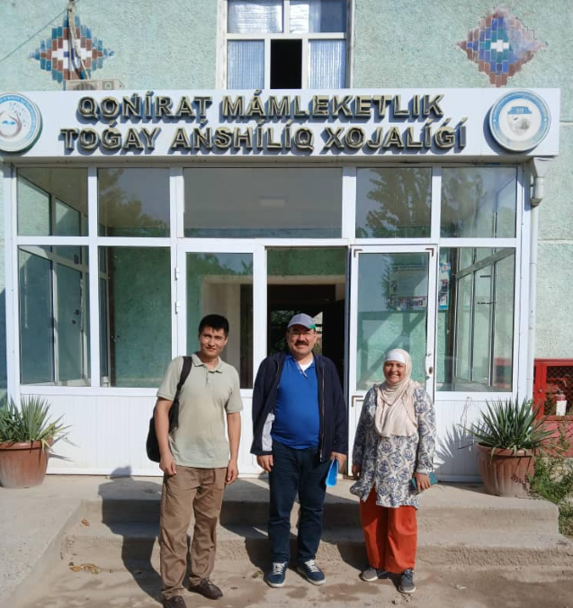

Following the preparatory work, Ismail Belen, who was appointed by OMO as "Guidelines Designer", , travelled to Uzbekistan from 12 to 18 August 2024, met with the authorities in Tashkent and then travelled to the Karakalpakstan Autonomous Region together with Jakhongir Babadjanov and Dildora Aralova, where he conducted field surveys and held meetings with the authorities and local people.
Figure 2. The Area Visited During the Field Visit 12-18 August 2024
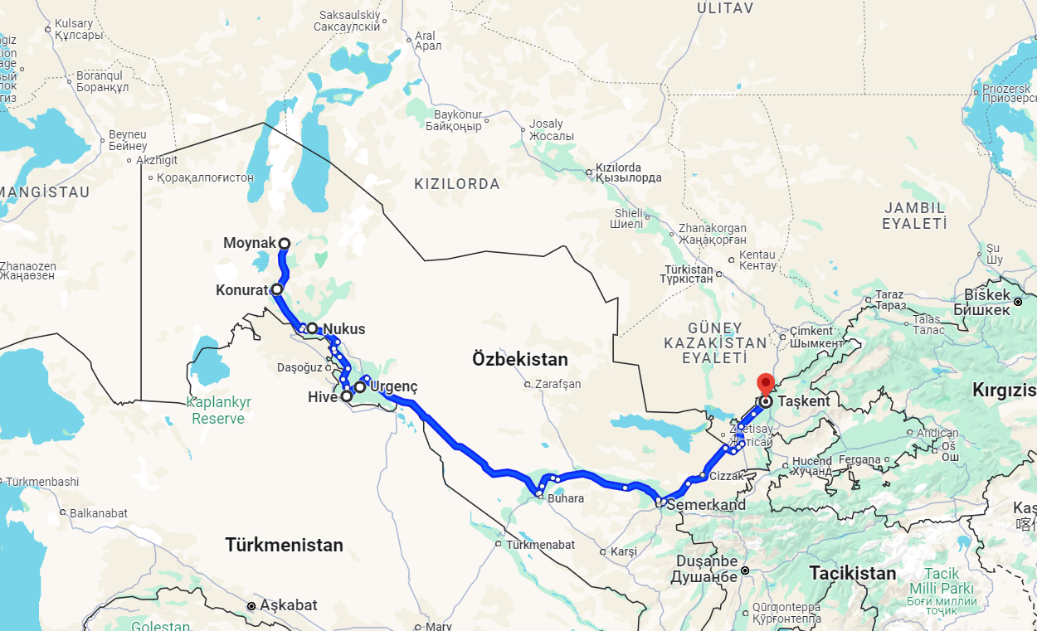

Box 1. List of Institutes Met During the Preparation Phase of the Guidelines
1. FAO-SEC Office in Ankara and FAO Office in Uzbekistan
2. Forestry Agency of the Ministry of Ecology, Environmental Protection and Climate Change of Uzbekistan
3. International Innovation Centre for Aral Sea Basin under the Ministry of Ecology, Environmental Protection and Climate Change of Uzbekistan
4. Ministry of Ecology of Karakalpakstan
5. Karalapsktan Forestry Agency
6. Kungrad Rayon Forestry and Hunting Directorate
7. Ministry of Ecology, Environmental Protection and Climate Change of the Republic of Uzbekistan (First Deputy Minister)
8. Muynak Forestry Directorate
9. Office of the UN Multi-Partner Trust Fund for Human Security in the Aral Sea Region
10. Project Manager - RESILAND CA+ Programme: Uzbekistan Resilient Landscapes Restoration Project
11. UNDP Uzbekistan Office

1.4. The structure
The Guidelines are structured into 10 chapters including the "Annex" chapter. In addition to these chapters, there are also "Executive Summary" and "Glossary" chapters.
- The introductory chapter explains the reason for the preparation of the guide, its objectives, preparation process, structure and target groups.
- The second chapter covers the study area and deals with the ecosystem, flora and fauna, social and economic status, land and human values, water resources and problems encountered.
- The third chapter is devoted to the problem statement and the objectives of the guidelines.
- The fourth chapter lists national, regional and international policy documents that support the objective of the Guidelines.
- The fifth chapter provides comprehensive and region-specific guidelines for ecosystem restoration in the Aral Sea region.
- The sixth chapter examines case studies from the study area, neighboring areas, other parts of the country and other countries, and evaluates whether these examples can be applied in the region.
- The seventh session is about the accommodations for the implementation of the guidelines.
- The eighth chapter deals with monitoring and evaluation.
- The ninth chapter lists sources of reference.
- Chapter ten is reserved for Annexes
Figure 3. Main components of ERG for Aral

1.5. Target Groups

The field of work covers different types of human resources. If we consider the Aral Sea Basin as a whole for 6 countries covering almost 174 million hectares, then we need to take into account the international and national as well as regional negotiators.
Due to its nature as a transboundary basin and a river basin, the diplomats responsible for international negotiators should understand the nature and their capacity on the ground. Similarly, technical experts are expected to have sufficient information to at least follow the international processes.
Many representatives of the United Nations and its policy departments and implementing agencies deal with the Aral Sea, as well as people from different countries' development agencies.
Of course, the local people who live and work in the area are at the center of all activities.
As a result, it can be said that the target groups of the Guidelines are policy makers from international agencies, government agencies, researchers, negotiators, academics, members of the media, local implementers, local people.

Intrroduction of the Study Area-ASB and DSAS

The second chapter covers the study area and deals with the ecosystem, flora and fauna, social and economic status, land and human resources, water resources, and problems encountered.

2.1. Republic of Uzbekistan

Uzbekistan is located in Central Asia, between Kazakhstan in the north, Kyrgyz Republic and Tajikistan in the east, Afghanistan in the south, and Turkmenistan in the west. Most of the country is in lowlands on plain terrain, including ASB in the northern and western parts and Kyzylkum, the largest desert of Central Asia, that covers particularly the southern part of Uzbekistan.
Uzbekistan is a resource-rich developing economy with a stable annual GDP growth of over 5%. The country has about 35 million population. According to UN estimates, the country's population will reach 37 million by 2030. With a total area of about 448.900 km² (44,9 million ha) approximately 49 percent of the population is concentrated in rural areas. Population density in rural areas is low except for the fertile and irrigated Fergana Valley.
Figure 4. Map of Uzbekistan
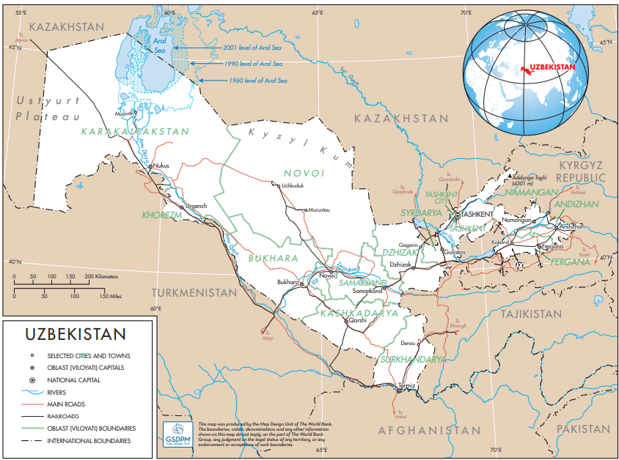
About 10 percent of the land is intensively cultivated, mostly in river valleys and oases with extensive irrigation systems (82 percent of arable land is irrigated). Some of the land in the foothills, where rainfall exceeds 350 mm per year, is used for non-irrigated agriculture (cereals, vines, pumpkins, oilseeds) and agroforestry. Overall, livestock production accounts for 40 percent of gross agricultural output.
Uzbek agriculture faces several challenges, including high water consumption (90 percent of total water consumption in Uzbekistan) and inefficiency of irrigation systems, declining soil fertility, and salinization (65 percent of irrigated area in 2000).
Uzbekistan is a low forest cover country (LFCC) with an effective forest cover of about 3.7 million ha in 2020, as reported to FAO/Forest Resources Assessment (FRA) (2020). Most of the forest is part of the State Forest Fund (SFF) that comprises 12.2 million ha of land.
Box 2. Forest Resoutces of Uzbekistan
- Total forest area 3 689 660
  - Naturally regenerating forest 1 422 980
  - Planted forest 2 266 680
- Other wooded land 1 175 020
- Forest and other wooded land 4 864 680
- Total Area Under State Forest Fund 12 200 000
- Total Country Area 44 890 000

Figure 5. Forest Resources in Central Asia
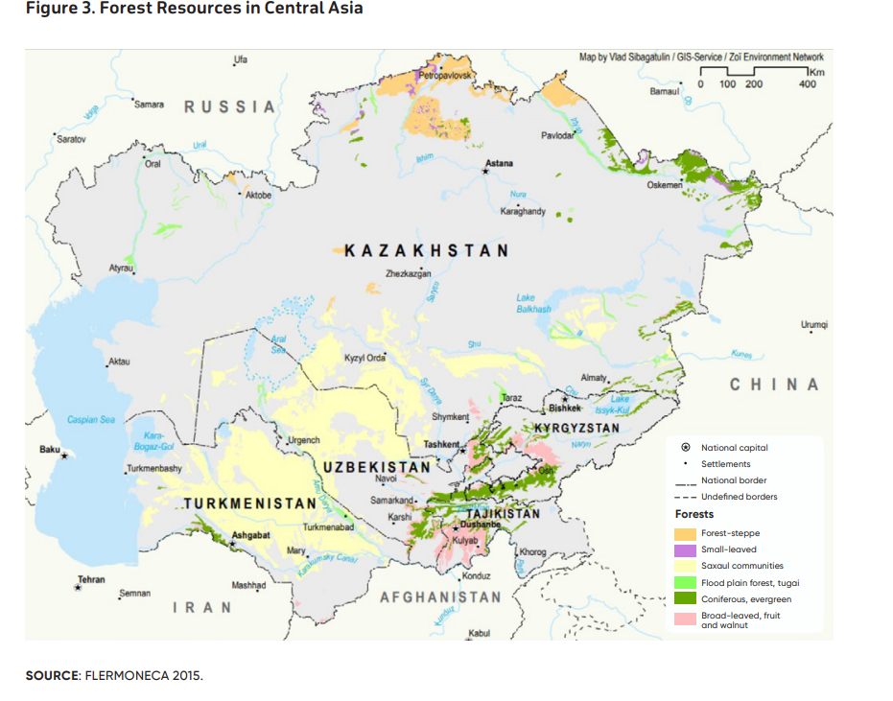
Forests are under pressure from multiple drivers. While in the past land conversion to commercial agriculture was a major threat, today the main pressures in desert, river valley and mountain areas are overgrazing, increasing demand for fuelwood and other forest products, impacts of unsustainable land use, impacts of forest and landscape fires, and climate hazards.
In spite of the low level of forest cover and the pressure on forests, the sector offers opportunities for future sustainable development in areas such as:
- Expand tree planting (afforestation, shelterbelts, etc.) to combat soil erosion and mitigate climate change;
- Expanding forest management plans to include local government forests to support sustainably managed community-based resources;
- Planting fast-growing tree species and woody energy crops to reduce pressure on natural forests and woodlands and support emissions targets;
- Increased production and trade of NWFPs;
- Improved management of protected areas; and
- Ecosystem and ecotourism development.
These rural-based opportunities would provide much needed employment in rural areas and contribute to the alleviation of poverty.
Saxaul trees and shrub woodlands in desert-like plains cover nearly four-fifths of the country,. Haloxylon spp. and Tamarix spp making up 66 percent and 5 percent, respectively, of all trees in Uzbekistan.
The main focus of forestry activities in the desert zone, including the DSAS Area, is afforestation to prevent or reduce salt and dust erosion from the soil surface as well as to stabilize shifting sands.
Tugai forests (riparian forests) develop in specific ecological conditions: a high-water table and periodic floods combined with a hot dry climate in summer, low air humidity, and an absence of summer precipitation.
Picture 2. A tugai forest on the road side to Moynak (Photo: İsmail Belen)
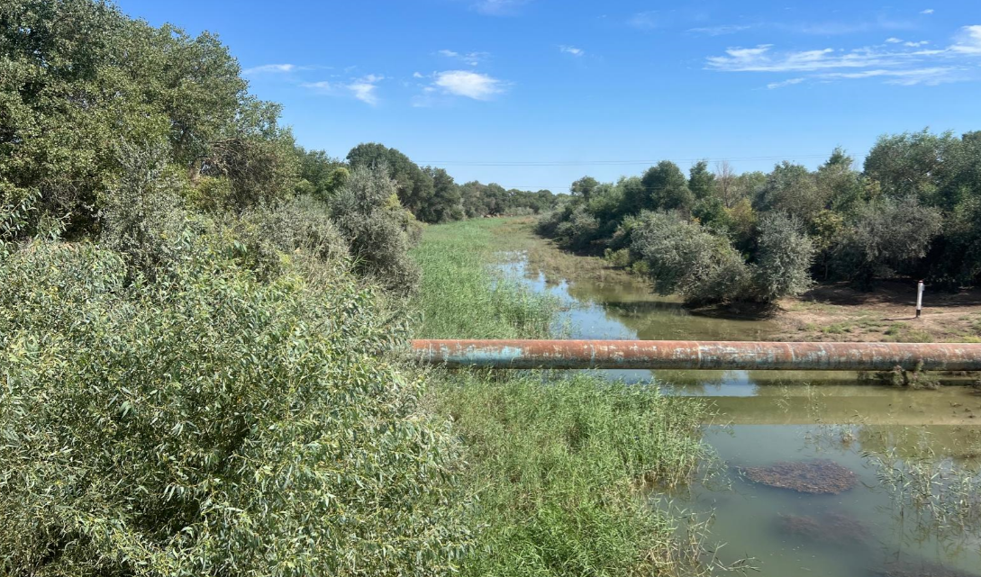
Primary forest-forming tugai species are native poplar species (Populus diversifolia, Populus pruinosa), Russian olive (Elaeagnus angustifolia L.), willow (Salix songarica) and tamarix. In total there are about 40 species of typical tugai plants. Tugai vegetation supports reptiles such as the lidless skink and grass snake, birds such as pheasant species and herons, mammals (jungle cat, jackal, fox, wolf, and badger), rodents, and ungulates (boar, Bukhara deer). However, the biodiversity in these mosaic forested landscapes is highly threatened.
Tugai forests were once widespread and played a major function in protecting waterflow and low-lying soils. The largest dispersed areas of tugai forest ecosystems occupy some 30,000 ha in the Republic of Karakalpakstan in the western part of the country, comprising about 10 percent of the initial tugai forests in the delta of the Amu Darya River. These areas also account for 75 percent of all remaining tugai forests in Uzbekistan and 20 percent of tugai forests of Central Asia.

2.2. Republic of Karakalpakstan

The Republic of Karakalpakstan occupies the entire northwestern tip of Uzbekistan accounting for about 37% of its total area. The entire territory of Karakalpakstan is predominantly occupied by plateaus and low deltaic plains (50-200 m above sea level).
The area has a very small population (1.9 million inhabitants in 2022 on a territory of 160,000 km², i.e., a density of around 11 inhabitants per km² against 78.6 inhabitants per km² nationally).
Picture 3. Streets of Nukus, Capital of Karakalpakstan
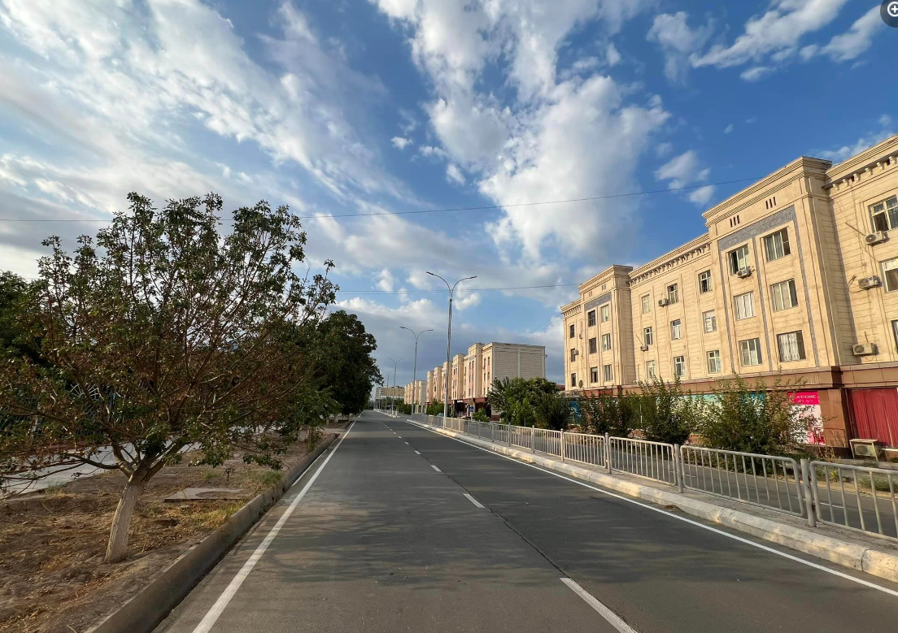

Table 1. Population by district in the Republic of Karakalpakstan
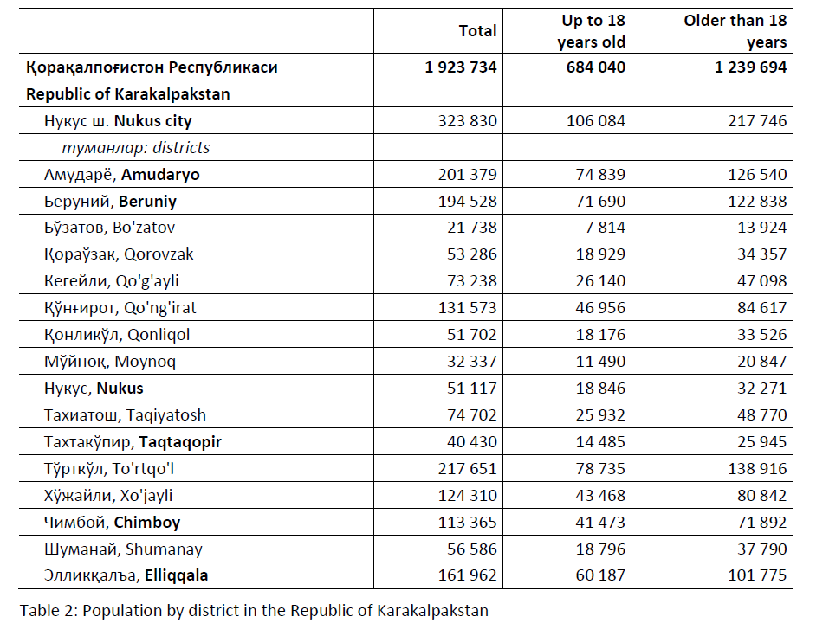

2.2. Aral Sea Basin

The Aral Sea basin, total area 1 737 270 km2 (173 727 000 hectare) is a transboundary river basin at the heart of the Eurasian continent.

Geographically it covers an extensive area of Central Asia, most of Tajikistan (99 percent), Turkmenistan (95 percent) and Uzbekistan (95 percent), Osh, Djalal-Abad and Naryn provinces of Kyrgyzstan (59 percent), Kyzylorda and South Kazakhstan provinces of Kazakhstan (13 percent), northern Afghanistan (38 percent) and a very small part of the Islamic Republic of Iran in the Tedzhen/Murghab basin.

There are basically two main rivers and their tributaries in the ASB, the Amu Darya (102,4 million ha) and the Syr Darya (53, 2 million ha).

Figure 6. Aral Sea River Basin
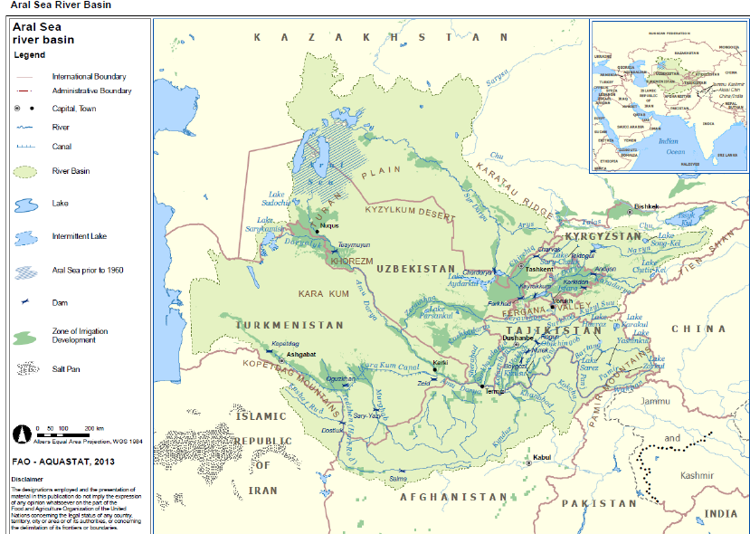

Picture 4. Central Asia in ancient time
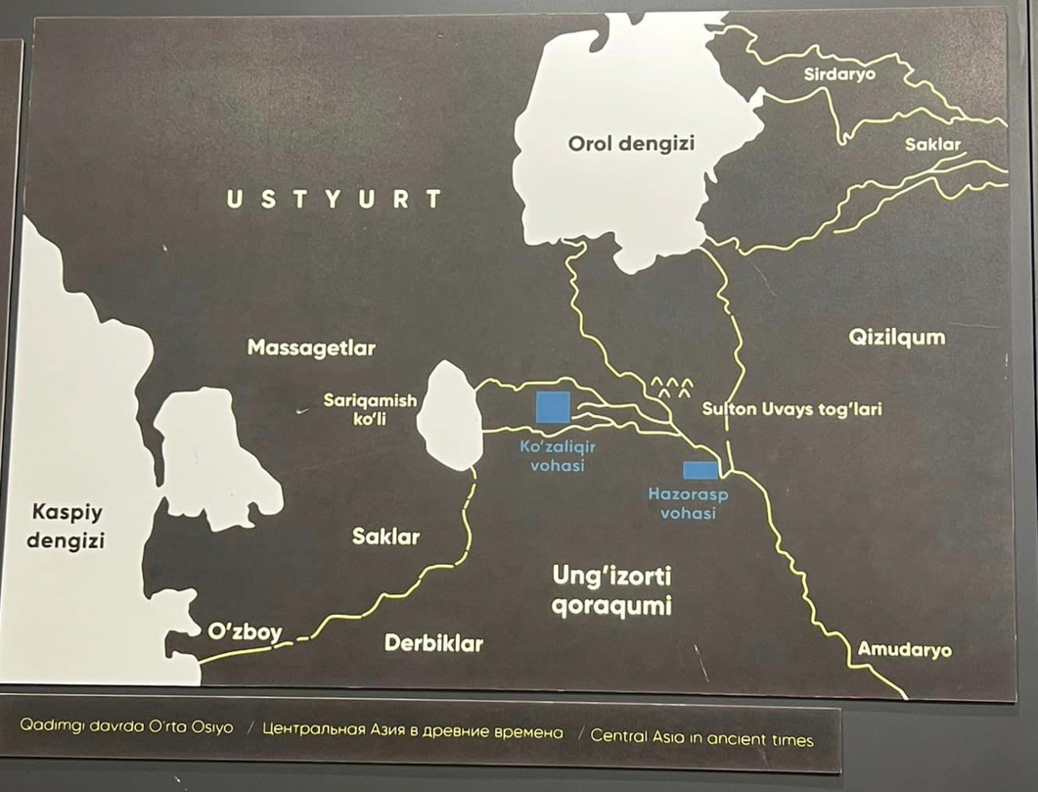

Picture 5. Animated Map of Aral Basin
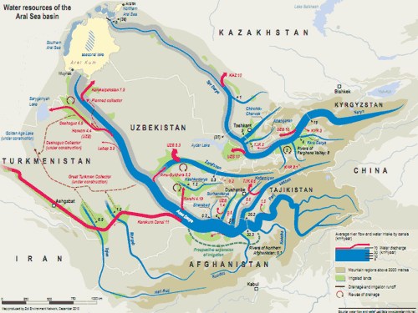
With the help of the geographical conditions of the region, the water of these three rivers has been used for agricultural irrigation for centuries, and throughout history it has been the subject of many small and large competitions, and water shortages have occurred from time to time.

However, especially after the 1960s, large-scale canals built for agricultural irrigation have seriously reduced the waters of the Amu Darya and Syr Darya rivers reaching the Aral Sea. As of 2019, the main concequences of the drying up of the Aral Sea, in addition to the decrease in water wolume and water surface, were manifested in the formation of a huge salt desert on more than 5,5 million hectares which replaced the dried seabed.

Considering that the main problem in the region is water scarcity, and that the Amu Darya and Syr Darya Rivers collect a large portion of their water from the upper basins of Tajikistan and Kyrgyzstan, the necessity of “integrated basin management” approaches that will cover the entire basin emerges. On the other hand, it is obvious that activities should be initiated on the basis of settlements, villages and neighbourhoods, and that solutions and activities should be implemented at the local and national levels.

When we look at basin-based activities, we see that more emphasis is given to the “water uses rights”. The Union of Soviet Socialist Republics (USSR) and Afghanistan signed “International Water Agreement” in 1946.

During USSR time, especially after 1960s, a single water-management system with centralized governance and complex hydraulic infrastructure was formed to meet growing demands of population and economic sectors. For efficient inter-republican allocation and use of water in Syr Darya and Amu Darya basins, the USSR established Syr Darya and Amu Darya basin authorities in 1987.

With the collapse of the USSR in 1991 and formation of five independent states in Central Asia (CA) including Kazakhstan, Kyrgyz Republic, Tajikistan, Turkmenistan, and Uzbekistan, the formerly internal water resources became transboundary ones.

In 1992, five newly independent countries (Kazakhstan, Kyrgyzstan, Tajikistan, Turkmenistan and Uzbekistan) signed interstate agreements on water sharing, use, protection, financing and management. The same year, the Interstate Commission on Water Coordination (ICWC) was established.

The International Fund for Saving the Aral Sea (IFAS) was established in 1993. In 1994, the “Aral Sea Basin Program-ASBP” prepared by the World Bank, UNDP and UNEP was approved by the Heads of State of the 5 countries.

These studies initiated by the countries in the region were also supported by the United Nations. The General Assembly of the UN granted an observer status of IFAS to the UN General Assembly by its resolution 63/133 of 11 December 2008. Later, the UN General Assembly made many decisions regarding the Aral Sea Region.

In 2018 “the Aral Sea UN Human Security Trust Fund for the Aral Sea in Uzbekistan" was established by the UN. In 2021 UN declared ASB a zone of ecological innovations and technologies" by its Resolution adopted by the General Assembly on 18 May 2021.

Following this Resolution a special program was launched for the Aral Sea Region with the decision of the UN General Assembly dated 22 May 2023. Finally, with the decision of the United Nations General Assembly dated 10 July 2024, a decision was taken to “promote sustainable forest management, including afforestation and reforestation in degraded lands, including drylands, as an effective solution to environmental challenges”.

The joint efforts of the countries in the region, both through the United Nations and IFAS, have led to the start of many projects in the Aral Sea Basin. In this context, RESILAND CA+ (Resilient Landscapes in Central Asia), which is being implemented by the World Bank together with other partners, stands out as an important project.

One of the projects being implemented in the region is the “Building knowledge and skills of local partners and communities to address environmental insecurities through innovative air, land, and water management solutions in the Aral Sea Region” project, implemented by UNDP-FAO with the financial support of the UN Multi-Partner Human Security Trust Fund for the Aral Sea region in Uzbekistan (MPHSTF).

When the studies on ASB are evaluated in general, the studies carried out by 5 Central Asian countries together with the United Nations and the existence of organizations such as IFAS are considered a great development and demonstrate the capacity to do business.

However, the countries' focus on water sharing rather than the "integrated basin management" approach, and on the other hand, the focus of projects, especially in recent years, on the DSAS region, constitute a serious obstacle to the effective solution of the problem.

Considering that 38% of Afghanistan is located within the Aral Sea Basin, it is considered appropriate to include Afghanistan in IFAS, of which Tajikistan, Turkmenistan, Uzbekistan, Kyrgyzstan and Kazakhstan are currently members.

On the other hand, considering that CA countries have already agreed on transboundary waters, it is considered that the European Commission Water Framework Directive could be a good example for the management of ASB as a whole.

Considering that citizens, nature and industry all need healthy rivers and lakes, groundwater and bathing waters, The Water Framework Directive (WFD) focuses on ensuring good qualitative and quantitative health, i.e. on reducing and removing pollution and on ensuring that there is enough water to support wildlife at the same time as human needs.

Since 2000, the WFD has been the main law for water protection in Europe. It applies to inland, transitional and coastal surface waters as well as groundwaters. It ensures an integrated approach to water management, respecting the integrity of whole ecosystems, including by regulating individual pollutants and setting corresponding regulatory standards. It is based on a river basin district approach to make sure that neighbouring countries cooperate to manage the rivers and other bodies of water they share.

It requires Member States to use their River Basin Management Plans (RBMPs) and Programmes of Measures (PoMs) to protect and, where necessary, restore water bodies in order to reach good status, and to prevent deterioration

2.3. Dried Seabed of Aral Sea (DSAS)

The Aral Sea, being unique, beautiful and one of the largest inland water bodies in the world, has almost disappeared within one genera¬tion’s life, resulted in unprecedented disaster and irreparable damage to the life of more than 60 million residents, the ecosystem and biodiversity of the Aral Sea region and adjacent territories.
More than 5.5 million hectares have turned into a salt desert, a source of salt aerosols being carried into the Earth’s atmosphere, with Kazakhstan’s part amounting to about 2.0 million hectares and the rest (3,5 million hectares)is in Uzbekistan border.
Picture 6. Dried Seabed of Aral Sea-DSAS
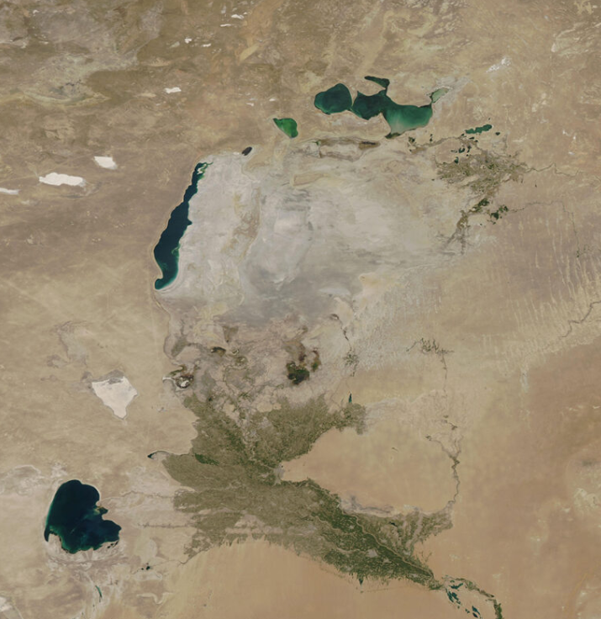
Today, the surface area of the remaining parts of the Aral Sea is less than 10% of the area in 1960. Accordingly, the amount of water has reduced by almost 15 times.
For the full restoration of the Aral Sea, 1080 km3 of water (sea level in 1950s) plus about 50 km3 annually will be required to compensate for evaporation losses. The total annual flow of the Amudarya and Syrdarya rivers is about 120 km3. Thus, to fill the sea until the initial level, all economic activities in the basin must be terminated for at least 30-40 years that is actually unrealistic!
At the time of the global climate change, the disappearance of the Aral Sea has resulted in fact that since 1980s the warming rate in the basin region exceeds the rate of global warming by more than twice. In general, it can be unequivocally said that climate change in the region has resulted in:
- Increased intensity of the dry hot period, in turn, resulted in increased evaporation in plains and foothills;
- High variability of precipitation with an increased number of days with heavy precipitation.
- Increased frequency of extreme events, droughts and water deficiency.
Due to changes in the temperature regime, the structure of atmospheric moisture transfer over the territory of Central Asia has also changed. At the same time, precipitation has occurred mainly during the warm period of the year, resulted in a reduced area of mountain glaciers of the Pamir and Tien Shan (the rate is 0.2%-l% per year). Snow cover in the mountain river basins of the region trends to be reduced, resulting in deteriorated available of water for agriculture.
Figure 7. General situation of Dried Seabed of Aral Sea-DSAS
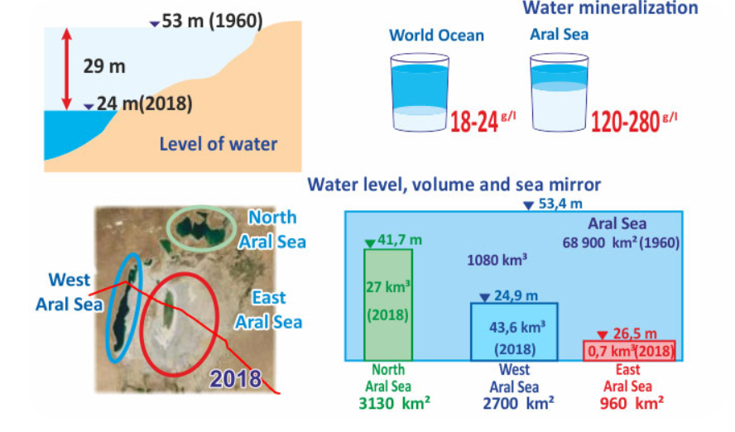

The results of Uzhydromet’s forecasts show that by 2050 the volume of river runoff in the Amudarya and Syrdarya river basins will be reduced by 10- 15% and 2-5%, respectively. The number of dry years and the number of years with drought will grow with the loss of runoff as low as 25-40%.
This will cause a drastic increase in water demand and aggravate water deficit. Meanwhile, this will require an increase of the irrigation rates by 5% in 2030, 7-10 % in 2050 and 12-16% in 2080.
If water demand is not met, this can cause crop losses, which, considering the population growth, will represent a serious risk to food security and restrict sustainable development.
Drying of the Aral initiated desertification process in the center of the belt of great Kyzylkum and Karakum deserts, where the new Aralkum desert was formed. The danger of this new desert includes the fact that the seabed, which in its natural state was a kind of desalination plant, now is acting as an artificial «anthropogenic volcano», emitting huge salt and fine dust masses o into the atmosphere. The pollution effect is enhanced by the fact that the Aral Sea is located, on the route of a strong airflow from west to east. This contributes to the emission of aerosols into the high layers and their rapid distribution in the atmosphere.
Picture 7.Dried Seabed of the Aral Sea (DSAS)
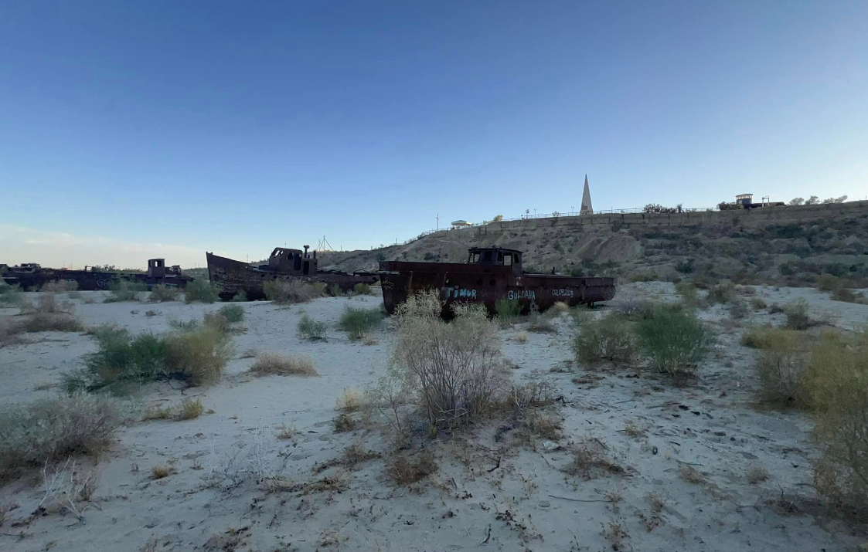
Billions of tons of poisonous salts have accumulated in the Aral Sea, which got there with water after the washing of fields. According to experts’ estimates, there are about 107-114 billion tons of salt on the dried bottom of the Aral Sea. This circumstance, as well as the death of almost all spawning grounds, led to a catastrophic reduction of the fish population, which numbered about 200 species. This has dealt a crushing blow to the local fishing industry, which once employed about 60,000 people.
Every year winds blow up to 80 million tons of toxic salts from the dried bottom of the Aral Sea. They are carried by dust storms for many thousands of kilometers – from Western Europe to the peaks of the Tien Shan and the Himalayas, having a negative impact on the health of people and ecosystems of all countries. Hundreds of thousands of people breathe poisonous air.
Salt dust covers high mountain glaciers with an impermeable film, which give rise to many rivers. This affects the quality of the water, which ends up in water pipes and wells, even thousands of kilometers away from the source, not to mention the inhabitants of coastal areas, who often suffer from diseases of the eyes, lungs, digestive and urinary tracts, blood and blood-forming organs, and so on.
At present, there is still a picture of extensive natural resource management. For example, to obtain high yields of cotton, rice and other crops, large amounts of mineral fertilizers and pesticides are applied to the soil, some of which do not even decompose in nature, and therefore pose an even greater danger to humans. All this complex of pesticides and herbicides, from the fields with the water gets into the Syrdarya, and thus into the Aral Sea, seeping into the ground and groundwater, which are used for drinking and household needs. This issue is particularly relevant for the Kyzylorda region OF Kazakistan located in the lowest part of the Syrdarya, and therefore most of all felt the impact of this factor.
Picture 8. Fishing boats left on the Dried Seabed of the Aral Sea (Photo İsmail Belen)
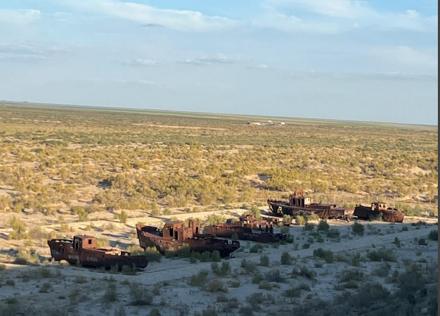
The main factor limiting the species diversity and resource importance of plant complexes is the pollution of water and soil by various pollutants (pesticides, herbicides, etc.).
Violation of the qualitative composition of soils and water proportionally increases the consumption of irrigation water, significantly exceeding the scientifically based standards. According to forecasts, if the current trend of salinization of water bodies and soils continues, most of the agricultural land in the Syrdarya River basin (the situation is probably similar in the Amudarya River basin) will become unsuitable for irrigated agriculture within a few decades. The level of salt pollution in the rivers will also be unsuitable for drinking water supply. This type of river pollution can cause irreparable damage to the environmental and socio-economic development of Kyzylorda oblast of Kazakistan.
FAO specialists carried out work on soil salinity mapping in Kyzylorda province in 2021. According to the data, almost 85% (20.3 million hectares) of the total area of agricultural land (22.6 million hectares) is currently salinized in the region. This situation requires immediate action to apply new technologies to regulate the rate and degree of salinization of the territory. Inefficient farming causes soil erosion, salt pollution, overgrazing, and increasing desertification. Pastures account for 46.7% of the oblast’s territory. At present more than 80% of pastures are degraded mainly because of soil salinization, groundwater mineralization and irrational use of natural resources.
At present, great efforts are aimed at combating salt and dust transfer, at fixing the moving sands, at localizing the negative impact of this phenomenon on the environment. In order to fix the sands on the exposed seabed, several thousand hectares of saxaul and other unpretentious plants, which easily tolerate the conditions of semi-desert and desert climate, are annually planted here.
As a result, forest massifs today in the Kazakh part of the DSAS are created on almost 337 000 hectares, including at the expense of self-reproduction.
Between 2021 – 2030 it is planned to carry out planting of 1.1 million hectares of forest in the Kazakhstan part of the DSAS. It is expected that in the short term, the “Green Aral Sea” will make a huge contribution to the global process of achieving carbon neutrality.
After all, one saxaul retains up to 4 tons of sand, 1 hectare of four-year-old saxaul absorbs 1,158.2 kg of carbon dioxide and releases 835.4 kg of oxygen per year,
Picture 9. A saxsaul seedling on the Dried Seabed of the Aral Sea
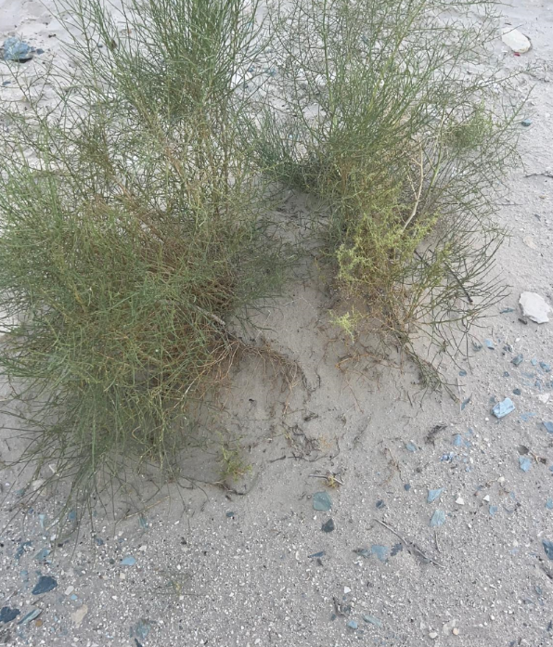
Lack of water resources and declining quality of drinking water, land degradation, climate change, increasing population morbidity, especially among children, a complex set of related socio-economic and demographic problems – these are the harsh realities that the Aral Sea area residents face.

Unfortunately, under current conditions, it is not possible for the dried parts of the AraL Sea to fill with water again and become a sea again. On the contrary, there is a risk that even the remaining small part will dry up.

The first threat and danger in the DSAS region is dust and sand transportation. For this reason, both Uzbekistan and Kazakhstan have given priority to afforestation.

As it is understood from the relevant reports and from the examinations made in the field and the interviews with the interested parties, it can be said that a significant part of the afforestation carried out has been successful and the frequency, number and impact of dust and sand storms have decreased significantly.

When afforestation is seen as the main solution tool for the problem in the region, it is seen that the management of the DSAS region is mainly in the hands of forest organizations on both Kazakhstan and Uzbekistan sides.

Since 2016, Uzbekistan's view of the region has settled into a wider range as it should be. In 2017, the President of Uzbekistan, who made a speech at the General Assembly, stated that the struggle with the results of the ASAS required international cooperation.
In the meeting held in Turkmenistan in 2018, the president proposed the declaration of the Ara Sea as an environmental innovation and technology center. As a reflection and result of this proposal, the the Multi-Partner Human Security Trust Fund for the Aral Sea Region (MPHSTF) was established during a special high-level meeting held on 27 November 2018 at the UN Headquarters in New York.
Along with this the Government of Uzbekistan developed and approved on 16 November 2018, by Resolution No. 965f, a roadmap for measures to implement the President’s instructions. One of the first activities under this programme was the substantial development of measures on the afforestation of the drained seabed to sustain the landscape and as a new climate change approach.
In 2018, the government of Uzbekistan launched a large-scale tree-planting campaign on the dried bottom of the Aral Sea to improve the ecological and socio-economic situation in the region. Significant numbers of both civilians and military personnel were involved, making it possible to cover an area of almost a million hectares in two years. Planting was carried out using airplane aerial seeding. During 2018–2022, the government carried out large-scale work to create “green covers,” i.e., protective forests on the dried Aral seabed. As a result, 1.7 million hectares of forest plantations of salt- and drought-tolerant plants—saksaul, cherkes, and kandym and other desert plants—were planted on the dried seabed. In 2023, afforestation is taking place on 100,000 hectares of the dried seabed, and “green belts” are being created in Navoi, Bukhara, and Khorezm regions on 50,000 hectares, 40,000 hectares, and 11,000 hectares, respectively. Regarding the survival of the trees planted, it was not reached to written reports but based on the interviews with technical workers it is estimated aroun 35-40 % whiccan be considered as a succesfull results for these harsh conditions.
Although the landscaping work was done mainly at the expense of the national budget, some contribution was made by UN organizations. Within the framework of the joint project “Solving Urgent Problems of Human Security in the Aral Sea Region by Promoting Sustainable Rural Development”, UNDP and UNESCO worked to strengthen the technical and institutional capacity of the state forestry body in Karakalpakstan.
However, the fact that the standards and opportunities of "National Emissions Trading System", "National Certification System" and "Voluntary Carbon Mechanisms", which have many environmental, sociological and economic advantages, have not been used, was considered a significant shortcoming.

In addition to the emissions trading system to be developed at the national level within the scope of the UNFCCC and the Paris Climate Agreement, many voluntary carbon mechanisms such as “Gold Standard, Verified Carbon Standard and Plan Vivo” have great advantages.

Cooperation with these mechanisms will also contribute the calculation of potential for carbon sequestration and support the implementation of Beside these mechanisms, working in close connection with the sertification systems such as “Forest Stewardship Council-FSC and” Programme for the Endorsement of Forest Certification-PEFC” will contribute to meeting environmental and social requirements and complying with sustainable development goals.

This aligment will also support the financial resource from different private companies as AstraZeneca announces $400 million investment in reforestation and biodiversity in support of climate action and human health. This kind of initiative will also support the General Assembly resolution 75/278 of 18 May 2021 pertains to declaring the Aral Sea region “a zone of ecological innovations and technologies”
On 16 October 2018, the President of the Republic of Uzbekistan signed Decree No. PP-3975 on the establishment of the International Innovation Center for the Aral Sea Region (IICAS). The main tasks and priorities of the IICAS were defined as follows:
- Improving the productivity of agro-ecosystems on the saline soils of the dried bottom of the Aral Sea and adjacent territories of the deltas of ASBto improve the well-being and incomes of the population living in this region;
- Creating experimental demonstration pilot sites for testing various salt-drought-resistant and frost-resistant crops and shrubs on saline soils and degraded pastures, developing and introducing innovative technologies and approaches in collaboration with international organizations aimed at restoring and increasing the productivity of water and land resources in Priaralye;
- Promotion and presentation of innovative technologies and approaches, including the sustainable use of water resources, including marginal categories, the afforestation of desert sandy arrays of the dried bottom of the Aral Sea.
- Agroforestry and the organization of desert-pasture forage production and animal husbandry, improving the fertility of saline degraded land, diversification and widespread adoption new and unconventional salt and drought-resistant, improvement of the issues of their selection, the technology of their cultivation and seed new products.
- Improvement and introduction of alternative systems for the introduction of agriculture on saline soils, the mobilization of plant material from natural pastures for the sustainable use of medicinal, technical, ornamental and other plants of the Aral basin;
- Development of measures and institutional approaches for managing and improving pasture productivity, restoring and improving the genetic quality of animal breeds, including the processing of animal products, marketing and export;
- Development of a set of measures and a national action plan to prevent and mitigate the effects of drought and adaptation of local people to climate change;
- Development of public-private partnership in order to eliminate the negative environmental and social consequences of the process of draining the Aral Sea;
- Development of a set of measures and approaches to improve the environmental situation, life, income and welfare of the population of the Aral Sea basin, conducting scientific, practical and innovative research;
- Assistance to research institutions in conducting research in the Aral Sea region;
- Participation in the development of international scientific and technical cooperation, the implementation of scientific, technical and innovative projects with foreign partners, including with the involvement of grants from international programs and funds.

2.4. The region around the base of the dried up Aral Sea

​Based on the documents read during the preparation of the guide and the impressions gained from interviews with relevant people during the field trip, there is a feeling that there is some confusion about the region.
The "Dried Seabed of the Aral Sea", or DSAS for short, is a region that dried up after the 1960s, covering an area of about 5.5 million hectares according to current estimates. There are currently no settlements here. The only activities taking place today are afforestation and deforestation. This area is under the responsibility of forestry organizations in both Uzbekistan and Kazakhstan.
Apart from this area, there are areas that were not previously covered by the sea, but are generally empty due to the difficult terrain. During the field surveys and interviews, it was felt that these two areas were confused.
Picture 10. In spite of salty soil condition Tamarix ssp are very succesful in the buffer zone
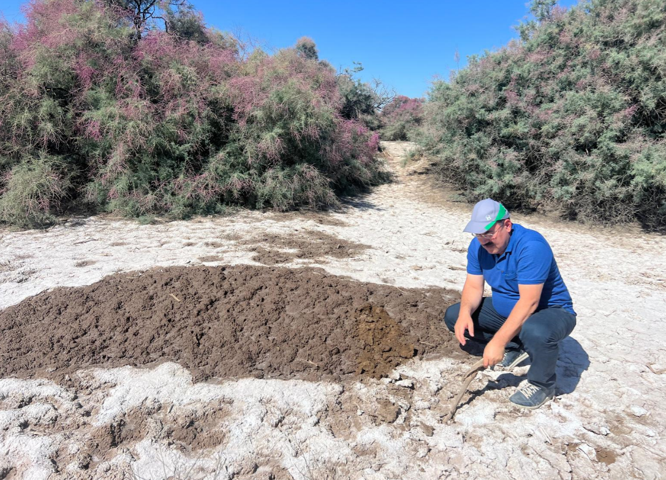

Although the soil conditions are difficult, there are many tree and shrub species in this buffer zone, successful reforestation has been done, there are abandoned water channels and small ponds in some places, it can be considered as a wetland in this state, and it is home to many bird species.​ During the trip, cattle were seen grazing along the roadsides. Local experts and local foresters stated that wild animals such as foxes and rabbits have been seen here.
The reason for this observation is that it is believed that a separate planning based on different approaches should be made for this buffer zone.

2.5. Ecosystem Types in the Aral Sea Basin and Dried Aral Seabed According to IUCN

The International Union for Conservation of Nature (IUCN) Global Ecosystem Typology which is considered one of the main source on ecosystem management comprises six hierarchical levels, with the three upper levels– realms, functional biomes and ecosystem functional groups – classify ecosystems based on their functional characteristics (such as structural roles of foundation species, water regime, climatic regime or food web structure), rather than based on which species live in them.
The three lower levels of classification – biogeographic ecotypes, global ecosystem types and sub global ecosystem types – are often already in use and incorporated into policy infrastructure at national levels and can be linked to these upper levels. This is crucial, as important conservation action occurs at local levels, where most ecosystem-specific knowledge and data reside.
Figure 8. IUCN Global Ecosystem Typlogy

There are four Realms as follows:
- Terresterial (7 biomes, 34 functional groups),
- Marine (4 biomes, 24 functional groups),
- Freshwater (3 biomes, 22 functional groups),
- Subterranean (2 biomes, 3 functional groups)
In the Aral Sea Region, a landrock region, there are two realms in general, The Terrestrial realm and the “Freshwater Realm”. The Terrestrial realm includes all dry land, its vegetation cover, proximate atmosphere and substrate (soils, rocks) to the rooting depth of plants, and associated animals and microbes.
Terrestrial realm has 7 biomes as follows:
- T1 Tropical-subtropical forests biome
- T2 Temperate-boreal forests and woodlands biome
- T3 Shrublands and shrubby woodlands biome
- T4 Savannas and grasslands biome
- T5 Deserts and semi-deserts biome
- T6 Polar/alpine (cryogenic) biome
- T7 Intensive land-use biome
Terrestrial biomes found in Aral Sea Region.
- T5 Deserts and semi-deserts biome
- T7 Intensive land-use biome
Functional Groups of “T5 Deserts and semi-deserts biome”
- T5.1 Semi-desert steppe
- T5.2 Succulent or Thorny deserts and semi-deserts
- T5.3 Sclerophyll hot deserts and semi-deserts
- T5.4 Cool deserts and semi-deserts
- T5.5 Hyper-arid deserts
It is clear that all "Functional Groups of Deserts and semi-deserts biome” can be found in Aral Sea Basin.
The 5 functional groups of the “Intensive land-use biome”, which all of them can be observed in Aral Sea Basin.
- T7.1 Annual croplands
- T7.2 Sown pastures and fields
- T7.3 Plantations
- T7.4 Urban and industrial ecosystems
- T7.5 Derived semi-natural pastures and old fields
The “Freshwater Realm” includes the three following biomes, which all functional groups can be observed in the Aral Sea basin.
- F1 Rivers and streams biome
- F2 Lakes biome
- F3 Artificial wetlands biome
F1 Rivers and streams biome has 7 functional group as follows:
- F1.1 Permanent upland streams
- F1.2 Permanent lowland rivers
- F1.3 Freeze-thaw rivers and streams
- F1.4 Seasonal upland streams
- F1.5 Seasonal lowland rivers
- F1.6 Episodic arid rivers
- F1.7 Large lowland rivers
F2 Lakes biome has 10 “Functional Group” as follows:
- F2.1 Large permanent freshwater lakes
- F2.2 Small permanent freshwater lakes
- F2.3 Seasonal freshwater lakes
- F2.4 Freeze-thaw freshwater lakes
- F2.5 Ephemeral freshwater lakes
- F2.6 Permanent salt and soda lakes
- F2.7 Ephemeral salt lakes
- F2.8 Artesian springs and oases
- F2.9 Geothermal pools and wetlands
- F2.10 Subglacial lakes

F3 Artificial wetlands biome has 5 Functional Grup
- F3.1 Large reservoirs
- F3.2 Constructed lacustrine wetlands
- F3.3 Rice paddies
- F3.4 Freshwater aquafarms
- F3.5 Canals, ditches and drains

F2 Lakes biome has 10 “Functional Group” as follows:
- F2.1 Large permanent freshwater lakes
- F2.2 Small permanent freshwater lakes
- F2.3 Seasonal freshwater lakes
- F2.4 Freeze-thaw freshwater lakes
- F2.5 Ephemeral freshwater lakes
- F2.6 Permanent salt and soda lakes
- F2.7 Ephemeral salt lakes
- F2.8 Artesian springs and oases
- F2.9 Geothermal pools and wetlands
- F2.10 Subglacial lakes
F3 Artificial wetlands biome has 5 Functional Grup- F3.1 Large reservoirs
- F3.2 Constructed lacustrine wetlands
- F3.3 Rice paddies
- F3.4 Freshwater aquafarms
- F3.5 Canals, ditches and drains
More information on ecosystem types and their management requirements can be found in Annex 2 or at this following link: https://global-ecosystems.org.
Specific information about the ecoscystems found in ASB is provided in Annexes chapter.

Problem and Objectives

The third chapter is designed to identify the problem and to set out the objectives of the Guidelines.

As of today, it is possible to divide the problems in the region into three parts as follows.

- Problems and solutions related to the entire “Aral Sea Basin (ASB)”, which covers a total of 6 countries and an area of ​​approximately 174 million hectares,
- Problems and solutions related to the “Dried Seabed of the Aral Sea (DSAS), limited to this area, and more of a national character,
- The ASB Subregion, the Buffer Zone around the DSAS or The region around the base of the dried up Aral Sea

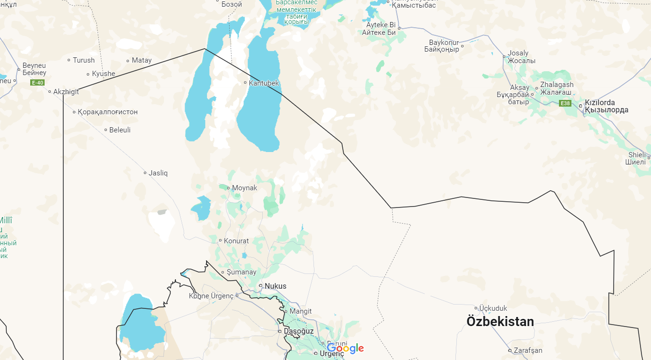
Lower Part of/Subbasin of Aral Sea Basin
Dried Seabed of the Aral Sea

Considering that the main problem in the region is water scarcity, and that the Amu Darya and Syr Darya Rivers collect a large portion of their water from the upper basins of Tajikistan and Kyrgyzstan, the necessity of “integrated basin management” approaches that will cover the entire basin emerges.

On the other hand, it is obvious that activities should be initiated on the basis of settlements, villages and neighbourhoods, and that solutions and activities should be implemented at the local and national levels.

As mentioned in detail in the relevant chapters, "the Objectives of the Guidelines" are;

- Address the current environmental degradation in Karakalpakstan including the Dried Seabed of the Aral Sea-DSAS to enable a comprehensive assessment of ecosystem services,

- Current environmental degredation in Karakalpakstan including the DSAS have been reviewed in detail at Chapter 2 titled “introduction of the study area” based on the information obtained from field visit, dicsussions with experts and local residens, as weel report and document such as;
  - Updated Nationally Determined Contribution of Republic of Uzbeskistan-2021,
  - FAO-Transboundary River Basin Overview – Aral Sea
  - MPTF-UN Multı-Partner Human Securıty Trust Fund for The Aral Sea Regıon in Uzbekıstan-2018
  - UNECE-Drainage Basin of the Aral Sea and Other Transboundary Surface Waters in Central Asıa
  - World Bank-Uzbekistan Country Forest Note- The State of Forests and Forest Landscapes in Uzbekistan; 2022

- Provide comprehensive and region-specific guidance for restoring ecosystems in the Aral Sea Basin.
- Many policy documents including but not limited to the followings have been reviewed in order to develop region specific (ASB, Lower Part of ASB, DSAS) guidelines:
  - The United Nations Decade on Ecosystem Restoration 2021–2030,
  - IUCN Global Standard for Nature-based Solutions.
  - FAO Global Guidelines for the Restoration of Degraded Forests and Landscapes in Drylands. Building Resilience and Benefitting Livelihoods
  - Guidelines on the Implementation of Nature-Based Solutions (NbSs) to Combat the Negative Impact of Climate Change on Forestry for the FAO-SEC Countries-2023
  - Guidelines on Safeguarding Native Tree Species for Conservation of Genetic Biodiversity in Central Asia-2021
  - Guidelines on Sustainable Forest Management under the Impact of Climate Change in Central Asia – Implications for Practitioners-2021

It is not possible to consider the problems in Karakalpakstan or the "Dried Seabed of the Aral Sea-DSAS" or “Lower Part/Subbasin of Aral Sea Basin” separately from the upper plateaus of Tajikistan or Kyrgyzstan, where the Amu Darya and Syr Darya Rivers originate, from glaciers or from people's water use habits.

Accordingly, it is considered that there is a need for a "current situation assessment" in which the entire Aral Sea Basin, “Lower Part/Subbasin of Aral Sea Basin and then the "Dried Seabed of the Aral Sea" region are addressed both separately and in an integrated manner.

After this "current situation assessment", future predictions and simulations should be made for both ASB, Lower Part/Subbasin of Aral Sea Basin and DSAS according to the findings in the field, projections for the region and the world, and scientific data.

It is extremely important that these predictions are completely realistic and clearly reflect the capacities of the countries and institutions. For example, it is not possible to reclaim the Aral Sea under current conditions. It is not possible to implement a plan that foresees this. On the other hand, although they have extremely serious problems, Uzbekistan and Kazakhstan have a new land area of ​​5.5 million hectares. The groundwater level of this area is not very deep. Extremely successful afforestation is being carried out. If the technical and intellectual accumulation of humanity as a whole is transferred to this, it is possible to carry out studies that will be an example and a hope for all humanity.

If legislation on "National Emissions Trading" and "Voluntary Carbon Mechanisms" compatible with the United Nations Framework Convention on Climate Change and the Paris Climate Agreement is enacted and the necessary infrastructure is established, it is possible to finance the afforestation projects, especially in the DSAS Region, entirely through these mechanisms.
After the "current situation assessment" and "future simulation and projections" are completed, "objectives" related to both ASB and DSAS should be determined.

For example, today, both Kazakhstan and Uzbekistan are primarily engaged in "dust transport prevention and soil stabilization" afforestation. Although the success here is appreciated, not using "emission trading opportunities" or "voluntary carbon mechanisms" in financing these afforestations is considered as not using a significant potential. On the other hand, when it is taken into account that the planted trees will remain in this area for at least 50 years and that it is quite difficult, even impossible, to make any type and location changes in the future, the importance of conducting a more comprehensive "environmental and social assessment" becomes evident.

After determining the "Objectives", planning should be made on how to achieve them. Before starting the planning, "planning principles" that will guide all parties and support obtaining common results should be determined and the planning should be made based on these principles.

It is evaluated that the following issues should be taken into consideration as planning principles.
- The entire region, including ASB, Lower Part of/Subbasin of ArSB and DSAS, together with their people, flora and fauna, should be addressed on the basis of "basin integrity" and "ecosystem approach",
- In planning, "Sustainable Development Goals", "UN Decade", "IUCN NBS" principles should be followed,
- Planning should be compatible with global, regional, national and local priorities, if there are inconsistencies in the country's legislation and practices, they should be changed in advance,
- It should take into account the current practices in the field
- The plans prepared should be binding on all local and foreign parties and projects

Figure 9. Planing of ASB, Lower Part of/Subbasin of ASB and DSAS

National, Regional and International Policy and technical Documents Supporting Objectives
The fourth chapter lists national, regional and international policy documents that support the objective of the Guidelines.

4.1. National Policy Documents

4.1.1. Updated Nationally Determined Contribution-2021

The Republic of Uzbekistan, being committed to the effective and transparent implementation of the Paris Agreement, has updated its nationally determined contribution and submitted to UNFCCC in 2021. The new goal of the Republic of Uzbekistan in terms of climate change mitigation, which seeks to be achieved by 2030, is 35% from the level of 2010.
This updated NDC refers to Aral Sea Crises many times as follows:
- The Adaptation section of the updated NDC document presents adaptation measures for agriculture and water management, social sector, ecosystems, strategic infrastructure and production systems, etc., as well as actions to mitigate the consequences of the Aral Sea disaster.
- Uzbekistan is facing one of the most acute problems for the Central Asian region – the environmental disaster of the Aral Sea, which is actually one of the largest environmental disasters in recent history.
- Uzbekistan has approved and is now implementing a five-year development strategy, the “Action Strategy on Five Priority Areas for Development of the Republic of Uzbekistan in 2017-2021”.
- The Strategy provides for the reduction of energy and resource intensity of the economy, widespread introduction of energy-saving technologies in production, increased use of renewable energy sources, which will help reduce GHG emissions; adoption of measures to mitigate the adverse impact of global climate change and the drying up of the Aral Sea on agricultural development and livelihoods of the population.
- The State Committee of Forestry is responsible for the implementation of measures to prevent desertification, conservation and restoration of irrigated and rainfed lands, pastures and forest resources, including on the dried bottom of the Aral Sea.
- The situation is exacerbated by the continuing drying up of the Aral Sea, which has already lost 57% of its area, 80% of its volume and 64% of its depth in the last four decades. The Aral Sea basin now represents a salt desert called Aralkum, which adversely affects the ecology of the entire country.
- Among key policy documents are the Agriculture Development Strategy of the Republic of Uzbekistan for 2020-2030, the Strategy on Transition of the Republic of the Republic of Uzbekistan to a Green Economy for 2019-2030, the State Programs for Development of the Aral Sea Region (2017-2021) and other policy documents that focus, inter alia, on specific actions to protect, preserve and restore degraded agro-ecosystems and conserve biodiversity.
- Adaptation measures cover a wide range of actions to protect communities from the adverse impacts of climate change, such as extreme droughts and hydrometeorological hazards associated with global warming; increasing the resilience of strategic infrastructure and ecosystems to conserve agrobiodiversity; reducing the adverse impact of the Aral Sea disaster on the environment and the lives of millions of people living in the Aral Sea region, including through well-designed target projects and programs, with financial and technical support from UN institutions, other international organizations and development partner countries.
- Mitigating the Aral Sea disaster
  - preserve the current fragile ecological balance in the Aral Sea region, combat desertification, improve the management system, efficiently and sustainably use water resources;
  - create conditions for reproduction and preservation of the gene pool and health of the Aral Sea region population, develop social infrastructure, extensive network of medical and educational organizations;
  - create the necessary socio-economic frameworks and incentives to improve the quality and living standards of the population, develop basic infrastructure and communication systems;
  - conserve and restore biodiversity of flora and fauna, including through creation of local water bodies in the Aral Sea region;
  - enhance foreign investment for the implementation of measures and actions to mitigate the consequences of natural disasters in the Aral Sea;
  - conserve and restore forest resources, including afforestation of the dried bottom of the Aral Sea.
- Indicator 13.2 “Include climate change responses in policies, development strategies, with special focus on measures implemented in the Aral Sea region”
- State Program for the “Development of the Aral Sea region in 2017-2021” focuses on implementing a set of technical and institutional interventions involving domestic and external investments and IFI loans, including deposits for combating desertification and water and land management, including:
  - (i) afforestation on 20,000 ha of the dried bottom of the Aral Sea;
  - (ii) implementation of the climate change adaptation program; and
  - (iii) improvement of water management in South Karakalpakstan on 100,000 ha.
- The Aral Sea Region Development Fund under the Ministry of Finance was established to implement the State Program for the Development of the Aral Sea Region. In December 2018, the Multi-Partner Trust Fund for the Aral Sea Region in Uzbekistan was established under the auspices of the UN.
- For the sustainable development of the region, the Fund will ensure consolidation and mobilization of technical and financial resources of the Government of Uzbekistan, UN agencies and the donor community with the involvement of new knowledge, innovative technologies and approaches in the region.
- Environmental Protection Concept-2030 (UP-5863 dated 30.10.2019). The concept provides for a set of measures for the protection of environment (atmospheric air, water, land, soil, subsoil, biodiversity, protected areas) from anthropogenic impact and other adverse factors, expansion of protected areas and improvement of environmentally sound waste management system.
- It also provides for measures to ensure environmentally sound use of toxic chemical and radioactive substances, increase the level of transparency of state bodies in the field of environmental protection, strengthen the role of civil society in this process and raise the environmental awareness of the population. The Concept seeks to achieve the following:
  - Bring the area of forest plantations on the Uzbek part of the dried bottom of the Aral Sea from 28% (0.9 million hectares) to 60% (2 million hectares);
Figure 10. Updated Nationally Determined Contribution of Republic of Uzbekistan-2021
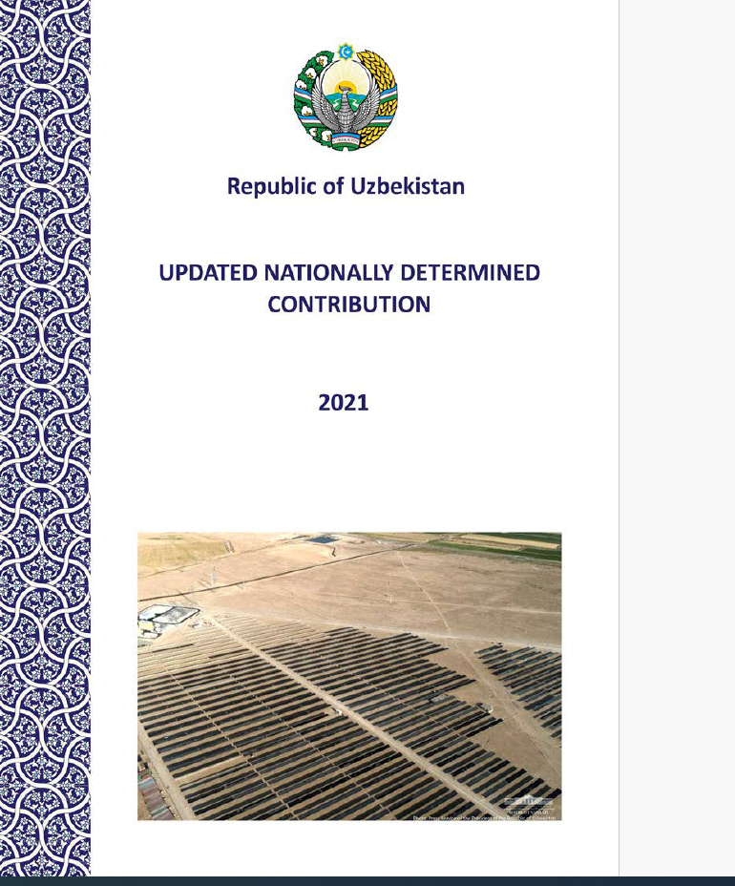

4.1.2. The UN Multi-Partner Human Security Trust Fund for the Aral Sea region in Uzbekistan (MPHSTF)

In the meeting held in Turkmenistan in 2018, the president proposed the declaration of the Ara Sea as an environmental innovation and technology center. As a reflection and result of this proposal, the the Multi-Partner Human Security Trust Fund for the Aral Sea Region (MPHSTF) was established during a special high-level meeting held on 27 November 2018 at the UN Headquarters in New York.
The goals and directions of the foundation aimed to catalyse and strengthen multisectoral and people-centred responses to one of the largest man-made disasters in the world, by being transformative, needs-based, human rights-based and inclusive in its purpose.
The MPHSTF provides a coherent strategy for coordinating aid flows and increasing government leadership of the assistance process to achieve sustainable results. The foundation’s strategies address six clusters of interrelated problems:
- Environmental safety
- Economic security
- Food security
- Health security
- Social security
- Inefficiency of donor assistance
Figure 11. Web Page of MPHSTF
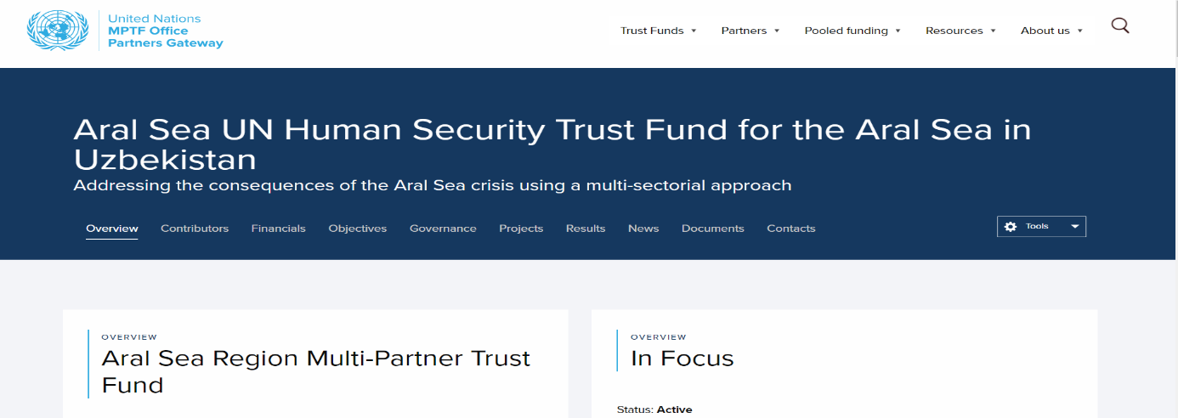

4.2. Regional Policy Documents

4.2.1. Guidelines on the Implementation of Nature-Based Solutions (NbSs) to Combat the Negative Impact of Climate Change on Forestry for the FAO-SEC Countries-2023

The "Guidelines on the Implementation of Nature-Based Solutions (NbSs) to Combat the Negative Impact of Climate Change on Forestry for the FAO-SEC Countries", prepared within the scope of the cooperation between the Chamber of Forest Engineers and FAOSEC, was published by FAO in 2023.
In this context, applications in Azerbaijan, Kazakhstan, Kyrgyzstan, Tajikistan, Turkey, Turkmenistan and Uzbekistan were evaluated and what could be done within the framework of "nature-based solutions" was explained. The "Executive Summary" of the Guidelines was added to the Annex Chapter
Since there is a close connection between “nature-based solutions” and “ecosystem restoration”, the Guidelines for NbSs is considered one of best resources for the Guidelines for Ecosystem Restoration. Beside both of them have been prepared for the Central Asia in a broader context. On the other hand, both of them includes the general approaches of United Nations spesifically FAO in tackling climate change impact.
Figure 12. FAO Guidelines on NBs
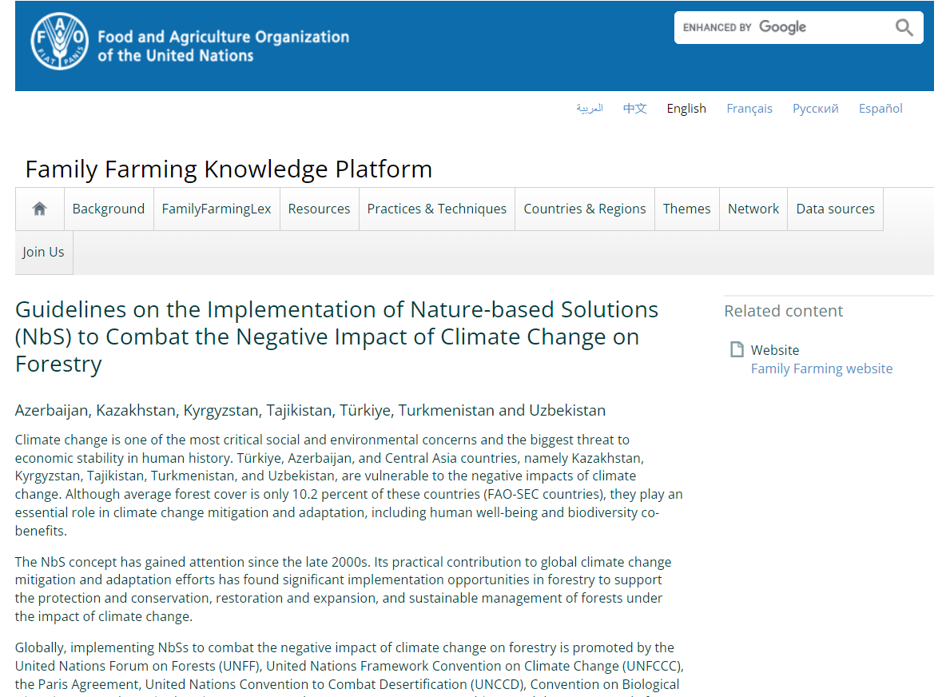

4.2.2. Guidelines on Safeguarding Native Tree Species for Conservation of Genetic Biodiversity in Central Asia-2021

Within the framework of the cooperation between FAO and the Chamber of Forest Engineers (OMO), "Guidelines on Safeguarding Native Tree Species for Conservation of Genetic Biodiversity in Central Asia" was prepared in 2021.
Within the scope of this Guidelines, recommendations were developed for the species;
- Malus niedzwetkyana,
- Malus sieversii,
- Pyrus korshinskyi,
- Pyrus tadshikistanica,
- Prunus armeniaca,
- Juglans regia,
- Pistacia vera,
- Juniperus semiglobosa,
- Juniperus seravschanica,
- Juniperus turkestanica,
- Picea schrenkiana,
- Betula tianschanica,
- Fraxinus sogdiana and,
- Haloxylon sp. found in Central Asia.
The "Executive Summary" of the guide is given in the Appendix section. Since this Guidelines offer solutions on safeguarding selected native tree species and elaborate on seed harvesting techniques, it is important to follow these techniques for having succesfull results.

4.2.3. Guidelines on Sustainable Forest Management under the Impact of Climate Change in Central Asia – Implications for Practitioners

Within the framework of the cooperation between FAO and the Chamber of Forest Engineers (OMO), "Guidelines on Sustainable Forest Management under the Impact of Climate Change in Central Asia – Implications for Practitioners" was prepared in 2021. In addition, a Conference was organized on this subject. The "Executive Summary" of the Guidelines was added to the Annex section.
There is a close connection between the climate change affects and ecosystem restoration works. The truth is that, in addition to inappropriate practices, one of the main reasons for the drying of the Aral Sea is climate change. With global warming, there has been a decrease in precipitation, and the glaciers in the upper basins have started to melt, thus changing the water regime. This situation will affect existing forests as well as forests being created through afforestation. Therefore, it is evaluated that this “Guidelines on Sustainable Forest Management under the Impact of Climate Change in Central Asia – Implications for Practitioners” will play a key role in the management of both existing forests and forests to be developed through afforestation.

4.3. International Policy Document

4.3.1. The United Nations Decade on Ecosystem Restoration 2021–2030

The United Nations Decade on Ecosystem Restoration began on World Environment Day, 5 June 2021. runs from 2021 to 2030 with the purpose of promoting global cooperation for the restoration of degraded and destroyed ecosystems. Before the official launch the General Assembly adopted a resolution on 1 March 2019.
"The United Nations Decade on Ecosystem Restoration" and other policy documents developed within this scope serve as a guide that can be applied in all regions of the world in terms of understanding ecosystems as a whole and presenting holistic solution proposals. It is widely used during the process of the preparation of the “Guidelines for the Ecosystem Restoration for the Aral Sea”.
The United Nations Decade on Ecosystem Restoration has a Strategy and Standards. Ten Principles of the Decade which are essential for ecosystem restoration could be summarisez as below:
- Principle 1: Ecosystem restoration contributes to the un sustainable development goals and the goals of the rio conventions
- Principle 2: Ecosystem restoration promotes inclusive and participatory governance, social fairness and equity from the start and throughout the process and outcomes
- Principle 3: Ecosystem restoration includes a continuum of restorative activities
- Prıncıple 4: Ecosystem restoratıon aıms to achıeve the hıghest level of recovery for bıodıversıty, ecosystem health and integrıty, and human well-beıng
- Prıncıple 5 Ecosystem restoratıon addresses the dırect and indırect causes of ecosystem degradatıon
- Prıncıple 6 Ecosystem restoratıon incorporates all types of knowledge and promotes theır exchange and integratıon throughout the process
- Prıncıple 7 Ecosystem restoratıon is based on well-defıned short-, medıum- and long-term ecologıcal, cultural and socıo-economıc objectıves and goals
- Prıncıple 8 Ecosystem restoratıon is taılored to the local ecologıcal, cultural and socıoeconomıc contexts, whıle consıderıng the larger landscape or seascape
- Prıncıple 9 Ecosystem restoratıon includes monıtorıng, evaluatıon and adaptıve management throughout and beyond the lıfetıme of the project or programme
- Prıncıple 10 Ecosystem restoratıon is enabled by polıcıes and measures that promote its long-term progress, fosterıng replıcatıon and scalıng-up

4.3.2. United Nations Decade on Combating Sand and Dust Storms (2025-2034)

The United Nations General Assembly (UNGA) adopted the “United Nations Decade on Combating Sand and Dust Storms (2025-2034)” at 1st of July, 2024 with the special emphasesis as listed below. Since one of the main problems in Aral Sea Region has been defined as “sand and dust storm” espeacilly in the Dried Sea Bed of Aral Sea (DSAS), this Decade and its projections has been accepted very important for the ecosystem restoration of Aral Sea Region.
- Noting that sand and dust storms are a challenge with impacts on, among others, infrastructure, transport, communication, agriculture, ecosystems and human health and transboundary impacts that require institutional, technical and scientific responses, and that the global frequency and intensity of sand and dust storms have increased in the last decade and pose a great challenge to the sustainable development of affected countries,
- Recognizing that sand and dust storms cause numerous human health problems in different regions around the world, especially in arid, semi-arid and dry subhumid regions, and that there is a need to reinforce protective strategies to reduce the negative impacts of sand and dust storms on human health and well-being,
- Stressing the need for cooperation at the global and regional levels with a view to managing and mitigating the effects of sand and dust storms through the enhancement of early warning systems and the sharing of climate and weather information to forecast sand and dust storms, and affirming that resilient action to combat and prevent sand and dust storms requires a better understanding of the severe multidimensional impacts of sand and dust storms, including the deterioration of the health, well-being and livelihood of people, increased desertification and land degradation, deforestation, loss of biodiversity and land productivity, and their impact on sustainable economic growth,
- Reaffirming that climate change is one of the greatest challenges of our time and, among other factors, is a serious challenge to the sustainable development of all countries, including those affected by sand and dust storms, and emphasizing that, among other factors, climate change is an important potential contributor to future wind erosion and the risk of sand and dust storms, especially the occurrence of more extreme wind events and the movement towards drier climates, although reverse effects are possible,

4.3.3. IUCN Global Standard for Nature-based Solutions

Nature-based solutions and ecosystem restoration are very closely related and complementary approaches. In this context, it has been evaluated that the "IUCN Global Standard for Nature-based Solutions" prepared by The International Union for Conservation of Nature (IUCN) should be one of the basic reference documents for studies in the Aral Sea Basin.

The Standard consists of 8 Criteria and 28 Indicators.
Criteria of IUCN Global Standars
- Criterion 1: NbS effectively address societal challenges
- Criterion 2: Design of NbS is informed by scale
- Criterion 3: NbS result in a net gain to biodiversity and ecosystem integrity
- Criterion 4: NbS are economically viable
- Criterion 5: NbS are based on inclusive, transparent and empowering governance processes
- Criterion 6: NbS equitably balance trade-offs between achievement of their primary goal(s) and the continued provision of multiple benefits
- Criterion 7: NbS are managed adaptively, based on evidence
- Criterion 8: NbS are sustainable and mainstreamed within an appropriate jurisdictional context

- Region-specific guidance for restoring ecosystems in the Aral Sea Region

The fifth chapter provides comprehensive and region-specific guidance for restoring ecosystems in the Aral Sea Region-

5.1. Recommandations for policymakers

5.1.1. Addressing the drivers of land degradation- current situation assessment

In order to create a healthy and sustainable solution and to rehabilitate the region, it is first necessary to fully and accurately understand the problem, its causes and the interacting factors.
As mentioned in the relevant chapters, the ASB is a very large basin, covering an area of 174 million hectares. The main element that shapes this basin is water. The source of this water is mainly glaciers and snow in the upper basins of Tajikistan and Kyrgyzstan. In recent years, it has often been mentioned that snowfall has decreased and glaciers have begun to melt. It is obvious that this situation will affect the whole basin. However, it is estimated that more detailed scientific studies on this melting of glaciers and decrease in snowfall and its impact on the basin are needed.
Accordingly, it is considered that there is a need for a "current situation assessment" in which the entire Aral Sea Basin, “Lower Part/Subbasin of Aral Sea Basin and then the "Dried Seabed of the Aral Sea" region are addressed both separately and in an integrated manner.

Objective 1: Address the current environmental degradation in Karakalpakstan including the Dried Seabed of the Aral Sea-DSAS and ASB as well as the region around the base of the dried up Aral Sea to enable a comprehensive assessment of ecosystem services.

Output 1. Current situation assessment and future projections

Activity 1.1: Study of the decrease in snowfall and melting of glaciers in the upper basins of the Amu Darya and Syr Darya, two important rivers of the Aral Sea Basin, in all countries, especially in Tajikistan and Kyrgyzstan. Define other possible reasons and their impact on the water regime, and determination of the measures to be taken.

The second major issue is the holistic management of water for industrial, domestic and agricultural use in the Aral Sea basin, which covers an area of 174 million hectares and a total of 6 countries.
In addition to the decrease of water due to snowfall and glaciers in the upper basins, one of the main problems is the appropriate use of water resources.
The waters of the Amu Darya and Syr Darya rivers have been used for centuries for agricultural irrigation and domestic needs, and thousands of canals, some hundreds of kilometers long and some small, have been built for this purpose.
On the other hand, with the development of technological and economic opportunities in recent years, dozens of dams and ponds have been built or are being built in the upper basins.
In addition, domestic and industrial water use has increased with population growth and easier access to water. For example, water use per person has increased from one unit 100 years ago to at least twenty units today. In the past, the entire village used to get its water from one well in the center of the village, in other words, one tap was enough for a village, but now a household has an average of 6 taps.

Activity 1.2: Identification of existing irrigation canals, dams and ponds, domestic and industrial uses throughout the Aral Sea Basin, assessment of their impacts, prevention of losses and leakages, development of principles and procedures to ensure that new construction is carried out according to predetermined standards.

The truth is that if water resources are not used effectively and efficiently, no amount of water will meet the demand. Due to the geographical and climatic conditions of the region, water that flows and is found in open areas evaporates and leaves salty soil. In other words, water that is given more than necessary and is not properly applied does more harm than good to the regional soil.
Given the conditions of the region, the scarcity of water, and the fact that the available water will gradually decrease, it is essential that water be used at least as carefully as oil and natural gas, that economic modeling be done accordingly, and that distribution channels and other types of use (domestic, industrial, etc.) be designed accordingly. Unlike oil and natural gas, the non-human world also needs water to sustain wildlife and ecosystems.
On the other hand, water used in the region for centuries has shaped both the soil and the ecosystem, and agricultural products, human behavior, and human settlements have evolved according to the presence and accessibility of water. In other words, if we consider 6 countries, it will not be possible to change the water course of any of the thousands of villages and settlements in the basin, unless the necessary preparations are made.
However, it is also clear that a solution that covers the entire region is needed. The 5.5-million-hectare area created by the drying up of the Aral Sea is the most obvious indicator of this.
It is likely that many of the existing irrigation channels are not registered and their impact has not been assessed.
Another issue is the structure of agricultural production in the region. Agricultural and livestock systems that are compatible and resilient to arid conditions should be developed, taking into account food security, the needs of the region, supply chains, marketing and transportation options, and people's livelihoods.
Similarly, domestic and industrial use should be re-examined, while losses and leakages should be reduced, and wastewater use should be re-examined environmentally, socially and economically.

Activity 1.3: Reporting on agricultural and livestock practices throughout the Aral Sea Basin and developing recommendations and strategies to support their adaptation to arid conditions and the ecosystem approach.

Activity 1.4. To prepare a report on the legal and administrative structuring of the entire basin, taking into account IFAS, United Nations General Assembly resolutions, international legislation on transboundary waters, the legislation and institutional structures of the countries within the basin boundaries, and the European Commission's Water Directive.

After this "current situation assessment", future predictions and simulations should be made for both ASB, Lower Part/Subbasin of Aral Sea Basin and DSAS according to the findings in the field, projections for the region and the world, and scientific data.

Activity 1.5: Prepare future projections for the ASB, DSAS, each of the countries and priority sites deemed appropriate, taking into account the current situation assessment, and prioritize actions according to these projections.

As a part of “current situation assessment” it is essential to give special attention to past, ongoing and planned afforestation implementations. In the relevant sections of this Guidelines, national and regional reports, international policy documents and United Nations resolutions, two of the most important problems that actually affect the region are expressed as "dust and sand transportation".
"Afforestation" stands out as the most effective way to combat these two problems. In this context, great hopes have been placed on the afforestation efforts carried out by both Kazakhstan and Uzbekistan.
However, there is no comprehensive report on the success of current afforestation efforts published officially.
Table 2. Observations and proposals of working group established at 9th of Otober, 2024 for Aral Sea
But, for the analysis of the general state of forest reclamation works carried out in 2018-2024 on the dry bottom of the Aral Sea, and to evaluate the processes of plant growth and development the Government of the Ministry of Ecology, Environmental Protection and Climate Change of the Republic of Uzbekistan established a working group dated October 9, 2024 consisting of around 20 scientists and foresters.

The members of this working group gathered from the;
- Ministry of Ecology, Environmental Protection and Climate Change of the Republic of Karakalpakstan,
- Forestry Agency,
- Scientific Research Institute of Forestry,
- Karakalpakstan Experimental Station,
- Tashkent State Agrarian University,
- "Yashilloiha" Design Institute,
- Regional Division of Soil Science and Agrochemical Research Institute of Khorezm Region,
- Muynoq State Forestry,
- Karaozak State Forestry.
This working group examined the afforestation areas between October 11-24 of 2024.
The observations of this working group can be summarised as below:
- In 2018-2024, forest reclamation activities were carried out on a total of 1,865,000 hectares of the Aral Sea, including 112,502 hectares in 2024. The state of forest reclamation measures carried out until 2024 is good, the average greenness of desert plants is 45-50%. In 2019-2024, the average height of saxaul trees was 2-3 meters. Currently, these desert plants are growing and spreading around, and the process of natural recovery is being observed. As a result, the ecosystem is restored and conditions are created for the increase of biodiversity.
- Any type of plant, including the hardiest desert plants, is too extreme for the dry type of the Aral Sea. The tropical conditions of this land vary from medium salinity to very strong salinity (high acidity), and the difference in temperature amplitude at night and day is high. In some places there is a lot of moisture (swamp), and in some places there is no moisture at all. Therefore, the results of the forest reclamation works are satisfactory when we conclude on the general situation.
- As a result of the works carried out in the dry seabed of the Aral Sea, positive results have been achieved year by year, by increasing the vegetation cover of the area, the ground has been created for the formation of flora that strengthens/fixing the sands. As a result, it is possible to directly and indirectly influence the reduction of the amount of small sand particles in the air and improve the health of the population living in the Aral Bay region by preventing the sand and dust accumulation observed in the area.
- According to the results of the studies, it is advisable to mix saxaul seeds with the seeds of halophyte plants in highly saline areas.
- It is recommended to establish at least three mini-meteorological stations in order to continuously monitor and analyze climate changes in the dry type of the Aral Sea. Considering that the construction of green coverings in the area will be carried out in a short period of time, it is necessary to have accurate information about its optimal periods (times of snow and rain). Also, it is necessary to constantly monitor changes in atmospheric precipitation, wind and moisture evaporation and other natural phenomena in the area.
- As a result of the conducted monitoring, it was found that it had a positive effect on the formation of newly formed plant cover and fauna in the Akantay massif. Based on scientific findings, the increase in animal life has an effect on soil formation and plant biomass changes in the area.
- In the future, it is desirable to use the remote sensing method, which is one of the modern methods, to assess the dynamics of changes in vegetation coverage of the dry type of the Aral Sea.
- During the monitoring of halophytic plants used in the establishment of green covers, it was found that the sown seeds germinated in 2-3 years.
- In areas with a high level of salinity, where the state of salinity is 20% racha, it is advisable to repeatedly sow the seeds of halophyte plants (karabarak (Halostachys belangeriana), fisheye (Climacoptera lanata) , etc.) with the help of aviation (as a result of observations, it was found that the main plant cover in the saline lands of the Akantay region is karabarak.
- It is recommended to announce a special competition by the Innovative Development Agency for the application of modern technologies, in particular bacteriological methods, which reduce the level of salinity in the dry type of water of the Aral Sea.
- During the next monitoring work, it is necessary to pay attention to the study of pests and diseases in forests established in the type of dry water of the Aral Sea.

It is assessed that a study is needed to determine the survival rates of planted saplings or the germination rates of seeds dropped from aircraft and whether they can adapt to the conditions in the region.
In the field survey conducted for the preparation of the guide and in the interviews conducted with the relevant persons, it was observed that the success rate in afforestation with sapling planting and seed sowing was around 35-40%. When the conditions of the region are taken into consideration, it can be easily said that these rates indicate a successful result. However, it is possible to increase this rate with some measures to be taken.
In this context;
- First of all, it is evaluated that emphasis can be given to shrub species that protect and enrich the soil. In the field surveys, it was observed that herbaceous/shrub species such as tamarix and saxsavul are naturally present along with capers (Capparis spinose). While the caper plant protects the soil on the one hand and provides shade and shelter for the planted saplings/planted seeds, on the other hand, it provides food for both humans and animals through its fruits.
- Although the afforestation in the field is largely done with saxavul, it is a result of the conditions and current experience, afforestation done with a single species in such large areas carries serious risks. In case of an insect epidemic or parasite or virus, all individuals are formed from the same species, in other words, monoculture afforestation carries great risks. Instead, it would be appropriate to try species such as Robinia pseudoacacia, which are resistant to drought conditions, can be used for their flowers and fruits, and will enrich the soil with their roots.
- In the success of afforestation, the quality of the seeds and their adaptation to local conditions, nursery techniques, and taking the necessary precautions during planting of the seedlings are of vital importance. It is a known fact that the capillary roots of the seedlings lose their ability to hold on and survive in the place where they are planted to a great extent if they are exposed to direct sunlight.
- During the field survey, it was observed that there was a need to increase the capacity of the nurseries belonging to the forestry units. Furthermore, more importantly, it was evaluated that it would be extremely beneficial for the administrators, technical staff and local people to see the work in other countries on site. This issue was repeatedly expressed by the relevant parties.

Activity 1.6. Evaluation of existing afforestation taking into account the issues included in this Guidelines.

Activity 1.7. Establishing seed gardens and nurseries, improving the capacities of existing ones.

Activity 1.8. Making trial plantations with species such as Robinia pseudoacacia and Capparis spinosa

Activity 1.9. Developing training programs and country visits to increase the capacity of technical staff, local people and administrators’/policy makers

5.1.2 Planning for the future in line with baseline reports, agreed priorities and planning principles

In a basin covering 174 million hectares, setting out and investing without a planning that includes all elements involves great risks and significantly reduces the likelihood of success. Unfortunately, all scientific data indicate that temperature and drought will increase and water resources will decrease.
On the other hand, considering the current economic, social and technical possibilities, it is seen that it is not possible to solve many problems at once.
In this context, after the problems are identified and priorities are agreed upon, planning should be made to realize these priorities.

Output 2: Plans

Activity 2.1. Define the "Planning Principles" that will be the basis for all planning, obtain permission or approval from the competent authorities in accordance with the legislation of the countries, and publish them in official platforms (Official Gazette, etc.) in a way that will be legally binding on all relevant parties.

Activity 2.2. Preparation of the " the Aral Sea Basin (174 million hectares, 6 countries) Management Stratety” based on the priorities ve rules identified in this Guidelines, to be implemented by IFAS.

Activity 2.3. Preparation of River Basin Management Plans (RBMPs) for the Amu Darya and Syr Darya Rivers based on the Aral Sea Basin Management Strategy Document.

Activity 2.4. Preperation of Rehabilitation and Management Plans (both for Uzbekistan and Kazakhistan sides) for the Dried Seabed of the Aral Sea.

5.1.4. Creating the enabling environmet for investment and resource mobilization for restoration

One of the obstacles to “ecosystem restoration” in the Aral Sea Basin (ASB) as a whole, in the “Dried Sebad of the Aral Sea” region and in the countries is economic and budgetary challenges. All 6 countries face economic challenges, although their situations are different.
It is considered that there are many different ways to overcome this challenge. The threats and challenges in the region are well known and have been highlighted in relevant reports and policy documents. But it must be recognized that the region is as much about opportunities as it is about threats. The fact that the 5 countries of the Aral Sea Basin are in harmony with each other and can act together is an extremely important achievement. As suggested in the relevant sections, it is believed that it would be highly appropriate for Afghanistan to join this alliance.
In this peaceful environment, both international development and aid organizations and the private sector have a lot of work to do. It is not difficult for international capital and manpower to come here, provided the necessary structural arrangements are put in place.
To give an example in this regard, it should be noted that the United Arab Emirates, one of the most developed countries in the world today, has achieved this development with the convinient policies implemented in recent years, as well as the natural resources it has. Although the transportation of dust and sand is a significant threat, wind and solar energy, which are among the most important sources of renewable energy today, represent a significant opportunity for the region. A major advantage is that today's oil and natural gas pipelines will, in the near future, be replaced by solar and wind energy transmission lines.
In this context, a special planning should be made especially for “The Dried Seabed of the Aral Sea” region. The fact that this area is entirely in public ownership and not inhabited by any settlement is considered to be an extremely important advantage for such a planning. In this context, it would be appropriate for both the governments of Uzbekistan and Kazakhstan to organize promotional campaigns by revealing the advantages of this region and attracting international capital to this region.
Preparation of an “economic plan” with special incentives and tax conditions for the region, in particular for “The Dried Seabed of the Aral Sea” region.

Activity 2.5. Preparation of an “economic plan” with special incentives and tax conditions for the region, in particular for “The Dried Seabed of the Aral Sea” region.

Activity 2.6. Preperation of a promotion strategy and action plan to promote the advantages of the” Dried Seabed of the Aral Sea” region to international investors, development organizations and the private sector.

As mentioned in the relevant chapters, especially in the region of “The Dried Seabed of the Aral Sea”, Uzbekistan and Kazakhstan have been reforesting large areas with their own means.
These afforestations, which are carried out in remote areas and under very difficult conditions, are extremely costly activities. In case of enactment of the necessary legislation and cooperation with international organizations, it is possible to carry out these afforestations in accordance with environmental, economic and social conditions and to provide financial support.
It would be appropriate to establish “National Emission Trading Systems” in countries, to realize these afforestations as part of the “Nationally Determined Contribution”, and to “establish the sub-legislation of voluntary carbon mechanisms”.

Activity 2.7. Preparation of a strategy document and action plan for the establishment of a “National Emissions Trading System” and utilization of “Voluntary Carbon Mechanisms” in relation with carbon sequestration.

5.3. Recommendations for Restoring Ecosystems in the ASB and DSAS

An ecosystem is a geographic area where plants, animals, and other organisms, as well as weather and landscape, work together to form a bubble of life. Ecosystem restoration means assisting in the recovery of ecosystems that have been degraded or destroyed, as well as conserving the ecosystems that are still intact. Healthier ecosystems, with richer biodiversity, yield greater benefits such as more fertile soils, bigger yields of timber and fish, and larger stores of greenhouse gases.
Restoration can happen in many ways – for example through actively planting or by removing pressures so that nature can recover on its own. It is not always possible – or desirable – to return an ecosystem to its original state.
For the restoration of ecosystems in the ASB and DSAS Region, it is necessary to first identify and map these ecosystems and determine their interconnections and relationships with each other.
Within the scope of the preparation of these Guidelines, the ecosystems in the ASB and DSAS regions have been reviewed based on IUCN's “Global Ecosystem Typology”. The details of these ecosystems are given in the sections “2.5. Ecosystem Types in the Aral Sea Basin and Dried Aral Seabed According to IUCN” and “Annex 3: Ecosystem Types in the Aral Sea Basin and Dried Aral Seabed According to IUCN”.
In the Aral Sea Region, a landrock region, there are two realms in general, The Terrestrial realm and the Freshwater Realm. The Terrestrial realm includes all dry land, its vegetation cover, proximate atmosphere and substrate (soils, rocks) to the rooting depth of plants, and associated animals and microbes. The “Freshwater Realm” includes the three following biomes: i) F1 Rivers and streams biome, ii) F2 Lakes biome, iii) F3 Artificial wetlands biome
Figure 13. Hierarchical levels ecosystems

Objectives 2 of the Guidelines: Provide comprehensive and region-specific guidance for restoring ecosystems in the Aral Sea Basin.

Output 3: Identification of ecosystems in ASB and DSAS Regions

Activity 3.1. Identification and mapping of ecosystems in ASB and DSAS regions and preparation of rehabilitation plans within the framework of IUCN criteria and UN Decade principles within the scope of a project to be prepared and implemented together with IUCN.

Case Studies
The sixth chapter examines case studies from different part of the world.

6.1. Sand Dune Stopping Works in in Türkiye
According to the data of the Ministry of Environment, Urbanization and Climate Change (General Directorate of Combating Desertification and Erosion), there are 46,583 hectares of coastal sand dunes in Türkiye. Sand dune reclamation and detection studies in Turkey began in 1961 and by the end of 1992, an area of ​​10,935 hectares had been afforested.
In the beginning, many species were used in sand dune afforestation. However, in the following years, Pinus pinea, Pinus pinaster, Cupressus sempervirens, Tamarix ssp., Acacia cyanophylla, Spartium junceum L., Robinia pseudoacacia L. and Eucalyptus camaldulensis species were generally used.
Muğla / Fethiye Kumluova Sand Dune Stopping Works: A total of 1,354 hectares of work was carried out here. These works were completed in three different time periods between 1962-1973, 1982-1983 and 2005-2010. Within the scope of the project, gridding works were carried out for sand dune detection and sapling planting works were carried out between the griddings. Immediately after the gridding, Arundo donax cuttings were used in the sapling planting in areas where the sand dunes were very active and it was very successful.
Other species planted were mainly Acacia cyanophylla (Acacia saligna) (MIMOSACEAE), as well as Tamarix, Nerium oleander, Robinia pseudo-acacia L), Eucalyptus and Oleaster. In the areas where the sand dune was stopped, species such as sunflower, blackberry, mastic etc. were used in small areas to provide a natural habitat. Stone pine was planted in areas where Cyprus acacia was successful.
Picture 11. Sand dune afforestation in Fethiye, Muğla, Türkiye-1970s
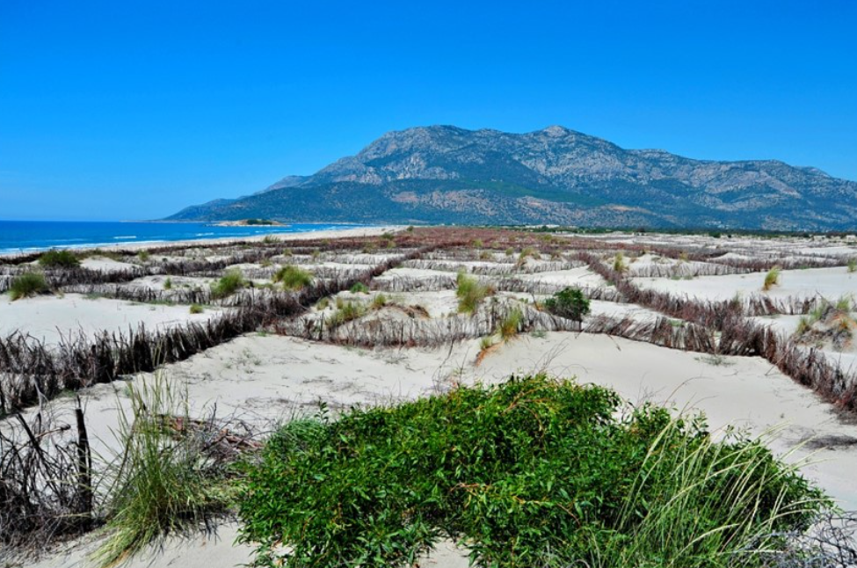
Picture 12. General view of the working field
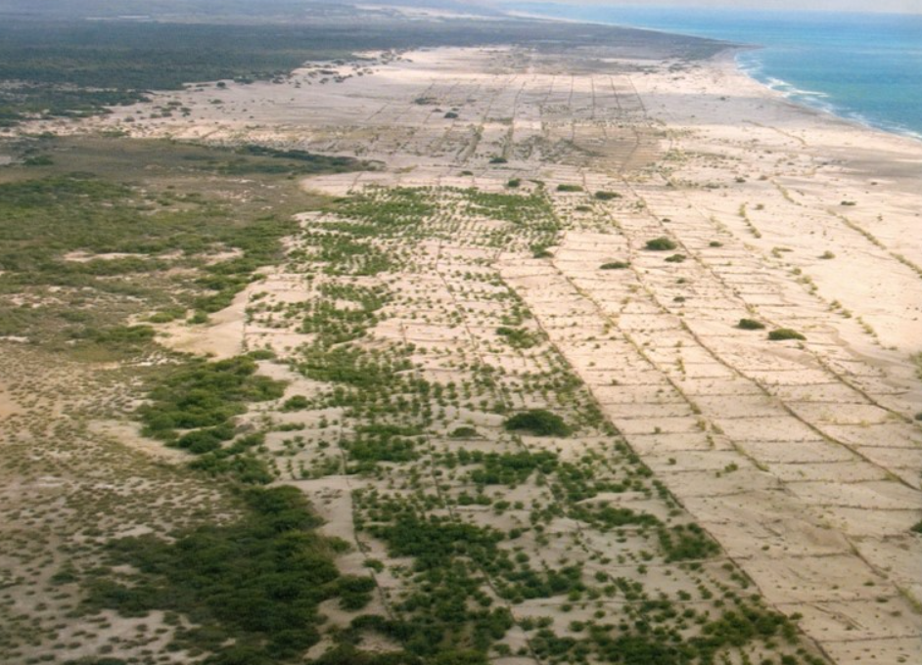
Picture 13. Current status of the study area as of 2024
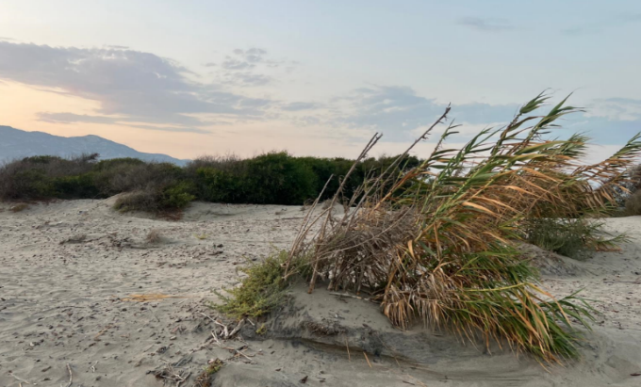 | 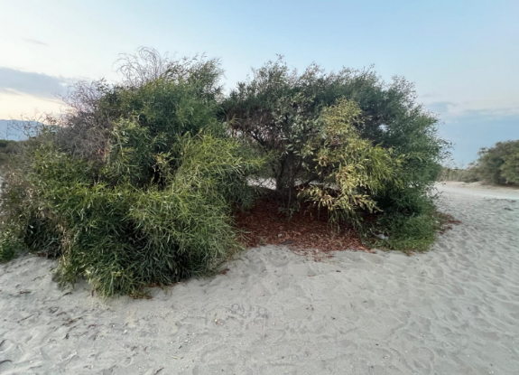
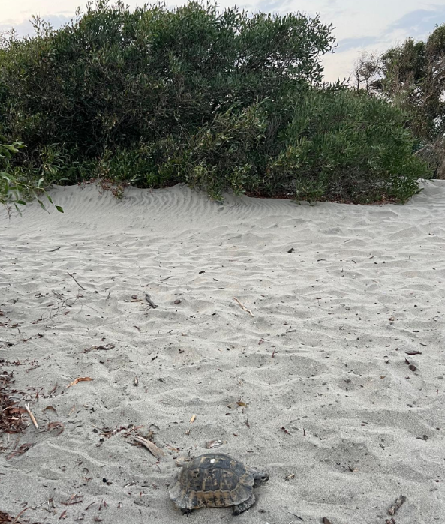 | 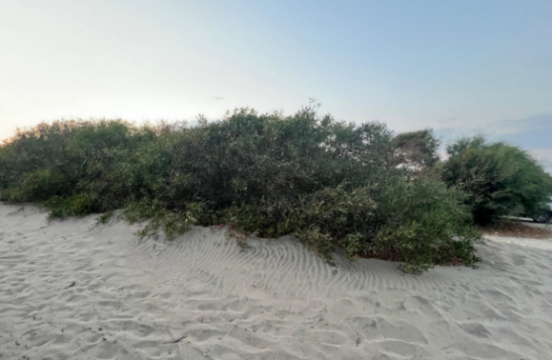  The sand dune stopping works initiated in the 1960s in the Fethiye district of Muğla, one of the provinces in the Aegean Region of Türkiye, have been successfully completed and as seen in the photographs, the area has almost become stable as of 2024. The eucalyptus, pine, and black locust (Robinia pseudoacacia) trees planted within the scope of these works have gained a structure that will sustain their own existence. The photographs here were taken by İsmail Belen in August 2024.

6.2. Utilization of low-quality soils and marginal lands- Hungary

The Great Hungarian Plain belongs to the Eurasian forest steppe climatic zone. This region is one of the most fundamental climate zones of Eurasia and is also a significant landscape of Hungary. The Plains extends over 52,000 km² in Hungary, exceeding the borders of Hungary with a total size of approximately 100,000 km².
In the 16th – 17th century there were only traces of forests in this vast area. It is characterized by a continental climate with significantly extreme conditions, such as cold winters below freezing point, as well as hot and dry summers with droughts. The annual precipitation is around 500 mm, which mostly happens outside of the vegetative period, from October until April.
The driest part of Hungary and within that, The Plains is the area and the dunes between the Duna and Tisza rivers, which was categorized by the United Nations Food and Agricultural Organization in 2004 as a semi-desert zone making up approximately 1/6 of the Hungarian Great Plains.
There is a 200-year-old tradition in the region regarding the afforestation of sandy soils and dunes, but the problem of low-quality sandy soils is still not fully solved. This means that further areas which are unsuitable for agricultural production must be introduced into the industrial wood production model to maximise efficiency and unitilise the now existing, genetically superior Robinia pseudoacia varieties, such as the ‘Turbo Obelisk’ vegetative varieties and the ‘Turbo’ progency tested seedling vartiety.
Today, the Hungarian Plains is a natural heritage, therefore quicksand is only present in national parks. Many of those areas, which were afforested in the past with Robinia pseudoacacia have been turned into arable land and are cultivated to this day with grapes, orchards and a great variety of crops.
The case of the utilization of Robinia pseudoacacia in the Great Hungarian Plains serves as an outstanding example for deploying the natural potential of non-arable lands with poor biodiversity through the application of selectively bred Robinia pseudoacaica varieties, which have a higher economic output and an improved resilience towards environmental conditions. When we consider the development of these areas, we can conclude that the introduction of Robinia pseudoacacia has significantly increased biodiversity and soil health, allowing for more wildlife and species to survive in these areas.
Due to the ever-growing urgency to act on climate change, it is vital to introduce new technologies and to develop new solutions for climate change mitigation.
The establishment of fast-growing industrial hardwood plantations with high carbon sequestration capcities whilst producing quality industrial timber is becoming vital, especially when considering the demand of the wood industry and the preservation of natural forests. This means that, in addition to the carbon sequestered by standing forests, harvested high-quality industrial timber also contributes to long-term carbon storage if we can utilize the wood as construction grade timber.
The establishment of new forests or plantations can typically take place in dry, low quality marginal soils within the forest steppe climate, which are unsuitable for agricultural production. These are mostly semi-arid, dry sandy soils with low humus content with high temperatures, under which conditions only a few species of trees can form a continuous forest population. As a result of climate change, it is vital to utilize species with a high tolerance to these new and extreme conditions and even more importantly special varieties of these species in these areas.
Wood yield and the Economic Qualities of the Robinia pseudoacacia ‘Turbo Obelisk’ variety group
Building on the work of Dr. Imre Kapusi and after decades of research and development, Silvanus Forestry/Hungaroplant has successfully propagated the Robinia pseudoacacia (Black Locust) ‘Turbo Obelisk’ variety group and developed the necessary cultivation technologies specifically for intensive industrial hardwood production plantations.

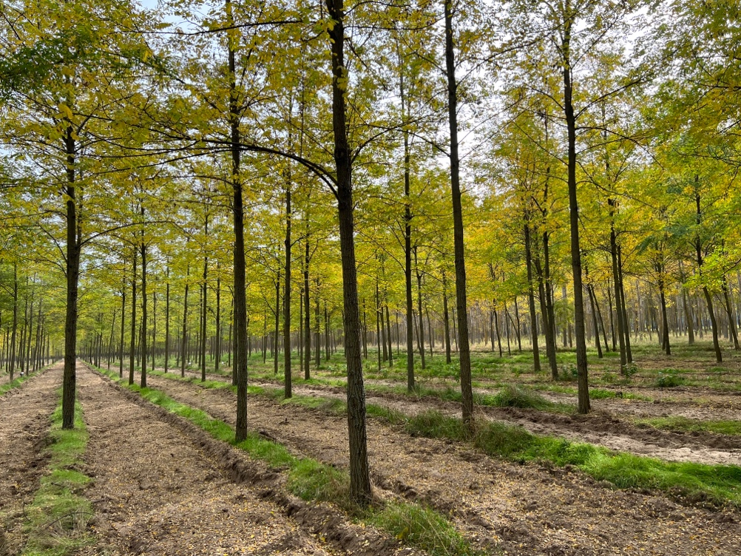
Picture 14. 9 year old Robinia pseudoacacia ‘Turbo Obelisk’ industrial wood production plantation in Csemő, Hungary

The Robinia pseudoacacia ‘Turbo Obelisk’ variety group has an even better tolerance to low quality, marginal soils than the common species. This means that in areas where the common black locust’s growth can be classified as weak, the growth of the ‘Turbo Obelisk’ varieties can be classified as good. This also means that the rotation period can be decreased due to the better growth.
The newly developed plantation maintenance technologies and the outstanding ‘Turbo Obelisk’ variety group also allows for high quality industrial pole wood and industrial roundwood production with a much higher output, hence decreasing the biomass or firewood output. This creates significantly higher value and allows for long-term carbon sequestration. This is due to not only its fast growth but its straight stem and hence wood quality. This can also be interesting from the perspective of the voluntary carbon credit market, as much more carbon can be sequestered with these varieties when compared to the common Robinia pseudoacacia species as well as when compared to other similar species.

Picture 15. 3-year-old flowering Robinia pseudoacacia ‘Turbo Obelisk’ industrial wood production plantation in Csemő, Hungary
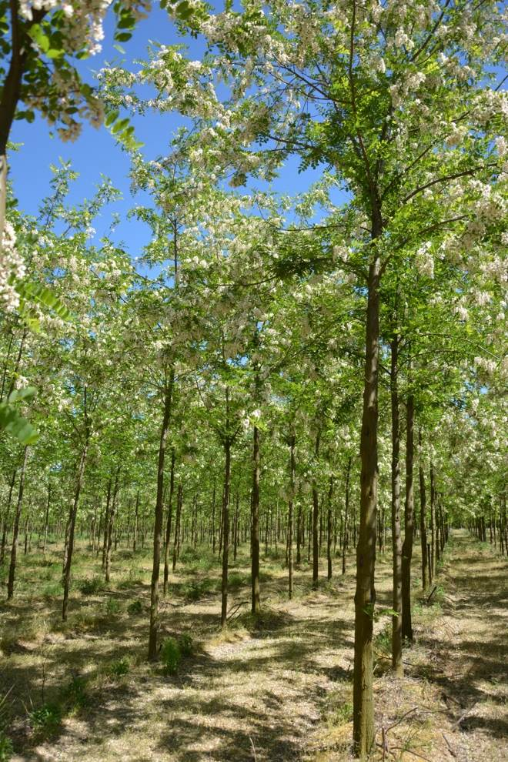
As an example, when considering a 20-year-old common black locust population with excellent wood yield, approximately 36% of the timber falls within the size range of industrial pole wood or industrial roundwood. Since the stem of common black locust is not straight but curved, the final industrial wood output will be as low as 15- 20%.
In comparison, when using the Robinia pseudoacacia 'Turbo Obelisk' variety group and the newly developed cultivation technologies, at the age of 20 years, 71% of the timber produced falls within the size range of industrial pole wood and industrial roundwood. In this situation, we can expect an approximate final industrial wood output of over 60%.
Furthermore, when considering medium wood productivity, the yield of a 15-year-old common black locust forest, with traditional practices, does not allow to produce any industrial wood, whilst the ‘Turbo Obelisk’ variety group is already able to produce a significant amount of industrial wood at this age.
Based on the previous examples, when using the selectively bred ‘Turbo Obelisk’ varieties, it can be expected significantly higher additional timber yield and longer sustainability due to not only the fast and straight growth of the varieties but also due to its higher tolerance to low quality soils. It is also important to consider its high and rich nectar yield, contributing to global apiary goals.
The amount of harvested industrial wood plays a significant role in the storage of sequestered carbon. It makes a huge difference whether you are producing firewood/biomass or quality hardwood of which quality products can be made, resulting in true long-term carbon sequestration. Further increasing the value of quality industrial wood is the natural durability of black locust hardwood.

Recommendations for the Implementation of the Guidelines

The seventh session is about the recommodations for the implementation of the Guidelines.
Since this Guidelines is prepared as a part of "Building knowledge and skills of local partners and communities to address environmental insecurities through innovative air, land, and water management solutions in the Aral Sea Region” developed by the United Nations Development Programme (UNDP) and the Food and Agriculture Organization of the United Nations (FAO) in response to the Fourth Call for Proposals of the MPHSTF in 2023, the implementation of the Guidelines is under the responsibility of FAO, UNDP, MPHSTF and Uzbekistan Forestry Agency based on the Activities proposed.

Monitoring and evaluation

This chapter is dedicated for monitoring and evaluation
The MPHSTF in close cooperation with FAO, UNDP and Uzbekistan Forestry Agency is responsible to monitor and evaluate this Guidelines when it is needed.

References, further reading, tools and guidelines, other case studies and websites
The ninth chapter lists reference sources.
- Monitoring the Dried Seabed of the Aral Sea: https://www.undp.org/uzbekistan/publications/monitoring-drained-bottom-aral-sea

- Sustainable Wild Collection Of Liquorice Information Package: https://greenaral.uz/en/e-learning/648

- World Bank Uzbekistan Country Forest Note The State of Forests and Forest Landscapes in Uzbekistan: https://documents1.worldbank.org/curated/en/099250007072236900/pdf/P1708700ef21870290b1a9019310003c250.pdf

- Four Expeditions Unveil Fascinating Insights from the Aral Sea's Dried Bed- https://www.undp.org/uzbekistan/press-releases/four-expeditions-unveil-fascinating-insights-aral-seas-dried-bed#:~:text=The%20first%20two%20expeditions%20were,Aral%20Sea%20region%E2%80%9D%20Joint%20programme

- Summary of the Results Report of the Final Expedition on the Dried Bed of the Aral Sea-April 30, 2024- https://www.undp.org/uzbekistan/publications/summary-results-report-final-expedition-dried-bed-aral-sea

- Resilient Landscapes Restoration Project for Uzbekistan- https://projects.worldbank.org/en/projects-operations/project-detail/P174135

- Global Guidelines for the Restoration of Degraded Forests and Landscapes in Drylands. Building Resilience and Benefitting Livelihoods. FAO Forestry Paper 175- https://www.fao.org/policy-support/tools-and-publications/resources-details/en/c/449353/

- AFD strengthens its long-term partnership with Uzbekistan- https://www.afd.fr/en/actualites/communique-de-presse/afd-strengthens-long-term-partnership-uzbekistan

Annexes

Annex 1: UNDP-FAO Joint Program 2024
By responding the Fourth Call for Proposals of the UN Multi-Partner Human Security Trust Fund for the Aral Sea region in Uzbekistan (MPHSTF) in 2023, the United Nations Development Program (UNDP) and the Food and Agriculture Organisation of the United Nations (FAO) jointly prepared a project titled “Building knowledge and skills of local partners and communities to address environmental insecurities through innovative air, land, and water management solutions in the Aral Sea Region”. This project approved by MPHSTF and started as of 5th July 2024.

Objectives of this project/programme designated as follows:
- Conduct a comprehensive assessment of ecosystem services in the Aral Sea Region, with the goal of improving local community management practices.
- Implement innovative approaches in water purification, afforestation, and soil stabilization within the region to address environmental degradation.
- Establish integrated air, water, and soil quality monitoring systems to facilitate improved regulatory practices in the Aral Sea Region.

Outputs and activities of this project as follows:

- Objective 1. Assessment of ecosystem services in the Aral Sea Region to enhance local management practices (UNDP and FAO)
  - Output 1.1. Participatory ecosystem restoration to enhance community-based tugai and desert pasture ecosystems management (UNDP)
    - Activity 1.1.1 Plan and conduct ecosystem services mapping in selected communities in three pilot districts of Karakalpakstan.
    - Activity 1.1.2 Engage community eco-volunteers into the assessment process through the established platform and integrate them into the existing health-volunteers platform to link environment and health issues of the region.
    - Activity 1.1.3 Enhance the capacity of local stakeholders on the value of ecosystem services and innovative approaches to ecosystem restoration based on local knowledge and international best practices.
    - Activity 1.1.4. Design education, communication, and outreach materials for various target groups at local, regional and national levels
  - Output 1.2 Enhanced Ecosystem Services (FAO)
    - Activity 1.2.1: “Develop Ecosystem Restoration Guidelines for the Aral Sea Region: Integrating UN Decade, FAO Solutions, and Native Tree Species Conservation

Activity 1.2.1 involves developing Ecosystem Restoration Guidelines for the region, integrating UN Decade principles, FAOSEC Solutions, and native tree species conservation. This initiative is expected to enable a comprehensive assessment of ecosystem services, ultimately enhancing local community management practices.

The goal of Activity 1.2.1 is to provide comprehensive and region-specific guidance for restoring ecosystems in the Aral Sea Region. This initiative, conducted jointly by FAO and the Chamber of Forest Engineers in Türkiye (OMO), aims to address the current environmental degradation in Karakalpakstan.

The collaboration between FAO and the Chamber of Forest Engineers in Türkiye (OMO) leverages expertise in ecosystem restoration and nature-based solutions (NbSs) developed for Türkiye and Central Asia. The guidelines on NbS implementation, jointly developed by OMO and FAO, serve as a foundation for the proposed activity, providing valuable insights and methodologies that can be adapted to address environmental degradation in Karakalpakstan. By building upon existing frameworks and expertise, this activity will effectively contribute to the overarching goals of environmental sustainability and community resilience in the Aral Sea Region.

The ecosystem restoration guidelines is expected to facilitate a comprehensive assessment of ecosystem services in the Aral Sea Region. This assessment will inform improved management practices by local communities, thereby reducing environmental stress and enhancing ecological resilience. The integration of UN Decade principles, FAO solutions, and native tree species conservation into the ecosystem restoration guidelines represents a pioneering effort in the region. By institutionalizing these innovative approaches, the Programme will promote the adoption of new technologies and practices for monitoring and improving water, air, and land resource utilization.

- Objective 2. Adopting new approaches in water purification, afforestation, and soil stabilization in the Region (UNDP, FAO).
  - Output 2.1. Supporting sustainable afforestation and land revitalizing practices in the Aral Sea Region (UNDP)
    - Activity 2.1.1 Establishing nurseries to scale up afforestation initiatives with stakeholders (rural cooperatives, IICAS, Forestry Department) based on the findings (over 20 plants are identified as desert resilient) of the four expeditions in the dried area of the Aral Sea. Within this activity, work with local communities will be conducted to increase the number of nurseries and desert pasture lands for livestock by applying innovative water saving technologies and advanced pasture management techniques. Initiate startups on chlorella, biohumus, zoohumus technologies etc. Train and engage communities in chistanche cultivation.
    - Activity 2.1.2: In cooperation with IICAS establishing mobile laboratories to analyze soil composition and to monitor sand and dust migration in the Region. IICAS is one of the instrumental partners on the ground which is promoting innovations in the Region. Included are plans to cooperate with IICAS to enhance the capacity of soil analysis and dust migration processes in order to provide valuable information to local communities, farmers and smallholders. Activity 2.1.3: Conduct field research in cooperation with local scientific institutions on sand and dust storms and assess loss and damage to ecosystem services.
  - Output 2.2. Enhanced Integrated Management and Restoration of Tugai Forest Ecosystems for Sustainable Livelihoods and Environmental Resilience (FAO).
    - Activity 2.2.1: Organize a Tugai Forest Restoration Showcase: Workshop, Planting Techniques, and Field Trip Review is designed to share successful experiences and insights gained from tugai forest restoration efforts in Kazakhstan. The goal is to contribute to the environmental restoration of Karakalpakstan by leveraging the expertise of WWF.
- Objective 3. Promoting integrated air, water, and soil quality monitoring systems to facilitate regulatory practices in the Region (UNDP, FAO).
  - Output 3.1 Facilitating Integrated Air Quality Management Systems and Regulatory Practices (UNDP)
    - Activity 3.1.1: Conduct needs assessment of the air quality monitoring systems in the region covering 8 district centers. Identify compatible air quality monitoring systems with existing national monitoring systems in cooperation with UzHydromet.
    - Activity 3.1.2: Based on the needs assessment, establish air quality monitoring systems in at least 8 locations. Undertake capacity building of national partners in monitoring air quality systems in the districts. Support at least three startup initiatives on air, soil, and water monitoring systems.
    - Activity 3.1.3: Integrated the air quality monitoring systems in the national air quality monitoring systems including with health care facilities. Based on the analysis of the air monitoring systems facilitated the development of a national standard on air pollution as per SDG 11 in the Aral Sea Region.
    - Activity 3.1.4: Awareness raising campaign conducted by involving health volunteers of the Region on the air quality monitoring system and its impact on the health of the people.
    - Activity 3.1.5: Engage community eco volunteers and health volunteers in promoting air quality monitoring systems.
  - Output 3.2. Enhanced Comprehensive Environmental Quality Management and Regulatory Practices (FAO)
    - The goal of the Activity 3.2.1: Assess water management in dust storm areas by installing a water quantity and quality monitoring network is to conduct a comprehensive assessment of water resource management in areas affected by dust storms in Karakalpakstan. The primary objective is to identify key challenges and propose sustainable solutions to address water-related issues contributing to environmental degradation.

Annex 2: The Multi-Partner Human Security Trust Fund for the Aral Sea region (MPHSTF)

A very important step in the practical implementation of the President’s initiative was the establishment of the Multi-Partner Human Security Trust Fund for the Aral Sea region (MPHSTF) during a special high-level meeting held on 27 November 2018 at the UN Headquarters in New York. The goals and directions of the foundation aimed to catalyse and strengthen multisectoral and people-centred responses to one of the largest man-made disasters in the world, by being transformative, needs-based, human rights-based and inclusive in its purpose. The MPHSTF provides a coherent strategy for coordinating aid flows and increasing government leadership of the assistance process to achieve sustainable results.
The foundation’s strategies address six clusters of interrelated problems:
- Environmental safety
- Economic security
- Food security
- Health security
- Social security
- Inefficiency of donor assistance

Annex 3: Ecosystem Types in the Aral Sea Basin and Dried Aral Seabed According to IUCN

The IUCN Global Ecosystem Typology which is considered one of the main source on ecosystem management comprises six hierarchical levels, with the three upper levels– realms, functional biomes and ecosystem functional groups – classify ecosystems based on their functional characteristics (such as structural roles of foundation species, water regime, climatic regime or food web structure), rather than based on which species live in them.
The three lower levels of classification – biogeographic ecotypes, global ecosystem types and sub global ecosystem types – are often already in use and incorporated into policy infrastructure at national levels and can be linked to these upper levels. This is crucial, as important conservation action occurs at local levels, where most ecosystem-specific knowledge and data reside.
Realms:
- Terresterial (7 biomes, 34 functional groups),
- Marine (4 biomes, 24 functional groups),
- Freshwater (3 biomes, 22 functional groups),
- Subterranean (2 biomes, 3 functional groups)

In the Aral Sea Region, a landrock region, there are two realms in general, The Terrestrial realm and the “Freshwater Realm”.

The Terrestrial realm includes all dry land, its vegetation cover, proximate atmosphere and substrate (soils, rocks) to the rooting depth of plants, and associated animals and microbes.
Terrestrial realm has 7 biomes as follows:
- T1 Tropical-subtropical forests biome
- T2 Temperate-boreal forests and woodlands biome
- T3 Shrublands and shrubby woodlands biome
- T4 Savannas and grasslands biome
- T5 Deserts and semi-deserts biome
- T6 Polar/alpine (cryogenic) biome
- T7 Intensive land-use biome
Terrestrial biomes found in Aral Sea Region.
- T5 Deserts and semi-deserts biome
- T7 Intensive land-use biome
Functional Groups of “T5 Deserts and semi-deserts biome”
- T5.1 Semi-desert steppe
- T5.2 Succulent or Thorny deserts and semi-deserts
- T5.3 Sclerophyll hot deserts and semi-deserts
- T5.4 Cool deserts and semi-deserts
- T5.5 Hyper-arid deserts

2.5.1. Functional Groups of “T5 Deserts and semi-deserts biome” of “Terresterial Realm”

2.5.1.1. T5.1 Semi-desert steppe

Semi-desert steppes on all continents are dominated by perennial shrubs, often with semi-fleshy or velvety foliage, and tussock grasses interspersed with bare ground. Low variable rainfall and extreme temperatures favour flora and fauna with drought and stress-tolerance adaptations, such as deep roots and nomadism. Growth and reproduction of shrubs and grasses is varies with rainfall, the cover of grass diminishing to near zero in extended droughts. Grass cover also depends on soil fertility and grazing animals, which may also limit shrub recruitment and growth. These steppes are among the most productive of desert ecosystems, with relatively abundant small and large herbivorous and seed-eating mammals supporting bird and mammal predators and scavengers.
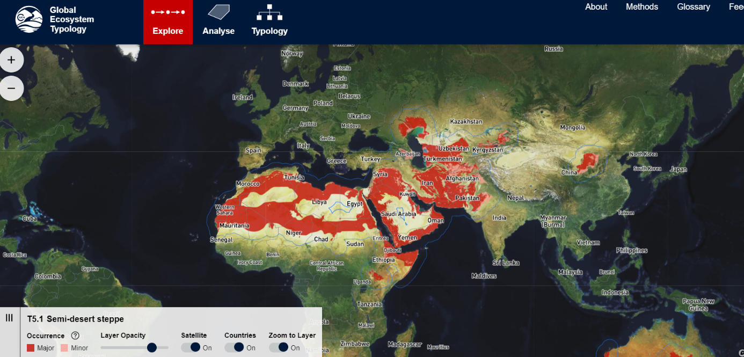
https://global-ecosystems.org/explore/groups/T5.1
These mixed semi-deserts are dominated by suffrutescent (i.e. with a woody base) or subsucculent (semi-fleshy) perennial shrubs and tussock grasses. Productivity and biomass are limited by low average precipitation, extreme temperatures and, to a lesser extent, soil nutrients, but vary temporally in response to water availability.
Vegetation takes a range of structural forms including open shrublands, mixed shrublands with a tussock grass matrix, prairie-like tall forb grasslands, and very low dwarf shrubs interspersed with forbs or grasses. Total cover varies from 10% to 30% and the balance between shrubs and grasses is mediated by rainfall, herbivory, and soil fertility. Stress-tolerator and ruderal life-history types are strongly represented in flora and fauna. Trait plasticity and nomadism are also common. Traits promoting water capture and conservation in plants include xeromorphy, deep roots, and C4 photosynthesis. Shrubs have small (less than nanophyll), non-sclerophyll, often hairy leaves with moderate SLA. Shrubs act as resource-accumulation sites, promoting heterogeneity over local scales. C3 photosynthesis is represented in short-lived shrubs, forbs, and grasses, enabling them to exploit pulses of winter rain. Consumers include small mammalian and avian granivores, medium-sized mammalian herbivores, and wide-ranging large mammalian and avian predators and scavengers. Abundant detritivores consume dead matter and structure resource availability and habitat characteristics over small scales. Episodic rainfall initiates trophic pulses with rapid responses by granivores and their predators, but less so by herbivores, which show multiple traits promoting water conservation. https://global-ecosystems.org/explore/groups/T5.1

2.5.1.2. T5.4 Cool deserts and semi-deserts
Cool deserts and semi-deserts occur on cool temperate plains and plateaus in central Eurasia and temperate parts of the Americas from sea level up to 4,000 m. Strong winds and freezing temperatures prevail, with low annual precipitation falling as winter snow or sleet. Productivity is low on infertile sandy and clay soils, often with high salinity. Vegetation comprises a sparse cover of low grasses and dwarf shrubs, interspersed with bare patches, with some areas having only lichens and mosses or no vegetation at all. Fauna includes large nomadic herbivores including antelopes, wild horses and camels, which control composition of vegetation. Predators include raptors, snakes, bears, and cats.
In these arid systems, productivity is limited by both low precipitation and cold temperatures but varies spatially in response to soil texture, salinity, and water table depth. Vegetation cover varies with soil conditions from near zero (on extensive areas of heavily salinized soils or mobile dunes) to >50% in upland grasslands and shrublands, but is generally low in stature (<1 m tall). The dominant plants are perennial C3 grasses and xeromorphic suffrutescent or non-sclerophyllous perennial shrubs. Dwarf shrubs, tending to prostrate or cushion forms occur in areas exposed to strong, cold winds. Plant growth occurs mainly during warming spring temperatures after winter soil moisture recharges. Eurasian winter annuals grow rapidly in this period after developing extensive root systems over winter. Diversity and local endemism are low across all taxa relative to other arid ecosystems. Trophic networks are characterised by large nomadic mammalian herbivores. Vertebrate herbivores including antelopes, equines, camelids, and lagomorphs are important mediators of shrub-grass dynamics, with heavy grazing promoting replacement of grasses by N-fixing shrubs. Grasses become dominant with increasing soil fertility or moisture but may be replaced by shrubs as grazing pressure increases. Fossorial lagomorphs and omnivorous rodents contribute to soil perturbation. Predator populations are sparse but taxonomically diverse. They include raptors, snakes, bears, and cats. Bio-crusts with cyanobacteria, mosses, and lichens are prominent on fine-textured substrates and become dominant where it is too cold for vascular plants. They play critical roles in soil stability and water and nutrient availability.
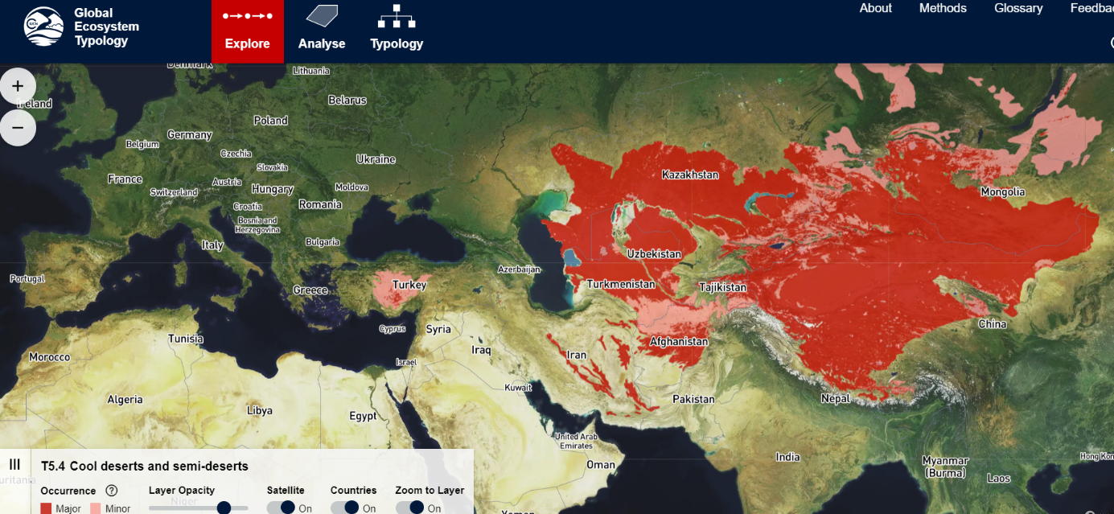
https://global-ecosystems.org/explore/groups/T5.4

2.5.2. Functional Groups of T7-Intensive land-use biome of of “Terresterial Realm”

Intensive land-use systems include major anthropogenic enterprises of cropping, pastoralism, plantation farming, and urbanisation. Human intervention is a dominating influence on this biome, also known as the “anthrome”.
Maintenance of these systems is contingent on continuing human interventions, including alterations to the physical structure of vegetation and substrates (e.g. clearing, earthworks, and drainage), the supplementation of resources (e.g. with irrigation and fertilisers), and the introduction and control of biota.
These interventions maintain disequilibrium community structure and composition, low endemism, and low functional and taxonomic diversity. Target biota are genetically manipulated (by selective breeding or molecular engineering) to promote rapid growth rates, efficient resource capture, enhanced resource allocation to production tissues, and tolerance to harsh environmental conditions, predators, and diseases. Non-target biota include widely dispersed, cosmopolitan opportunists with short lifecycles.
Many intensive land use systems are maintained as artificial mosaics of contrasting patch types at scales of metres to hundreds of metres. Typically, but not exclusively, they are associated with temperate or subtropical climates and the natural availability of freshwater and nutrients from fertile soils on flat to undulating terrain accessible by machinery. The antecedent ecosystems that they replaced include forests, shrublands, grasslands and palustrine wetlands (T1, T2, T3, T4 and TF1).
On global and regional scales, intensive land-use systems are engaged in climate feedback processes via alterations to the water cycle and the release of greenhouse gases from vegetation, soils, livestock, and fossil fuels. On local scales, temperatures may be modified by human-built structures (e.g. heat-island effects) or may be artificially controlled
The 5 functional groups of the Intensive land-use biome
- T7.1 Annual croplands
- T7.2 Sown pastures and fields
- T7.3 Plantations
- T7.4 Urban and industrial ecosystems
- T7.5 Derived semi-natural pastures and old fields

2.5.2.1. T7.1 Annual croplands
Croplands are intensively managed agricultural ecosystems maintained by supplementation of nutrients and water, sowing and harvesting, soil cultivation and control of non-target plants and animals (weeds and pests). They currently cover 11% of the world’s land surface. Some systems of management include domestic herbivores introduced on harvested stubble or in ‘fallow’ years. These are structurally simple, very low-diversity, high-productivity systems, dominated by one or few non-woody, shallow-rooted annual plant species such as grains (mostly C3 grasses), vegetables, ‘cut flowers’, legumes, or fibre plants harvested annually by humans for commercial or subsistence production of food, materials, or ornamental displays.

High-productivity croplands are maintained by the intensive anthropogenic supplementation of nutrients, water, and artificial disturbance regimes (e.g. annual cultivation), translocation (e.g. sowing), and harvesting of annual plants. These systems are typically dominated by one or few shallow-rooted short-lived plant species such as grains (mostly C3 grasses), vegetables, ‘flowers’, legumes, or fibre species harvested annually by humans for the commercial or subsistence production of food, materials, or ornamental displays. Disequilibrium community structure and composition is maintained by translocations and/or managed reproduction of target species and usually by periodic application of herbicides and pesticides and/or culling to exclude competitors, predators, herbivores, and/or pathogens. Consequently, compared to antecedent ‘natural’ systems, croplands are structurally simple, have low functional, genetic, and taxonomic diversity and no local endemism. Subsistence croplands, including Swidden rotation systems, are typically more diverse than industrial croplands. Productivity is highly sensitive to variations in resource availability. Target biota are genetically manipulated by selective breeding or molecular engineering to promote rapid growth rates, efficient resource capture, enhanced resource allocation to production tissues, and tolerance to harsh environmental conditions, insect predators, and diseases. Typically, at least 40% of net primary productivity is appropriated by humans. Croplands may be rotated inter-annually with livestock pastures or fallow fields (T7.2) or may be integrated into mixed cropping-livestock systems. Target biota coexists with a cosmopolitan ruderal biota (e.g. weedy plants, mice, and starlings) that exploits production landscapes opportunistically through efficient dispersal, itinerant foraging, rapid establishment, high fecundity, and rapid population turnover. Native biota from adjoining non-anthropogenic systems may also interact with croplands. When actively managed systems are abandoned or managed less intensively, these non-target biota, especially non-woody plants, become dominant and may form a steady, self-maintaining state or a transitional phase to novel ecosystems. https://global-ecosystems.org/explore/groups/T7.1

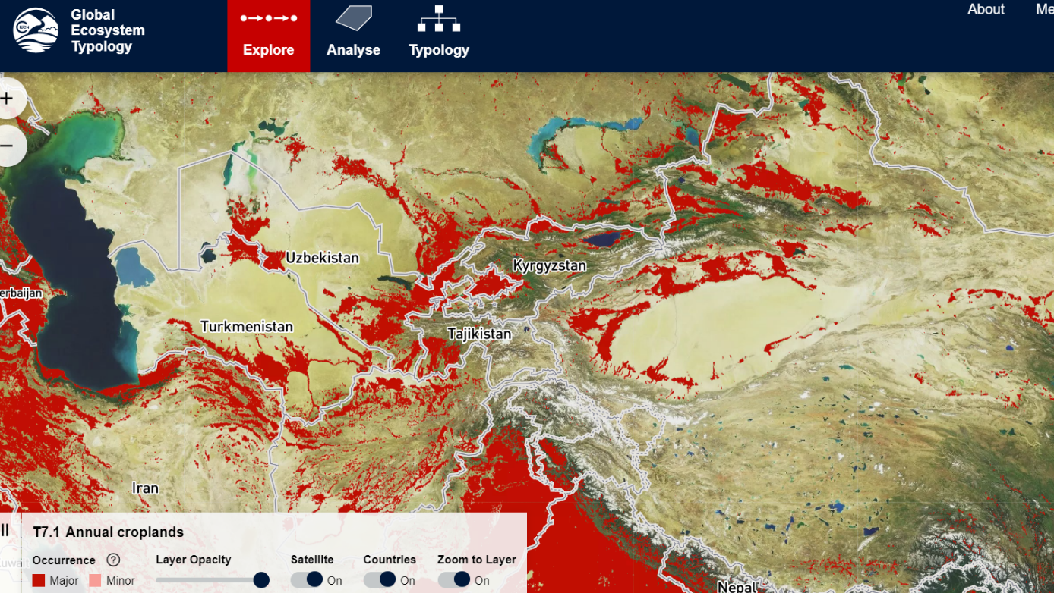

2.5.2.2. T7.2 Sown pastures and fields
In these intensively managed agricultural systems, grasses and legumes are sown and cultivated, with regular inputs of nutrients and (sometimes) water, primary for the mostly commercial production of livestock or food (hay) for livestock. Sown pastures are structurally simple ecosystems with low-diversity and high-productivity. They are dominated by one or few selected plant species as primary food sources for one animal species (usually large mammalian herbivores). Management includes chemical or physical treatments to exclude competitors, predators, herbivores, or pathogens. They differ from less intensively managed rangeland (e.g. T5) and semi-natural grasslands (T7.5), where livestock graze in predominantly native ecosystems.

Structurally simple, high-productivity pastures are maintained by the intensive anthropogenic supplementation of nutrients (more rarely water) and artificial disturbance regimes (e.g. periodic ploughing,), translocation (e.g. livestock movement and sowing), and harvesting of animals or plants. The magnitude of these inputs distinguish these systems from semi-natural pastures and rangelands in biomes T4 and T5 used for less intense livestock production. They are dominated by one or few selected plant species (C3 and C4 perennial pasture grasses and/or herbaceous legumes) and animal species (usually large mammalian herbivores) for commercial production of food or materials, ornamental displays, or sometimes subsistence. Their composition and structure is maintained by the translocation and/or managed reproduction of target species and the periodic application of herbicides and pesticides and/or culling to exclude competitors, predators, herbivores, or pathogens. Consequently, compared to ‘natural’ rangeland systems and semi-natural pastures, these systems have low functional and taxonomic diversity and little or no local endemism. Target biota are genetically manipulated to promote rapid growth rates, efficient resource capture, enhanced resource allocation to production tissues, and tolerance to harsh environmental conditions, diseases, and predators, . They are harvested by humans continuously or periodically for consumption or maintenance. Typically, at least 40% of net primary productivity is appropriated by humans. Major examples include intensively managed production pastures for livestock or forage (e.g. hay). Livestock pastures may be rotated inter-annually with non-woody crops (T7.1), or they may be managed as mixed silvo-pastoral systems (T7.3). Target biota coexist with native and cosmopolitan ruderal biota that exploits production landscapes through efficient dispersal, rapid establishment, high fecundity, and rapid population turnover. When the ecosystem is abandoned or managed less intensively, non-target biota become dominant and may form a steady, self-maintaining state or a transitional phase to novel ecosystems. https://global-ecosystems.org/explore/groups/T7.2
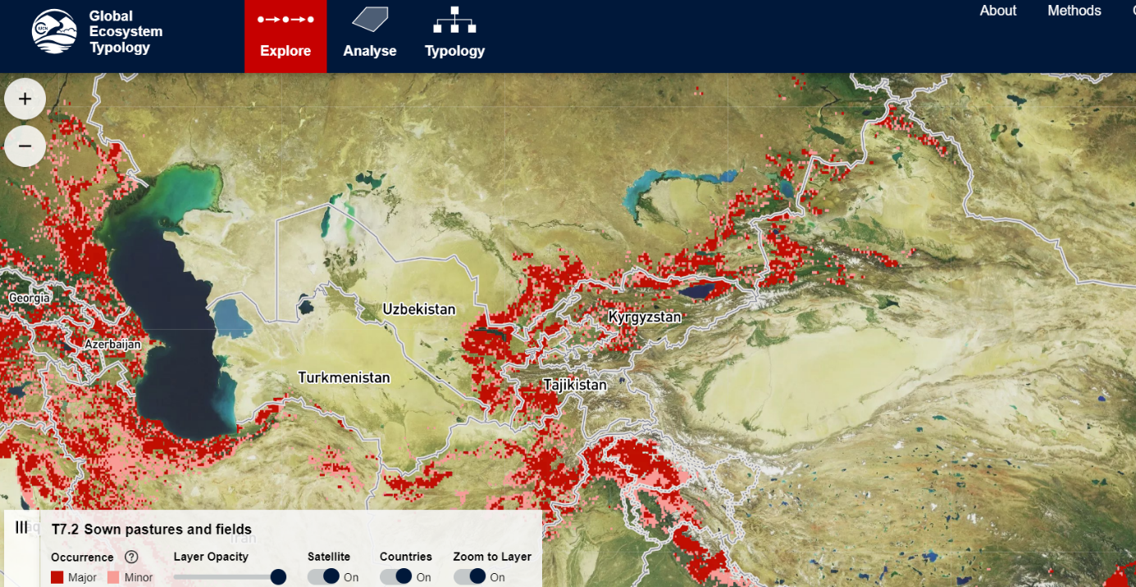

2.5.2.3. T7.3 Plantations
Plantations are generally long-rotation perennial woody crops established and maintained for a variety of food and materials. The harvested products include wood, various fruits, tea, coffee, palm oil and other food additives, materials such as rubber, ornamental materials (cut flowers), etc. The vegetation of most plantations comprises at least two vertical strata (the managed woody species and a ruderal ground layer), although mixed plantings may be more complex and host a relatively diverse flora and fauna if managed to promote habitat features. Fertilisers and water subsidies are applied, and harvesting occurs at intervals depending on the crop.
These moderate to high productivity autotrophic systems are established by the translocation (i.e. planting or seeding) of woody perennial plants. Target biota may be genetically manipulated by selective breeding or molecular engineering to promote rapid growth rates, efficient resource capture, enhanced resource allocation to production tissues, and tolerance of harsh environmental conditions, insect predators, and diseases. The diversity, structure, composition, function, and successional trajectory of the ecosystem depends on the identity, developmental stage, density, and traits (e.g. phenology, physiognomy, and growth rates) of planted species, as well as the subsequent management of plantation development. Most plantations comprise at least two vertical strata (the managed woody species and a ruderal ground layer). Mixed forest plantings may be more complex and host a relatively diverse flora and fauna if managed to promote habitat features. Cyclical harvest may render the habitat periodically unsuitable for some biota. Mixed cropping systems may comprise two vertical strata of woody crops or a woody and herbaceous layer. Secondary successional processes involve colonisation and regeneration, initially of opportunistic biota. Successional feedbacks occur as structural complexity increases, promoting visits or colonisation by vertebrates and the associated dispersal of plants and other organisms. Crop replacement (which may occur on inter-annual or decadal cycles), the intensive management of plantation structure, or the control of non-target species may reset, arrest, or redirect successional processes. Examples with increasing management intervention include: environmental plantations established for wildlife or ecosystem services; agroforestry plantings for subsistence products or livestock benefits; forestry plantations for timber, pulp, fibre, bio-energy, rubber, or oils; and vineyards, orchards, and other perennial food crops (e.g. cassava, coffee, tea, palm oil, and nuts). Secondary (regrowth) forests and shrublands are not included as plantations even where management includes supplementary translocations.
https://global-ecosystems.org/explore/groups/T7.3
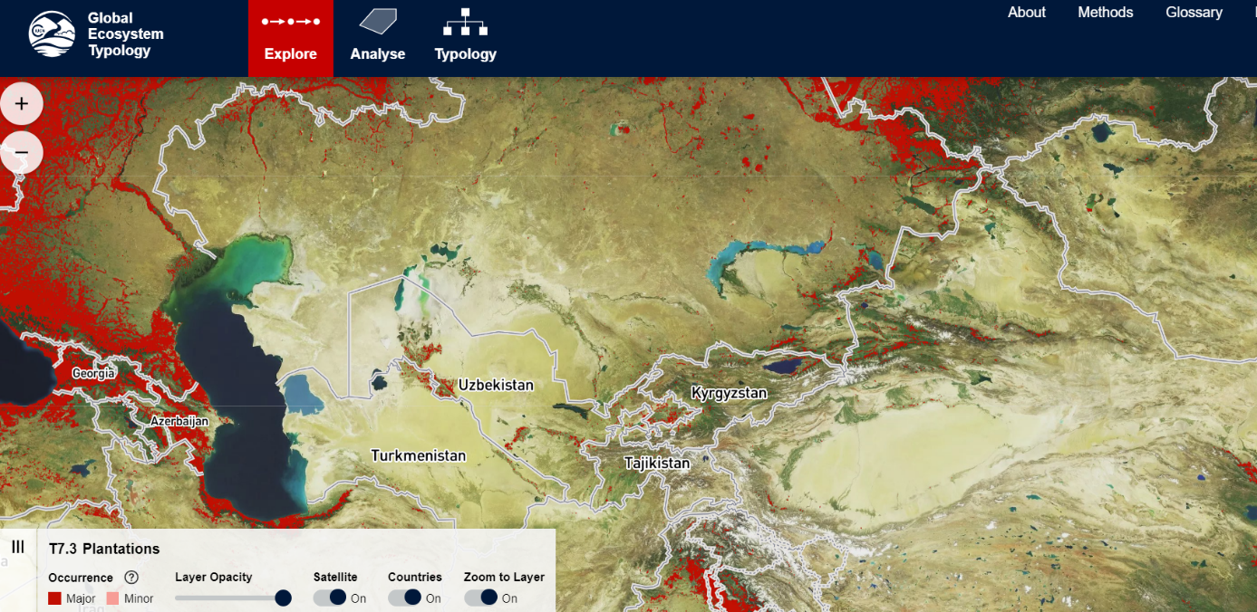

2.5.2.4. T7.4 Urban and industrial ecosystems

Cities, smaller settlements and industrial areas are structurally complex ecosystems and characterised by their highly dynamic spatial structure. Diverse patch types include buildings, paved surfaces, transport infrastructure, parks and gardens; excavations, bare ground and refuse areas. Patches undergo periodic destruction and renewal. Human population density is high, relative to other ecosystems, and dependent on large subsidies of imported resources (particularly water, nutrients and food). Interactions among patch types and human social behaviours produce emergent properties and complex feedbacks among ecosystem components.
These systems are structurally complex and highly heterogeneous fine-scale spatial mosaics of diverse patch types that may be recognised in fine-scale land use classifications. These include: a) buildings; b) paved surfaces; c) transport infrastructure: d) treed areas; e) grassed areas; f) gardens; g) mines or quarries; h) bare ground; and i) refuse areas. Patch mosaics are dynamic over decadal time scales and driven by socio-ecological feedbacks and a human population that is highly stratified, functionally, socially and economically. Interactions among patch types and human social behaviours produce emergent properties and complex feedbacks among components within each system and interactions with other ecosystem types. Unlike most other terrestrial ecosystems, the energy, water and nutrient sources of urban/industrial village systems are highly allochthonous and processes within urban systems drive profound and extensive global changes in land use, land cover, biodiversity, hydrology, and climate through both resource consumption and waste discharge. Biotic community structure is characterised by low functional and taxonomic diversity, highly skewed rank-abundance relationships and relict local endemism. Trophic networks are simplified and sparse and each node is dominated by few taxa. Urban/village biota include humans, dependents (e.g. companion animals and cultivars), opportunists and vagrants, and legacy biota whose establishment pre-dates settlement. Many biota have highly plastic realised niches, traits enabling wide dispersal, high fecundity, and short generation times. The persistence of dependent biota is maintained by human-assisted migration, managed reproduction, genetic manipulation, amelioration of temperatures, and intensive supplementation of nutrients, food, and water. Pest biota are controlled by the application of herbicides and pesticides or culling with collateral impacts on non-target biota.
https://global-ecosystems.org/explore/groups/T7.4
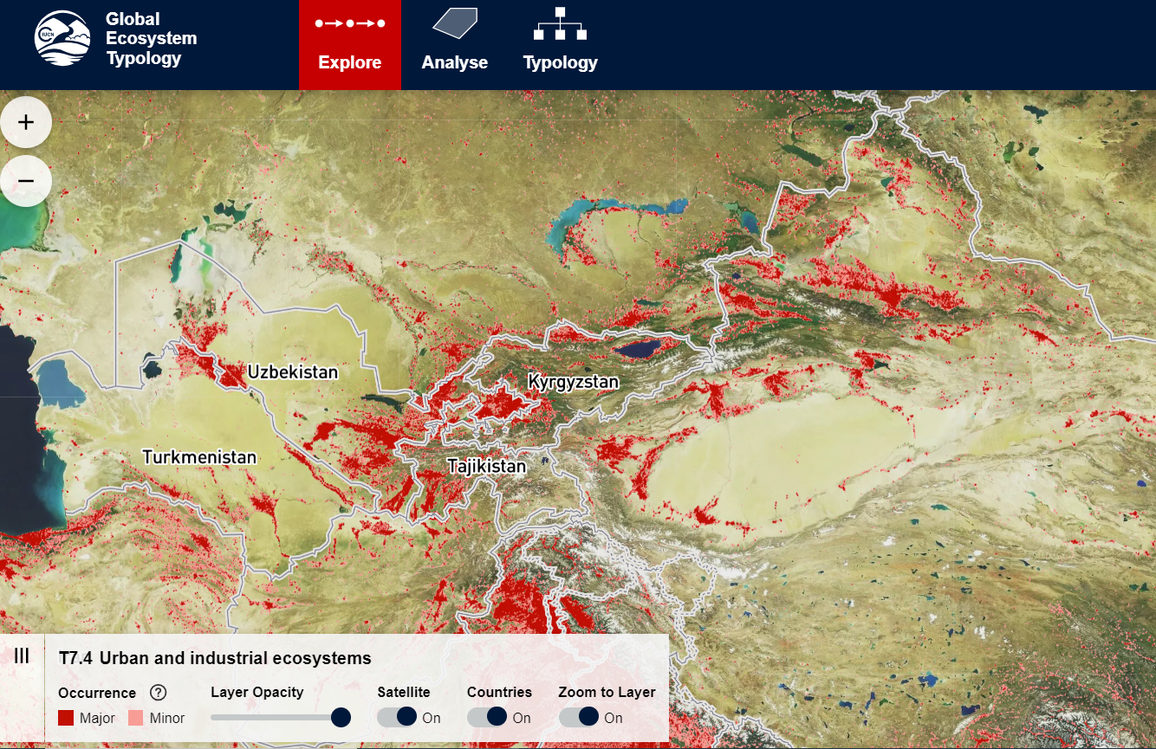

2.5.2.5. T7.5 Derived semi-natural pastures and old fields
These managed ecosystems are derived from a range of other ecosystems (mostly from T1 - T4, a few from T5) by the removal or modification of woody plant components. The remaining vegetation includes both local indigenous species and introduced species, providing habitat for a mixed indigenous and non-indigenous fauna. They are used mainly for livestock grazing, which is essential to maintaining the structure of the system. Unlike sown pastures, inputs of water and nutrients are limited. Although structurally simpler than the systems from which they were derived, they often harbour an appreciable diversity of native organisms.

Extensive ‘semi-natural’ grasslands and open shrublands exist where woody components of vegetation have been removed or greatly modified for agricultural land uses. Hence they have been ‘derived’ from a range of other ecosystems (mostly from biomes T1, T2, T3, T4, a few from T5). Remaining vegetation includes a substantial component of local indigenous species, as well as an introduced exotic element, providing habitat for a mixed indigenous and non-indigenous fauna. Although structurally simpler at site scales than the systems from which they were derived, spatial complexity may be greater in fragmented landscapes and they often harbour appreciable diversity of native organisms, including some no longer present in ‘natural’ ecosystems. Dominant plant growth forms include tussock or stoloniferous grasses and forbs, with or without non-vascular plants, shrubs and scattered trees. These support microbial decomposers and diverse invertebrate groups that function as detritivores, herbivores and predators, as well as vertebrate herbivores and predators characteristic of open habitats. Energy sources are primarily autochthonous, with varying levels of indirect allochthonous subsidies (e.g. via surface water sheet flows), but few managed inputs (cf. T7.2). Productivity can be low or high, depending on climate and substrate, but is generally lower and more stable than more intensive anthropogenic systems (T7.1-T7.3). Trophic networks include all levels, but complexity and diversity depends on the species pool, legacies from antecedent ecosystems, successional stage, and management regimes. These novel ecosystems may persist in a steady self-maintaining state, or undergo passive transformation (e.g. oldfield succession) unless actively maintained in disequilibrium. For example, removal of domestic herbivores may initiate transition to tree-dominated ecosystems. https://global-ecosystems.org/explore/groups/T7.5

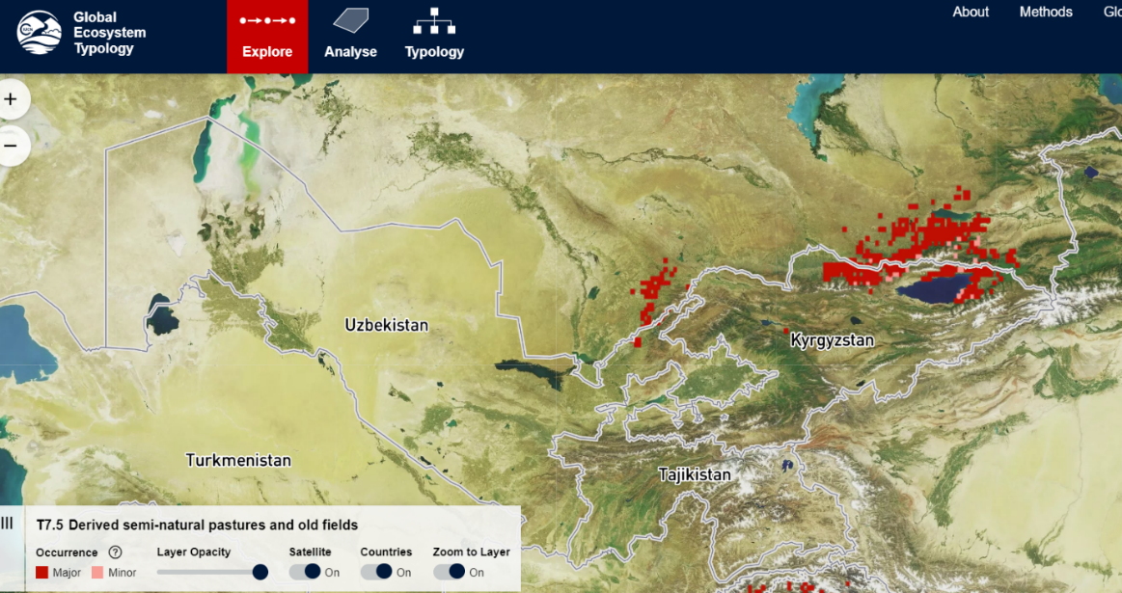

2.5.3. Functional Groups of “F1 Rivers and streams biome” of the “Freshwater Realm”

The Freshwater realm includes the three following biomes:
- F1 Rivers and streams biome
- F2 Lakes biome
- F3 Artificial wetlands biome
F1 Rivers and streams biome has 7 functional group as follows:
- F1.1 Permanent upland streams
- F1.2 Permanent lowland rivers
- F1.3 Freeze-thaw rivers and streams
- F1.4 Seasonal upland streams
- F1.5 Seasonal lowland rivers
- F1.6 Episodic arid rivers
- F1.7 Large lowland rivers
F2 Lakes biome has 10 “Functional Group” as follows:
https://global-ecosystems.org/explore/biomes/F2
- F2.1 Large permanent freshwater lakes
- F2.2 Small permanent freshwater lakes
- F2.3 Seasonal freshwater lakes
- F2.4 Freeze-thaw freshwater lakes
- F2.5 Ephemeral freshwater lakes
- F2.6 Permanent salt and soda lakes
- F2.7 Ephemeral salt lakes
- F2.8 Artesian springs and oases
- F2.9 Geothermal pools and wetlands
- F2.10 Subglacial lakes

F3 Artificial wetlands biome has 5 Functional Grup- https://global-ecosystems.org/explore/biomes/F3
- F3.1 Large reservoirs
- F3.2 Constructed lacustrine wetlands
- F3.3 Rice paddies
- F3.4 Freshwater aquafarms
- F3.5 Canals, ditches and drains

2.5.3.1. F1.1 Permanent upland streams
These small rivers or streams in mountainous or hilly areas are characterised by steep gradients and fast flow. They flow all year, increasing in wet periods, in humid tropical and temperate zones. Stones are common along their rapids and pools, turning over and oxygenating the water. Dependent organisms are specialised for these high flow-velocity environments, with resources for food webs derived mainly from the stream and inputs from adjacent and upstream vegetation.
These 1st-3rd order streams generally have steep gradients, fast flows, coarse substrates, often with a riffle-pool (shallow and fast vs deeper and slow) sequence of habitats, and periodic (usually seasonal) high-flow events. Many organisms have specialised morphological and behavioural adaptations to high flow-velocity environments. Riparian trees produce copious leaf fall that provide allochthonous subsidies, and support somewhat separate foodwebs to those based on in situ primary production by bryophytes and biofilms. Tree shade conversely light-limits productivity, a trade-off that relaxes seasonally where deciduous trees dominate. Microbes and detritivores (e.g. invertebrate shredders) break down leaf fall and other organic matter. Microbial biofilms comprising algae, fungi and bacteria establish on rocks and process dissolved organic matter. Invertebrates include shredders (consuming coarse particles), grazers (consuming biofilm), collectors and filter feeders (consuming benthic and suspended fine particles, respectively), and predators. Many benthic macroinvertebrates, mostly insects, have aquatic larvae and terrestrial adults. Filter feeders have traits adapted to swift flows, allowing them to hold fast to substrates while capturing resources, while benthic bryophytes provide shelter for other organisms. Fish are typically small predators of aquatic invertebrates and insects on the water surface. Birds typically have specialised foraging behaviours (e.g. dippers and kingfishers). Trophic cascades involving rapid algal growth, invertebrate grazers and fish are common. https://global-ecosystems.org/explore/groups/F1.1

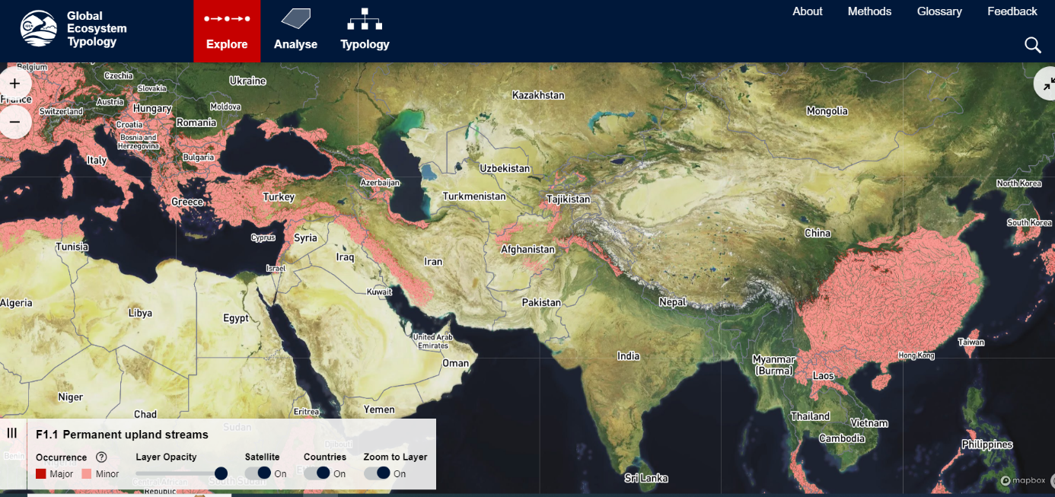
https://global-ecosystems.org/explore/groups/F1.1

2.5.3.2. F1.2 Permanent lowland rivers

Lowland rivers with slow continuous flows up to 10,000m3/s are common at low elevations throughout tropical and temperate parts of the world. These are productive ecosystems with major energy and fine sediment inputs from floodplains and upper catchments. Zooplankton can be abundant, along with aquatic plants and diverse communities of fish able to tolerate a range of temperatures and oxygen concentrations, as well as reptiles, birds, and mammals that depend wholly or partly on lowland lotic aquatic habitats.

Small-medium lowland rivers (stream orders 4-9) are productive depositional ecosystems with trophic webs that are less diverse than large lowland rivers (F1.7). Macrophytes rooted in benthos or along the river margins contribute most primary production, but allochthonous inputs from floodplains and upper catchments generally dominate energy flow in the system. The biota tolerates a range of temperatures, which vary with catchment climate. Aquatic biota have physiological, morphological and even behavioural adaptations to lower oxygen concentrations, which may vary seasonally and diurnally. Zooplankton can be abundant in slower deeper rivers. Sessile (e.g. mussels) and scavenging (e.g. crayfish) macroinvertebrates are associated with the hyporheic zone and structurally complex microhabitats in moderate flow environments, including fine sediment and woody debris. Fish communities are diverse and may contribute to complex trophic networks. They include large predatory fish (e.g. sturgeons), smaller predators of invertebrates, herbivores, and detritivores. The feeding activities and movement of piscivorous birds (e.g. cormorants), diadromous fish (seawater-freshwater migrants), mammals (e.g. otters), and reptiles (e.g. turtles) extend trophic network beyond instream waters. Riparian zones vary in complexity from forested banks to shallow areas where emergent, floating and submerged macrophyte vegetation grows. Intermittently connected oxbow lakes or billabongs increase the complexity of associated habitats, providing more lentic waters for a range of aquatic fauna and flora.

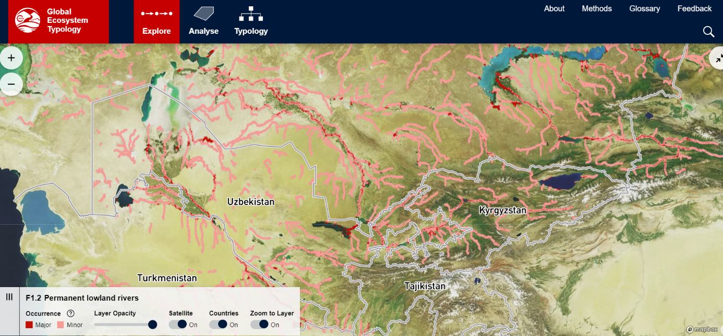
https://global-ecosystems.org/explore/groups/F1.2

2.5.3.3. F1.5 Seasonal lowland rivers

These medium to large rivers in tropical, subtropical and temperate lowlands have markedly seasonal flows due to seasonal water supply in the catchments. Their single or multi-channelled forms link to floodplain wetlands, and transport large floods during wet seasons: summer in the tropics or winter-spring in temperate latitudes. Productivity is high, both within channels and on connected floodplains, with algae and aquatic plants supporting complex food webs, and providing seasonal nurseries for breeding animals.

These large riverine systems (stream orders 5-9) can be highly productive with trophic structures and processes shaped by seasonal hydrology and linkages to floodplain wetlands. In combination with biophysical heterogeneity, this temporal variability promotes functional diversity in the biota. Although trophic networks are complex due to the diversity of food sources and the extent of omnivory amongst consumers, food chains tend to be short and large mobile predators such as otters, large piscivorous waterbirds, sharks, dolphins, and crocodilians (in the tropics) can have a major impact on the food webs. Benthic algae are key contributors to primary productivity, although macrophytes become more important during the peak and late wet season when they also provide substrate for epiphytic algae. Rivers receive very significant resource subsidies from both algae and macrophytes on adjacent floodplains when they are connected by flows. Enhanced longitudinal hydrological connectivity during the wet season enables fish and other large aquatic consumers to function as mobile links, extending floodplain and estuarine resource subsidies upstream. Life cycle processess including reproduction, recruitment, and dispersal in most biota are tightly cued to seasonally high flow periods, often with floodplain nursery areas for river fish, amphibians and larger invertebrates. https://global-ecosystems.org/explore/groups/F1.5

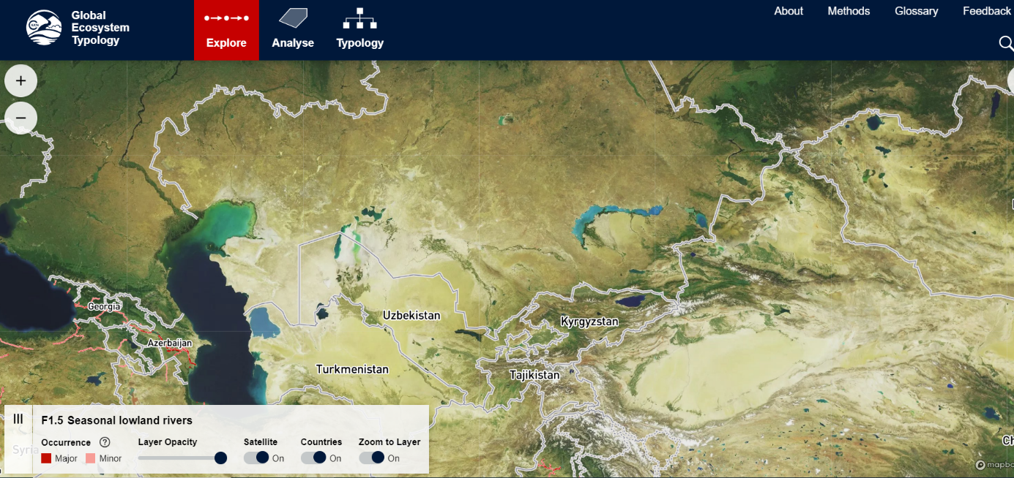
https://global-ecosystems.org/explore/groups/F1.5

2.5.3.4. F1.6 Episodic arid rivers
These desert rivers occur mostly in flat areas of arid and semi-arid mid-latitudes. Channels are typically broad, flat, and often branching, with soft sandy sediments. They are dry most of the time, but punctuated by high-volume, short duration flows that transport nutrients and stimulate high productivity by algae and zooplankton. Plants and animals can either tolerate or avoid long, dry periods and then exploit short pulses of abundant resources, producing hotspots of biodiversity and ecological activity in arid landscapes.

Episodic rivers have high temporal variability in flows and resource availability, shaping a low-diversity biota with periodically high abundance of some organisms. Productivity is episodically high and punctuated by longer periods of low productivity (i.e. boom-bust dynamics). The trophic structure can be complex and dominated by autochthonous primary production. Even though riparian vegetation is sparse, allochthonous inputs from connected floodplains may be important. Top-down control of ecosystem structure is evident in some desert streams. Episodic rivers are hotspots of biodiversity and ecological activity in arid landscapes, acting as both evolutionary and ecological refuges. Most biota have ruderal life cycles, dormancy phases, or high mobility enabling them to tolerate or avoid long, dry periods and to exploit short pulses of high resource availability during flooding. During dry periods, many organisms survive as dormant life phases (e.g. eggs or seeds), by reducing metabolism, or by persisting in perennial refugia (e.g. waterholes, shallow aquifers). They may rapidly recolonise the channel network during flow (networkers). Waterbirds survive dry phases by moving elsewhere, returning to breed during flows. The abundance of water, nutrients and food during flows and floods initiates rapid primary production (especially by algae), breeding and recruitment. Zooplankton are abundant in slower reaches during periods of flow. Macroinvertebrates such as sessile filter-feeders (e.g. mussels) and scavengers (e.g. crayfish) may occur in moderate flow environments with complex microhabitats in fine sediment and amongst woody debris. Assemblages of fish and amphibians are dominated by small body sizes. Most fish species use inundated floodplains in larval, juvenile and mature life stages, and produce massive biomass after large floods. Organisms generally tolerate wide ranges of temperature, salinity, and oxygen. https://global-ecosystems.org/explore/groups/F1.6

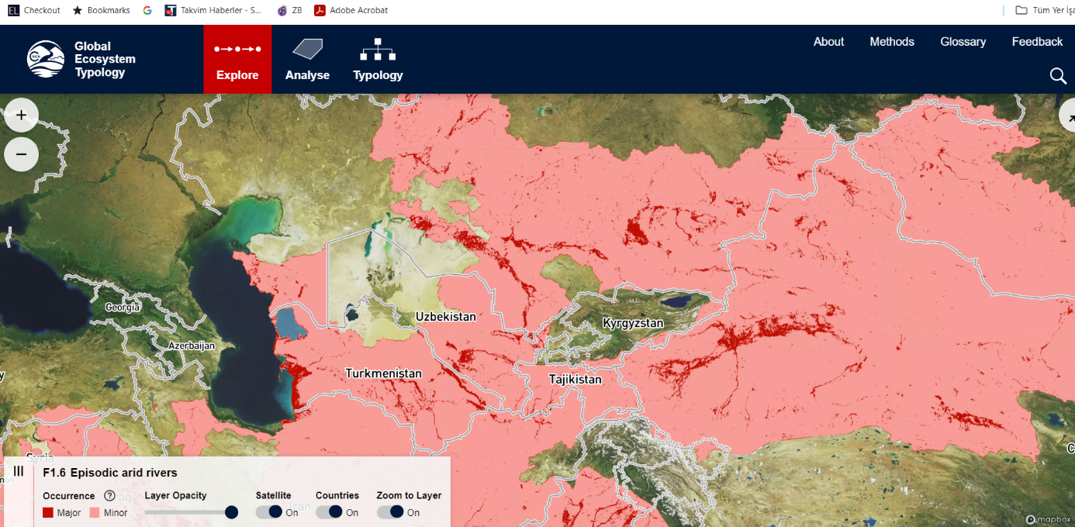

2.5.3.5. F1.7 Large lowland rivers

These very large rivers transport massive volumes of freshwater (>10,000m3/s) through flat lowlands, mostly in tropical or subtropical regions. Their very large flow volumes, diverse habitats and slow to moderate flows make them highly productive. High nutrient levels come from upstream catchments and floodplains, with additional productivity contributed by in-channel algae and aquatic plants. Their food webs are complex, with a high diversity of plants and animals, including large-bodied fish, reptiles and mammals.

Large lowland rivers (typically stream orders 8-12) are highly productive environments with complex trophic webs which are supported by very large flow volumes. Primary production is mostly from autochthonous phytoplankton and riparian macrophytes, with allochthonous inputs from floodplains and upper catchments generally dominating energy flow in the system. The fauna includes a significant diversity of pelagic organisms. Zooplankton are abundant, while sessile (e.g. mussels), burrowing (e.g. annelids) and scavenging (e.g. crustaceans) macroinvertebrates occur in the fine sediment and amongst woody debris. Fish communities are diverse and contribute to complex trophic networks. They include large predatory fish (e.g. freshwater sawfish, Pirhana, Alligator Gar) and in some rivers endemic River Dolphins, smaller predators of invertebrates (benthic and pelagic feeders), phytoplankton herbivores, and detritivores. The feeding activities and movement of semi-aquatic piscivorous birds (e.g. cormorants), mammals (e.g. otters), and reptiles (e.g. turtles, crocodilians) connect the trophic network to other ecosystems beyond instream waters. Riparian and large floodplain zones vary in complexity from forested banks, to productive lentic oxbow lakes and extensive and complex flooded areas where emergent and floodplain vegetation grows (e.g. reeds and macrophytes, shrubs, trees). Riparian zones can be complex but have less direct influence on large rivers than on smaller river ecosystems.

2.5.4. Functional Groups of “F2 Lakes biome” of the “Freshwater Realm”

F2 Lakes biome has 10 “Functional Group” as follows:
https://global-ecosystems.org/explore/biomes/F2
- F2.1 Large permanent freshwater lakes
- F2.2 Small permanent freshwater lakes
- F2.3 Seasonal freshwater lakes
- F2.4 Freeze-thaw freshwater lakes
- F2.5 Ephemeral freshwater lakes
- F2.6 Permanent salt and soda lakes
- F2.7 Ephemeral salt lakes
- F2.8 Artesian springs and oases
- F2.9 Geothermal pools and wetlands
- F2.10 Subglacial lakes

2.5.5. Functional Groupf of “F3 Artificial wetlands biome” of the “Freshawater Realm”

F3 Artificial wetlands biome has 5 Functional Grup- https://global-ecosystems.org/explore/biomes/F3
- F3.1 Large reservoirs
- F3.2 Constructed lacustrine wetlands
- F3.3 Rice paddies
- F3.4 Freshwater aquafarms
- F3.5 Canals, ditches and drains

Annex 4: Executive summary of the FAO’s NBs Guidelines

Climate change is one of the most critical social and environmental concerns and the biggest threat to economic stability in human history. Türkiye, Azerbaijan, and Central Asia countries, namely Kazakhstan, Kyrgyzstan, Tajikistan, Turkmenistan, and Uzbekistan, are vulnerable to the negative impacts of climate change. Although average forest cover is only 10.2 percent of these countries (FAO-SEC countries), they play an essential role in climate change mitigation and adaptation, including human well-being and biodiversity co-benefits.

The NbS concept has gained attention since the late 2000s. Its practical contribution to global climate change mitigation and adaptation efforts has found significant implementation opportunities in forestry to support the protection and conservation, restoration and expansion, and sustainable management of forests under the impact of climate change.

Globally, implementing NbSs to combat the negative impact of climate change on forestry is promoted by the United Nations Forum on Forests (UNFF), United Nations Framework Convention on Climate Change (UNFCCC), the Paris Agreement, United Nations Convention to Combat Desertification (UNCCD), Convention on Biological Diversity (CBD), The United Nations Human Settlements Programme (UN-Habitat), and the 2030 Agenda for Sustainable Development.

Regionally, implementing NbSs to combat the negative impacts of climate change on forestry has been included in the forest policy initiatives of the countries in the sub-region recently. As a result, governments have implemented NbSs through national strategies and programs to address societal challenges by enhancing ecosystem services and promoting human well-being and biodiversity co-benefits. For example, Azerbaijan has implemented afforestation, reforestation, rehabilitation, and restoration activities in forest fund lands on an average of 9 727 hectares (ha) annually since 2000. Kazakhstan aims to save the Aral Sea basin from salinity and improve soil fertility through afforestation activities of saxaul species on 0.25 million ha, and the afforestation area in the Aral Sea will be extended by 1 million ha till 2025. Kyrgyzstan has planned a 1,000-ha annual plantation program to expand protected natural areas to 10 percent. Tajikistan implements 2,000 ha of annual plantation activities to increase the greenhouse gas (GHG) mitigation potential through participatory forestry sector development. Türkiye implemented afforestation, soil conservation, forest rehabilitation, pasture rehabilitation, private afforestation, artificial regeneration, and establishment of energy forests activities on 9.62 million ha from 1946 to 2022. Turkmenistan conducts afforestation activities with drought-resistant plant species and established the "Golden Century Lake" in the Karakum Desert to improve the climate conditions and conserve biodiversity. Uzbekistan declared the Aral Sea region an environmental protection area and plans to implement afforestation activities on 0.5 million ha until 2030 to create the green cover zone.

The theoretical part of these Guidelines is intended to serve as a reference to provide brief information on forest cover and climate change trends in the sub-region, improve understanding of the NbS concept for forests, and facilitate NbS implementation to enhance climate change mitigation and adaptation. The practical part of the Guidelines is centered around six topics:

- Global frameworks promoting the implementation of NbSs;
- Global and regional initiatives, platforms, projects, and examples;
- Current NbS implementation in the sub-region;
- Suitable NbS approaches for sub-region forests under climate change;
- Applicability of NbSs in the sub-region; and
- Investments in NbSs.

The broad global frameworks promoting the implementation of NbSs are Nationally Determined Contributions (NDCs), the Bonn Challenge, the New York Declaration on Forests, the Sendai Framework for Disaster Risk Reduction 2015–2030, Land Degradation Neutrality (LDN) Target Setting Programme, United Nations (UN) Strategic Plan for Forests, UNCCD 2018-2030 Strategic Framework, the United Nations Decade on Ecosystem Restoration, Post-2020 Global Biodiversity Framework, and the Glasgow Leaders’ Declaration on Forests and Land Use, executed by the UN agencies and national governments, supported by non-governmental organizations and the private sector. Several platforms, initiatives, and projects have been established and developed globally and regionally to implement NbSs. Worldwide and sub-regional NbS implementation primarily focuses on three primary strategies: forest protection and conservation, forest ecosystem restoration and expansion, and sustainable management of forest resources. Forest protection and conservation mainly include protected area management, biodiversity conservation (i.e. in-situ and ex-situ conservation methodologies), existing forest protection (avoided forest conversion), improved fire management, and pest and disease management. Forest ecosystem restoration and expansion include revegetation, afforestation, reforestation, restoration, rehabilitation, and invasive species removal. Sustainable forest management covers improved forest management, adaptive forest management, avoided fuelwood, natural regeneration, and assisted natural regeneration. Suitable NbSs for sub-region forests under climate change are synthesized and categorized under the selected NbS approaches. To support regional and national efforts, these Guidelines offer selected NbSs to combat the negative impact of climate change. The selected NbS approaches include:
- Ecosystem restoration approaches;
- Infrastructure-related approaches;
- Ecosystem-based management approaches;
- Issue-specific ecosystem-related approaches; and
- Ecosystem protection and conservation approaches.

- Ecological (ecosystem) restoration approaches

Ecological restoration can extend forest area and tree coverage in the sub-region through revegetation, afforestation, reforestation, restoration, rehabilitation practices, and invasive species removal. These activities enhance the carbon sequestration and storage capacity of forests and strengthen the forest structure under the negative impacts of climate change. Similarly, Forest Landscape Restoration aims to regain ecological functionality and enhance human well-being in deforested or degraded landscapes.

- Infrastructure-related approaches

Urban trees, public open green spaces, green corridors, botanical gardens, arboretums, gardens, and parks are integral to green infrastructure, including ecosystem ponds, detention ponds, and detention pockets for flood control. Urban and peri-urban forests are natural infrastructures that play a critical role in climate change mitigation and adaptation and provide various forest ecosystem goods and services, such as wood, non-wood forest products, recreation, ecotourism, carbon sequestration and storage, soil and water conservation, and biodiversity conservation.

- Ecosystem-based management approaches

Improved forest management is a practical methodology covering several silvicultural activities that enhance carbon stocks in carbon pools and reduce GHG emissions to improve the climate change mitigation potential of forests. Adaptive forest management is fundamental to reducing forest vulnerability and maintaining forest productivity. Adaptation measures might include the selection of heat-tolerant and drought-tolerant species, using planting stock from a range of provenances, underplanting using tree varieties adapted to expected climatic conditions, and the assisted natural regeneration of adapted species and varieties. Integrated natural resource management or integrated (sustainable) land management involves coordination and cooperation among stakeholders to implement sustainable forest, land, water, and biological resource management. The use of forest resources is integrated with the use of other resources that form a specific productive landscape. Natural regeneration is the process whereby forests are restocked by trees germinating from seeds falling from nearby standing mother trees. It can also include regeneration from stumps and roots. Assisted natural regeneration can be defined as the process of rehabilitating clear-cut forest lands by taking advantage of trees already growing in the surrounding area.

- Issue-specific ecosystem-related approaches

Ecosystem-based adaptation is one of the subsets of NbS approaches developed to address the role of ecosystem services in facilitating the adaptation of humans to climate change. Ecosystem-based mitigation focuses on carbon sequestration and storage and avoiding GHG emissions in ecosystems to ensure ecosystem functionality, human health, and socio-economic security. Climate adaptation services aim to complement the ecosystem services concept and contribute to developing options for climate change adaptation, focusing on understanding the vital ecological mechanisms and characteristics that support the ecosystem capacity. Ecosystem-based disaster risk reduction approach focuses on minimizing the impacts of hazards by enhancing the capacity of communities to better manage and recover from the effects of hazards.

- Ecosystem protection and conservation approaches

NbS implementation generates biodiversity co-benefits. Biodiversity conservation is essential to combat the negative impacts of climate change, and NbSs that conserve and restore biodiversity lead to more resilient forests and ecosystem services. In this regard, area-based conservation and protected area management ensure the conservation of particular areas and species with significant importance. Establishing protected areas to conserve particular areas and species is one of the best examples of area-based conservation. Assisted migration of native tree species and populations inside the native range is recognized as a potentially critical response to climate change. Old-growth forests must be strictly protected. Old-growth forests store significant carbon stocks and remove carbon from the atmosphere while being of paramount importance for biodiversity and the provision of critical ecosystem services. Improved fire management is essential to climate change adaptation and mitigation strategies. It includes fuel management, fire occurrence prediction, fire prevention, fire detection, initial attack and suppression, and forest restoration. Pest and disease management and preventing their spread will help ensure that forests remain healthy in the face of climate change.

Annex 5: Executive Summary of the Guidelines on Safeguarding Native Tree Species for Conservation of Genetic Biodiversity in Central Asia

Central Asia is the centre of origin and diversity for many species of global importance, including fruit and nut trees. Although forests cover only 5.7% of the total land area, native tree species play a crucial role in the region by providing high genetic biodiversity. Nevertheless, 46 out of 96 native tree species are globally threatened with extinction, according to the Red List of the International Union for Conservation of Nature (IUCN). Hence, it is essential to facilitate concerted efforts to overturn this unfavourable situation as soon as possible.

Globally, solutions for conserving genetic biodiversity were initiated by the Convention on Biological Diversity (CBD), which entered in force on 29 December 1993. Additionally, the International Treaty on Plant Genetic Resources for Food and Agriculture, Nagoya Protocol on the Access to Genetic Resources and the Fair and Equitable Sharing of Benefits Arising from their Utilisation and the 2030 Agenda for Sustainable Development were concluded to support the conservation and sustainable use and utilisation of genetic resources.

Regionally, biodiversity conservation has always been on the environmental agenda of Central Asian Countries. As a result, governments have developed policies, strategies, action plans and national targets to support the global conservation efforts. For example, Kazakhstan has developed the National Strategy and Action Plan on Conservation and Sustainable Use of Biological Diversity and the Strategic Development Plan until 2025; Kyrgyzstan has elaborated A New Concept of Improving the Forestry Sector until 2040 and a National Action Plan for the Development of the Forestry Sector until 2023; Tajikistan has approved the Strategy for the Forestry Sector Development until 2030; Turkmenistan has put in force the Strategy and Action Plan on Biodiversity Conservation; and Uzbekistan has prepared the National Biodiversity Strategy and Action Plan 2018-2027.

To support the global and regional efforts, the presented Guidelines offer further solutions on safeguarding selected native tree species and elaborate on seed harvesting techniques. The selected tree species include the following: Malus niedzwetkyana, Malus sieversii, Pyrus korshinskyi, Pyrus tadshikistanica, Prunus armeniaca, Juglans regia, Pistacia vera, Juniperus semiglobosa, Juniperus seravschanica, Juniperus turkestanica, Picea schrenkiana, Betula tianschanica, Fraxinus sogdiana and Haloxylon sp.

The theoretical part of the Guidelines intends to serve as a reference for drafting the regional strategy for developing the seed sector in a comprehensive, environmentally sustainable, and socially equitable manner. Such regional strategy can be recognized as an umbrella for the establishment of a seed system. The system will ensure that high-quality seeds of native tree species are produced and fully available in time and affordable to all stakeholders. The Guidelines can support the creation of a regional technical network to facilitate policy alignment, cooperation and coordination in the wider area of sustainable management of plant genetic resources, including on sets of rules for regulatory frameworks such as seed quality protocols, seed production and delivery standards, seed security, rehabilitation activities using native genetic materials and seed marketing in the long term.

The practical part of the Guidelines is centred around two basic strategies available to conserve genetic biodiversity: in situ and ex situ. In situ conservation refers to conserving ecosystems and natural habitats and maintaining and recovering viable species populations in their natural surroundings. Ex situ conservation refers to conserving biodiversity outside their natural habitats. When implemented in parallel, in situ and ex situ strategies complement each other to conserve native tree species (inter-specific) and intra-specific genetic variations. While in situ conservation allows natural evolutionary processes to continue through adaptation to changing conditions, ex situ conservation could be an option if species or populations are threatened in the wild.

Historically, establishing protected areas to conserve particular tree species is one of the best examples of in situ conservation. However, in Central Asia, the distribution range of the selected native tree species is not well represented in protected areas. Hence, in addition to protected areas, consideration of managed forests and trees outside of forests supports in situ conservation in situations where the conservation of genetic biodiversity may not be the premium priority objective. Ecosystem and landscape-based conservation approaches provide a holistic perspective to safeguard genetic biodiversity in natural and fragmented habitats. A practical conservation approach to support the multi-functions of native tree species (i.e. production of goods and services such as timber, fuel wood, fruits and habitat for pollinators) is sustainable forest management in forestlands or integrated/sustainable land management in other lands with trees. A targeted species-specific conservation approach could be adopted and implemented for those native tree species that need urgent action. Tree breeding programmes are valuable tools for conserving genetic biodiversity by mitigating and adapting to climate change. Rich species diversity will typically increase the resilience to climate change. Conservation efforts may also focus on conserving particular adaptive traits found in provenance research of native tree species, such as resistance to pests, diseases, temperature, moisture or drought. Assisted migration of native tree species inside the native range includes managed movement of well-adapted species to areas where they are not yet present by introducing better-suited populations selected from existing distribution areas. Tree-specific action and management plans for the native tree species outside forests and ecosystem-based multi-functional forest management plans could play a key role by defining assisted natural regeneration, afforestation, reforestation, restoration and rehabilitation activities to conserve genetic biodiversity. Cooperation with local farmers would be crucial because they rely on goods and services provided by the native trees for their livelihoods.

Good quality seed harvesting from the native tree species could be the first step of ex situ conservation measures to conserve genetic biodiversity outside of natural habitats and assist in situ conservation measures by collecting reproductive material. Seeds can be harvested from natural populations, managed populations and cultivated tree seed stands or seed orchards of single or multiple tree species. It is crucial to collect seeds locally and from natural populations to conserve gene flow and genetic biodiversity.

Annex 6: Executive Summary of the Guidelines on Sustainable Forest Management under the Impact of Climate Change in Central Asia – Implications for Practitioners

Climate change is one of the most critical challenges of human history, and Central Asia is one of the regions most vulnerable to climate change. Although forests cover only 5.7 percent of Central Asia, they play a crucial role in climate change mitigation and adaptation. However, only sustainably managed or natural forests can fully contribute to this role.

Globally, solutions against climate change were initiated by the United Nations Framework Convention on Climate Change (UNFCCC), which entered into force on 21 March 1994. Additionally, the Paris Agreement, the United Nations Forum on Forests (UNFF), and the 2030 Agenda for Sustainable Development were concluded to support the conservation, restoration, expansion, and sustainable management and use of forests under the impact of climate change.

Regionally, sustainable forest management (SFM) and climate change have been on the environmental agenda of Central Asian Countries (CACs) following the signing of the UNFCCC. As a result, governments have developed national strategies and programs to support global climate change mitigation and adaptation actions to reduce greenhouse gas emissions (GHG) and adapt to climate change. For example, Kazakhstan has developed the "Green Kazakhstan Programme"; Kyrgyzstan has elaborated a new Concept of Improving the Forestry Sector until 2040 and a National Action Plan for the Development of the Forestry Sector until 2023; Tajikistan has developed the Draft Strategy for the Development of Forestry for the period 2016–2030 and approved the National Strategy of Adaptation to Climate Change for the period until 2030; Turkmenistan has put in force the "Climate Change Programme" and "Forestry Programme"; and Uzbekistan has developed the Forestry Concept 2030.

The theoretical part of these Guidelines is intended to serve as a reference to integrate climate change into SFM practices, improve understanding of climate change impacts on forests, revise strategies related to forestry and climate change, and adjust forest management practices to enhance climate change mitigation and adaptation.

The practical part of the Guidelines is centred around four topics:

- Observed impacts of climate change;
- Anticipated impacts of climate change;
- current SFM implementation; and
- Required actions to strengthen SFM and best practice examples of SFM.

Observed impacts of climate change are decline in water resources; poor regeneration; the low survival rate of native tree species; biodiversity loss; tree cover loss; increased number, frequency and intensity of wildfires, landslides, floods, and extreme weather events; increased pests and diseases attacks; decreased production; and melting glaciers. Anticipated impacts of climate change in addition to those already observed are increased temperature; increased period of drought; increased number and impact of storms and avalanches; changes in tree species distribution; and decline in forest functions and provision of ecosystem services. Current SFM implementation in Central Asia focuses on two primary strategies: increasing forest areas and conserving the existing forests and biodiversity. Increasing forest areas is achieved through natural regeneration, afforestation and rehabilitation activities. Conserving the existing forests and biodiversity is ensured by in situ and ex situ conservation methodologies in Central Asia. Required actions to strengthen SFM and best practice examples are synthesized and categorized under the selected nature-based solutions (NBSs) approaches mentioned below.

To support global and regional efforts, these Guidelines offer selected NBSs for SFM under the impact of climate change. The selected NBSs include:

- Ecosystem restoration approaches;
- Issue-specific ecosystem-related approaches;
- Ecosystem-based management approaches;
- Ecosystem protection approaches; and
- Infrastructure-related approaches.

- Ecosystem restoration approaches

There is potential to extend forest area and tree coverage in Central Asia through afforestation and reforestation activities. Afforestation, reforestation and avoiding tree cover loss increases the carbon pools held in aboveground and belowground biomass, litter, dead organic matter and soil organic carbon. The success of adaptation measures also depends on rehabilitation and reforestation techniques. In this sense, forest landscape restoration aims to regain ecological functionality and enhance human well-being in deforested or degraded landscapes. Adaptation measures might include selecting and using drought-tolerant, heat-, salinity- and/or pest-resistant, fast-growing, and income-generating native tree species. This could be ensured by planting good-quality seedlings produced in forest tree nurseries.

- Issue-specific ecosystem-related approaches

Adaptive thinning practices help reduce water competition and improve water balance. Forest plots where tree density is reduced could resist drought events. The pruning of dead tree branches helps create discontinuity between the forest floor and tree crowns and reduces the risk of fire spreading. Changes in optimal rotation age, such as a more extended growth period, could compensate for the reduction in the growth rate due to water constraints and the increased amount of carbon sequestered in tree biomass, forest soil and vegetation. Changes in thinning periods, the planned number of years between the formation or regeneration of a crop of trees and the time when the same crop is felled for final harvest, and close-to-nature forest management could also support the adaptation of forests to the impacts of climate change.

Natural regeneration is the process whereby forests are restocked by trees that germinate from seeds falling from nearby standing mother trees. It can also include regeneration from stumps and roots. Assisted natural regeneration (ANR) can be defined as the process of rehabilitating clear-cut forest lands by taking advantage of trees already growing in the surrounding area.

Assisted migration of native tree species and populations within species is recognized as a potentially critical response to climate change. Assisted migration includes the managed movement of species to areas where they are not yet present and the introduction of better-suited populations within species.

- Ecosystem-based management approaches

Adaptive forest management is a fundamental approach to reducing forest vulnerability and maintaining forest productivity. Adaptation measures might include the selection of heat-tolerant and drought-tolerant species, the use of planting stock from a range of provenances, underplanting using tree varieties adapted to expected climatic conditions, and the assisted natural regeneration of adapted species and varieties. Integrated natural resource management involves coordination and cooperation among stakeholders to implement sustainable forest, land, water and biological resource management. The use of forest resources is integrated with the use of other resources that form a specific productive landscape. Multi-purpose forest management planning (MP-FM) is a common global trend. In addition to producing commercial wood and non-wood forest products (NWFP), MP-FM planning also considers appropriate protections for soil, water, climate, environment, biodiversity and recreational values of forests. It is based on a variety of forest functions, which deliver a broader spectrum of forest-based products for the benefit of rural people through ecosystem services. Forests are a foundation of the green economy concept, sustaining a wide range of sectors and livelihoods. The wood and forestry sectors can significantly contribute to meeting green economy objectives linked to climate change policies, mainly through mitigating GHG emissions and expanding renewable energy objectives. There are three main routes by which the wood and forestry sectors can contribute: the supply of biomass for energy production, the use of wood products in green infrastructure and construction, and the role of forests as carbon sinks.

- Ecosystem protection approaches

Biodiversity conservation is essential for climate change adaptation. Forest management practices that conserve and restore biodiversity lead to more resilient forests. Therefore, all forests should be sufficiently biodiverse, considering the differences in natural conditions, biogeographic regions and forest typology. Old-growth forests must be strictly protected. Old-growth forests store significant carbon stocks and remove carbon from the atmosphere while being of paramount importance for biodiversity and the provision of critical ecosystem services. Fire management is an essential part of climate change adaptation and mitigation strategies. It includes fuel management, fire occurrence prediction, fire prevention, fire detection, initial attack and suppression, and forest restoration. Management of pests and diseases and the prevention of their spread will help ensure that forests remain healthy in the face of climate change. Robust forest monitoring and reporting systems are vital aspects of forest-based responses to climate change to inform the international community on the actual status of forests.

- Infrastructure-related approaches

The underdeveloped infrastructure within the forest sector currently hinders the sustainable management, use and protection of forests. It is vital to invest in forest road networks to support forest management, improve forest protection, temporarily store forest products, ensure the transport of forest products, reduce the risk of forest fires and outbreaks of pests and diseases, and support the transportation of goods and services to remote rural areas adjacent to forests.

Annex 7: Principles of UN Decade on Ecosystem Restoration

Principle 1: Ecosystem Restoration Contributes to The Un Sustainable Development Goals and The Goals of the Rio Conventions

Restoration projects, programmes and initiatives at all spatial scales, from individual sites to large landscapes and seascapes, play an essential role in achieving ambitious global targets for sustaining life on Earth. Successful ecosystem restoration aims to contribute to the achievement of the 2030 Agenda for Sustainable Development and its 17 Sustainable Development Goals (SDGs), which seek to end poverty, conserve biodiversity, combat climate change and improve livelihoods for everyone, everywhere. The SDGs are unlikely to be met unless ecosystem degradation is stopped and ecosystem restoration is undertaken at cumulative scales of hundreds of millions of hectares globally. Effective restoration simultaneously supports achievement of the biodiversity, climate and land-degradation neutrality goals of the Rio Conventions – CBD, United Nations Convention to Combat Desertification (UNCCD) and United Nations Framework Convention on Climate Change (UNFCCC) – and allied global initiatives. Preventing, halting and reversing ecosystem degradation, as a contribution to global targets, is a shared responsibility among all public and private sectors and stakeholders at local, national and international levels.

Principle 2: Ecosystem Restoration Promotes Inclusive And Participatory Governance, Social Fairness And Equity From The Start And Throughout The Process And Outcomes

All stakeholders, right-holders, and especially under-represented groups should be equitably and inclusively provided with opportunities to be engaged and integrated in meaningful, free and active ways. Such inclusive participation is necessary for achieving the desired outcomes of restoration over the long term, and should be promoted as much as possible throughout the process, from planning to monitoring. This participation can be achieved by securing equal and regular access to information and knowledge; recognizing and addressing social asymmetries through empowerment and capacity development of underrepresented groups; seeking free, prior and informed consent providing effective incentives and improving livelihoods, food security and opportunities for local communities; promoting co-management and ensuring a key role for local communities in decision-making; recognizing rights, needs and concerns; fostering tenure security; pursuing fair and equitable distribution of benefits and responsibilities; and building dialogue, trust and mutual respect through inclusive and transparent governance with mechanisms for impartial conflict resolution.

Principle 3: Ecosystem Restoration Includes A Continuum Of Restorative Activities
Ecosystem restoration encompasses a wide range of activities, employed singly or collectively, which aim to repair degraded ecosystems of all kinds. To be considered ecosystem restoration, however, the activity must result in net gain for biodiversity, ecosystem health and integrity, and human well-being, including sustainable production of goods and services. Ecosystem restoration can be implemented in all types of degraded ecosystems, landscapes and seascapes, including urban, production, cultural, semi-natural and natural systems. Major categories of restorative activities include: (1) reduction of negative environmental and societal impacts, such as pollution and unsustainable resource use and management; (2) removal of contaminants, pollutants and other threats, often known as remediation; (3) rehabilitation of ecosystem functions and services in highly modified areas such as former mining sites and degraded production systems; and (4) ecological restoration, which aims to remove degradation and assists in recovering an ecosystem to the trajectory it would be on if degradation had not occurred, accounting for environmental change.

Prıncıple 4: Ecosystem Restoratıon Aıms To Achıeve The Hıghest Level Of Recovery For Bıodıversıty, Ecosystem Health And Integrıty, And Human Well-Beıng

Ecosystem restoration aims to achieve and sustain the greatest net gain possible, given project- and programme-level goals, for biodiversity, ecosystem health and integrity, ecosystem goods and services, climate-change mitigation, and human health and well-being at local, national and global scales. It should enhance and not be a substitute for nature conservation, especially in areas with high ecological integrity and high value for ensuring ecological connectivity, as well as in other priority areas for conservation, including those within the territories of Indigenous peoples and traditional communities.
Management practices intended to be restorative should support and assist natural recovery processes and not cause further degradation. The use of genetically appropriate germplasm of native species should be favoured, whereas non-native species potentially or already proven to be invasive should be avoided.

Prıncıple 5 Ecosystem Restoratıon Addresses The Dırect And Indırect Causes Of Ecosystem Degradatıon

All restorative activities should concurrently address the direct and indirect causes of ecosystem degradation and fragmentation, and the loss of biodiversity and ecosystem goods and services. If the causes are not addressed, restorative activities may fail over the long term. During the planning phase of restoration projects, programmes or initiatives, the degree and causes of degradation should be identified, and actions should be developed to reduce and mitigate their impacts at the appropriate scale. These actions should include eliminating incentives that directly or indirectly promote ecosystem degradation. Importantly, land uses and property regimes that promote ecosystem degradation and prevent the long-term permanence of restored ecosystems should be addressed.
The adoption of sustainable practices that enhance biodiversity conservation (including in production systems), and contribute to the mitigation of and adaptation to climate change, should be promoted; along with measures that reduce the environmental impacts of urbanization, infrastructure development, extractive activities, and unsustainable production and consumption. The development and implementation of plans and policy instruments that aim to prevent, halt or reverse ecosystem degradation should incorporate ecological, cultural and socio-economic considerations, and be harmonized with other policies and actions that govern and shape land and resource use to avoid confusion and conflict.

Prıncıple 6 Ecosystem Restoratıon Incorporates All Types Of Knowledge And Promotes Theır Exchange And Integratıon Throughout The Process

Ecosystem restoration should strive to integrate all types of knowledge – including, but not limited to, Indigenous, traditional, local and scientific ways of knowing – and practices in order to achieve greater kinship with nature, cooperation and effectiveness. Such integration will foster inclusive and consensual decision-making throughout the process, while enabling full participation of local stakeholders and right-holders. Likewise, capacity-development efforts should be focused on promoting mutual learning, as well as knowledge-sharing among stakeholders and communities of practice at local, national and global levels. In particular, knowledge about effective practices and innovative approaches should be systematically captured and shared to develop, adapt and replicate successful experiences, and to avoid repeating mistakes. This will also allow for the identification of knowledge gaps and strategic research and capacity-development priorities.
The incorporation of Indigenous, local and traditional knowledge should comply with the principles of free, prior and informed consent. To facilitate the exchange of knowledge and information, platforms and networks for documenting, integrating and sharing that knowledge and information should be developed and made widely available through regularly updated, easily accessible, understandable and culturally appropriate communication and dissemination channels (taking into account languages and literacy levels.

Prıncıple 7 Ecosystem Restoratıon Is Based On Well-Defıned Short-, Medıum- And Long-Term Ecologıcal, Cultural And Socıo-Economıc Objectıves And Goals

During the planning phase of restoration projects and programmes, realistic and achievable short-, medium- and longterm ecological, cultural and socio-economic objectives and goals should be established, based on a shared vision of desired outcomes. They should include targets and indicators that are measurable against the baseline condition, and that specify the direction (e.g. increase or decrease) and magnitude of change desired, and are time-bound, where appropriate.
The inclusion of measurable objectives and goals will allow clear communication of expected results, set the basis for co-development of an implementation plan and enable monitoring, evaluation and adaptive management. Trade-offs among ecological, cultural, and socio-economic objectives and goals should be addressed and reconciled through fair and transparent negotiation, and in a manner that does not compromise ecosystem recovery.

Prıncıple 8 Ecosystem Restoratıon Is Tailored to The Local Ecologıcal, Cultural and Socıoeconomıc Contexts, Whıle Consıderıng The Larger Landscape Or Seascape

Although ecosystem restoration can be undertaken at any spatial scale, from areas of less than a hectare to large landscapes or seascapes, the ecological, cultural and socio-economic contexts, at both the local and larger landscape or seascape scale, should be taken into account throughout the process. Consideration of the local context facilitates alignment of project objectives and goals with local needs.
Additionally, successful restoration depends on adequately addressing land- and seascape-level factors, including threats from the larger landscape or seascape, exchanges of energy and organisms across ecosystem boundaries, ecological and hydrological connectivity, and transboundary effects. The use of spatial planning processes will facilitate the tailoring of projects, programmes and initiatives to the larger landscape, seascape or ecoregion in order to maximize net gain for biodiversity, ecosystem health and integrity, and human well-being, including sustainable production of goods and services.

Prıncıple 9 Ecosystem Restoratıon Includes Monıtorıng, Evaluatıon And Adaptıve Management Throughout And Beyond The Lıfetıme Of The Project Or Programme

The monitoring of biodiversity, ecosystem health and integrity, and human well-being responses to restoration should be undertaken to determine whether objectives and goals are being met. For monitoring to be effective, it should begin at the inception of the project, programme or initiative, to allow baseline measurements of relevant site- and landscape- or seascape-level indicators to be taken and the assessment of the direction and magnitude of change over time. Different methodological approaches (from statistically rigorous to less formal) can be valuable for understanding patterns and processes of change.
The engagement of stakeholders in monitoring can promote social learning, capacity development and communication among stakeholder groups and communities of practice, at local, national and global scales. Because restoration is a long-term endeavour and, therefore, changing conditions are inevitable, adaptive management – the iterative process of monitoring, evaluating, reflecting and adapting activities and approaches as needed – allows identification of unanticipated (positive and negative) outcomes and improvement of future actions. Monitoring should continue beyond the lifetime of the project, programme or initiative to capture medium- and longer-term impacts.

Prıncıple 10 Ecosystem Restoratıon Is Enabled By Polıcıes And Measures That Promote Its Long-Term Progress, Fosterıng Replıcatıon And Scalıng-Up

Ensuring an enabling policy environment, including through intersectoral policy coordination, is important for achieving restoration objectives and goals over the long term. To this end, all relevant governance instruments (laws, regulations, policies, strategies and plans) should be mapped, adapted where appropriate, and integrated in the planning and implementation of projects, programmes and initiatives.
In addition, maximizing long-term net gain from restorative activities requires: coordinating actions among institutions, sectors and stakeholders, through a well-functioning governance system; fostering local, national and international political commitment and transboundary agreements; providing capacity-development opportunities to empower the people, organizations, institutions and networks involved in restoration; mainstreaming effective practices to have broad influence and allow replication; identifying, mobilizing and maintaining adequate funding (from government, the private sector, international organizations, or other sources) to complete all phases of the process; developing income mechanisms (e.g. through sustainable production, ecotourism, payment for ecosystem services and other sustainable uses of natural resources) that do not compromise the integrity of the restoration process and support its financial viability; and protecting the security of stakeholders and rightholders, especially in areas of political conflict or conflict over natural resources.
Likewise, promoting and replicating successful ecosystem restoration activities and approaches will facilitate and influence the design of laws, policies and measures – at local, national and global levels – to help prevent, halt and reverse ecosystem degradation.

Annex 8: IUCN Global Standard for Nature-based Solutions
The Standard consists of 8 Criteria and 28 Indicators.

Criterion 1: NbS effectively address societal challenges
Guidance: The purpose of this Criterion is to ensure that the NbS is designed as a response to a societal challenge(s) that has been identified as a priority by those who are or will be directly affected by the challenge(s).
All stakeholders, especially rights holders and beneficiaries of the NbS, must be involved in the decision-making process used for identifying the priority challenge(s).
Indicators 1.1 The most pressing societal challenge(s) for rights-holders and beneficiaries are prioritised
Guidance: The NbS intervention must address clearly specified challenges that have significant and demonstrable impacts on society. Identification of the most pressing societal challenges is best informed by a transparent and inclusive consultation process (Criterion 5), as opinions may differ between external stakeholders and local populations and vice versa.
1.2 The societal challenge(s) addressed are clearly understood and documented Guidance:
Establishing a clear understanding and rationale of the challenges to be addressed, and ensuring these are documented, is important for future accountability and optimising those strategies to contribute to human well-being outcomes (1.3). An NbS often yields multiple societal benefits, such as job creation or increased flow of ecosystem services, and the societal challenges these additional benefits address should also be documented. 1.3 Human well-being outcomes arising from the NbS are identified, benchmarked and periodically assessed Guidance: NbS must deliver tangible and substantive benefits to human well-being. Specific, measurable, attainable, realistic and timely (SMART) targets should be used as appropriate, as they are important for accountability and informing adaptive management (Criterion 7).

Criterion 2: Design of NbS is informed by scale

Guidance: The purpose of this Criterion is to encourage NbS designs that recognise the complexity and uncertainty that occur in living dynamic land/seascapes. Scale applies not only to the biophysical or geographic perspective but also to the influence of economic systems, policy frameworks and the importance of cultural perspectives. NbS design will be informed by what stakeholders know about the interactions between different aspects of a land/seascape using a three-scale framework that considers the parts within the land/seascape; the land/seascape itself; and the wider environment around the land/seascape. One example would be households within villages within a local authority area. Understanding the interactions which affect attributes like cultural values, laws, soils, forests and water are important in this regard, as they are relevant to the assessment of the risk of undesirable change, or the probability of creating desirable change.
NbS design seeks to maintain the productive capacity of ecosystems as well as the production of benefits necessary for human well-being.
Indicators 2.1 The design of the NbS recognises and responds to interactions between the economy, society and ecosystems Guidance: The success of an NbS will be determined not only by the quality of the technical intervention but, critically, how well the interactions between people, the economy and the ecosystem are understood and responded to. For the solutions to be durable and sustainable, the design of NbS requires a “systems” framing that acknowledges and addresses these types of interactions and builds them into the decision-making process.
2.2 The design of the NbS is integrated with other complementary interventions and seeks synergies across sectors Guidance: NbS will seek to work with and compliment other types of interventions, such as engineering projects, information technology, financial instruments, etc. Such complementary actions will inherently require the identification of synergies across different sectors according to the specifics and context of each situation.
2.3 The design of the NbS incorporates risk identification and risk management beyond the intervention site Guidance: NbS has the potential to either positively or negatively impact, or be impacted by, stakeholders, interests and ecosystems outside the immediate intervention area. For the solution to be durable and sustainable, such types of interactions both within and around the intervention area need to be understood and accounted for in the decision-making processes. Appropriate risk management options should be incorporated into the intervention design.

Criterion 3: NbS result in a net gain to biodiversity and ecosystem integrity
Guidance: NbS are derived as goods and services from ecosystems, therefore strongly depend on the health of an ecosystem. Biodiversity loss and ecosystem change can have significant impacts on the functioning and integrity of the system. Therefore, NbS design and implementation must avoid undermining the integrity of the system and instead, proactively seek to enhance the functionality and connectivity of the ecosystem. Doing so can also ensure the long-term resilience and durability of the NbS.
Indicators 3.1 The NbS actions directly respond to evidence-based assessment of the current state of the ecosystem and prevailing drivers of degradation and loss Guidance: To develop a solution using nature, one must have a well-founded understanding of the current state of the ecosystems concerned. The baseline assessment needs to be broad enough to characterise ecological state, drivers for ecosystem loss and options for net improvements, making use of both local knowledge and scientific understanding where possible.
3.2 Clear and measurable biodiversity conservation outcomes are identified, benchmarked and periodically assessed Guidance: In order to inform the design, monitoring and assessment of an NbS, targets for enhancing key biodiversity values should be established. For each NbS, the type of target may differ; for example, the target could be the percentage of ecosystem area restored or the return of a keystone species.
3.3 Monitoring includes periodic assessments of unintended adverse consequences on nature arising from the NbS Guidance: Ecosystems are complex with interdependent components and processes. There will always be a level of uncertainty in how they will react to specific interventions or other external changes. Therefore, NbS should be designed and monitored to minimise and mitigate unanticipated risks that might undermine the ecological foundations of the solution itself.
3.4 Opportunities to enhance ecosystem integrity and connectivity are identified and incorporated into the NbS strategy Guidance: Utilising NbS can provide an opportunity to enhance biodiversity conservation and ecosystem management efforts in ways that other types of intervention, in isolation (such as engineering), will not be able to achieve. If solutions are to be implemented close to natural ecosystems that are managed explicitly for conservation outcomes, the NbS should be designed to enable greater ecosystem connectivity. Furthermore, they could be designed to re-introduce lost components of an existing ecosystem, for example, by deliberately choosing formerly existing species of vegetation when restoring.

Criterion 4: NbS are economically viable
Guidance: The return on investment, the efficiency and effectiveness of the intervention, and equity in the distribution of benefits and costs are key determinants of success for an NbS. This Criterion requires that sufficient consideration is given to the economic viability of the intervention, both at the design stage and through monitoring the implementation. For NbS to be sustainable, there must be strong consideration of the economic aspects as, most likely, longterm gains must be balanced against short-term costs, with short-term actions developed within the context of long-term (over generations) goals and plans. If the economic feasibility is not adequately addressed, NbS run the risk of being short-term projects, where, after closing, the solution and benefits provided cease to exist, potentially leaving the landscape and communities worse off than before. Innovative and evidence-based tools for the valuation of nature, along with ideas for NbS contributions to markets and jobs, encourage creative (blended) financing of NbS, thereby increasing the likelihood of their long-term success.
Indicators 4.1 The direct and indirect benefits and costs associated with the NbS, who pays and who benefits, are identified and documented Guidance: Identification and documentation of the main benefits derived, including their direct and indirect, financial and nonfinancial elements are key components for assessing the economic feasibility of the intervention, over time. This information should be differentiated according to who receives the benefits and who bears the costs.
4.2 A cost-effectiveness study is provided to support the choice of NbS including the likely impact of any relevant regulations and subsidies Guidance: Investing heavily in upfront costs without considering the longer-term economic and financial sustainability can negatively impact the intervention’s viability. A cost-effectiveness study not only enables an examination of the upfront and recurring costs against the anticipated longer-term benefits of the proposed intervention(s) over time but also allows key (or hidden) assumptions to be made explicit, tested and verified.
4.3 The effectiveness of the NbS design is justified against available alternative solutions, taking into account any associated externalities Guidance: A key attribute of an NbS is that it is capable of addressing at least one societal challenge in a manner that is both economically viable and efficient. This means that the cost-effectiveness and affordability of the solution must be tested against viable alternatives. Alternative solutions may include a different nature-based solution (for example watershed catchment management rather than floodplain management), a different combination of conventional and nature-based solutions, or substitution of the nature-based solution entirely with a more conventional approach such as engineered infrastructure.
4.4 NbS design considers a portfolio of resourcing options such as market-based, public sector, voluntary commitments and actions to support regulatory compliance Guidance: The fact that NbS simultaneously offers multiple benefits to different stakeholders may place limits on some sources of financing, thereby undermining the interventions long-term viability.
For example, private investors may not wish to bear the cost of delivering public goods or public authorities may be reluctant to cover costs for benefits that will accrue privately. This may require a resourcing package that integrates a range of financial mechanisms. Sources of investment can include publicsector grants, incentives and low interest loans, private-sector loans and equity, blended public-private partnerships as well as philanthropic and voluntary contributions or combinations of the above, reflecting an equitable distribution of both the risks.

Criterion 5: NbS are based on inclusive, transparent and empowering governance processes
Guidance: This criterion requires that NbS acknowledge, involve and respond to the concerns of a variety of stakeholders, especially rights holders. Good governance arrangements are proven to not only reduce an intervention’s sustainability risks, but also to enhance its social ‘license to operate’. Conversely inadequate governance provision for otherwise well-intended actions can adversely affect the legitimacy of benefit and cost sharing arrangements. At a minimum, NbS must adhere to and align with the prevailing legal and regulatory provisions, being clear on where legal responsibilities and liabilities lie. However, as often is the case with natural resources, basic compliance will need to be complemented with ancillary mechanisms that actively engage and empower local communities and other affected stakeholders.
Indicators 5.1 A defined and fully agreed upon feedback and grievance resolution mechanism is available to all stakeholders before an NbS intervention is initiated Guidance: Feedback and grievance resolution mechanisms can include formal, legal or informal non-legal complaint systems that operate according to a clear set of procedures, roles and rules for receiving complaints and providing a remedy. Effective grievance resolution mechanisms are characterised by their acceptance and legitimacy among affected stakeholders, transparency, accessibility and adherence to rights-based approaches. They should operate in a predictable and equitable manner, and be based on engagement and dialogue.
5.2 Participation is based on mutual respect and equality, regardless of gender, age or social status, and upholds the right of Indigenous Peoples to Free, Prior and Informed Consent (FPIC) Guidance: In order that governance arrangements function effectively, all affected stakeholders need to be equipped with the right information at the right time and the inputs they provide need to be meaningfully addressed. In doing so, a conscious effort is required to ensure that traditionally excluded groups are actively brought into the process in a manner that upholds their dignity and encourages their participation. This is particularly the case when an NbS intervention operates or impacts on the lands and territories of indigenous peoples, where their right to self-determine interventions and outcomes should follow established FPIC protocols.
5.3 Stakeholders who are directly and indirectly affected by the NbS have been identified and involved in all processes of the NbS intervention Guidance: Stakeholder mapping and analysis identifies those who may be directly and indirectly, positively or negatively, affected by the NbS. This allows the intervention to afford opportunities to affected stakeholders to engage with and participate in the design and implementation, advocate clearly to uphold their own rights and interests, and where necessary, prevent further marginalisation.
5.4 Decision-making processes document and respond to the rights and interests of all participating and affected stakeholders Guidance: It is important that transparent and accessible documentation records key steps in NbS decision-making procedures. This helps enhance accountability and provides a strong basis for recourse in the case of any disputes or disagreements. Specific attention should be paid to noting which stakeholders where involved in decision-making and the role they played. This is particularly important where extreme inequity persists so that processes can be adapted to encourage meaningful and effective participation. 5.5 Where the scale of the NbS extends beyond jurisdictional boundaries, mechanisms are established to enable joint decisionmaking of the stakeholders in the affected jurisdictions Guidance: Ecosystems do not follow political and administrative borders. Where appropriate, transboundary cooperation agreements between relevant authorities underpin NbS planning and implementation across frontiers to help ensure coherency and consistency of approach and desired outcomes.

Criterion 6: NbS equitably balance trade-offs between achievement of their primary goal(s) and the continued provision of multiple benefits

Guidance: Trade-offs in land and natural resource management is inevitable. Ecosystems provide a wealth of different benefits and not everyone values each of them in the same way. While tradeoffs cannot be avoided, they can be effectively and equitably managed. This Criterion requires that NbS proponents acknowledge these tradeoffs and follow a fair, transparent and inclusive process to balance and manage them over both time and geographic space. This involves a credible assessment, full disclosure and agreement among the most affected stakeholders on how the trade-offs should be addressed. Fair and transparent negotiation of trade-offs and compensation among potentially affected parties for any damages or trade-offs to local opportunities and livelihoods provides the basis for successful long-term NbS outcomes. Critically, it is important to recognise that tradeoffs have social and ecological limits beyond which point certain values or benefits can be lost in perpetuity. This means that safeguards will be necessary to ensure, inter alia, that the integrity of ecosystems and the long-term stabilising properties of ecosystem services are not exceeded.
Indicators 6.1 The potential costs and benefits of associated trade-offs of the NbS intervention are explicitly acknowledged and inform safeguards and any appropriate corrective actions Guidance: All trades-off are accompanied with an associated set of costs and benefits which may be subject to change over the entire NbS lifecycle. A key function of NbS safeguards is to ensure that necessary trade-offs do not negatively impact the most disadvantaged elements of society or, equally, that they are denied access to the intervention’s benefits. It is therefore important that the costs and benefits of trade-off arrangements are fully understood, widely shared among affected stakeholders, and periodically revisited (6.3)
6.2 The rights, usage of and access to land and resources, along with the responsibilities of different stakeholders, are acknowledged and respected Guidance: The legal and customary rights to access, use and control management over land and natural resources, particularly of vulnerable and marginalised groups, needs to be respected and upheld. Rights, use and responsibilities of stakeholder groups in relation to the NbS should be analysed and assessed, using appropriate tools and by building upon the outcomes of stakeholder analysis or mapping (5.3). This is particularly important when dealing with Indigenous communities, where Free, Prior and Informed Consent (FPIC) must be used (5.2).
6.3 The established safeguards are periodically reviewed to ensure that mutually-agreed trade-off limits are respected and do not destabilise the entire NbS Guidance: Where risk is unavoidable, safeguards must be in place and periodically reviewed to anticipate and avoid adverse consequences of interventions, especially considering that inequity in trade-offs may change over time and that not all stakeholders may be equally affected. Therefore, NbS design and strategy needs to be explicit about whose benefits and whose costs will be addressed, including when and how this will be reviewed. Safeguards may be put in place for biodiversity (e.g. setting aside a certain area for protection or limiting the timing of fishing) and for people (e.g. procedural – grievance mechanisms, consultation obligations, right to appeal or substantive – contracts, legal and regulatory provisions).

Criterion 7: NbS are managed adaptively, based on evidence
Guidance: This Criterion requires that NbS implementation plans include provisions to enable adaptive management as a response to uncertainty and as an option to effectively harness ecosystem resilience. A degree of uncertainty is inherent when managing most ecosystems due to their complex, dynamic and self-organising nature. This also means that ecosystems have greater resilience which confers a wider range of options to respond to unanticipated social, economic or climate events. The foundation of adaptive management is the evidence-base provided by regular monitoring and evaluation, drawing on scientific understanding as well as indigenous, traditional and local knowledge. By proactively adopting an adaptive management approach, the NbS can continue to be relevant through the lifecycle of the intervention and the risk of redundancy and stranded investments minimised.
Indicators 7.1 A NbS strategy is established and used as a basis for regular monitoring and evaluation of the intervention Guidance: An NbS strategy, at its most basic, includes the reasoning behind the NbS, a precise articulation of the intended outcomes and clear understanding of how these should be achieved through the actions taken. It should be informed by the prevailing economic, social and ecological conditions, and clearly state the assumptions as to whether and how they are expected to change.
7.2 A monitoring and evaluation plan is developed and implemented throughout the intervention lifecycle Guidance: A monitoring and evaluation plan is a key requirement to understand whether the NbS strategy effectively delivers the intended outcomes and, thereby addressing the societal challenge; and, whether risks or unexpected impacts mean a change in strategy or action is required. Where NbS have synergies with other interventions or approaches, these should be included in the monitoring and evaluation (M&E) plan. Observed and sustained deviations from the key elements of the NBS strategy (7.1) should trigger an adaptive management response (7.3).
7.3 A framework for iterative learning that enables adaptive management is applied throughout the intervention lifecycle Guidance: Learning based on evidence should drive NbS management. Furthermore, iterative -learning is essential in informing adaptive management actions, in order to respond to the factors influencing NbS interventions. For this Criterion, indicators 7.1 and 7.2 provide a continuous feedback loop to learn and adapt the NbS intervention. Ideally, iterative learning is institutionalised so that it carries on even after the NbS intervention ceases.

Criterion 8: NbS are sustainable and mainstreamed within an appropriate jurisdictional context
Guidance: This Criterion requires that NbS interventions are designed and managed with a view to long-term sustainability and that they take account of, work with and align with sectoral, national and other policy frameworks. There are various approaches to mainstreaming NbS; however, all rely on strategic communications and outreach. Audiences to consider include individuals (e.g. the public, academics), institutions (e.g. national government, start-ups, businesses, and organisations) and global networks (e.g. Sustainable Development Goals, Paris Agreement).
Indicators 8.1 The NbS design, implementation and lessons learnt are shared to trigger transformative change Guidance: Transformative change can be characterised by scaling up (policy or programmatic mainstreaming), scaling out (expansion at the geographical or sectoral level) or replication of the NbS. Consequently, it is important that the process of design and implementation captures, documents and makes available lessons learnt to individuals and stakeholders interested in replicating the process. This includes decision makers, investors and other NbS users from the public and private sectors.
8.2 The NbS informs and enhances facilitating policy and regulation frameworks to support its uptake and mainstreaming Guidance: The implementation of NbS is subject to a range of pre-existing policies, laws and sectoral regulations, some of which may not be consistent or mutually reinforcing. In some situations, inconsistent policies and regulations may limit the effective rollout of NBS or, worse, actually contribute to the loss of important ecosystem functions over time. In such situations, it is important to a) be aware of policy, regulatory and legal limitations and b) work with local and/or national decision makers as well as other key stakeholders, to highlight such obstacles and identify effective responses or other enabling solutions.
8.3 Where relevant, the NbS contributes to national and global targets for human well-being, climate change, biodiversity and human rights, including the United Nations Declaration on the Rights of Indigenous Peoples (UNDRIP) Guidance: NbS can make significant contributions to national economic, social and conservation targets and help achieve national commitments to international processes on climate change, human rights, human development and biodiversity. Making these linkages explicit, documenting and communicating them, help further reinforce the profile and role of NbS nationally, secure broad-based and durable political commitment as well as societal support, thereby enhancing the long-term sustainability of the intervention.



https://www.nationalgeographic.org/society/
https://iucn.org/resources/publication/iucn-global-ecosystem-typology-20
https://global-ecosystems.org/page/typology
https://www.ipbes.net/policy-support/tools-instruments/iucn-red-list-ecosystems
https://en.wikipedia.org/wiki/IUCN_Red_List_of_Ecosystems
https://www.decadeonrestoration.org/types-ecosystem-restoration
https://iucn.org/our-work/nature-based-solutions
https://portals.iucn.org/library/sites/library/files/documents/2020-020-En.pdf
https://www.fao.org/aquastat/en/countries-and-basins/transboundary-river-basins/aral-sea
Monitoring the Dried Seabed of the Aral Sea: https://www.undp.org/uzbekistan/publications/monitoring-drained-bottom-aral-sea
Monitoring the Dried Seabed of the Aral Sea: https://www.undp.org/uzbekistan/publications/monitoring-drained-bottom-aral-sea
https://mptf.undp.org/fund/arl00
https://mptf.undp.org/news/fourth-call-proposals-announced
https://mptf.undp.org/project/00140724
https://unfccc.int/sites/default/files/NDC/2022-06/Uzbekistan_Updated%20NDC_2021_EN.pdf
https://documents.un.org/doc/undoc/ltd/n24/191/33/pdf/n2419133.pdf
https://www.decadeonrestoration.org/
https://portals.iucn.org/library/sites/library/files/documents/2020-020-En.pdf
https://www.fao.org/policy-support/tools-and-publications/resources-details/en/c/449353/
https://astanatimes.com/2024/09/international-fund-for-saving-aral-sea-approves-work-plan-for-next-two-years/
https://thediplomat.com/2023/07/the-talibans-new-canal-threatens-water-security-in-uzbekistan-and-turkmenistan/
https://environment.ec.europa.eu/topics/water/water-framework-directive_en
https://www.unccd.int/resources/publications/guideline-integration-sand-and-dust-storm-management-key-policy-areas
https://cdm.unfccc.int/EB/governance.html
https://www.astrazeneca.com/media-centre/press-releases/2023/astrazeneca-announces-400-million-investment-in-reforestation-and-biodiversity-in-support-of-climate-action-and-human-health.html
https://documents.un.org/doc/undoc/ltd/n23/356/05/pdf/n2335605.pdf
Agostini,Paola; Setlur,Banu. Uzbekistan - Country Forest Note: The State of Forests and Forest Landscapes (English). Washington, D.C. : World Bank Group http://documents.worldbank.org/curated/en/099250007072236900/P1708700ef21870290b1a9019310003c250
The Republic of Uzbekistan Nationally Determined Contribution 2021, https://unfccc.int/sites/default/files/NDC/2022-06/Uzbekistan_Updated%20NDC_2021_EN.pdf
Global Forest Resources Assessment (FRA) 2020 Uzbekistan – Report https://openknowledge.fao.org/server/api/core/bitstreams/bc3a5803-b554-4f93-a649-195c500f8527/content
AfD-EIB- Rehabilitation of degraded lands in the lower Aral Sea Basin- Feasibility study, Environmental and Social Safeguards and Support to the project implementation-2024
https://www.fao.org/aquastat/en/countries-and-basins/transboundary-river-basins/aral-sea
FAO. 2012. AQUASTAT Transboundary River Basin Overview – Aral Sea. Food and Agriculture Organization of the United Nations (FAO). Rome, Italyhttps://openknowledge.fao.org/server/api/core/bitstreams/8531eff7-f8d7-46ce-a644-168ea15ab5a5/content
FAO. 2012. AQUASTAT Transboundary River Basin Overview – Aral Sea,Food and Agriculture Organization of the United Nations (FAO). Rome, Italy
Photo by İsmail Belen, Itchan Kala Museum
Interstate Commission for Water Coordination of Central Asia, http://www.icwc-aral.uz/activity.htm
Monitoring the Dried Seabed of the Aral Sea: https://www.undp.org/uzbekistan/publications/monitoring-drained-bottom-aral-sea
https://un.mission.gov.tm/uploads/zqGR54R0ob.pdf
https://documents.un.org/doc/undoc/ltd/n24/203/24/pdf/n2420324.pdf
https://unece.org/sites/default/files/2020-12/FR-Finacing%20WB-Nemova-Agostini.workshop%209%20December%202020.pdf
https://mptf.undp.org/project/00140724
https://environment.ec.europa.eu/topics/water/water-framework-directive_en
Agency of IFAS-Agency of IFAS for implementation of the Aral Sea Basin- https://aral.uz/en/crisis/
The Executive Board of the International Fund for saving the Aral Sea in the Republic of Kazakhstan- https://kazaral.org/en/aral-sea/general-information/
Agency of IFAS-Agency of IFAS for implementation of the Aral Sea basinhttps://aral.uz/en/crisis/
The Executive Board of the International Fund for saving the Aral Sea in the Republic of Kazakhstan- https://kazaral.org/en/aral-sea/general-information/
The Executive Board of the International Fund for saving the Aral Sea in the Republic of Kazakhstan https://kazaral.org/en/aral-sea/general-information/
National State of the Environment Report-Uzbekistan, 2023 https://www.iisd.org/system/files/2024-02/uzbekistan-state-of-the-environment-en.pdf
https://www.goldstandard.org/
https://verra.org/programs/verified-carbon-standard/
https://www.planvivo.org/
International innovation Center for the Aral Sea Basin under the Ministry of Ecology, Environmental Protection and Climate Change of the Republic of Uzbekistan, https://iic-aralsea.uz/en/
https://iucn.org/resources/conservation-tool/iucn-global-ecosystem-typology#8410
https://global-ecosystems.org/page/typology
https://unfccc.int/sites/default/files/NDC/2022-06/Uzbekistan_Updated%20NDC_2021_EN.pdf
https://mptf.undp.org/fund/arl00
https://www.fao.org/family-farming/detail/en/c/1651771/
https://documents.un.org/doc/undoc/gen/n19/060/16/pdf/n1906016.pdf
https://openknowledge.fao.org/server/api/core/bitstreams/b234f058-9f77-4481-b870-a7fa2e7ad5f8/content
https://documents.un.org/doc/undoc/ltd/n24/191/33/pdf/n2419133.pdf
https://portals.iucn.org/library/sites/library/files/documents/2020-020-En.pdf
Personal interview with Dildora Aralova on 11th of November, 2024.
Ministry of Environment, Urbanization and Climate Change (General Directorate of Combating Desertification and Erosion) https://cem.csb.gov.tr/turkiye-de-kiyi-kumullari-ve-kumul-tesbit-calismalari-raporu-i-103696
Arundo donax is a tall perennial cane. It is one of several so-called reed species. It has several common names including giant cane, elephant grass, carrizo, arundo, Spanish cane, Colorado river reed, wild cane, and giant reed. Arundo and donax are respectively the old Latin and Greek names for reed. Arundo donax grows in damp soils, either fresh or moderately saline, and is native to the Greater Middle East. https://en.wikipedia.org/wiki/Arundo_donax
Márton Németh, Managing Director, Silvanus Forestry Ltd./Hungaroplant Ltd., Budapest Hungary 1147 Teréz körút 47., email:marton.nemeth@silvanus.hu, Phonel: +36703767798]
https://mptf.undp.org/news/fourth-call-proposals-announced
https://mptf.undp.org/project/00140724
https://openknowledge.fao.org/items/1dee30d4-2158-4235-a487-e72e42603b78
https://global-ecosystems.org/page/typology

